https://leetcode.com/problems/distribute-coins-in-binary-tree/description/
You are given the root of a binary tree with n nodes where each node in the tree has node.val coins. There are n coins in total throughout the whole tree.
In one move, we may choose two adjacent nodes and move one coin from one node to another. A move may be from parent to child, or from child to parent.
Return the minimum number of moves required to make every node have exactly one coin.

Example 1:
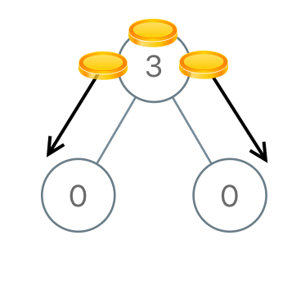
Input: root = [3,0,0]
Output: 2
Explanation: From the root of the tree, we move one coin to its left child, and one coin to its right child.

Example 2:
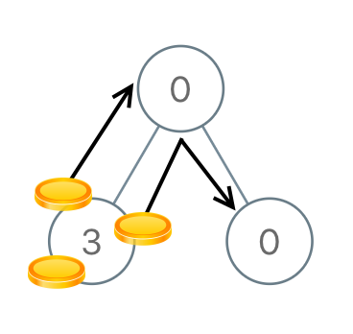
Input: root = [0,3,0]
Output: 3
Explanation: From the left child of the root, we move two coins to the root [taking two moves]. Then, we move one coin from the root of the tree to the right child.

Constraints:
- The number of nodes in the tree is n.
- 1 <= n <= 100
- 0 <= Node.val <= n
- The sum of all Node.val is n.

Attempt 1: 2025-12-05
Solution 1: DFS (60 min)
/**
* Definition for a binary tree node.
* public class TreeNode {
* int val;
* TreeNode left;
* TreeNode right;
* TreeNode() {}
* TreeNode(int val) { this.val = val; }
* TreeNode(int val, TreeNode left, TreeNode right) {
* this.val = val;
* this.left = left;
* this.right = right;
* }
* }
*/
class Solution {
private int moves = 0;

public int distributeCoins(TreeNode root) {
helper(root);
return moves;
}

// Returns the balance of coins for this subtree
// Positive = excess coins to send up
// Negative = needs coins from parent
// Zero = balanced (exactly 1 coin per node)
private int helper(TreeNode node) {
if (node == null) {
return 0;
}

// Get balance from left and right subtrees
int leftBalance = helper(node.left);
int rightBalance = helper(node.right);

// Current node's balance: (node's coins - 1) + children's balances
int balance = node.val - 1 + leftBalance + rightBalance;

// Add the absolute movements needed for children
moves += Math.abs(leftBalance) + Math.abs(rightBalance);

return balance;
}
}

Refer to Deepseek
For LeetCode 979 (Distribute Coins in Binary Tree), the key is to calculate balance = coins - 1 for each subtree and sum the absolute movements needed. Here's the optimal Java solution:
class Solution {
private int moves = 0;

public int distributeCoins(TreeNode root) {
dfs(root);
return moves;
}

// Returns the balance of coins for this subtree
// Positive = excess coins to send up
// Negative = needs coins from parent
// Zero = balanced (exactly 1 coin per node)
private int dfs(TreeNode node) {
if (node == null) {
return 0;
}

// Get balance from left and right subtrees
int leftBalance = dfs(node.left);
int rightBalance = dfs(node.right);

// Current node's balance: (node's coins - 1) + children's balances
int balance = node.val - 1 + leftBalance + rightBalance;

// Add the absolute movements needed for children
moves += Math.abs(leftBalance) + Math.abs(rightBalance);

return balance;
}
}
🧮 How It Works: Step-by-Step
1. The Balance Concept
Each node needs exactly 1 coin. For a node with node.val coins:
- If node.val > 1: Has excess coins to distribute
- If node.val < 1: Needs coins (actually means 0 coins, needs 1)
- If node.val = 1: Perfectly balanced
Balance formula: node.val - 1
2. Why Sum Absolute Values?
The moves counter tracks physical coin movements:
Example:
0 (needs 1 coin)
/ \
3 0
(has 2 excess) (needs 1)
- Left child balance = 3 - 1 = +2 (2 excess coins)
- Right child balance = 0 - 1 = -1 (needs 1 coin)
- Root balance = 0 - 1 + 2 + (-1) = 0 (eventually balanced)
Moves calculation:
- Left → Root: Math.abs(2) = 2 moves
- Right → Root: Math.abs(-1) = 1 move
- Total moves = 2 + 1 = 3
3. Visual Example
Initial: After Distribution:
2 1
/ \ / \
0 0 →→→→ 1 1
/ \ / \
3 0 1 1
DFS Calculation:
1. Node 3 (leaf): excess = 3 - 1 = +2, moves += 0 = 0
2. Node 0 (leaf sibling): excess = 0 - 1 = -1, moves += 0 = 0
3. Left parent (0): excess = 0 + 2 + (-1) - 1 = 0, moves += |2| + |-1| = 3
4. Right child (0): excess = 0 - 1 = -1, moves += 0 = 0
5. Root (2): excess = 2 + 0 + (-1) - 1 = 0, moves += |0| + |-1| = 1

Total moves = 0 + 0 + 3 + 0 + 1 = 4 ✅
🧠 Key Insight
The algorithm counts coin movements across edges:
- Each edge is counted once: When a child returns its excess to parent (positive or negative), Math.abs(excess) represents coins moving across that child-parent edge.
- Why it works:
  - If a child has excess (+), those coins must move up through the edge
  - If a child has deficit (-), coins must move down through the edge
  - Either way, |excess| movements occur across that edge
- Post-order is essential: We need to know children's excess before deciding parent's needs.
📊 Complexity Analysis
Metric | Value | Explanation
Time | O(N) | Each node visited once
Space | O(H) | Recursion depth = tree height
Key Insight: We don't need to simulate actual coin transfers. Just track net flow between nodes using post-order traversal.
🔄 Alternative: Return Array for Clarity
class Solution {
public int distributeCoins(TreeNode root) {
int[] result = new int[1]; // moves count
dfs(root, result);
return result[0];
}

private int dfs(TreeNode node, int[] moves) {
if (node == null) return 0;

int left = dfs(node.left, moves);
int right = dfs(node.right, moves);

moves[0] += Math.abs(left) + Math.abs(right);

return node.val - 1 + left + right;
}
}
🎯 Why This Approach is Optimal
- Single Pass: Calculates moves while computing balance
- No Extra Simulation: Math.abs() captures bidirectional flow
- Post-order Necessity: Need children's balances before parent
The solution elegantly solves the problem by recognizing that total moves = sum of absolute imbalances at each edge!

Refer to
L968.Binary Tree Cameras (Ref.L979)

