https://leetcode.ca/2017-01-29-426-Convert-Binary-Search-Tree-to-Sorted-Doubly-Linked-List/
Convert a Binary Search Tree to a sorted Circular Doubly-Linked List in place.
You can think of the left and right pointers as synonymous to the predecessor and successor pointers in a doubly-linked list. For a circular doubly linked list, the predecessor of the first element is the last element, and the successor of the last element is the first element.
We want to do the transformation in place. After the transformation, the left pointer of the tree node should point to its predecessor, and the right pointer should point to its successor. You should return the pointer to the smallest element of the linked list.

Example 1:
Let's take the following BST as an example, it may help you understand the problem better:

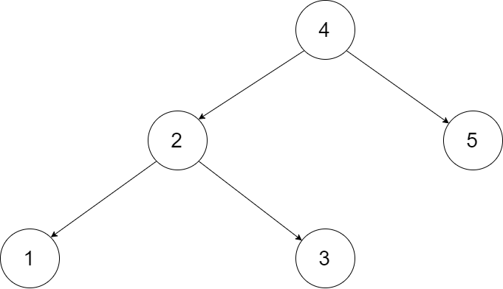

We want to transform this BST into a circular doubly linked list. Each node in a doubly linked list has a predecessor and successor. For a circular doubly linked list, the predecessor of the first element is the last element, and the successor of the last element is the first element.
The figure below shows the circular doubly linked list for the BST above. The "head" symbol means the node it points to is the smallest element of the linked list.

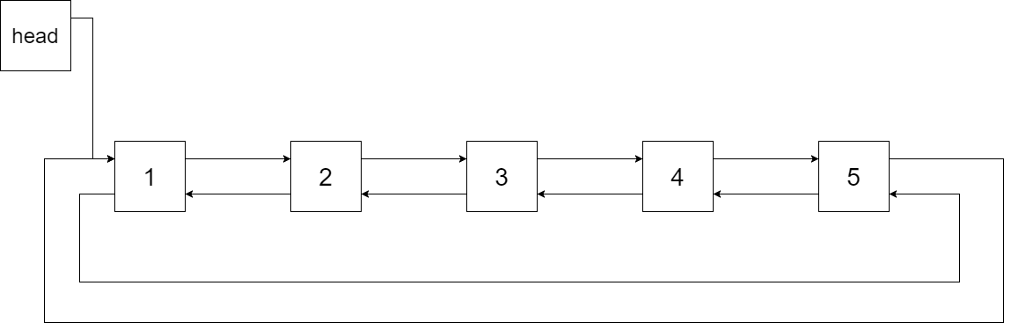

Specifically, we want to do the transformation in place. After the transformation, the left pointer of the tree node should point to its predecessor, and the right pointer should point to its successor. We should return the pointer to the first element of the linked list.
The figure below shows the transformed BST. The solid line indicates the successor relationship, while the dashed line means the predecessor relationship.

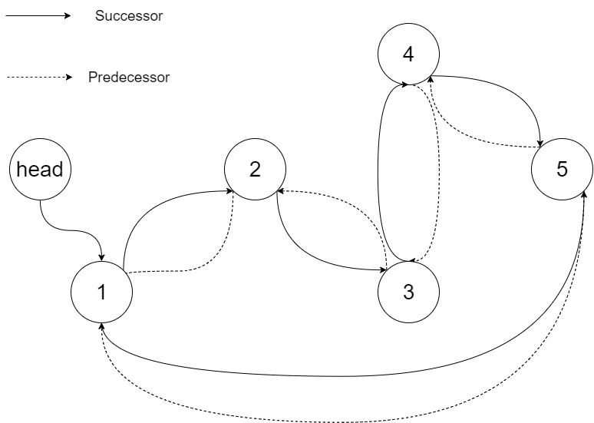

Example 2:
Input: root = [2,1,3]
Output: [1,2,3]

Constraints:
- The number of nodes in the tree is in the range [0, 2000].
- -1000 <= Node.val <= 1000
- All the values of the tree are unique.

Attempt 1: 2026-05-25
Solution 1: In-order Traversal (30min)
Refer to Deepseek
Here's a Java solution for LeetCode 426 "Convert Binary Search Tree to Sorted Doubly Linked List" using in‑order traversal.
/*
// Definition for a Node.
class Node {
public int val;
public Node left;
public Node right;

public Node() {}

public Node(int _val) {
val = _val;
}

public Node(int _val, Node _left, Node _right) {
val = _val;
left = _left;
right = _right;
}
};
*/

class Solution {
private Node first = null; // head of the sorted list
private Node last = null; // tail of the sorted list

public Node treeToDoublyList(Node root) {
if (root == null) return null;

inorder(root);

// Make it circular: connect first and last
first.left = last;
last.right = first;

return first;
}

private void inorder(Node node) {
if (node == null) return;

// Left subtree
inorder(node.left);

// Process current node
if (last == null) {
// This is the smallest node (first in list)
first = node;
} else {
// Link previous node (last) with current node
last.right = node;
node.left = last;
}
last = node; // move last to current

// Right subtree
inorder(node.right);
}
}
Key Points:
- Use an in‑order traversal (left → node → right) to visit nodes in increasing order.
- Maintain first (head) and last (tail) pointers.
- When visiting a node, link last.right to current node and current.left to last, then update last.
- After traversal, connect the first and last nodes to make the list circular.
- This solution runs in O(n) time and O(h) recursion stack space (where h is the tree height).

Can you show me how 'first' and 'last' node working process during the traversal ?
Sure! Let's walk through an example to see how first and last work during the in‑order traversal.
Example BST
Consider the following BST:
4
/ \
2 5
/ \
1 3
In‑order traversal: left → node → right → yields sorted order: 1, 2, 3, 4, 5.

Initial State
- first = null
- last = null

Step-by-step Traversal
1. Start at root (4)
- Go left to node 2
- Go left to node 1
- Node 1 has no left child → process node 1
Process node 1:
- last == null → set first = node1
- last = node1
State:
first = 1
last = 1
List so far: 1

2. Backtrack to node 2 (after finishing left subtree of 2)
- Process node 2:
- last != null → link last.right = node2 → 1.right = 2
- Link node2.left = last → 2.left = 1
- Update last = node2
State:
first = 1
last = 2
List: 1 <-> 2

3. Go to right subtree of node 2 → node 3
- Node 3 has no left child → process node 3:
- last != null → link 2.right = 3, 3.left = 2
- Update last = 3
State:
first = 1
last = 3
List: 1 <-> 2 <-> 3

4. Backtrack to node 4 (after finishing left subtree)
- Process node 4:
- Link 3.right = 4, 4.left = 3
- Update last = 4
State:
first = 1
last = 4
List: 1 <-> 2 <-> 3 <-> 4

5. Go to right subtree of node 4 → node 5
- Node 5 has no left child → process node 5:
- Link 4.right = 5, 5.left = 4
- Update last = 5
Final state:
first = 1
last = 5
List: 1 <-> 2 <-> 3 <-> 4 <-> 5

After traversal
We have a doubly linked list from first (1) to last (5).
To make it circular, we then do:
first.left = last; // 1.left = 5
last.right = first; // 5.right = 1

Summary visual
Step | Node processed | first | last | List state
1 | 1 | 1 | 1 | 1
2 | 2 | 1 | 2 | 1 ↔ 2
3 | 3 | 1 | 3 | 1 ↔ 2 ↔ 3
4 | 4 | 1 | 4 | 1 ↔ 2 ↔ 3 ↔ 4
5 | 5 | 1 | 5 | 1 ↔ 2 ↔ 3 ↔ 4 ↔ 5
- first always points to the smallest node (first visited) and never changes after assignment.
- last moves forward each time we process a new node, always pointing to the most recently added node (the largest so far).
- Each new node is linked to the previous last, making the list grow in sorted order.

Refer to QWEN
Here's a clean, optimal Java solution for LeetCode 426. Convert Binary Search Tree to Sorted Doubly Linked List using Inorder Traversal:
class Solution {
private Node prev = null;
private Node head = null;

public Node treeToDoublyList(Node root) {
if (root == null) return null;

// Reset for safety across multiple test cases
prev = null;
head = null;

inorder(root);

// Connect head and tail to make it circular
head.left = prev;
prev.right = head;

return head;
}

private void inorder(Node curr) {
if (curr == null) return;

// 1. Traverse left subtree
inorder(curr.left);

// 2. Visit current node
if (prev == null) {
head = curr; // First visited node is the smallest (head)
} else {
prev.right = curr;
curr.left = prev;
}
prev = curr; // Update previous pointer

// 3. Traverse right subtree
inorder(curr.right);
}
}
🔍 How it Works:
- Inorder Property: BST inorder traversal (left → root → right) naturally visits nodes in ascending order.
- Pointer Manipulation: As we visit each node, we link it to prev (the node visited just before it). prev.right = curr and curr.left = prev build the DLL incrementally.
- Head Tracking: The first node visited (leftmost) becomes head.
- Circular Closure: After traversal, prev points to the last visited node (rightmost/tail). We connect head.left = tail and tail.right = head to satisfy the circular requirement.
⏱️ Complexity:
- Time: O(N) where N is the number of nodes. Each node is visited exactly once.
- Space: O(H) auxiliary space for the recursion stack, where H is tree height. O(log N) average, O(N) worst-case (skewed tree).
💡 Key Interview Insights:
Concept | Why It Matters
Inorder = Sorted | BST + sorted output → always consider inorder traversal first.
In-Place Modification | We're only rewiring existing pointers. No new nodes created →  O(1)  extra space (excluding call stack).
Circular Linkage | Don't forget the final  head ↔ tail  connection. Many candidates lose points here.
State Reset | Always reset class-level trackers (  prev  ,  head  ) in the public method. LeetCode sometimes reuses  Solution  instances across test cases.
🔄 Iterative Alternative (Zero Recursion Stack)
If you want to avoid recursion depth limits, here's the stack-based version:
public Node treeToDoublyList(Node root) {
if (root == null) return null;
Node prev = null, head = null;
Stack<Node> stack = new Stack<>();
Node curr = root;

while (curr != null || !stack.isEmpty()) {
while (curr != null) {
stack.push(curr);
curr = curr.left;
}
curr = stack.pop();

if (prev == null) head = curr;
else { prev.right = curr; curr.left = prev; }
prev = curr;

curr = curr.right;
}

head.left = prev;
prev.right = head;
return head;
}
Use iterative if explicitly asked to optimize space or handle deeply skewed trees.
Let me know if you'd like a visual walkthrough of the pointer rewiring process or a comparison with Morris Traversal (O(1) space)!

Refer to Kimi
Here is a clean recursive Java solution for LeetCode 426. Convert Binary Search Tree to Sorted Doubly Linked List.
Approach
An in-order traversal of a BST naturally visits nodes in ascending sorted order. During the traversal, we rewire the left and right pointers to act as prev and next pointers of a doubly linked list.
- first — tracks the head of the list (smallest node, first visited).
- last — tracks the tail of the list so far (most recently visited node).
After the traversal, we connect first and last to make the list circular.
Time Complexity: O(n)
Space Complexity: O(h) — recursion stack, where h is the height of the tree
/*
// Definition for a Node.
class Node {
public int val;
public Node left;
public Node right;

public Node() {}

public Node(int _val) {
val = _val;
}

public Node(int _val, Node _left, Node _right) {
val = _val;
left = _left;
right = _right;
}
};
*/

class Solution {
private Node first = null;
private Node last = null;

public Node treeToDoublyList(Node root) {
if (root == null) return null;

inorder(root);

// Close the circular DLL
last.right = first;
first.left = last;

return first;
}

private void inorder(Node node) {
if (node == null) return;

// 1. Traverse left subtree
inorder(node.left);

// 2. Process current node
if (first == null) {
// This is the leftmost (smallest) node — the head of the list
first = node;
} else {
// Link the previous node (last) with current
last.right = node;
node.left = last;
}
last = node; // Update tail to current node

// 3. Traverse right subtree
inorder(node.right);
}
}
How it works
Step | Action
In-order traversal | Visits nodes in ascending order:  1 → 2 → 3 → 4 → 5
first | Set once at the very first node visited (  1  )
last | Updated at every step; before moving to the next node, links  last.right = curr  and  curr.left = last
Final wiring | last.right = first  and  first.left = last  closes the circle
If you prefer an iterative solution (using a stack to avoid recursion), let me know and I can provide that version too.

Refer to

