https://leetcode.com/problems/subtree-of-another-tree/description/
Given the roots of two binary trees root and subRoot, return true if there is a subtree of root with the same structure and node values of subRoot and false otherwise.
A subtree of a binary tree tree is a tree that consists of a node in tree and all of this node's descendants. The tree tree could also be considered as a subtree of itself.

Example 1:
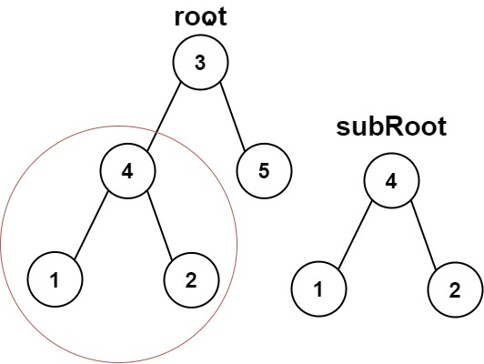
Input: root = [3,4,5,1,2], subRoot = [4,1,2]
Output: true

Example 2:
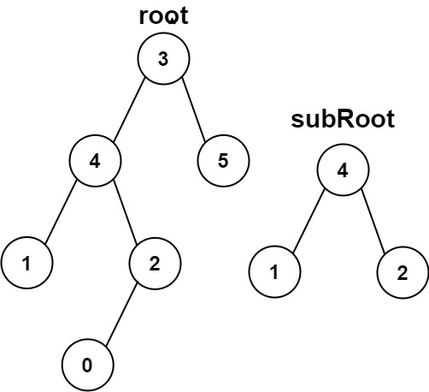
Input: root = [3,4,5,1,2,null,null,null,null,0], subRoot = [4,1,2]
Output: false

Constraints:
- The number of nodes in the root tree is in the range [1, 2000].
- The number of nodes in the subRoot tree is in the range [1, 1000].
- -104 <= root.val <= 10^4
- -104 <= subRoot.val <= 10^4

Attempt 1: 2025-12-16
Solution 1: DFS (10 min)
/**
* Definition for a binary tree node.
* public class TreeNode {
* int val;
* TreeNode left;
* TreeNode right;
* TreeNode() {}
* TreeNode(int val) { this.val = val; }
* TreeNode(int val, TreeNode left, TreeNode right) {
* this.val = val;
* this.left = left;
* this.right = right;
* }
* }
*/
class Solution {
public boolean isSubtree(TreeNode root, TreeNode subRoot) {
if(root == null) {
return false;
}
return isSameTree(root, subRoot) || isSubtree(root.left, subRoot) || isSubtree(root.right, subRoot);
}

private boolean isSameTree(TreeNode a, TreeNode b) {
if(a == null || b == null) {
return a == b;
}
return a.val == b.val && isSameTree(a.left, b.left) && isSameTree(a.right, b.right);
}
}

Time Complexity: O(m * n), In the worst case (e.g., a skewed tree),
for each of the n nodes in root, we might check against all m nodes of subRoot.
Space Complexity: O(h), The space is determined by the recursion stack,
which depends on the height h of the main tree root.

Refer to Deepseek
For LeetCode 572 (Subtree of Another Tree), the standard Java solution is a recursive Depth-First Search (DFS) approach. The core idea is to traverse the main tree and, at each node, check if the subtree rooted there is identical to the given subRoot.
📝 Java Solution (Recursive DFS)
Here is the complete, well-commented Java solution:
/**
* Definition for a binary tree node.
* public class TreeNode {
* int val;
* TreeNode left;
* TreeNode right;
* TreeNode() {}
* TreeNode(int val) { this.val = val; }
* TreeNode(int val, TreeNode left, TreeNode right) {
* this.val = val;
* this.left = left;
* this.right = right;
* }
* }
*/
class Solution {
public boolean isSubtree(TreeNode root, TreeNode subRoot) {
// Base case: if the main tree is null, it cannot contain a subtree
if (root == null) {
return false;
}

// Check: 1. If trees match from the current root, OR
// 2. If the subtree exists in the left child, OR
// 3. If the subtree exists in the right child.
return isSameTree(root, subRoot)
|| isSubtree(root.left, subRoot)
|| isSubtree(root.right, subRoot);
}

// Helper function to check if two trees are identical
private boolean isSameTree(TreeNode p, TreeNode q) {
// If either node is null, both must be null for the trees to be identical
if (p == null || q == null) {
return p == q;
}
// Check if the current nodes have the same value
// AND their left subtrees are identical
// AND their right subtrees are identical
return p.val == q.val
&& isSameTree(p.left, q.left)
&& isSameTree(p.right, q.right);
}
}
🔍 How the Algorithm Works
The solution uses a two-part recursive strategy:
- isSubtree: This is the main function. It recursively traverses every node in the root tree, treating each node as a potential starting point for the subRoot tree. It checks three possibilities at each step: if the trees match at the current node, or if the subRoot is a subtree of the left child, or if it's a subtree of the right child .
- isSameTree: This helper function checks if two given trees are structurally identical and have matching node values at every corresponding position. It's called by isSubtree to verify a match at a specific node .
This is visualized in the flowchart below:
flowchart TD
Start["isSubtree(root, subRoot)"] --> CheckRoot{"root == null?"}

CheckRoot -->|Yes| ReturnFalse["Return false"]

CheckRoot -->|No| CheckCurrent["Check: isSameTree(root, subRoot)"]
CheckCurrent -->|Trees are identical| ReturnTrue["Return true"]

CheckCurrent -->|Not identical| CheckLeft["Recurse: isSubtree(root.left, subRoot)"]
CheckLeft -->|Found in left| ReturnTrue

CheckLeft -->|Not in left| CheckRight["Recurse: isSubtree(root.right, subRoot)"]
CheckRight -->|Found in right| ReturnTrue
CheckRight -->|Not found anywhere| ReturnFalse
📊 Complexity Analysis
Aspect | Complexity | Explanation
Time Complexity | O(m × n) | In the worst case (e.g., a skewed tree), for each of the  n  nodes in  root  , we might check against all  m  nodes of  subRoot  .
Space Complexity | O(h) | The space is determined by the recursion stack, which depends on the height  h  of the main tree  root  .
💡 Alternative Approach: Tree Serialization
For a more advanced solution with better worst-case time complexity, you can serialize both trees into strings and perform substring matching (e.g., using the KMP algorithm). This approach has an O(m + n) time and space complexity but is more complex to implement . The recursive DFS method above is typically preferred for interviews due to its clarity.
✅ Edge Cases to Consider
When testing your solution, make sure it handles these scenarios:
- Empty subRoot: An empty tree is always a subtree. The code above returns false for this case, but LeetCode's constraints state the number of nodes is at least 1 .
- Identical trees: The main tree is considered a subtree of itself .
- subRoot is a leaf node: The algorithm should correctly match a single node.
- Values match but structure differs: The isSameTree function catches this by checking structure.
I hope this detailed explanation helps you understand the solution. Would you like me to walk through a specific example or explain the alternative serialization approach in more detail?

Refer to
L1770.Maximum Score from Performing Multiplication Operations (Ref.L1423)
DFS return logic

