https://leetcode.com/problems/maximal-rectangle/description/

Given a rows x cols binary matrix filled with 0's and 1's, find the largest rectangle containing only 1's and return its area.
Example 1:
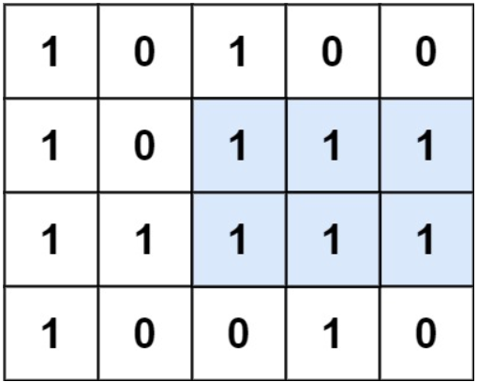

Input: matrix = [["1","0","1","0","0"],["1","0","1","1","1"],["1","1","1","1","1"],["1","0","0","1","0"]]
Output: 6
Explanation: The maximal rectangle is shown in the above picture.

Example 2:
Input: matrix = [["0"]]
Output: 0

Example 3:
Input: matrix = [["1"]]
Output: 1

Constraints:
- rows == matrix.length
- cols == matrix[i].length
- 1 <= row, cols <= 200
- matrix[i][j] is '0' or '1'.
Attempt 1: 2023-08-28
Solution 1: DP (360 min, its not a standard DP, but derive recurrence formula on 2D array)
class Solution {
public int maximalRectangle(char[][] matrix) {
int maxArea = 0;
int m = matrix.length;
int n = matrix[0].length;
int[] heights = new int[n];
// firstLeftLessHeightBarPos[i] 代表左边第一个比当前柱子矮的下标
int[] firstLeftLessHeightBarPos = new int[n];
// firstRightLessHeightBarPos[i] 代表右边第一个比当前柱子矮的下标
int[] firstRightLessHeightBarPos = new int[n];
for(int i = 0; i < n; i++) {
// 初始化为 -1，也就是最左边
firstLeftLessHeightBarPos[i] = -1;
// 初始化为 n，也就是最右边
firstRightLessHeightBarPos[i] = n;
}
for(int i = 0; i < m; i++) {
// 更新所有高度
for(int j = 0; j < n; j++) {
if(matrix[i][j] == '1') {
heights[j] += 1;
} else {
heights[j] = 0;
}
}
// 更新所有firstLeftLessHeightBarPos
// 记录上次出现 0 的位置
int boundary = -1;
for(int j = 0; j < n; j++) {
// 和上次出现 0 的位置比较
if(matrix[i][j] == '1') {
firstLeftLessHeightBarPos[j] = Math.max(firstLeftLessHeightBarPos[j], boundary);
} else {
// 当前是 0 代表当前柱子高度是 0，所以重新初始化为 -1，意味着左边第一
// 个比当前高度为 0 的柱子矮的柱子不存在，下标重置为初始值-1防止对下次
// 循环(外层循环进入到下一行并循环到第j列的时候)的影响，因为下次循环
// 依然使用的是同一个firstLeftLessHeightBarPos数组，只是要更新数值
firstLeftLessHeightBarPos[j] = -1;
// 更新 0 的位置
boundary = j;
}
}
// 右边同理
boundary = n;
for(int j = n - 1; j >= 0; j--) {
if(matrix[i][j] == '1') {
firstRightLessHeightBarPos[j] = Math.min(firstRightLessHeightBarPos[j], boundary);
} else {
firstRightLessHeightBarPos[j] = n;
boundary = j;
}
}
// 更新所有面积
for(int j = 0; j < n; j++) {
maxArea = Math.max(maxArea, (firstRightLessHeightBarPos[j] - firstLeftLessHeightBarPos[j] - 1) * heights[j]);
}
}
return maxArea;
}
}

Time Complexity : O(M*N)
Space Complexity : O(N)

Refer to
https://leetcode.wang/leetCode-85-Maximal-Rectangle.html

解法四 动态规划
参考这里，这是 leetcode Solution 中投票最高的，但比较难理解，但如果结合 84 题去想的话就很容易了。

解法二中，用了 84 题的两个解法，解法三中我们把栈糅合进了原算法，那么另一种可以一样的思路吗？不行！因为栈不要求所有的高度，可以边更新，边处理。而另一种，是利用两个数组， leftLessMin [ ] 和 rightLessMin [ ]。而这两个数组的更新，是需要所有高度的。

解法二中，我们更新一次 heights，就利用之前的算法，求一遍 leftLessMin [ ] 和 rightLessMin [ ]，然后更新面积。而其实，我们求 leftLessMin [ ] 和 rightLessMin [ ] 可以利用之前的 leftLessMin [ ] 和 rightLessMin [ ] 来更新本次的。

我们回想一下 leftLessMin [ ] 和 rightLessMin [ ] 的含义， leftLessMin [ i ] 代表左边第一个比当前柱子矮的下标，如下图橙色柱子时当前遍历的柱子。rightLessMin [ ] 时右边第一个。

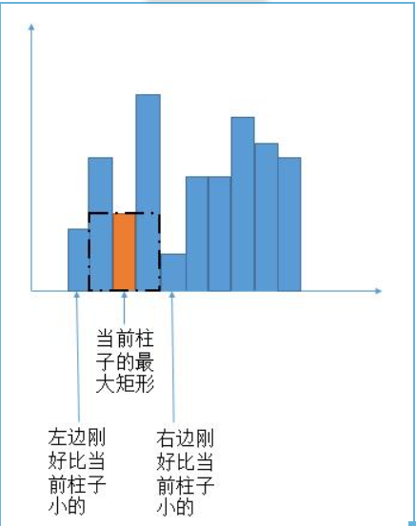
left 和 right 是对称关系，下边只考虑 left 的求法。

如下图，如果当前新增的层全部是 1，当然这时最完美的情况，那么 leftLessMin [ ] 根本不需要改变。

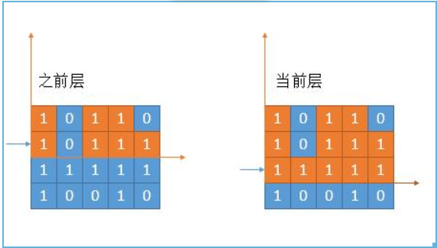
然而事实是残酷的，一定会有 0 的出现。
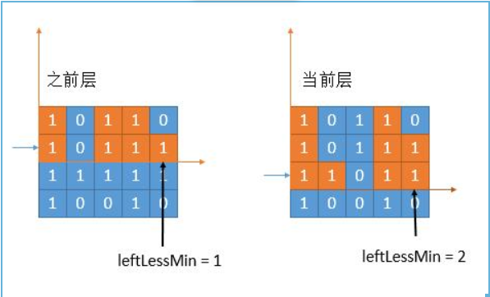
我们考虑最后一个柱子的更新。上一层的 leftLessMin = 1，也就是蓝色 0 的位置是第一个比它低的柱子。但是在当前层，由于中间出现了 0。所以不再是之前的 leftLessMin ，而是和上次出现 0 的位置进行比较（因为 0 一定比当前柱子小），谁的下标大，更接近当前柱子，就选择谁。上图中出现 0 的位置是 2，之前的 leftLessMin 是 1，选一个较大的，那就是 2 了。
public int maximalRectangle4(char[][] matrix) {
if (matrix.length == 0) {
return 0;
}
int maxArea = 0;
int cols = matrix[0].length;
//leftLessMin[i] 代表左边第一个比当前柱子矮的下标
int[] leftLessMin = new int[cols];
//rightLessMin[i] 代表右边第一个比当前柱子矮的下标
int[] rightLessMin = new int[cols];
Arrays.fill(leftLessMin, -1); //初始化为 -1，也就是最左边
Arrays.fill(rightLessMin, cols); //初始化为 cols，也就是最右边
int[] heights = new int[cols];
for (int row = 0; row < matrix.length; row++) {
//更新所有高度
for (int col = 0; col < cols; col++) {
if (matrix[row][col] == '1') {
heights[col] += 1;
} else {
heights[col] = 0;
}
}
//更新所有leftLessMin
int boundary = -1; //记录上次出现 0 的位置
for (int col = 0; col < cols; col++) {
if (matrix[row][col] == '1') {
//和上次出现 0 的位置比较
leftLessMin[col] = Math.max(leftLessMin[col], boundary);
} else {
//当前是 0 代表当前高度是 0，所以初始化为 -1，防止对下次循环的影响
leftLessMin[col] = -1;
//更新 0 的位置
boundary = col;
}
}
//右边同理
boundary = cols;
for (int col = cols - 1; col >= 0; col--) {
if (matrix[row][col] == '1') {
rightLessMin[col] = Math.min(rightLessMin[col], boundary);
} else {
rightLessMin[col] = cols;
boundary = col;
}
}
//更新所有面积
for (int col = cols - 1; col >= 0; col--) {
int area = (rightLessMin[col] - leftLessMin[col] - 1) * heights[col];
maxArea = Math.max(area, maxArea);
}
}
return maxArea;
}
时间复杂度：O（mn）。
空间复杂度：O（n）。

Solution 2: Based on L84. Largest Rectangle in Histogram (120 min)
class Solution {
public int maximalRectangle(char[][] matrix) {
int maxArea = 0;
int m = matrix.length;
int n = matrix[0].length;
int[] heights = new int[n];
for(int i = 0; i < m; i++) {
for(int j = 0; j < n; j++) {
if(matrix[i][j] == '1') {
heights[j] += 1;
} else {
heights[j] = 0;
}
}
maxArea = Math.max(maxArea, largestRectangleArea(heights));
}
return maxArea;
}
private int largestRectangleArea(int[] heights) {
Stack<Integer> stack = new Stack<Integer>();
int maxArea = 0;
for(int i = 0; i <= heights.length; i++) {
int h = i < heights.length ? heights[i] : 0;
if(stack.isEmpty() || h >= heights[stack.peek()]) {
stack.push(i);
} else {
int height = heights[stack.pop()];
int width = 0;
if(stack.isEmpty()) {
width = i;
} else {
width = i - 1 - stack.peek();
}
maxArea = Math.max(maxArea, height * width);
i--;
}
}
return maxArea;
}
}

Time Complexity : O(M*N)
Space Complexity : O(N)
Refer to
L84. Largest Rectangle in Histogram
class Solution {
public int largestRectangleArea(int[] heights) {
int maxArea = 0;
Stack<Integer> stack = new Stack<Integer>();
// 'i <= heights.length' includes '==' condition
for(int i = 0; i <= heights.length; i++) {
// Corner case to add dummy height = 0 when i == heights.length
// which helps calculation of rectangle area close to right end
int h = (i == heights.length ? 0 : heights[i]);
if(stack.isEmpty() || h >= heights[stack.peek()]) {
stack.push(i);
} else {
int height = heights[stack.pop()];
int width = 0;
if(stack.isEmpty()) {
width = i;
} else {
//int right_boundary = i - 1;
//int left_boundary = stack.peek();
//width = right_boundary - left_boundary + 1;
// Why left boundary is stack.peek() ?
// Take {2,1,5,6,2,3} as example, when process the 2nd 2
// which index = 4, originally we have stored index = {1,2,3}
// on stack, corresponding to {1,5,6}, because 2 < 6, pop
// peak index = 3, now we have {1,2} stored on stack, the
// left boundary index is stack.peek() as 2, which represents
// the rectangle height = 5, now why we say height as 5 rectangle
// must be left boundary, because of maintaining an increasing
// monotonic stack, if any rectangle before height as 5 rectangle
// exist, its corresponding index would be popped out from the
// stack already before we push current height as 5 rectangle's
// index = 2 onto stack based on 'else branch logic', so the remain
// height as 5 rectangle on index = 2 is definitely the "shortest"
// rectangle still existing on stack, but also be the "highest"
// rectangle pushing into stack till now, can be used as left boundary
width = i - 1 - stack.peek();
}
maxArea = Math.max(maxArea, height * width);
// Why we have to use i-- ?
// When we in the else branch, means the h (height[i]) is
// smaller than height[s.peek()], what we do is updating
// the maxArea, but the height[i] is still waiting to be
// put into the stack, we do i-- to counteract the i++
// statement in the for loop, so that we will get the same
// i in the next time
// Take {2,1,5,6,2,3} as example, when try tp push 1 onto stack,
// since 1 < 2 go into "else branch" but no push logic, only pop
// logic in "else branch", to push it we have to waiting till
// next iteration, to compensate auto i++, we preparatorily
// decrease as i-- in current iteration
i--;
}
}
return maxArea;
}
}
Refer to
https://leetcode.wang/leetCode-85-Maximal-Rectangle.html

解法二
参考这里-solution-based-on-Largest-Rectangle-in-Histogram>)，接下来的解法，会让这道题变得异常简单。还记得 84 题吗？求一个直方图矩形的最大面积。

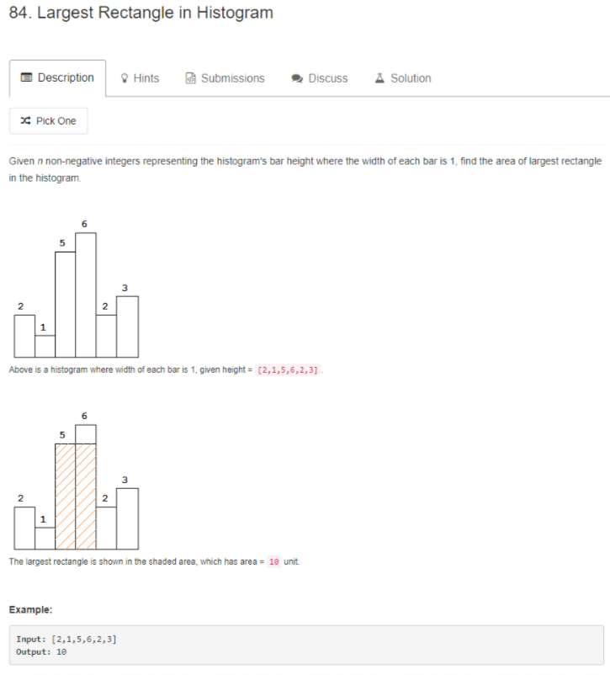
大家可以先做 84 题，然后回来考虑这道题。

再想一下这个题，看下边的橙色的部分，这完全就是上一道题呀！

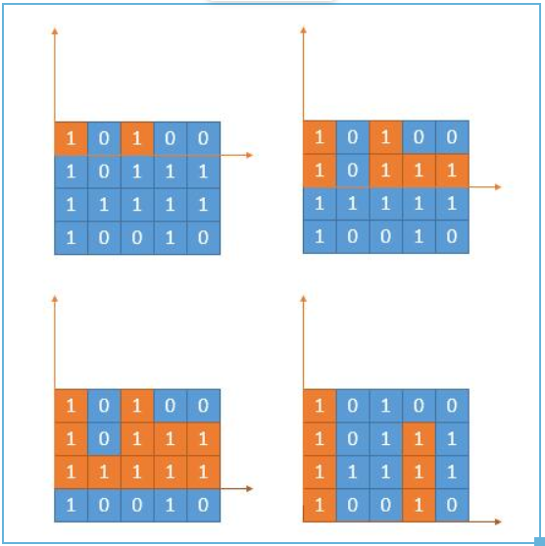
算法有了，就是求出每一层的 heights[] 然后传给上一题的函数就可以了。

利用上一题的栈解法。
public int maximalRectangle(char[][] matrix) {
if (matrix.length == 0) {
return 0;
}
int[] heights = new int[matrix[0].length];
int maxArea = 0;
for (int row = 0; row < matrix.length; row++) {
//遍历每一列，更新高度
for (int col = 0; col < matrix[0].length; col++) {
if (matrix[row][col] == '1') {
heights[col] += 1;
} else {
heights[col] = 0;
}
}
//调用上一题的解法，更新函数
maxArea = Math.max(maxArea, largestRectangleArea(heights));
}
return maxArea;
}
public int largestRectangleArea(int[] heights) {
int maxArea = 0;
Stack<Integer> stack = new Stack<>();
int p = 0;
while (p < heights.length) {
//栈空入栈
if (stack.isEmpty()) {
stack.push(p);
p++;
} else {
int top = stack.peek();
//当前高度大于栈顶，入栈
if (heights[p] >= heights[top]) {
stack.push(p);
p++;
} else {
//保存栈顶高度
int height = heights[stack.pop()];
//左边第一个小于当前柱子的下标
int leftLessMin = stack.isEmpty() ? -1 : stack.peek();
//右边第一个小于当前柱子的下标
int RightLessMin = p;
//计算面积
int area = (RightLessMin - leftLessMin - 1) * height;
maxArea = Math.max(area, maxArea);
}
}
}
while (!stack.isEmpty()) {
//保存栈顶高度
int height = heights[stack.pop()];
//左边第一个小于当前柱子的下标
int leftLessMin = stack.isEmpty() ? -1 : stack.peek();
//右边没有小于当前高度的柱子，所以赋值为数组的长度便于计算
int RightLessMin = heights.length;
int area = (RightLessMin - leftLessMin - 1) * height;
maxArea = Math.max(area, maxArea);
}
return maxArea;
}
时间复杂度：O（mn）。
空间复杂度：O（n）。

