<https://leetcode.com/problems/rotting-oranges/>

You are given an m x n grid where each cell can have one of three values:

* 0 representing an empty cell,
* 1 representing a fresh orange, or
* 2 representing a rotten orange.

Every minute, any fresh orange that is **4-directionally adjacent** to a rotten orange becomes rotten.

Return *the minimum number of minutes that must elapse until no cell has a fresh orange*. If *this is impossible, return*-1.

**Example 1:**

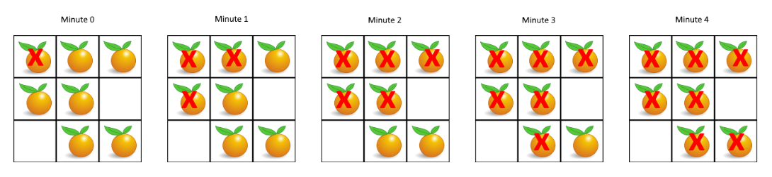

Input: grid = [[2,1,1],[1,1,0],[0,1,1]]

Output: 4

**Example 2:**

Input: grid = [[2,1,1],[0,1,1],[1,0,1]]

Output: -1

Explanation: The orange in the bottom left corner (row 2, column 0) is never rotten, because rotting only happens 4-directionally.

**Example 3:**

Input: grid = [[0,2]]

Output: 0

Explanation: Since there are already no fresh oranges at minute 0, the answer is just 0.

**Constraints:**

* m == grid.length
* n == grid[i].length
* 1 <= m, n <= 10
* grid[i][j]is 0, 1, or 2.

**Attempt 1: 2023-10-8**

**Solution 1: BFS + Level order traversal (10min, no extra space visited 2D array needed)**

class Solution {

public int orangesRotting(int[][] grid) {

int count = 0;

Queue<int[]> q = new LinkedList<>();

int m = grid.length;

int n = grid[0].length;

for(int i = 0; i < m; i++) {

for(int j = 0; j < n; j++) {

if(grid[i][j] == 2) {

q.offer(new int[] {i, j});

}

if(grid[i][j] == 1) {

count++;

}

}

}

// Corner case: Test out by input [[0]] or [[0, 2]], expect 0

// Since there are already no fresh oranges at minute 0,

// the answer is just 0.

if(count == 0) {

return 0;

}

// BFS level traversal, the 'level' required to empty queue

// equal to minimum minutes required, initialize with -1 means

// the 1st rotten orange pulled out of queue will be minute 0

// since level = -1 will add 1 to 0

int level = -1;

int[] dx = new int[] {0, 0, 1, -1};

int[] dy = new int[] {1, -1, 0, 0};

while(!q.isEmpty()) {

int size = q.size();

for(int i = 0; i < size; i++) {

int[] cur = q.poll();

// Set to -1 means already visited

grid[cur[0]][cur[1]] = -1;

for(int k = 0; k < 4; k++) {

int new_x = cur[0] + dx[k];

int new_y = cur[1] + dy[k];

if(new_x >= 0 && new_x < m && new_y >= 0 && new_y < n

&& grid[new_x][new_y] == 1) {

q.offer(new int[] {new_x, new_y});

// Set to -1 means already visited and must have this

// change to mark as visited before adding {new_x, new_y}

// into queue, otherwise if not mark visited and continue

// search in for loop on 4 directions will have chance to

// duplicate find same new cell equal to 1

grid[new_x][new_y] = -1;

count--;

}

}

}

level++;

}

return count == 0 ? level : -1;

}

}

**Refer to**

**The below way have extra space requirement for boolean visited 2D array**

// Refer to

// https://github.com/lampardchelsea/hello-world/blob/master/leetcode/BFS/WallsAndGates.java

class Solution {

public int orangesRotting(int[][] grid) {

int fresh_orange = 0;

boolean[][] visited = new boolean[grid.length][grid[0].length];

Queue<int[]> q = new LinkedList<int[]>();

for(int i = 0; i < grid.length; i++) {

for(int j = 0; j < grid[0].length; j++) {

if(grid[i][j] == 1) {

fresh_orange++;

} else if(grid[i][j] == 2) {

q.offer(new int[] {i, j});

visited[i][j] = true;

}

}

}

if(fresh_orange == 0) {

return 0;

}

int[] dx = new int[] {0,0,1,-1};

int[] dy = new int[] {1,-1,0,0};

int time = 0;

while(!q.isEmpty()) {

if(fresh_orange == 0) {

return time;

}

time++;

int size = q.size();

for(int i = 0; i < size; i++) {

int[] cur = q.poll();

for(int j = 0; j < 4; j++) {

int new_x = cur[0] + dx[j];

int new_y = cur[1] + dy[j];

if(new_x >= 0 && new_x < grid.length && new_y >= 0 && new_y < grid[0].length && !visited[new_x][new_y]) {

visited[new_x][new_y] = true;

if(grid[new_x][new_y] == 1) {

grid[new_x][new_y] = 2;

q.offer(new int[] {new_x, new_y});

fresh_orange--;

}

}

}

}

}

return -1;

}

}