<https://stackoverflow.com/questions/38159668/monitor-vs-mutex>

Q: Can someone tell me the difference between mutex and monitor as both help achieve the same thing (Mutual Exclusion)?

A1:

Since you haven't specified which OS or language/library you are talking about, let me answer in a generic way.

Conceptually they are the same. But usually they are implemented slightly differently

**Monitor**

Usually, the implementation of monitors is faster/light-weight, since it is designed for multi-threaded synchronization within the same process. Also, usually, it is provided by a framework/library itself (as opposed to requesting the OS).

**Mutex**

Usually, mutexes are provided by the OS kernel and libraries/frameworks simply provide an interface to invoke it. This makes them heavy-weight/slower, but they work across threads on different processes. OS might also provide features to access the mutex by name for easy sharing between instances of separate executables (as opposed to using a handle that can be used by fork only).

A2:

Monitor are different then Mutex but they can be considered similar in a sense that Monitor are build on top of Mutex. See depiction of monitor in an image at the bottom, for clarity.

**Monitor is a synchronization construct that allows threads to have both mutual exclusion (using locks) and cooperation** i.e. the ability to make threads wait for certain condition to be true (using wait-set).

In other words, along with data that implements a lock, every Java object is logically associated with data that implements a wait-set. Whereas locks help threads to work independently on shared data without interfering with one another, wait-sets help threads to cooperate with one another to work together towards a common goal e.g. all waiting threads will be moved to this wait-set and all will be notified once lock is released. This wait-set helps in building monitors with additional help of lock (**mutex**).

[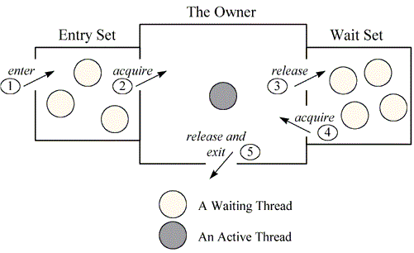](https://i.stack.imgur.com/wzFDc.gif)

I you want, you can see my answer [here](https://stackoverflow.com/a/35941841/4774371), which may or may not be relevant to this question.

You can find another relevant discussion here

[Semaphore vs. Monitors - what's the difference?](https://stackoverflow.com/questions/7335950/semaphore-vs-monitors-whats-the-difference?lq=1)