<https://leetcode.com/problems/permutations-ii/>

Given a collection of numbers, nums, that might contain duplicates, return *all possible unique permutations* ***in any order****.*

**Example 1:**

Input: nums = [1,1,2]

Output:

[[1,1,2],

[1,2,1],

[2,1,1]]

**Example 2:**

Input: nums = [1,2,3]

Output: [[1,2,3],[1,3,2],[2,1,3],[2,3,1],[3,1,2],[3,2,1]]

**Constraints:**

* 1 <= nums.length <= 8
* -10 <= nums[i] <= 10

**Attempt 1: 2022-10-20**

**Solution 1: Backtracking style 1 (10min)**

class Solution {

public List<List<Integer>> permuteUnique(int[] nums) {

List<List<Integer>> result = new ArrayList<List<Integer>>();

boolean[] visited = new boolean[nums.length];

Arrays.sort(nums);

helper(nums, result, new ArrayList<Integer>(), visited, 0);

return result;

}

private void helper(int[] nums, List<List<Integer>> result, List<Integer> tmp, boolean[] visited, int index) {

if(tmp.size() == nums.length) {

result.add(new ArrayList<Integer>(tmp));

return;

}

for(int i = index; i < nums.length; i++) {

if(visited[i] || (i > 0 && !visited[i - 1] && nums[i] == nums[i - 1])) {

continue;

}

tmp.add(nums[i]);

visited[i] = true;

helper(nums, result, tmp, visited, index);

tmp.remove(tmp.size() - 1);

visited[i] = false;

}

}

}

Refer to

https://leetcode.com/problems/permutations-ii/discuss/18594/Really-easy-Java-solution-much-easier-than-the-solutions-with-very-high-vote/121098

The worst-case time complexity is O(n! * n).

For any recursive function, the time complexity is O(branches^depth) * amount of work at each node in the recursive call tree. However, in this case, we have n*(n-1)*(n*2)*(n-3)*...*1 branches at each level = n!, so the total recursive calls is O(n!)

We do n-amount of work in each node of the recursive call tree, (a) the for-loop and (b) at each leaf when we add n elements to an ArrayList. So this is a total of O(n) additional work per node.

Therefore, the upper-bound time complexity is O(n! * n).

Refer to

https://leetcode.com/problems/permutations/discuss/1527929/Java-or-TC%3A-O(N*N!)-or-SC%3A-O(N)-or-Recursive-Backtracking-and-Iterative-Solutions

Time Complexity: O(N * N!). Number of permutations = P(N,N) = N!.

Each permutation takes O(N) to construct

T(n) = n*T(n-1) + O(n)

T(n-1) = (n-1)*T(n-2) + O(n-1)

...

T(2) = (2)*T(1) + O(2)

T(1) = O(N) -> To convert the nums array to ArrayList.

Above equations can be added together to get:

T(n) = n + n*(n-1) + n*(n-1)*(n-2) + ... + (n....2) + (n....1) * n

= P(n,1) + P(n,2) + P(n,3) + ... + P(n,n-1) + n*P(n,n)

= (P(n,1) + ... + P(n,n)) + (n-1)*P(n,n)

= Floor(e*n! - 1) + (n-1)*n!

= O(N * N!)

Space Complexity: O(N). Recursion stack.

N = Length of input array.

**Refer to**

<https://leetcode.com/problems/permutations-ii/discuss/18594/Really-easy-Java-solution-much-easier-than-the-solutions-with-very-high-vote/324818>

The difficulty is to handle the duplicates.

With inputs as [1a, 1b, 2a],

If we don't handle the duplicates, the results would be: [1a, 1b, 2a], [1b, 1a, 2a]...,

so we must make sure 1a goes before 1b to avoid duplicates

By using nums[i-1]==nums[i] && !used[i-1], we can make sure that 1b cannot be chosen before 1a

<http://www.jiuzhang.com/solutions/permutations-ii/>

public class Solution {

public List<List<Integer>> permuteUnique(int[] nums) {

List<List<Integer>> result = new ArrayList<List<Integer>>();

if(nums == null || nums.length == 0) {

return result;

}

Arrays.sort(nums);

List<Integer> combination = new ArrayList<Integer>();

helper(nums, result, combination, new boolean[nums.length]);

return result;

}

private void helper(int[] nums, List<List<Integer>> result, List<Integer> combination, boolean[] used) {

if(combination.size() == nums.length) {

result.add(new ArrayList<Integer>(combination));

}

for(int i = 0; i < nums.length; i++) {

/*

判断主要是为了去除重复元素影响。

比如，给出一个排好序的数组，[1,2,2]，那么第一个2和第二2如果在结果中互换位置，

我们也认为是同一种方案，所以我们强制要求相同的数字，原来排在前面的，在结果

当中也应该排在前面，这样就保证了唯一性。所以当前面的2还没有使用的时候，就

不应该让后面的2使用。

*/

if(used[i] || (i > 0 && !used[i - 1] && nums[i] == nums[i - 1])) {

continue;

}

used[i] = true;

combination.add(nums[i]);

helper(nums, result, combination, used);

combination.remove(combination.size() - 1);

// Don't forget to reset 'used' boolean flag back to false

used[i] = false;

}

}

}

**Solution 2: Backtracking style 2 (10min, no Arrays.sort(), no boolean visited, but frequency Hash Map)**

class Solution {

public List<List<Integer>> permuteUnique(int[] nums) {

List<List<Integer>> result = new ArrayList<List<Integer>>();

//boolean[] visited = new boolean[nums.length];

//Arrays.sort(nums);

Map<Integer, Integer> freq = new HashMap<Integer, Integer>();

for(int num : nums) {

freq.put(num, freq.getOrDefault(num, 0) + 1);

}

helper(nums, result, new ArrayList<Integer>(), freq, 0);

return result;

}

private void helper(int[] nums, List<List<Integer>> result, List<Integer> tmp, Map<Integer, Integer> freq, int index) {

if(tmp.size() == nums.length) {

result.add(new ArrayList<Integer>(tmp));

return;

}

// Instead of loop on 'nums' array, loop on key set of frequency map since

// we only iterate over the unique value to pick up

for(int k : freq.keySet()) {

// Only when unique value's frequency > 0, we are allowed to choose

if(freq.get(k) > 0) {

tmp.add(k);

freq.put(k, freq.get(k) - 1);

helper(nums, result, tmp, freq, index);

// Why backtrack?

// After DFS done and hit base case to store current combination, we

// have to restore the statistics, prepare for next for loop iteration

// which start from new unique value to build new combination

tmp.remove(tmp.size() - 1);

freq.put(k, freq.get(k) + 1);

}

}

}

}

Refer to

https://leetcode.com/problems/permutations-ii/discuss/18594/Really-easy-Java-solution-much-easier-than-the-solutions-with-very-high-vote/121098

The worst-case time complexity is O(n! * n).

For any recursive function, the time complexity is O(branches^depth) * amount of work at each node in the recursive call tree. However, in this case, we have n*(n-1)*(n*2)*(n-3)*...*1 branches at each level = n!, so the total recursive calls is O(n!)

We do n-amount of work in each node of the recursive call tree, (a) the for-loop and (b) at each leaf when we add n elements to an ArrayList. So this is a total of O(n) additional work per node.

Therefore, the upper-bound time complexity is O(n! * n).

Refer to

https://leetcode.com/problems/permutations/discuss/1527929/Java-or-TC%3A-O(N*N!)-or-SC%3A-O(N)-or-Recursive-Backtracking-and-Iterative-Solutions

Time Complexity: O(N * N!). Number of permutations = P(N,N) = N!.

Each permutation takes O(N) to construct

T(n) = n*T(n-1) + O(n)

T(n-1) = (n-1)*T(n-2) + O(n-1)

...

T(2) = (2)*T(1) + O(2)

T(1) = O(N) -> To convert the nums array to ArrayList.

Above equations can be added together to get:

T(n) = n + n*(n-1) + n*(n-1)*(n-2) + ... + (n....2) + (n....1) * n

= P(n,1) + P(n,2) + P(n,3) + ... + P(n,n-1) + n*P(n,n)

= (P(n,1) + ... + P(n,n)) + (n-1)*P(n,n)

= Floor(e*n! - 1) + (n-1)*n!

= O(N * N!)

Space Complexity: O(N). Recursion stack.

N = Length of input array.

**Video explain for Solution 2: Backtracking style 2 how to work with HashMap**

[Permutations II - Backtracking - Leetcode 47](https://www.youtube.com/watch?v=qhBVWf0YafA)

<https://www.youtube.com/watch?v=qhBVWf0YafA>

**We cannot use duplicate elements in the same position which will result into same permutation**

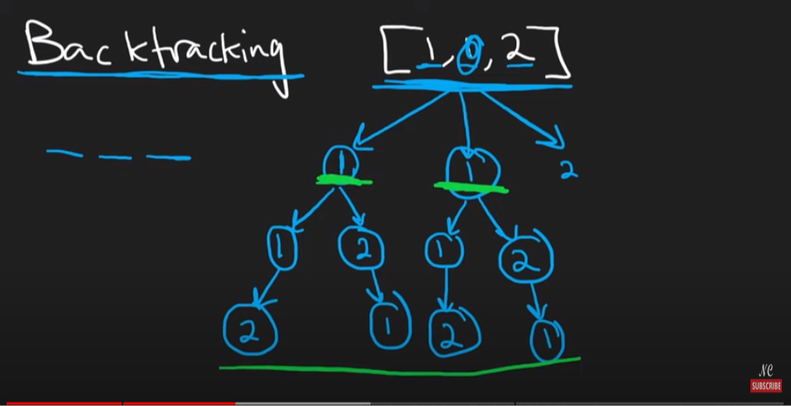

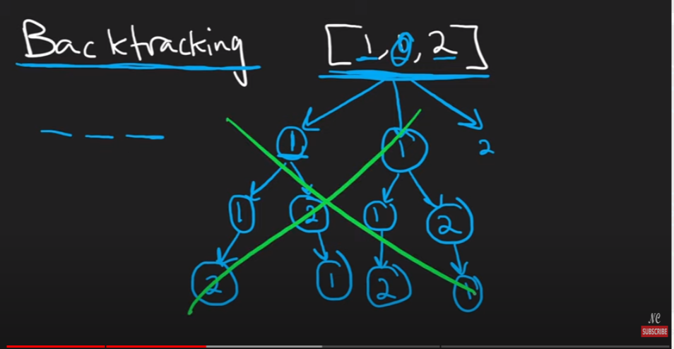

**Create frequency table based on given input, when use an element decrease the frequency of that element**

**e.g initially element 1 frequency is 2, after using one of them, decrease 1 from frequency as 2 - 1 = 1**

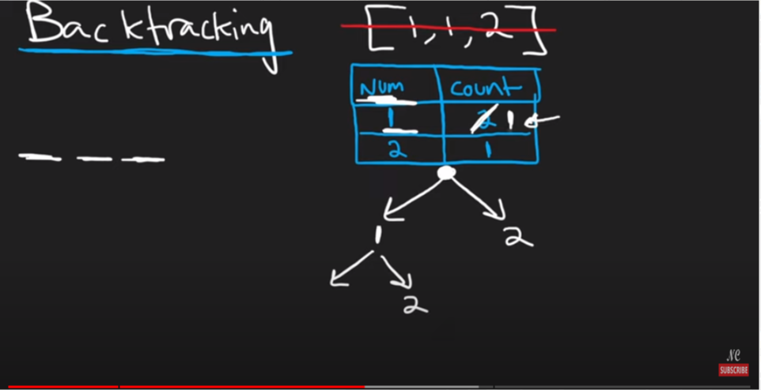

**After using two 1 and one 2 to build one permutation {1,1,2}, both element 1 and 2's frequency drop to 0**

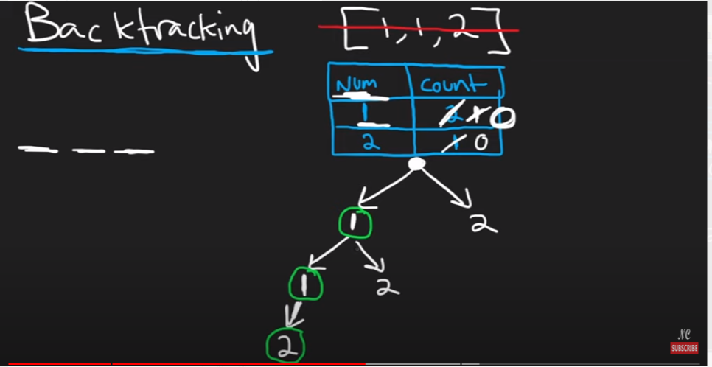

**Refer to**

<https://leetcode.com/problems/permutations-ii/discuss/1768113/Java-Backtracking-HashMap>

class Solution {

public List<List<Integer>> permuteUnique(int[] nums) {

List<List<Integer>> result = new ArrayList();

Map<Integer, Integer> map = new HashMap();

for (int num:nums)

map.put(num, map.getOrDefault(num,0)+1);

backtracking(nums, result, map, new ArrayList<Integer>());

return result;

}

private void backtracking(int[] nums, List<List<Integer>> result, Map<Integer, Integer> map, List<Integer> list){

if (list.size() == nums.length){

result.add(new ArrayList<Integer>(list));

return;

}

for (Integer key: map.keySet()){

if (map.get(key)>0){

list.add(key);

map.put(key, map.get(key) -1);

backtracking(nums, result, map, list);

map.put(key, map.get(key) +1);

list.remove(list.size() -1);

}

}

}

}

**No "Not pick" and "Pick" branch available for this problem yet (normal decision tree not gonna work)**

**Because in L47. we have to use all numbers in the given array, not like L77. we just pick k out of n numbers, so there is no chance for a number in L47 to 'Not pick', hence no "Not pick" and "Pick" strategy here**