## Where does java reference variable stored?

<https://stackoverflow.com/questions/19623563/where-does-java-reference-variable-stored>

Q: How does Java's reference variable stored? Is that work similar to C pointer?

what I mean by reference variable is myDog in this code

```

Dog myDog = new Dog();

```

I understood about C pointer, it stores in the heap if global variable, and it stores in the stack if local variable. I wonder java works same way.

A: You need to understand a bit of the lower levels of Java memory organization. On the stack, primitives(int, double, boolean, etc) and object references pointing to the heap are stored.

Inside any object the same is true. It either contains references to other objects or primitives directly. Objects are always references in any context and those references are passed by value.

So we may have:

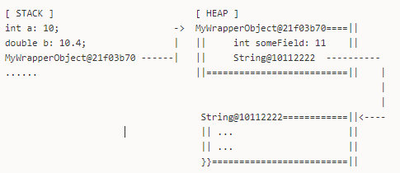

Note that use in some cases(as in via JVM internals) objects may be stored in non-heap memory.

All the references to s1, s2, ob1, obj2 and obj3 will be stored in the Stack.

The objects data, will be stored in the Heap (and for String for example in can be stored in a special constant pool).

