<https://leetcode.com/problems/maximal-square/discuss/600149/Python-Thinking-Process-Diagrams-DP-Approach>

##### [Python] Thinking Process Diagrams - DP Approach

**Understanding basics**  
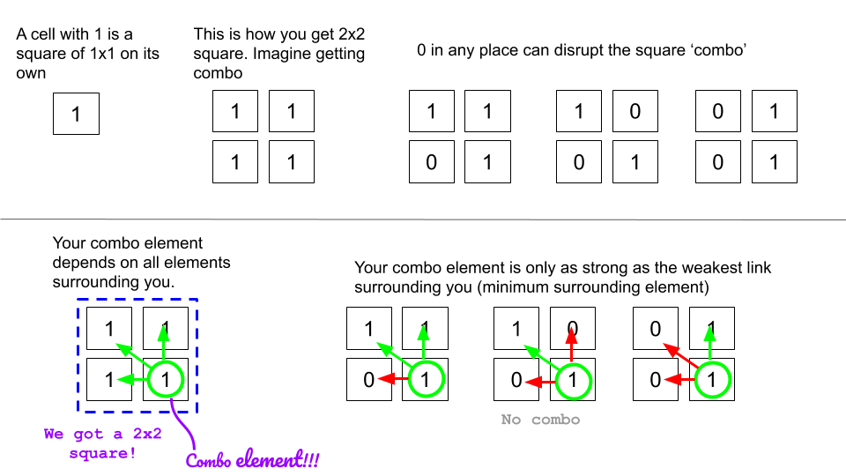

* Here I want to mention that we are drawing squares from top left corner to bottom right corner. Therefore, when I mention, "surrounding elements", I am saying cells above the corner cell and the cells on the left of the corner cell.

**Building DP grid to memoize**

* We are going to create a dp grid with initial values of 0.
* We are going to update dp as described in the following figure.

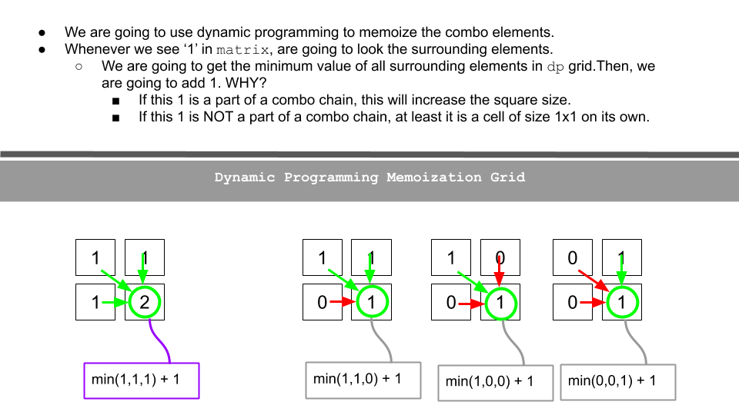

**Bigger Example**

* Let's try to see a bigger example.
* We go over one cell at a time row by row in the matrix and then update our dp grid accordingly.
* Update max_side with the maximum dp cell value as you update.

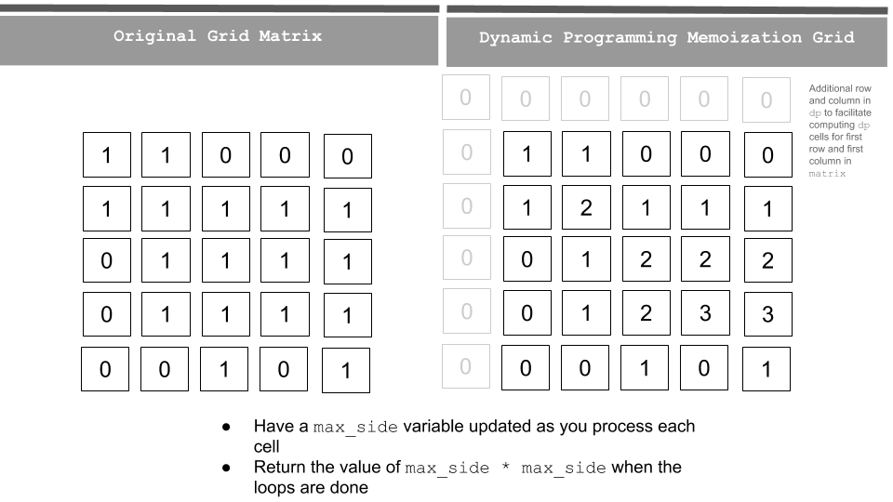

In the code, I create a dp grid which has one additional column and one additional row. The reason is to facilitate the index dp[r-1][c] dp[r][c-1] and dp[r-1][c-1] for cells in first row and first column in matrix.

class Solution:

def maximalSquare(self, matrix: List[List[str]]) -> int:

if matrix is None or len(matrix) < 1:

return 0

rows = len(matrix)

cols = len(matrix[0])

dp = [[0]*(cols+1) for _ in range(rows+1)]

max_side = 0

for r in range(rows):

for c in range(cols):

if matrix[r][c] == '1':

dp[r+1][c+1] = min(dp[r][c], dp[r+1][c], dp[r][c+1]) + 1 # Be careful of the indexing since dp grid has additional row and column

max_side = max(max_side, dp[r+1][c+1])

return max_side * max_side

**Complexity Analysis**

Time complexity : O(mn). Single pass - row x col (m=row; n=col)  
Space complexity : O(mn). Additional space for dp grid (don't need to worry about additional 1 row and col).

**Follow up**  
Space can be optimized as we don't need to keep the whole dp grid as we progress down the rows in matrix.

Aren't Dynamic Programming problems much like this joke? :D  
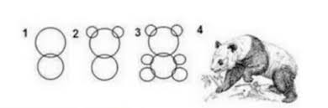

Thanks a lot for your explanation [@arkaung](https://leetcode.com/arkaung) This is how you explain DP problems to anyone who does not have much experience with DP problems. Below is my 1-D version which is inspired from your above solution if anyone is interested.

def maximalSquare(self, matrix):

if not matrix:

return 0

dp = [0] * (len(matrix[0])+1)

maxLen = prev = 0

for i in range(len(matrix)):

for j in range(len(matrix[0])):

temp = dp[j+1]

if matrix[i][j] == '1':

dp[j+1] = min(prev, dp[j], dp[j+1]) + 1

maxLen = max(maxLen, dp[j+1])

else:

dp[j+1] = 0

prev = temp

return maxLen * maxLen