<https://leetcode.com/problems/unique-paths/>

There is a robot on an m x n grid. The robot is initially located at the **top-left corner** (i.e., grid[0][0]). The robot tries to move to the **bottom-right corner** (i.e., grid[m - 1][n - 1]). The robot can only move either down or right at any point in time.

Given the two integers m and n, return *the number of possible unique paths that the robot can take to reach the bottom-right corner*.

The test cases are generated so that the answer will be less than or equal to 2 * 10^9.

**Example 1:**



Input: m = 3, n = 7

Output: 28

**Example 2:**

Input: m = 3, n = 2

Output: 3

Explanation: From the top-left corner, there are a total of 3 ways to reach the bottom-right corner:

1. Right -> Down -> Down

2. Down -> Down -> Right

3. Down -> Right -> Down

**Constraints:**

1 <= m, n <= 100

**Attempt 1: 2023-06-06**

**Solution 1: Native DFS (10 min, TLE 38/63, m = 19, n = 13)**

class Solution {

    public int uniquePaths(int m, int n) {

        return helper(0, 0, m, n);

    }

    private int helper(int x, int y, int m, int n) {

        if(x >= m || y >= n) {

            return 0;

        }

        if(x == m - 1 && y == n - 1) {

            return 1;

        }

        return helper(x + 1, y, m, n) + helper(x, y + 1, m, n);

    }

}

Time Complexity : O(2m+n), where m and n are the given input dimensions of the grid

Space Complexity : O(m+n), required by implicit recursive stack

**Refer to**

<https://leetcode.com/problems/unique-paths/solutions/1581998/c-python-5-simple-solutions-w-explanation-optimization-from-brute-force-to-dp-to-math/>

❌ ***Solution - I (Brute-Force) [TLE]***

Let's start with brute-force solution. For a path to be unique, at least 1 of move must differ at some cell within that path.

At each cell we can either move down or move right.

Choosing either of these moves could lead us to an unique path

So we consider both of these moves.

If the series of moves leads to a cell outside the grid's boundary, we can return 0 denoting no valid path was found.

If the series of moves leads us to the target cell (m-1, n-1), we return 1 denoting we found a valid unique path from start to end.

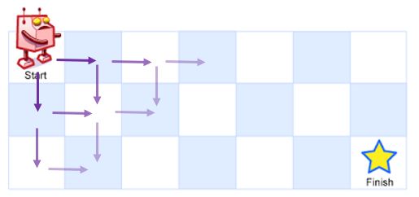

**C++**

class Solution {

public:

    int uniquePaths(int m, int n, int i = 0, int j = 0) {

        if(i >= m || j >= n) return 0;                                    // reached out of bounds - invalid

        if(i == m-1 && j == n-1) return 1;                                // reached the destination - valid solution

        return uniquePaths(m, n, i+1, j) + uniquePaths(m, n, i, j+1);    // try both down and right

    }

};

***Time Complexity :*** **O(2^(m+n))**, where m and n are the given input dimensions of the grid

***Space Complexity :*** **O(m+n)**, required by implicit recursive stack

**Solution 2: DFS + Memoization (10 min)**

class Solution {

    public int uniquePaths(int m, int n) {

        Integer[][] memo = new Integer[m][n];

        return helper(0, 0, m, n, memo);

    }

    private int helper(int x, int y, int m, int n, Integer[][] memo) {

        if(x >= m || y >= n) {

            return 0;

        }

        if(memo[x][y] != null) {

            return memo[x][y];

        }

        if(x == m - 1 && y == n - 1) {

            return 1;

        }

        return memo[x][y] = helper(x + 1, y, m, n, memo) + helper(x, y + 1, m, n, memo);

    }

}

Time Complexity : O(m*n), the answer to each of cell is calculated only once and memoized. There are m*n cells in total and thus this process takes O(m*n) time.

Space Complexity : O(m*n), required to maintain dp.

**Refer to**

<https://leetcode.com/problems/unique-paths/solutions/1581998/c-python-5-simple-solutions-w-explanation-optimization-from-brute-force-to-dp-to-math/>

✔️ ***Solution - II (Dynamic Programming - Memoization)***

The above solution had a lot of redundant calculations. There are many cells which we reach multiple times and calculate the answer for it over and over again. However, the number of unique paths from a given cell

(i,j) to the end cell is always fixed. So, we don't need to calculate and repeat the same process for a given cell multiple times. We can just store (or memoize) the result calculated for cell

(i, j) and use that result in the future whenever required.

Thus, here we use a 2d array dp, where dp[i][j] denote the number of unique paths from cell (i, j) to the end cell (m-1, n-1). Once we get an answer for cell (i, j), we store the result in dp[i][j] and reuse it instead of recalculating it.

class Solution {

public:

    int dp[101][101]{};

    int uniquePaths(int m, int n, int i = 0, int j = 0) {

        if(i >= m || j >= n) return 0;

        if(i == m-1 && j == n-1) return 1;

        if(dp[i][j]) return dp[i][j];

        return dp[i][j] = uniquePaths(m, n, i+1, j) + uniquePaths(m, n, i, j+1);

    }

};

A more generalized solution should be as follows -

class Solution {

public:

    int uniquePaths(int m, int n) {

        vector<vector<int>> dp(m, vector<int>(n));

        return dfs(dp, 0, 0);

    }

    int dfs(vector<vector<int>>& dp, int i, int j) {

        if(i >= size(dp)  || j >= size(dp[0]))  return 0;    // out of bounds - invalid

        if(i == size(dp)-1 && j == size(dp[0])-1) return 1;    // reached end - valid path

        if(dp[i][j]) return dp[i][j];                          // directly return if already calculated

        return dp[i][j] = dfs(dp, i+1, j) + dfs(dp, i, j+1);    // store the result in dp[i][j] and then return

    }

};

***Time Complexity :*** **O(m*n)**, the answer to each of cell is calculated only once and memoized. There are m*n cells in total and thus this process takes O(m*n) time.

***Space Complexity :*** **O(m*n)**, required to maintain dp.

**Solution 3: DP (10 min)**

class Solution {

    public int uniquePaths(int m, int n) {

        // dp[i][j] will denote the number of unique paths from

        // cell (0, 0) to the cell (i, j). (Note this differs from

        // memoization approach where dp[i][j] denoted number of

        // unique paths from cell (i, j) to the cell (m-1, n-1))

        int[][] dp = new int[m][n];

        // We start at cell (0, 0), so dp[0][0] = 1, means number

        // of unique paths from cell (0, 0) to cell(i, j) as

        // cell(0, 0) is 1 as itself

        dp[0][0] = 1;

        // Since we can only move right or down, there is only one

        // way to reach a cell (i, 0) or (0, j). Thus, we also

        // initialize dp[i][0] = 1 and dp[0][j]=1.

        for(int i = 1; i < m; i++) {

            dp[i][0] = 1;

        }

        for(int j = 1; j < n; j++) {

            dp[0][j] = 1;

        }

        // For every other cell (i, j) (where 1 <= i <= m-1 and

        // 1 <= j <= n-1), we can reach here either from the top

        // cell (i-1, j) or the left cell (i, j-1). So the result

        // for number of unique paths to arrive at (i, j) is the

        // summation of both, i.e, dp[i][j] = dp[i-1][j] + dp[i][j-1].

        for(int i = 1; i < m; i++) {

            for(int j = 1; j < n; j++) {

                dp[i][j] = dp[i - 1][j] + dp[i][j - 1];

            }

        }

        return dp[m - 1][n - 1];

    }

}

Time Complexity : O(m*n), we are computing dp values for each of the m*n cells from the previous cells value. Thus, the total number of iterations performed is requires a time of O(m*n).

Space Complexity : O(m*n), required to maintain the dp matrix

**Refer to**

<https://leetcode.com/problems/unique-paths/solutions/1581998/c-python-5-simple-solutions-w-explanation-optimization-from-brute-force-to-dp-to-math/>

✔️ ***Solution - III (Dynamic Programming - Tabulation)***

We can also convert the above approach to an iterative version. Here, we will solve it in bottom-up manner by iteratively calculating the number of unique paths to reach cell (i, j) starting from (0, 0) where 0 <= i <= m-1 and 0 <= j <= n-1. We will again use dynamic programming here using a dp matrix where

**dp[i][j] will denote the number of unique paths from cell (0, 0) to the cell (i, j). (Note this differs from memoization approach where**

**dp[i][j] denoted number of unique paths from cell (i, j) to the cell (m-1,n-1))**

In this case, we first establish some base conditions first.

We start at cell (0, 0), so dp[0][0] = 1.

Since we can only move right or down, there is only one way to reach a cell (i, 0) or (0, j). Thus, we also initialize dp[i][0] = 1 and dp[0][j]=1.

For every other cell (i, j) (where 1 <= i <= m-1 and 1 <= j <= n-1), we can reach here either from the top cell (i-1, j) or the left cell (i, j-1). So the result for number of unique paths to arrive at (i, j) is the summation of both, i.e, dp[i][j] = dp[i-1][j] + dp[i][j-1].

**C++**

class Solution {

public:

    int uniquePaths(int m, int n) {

        vector<vector<int>> dp(m, vector<int>(n, 1));

        for(int i = 1; i < m; i++)

            for(int j = 1; j < n; j++)

                dp[i][j] = dp[i-1][j] + dp[i][j-1];  // sum of unique paths ending at adjacent top and left cells

        return dp[m-1][n-1];        // return unique paths ending at cell (m-1, n-1)

    }

};

***Time Complexity :*** **O(m*n)**, we are computing dp values for each of the m*n cells from the previous cells value. Thus, the total number of iterations performed is requires a time of O(m*n).

***Space Complexity :*** **O(m*n)**, required to maintain the dp matrix

**Solution 4: Space Optimized to two rows DP (10 min)**

class Solution {

    public int uniquePaths(int m, int n) {

        int[] dp = new int[n];

        int[] dpPrev = new int[n];

        for(int i = 0; i < n; i++) {

            dp[i] = 1;

            dpPrev[i] = 1;

        }

        for(int i = 1; i < m; i++) {

            for(int j = 1; j < n; j++) {

                // dp[i][j] = dp[i - 1][j] + dp[i][j - 1];

                dp[j] = dpPrev[j] + dp[j - 1];

            }

            dpPrev = dp;

        }

        return dpPrev[n - 1];

    }

}

Time Complexity: O(M*N), where M <= 100 is number of rows, N <= 100 is number of columns.

Space Complexity: O(M)

**Refer to**

<https://leetcode.com/problems/unique-paths/solutions/254228/python-3-solutions-bottom-up-dp-math-picture-explained-clean-concise/>

Since we only access 2 states: current state dp and previous state dpPrev, we can reduce the space complexity to O(M).

class Solution:

    def uniquePaths(self, m: int, n: int) -> int:

        dp, dpPrev = [0] * n, [0] * n

        for r in range(m):

            for c in range(n):

                if r == 0 or c == 0:

                    dp[c] = 1

                else:

                    dp[c] = dpPrev[c] + dp[c-1]

            dp, dpPrev = dpPrev, dp

        return dpPrev[n-1]

**Complexity**

Time: O(M*N), where M <= 100 is number of rows, N <= 100 is number of columns.

Space: O(M)

**Solution 5: Space Optimized to single row DP (10 min)**

class Solution {

    public int uniquePaths(int m, int n) {

        int[] dp = new int[n];

        for(int i = 0; i < n; i++) {

            dp[i] = 1;

        }

        // Truncate first dimension as row and only needs second

        // dimension as column to compute

        // dp[i][j] => dp[j], dp[i - 1][j] => dp[j], dp[i][j - 1] => dp[j - 1]

        for(int i = 1; i < m; i++) {

            for(int j = 1; j < n; j++) {

                dp[j] = dp[j - 1] + dp[j];

            }

        }

        return dp[n - 1];

    }

}

Time Complexity : O(m*n), for computing dp values for each of the m*n cells.

Space Complexity : O(n), required to maintain dp. We are only keeping two rows of length n giving space complexity of O(n).

**Refer to**

<https://leetcode.com/problems/unique-paths/solutions/1581998/c-python-5-simple-solutions-w-explanation-optimization-from-brute-force-to-dp-to-math/>

✔️ ***Solution - IV (Space Optimized Dynamic Programming)***

In the above solution, we can observe that to compute the dp matrix, we are only ever using the cells from previous row and the current row. So, we don't really need to maintain the entire m x n matrix of dp. We can optimize the space usage by only keeping the current and previous rows.

A common way in dp problems to optimize space from 2d dp is just to convert the dp matrix from m x n grid to 2 x n grid denoting the values for current and previous row. We can just overwrite the previous row and use the current row as the previous row for next iteration. We can simply alternate between these rows using the & (AND) operator as can be seen below -

**C++**

class Solution {

public:

    int uniquePaths(int m, int n) {

        vector<vector<int>> dp(2, vector<int>(n,1));

        for(int i = 1; i < m; i++)

            for(int j = 1; j < n; j++)

                dp[i & 1][j] = dp[(i-1) & 1][j] + dp[i & 1][j-1];  // <- &  used to alternate between rows

        return dp[(m-1) & 1][n-1];

    }

};

Or still better yet, in this case, you can use a single vector as well. We are only accessing same column from previous row which can be given by

dp[j] and previous column of current row which can be given by dp[j-1]. So the above code can be further simplified to (Credits - [@zayne-siew](https://leetcode.com/zayne-siew)) -

**C++**

class Solution {

public:

    int uniquePaths(int m, int n) {

        vector<int> dp(n, 1);

        for(int i = 1; i < m; i++)

            for(int j = 1; j < n; j++)

                dp[j] += dp[j-1];

        return dp[n-1];

    }

};

***Time Complexity :*** **O(m*n)**, for computing dp values for each of the m*n cells.

***Space Complexity :*** **O(n)**, required to maintain dp. We are only keeping two rows of length n giving space complexity of O(n).There's a small change that can allow us to optimize the space complexity down to O(min(m, n)).

*Comment below if you can figure it out?*?

**Refer to**

<https://leetcode.com/problems/unique-paths/solutions/405983/easy-understand-java-solutions-with-explanations-dp-top-down-bottom-up-linear-space/>

Reduce the O(MN) space complexity to O(N) (a row) or O(M)(a column). In terms of a row, we would update dp[j] by its old value plus dp[j - 1]

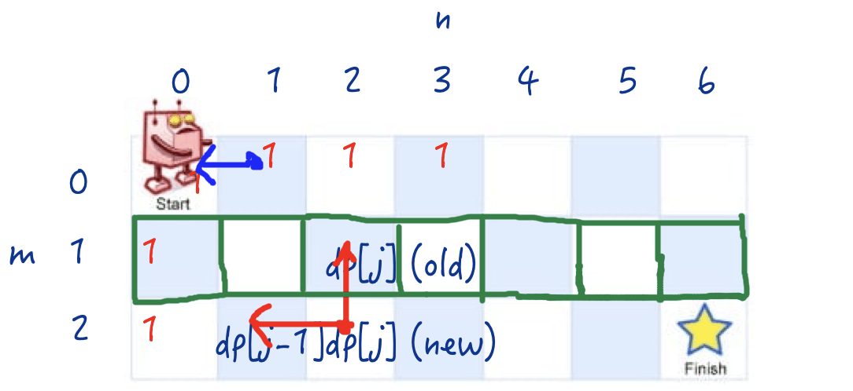

public int uniquePaths(int m, int n) {

  if (m == 0 || n == 0) {

    throw new IllegalArgumentException("m or n can't be 0");

  }

  int[] dp = new int[n]; // row

  // init

  for (int i = 0; i < n; ++i) dp[i] = 1;

  // dp

  for (int i = 1; i < m; ++i) {

    for (int j = 1; j < n; ++j) {

      dp[j] = dp[j] + dp[j - 1];

    }

  }

  return dp[n - 1];

}

**Time:** O(MN)

**Space:** O(N) or O(M)

**Solution 6: Math (? min)**

**Just for documentation**

**Refer to**

<https://leetcode.com/problems/unique-paths/solutions/1581998/c-python-5-simple-solutions-w-explanation-optimization-from-brute-force-to-dp-to-math/>

✔️ ***Solution - V (Math)***

This problem can be modelled as a math combinatorics problem.

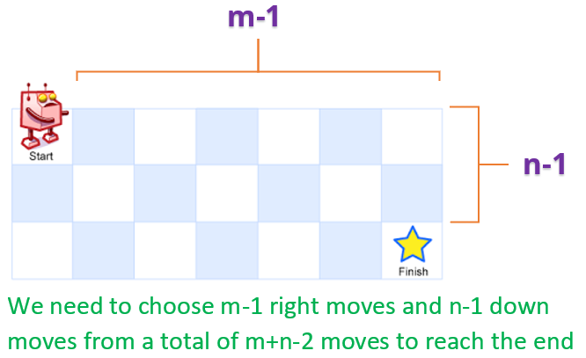

We start at (0, 0) cell and move to (m-1, n-1) cell.

We need to make **m-1 down-moves** and **n-1 right-moves** to reach the destination cell.

Thus, we need to perform a **total number of m+n-2 moves**.

At each cell along the path, we can choose either the right-move or down-move and we need to find the number of unique combinations of these choices (which eventually leads to unique paths).

This is nothing but calculating the **number of different ways to choose m-1 down-moves and n-1 right-moves from a total of m+n-2 moves**. Mathematically, this can be represented as -

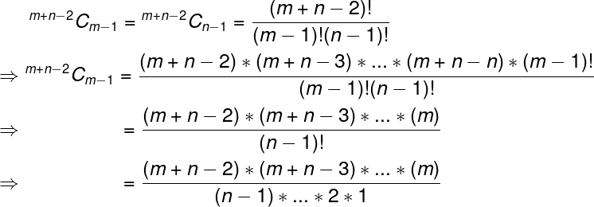

We could cancel out the (n-1)! as well in the above evaluation. We will do one of those based on min(m,n) to give best time complexity in the solution below.

**C++**

class Solution {

public:

    int uniquePaths(int m, int n) {

        long ans = 1;

        for(int i = m+n-2, j = 1; i >= max(m, n); i--, j++)

            ans = (ans * i) / j;

        return ans;

    }

};

***Time Complexity :*** **O(min(m,n))** for C++, and **O(m+n)** for Python. We could do it in O(min(m,n)) for python as well using technique used in C++.

***Space Complexity :*** **O(1)**

**Attempt 2: 2025-06-09**

**Solution 1: DP (10 min)**

**Refer to Deepseek**

**i need dp solution exactly match the above native dfs solution logic**

**DP Solution Matching below DFS Logic**

class Solution {

public int uniquePaths(int m, int n) {

return dfs(0, 0, m, n);

}

private int dfs(int row, int col, int m, int n) {

// Base case: reached destination

if (row == m - 1 && col == n - 1) {

return 1;

}

// Out of bounds cases

if (row >= m || col >= n) {

return 0;

}

// Explore both directions: right and down

return dfs(row + 1, col, m, n) + dfs(row, col + 1, m, n);

}

}

To create a DP solution that exactly matches the logic of the native DFS solution, we'll implement a bottom-up approach that mirrors the recursive calls of the DFS. The key insight is that the DP table will be filled in a way that corresponds to how the DFS explores the grid.

**Approach**

**State Representation**:

dp[row][col] represents the number of ways to reach position (row, col) from the start (0, 0)

**Base Case**:

dp[m-1][n-1] = 1 (destination has one way to "reach itself")

**Transition**:

For each cell, the number of ways equals:

Ways from the cell below (if exists) + ways from the cell to the right (if exists)

This mirrors the DFS recursive calls: dfs(row+1, col) + dfs(row, col+1)

**Filling Order**:

Fill the table from bottom-right to top-left to match DFS's exploration order

**Solution Code**

class Solution {

public int uniquePaths(int m, int n) {

int[][] dp = new int[m][n];

// Initialize destination cell

dp[m-1][n-1] = 1;

// Fill the DP table from bottom-right to top-left

for (int row = m-1; row >= 0; row--) {

for (int col = n-1; col >= 0; col--) {

// Skip the destination cell (already initialized)

if (row == m-1 && col == n-1) continue;

// Number of ways equals sum of ways from below and right

int ways = 0;

if (row + 1 < m) ways += dp[row+1][col]; // down move

if (col + 1 < n) ways += dp[row][col+1]; // right move

dp[row][col] = ways;

}

}

return dp[0][0]; // Number of ways from start position

}

}

**Explanation**

**Initialization**:

The destination cell (m-1, n-1) is initialized to 1 (base case matching DFS)

**Table Filling**:

We iterate from the bottom-right to top-left

For each cell, we sum the ways from:

The cell below (if within bounds) - equivalent to dfs(row+1, col)

The cell to the right (if within bounds) - equivalent to dfs(row, col+1)

**Result**:

The top-left cell (0, 0) contains the total number of unique paths

**Key Features**

**Matches DFS Logic**:

Same recursive relation as the DFS solution

Same base case (destination = 1)

Same movement options (down and right)

**Efficiency**:

Time complexity: O(m*n)

Space complexity: O(m*n) (can be optimized to O(n) if needed)

This DP solution exactly mirrors the recursive logic of the DFS approach while providing better performance through dynamic programming.

**2-Row DP Solution (Right-to-Left Iteration Matching 2D DP)**

Here's a space-optimized 2-row DP solution that exactly matches the right-to-left iteration order of your 2D DP solution:

class Solution {

public int uniquePaths(int m, int n) {

// currentRow is the row one line below nextRow

// e.g

// nextRow

// currentRow

int[] currentRow = new int[n];

int[] nextRow = new int[n];

// Initialize bottom row (last row in 2D DP)

for (int col = n-1; col >= 0; col--) {

currentRow[col] = 1;

}

// Process rows from bottom to top

for (int row = m-2; row >= 0; row--) {

// Initialize rightmost column (always 1)

nextRow[n-1] = 1;

// Process columns from right to left

for (int col = n-2; col >= 0; col--) {

nextRow[col] = currentRow[col] + nextRow[col+1];

}

// Swap rows for next iteration

int[] temp = currentRow;

currentRow = nextRow;

nextRow = temp;

}

return currentRow[0];

}

}

**Key Differences from Left-to-Right Version:**

class Solution {

public int uniquePaths(int m, int n) {

int[] dp = new int[n];

int[] dpPrev = new int[n];

// Initialize first row (all 1s)

for (int j = 0; j < n; j++) {

dpPrev[j] = 1;

}

for (int i = 1; i < m; i++) {

dp[0] = 1; // First column is always 1

for (int j = 1; j < n; j++) {

dp[j] = dpPrev[j] + dp[j-1];

}

// Swap references for next iteration

int[] temp = dpPrev;

dpPrev = dp;

dp = temp;

}

return dpPrev[n-1];

}

}

**Initialization Direction**:

Fills currentRow from right to left (starting at n-1)

Matches the 2D DP's bottom-up initialization

**Row Processing Order**:

Processes rows from m-2 up to 0 (bottom to top)

Matches the 2D DP's row iteration order

**Column Processing Order**:

Processes columns from n-2 down to 0 (right to left)

Matches the 2D DP's column iteration order

**DP Transition**:

nextRow[col] = currentRow[col] + nextRow[col+1]

currentRow[col] = paths from below (equivalent to dp[row+1][col])

nextRow[col+1] = paths from right (equivalent to dp[row][col+1])

**Why This Works:**

**Same Dependencies**:

Each cell still only depends on its right and bottom neighbors

The iteration order ensures these are always computed first

**Correct State Propagation**:

Moving right-to-left ensures nextRow[col+1] is available

Moving bottom-to-top ensures currentRow contains correct values

**Space Efficiency**:

Uses only 2 rows instead of full 2D grid

Maintains O(n) space complexity while matching 2D DP logic

This solution provides identical results to your 2D DP version while using significantly less memory, and it maintains the exact same computation order (bottom-right to top-left).

**Optimized 1D DP Solution (Right-to-Left Iteration)**

Here's the most space-efficient solution using just a single 1D array, while maintaining the right-to-left iteration order that matches your original 2D DP approach:

class Solution {

public int uniquePaths(int m, int n) {

int[] dp = new int[n];

// Initialize last row (all 1s)

for (int j = 0; j < n; j++) {

dp[j] = 1;

}

// Process rows from bottom to top (starting from m-2)

for (int i = m - 2; i >= 0; i--) {

// Rightmost column is always 1

dp[n - 1] = 1;

// Process columns from right to left

for (int j = n - 2; j >= 0; j--) {

dp[j] = dp[j] + dp[j + 1];

}

}

return dp[0];

}

}

**Key Insights:**

**Single Array Usage**:

We only need one array (dp) instead of two

The trick is that we can overwrite the array as we go because:

dp[j] (before update) represents the value from the row below (dp[row+1][col])

dp[j+1] represents the already-updated value from the right (dp[row][col+1])

**Initialization**:

First initialize the array as the bottom row (all 1s)

This corresponds to dp[m-1][col] = 1 in the 2D version

**Processing Order**:

Rows processed from m-2 up to 0 (bottom to top)

Columns processed from n-2 down to 0 (right to left)

This ensures dependencies are available when needed

**Why This Works:**

**Dependency Preservation**:

When computing dp[j], we need:

The value from below (original dp[j])

The value from the right (already computed dp[j+1])

Right-to-left column processing ensures the right value is available

**Space Optimization**:

Reduces space from O(n) to O(n)

While the space complexity class remains the same, we've halved the actual memory usage

**Correctness**:

Mathematically equivalent to the 2D DP solution

Maintains the same computation order as the original 2D version

**Time and Space Complexity:**

**Time Complexity**: O(m × n) - same as original

**Space Complexity**: O(n) - single array of size n

This is the most space-efficient version possible while still maintaining the right-to-left computation order that matches your original 2D DP solution. The key insight is recognizing that we can overwrite the array values in place because of the specific order we're processing the cells.

**For 1D DP solution, i just wonder by the loop direction we can still keep as right to left ?**

// Process columns from right to left

for (int j = n - 2; j >= 0; j--) {

dp[j] = dp[j] + dp[j + 1];

}

Your analysis as:

**Dependency Preservation**:

When computing dp[j], we need:

The value from below (original dp[j])

The value from the right (already computed dp[j+1])

Right-to-left column processing ensures the right value is available

**As the DP theory, the new state always calculate from stable old state, the thing i am concerning here is "The value from the right (already computed dp[j+1])", is this match the theory ? and if we change the iteration direction to loop from left to right, what will happen ?**

**Understanding 1D DP Directionality in Unique Paths**

Let me clarify the directionality in the 1D DP solution and why right-to-left works while left-to-right would fail.

**Right-to-Left Iteration (Correct Approach)**

for (int j = n - 2; j >= 0; j--) {

dp[j] = dp[j] + dp[j + 1];

}

**Why This Works:**

**State Dependencies**:

dp[j] (before update) = paths from below (dp[row+1][col] in 2D)

dp[j+1] = paths from right (dp[row][col+1] in 2D)

These represent the two possible moves (down and right)

**Update Order**:

Processing right-to-left ensures dp[j+1] is already updated for the current row

dp[j] (original value) still holds the value from the row below

This perfectly matches the DP theory of using stable old states

**Visualization**:

Before update: [1, 1, 1, 1] (row below)

After update: [X, X, 2, 1] (current row in progress)

↑ ↑

j+1 j

**Left-to-Right Iteration (Problematic Approach)**

for (int j = 1; j < n; j++) {

dp[j] = dp[j] + dp[j - 1];

}

**Why This Fails:**

**State Corruption**:

When updating left-to-right, dp[j-1] already contains the new row's value

This mixes values from the current row and previous row incorrectly

**Dependency Violation**:

We need the value from below (dp[row+1][col]), but dp[j] gets overwritten

Then subsequent cells use this corrupted value when looking left

**Visualization**:

Before update: [1, 1, 1, 1] (row below)

After update: [1, 2, 3, 4] (but this is wrong!)

↑ ↑

j-1 j

**Key Theoretical Points**

**DP Principle Compliance**:

Right-to-left works because it maintains the invariant that:

dp[j] (before update) = value from below (stable old state)

dp[j+1] = already updated value from right (new state for current row)

**Order Matters**:

**The update direction must ensure we don't overwrite values needed for other calculations**

**Right-to-left preserves the downward lookups while properly propagating rightward values**

**Alternative Interpretation**:

You can think of the 1D array as simultaneously representing:

The previous row's values (before update)

The current row's values (after update)

The right-to-left order keeps these representations properly separated

**Conclusion**

The right-to-left iteration is correct because it perfectly maintains the DP principle of only using stable old states when computing new states. Left-to-right iteration would corrupt the state dependencies and produce incorrect results. This directionality is crucial for the space optimization to work correctly.

**Refer to**

[L63.Unique Paths II (Ref.L62)](note://37FCA39A01734A37B2CF4CFACA8170E0)

[L64.Minimum Path Sum (Ref.L62)](note://E75C518E4D6D4A52AC2BB448D57184AE)

[L174.Dungeon Game (Ref.L62,L72)](note://75C35C97814B4CAE8FC048CE585402E4)

[L2087.Minimum Cost Homecoming of a Robot in a Grid (Ref.L62)](note://WEB9bebe70b3ca1bf2b60309cf05cb31670)

[L2304.Minimum Path Cost in a Grid (Ref.L62)](note://WEB6b0fa3b6bbff71ea9e3406f73679c5e2)

[L2400.Number of Ways to Reach a Position After Exactly k Steps (Ref.L62,L70)](note://WEB0d086d1f5849b8970f5b9498bd68e08d)

[L2435.Paths in Matrix Whose Sum Is Divisible by K (Ref.L62)](note://WEB2e1f15d82976dbe1f3c531b0aa3a7504)