<https://www.geeksforgeeks.org/check-if-a-graph-is-strongly-unilaterally-or-weakly-connected/>

Given an unweighted directed [graph](https://www.geeksforgeeks.org/graph-and-its-representations/) **G** as a path matrix, the task is to find out if the graph is [Strongly Connected](https://www.geeksforgeeks.org/connectivity-in-a-directed-graph/) or Unilaterally Connected or Weakly Connected.

* ***Strongly Connected:*** *A graph is said to be* ***strongly connected*** *if every pair of vertices(u, v) in the graph contains a path between each other. In an unweighted directed graph G, every pair of vertices u and v should have a path in each direction between them i.e., bidirectional path. The elements of the path matrix of such a graph will contain all* ***1’s****.*
* ***Unilaterally Connected:*** *A graph is said to be* ***unilaterally connected*** *if it contains a directed path from u to v OR a directed path from v to u for every pair of vertices u, v. Hence, at least for any pair of vertices, one vertex should be reachable form the other. Such a path matrix would rather have upper triangle elements containing* ***1’s****OR lower triangle elements containing* ***1’s****.*
* ***Weakly Connected:*** *A directed graph is weakly connected if there is a path between every two vertices in the underlying undirected graph (i.e., the graph formed when the direction of the edges are removed).*

**Examples:**

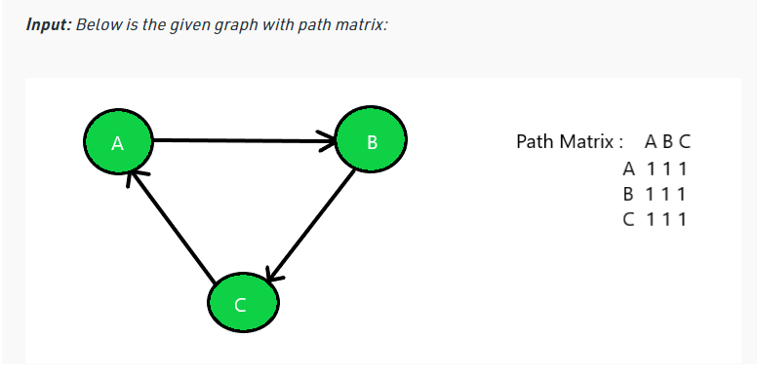

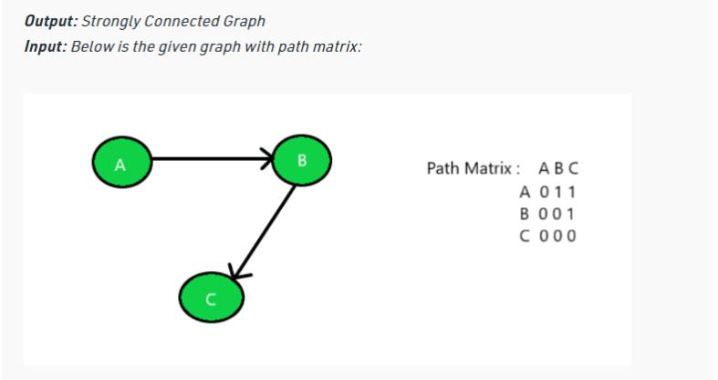

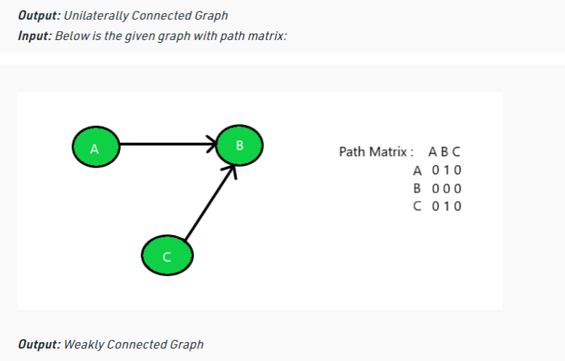

**Approach:**

1. For the graph to be [**Strongly Connected**](https://www.geeksforgeeks.org/strongly-connected-components/), traverse the given path matrix using the approach discussed in [this](https://www.geeksforgeeks.org/traverse-a-given-matrix-using-recursion/) article check whether all the values in the cell are **1**or not. If yes then print **“Strongly Connected Graph”** else check for the other two graphs.
2. For the graph to be **Unilaterally Connected**, traverse the given path matrix using the approach discussed in [this](https://www.geeksforgeeks.org/traverse-a-given-matrix-using-recursion/) article and check the following:
   * If all the values above the main diagonal are **1s**and all the values other than that are **0s**.
   * If all the values below the main diagonal are **1s**and all the values other than that are **0s**.
3. If one of the above two conditions satisfies then the given graph is **Unilaterally Connected** else the graph is **Weakly Connected Graph**.

Below is the implementation of the above approach:

// Java implementation of the above approach

import java.util.*;

class GFG {

static final int V = 3;

// Function to find the characteristic

// of the given graph

static int checkConnected(int graph[][], int n)

{

// Check whether the graph is

// strongly connected or not

boolean strongly = true;

// Traverse the path matrix

for (int i = 0; i < n; i++) {

for (int j = 0; j < n; j++) {

// If all the elements are

// not equal then the graph

// is not strongly connected

if (graph[i][j] != graph[j][i]) {

strongly = false;

break;

}

}

// Break out of the loop if false

if (!strongly) {

break;

}

}

// If true then print strongly

// connected and return

if (strongly) {

System.out.print("Strongly Connected");

return 0;

}

// Check whether the graph is

// Unilaterally connected by

// checking Upper Triangle element

boolean uppertri = true;

// Traverse the path matrix

for (int i = 0; i < n; i++) {

for (int j = 0; j < n; j++) {

// If uppertriangle elements

// are 0 then break out of the

// loop and check the elements

// of lowertriangle matrix

if (i > j && graph[i][j] == 0) {

uppertri = false;

break;

}

}

// Break out of the loop if false

if (!uppertri) {

break;

}

}

// If true then print unilaterally

// connected and return

if (uppertri) {

System.out.print("Unilaterally Connected");

return 0;

}

// Check lowertraingle elements

boolean lowertri = true;

// Traverse the path matrix

for (int i = 0; i < n; i++) {

for (int j = 0; j < n; j++) {

// If lowertraingle elements

// are 0 then break cause

// 1's are expected

if (i < j && graph[i][j] == 0) {

lowertri = false;

break;

}

}

// Break out of the loop if false

if (!lowertri) {

break;

}

}

// If true then print unilaterally

// connected and return

if (lowertri) {

System.out.print("Unilaterally Connected");

return 0;

}

// If elements are in random order

// unsynchronized then print weakly

// connected and return

else {

System.out.print("Weakly Connected");

}

return 0;

}

// Driver Code

public static void main(String[] args)

{

// Number of nodes

int n = 3;

// Given Path Matrix

int graph[][]

= { { 0, 1, 1 }, { 0, 0, 1 }, { 0, 0, 0 } };

// Function call

checkConnected(graph, n);

}

}

// This code is contributed by 29AjayKumar

**Output**

Unilaterally Connected

**Time Complexity:** *O(N2)*

**Auxiliary Space:** *O(1)*