Many people solve this problem with a DFS algorithm and have a problem with some very big test cases. I found a short test case will fail the DFS solutions and explain the reason.

This test case will fail a DFS solution(I already contributed this test case):

6

[[0,1,10],[0,2,1],[2,3,1],[1,3,1],[1,4,1],[4,5,10]]

20

The graph looks like this, and The **distanceThreshold = 20**  
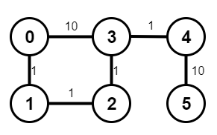

If your DFS go though the **0->3** before the **0->1** the error will encounter. Note the visited list.  
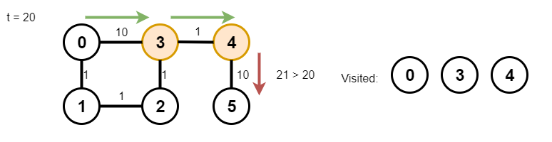

The next time your DFS goes **0->1** it will find the 3 already visited and the 5 will never visit. So that's why those case will have fewer city visit than expect.  
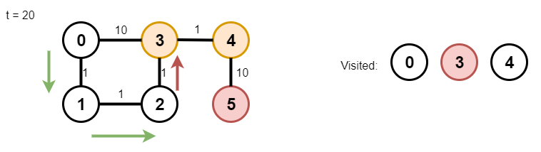

By the way, this question is basiclly a trap. If you never heard of **Floyd-Warshall algorithm** or noticed those cases. A lot people will directly use DFS. This question's contest AC rate only: **0.259**