<https://leetcode.com/problems/clone-graph/>

Given a reference of a node in a **[connected](https://en.wikipedia.org/wiki/Connectivity_(graph_theory)" \l "Connected_graph)** undirected graph.

Return a **[deep copy](https://en.wikipedia.org/wiki/Object_copying" \l "Deep_copy)** (clone) of the graph.

Each node in the graph contains a value (int) and a list (List[Node]) of its neighbors.

class Node {

public int val;

public List<Node> neighbors;

}

**Test case format:**

For simplicity, each node's value is the same as the node's index (1-indexed). For example, the first node with val == 1, the second node with val == 2, and so on. The graph is represented in the test case using an adjacency list.

**An adjacency list** is a collection of unordered **lists** used to represent a finite graph. Each list describes the set of neighbors of a node in the graph.

The given node will always be the first node with val = 1. You must return the **copy of the given node** as a reference to the cloned graph.

**Example 1:**

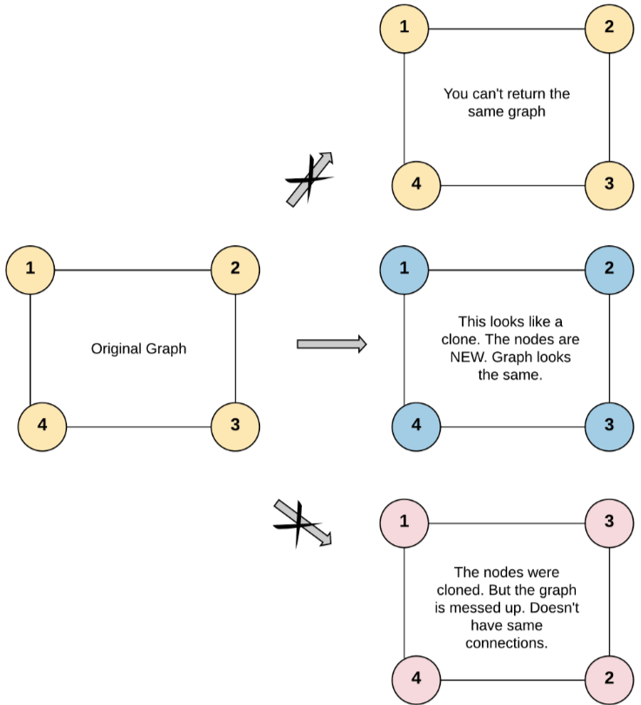

Input: adjList = [[2,4],[1,3],[2,4],[1,3]]

Output: [[2,4],[1,3],[2,4],[1,3]]

Explanation: There are 4 nodes in the graph.

1st node (val = 1)'s neighbors are 2nd node (val = 2) and 4th node (val = 4).

2nd node (val = 2)'s neighbors are 1st node (val = 1) and 3rd node (val = 3).

3rd node (val = 3)'s neighbors are 2nd node (val = 2) and 4th node (val = 4).

4th node (val = 4)'s neighbors are 1st node (val = 1) and 3rd node (val = 3).

**Example 2:**

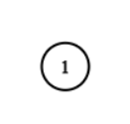

Input: adjList = [[]]

Output: [[]]

Explanation: Note that the input contains one empty list. The graph consists of only one node with val = 1 and it does not have any neighbors.

**Example 3:**

Input: adjList = []

Output: []

Explanation: This an empty graph, it does not have any nodes.

**Constraints:**

* The number of nodes in the graph is in the range [0, 100].
* 1 <= Node.val <= 100
* Node.val is unique for each node.
* There are no repeated edges and no self-loops in the graph.
* The Graph is connected and all nodes can be visited starting from the given node.

**Attempt 1: 2023-06-03**

**Solution 1: BFS (10 min)**

/\*

// Definition for a Node.

class Node {

public int val;

public List<Node> neighbors;

public Node() {

val = 0;

neighbors = new ArrayList<Node>();

}

public Node(int \_val) {

val = \_val;

neighbors = new ArrayList<Node>();

}

public Node(int \_val, ArrayList<Node> \_neighbors) {

val = \_val;

neighbors = \_neighbors;

}

}

\*/

class Solution {

public Node cloneGraph(Node node) {

if(node == null) {

return null;

}

Map<Node, Node> map = new HashMap<Node, Node>();

Queue<Node> q = new LinkedList<Node>();

Node clone\_node = new Node(node.val);

map.put(node, clone\_node);

q.offer(node);

while(!q.isEmpty()) {

Node cur = q.remove();

for(Node neighbor : cur.neighbors) {

if(!map.containsKey(neighbor)) {

q.offer(neighbor);

Node clone\_neighbor = new Node(neighbor.val);

map.put(neighbor, clone\_neighbor);

}

// Build connection between clone node and its clone neighbor

Node clone\_cur = map.get(cur);

clone\_cur.neighbors.add(map.get(neighbor));

}

}

return clone\_node;

}

}

**Refer to**

<https://aaronice.gitbook.io/lintcode/graph_search/clone_graph>

思路1：使用BFS，先将头节点入queue，每一次queue出列一个node，然后检查这个node的所有的neighbors，如果没visited过，就入队，并更新neighbor

这是一种对图的遍历方法，对于一个节点来说先把所有neighbors都检查一遍，再从 第一个neighbor开始，循环往复。

由于BFS的这个特质，BFS可以帮助寻找最短路径。

通常BFS用queue+循环实现。

BFS - breadth first search, non-recursive

/\*\*

\* Definition for undirected graph.

\* class UndirectedGraphNode {

\* int label;

\* ArrayList<UndirectedGraphNode> neighbors;

\* UndirectedGraphNode(int x) { label = x; neighbors = new ArrayList<UndirectedGraphNode>(); }

\* };

\*/

public class Solution {

/\*\*

\* @param node: A undirected graph node

\* @return: A undirected graph node

\*/

public UndirectedGraphNode cloneGraph(UndirectedGraphNode node) {

if (node == null) {

return null;

}

HashMap<UndirectedGraphNode, UndirectedGraphNode> hm = new HashMap<UndirectedGraphNode, UndirectedGraphNode>();

LinkedList<UndirectedGraphNode> queue = new LinkedList<UndirectedGraphNode>();

UndirectedGraphNode head = new UndirectedGraphNode(node.label);

hm.put(node, head);

queue.add(node);

while (!queue.isEmpty()) {

UndirectedGraphNode currentNode = queue.remove();

for (UndirectedGraphNode neighbor : currentNode.neighbors) {

if (!hm.containsKey(neighbor)) {

queue.add(neighbor);

UndirectedGraphNode newNeighbor = new UndirectedGraphNode(neighbor.label);

hm.put(neighbor, newNeighbor);

}

hm.get(currentNode).neighbors.add(hm.get(neighbor));

}

}

return head;

}

}

**Solution 2: DFS (30 min)**

**How to traverse a graph based on DFS ?**

**Refer to**

**Graph Traversals and Directed Graph Cycle Detection (in Graph Document)**

<https://www.ics.uci.edu/~thornton/ics46/Notes/GraphTraversals/>

**Style 1: Using "visited" set as classic DFS graph traversal way**

/\*

// Definition for a Node.

class Node {

public int val;

public List<Node> neighbors;

public Node() {

val = 0;

neighbors = new ArrayList<Node>();

}

public Node(int \_val) {

val = \_val;

neighbors = new ArrayList<Node>();

}

public Node(int \_val, ArrayList<Node> \_neighbors) {

val = \_val;

neighbors = \_neighbors;

}

}

\*/

class Solution {

public Node cloneGraph(Node node) {

if(node == null) {

return null;

}

// In this question we will create an array of Node(not boolean)

// why ? , because i have to add all the adjacent nodes of particular

// vertex, whether it's visited or not, so in the Node[] initially

// null is stored, if that node is visited, we will store the

// respective node at the index, and can retrieve that easily.

Node[] visited = new Node[101];

Node clone\_node = new Node(node.val);

// Make a dfs call for traversing all the vertices of the root node

helper(node, clone\_node, visited);

// Return the copy root node

return clone\_node;

}

private void helper(Node node, Node clone\_node, Node[] visited) {

// Store the current node at it's val index which will tell us that

// this node is now visited

visited[node.val] = clone\_node;

// Traverse for the adjacent nodes of root node

for(Node neighbor : node.neighbors) {

// Check whether that node is visited or not

// if it is not visited, there must be null

if(visited[neighbor.val] == null) {

// If it not visited, create a new node, add this node as

// the neighbor of the prev copied node

Node clone\_neighbor = new Node(neighbor.val);

clone\_node.neighbors.add(clone\_neighbor);

// Make dfs call for this unvisited node (start with 'neighbor')

// to discover whether it's adjacent nodes are explored or not

helper(neighbor, clone\_neighbor, visited);

} else {

// If that node is already visited, retrieve that node from visited

// array and add it as the adjacent node of prev copied node

// THIS IS THE POINT WHY WE USED NODE[] INSTEAD OF BOOLEAN[] ARRAY

clone\_node.neighbors.add(visited[neighbor.val]);

// No need dfs call for already visited node

}

}

}

}

**Refer to**

<https://leetcode.com/problems/clone-graph/solutions/1793436/java-simple-code-with-heavy-comments/>

/\*

// Definition for a Node.

class Node {

public int val;

public List<Node> neighbors;

public Node() {

val = 0;

neighbors = new ArrayList<Node>();

}

public Node(int \_val) {

val = \_val;

neighbors = new ArrayList<Node>();

}

public Node(int \_val, ArrayList<Node> \_neighbors) {

val = \_val;

neighbors = \_neighbors;

}

}

\*/

class Solution {

public void dfs(Node node , Node copy , Node[] visited){

visited[copy.val] = copy;// store the current node at it's val index which will tell us that this node is now visited

// now traverse for the adjacent nodes of root node

for(Node n : node.neighbors){

// check whether that node is visited or not

// if it is not visited, there must be null

if(visited[n.val] == null){

// so now if it not visited, create a new node

Node newNode = new Node(n.val);

// add this node as the neighbor of the prev copied node

copy.neighbors.add(newNode);

// make dfs call for this unvisited node to discover whether it's adjacent nodes are explored or not

dfs(n , newNode , visited);

}else{

// if that node is already visited, retrieve that node from visited array and add it as the adjacent node of prev copied node

// THIS IS THE POINT WHY WE USED NODE[] INSTEAD OF BOOLEAN[] ARRAY

copy.neighbors.add(visited[n.val]);

}

}

}

public Node cloneGraph(Node node) {

if(node == null) return null; // if the actual node is empty there is nothing to copy, so return null

Node copy = new Node(node.val); // create a new node , with same value as the root node(given node)

Node[] visited = new Node[101]; // in this question we will create an array of Node(not boolean) why ? , because i have to add all the adjacent nodes of particular vertex, whether it's visited or not, so in the Node[] initially null is stored, if that node is visited, we will store the respective node at the index, and can retrieve that easily.

Arrays.fill(visited , null); // initially store null at all places

dfs(node , copy , visited); // make a dfs call for traversing all the vertices of the root node

return copy; // in the end return the copy node

}

}

**Style 2: Not using "visited" set as classic DFS graph traversal way, Hashmap is doing the same thing that "visited" set do.**

/\*

// Definition for a Node.

class Node {

public int val;

public List<Node> neighbors;

public Node() {

val = 0;

neighbors = new ArrayList<Node>();

}

public Node(int \_val) {

val = \_val;

neighbors = new ArrayList<Node>();

}

public Node(int \_val, ArrayList<Node> \_neighbors) {

val = \_val;

neighbors = \_neighbors;

}

}

\*/

class Solution {

public Node cloneGraph(Node node) {

if(node == null) {

return null;

}

return helper(node, new HashMap<Node, Node>());

}

private Node helper(Node node, Map<Node, Node> map) {

Node clone\_node = new Node(node.val);

map.put(node, clone\_node);

for(Node neighbor : node.neighbors) {

Node clone\_neighbor = map.get(neighbor);

if(clone\_neighbor != null) {

clone\_node.neighbors.add(clone\_neighbor);

} else {

clone\_node.neighbors.add(helper(neighbor, map));

}

}

return clone\_node;

}

}

**Refer to**

<https://aaronice.gitbook.io/lintcode/graph_search/clone_graph>

思路2：使用DFS，可以分为迭代和循环两种方式，后者需要利用stack。

DFS - depth first search, recursive

public class Solution {

public UndirectedGraphNode cloneGraph(UndirectedGraphNode node) {

if (node == null) {

return null;

}

return cloneGraph(node, new HashMap<>());

}

private UndirectedGraphNode cloneGraph(UndirectedGraphNode node,

Map<UndirectedGraphNode, UndirectedGraphNode> cloneMap) {

UndirectedGraphNode clone = new UndirectedGraphNode(node.label);

cloneMap.put(node, clone);

for (UndirectedGraphNode neighbor : node.neighbors) {

UndirectedGraphNode neighborClone = cloneMap.get(neighbor);

if (neighborClone != null) {

clone.neighbors.add(neighborClone);

}

else {

clone.neighbors.add(cloneGraph(neighbor, cloneMap));

}

}

return clone;

}

}

DFS - depth first search, non-recursive

/\*\*

\* Definition for undirected graph.

\* class UndirectedGraphNode {

\* int label;

\* ArrayList<UndirectedGraphNode> neighbors;

\* UndirectedGraphNode(int x) { label = x; neighbors = new ArrayList<UndirectedGraphNode>(); }

\* };

\*/

public class Solution {

/\*\*

\* @param node: A undirected graph node

\* @return: A undirected graph node

\*/

public UndirectedGraphNode cloneGraph(UndirectedGraphNode node) {

if(node == null)

return null;

HashMap<UndirectedGraphNode, UndirectedGraphNode> hm = new HashMap<UndirectedGraphNode, UndirectedGraphNode>();

LinkedList<UndirectedGraphNode> stack = new LinkedList<UndirectedGraphNode>();

UndirectedGraphNode head = new UndirectedGraphNode(node.label);

hm.put(node, head);

stack.push(node);

while(!stack.isEmpty()){

UndirectedGraphNode curnode = stack.pop();

for(UndirectedGraphNode aneighbor: curnode.neighbors){//check each neighbor

if(!hm.containsKey(aneighbor)){//if not visited,then push to stack

stack.push(aneighbor);

UndirectedGraphNode newneighbor = new UndirectedGraphNode(aneighbor.label);

hm.put(aneighbor, newneighbor);

}

hm.get(curnode).neighbors.add(hm.get(aneighbor));

}

}

return head;

}

}