<https://leetcode.com/problems/top-k-frequent-elements/>

Given an integer array nums and an integer k, return *the* k *most frequent elements*. You may return the answer in **any order**.

**Example 1:**

Input: nums = [1,1,1,2,2,3], k = 2

Output: [1,2]

**Example 2:**

Input: nums = [1], k = 1

Output: [1]

**Constraints:**

* 1 <= nums.length <= 105
* -104 <= nums[i] <= 104
* k is in the range [1, the number of unique elements in the array].
* It is **guaranteed** that the answer is **unique**.

**Follow up:** Your algorithm's time complexity must be better than O(n log n), where n is the array's size.

**Attempt 1: 2023-02-26**

**Solution 1: PriorityQueue + Hash Table (10 min)**

class Solution {

public int[] topKFrequent(int[] nums, int k) {

Map<Integer, Integer> freq = new HashMap<Integer, Integer>();

for(int num : nums) {

freq.put(num, freq.getOrDefault(num, 0) + 1);

}

PriorityQueue<Integer> maxPQ = new PriorityQueue<Integer>((a, b) -> freq.get(b) - freq.get(a));

for(int n : freq.keySet()) {

maxPQ.offer(n);

}

int[] result = new int[k];

for(int i = 0; i < k; i++) {

result[i] = maxPQ.poll();

}

return result;

}

}

Time complexity: O(Nlog⁡k), if k<N and O(N) in the particular case of N=k. That ensures time complexity to be better than O(Nlog⁡N).

Space complexity: O(N+k) to store the hash map with not more N elements and a heap with k elements.

**Refer to**

<https://leetcode.com/problems/top-k-frequent-elements/editorial/>

#### **Approach 1: Heap**

Let's start from the simple [heap](https://en.wikipedia.org/wiki/Heap_(data_structure)) approach with O(Nlog⁡k) time complexity. To ensure that O(Nlog⁡k) is always less than O(Nlog⁡N), the particular case k=N could be considered separately and solved in O(N) time.

**Algorithm**

* The first step is to build a hash map element -> its frequency. In Java, we use the data structure HashMap. Python provides dictionary subclass Counter to initialize the hash map we need directly from the input array.
* This step takes O(N) time where Nis a number of elements in the list.
* The second step is to build a heap of *size k using N elements*. To add the first k elements takes a linear time O(k) in the average case, and O(log⁡1+log⁡2+...+log⁡k)=O(logk!)=O(klog⁡k)in the worst case. It's equivalent to [heapify implementation in Python](https://hg.python.org/cpython/file/2.7/Lib/heapq.py" \l "l16). After the first k elements we start to push and pop at each step, N - k steps in total. The time complexity of heap push/pop is O(log⁡k) and we do it N - k times that means O((N−k)log⁡k) time complexity. Adding both parts up, we get O(Nlog⁡k) time complexity for the second step.
* The third and the last step is to convert the heap into an output array. That could be done in O(klog⁡k) time.

In Python, library heapq provides a method n largest, which [combines the last two steps under the hood](https://hg.python.org/cpython/file/2.7/Lib/heapq.py" \l "l203) and has the same O(Nlog⁡k) time complexity.

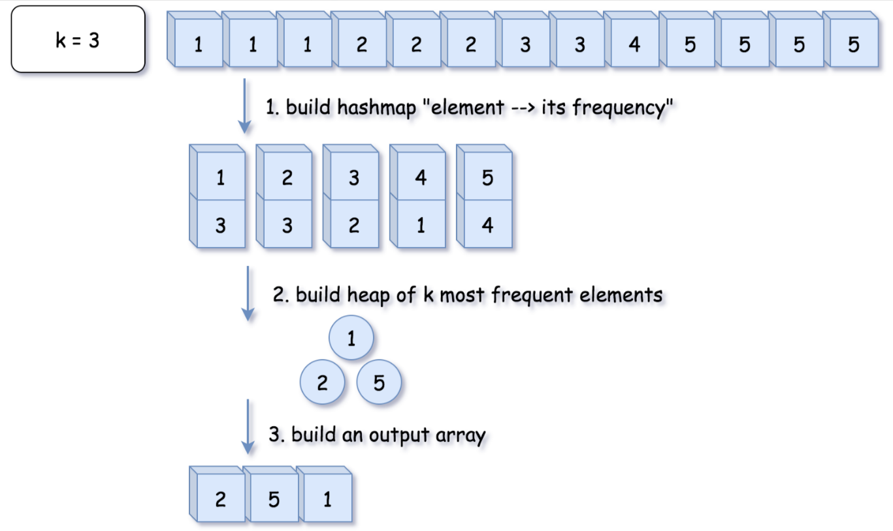

class Solution {

public int[] topKFrequent(int[] nums, int k) {

// O(1) time

if (k == nums.length) {

return nums;

}

// 1. build hash map : character and how often it appears

// O(N) time

Map<Integer, Integer> count = new HashMap();

for (int n: nums) {

count.put(n, count.getOrDefault(n, 0) + 1);

}

// init heap 'the less frequent element first'

Queue<Integer> heap = new PriorityQueue<>(

(n1, n2) -> count.get(n1) - count.get(n2));

// 2. keep k top frequent elements in the heap

// O(N log k) < O(N log N) time

for (int n: count.keySet()) {

heap.add(n);

if (heap.size() > k) heap.poll();

}

// 3. build an output array

// O(k log k) time

int[] top = new int[k];

for(int i = k - 1; i >= 0; --i) {

top[i] = heap.poll();

}

return top;

}

}

**Complexity Analysis**

* Time complexity : O(Nlog⁡k)if k<N and O(N) in the particular case of N=k. That ensures time complexity to be better than O(Nlog⁡N).
* Space complexity : O(N+k) to store the hash map with not more N elements and a heap with k elements.

**Solution 2: Bucket Sort (10 min)**

class Solution {

public int[] topKFrequent(int[] nums, int k) {

Map<Integer, Integer> freq = new HashMap<Integer, Integer>();

for(int num : nums) {

freq.put(num, freq.getOrDefault(num, 0) + 1);

}

// Array index represent frequency, list on certain index

// represent values happen as that frequence (range 1 to n)

// that's why increase length with 1 to include frequence = n

// Note: Don't write as "new List<Integer>[nums.length + 1]",

// will throw out generic array creation

// Refer to

// http://stackoverflow.com/questions/7131652/generic-array-creation-error

List<Integer>[] bucket = new List[nums.length + 1];

for(Map.Entry<Integer, Integer> entry : freq.entrySet()) {

if(bucket[entry.getValue()] == null) {

bucket[entry.getValue()] = new ArrayList<Integer>();

}

bucket[entry.getValue()].add(entry.getKey());

}

// Loop the bucket and print all bucket not null from highest freq

// which equals to start from right index

// Note: Don't forget limitation on k with "result.size() < k"

List<Integer> result = new ArrayList<Integer>();

for(int i = bucket.length - 1; i >= 0 && result.size() < k; i--) {

if(bucket[i] != null) {

result.addAll(bucket[i]);

}

}

// Refer to

// How to convert an ArrayList containing Integers to primitive int array?

// https://stackoverflow.com/questions/718554/how-to-convert-an-arraylist-containing-integers-to-primitive-int-array

return result.stream().mapToInt(i -> i).toArray();

}

}

Time complexity: O(N)

Space complexity: O(N+k) to store the hash map with not more N elements and a heap with k elements.

**Refer to**

<https://leetcode.com/problems/top-k-frequent-elements/solutions/81602/java-o-n-solution-bucket-sort>

Idea is simple. Build a array of list to be buckets with length 1 to sort

public List<Integer> topKFrequent(int[] nums, int k) {

List<Integer>[] bucket = new List[nums.length + 1];

Map<Integer, Integer> frequencyMap = new HashMap<Integer, Integer>();

for (int n : nums) {

frequencyMap.put(n, frequencyMap.getOrDefault(n, 0) + 1);

}

for (int key : frequencyMap.keySet()) {

int frequency = frequencyMap.get(key);

if (bucket[frequency] == null) {

bucket[frequency] = new ArrayList<>();

}

bucket[frequency].add(key);

}

List<Integer> res = new ArrayList<>();

for (int pos = bucket.length - 1; pos >= 0 && res.size() < k; pos--) {

if (bucket[pos] != null) {

res.addAll(bucket[pos]);

}

}

return res;

}

Thanks for sharing, only one nitpick:

Think about the case when K=2,and you have 1 number that has max frequency, say 10 times.and you have 10 numbers that has 2nd max frequency, say 9 times.With your algo, the returned list will contain 11 numbers instead of 2.

Any easy fix:return res.subList(0,k);

(It seems the above scenario is not covered by the existing test cases.)

I tweaked the code a bit so it would give [1,2] for test case " [1,1,1,2,2,2,3,3,3] k=2" instead of [1,2,3].

public List<Integer> topKFrequent(int[] nums, int k) {

Map<Integer, Integer> hm = new HashMap<>();

List<Integer>[] bucket = new List[nums.length + 1];

List<Integer> res = new ArrayList<>();

for(int num: nums){

hm.put(num, hm.getOrDefault(num, 0) + 1);

}

for(int key: hm.keySet()){

int frequency = hm.get(key);

if(bucket[frequency] == null)

bucket[frequency] = new ArrayList<>();

bucket[frequency].add(key);

}

for(int pos = bucket.length-1; pos >= 0; pos--){

if(bucket[pos] != null){

for(int i = 0; i < bucket[pos].size() && res.size() < k; i++)

res.add(bucket[pos].get(i));

}

}

return res;

}