<https://leetcode.com/problems/partition-labels/>

You are given a string s. We want to partition the string into as many parts as possible so that each letter appears in at most one part.

Note that the partition is done so that after concatenating all the parts in order, the resultant string should be s.

Return *a list of integers representing the size of these parts*.

**Example 1:**

Input: s = "ababcbacadefegdehijhklij"

Output: [9,7,8]

Explanation:

The partition is "ababcbaca", "defegde", "hijhklij".

This is a partition so that each letter appears in at most one part.

A partition like "ababcbacadefegde", "hijhklij" is incorrect, because it splits s into less parts.

**Example 2:**

Input: s = "eccbbbbdec"

Output: [10]

**Constraints:**

1 <= s.length <= 500

s consists of lowercase English letters.

**Attempt 1: 2023-01-31**

**Solution 1: Greedy + Hash Table + 2 Pass O(n) space (30 min)**

class Solution {

    public List<Integer> partitionLabels(String s) {

        List<Integer> result = new ArrayList<Integer>();

        Map<Character, Integer> map = new HashMap<Character, Integer>();

        // First pass store each character's last index

        for(int i = 0; i < s.length(); i++) {

            map.put(s.charAt(i), i);

        }

        // Second pass calculate each section length

        for(int i = 0; i < s.length(); i++) {

            int sectionLastIndex = map.get(s.charAt(i));

            for(int j = i; j <= sectionLastIndex; j++) {

                sectionLastIndex = Math.max(sectionLastIndex, map.get(s.charAt(j)));

            }

            int sectionLen = sectionLastIndex - i + 1;

            result.add(sectionLen);

            // Don't forget to update i to the end of section as we finish current

            // section and prepare for next section, after auto i++ (means

            // sectionLastIndex++ will be the beginning i in next round)

            i = sectionLastIndex;

        }

        return result;

    }

}

Time Complexity: O(N)

Space Complexity: O(N)

**Solution 2: Greedy + Hash Table + 2 Pass O(1) space (30 min)**

**Map can also use int[26] instead**

class Solution {

    public List<Integer> partitionLabels(String s) {

        List<Integer> result = new ArrayList<Integer>();

        Map<Character, Integer> map = new HashMap<Character, Integer>();

        // First pass store each character's last index

        for(int i = 0; i < s.length(); i++) {

            map.put(s.charAt(i), i);

        }

        // Second pass calculate each section length

        int section_start = 0;

        int sectionLastIndex = 0;

        for(int i = 0; i < s.length(); i++) {

            sectionLastIndex = Math.max(sectionLastIndex, map.get(s.charAt(i)));

            if(i == sectionLastIndex) {

                result.add(sectionLastIndex - section_start + 1);

                section_start = sectionLastIndex + 1;

            }

        }

        return result;

    }

}

Time Complexity: O(N)

Space Complexity: O(1)

**Refer to**

<https://leetcode.com/problems/partition-labels/solutions/1868842/java-c-visually-explaineddddd/>

How's Going Ladies - n - Gentlemen, today we are going to solve one of the coolest problem i.e. **Partition Labels**

Let's understand what problem statement is,

We have given an string. And we have to divide strings into partition. But here is one condition :-

"Character's are not present beyond it's partition"

***Let's understand with an example,***

**Input**: s = "ababcbacadefegdehijhklij"

**Output**: [9,7,8]

So, what we'll do now is jump on an character and see till where a particular character exists Let's understand it visually:

As you can see we jump over the character a till where it's impacting.



Now we jump over character b till there it's impacting.



Now we jump over character c till there it's impacting.



So as you can see we get **one of the partition**, as up till here similar character's are present.

**Similarly, we gonna do the same thing for other as well.**

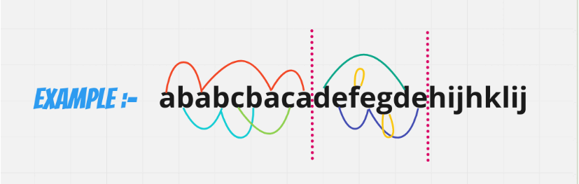

Now finally, return each partition length in List i.e.[9, 7, 8] :-

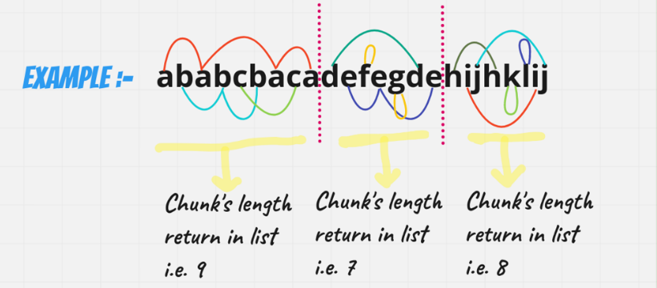

Okay, so till now we have understand the problem, now let's talk about it's approach how we gonna solve it:-

Well, i think for that we gonna need the help of HashMap, to solve this problem!! Now you will ask, why HashMap?? I'll say because, we gonna need each & every character index in our hashmap & by that we'll got an idea, from where to partition it.

Still, confuse. Don't worry just walk with me >>First create an HashMap of Character & Integer

*[where integer tell us maximum imapct of a character at this index]* & after that fill it:

Let's look at it visually >

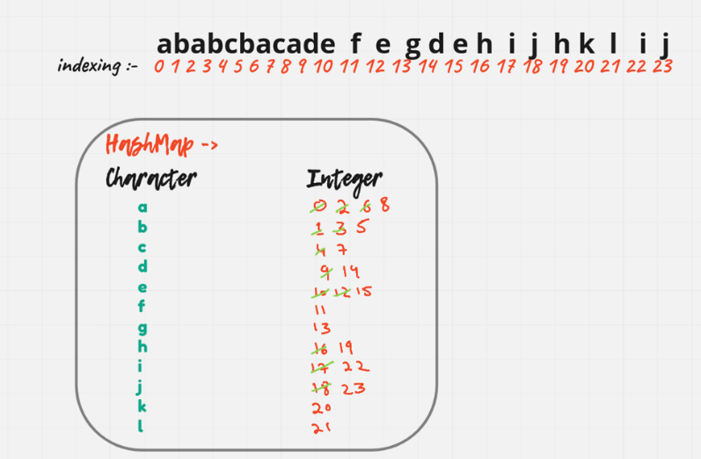

Now, we will use one formula in order to solve this so, our formula will be **max - prev** where max initially is **0** & prev initially is **-1**

Using the same above example, let's implement it:

Initially we will be at a and in our hashmap we know that a is impacting till **8**. So, we will update our **max to 8** for now.

Next we encounter b & it's range is 5. So, it is in the range of **8**

Next we encounter b & it's range is 7. So, it is in the range of **8**

So, there is no more element further in our range, we gonna use our formula :-

max - prev                                  where max is 8 & prev is -1

8 - (-1)

=> 9

Now we are at d and in our hashmap we know that d is impacting till **14**. So, we will update our **max to 14** for now & update our **previous as well to 8**

Next we encounter e & it's range is 15. So, it is out the range of **14** we gonna update our max to **15**

Next we encounter f & it's range is 11. So, it is in the range of **15**

Next we encounter g & it's range is 13. So, it is in the range of **15**

So, there is no more element further in our range, we gonna use our formula :-

max - prev                                  where max is 15 & prev is 8

15 - 8

=> 7

Now we are at h and in our hashmap we know that h is impacting till **19**. So, we will update our **max to 19** for now & update our **previous as well to 15**

Next we encounter i & it's range is 22. So, it is out the range of **19** we gonna update our max to **22**

Next we encounter j & it's range is 23. So, it is out the range of **22** we gonna update our max to **23**

Next we encounter k & it's range is 20. So, it is in the range of **23**

Next we encounter l & it's range is 21. So, it is in the range of **23**

So, there is no more element further in our range, we gonna use our formula :-

max - prev                                  where max is 23 & prev is 15

23 - 15

=> 8

Thus, we add these values to our ArrayList of let's say result & return them i.e. [9, 7, 8]

*I hope ladies - n - gentlemen approach is absolute clear,* **Let's code it up,**

**Java**

class Solution {

    public List<Integer> partitionLabels(String s) {

        Map<Character, Integer> map = new HashMap<>();

        // filling impact of character's

        for(int i = 0; i < s.length(); i++){

            char ch = s.charAt(i);

            map.put(ch, i);

        }

        // making of result

        List<Integer> res = new ArrayList<>();

        int prev = -1;

        int max = 0;

        for(int i = 0; i < s.length(); i++){

            char ch = s.charAt(i);

            max = Math.max(max, map.get(ch));

            if(max == i){

                // partition time

                res.add(max - prev);

                prev = max;

            }

        }

        return res;

    }

}

Time Complexity :- BigO(N)

Space Complexity :- BigO(N)