<https://leetcode.com/problems/merge-k-sorted-lists/description/>

You are given an array of k linked-lists lists, each linked-list is sorted in ascending order.

*Merge all the linked-lists into one sorted linked-list and return it.*

**Example 1:**

Input: lists = [[1,4,5],[1,3,4],[2,6]]

Output: [1,1,2,3,4,4,5,6]

Explanation: The linked-lists are:

[

1->4->5,

1->3->4,

2->6

]

merging them into one sorted list:

1->1->2->3->4->4->5->6

**Example 2:**

Input: lists = []

Output: []

**Example 3:**

Input: lists = [[]]

Output: []

**Constraints:**

* k == lists.length
* 0 <= k <= 104
* 0 <= lists[i].length <= 500
* -104 <= lists[i][j] <= 104
* lists[i] is sorted in **ascending order**.
* The sum of lists[i].length will not exceed 104.

**Attempt 1: 2023-02-19**

**Solution 1:  Priority Queue Solution (30 min)**

/**

* Definition for singly-linked list.

* public class ListNode {

* int val;

* ListNode next;

* ListNode() {}

* ListNode(int val) { this.val = val; }

* ListNode(int val, ListNode next) { this.val = val; this.next = next; }

* }

*/

class Solution {

public ListNode mergeKLists(ListNode[] lists) {

if(lists == null || lists.length == 0) {

return null;

}

ListNode dummy = new ListNode();

ListNode iter = dummy;

PriorityQueue<ListNode> minPQ = new PriorityQueue<ListNode>(lists.length, (a, b) -> a.val - b.val);

for(ListNode listHead : lists) {

if(listHead != null) {

minPQ.offer(listHead);

}

}

while(!minPQ.isEmpty()) {

ListNode curPeek = minPQ.poll();

iter.next = curPeek;

iter = iter.next;

if(curPeek.next != null) {

minPQ.offer(curPeek.next);

}

}

return dummy.next;

}

}

Time complexity:O(Nlog⁡k) where k is the number of linked lists.

- The comparison cost will be reduced to O(log⁡k) for every pop and insertion to priority queue. But finding the node with the smallest value just costs O(1) time.

- There are N nodes in the final linked list.

Space complexity:O(n) Creating a new linked list costs O(n)space.

- O(k) The code above present applies in-place method which cost O(1) space. And the priority queue (often implemented with heaps) costs O(k) space (it's far less than N in most situations).

**Refer to**

<https://leetcode.com/problems/merge-k-sorted-lists/solutions/10528/a-java-solution-based-on-priority-queue/>

public class Solution {

public ListNode mergeKLists(List<ListNode> lists) {

if (lists==null||lists.size()==0) return null;

PriorityQueue<ListNode> queue= new PriorityQueue<ListNode>(lists.size(),new Comparator<ListNode>(){

@Override

public int compare(ListNode o1,ListNode o2){

if (o1.val<o2.val)

return -1;

else if (o1.val==o2.val)

return 0;

else

return 1;

}

});

ListNode dummy = new ListNode(0);

ListNode tail=dummy;

for (ListNode node:lists)

if (node!=null)

queue.add(node);

while (!queue.isEmpty()){

tail.next=queue.poll();

tail=tail.next;

if (tail.next!=null)

queue.add(tail.next);

}

return dummy.next;

}

}

-------------------------------------------------------------------------------------------------------

Using Java 8:-

class Solution {

public ListNode mergeKLists(ListNode[] lists) {

if (lists==null || lists.length==0) return null;

PriorityQueue<ListNode> queue= new PriorityQueue<ListNode>(lists.length, (a,b)-> a.val-b.val);

ListNode dummy = new ListNode(0);

ListNode tail=dummy;

for (ListNode node:lists)

if (node!=null)

queue.add(node);

while (!queue.isEmpty()){

tail.next=queue.poll();

tail=tail.next;

if (tail.next!=null)

queue.add(tail.next);

}

return dummy.next;

}

}

**Refer to**

<https://leetcode.com/problems/merge-k-sorted-lists/solutions/127466/merge-k-sorted-list/>

#### **Approach 2: Compare one by one**

**Algorithm**

* Compare every k nodes (head of every linked list) and get the node with the smallest value.
* Extend the final sorted linked list with the selected nodes.

Step 1

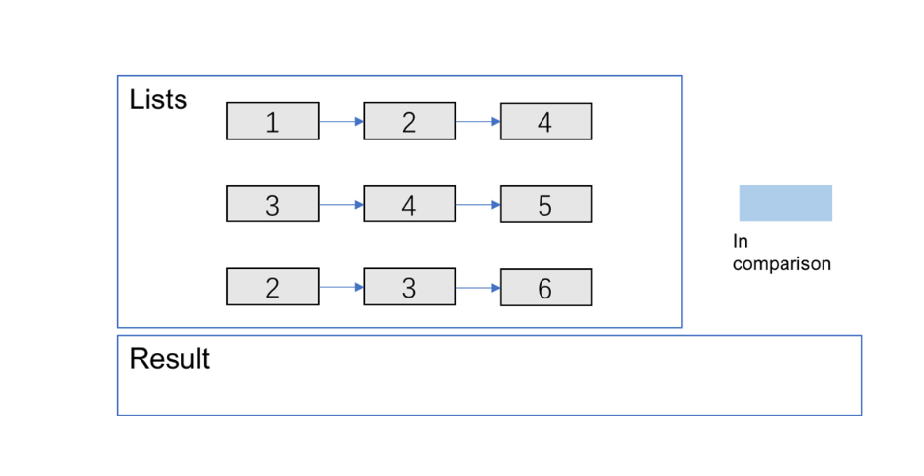

Step 2

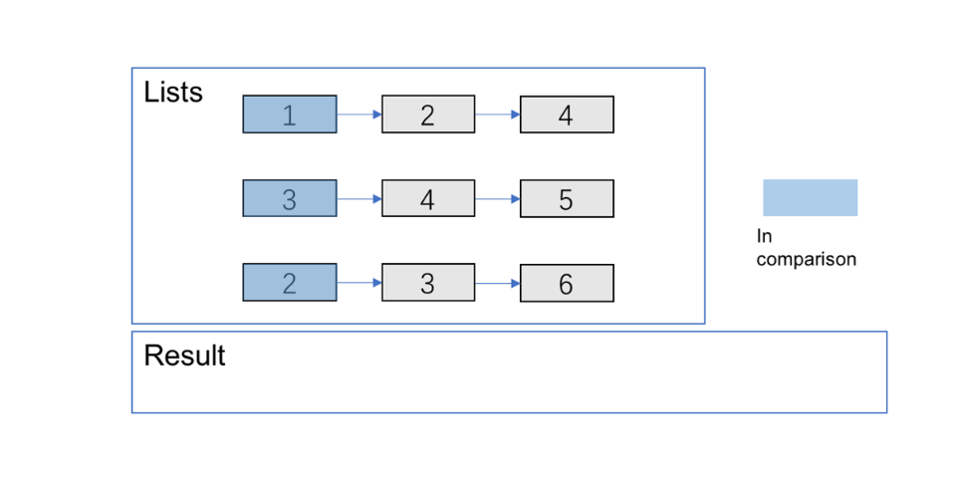

Step 3

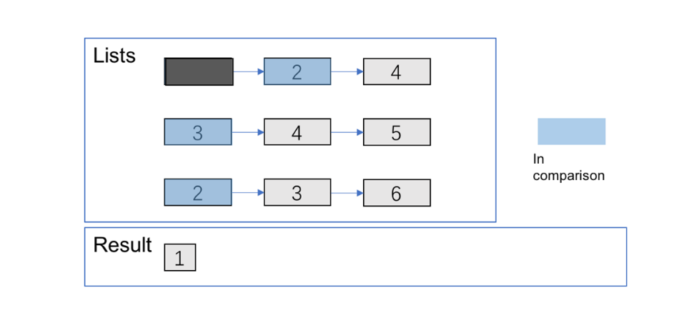

Step 4

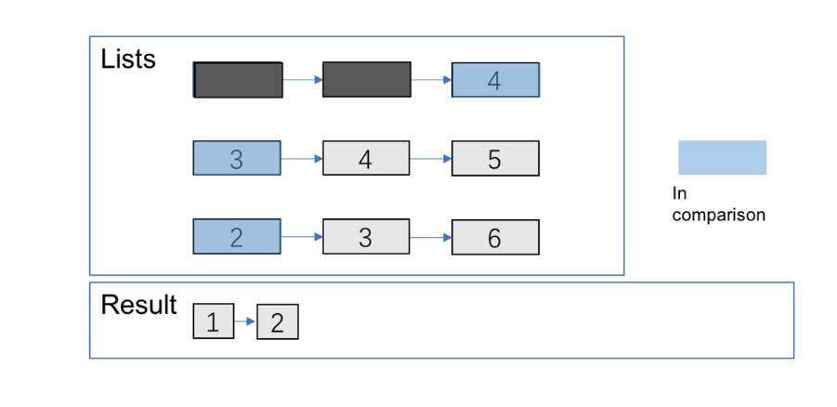

Step 5

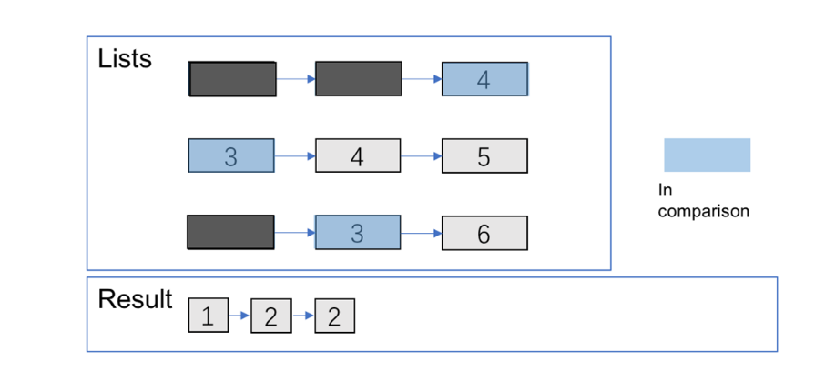

Step 6

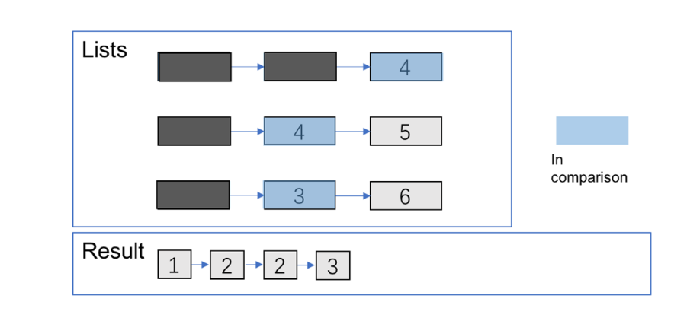

Step 7

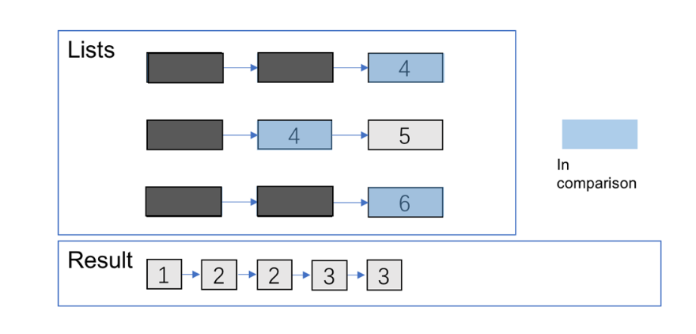

Step 8

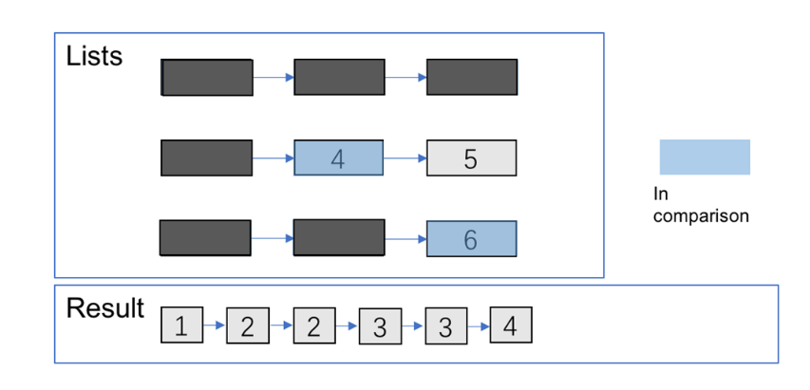

Step 9

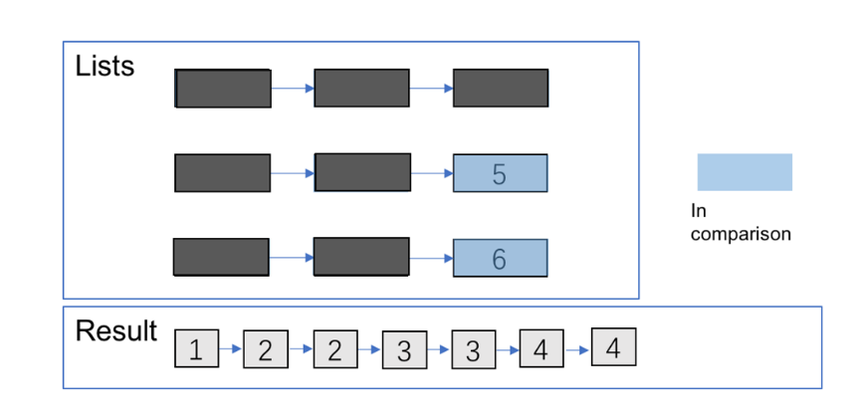

Step 10

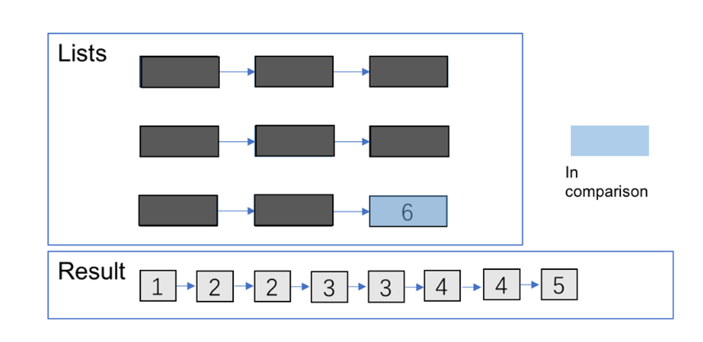

Step 11

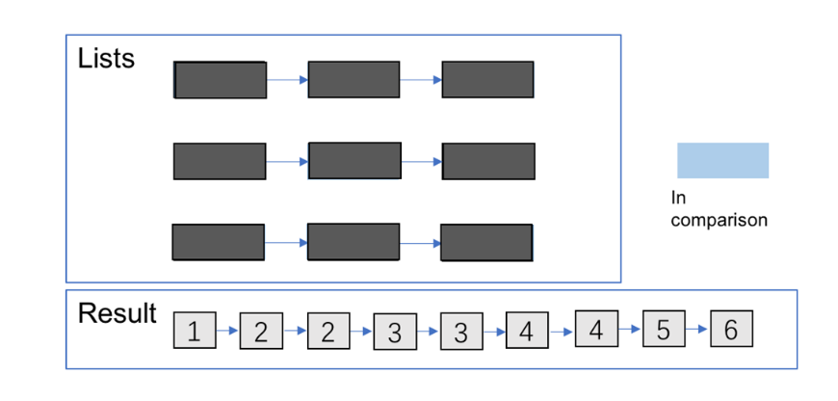

#### **Approach 3: Optimize Approach 2 by Priority Queue**

**Algorithm**

Almost the same as the one above but optimize the **comparison process** by **priority queue**. You can refer [here](https://en.wikipedia.org/wiki/Priority_queue) for more information about it.

from Queue import PriorityQueue

class Solution(object):

def mergeKLists(self, lists):

"""

:type lists: List[ListNode]

:rtype: ListNode

Note: this is Python2 code

"""

head = point = ListNode(0)

q = PriorityQueue()

for l in lists:

if l:

q.put((l.val, l))

while not q.empty():

val, node = q.get()

point.next = ListNode(val)

point = point.next

node = node.next

if node:

q.put((node.val, node))

return head.next

**Complexity Analysis**

Time complexity : O(Nlog⁡k) where k is the number of linked lists.

The comparison cost will be reduced to O(log⁡k)for every pop and insertion to priority queue. But finding the node with the smallest value just costs O(1) time.

There are N nodes in the final linked list.

Space complexity :

O(n) Creating a new linked list costs O(n)space.

O(k) The code above present applies in-place method which cost O(1) space. And the priority queue (often implemented with heaps) costs O(k) space (it's far less than N in most situations).