Definition:  
**valid**: describes a subarray that has its maximum in range L..R;  
**j**: start index of the longest valid subarray up till i;  
**count**: length of subarray A[j..x] where A[x] is the last number (within A[j..i]) that is still in range L..R;

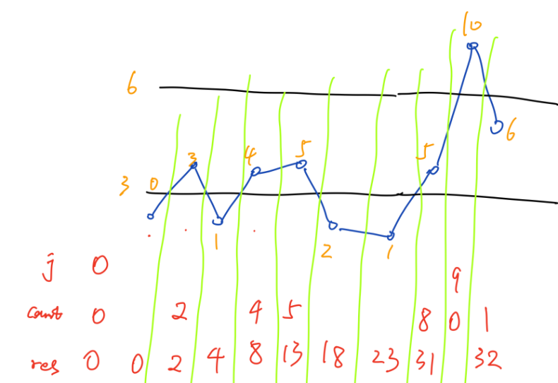

If A[i] is in range L..R, then we count subarrays it can contribute: those subarrays **ending at** A[i]. This counting avoids duplicate. Say we are at A[4] = 5, any point within A[j..4-1] can be the start point.

The tricky part is to think, say when i is 5 or 6, what do we do with A[5] = 2 or A[6] = 1?  
Take i == 6 for example: why do we add 5 here to res?

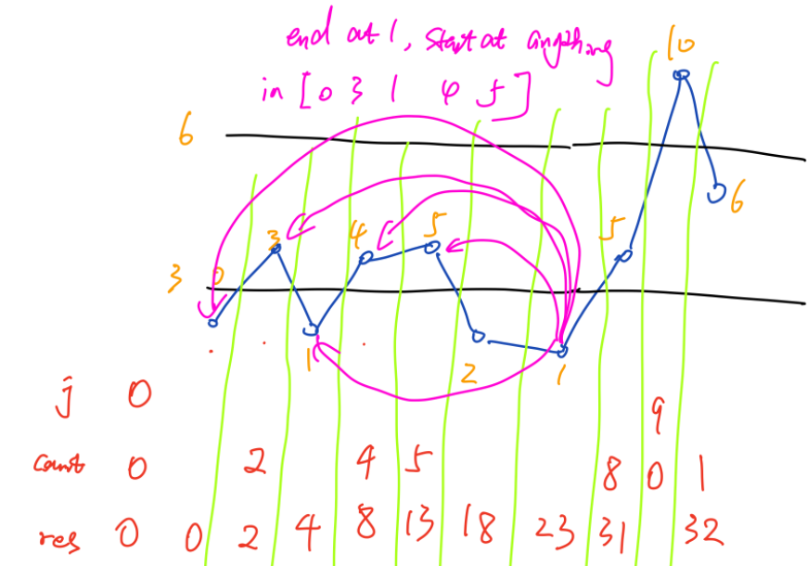

The number of subarrays that A[6]=1 can contribute are marked with purple. Anything in the range of A[0..5-1] can be the start point of the subarray that **ends at** A[6]=1, which are subarrays contributed by A[6]=1.