<https://www.prepbytes.com/blog/stacks/sort-an-array-using-stacks/>

**A monotonic stack is a stack whose elements are monotonically increasing or decreasing. If the top elements of the stack are less than bottom elements , then it is called decreasing stack , else If the top elements of the stack is greater than the bottom elements , then it is called increasing stack.**

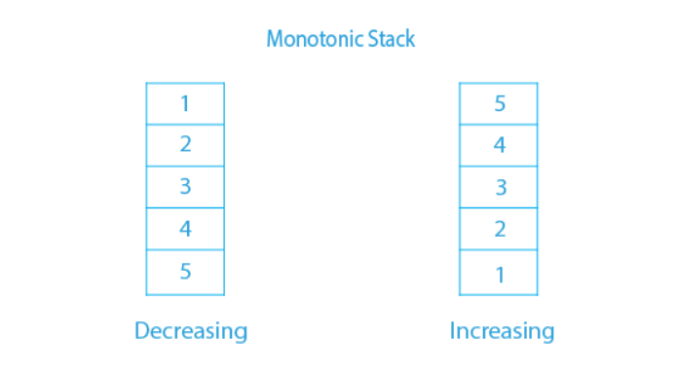

**Refer to**

<https://liuzhenglaichn.gitbook.io/algorithm/monotonic-stack>

A monotonic stack is a stack whose elements are monotonically increasing or descreasing.

Sometimes we store the index of the elements in the stack and make sure the elements corresponding to those indexes in the stack forms a mono-sequence.

## Increasing or decreasing?

If we need to pop **smaller** elements from the stack before pushing a new element, the stack is **decreasing** from bottom to top.

Otherwise, it's **increasing** from bottom to top.

For example, Mono-decreasing Stack

Before: [5,4,2,1]

To push 3, we need to pop smaller (or equal) elements first

After: [5,4,3]

## Notes

For a mono-**decreasing** stack:

we need to pop **smaller** elements before pushing.

it keep tightening the result as Lexi graphically **greater** as possible. (Because we keep popping smaller elements out and keep greater elements).

