<https://leetcode.com/problems/serialize-and-deserialize-binary-tree/>

Serialization is the process of converting a data structure or object into a sequence of bits so that it can be stored in a file or memory buffer, or transmitted across a network connection link to be reconstructed later in the same or another computer environment.

Design an algorithm to serialize and deserialize a binary tree. There is no restriction on how your serialization/deserialization algorithm should work. You just need to ensure that a binary tree can be serialized to a string and this string can be deserialized to the original tree structure.

**Clarification:** The input/output format is the same as [how LeetCode serializes a binary tree](https://support.leetcode.com/hc/en-us/articles/360011883654-What-does-1-null-2-3-mean-in-binary-tree-representation-). You do not necessarily need to follow this format, so please be creative and come up with different approaches yourself.

**Example 1:**

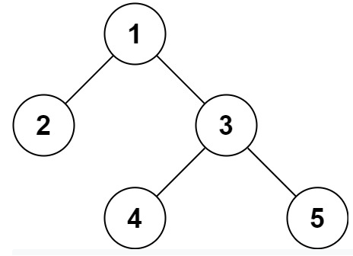

Input: root = [1,2,3,null,null,4,5]

Output: [1,2,3,null,null,4,5]

**Example 2:**

Input: root = []

Output: []

**Constraints:**

* The number of nodes in the tree is in the range [0, 104].
* -1000 <= Node.val <= 1000

**What does [1,null,2,3] mean in binary tree representation?**

<https://support.leetcode.com/hc/en-us/articles/360011883654-What-does-1-null-2-3-mean-in-binary-tree-representation>-

The input [1,null,2,3] represents the *serialized* format of a binary tree using **level order traversal**, **where null signifies a path terminator where no node exists below**.

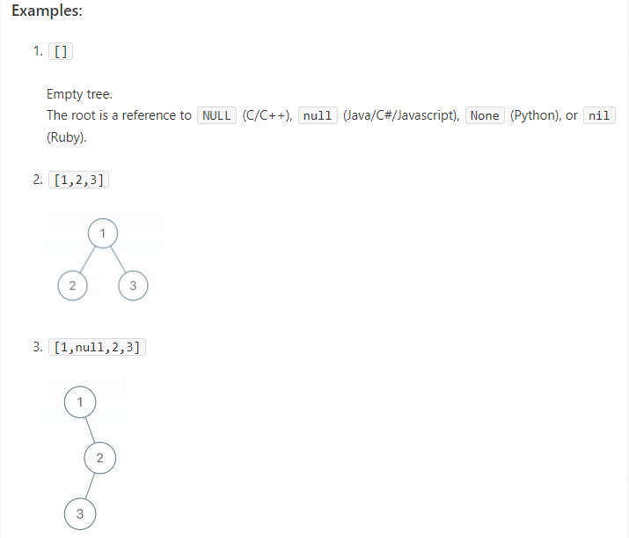

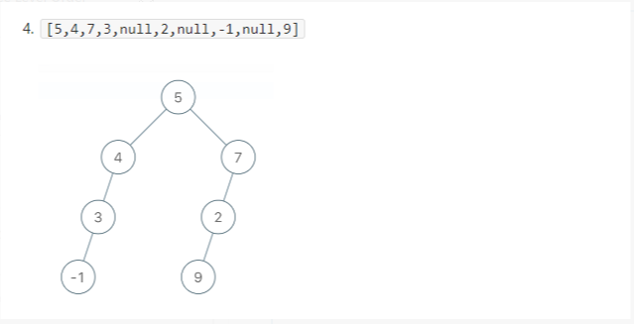

**Attempt 1: 2022-11-01**

**Solution 1:  Preorder traversal for Serialize using DFS and for Deserialize using DFS (based on Queue) (30min)**

**Two key points:**

**1. Use preorder traversal (root -> left -> right) and mark NULL as "#"**

**2. Deserialize with Queue based on preorder sequence (root -> left -> right)**

/**

* Definition for a binary tree node.

* public class TreeNode {

* int val;

* TreeNode left;

* TreeNode right;

* TreeNode(int x) { val = x; }

* }

*/

public class Codec {

private String NA = "X";

private String spliter = ",";

// Encodes a tree to a single string.

public String serialize(TreeNode root) {

StringBuilder sb = new StringBuilder();

serializeHelper(root, sb);

return sb.toString();

}

/**

e.g

5 5

/ \ / \

3 6 => if considering NULL(x) => 3 6

/ \ \ / \ / \

2 4 7 2 4 x 7

/ \ / \ / \

x x x x x x

preorder serialize into string: 5,3,2,X,X,4,X,X,6,X,7,X,X,

*/

// Style 1

private void serializeHelper(TreeNode root, StringBuilder sb) {

// Base case: Handle NULL

if(root == null) {

sb.append(NA).append(spliter);

return;

}

// Preorder traversal

sb.append(root.val).append(spliter);

serializeHelper(root.left, sb);

serializeHelper(root.right, sb);

}

// Style 2

//private void serializeHelper(TreeNode root, StringBuilder sb) {

// if(root == null) {

// sb.append(NA).append(spliter);

// } else {

// sb.append(root.val).append(spliter);

// serializeHelper(root.left, sb);

// serializeHelper(root.right, sb);

// }

//}

// Decodes your encoded data to tree.

public TreeNode deserialize(String data) {

Queue<String> q = new LinkedList<String>();

q.addAll(Arrays.asList(data.split(spliter)));

return buildTree(q);

}

// Decode preorder traversal (5,3,2,X,X,4,X,X,6,X,7,X,X,) into tree

private TreeNode buildTree(Queue<String> q) {

String rootVal = q.poll();

if(rootVal.equals(NA)) {

return null;

}

TreeNode root = new TreeNode(Integer.valueOf(rootVal));

// Based on preorder, first build left subtree, then right subtree,

// and on each recursion Queue will pop out one element, since Queue

// is a object and no backtrack here, the number of elements on

// Queue will keep decreasing

root.left = buildTree(q);

root.right = buildTree(q);

return root;

}

}

// Your Codec object will be instantiated and called as such:

// Codec ser = new Codec();

// Codec deser = new Codec();

// TreeNode ans = deser.deserialize(ser.serialize(root));

Time Complexity: O(N), where N <= 10^4 is number of nodes in the Binary Tree.

Space Complexity: O(N)

**Difference between L297.Serialize and Deserialize Binary Tree (use only preorder to construct tree) and L105.Construct Binary Tree from Preorder and Inorder Traversal (use both preorder and inorder to construct tree) ?**

**Refer to**

<https://leetcode.com/problems/serialize-and-deserialize-binary-tree/discuss/74253/Easy-to-understand-Java-Solution/269310>

**Difference** between reconstruct the tree [#105](https://leetcode.com/problems/construct-binary-tree-from-preorder-and-inorder-traversal) **preorder/postorder + inorder** and this problem which just uses **preorder**

1. [#105](https://leetcode.com/problems/construct-binary-tree-from-preorder-and-inorder-traversal) preorder/postorder + inorder: **why we have to use 2 lists/traversals?**

The lists **does not preserve the null**, so we do not have an indicator to check if a node is in the left subtree or right subtree, so 2 traversals are needed.

1. But for this problem, we can preserve null, so we can reconstruct by just using 1 list, i.e. preorder list

**Refer to**

<https://leetcode.com/problems/serialize-and-deserialize-binary-tree/discuss/74253/Easy-to-understand-Java-Solution/77362>

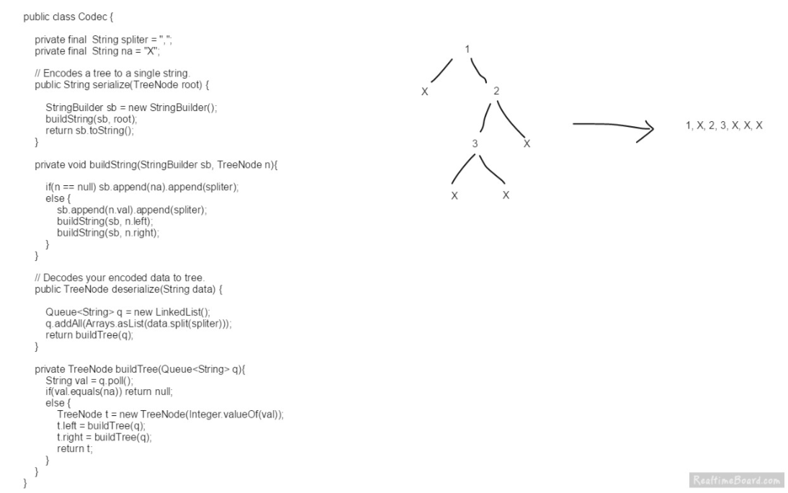

**Solution 2: Level order traversal for Serialize using BFS (Queue) and for Deserialize using BFS (Queue) (60min)**

/**

* Definition for a binary tree node.

* public class TreeNode {

* int val;

* TreeNode left;

* TreeNode right;

* TreeNode(int x) { val = x; }

* }

*/

public class Codec {

private String NA = "X";

private String spliter = ",";

/**

e.g

5 5

/ \ / \

3 6 => if considering NULL(x) => 3 6

/ \ \ / \ / \

2 4 7 2 4 x 7

/ \ / \ / \

x x x x x x

level order serialize into string: 5,3,6,2,4,X,7,X,X,X,X,X,X,

*/

// Encodes a tree to a single string.

public String serialize(TreeNode root) {

if(root == null) {

return "";

}

StringBuilder sb = new StringBuilder();

Queue<TreeNode> q = new LinkedList<TreeNode>();

q.offer(root);

while(!q.isEmpty()) {

TreeNode node = q.poll();

if(node == null) {

sb.append(NA).append(spliter);

// Must terminate early since node already NULL,

// if not skip following statement then NullPointerException

// will happen because of 'node.val' not exist

continue;

}

sb.append(node.val).append(spliter);

// Add left and right child (even if it is NULL) on queue

q.offer(node.left);

q.offer(node.right);

}

return sb.toString();

}

// Decodes your encoded data to tree.

// Decode level order traversal (5,3,6,2,4,X,7,X,X,X,X,X,X,) into tree

public TreeNode deserialize(String data) {

if(data == "") {

return null;

}

Queue<TreeNode> q = new LinkedList<TreeNode>();

String[] values = data.split(spliter);

TreeNode root = new TreeNode(Integer.parseInt(values[0]));

q.offer(root);

for(int i = 1; i < values.length; i++) {

TreeNode node = q.poll();

if(!values[i].equals(NA)) {

TreeNode leftNode = new TreeNode(Integer.parseInt(values[i]));

node.left = leftNode;

q.offer(leftNode);

}

i++;

if(!values[i].equals(NA)) {

TreeNode rightNode = new TreeNode(Integer.parseInt(values[i]));

node.right = rightNode;

q.offer(rightNode);

}

}

return root;

}

}

// Your Codec object will be instantiated and called as such:

// Codec ser = new Codec();

// Codec deser = new Codec();

// TreeNode ans = deser.deserialize(ser.serialize(root));

Time Complexity: O(N), where N <= 10^4 is number of nodes in the Binary Tree.

Space Complexity: O(N)

**Refer to**

<https://leetcode.com/problems/serialize-and-deserialize-binary-tree/discuss/74264/Short-and-straight-forward-BFS-Java-code-with-a-queue>

Here I use typical BFS method to handle a binary tree. I use string n to represent null values. The string of the binary tree in the example will be "1 2 3 n n 4 5 n n n n ".

When deserialize the string, I assign left and right child for each not-null node, and add the not-null children to the queue, waiting to be handled later.

public class Codec {

public String serialize(TreeNode root) {

if (root == null) return "";

Queue<TreeNode> q = new LinkedList<>();

StringBuilder res = new StringBuilder();

q.add(root);

while (!q.isEmpty()) {

TreeNode node = q.poll();

if (node == null) {

res.append("n ");

continue;

}

res.append(node.val + " ");

q.add(node.left);

q.add(node.right);

}

return res.toString();

}

public TreeNode deserialize(String data) {

if (data == "") return null;

Queue<TreeNode> q = new LinkedList<>();

String[] values = data.split(" ");

TreeNode root = new TreeNode(Integer.parseInt(values[0]));

q.add(root);

for (int i = 1; i < values.length; i++) {

TreeNode parent = q.poll();

if (!values[i].equals("n")) {

TreeNode left = new TreeNode(Integer.parseInt(values[i]));

parent.left = left;

q.add(left);

}

if (!values[++i].equals("n")) {

TreeNode right = new TreeNode(Integer.parseInt(values[i]));

parent.right = right;

q.add(right);

}

}

return root;

}

}

**Refer to**

<https://leetcode.com/problems/serialize-and-deserialize-binary-tree/discuss/74264/Short-and-straight-forward-BFS-Java-code-with-a-queue/980762>

Q: I also think if we are using a level order traversal, the left child is at index 2 *index + 1 and right child at index 2 * index + 2 can this info be applied in deserializing, and avoid the extra space, and do it recursively ?

A: Not able to because its difficult to update 2 root in one round for next iteration

// 5,3,6,2,4,X,7,X,X,X,X,X,X,

// Decodes your encoded data to tree.

public TreeNode deserialize(String data) {

if(data == "") {

return null;

}

//Queue<TreeNode> q = new LinkedList<TreeNode>();

String[] values = data.split(spliter);

TreeNode root = new TreeNode(Integer.parseInt(values[0]));

//int index = 0;

//q.offer(root);

int len = values.length;

for(int i = 0; i < values.length; i++) {

int leftIndex = i * 2 + 1;

int rightIndex = i * 2 + 2;

if(leftIndex < len && !values[leftIndex].equals(NA)) {

root.left = new TreeNode(Integer.parseInt(values[leftIndex]));

}

if(rightIndex < len && !values[rightIndex].equals(NA)) {

root.right = new TreeNode(Integer.parseInt(values[rightIndex]));

}

// Not able to update both left / right subtree node for next iteration

// in one for loop

}

return root;

}

**Video explain:**

[Serialize and Deserialize Binary Tree - Preorder Traversal - Leetcode 297 - Python](https://www.youtube.com/watch?v=u4JAi2JJhI8)

<https://www.youtube.com/watch?v=u4JAi2JJhI8>