<https://leetcode.com/problems/binary-tree-inorder-traversal/>

Given the root of a binary tree, return *the inorder traversal of its nodes' values*.

**Example 1:**

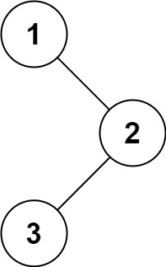

Input: root = [1,null,2,3]

Output: [1,3,2]

**Example 2:**

Input: root = []

Output: []

**Example 3:**

Input: root = [1]

Output: [1]

**Constraints:**

The number of nodes in the tree is in the range [0, 100].

-100 <= Node.val <= 100

**Follow up:** Recursive solution is trivial, could you do it iteratively?

**Attempt 1: 2022-10-23**

**Solution 1:  Recursive traversal (10min)**

/**

* Definition for a binary tree node.

* public class TreeNode {

*    int val;

*    TreeNode left;

*    TreeNode right;

*    TreeNode() {}

*    TreeNode(int val) { this.val = val; }

*    TreeNode(int val, TreeNode left, TreeNode right) {

*        this.val = val;

*        this.left = left;

*        this.right = right;

*    }

* }

*/

class Solution {

    public List<Integer> inorderTraversal(TreeNode root) {

        List<Integer> result = new ArrayList<Integer>();

        if(root == null) {

            return result;

        }

        // No modification on tree structure, can use original object 'root' to traverse

        helper(root, result);

        return result;

    }

    private void helper(TreeNode root, List<Integer> result) {

        if(root == null) {

            return;

        }

        helper(root.left, result);

        result.add(root.val);

        helper(root.right, result);

    }

}

Time Complexity: O(n)

Space Complexity: O(n)

**Test:**

import java.util.ArrayList;

import java.util.List;

public class Test {

    public static void main(String[] args) {

        /**

          1

            \

            3      ==> Expected: 1 2 3 4 5

            / \

          2  4

                \

                5

        */

        Test b = new Test();

        TreeNode one = b.new TreeNode(1);

        TreeNode two = b.new TreeNode(2);

        TreeNode three = b.new TreeNode(3);

        TreeNode four = b.new TreeNode(4);

        TreeNode five = b.new TreeNode(5);

        one.right = three;

        three.left = two;

        three.right = four;

        four.right = five;

        List<Integer> result = b.inorderTraversal(one);

        System.out.println(result);

    }

    private class TreeNode {

        public int val;

        public TreeNode left, right;

        public TreeNode(int val) {

            this.val = val;

            this.left = this.right = null;

        }

    }

    public List<Integer> inorderTraversal(TreeNode root) {

        List<Integer> result = new ArrayList<Integer>();

        if (root == null) {

            return result;

        }

        helper(root, result);

        return result;

    }

    public void helper(TreeNode root, List<Integer> result) {

        if (root == null) {

            return;

        }

        helper(root.left, result);

        result.add(root.val);

        helper(root.right, result);

    }

}

**Refer to**

<https://leetcode.com/problems/binary-tree-inorder-traversal/discuss/283746/All-DFS-traversals-(preorder-inorder-postorder)-in-Python-in-1-line>

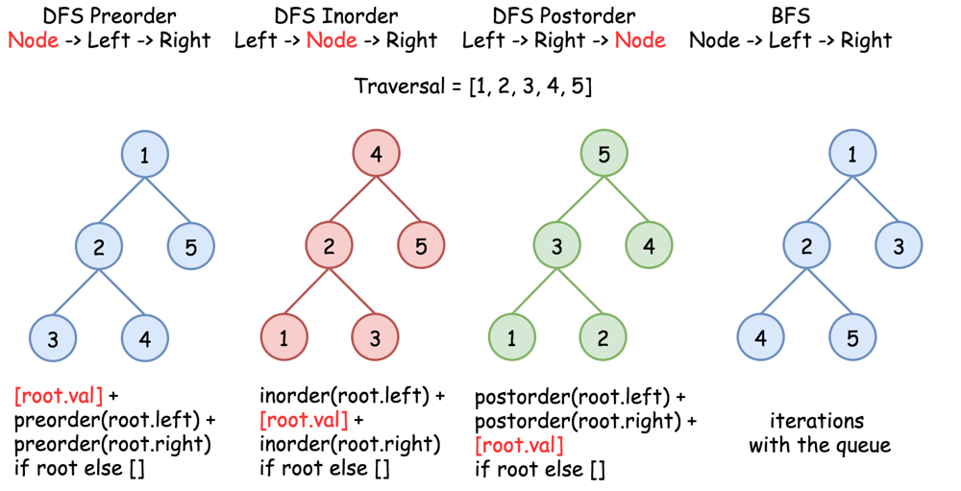

def preorder(root):

  return [root.val] + preorder(root.left) + preorder(root.right) if root else []

def inorder(root):

  return  inorder(root.left) + [root.val] + inorder(root.right) if root else []

def postorder(root):

  return  postorder(root.left) + postorder(root.right) + [root.val] if root else []

**Refer to**

<https://leetcode.com/problems/binary-tree-inorder-traversal/discuss/31231/C%2B%2B-Iterative-Recursive-and-Morris>

// Recursive solution

class Solution {

public:

    vector<int> inorderTraversal(TreeNode* root) {

        vector<int> nodes;

        inorder(root, nodes);

        return nodes;

    }

private:

    void inorder(TreeNode* root, vector<int>& nodes) {

        if (!root) {

            return;

        }

        inorder(root -> left, nodes);

        nodes.push_back(root -> val);

        inorder(root -> right, nodes);

    }

};

**Solution 2: Iterative traversal with Stack (10min)**

/**

* Definition for a binary tree node.

* public class TreeNode {

*    int val;

*    TreeNode left;

*    TreeNode right;

*    TreeNode() {}

*    TreeNode(int val) { this.val = val; }

*    TreeNode(int val, TreeNode left, TreeNode right) {

*        this.val = val;

*        this.left = left;

*        this.right = right;

*    }

* }

*/

class Solution {

    public List<Integer> inorderTraversal(TreeNode root) {

        List<Integer> result = new ArrayList<Integer>();

        Stack<TreeNode> stack = new Stack<TreeNode>();

        while(root != null || !stack.isEmpty()) {

            while(root != null) {

                stack.push(root);

                root = root.left;

            }

            // Don't write as "TreeNode node = stack.pop()" which cannot update 'root'

            // for next iteration, must update original iterative object 'root' by

            // "root = stack.pop()"

            root = stack.pop();

            result.add(root.val);

            root = root.right;

        }

        return result;

    }

}

Time Complexity: O(n)

Space Complexity: O(n)

**Refer to**

<https://leetcode.com/problems/binary-tree-inorder-traversal/discuss/31213/Iterative-solution-in-Java-simple-and-readable>

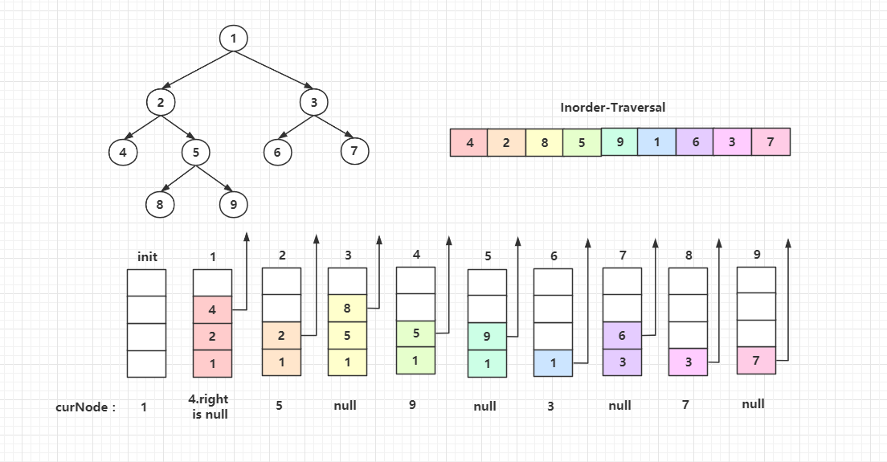

public List<Integer> inorderTraversal(TreeNode root) {

    List<Integer> list = new ArrayList<Integer>();

    Stack<TreeNode> stack = new Stack<TreeNode>();

    TreeNode cur = root;

    while(cur!=null || !stack.empty()){

        while(cur!=null){

            stack.add(cur);

            cur = cur.left;

        }

        cur = stack.pop();

        list.add(cur.val);

        cur = cur.right;

    }

    return list;

}

**Refer to**

[L98.Validate Binary Search Tree (Ref.L94,L333,L230)](note://FE39F5C607864CBFABA303F6582EAC41)

[L230.Kth Smallest Element in a BST (Ref.L98)](note://28B70EB5DF2F48F6803E1D69A522EA24)

[L144.Binary Tree Preorder Traversal (Ref.L94,L145)](note://52ADE74433F641C2A69779363DAC07E8)

[L145.Binary Tree Postorder Traversal (Ref.L94,L144)](note://34E1B6B972DD48B8BEB67851514E42AE)