<https://leetcode.com/problems/multiply-strings/>

Given two non-negative integers num1 and num2 represented as strings, return the product of num1 and num2, also represented as a string.

**Note:** You must not use any built-in BigInteger library or convert the inputs to integer directly.

**Example 1:**

Input: num1 = "2", num2 = "3"

Output: "6"

**Example 2:**

Input: num1 = "123", num2 = "456"

Output: "56088"

**Constraints:**

* 1 <= num1.length, num2.length <= 200
* num1 and num2 consist of digits only.
* Both num1 and num2 do not contain any leading zero, except the number 0 itself.

**Attempt 1: 2023-03-09**

**Solution 1: Sum the products from all pairs of digits (30 min)**

class Solution {

public String multiply(String num1, String num2) {

int m = num1.length();

int n = num2.length();

int[] pos = new int[m + n];

for(int i = m - 1; i >= 0; i--) {

for(int j = n - 1; j >= 0; j--) {

int mul = (num1.charAt(i) - '0') * (num2.charAt(j) - '0');

int p1 = i + j;

int p2 = i + j + 1;

int sum = mul + pos[p2];

pos[p1] += sum / 10;

pos[p2] = sum % 10;

}

}

StringBuilder sb = new StringBuilder();

// In case of num1 = "0", num2 = "0", must NOT append digit directly

for(int p : pos) {

if(!(sb.length() == 0 && p == 0)) {

sb.append(p);

}

}

return sb.length() == 0 ? "0" : sb.toString();

}

}

**Refer to**

<https://leetcode.com/problems/multiply-strings/solutions/17605/easiest-java-solution-with-graph-explanation/>

Remember how we do multiplication?

Start from right to left, perform multiplication on every pair of digits, and add them together. Let's draw the process! From the following draft, we can immediately conclude:

`num1[i] * num2[j]` will be placed at indices `[i + j`, `i + j + 1]`

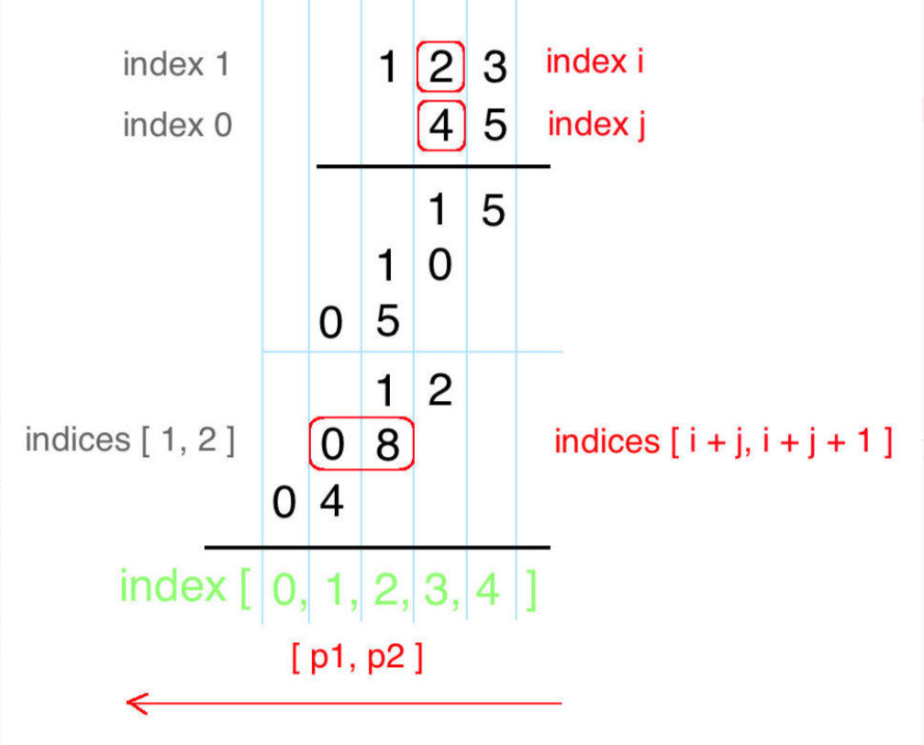

public String multiply(String num1, String num2) {

int m = num1.length(), n = num2.length();

int[] pos = new int[m + n];

for(int i = m - 1; i >= 0; i--) {

for(int j = n - 1; j >= 0; j--) {

int mul = (num1.charAt(i) - '0') * (num2.charAt(j) - '0');

int p1 = i + j, p2 = i + j + 1;

int sum = mul + pos[p2];

pos[p1] += sum / 10;

pos[p2] = (sum) % 10;

}

}

StringBuilder sb = new StringBuilder();

for(int p : pos) if(!(sb.length() == 0 && p == 0)) sb.append(p);

return sb.length() == 0 ? "0" : sb.toString();

}