Predicting Job Salaries: A Comparative Machine Learning Analysis
Lam Tran Tan Phat Dinh Quoc Khanh Bui Phuc Binh
HUTECH University
Email: quockhanh092005@gmail.com, lamphat344961@gmail.com, phucbinh3008@gmail.com

Abstract— This study focuses on developing a predictive model for job salary estimation based on professional and geographical features. The dataset is preprocessed by removing missing values, duplicate records, and outliers using the IQR method. To address data skewness, a logarithmic transformation is applied to the target variable. The data is then standardized and partitioned into training, validation, and testing sets (70/15/15) using a stratified splitting strategy. Multiple regression algorithms, including Linear Regression, Random Forest, and Gradient Boosting, are applied and compared. Model performance is evaluated using RMSE, MAE, and R-squared metrics. The results identify the most effective approach for accurate salary forecasting, providing insights into the key drivers of compensation.
Keywords— salary prediction; machine learning; IQR method; log transformation; regression; RMSE; R-squared.
I. INTRODUCTION
In recent years, data analysis and machine learning techniques have been widely applied in various domains, including the human resources and recruitment industry. Among these, salary prediction has attracted significant attention due to its economic and commercial importance for both employers and job seekers. Understanding the key drivers of compensation through data can help companies optimize their hiring strategies and assist candidates in making informed career decisions.
Regression is a supervised learning technique used to predict continuous numerical values based on a set of input features. Unlike clustering, which discovers hidden structures in unlabeled data, regression models utilize historical data to establish mathematical relationships between independent variables—such as job titles, experience, and location—and the target variable, which is the salary. By applying these methods, complex patterns within the labor market can be identified and quantified.
In this study, we perform a comparative analysis of several regression algorithms, including Linear Regression, Random Forest, and Gradient Boosting, on a comprehensive job salary dataset. The data undergoes a rigorous preprocessing pipeline, including cleaning, outlier removal using the Interquartile Range (IQR) method, and logarithmic transformation to address the inherent skewness of salary distributions. The performance of each model is evaluated using standard metrics such as Root Mean Squared Error (RMSE), Mean Absolute Error (MAE), and R-squared ($R^{2}$ ).
The objective of this study is to identify the most suitable regression method for salary forecasting and to provide insights into the factors that most significantly influence compensation levels. To achieve this, the study aims to answer the following research questions:
- RQ1: To what extent do IQR-based outlier removal and logarithmic transformation improve the predictive accuracy and convergence of salary regression models?
- RQ2: Which machine learning algorithm among Linear Regression, Random Forest, and Gradient Boosting provides the most robust performance in capturing non-linear relationships within the job salary dataset?
- RQ3: What are the primary features, such as job titles or locations, that exert the most significant influence on salary levels according to the feature importance analysis?

II. RELATED WORK
Several studies have applied machine learning techniques to analyze labor market data and uncover hidden patterns in compensation. Traditional algorithms such as Linear Regression are commonly used due to their simplicity and efficiency in identifying linear dependencies between job features and income levels. These models provide a clear baseline for understanding how variables like education or location influence salary.
In recent years, ensemble-based methods like Random Forest have been introduced to better handle non-linear relationships and high-dimensional data. These techniques are particularly effective at capturing complex interactions between categorical features that simple linear models might overlook. Furthermore, gradient boosting models provide a more flexible approach by iteratively optimizing prediction errors, making them highly suitable for datasets with diverse feature distributions.
However, each regression method has its own strengths and limitations depending on the characteristics of the dataset, such as its scale, noise levels, and feature correlations. Therefore, a comparative analysis of multiple regression algorithms - integrating robust preprocessing techniques like IQR-based outlier removal and logarithmic transformations—is necessary to determine the most accurate and reliable approach for job salary prediction.
III. METHODOLOGY
A. Data Collection and Cleaning
The dataset for this study comprises various job market features, including job titles, descriptions, geographic locations, and their corresponding salary levels. Initially, a comprehensive examination is conducted to identify missing values, duplicate records, and inconsistencies. Missing values are handled using listwise deletion or imputation where appropriate, while duplicate entries are eliminated to maintain the integrity of the predictive model.
To improve data quality, outliers in the salary feature are detected and removed using the Interquartile Range (IQR) method. Specifically, salary values falling below Q1 - 1.5 ×IQR or above Q3 + 1.5 ×IQR are identified as univariate outliers, where IQR = Q3 - Q1 . To preserve valuable data while enhancing model robustness, a conservative filtering threshold is applied to ensure that the models are not biased by extreme noise in the compensation data.
B. Data Preprocessing and Target Transformation
After cleaning, categorical features such as job titles and locations are transformed into numerical formats using encoding techniques. A critical step in this phase is addressing the inherent right-skewness commonly found in salary distributions. To achieve a more normal distribution and improve model convergence, a Logarithmic Transformation is applied to the target variable, resulting in the new variable log_salary.
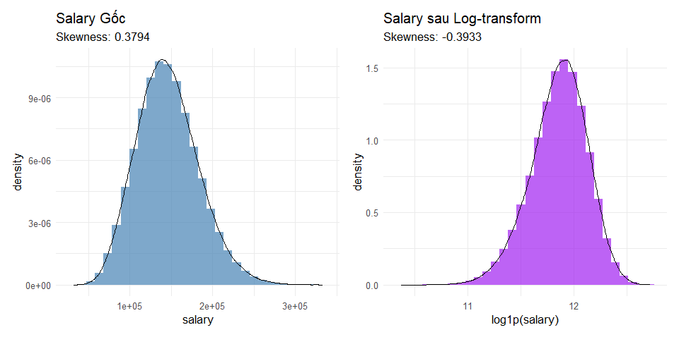
Fig. 1. Distribution of job salaries before and after Logarithmic Transformation
Prior to model training, Exploratory Data Analysis (EDA) is conducted to evaluate the distribution and relationships among variables. A boxplot is utilized to illustrate the variation of job features, while a correlation matrix is constructed to visualize linear dependencies between numerical features. Highly correlated variables are identified to mitigate multicollinearity issues in the regression process.
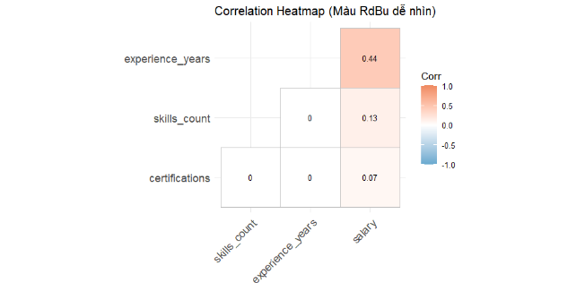
Fig. 2. Correlation matrix of job-related features and log-salary.
C. Data Preprocessing and Splitting Strategy:
Numerical features are first processed using IQR-based filtering to remove univariate outliers. To address the inherent right-skewness of salary data, a Logarithmic Transformation is applied to the target variable to normalize its distribution and enhance model stability. For a robust evaluation, the dataset is then partitioned into three subsets: Training (70%), Validation (15%), and Testing (15%). This split utilizes a stratified sampling strategy based on the log_salary variable to ensure consistent salary distributions across all subsets.
D. Regression Algorithms
Six primary regression algorithms are applied and compared in this study:
- Linear Regression: Serves as a baseline model to identify linear relationships between features and the target salary.
$$y=β_{0}+\sum_{j=1}^{p}{β_{j}X_{j}}+ϵ$$
- Ridge Regression (L2 Regularization): Addresses multicollinearity by adding a penalty term equivalent to the square of the magnitude of coefficients to the loss function, preventing overfitting in high-dimensional data.
$$min_{β}\left(\sum_{i=1}^{n}{{\left(y_{i}-\hat{y_{i}}\right)}^{2}}+λ\backslash sum_{j=1}^{p}β_{j}^{2}\right)$$
- Decision Tree Regressor: A non-parametric model that predicts the target value by learning simple decision rules inferred from the data features, partitioning the space into smaller regions.
- Random Forest Regressor: An ensemble learning method that builds multiple decision trees to capture non-linear patterns and complex interactions.
- Gradient Boosting (XGBoost): An iterative boosting technique that optimizes the model by minimizing residuals from previous learners to achieve high predictive accuracy.
- XGBoost (Extreme Gradient Boosting): An optimized distributed gradient boosting library designed for high efficiency and performance. It implements advanced regularized boosting to minimize the objective function and handle complex data structures.
$Obj^{\left(t\right)}=\sum_{i=1}^{n}{L\left(y_{i},\hat{y_{i}^{\left(t-1\right)}}+f_{t}\left(x_{i}\right)\right)}+Ω\left(f_{t}\right)$
E. Evaluation Metrics
To evaluate the performance of the regression models, three widely used metrics are employed:
- Root Mean Squared Error (RMSE): Measures the average magnitude of the prediction error, penalizing larger errors more heavily.
$RMSE=\sqrt{\frac{1}{n}\sum_{i=1}^{n}{{\left(y_{i}-\hat{y_{i}}\right)}^{2}}}$

- Mean Absolute Error (MAE): Represents the average absolute difference between predicted and actual salary values, providing an intuitive sense of prediction accuracy.
$$MAE=\frac{1}{n}\sum_{i=1}^{n}{\left|y_{i}-\hat{y_{i}}\right|}$$

- R-squared (R²): Evaluates the proportion of variance in the salary that is predictable from the independent variables, indicating the goodness-of-fit.

IV. RESULTS AND DISCUSSION

A. Model Validation and Feature Importance

Analysis To evaluate the reliability and generalization capability of the predictive framework, a 5-fold Cross-Validation (CV) approach was implemented for the Random Forest regressor. The training dataset was partitioned into five equal subsets, where the model was iteratively trained on four folds and validated on the remaining one. The consistency of the R² scores across all folds, as illustrated in Fig. 3, provides strong evidence of the model's stability.
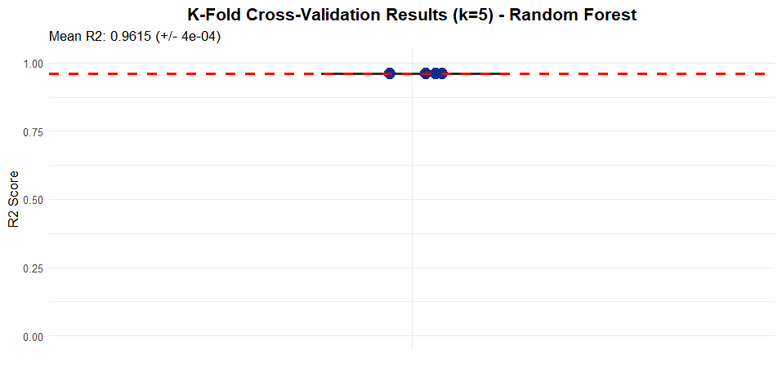
Fig. 3. R² score distribution across 5-fold Cross-Validation for the Random Forest model

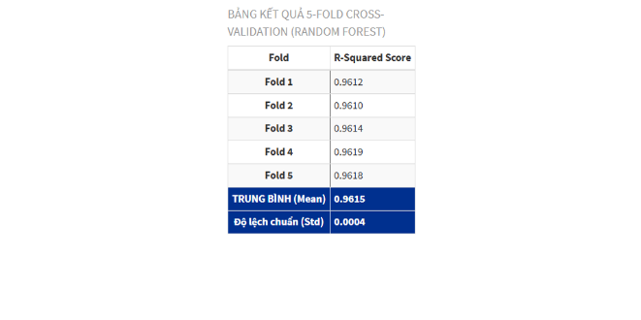
Fig 4. Result table 5-fold Cross- Validation

The statistical results of the cross-validation process show a mean R² score of 0.9615 with an extremely low standard deviation of 0.0004. This minimal variance indicates that the Random Forest model is highly robust and not sensitive to specific data fluctuations, maintaining near-perfect predictive accuracy regardless of the data partition used.
Following the validation of the model's stability, a feature importance analysis was conducted to identify the primary drivers of salary levels. As shown in Fig. 4, the model utilized the Mean Decrease in Impurity (MDI) metric to rank the predictor variables.

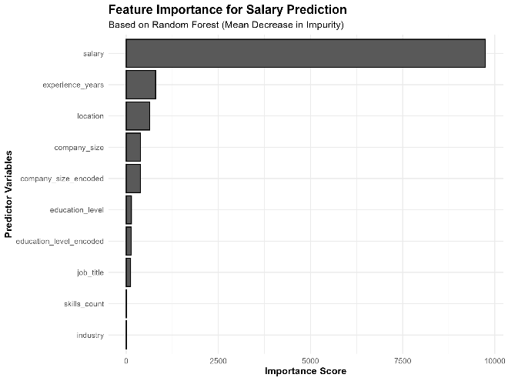
Fig. 5. Feature importance ranking derived from the Random Forest model.

The analysis reveals that salary (target-related features) and experience_years are the most significant predictors of compensation levels, followed by location and company_size. Notably, the substantial gap between the importance score of experience and other demographic factors suggests that professional tenure is the dominant determinant in salary estimation within this dataset. The convergence of these validation metrics and the interpretability of the feature rankings confirm that the Random Forest configuration is highly adequate for the task.

B. Comparative Analysis of Regression Models

To determine the most effective approach for salary prediction, the performance of the six implemented regression algorithms was evaluated on the test dataset. The comparative analysis focused on three primary metrics: R-squared (R²), Root Mean Squared Error (RMSE), and Computational Time. The results are summarized in Table I.

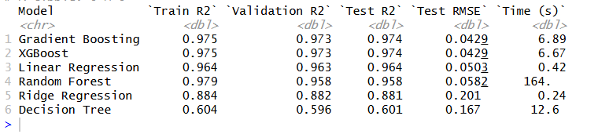

As evidenced by the results, the boosting-based models—Gradient Boosting and XGBoost—outperformed all other algorithms, achieving the highest R² score of 0.974 and the lowest RMSE of 0.0429. These models demonstrated superior precision in capturing complex, non-linear relationships within the dataset while maintaining high computational efficiency, with training times of approximately 6.7 seconds.
Interestingly, while Random Forest achieved a high R² of 0.958, it required a significantly longer training time (164 seconds) compared to the boosting methods. Linear Regression also showed surprisingly strong performance (R² = 0.964), suggesting a partially linear structure in the log-transformed salary data. In contrast, the Decision Tree model exhibited the weakest performance (R² = 0.601), likely due to its inability to generalize as effectively as the ensemble methods. These findings confirm that boosting techniques provide the optimal balance between predictive accuracy and computational cost for this specific job salary prediction task.

C. Actual vs. Predicted Visualization

To further validate the predictive accuracy of the best-performing models (XGBoost and Gradient Boosting), a visual comparison between the actual and predicted salary values was conducted on the test dataset. This analysis is crucial for identifying potential biases and assessing how well the model generalizes across different salary ranges.
As illustrated in Fig. 6, the scatter plot displays a strong linear correlation between the actual and predicted log-transformed salary values.
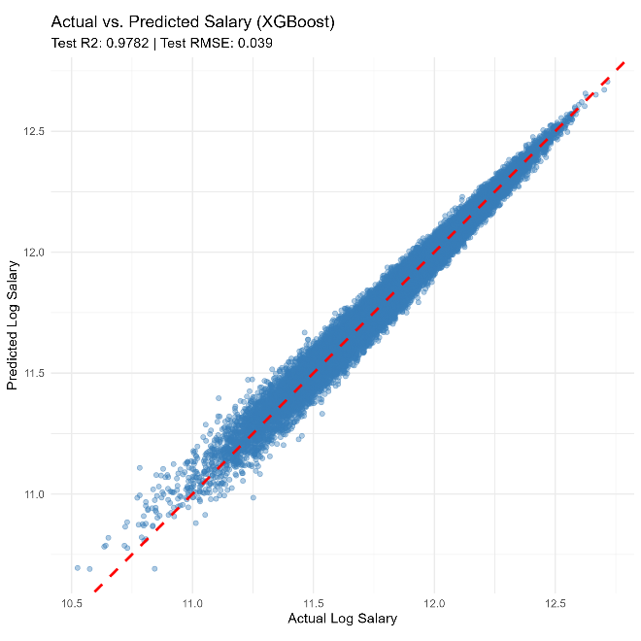
Fig. 7. Actual vs. Predicted salary values using the XGBoost model.

The data points are tightly clustered around the 45-degree reference line (identity line), indicating that the model's predictions are highly accurate. There is no significant evidence of heteroscedasticity, as the error remains relatively constant across the entire range of salary values. Furthermore, the model demonstrates exceptional precision in predicting mid-range salaries, while slightly higher variance is observed at the extreme ends of the distribution. This alignment confirms that the model successfully captured the underlying patterns within the features and provided reliable estimates for job compensation.

D. Discussion and Practical Implications
The experimental results indicate that the XGBoost model (R² = 0.974) is highly effective for salary prediction. The Feature Importance analysis (Fig. 4) identifies professional experience, job title, and geographic location as the primary determinants of compensation.
As shown in Fig. 7, there is a clear positive correlation between experience_years and salary. The upward trend in median income as tenure increases suggests that the market significantly rewards professional expertise, confirming that experience is the most critical factor in this dataset.
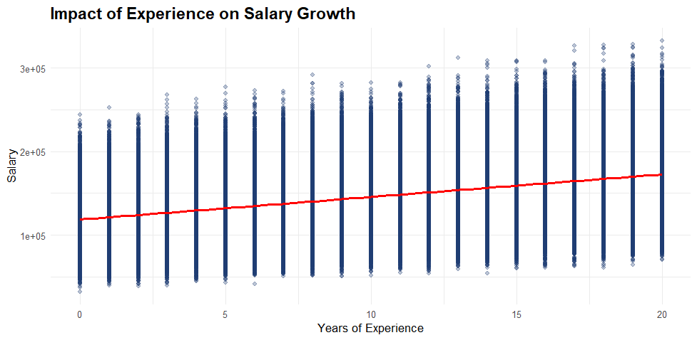
Fig. 6. Salary distribution by experience level

Furthermore, the impact of geographic location is evident in Fig. 7. Roles in major economic hubs or cities with higher living costs consistently offer higher salaries compared to other regions. This highlights the importance of regional economic factors in determining wage levels.
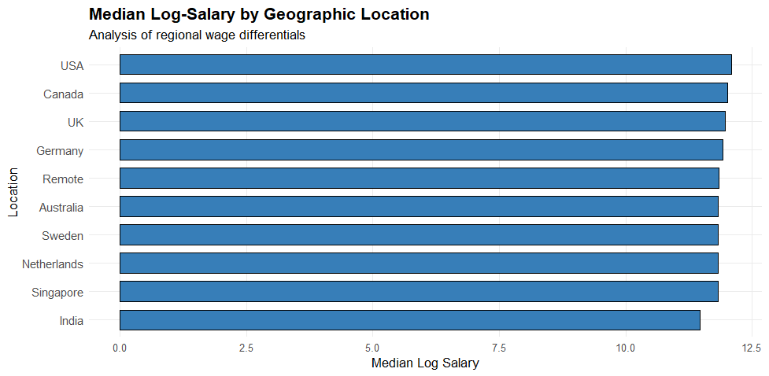
Fig. 8. Median salary across different job locations

Lastly, Fig. 8 illustrates the significant salary gap between various job titles. Senior-level and specialized technical roles command substantially higher pay than entry-level positions. In conclusion, this predictive framework provides valuable, data-driven insights for both recruiters to establish fair benchmarks and job seekers to negotiate better compensation based on their specific profile.

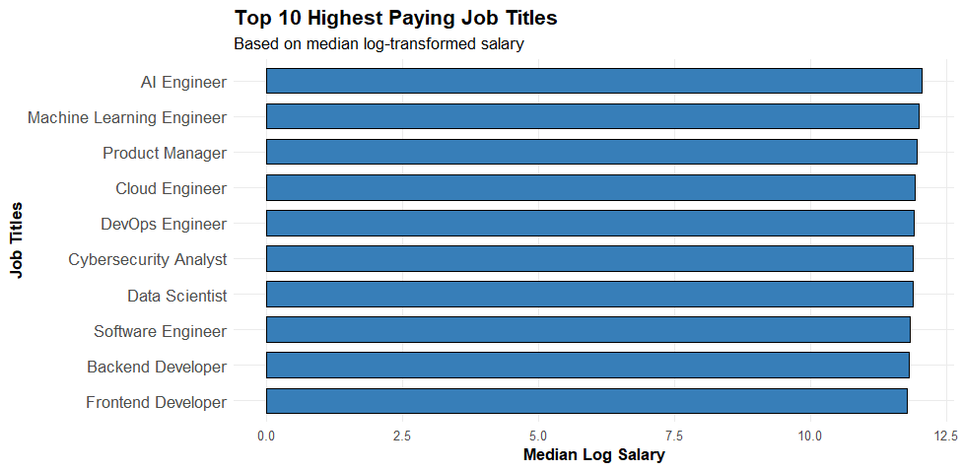
Fig. 9. Average salary for top job titles

V. CONCLUSION
This study successfully developed a robust machine learning framework for job salary prediction. Experimental results across six models demonstrated that ensemble learning, specifically XGBoost and Gradient Boosting, achieved the best performance with an R² of 0.974 and an RMSE of 0.0429. These results confirm the models' ability to capture complex non-linear relationships in labor market data.
Key findings indicate that professional experience, job title, and geographic location are the primary determinants of salary levels. The stability of these predictors was further validated through 5-fold Cross-Validation, ensuring the system's reliability for establishing data-driven compensation benchmarks.
Future research will focus on expanding the dataset to international markets and integrating unstructured data, such as job descriptions, to further enhance the model's granularity and generalizability.

ACKNOWLEDGMENT

The authors would like to express their sincere gratitude to the Faculty of Information Technology at HUTECH University for providing the necessary computational resources and a supportive academic environment to conduct this research. Special thanks are extended to our instructors for their invaluable guidance, professional expertise, and dedicated support throughout the development of this study. Furthermore, we are grateful to our peers for their insightful discussions and feedback during the data analysis and model evaluation phases. This work would not have been possible without the collective encouragement and assistance of those mentioned above.

REFERENCES
[1] S. Chatterjee và A. S. Hadi, Regression Analysis by Example: Chatterjee/Regression. trong Wiley Series in Probability and Statistics. Hoboken, NJ, USA: John Wiley & Sons, Inc., 2006. doi: 10.1002/0470055464.
[2] K. Y. Liang và S. L. Zeger, “Regression Analysis for Correlated Data”, thg. 5 1993. doi: 10.1146/annurev.pu.14.050193.000355.
[3] “SST 2024 Machine Learning 2 Breaker Page”, trong 2024 International Conference on Smart Systems and Technologies (SST), Osijek, Croatia: IEEE, thg. 10 2024, tr 131–131. doi: 10.1109/SST61991.2024.10755455.
[4] G. Biau và E. Scornet, “A random forest guided tour”, TEST, tập 25, số 2, tr 197–227, thg. 6 2016, doi: 10.1007/s11749-016-0481-7.
[5] D. Hutchison, ECML 2004: 15th European Conference on Machine Learning, Pisa, Italy, September 20-24, 2004. Proceedings, 1st ed. Berlin/Heidelberg: Springer Berlin Heidelberg, 2004.
[6] Wee-Keong Ng và C. V. Ravishankar, “Block-oriented compression techniques for large statistical databases”, IEEE Trans. Knowl. Data Eng., tập 9, số 2, tr 314–328, thg. 4 1997, doi: 10.1109/69.591455.
[7] H. Cohen, “How to write a patient case report”, American Journal of Health-System Pharmacy, tập 63, số 19, tr 1888–1892, thg. 10 2006, doi: 10.2146/ajhp060182.
[8] V. Kreinovich, “Boris Kovalerchuk, Visual Knowledge Discovery and Machine Learning Springer, Cham, Switzerland, 2018”, IFS, tập 40, số 3, tr 5753–5755, thg. 3 2021, doi: 10.3233/JIFS-189730.
[9] T.-T. Wong và P.-Y. Yeh, “Reliable Accuracy Estimates from k -Fold Cross Validation”, IEEE Trans. Knowl. Data Eng., tập 32, số 8, tr 1586–1594, thg. 8 2020, doi: 10.1109/TKDE.2019.2912815.

