Title

Author

Date

# Heading 1

## Heading 2

Compact

Compact

# Heading 1

Normal text.

Normal text.

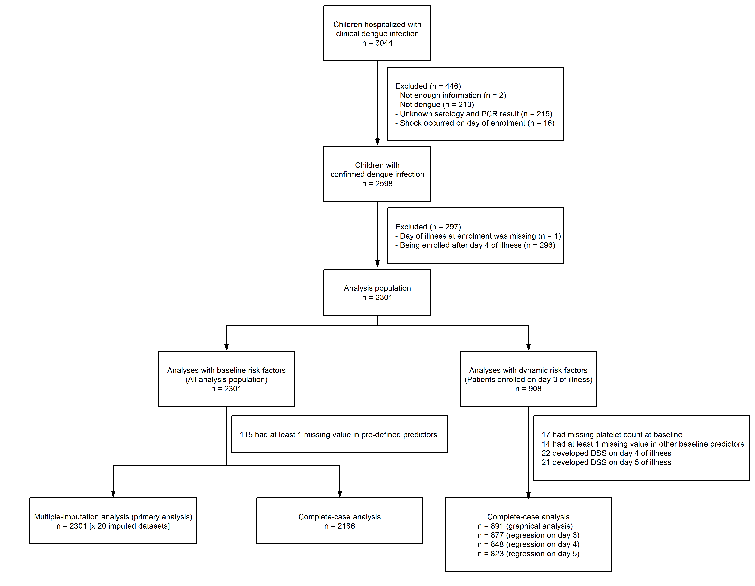

*Figure 1 legend:* Participant flow diagram

Normal text.

Normal text.

|  |  |  |
| --- | --- | --- |
|  |  | All patients (N=2301) |
| Characteristic | n | Summary statistic |
| Age [year] | 2300 | 12 (10, 13) |
| Bleeding during hospitalization | 2288 |  |
| - No |  | 1333 (58%) |
| - Skin |  | 842 (37%) |
| - Mucose |  | 110 (5%) |
| - Other |  | 3 (0%) |
| Platelet nadir [cells/mm³] | 2279 | 65200 (40750, 99000) |
| Day of illness of platelet nadir | 2279 | 6 (5, 7) |
| Maximum haematocrit [%] | 2283 | 44 (41, 47) |
| Day of illness of maximum haematocrit | 2283 | 5 (4, 6) |
| Overall haemoconcentration [%] | 2282 | 13 (6, 22) |

Summary statistic is absolute count (%) for categorical variables and median (IQR) for continuous data.

*Table 1 footnote:* Summary statistics are median (IQR) for continuous variables and frequency (%) for categorical variables

# References

1. World Health Organization. Global strategy for dengue prevention and control 2012-2020. World Health Organization; 2012.

2. Bhatt S, Gething PW, Brady OJ, Messina JP, Farlow AW, Moyes CL, et al. The global distribution and burden of dengue. Nature. Nature Publishing Group; 2013;496: 504–7. doi:[10.1038/nature12060](http://dx.doi.org/10.1038/nature12060)

3. Lam PK, Tam DTH, Diet TV, Tam CT, Tien NTH, Kieu NTT, et al. Clinical characteristics of dengue shock syndrome in Vietnamese children; a 10-year prospective study in a single hospital. Clinical infectious diseases : an official publication of the Infectious Diseases Society of America. 2013;57: 1577–86. doi:[10.1093/cid/cit594](http://dx.doi.org/10.1093/cid/cit594)

4. Bunnag T, Kalayanarooj S. Dengue shock syndrome at the emergency room of Queen Sirikit National Institute of Child Health, Bangkok, Thailand. Journal of the Medical Association of Thailand. 2011;94 Suppl 3: S57–63.