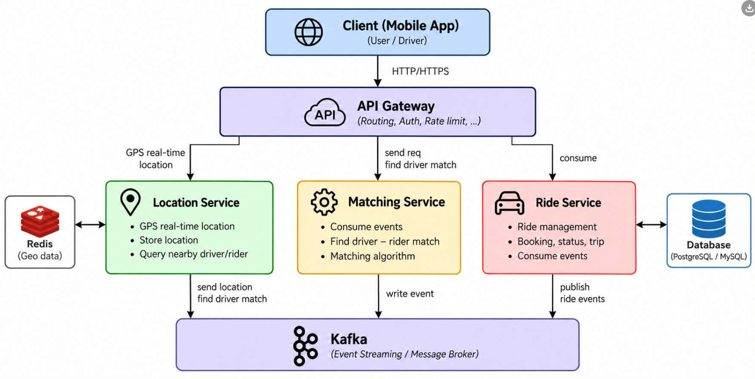

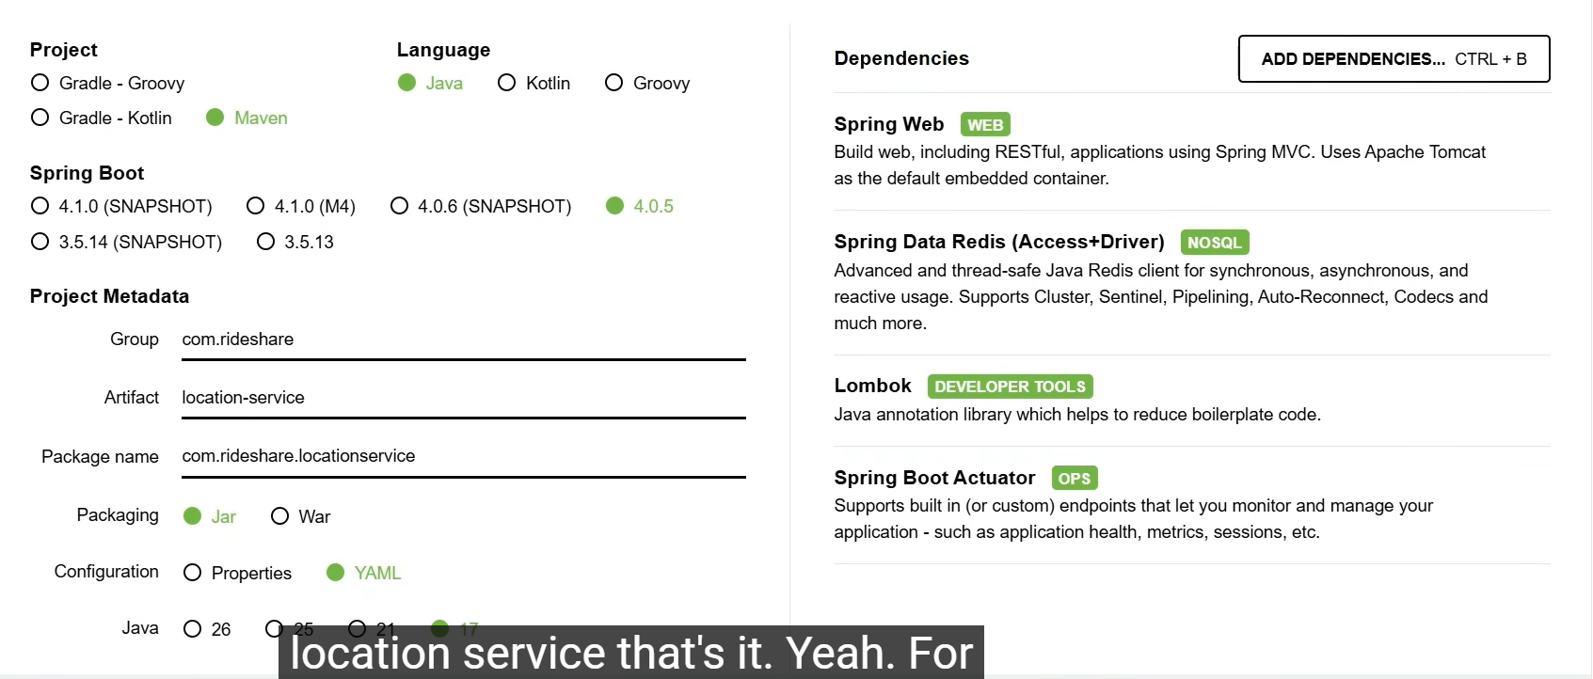

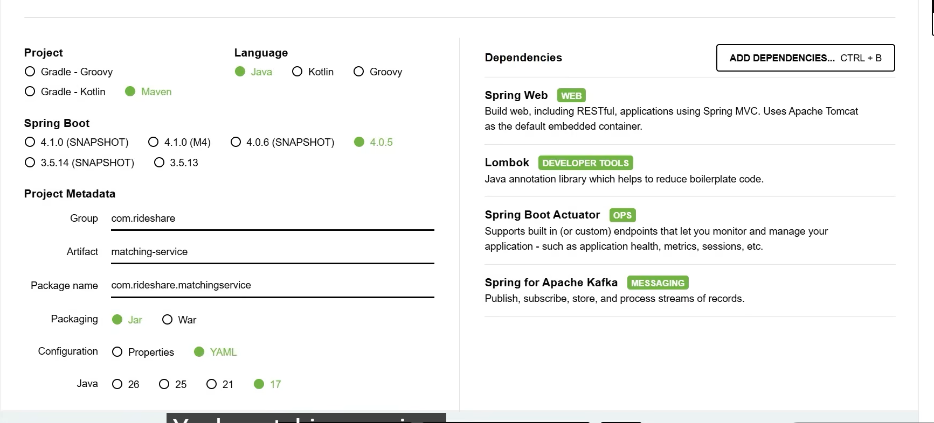

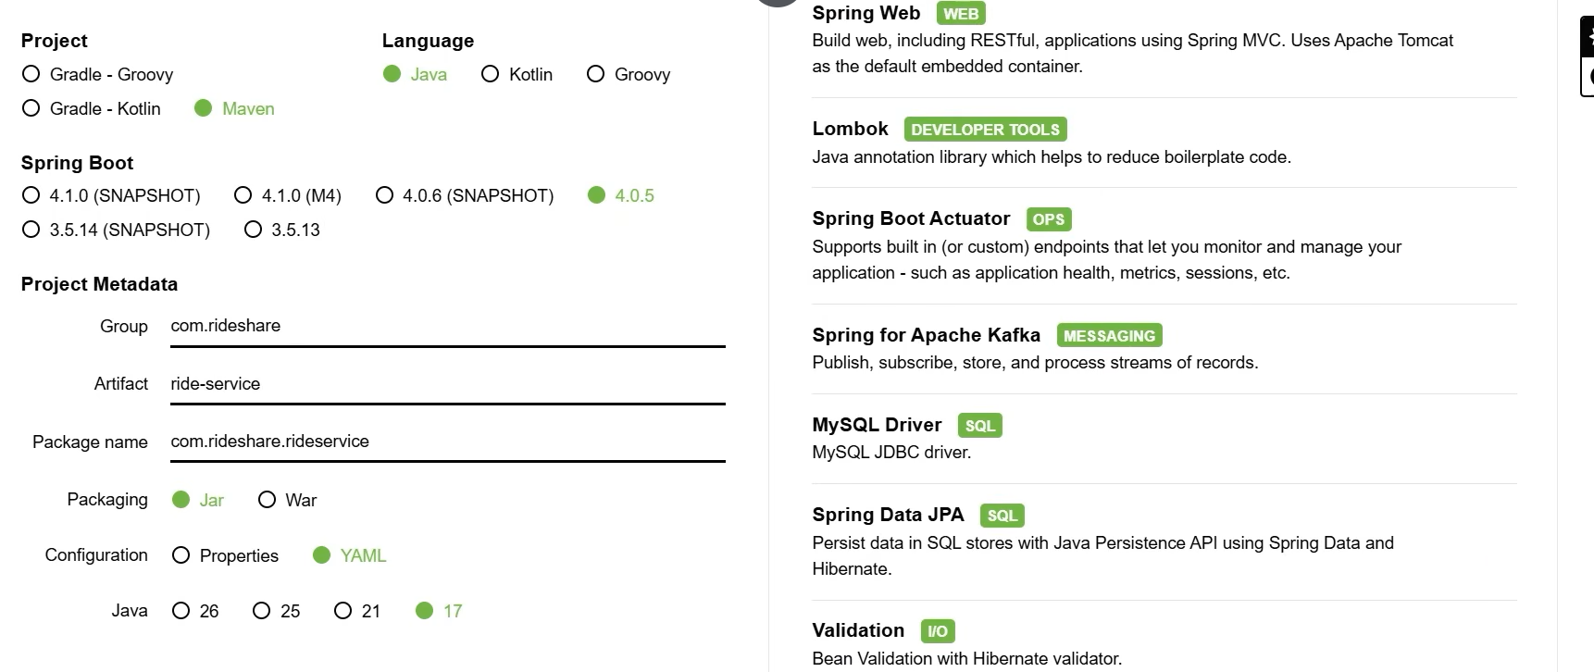
maven muilti project để set up microservice(dạng multi-module)
<?xml version="1.0" encoding="UTF-8"?>
<project xmlns="http://maven.apache.org/POM/4.0.0"
xmlns:xsi="http://www.w3.org/2001/XMLSchema-instance"
xsi:schemaLocation="http://maven.apache.org/POM/4.0.0 http://maven.apache.org/xsd/maven-4.0.0.xsd">
<modelVersion>4.0.0</modelVersion>

<groupId>com.rideshare</groupId>
<artifactId>uber-app</artifactId>
<version>1.0.0</version>
<packaging>pom</packaging>

<modules>
<module>location-service</module>
<module>matching-service</module>
<module>ride-service</module>
</modules>

<properties>
<java.version>17</java.version>
<project.build.sourceEncoding>UTF-8</project.build.sourceEncoding>
</properties>
</project>
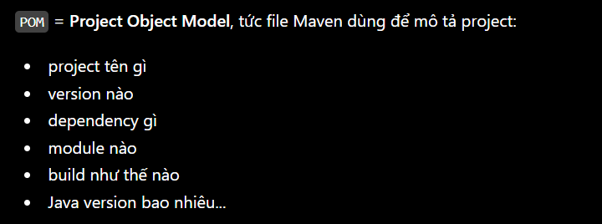
Thông tin về project
