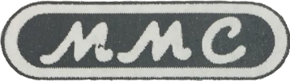

**MMC INTERNATIONAL CORP.**

60 INIP DRIVE, INWOOD, N.Y. 11096-0664

TELEPHONE NO.: (516) 239-7339 / (718) 327-3430

FAX NO. (516) 371-3134

E-MAIL ADDRESS: MMCINWD@AOL.COM

**CERTIFICATE**

**OF**

**STANDARD TEMPERATURE CALIBRATION**

# Owner: DSFSDF

# Certificate No.: 12312-N

Calibrated in Degrees: CELSIUS

Dated Calibrated: 2016-11-01

Model No.: 123123

Function: TRIMODE

Serial No.: 123 Length: 1

Type: NEW

Calibration Method: MMC A-2706-67, (TCP-100)

**STATEMENT**

**OF**

**STANDARD TEMPERATURE CALIBRATION**

This is to certify that the basic steel gauging tape described above, has been 2 point temperature calibrated per MMC’s standard temperature calibration procedure (MMC A-2706-67, (TCP-100)), using thermometers which have been tested to NIST Test No. 255610, and calibrated per MIL-STD-45662A.

Standard Accuracy Tolerance: +/-0.5 degrees F, +/-0.2 degrees C.

For listing of measuring tape linear accuracy and manufacturing standards, see instruction manual supplied with the equipment.

Temperature Calibration by MMC is recommended at twelve-month intervals, with periodic checks being carried out as necessary between these intervals.

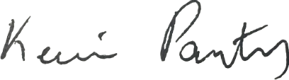

______________________________ __________________________

Authorized Signature: Issue Date:

10/96;11/99 Form No. A-2706-22R

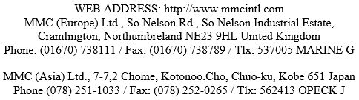Authorized By: F.S. Giannone Revision Level B