Title: 2D Array Data Structure Problem

Date: 12/09/2019

Language: C++

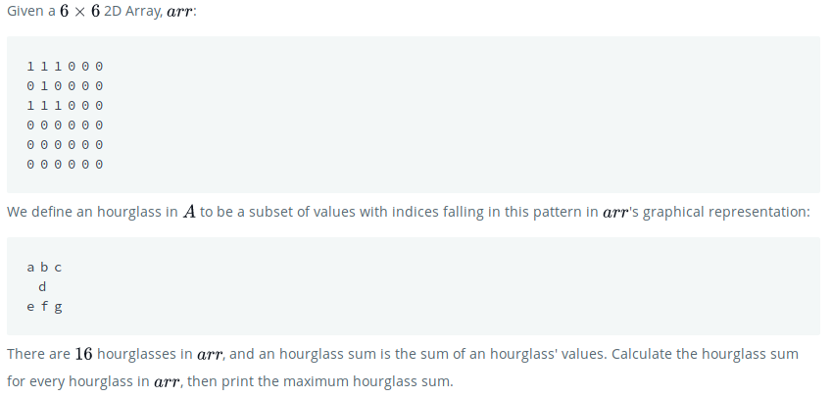
Problem:

Solution:

In our solution we iterate through the array first by row and then by column to calculate hourglass sum. We determine the maximum by comparing the previous known max with the current sum. If our current sum is larger than maxSum, we replace maxSum with current Sum(currSum).

In the example hourglass:

6 5 4
2
4 2 4

We determine the sum by adding

Code:
---------------------------------------------------------------------

int tLeft = arr[row][column]; //Grabbing Top left field
int tMid = arr[row][column+1]; //Grabbing top middle field
int tRight = arr[row][column+2]; //grabbing top right field
int midMid = arr[row+1][column+1]; //grabbing middle middle of hourglass
int bLeft = arr[row+2][column]; //grabbing bottom left field
int bMid = arr[row+2][column+1]; //grabbing bottom middle field
int bRight = arr[row+2][column+2]; //grabbing bottom right field

currSum = tLeft + tMid + tRight + midMid + bLeft + bMid + bRight;

together and placing into the currSum variable we created.

We then determine the maximum value by evaluating currSum with maxSum to determine if currSum is larger than maxSum. If currSum is larger than maxSum, we replace maxSum with currSum and iterate again.

Code:
---------------------------------------------------------------------

if(maxSum=< currSum ){

maxSum = currSum;
}

---------------------------------------------------------------------

We end our solution by returning sMax

Code:

return sMax;

---------------------------------------------------------------------

