**BÀI TẬP THỰC HÀNH 1**

MSSV: 22520743

Họ và tên: Phạm Thành Lam

**Bài 1:**

Code:

|  |
| --- |
| <!-- 22520743 -->  <!DOCTYPE html>  <html lang="en-US">    <head>      <meta charset="UTF-8" />      <meta name="description" content="Dr Eleanor Gaye" />      <title>Email</title>      <link rel="stylesheet" href="style.css" />    </head>    <body>      <div class="info">        <address class="sender-column">          <strong>Dr. Eleanor Gaye</strong><br />          Awesome Science faculty<br />          University of Awesome<br />          Bobtown, CA 99999,<br />          USA <br />          <strong>Tel:</strong> 123-456-7890<br />          <strong>Email:</strong> no_reply@example.com<br />        </address>        <p class="sender-column">          <time datetime="2016-01-20">20 January 2016</time>        </p>      </div>      <address>        <strong>Miss Eileen Dover</strong><br />        4321 Cliff Top Edge<br />        Dover, CT9 XXX<br />        UK<br />      </address>      <h1>Re: Eileen Dover university application</h1>      <p>Dear Eileen,</p>      <p>        Thank you for your recent application to join us at the University of        Awesome's science faculty to study as part of your        <abbr title="Doctor of Philosophy">PhD</abbr> next year. I will answer        your questions one by one, in the following sections.      </p>      <h2>Starting dates</h2>      <p>        We are happy to accommodate you starting your study with us at any time,        however it would suit us better if you could start at the beginning of a        semester; the start dates for each one are as follows:      </p>      <ul>        <li>          First semester: <time datetime="2016-09-09">9 September 2016</time>        </li>        <li>          Second semester: <time datetime="2017-01-15">15 January 2017</time>        </li>        <li>Third semester: <time datetime="2017-05-02">2 May 2017</time></li>      </ul>      <p>        Please let me know if this is ok, and if so which start date you would        prefer.      </p>      <p>        You can find more information about        <a href="https://uit.edu.vn">important university dates</a> on our        website.      </p>      <h2>Subjects of study</h2>      <p>        At the Awesome Science Faculty, we have a pretty open-minded research        facility — as long as the subjects fall somewhere in the realm of science        and technology. You seem like an intelligent, dedicated researcher, and        just the kind of person we'd like to have on our team. Saying that, of the        ideas you submitted we were most intrigued by are as follows, in order of        priority:      </p>      <ol>        <li>          Turning H<sub>2</sub>O into wine, and the health benefits of Resveratrol          (C<sub>14</sub>H<sub>12</sub>O<sub>3</sub>.)        </li>        <li>          Measuring the effect on performance of funk bassplayers at temperatures          exceeding 30°C (86°F), when the audience size exponentially increases          (effect of 3 × 10<sup>3</sup> increasing to 3 × 10<sup>4</sup>.)        </li>        <li>          <abbr title="HyperText Markup Language">HTML</abbr> and          <abbr title="Cascading Style Sheet">CSS</abbr> constructs for          representing musical scores.        </li>      </ol>      <p>        So please can you provide more information on each of these subjects,        including how long you'd expect the research to take, required staff and        other resources, and anything else you think we'd need to know? Thanks.      </p>      <h2>Exotic dance moves</h2>      <p>        Yes, you are right! As part of my post-doctorate work, I        <em>did</em> study exotic tribal dances. To answer your question, my        favourite dances are as follows, with definitions:      </p>      <dl>        <dt>Polynesian chicken dance</dt>        <dd>          A little known but <em>very</em> influential dance dating back as far as          300<abbr title="Before Christ">BC</abbr>, a whole village would dance          around in a circle like chickens, to encourage their livestock to be          "fruitful".        </dd>        <dt>Icelandic brownian shuffle</dt>        <dd>          Before the Icelanders developed fire as a means of getting warm, they          used to practice this dance, which involved huddling close together in a          circle on the floor, and shuffling their bodies around in imperceptibly          tiny, very rapid movements. One of my fellow students used to say that          he thought this dance inspired modern styles such as Twerking.        </dd>        <dt>Arctic robot dance</dt>        <dd>          An interesting example of historic misinformation, English explorers in          the 1960s believed to have discovered a new dance style characterized by          "robotic", stilted movements, being practiced by inhabitants of Northern          Alaska and Canada. Later on however it was discovered that they were          just moving like this because they were really cold.        </dd>      </dl>      <p>        For more of my research, see my        <a href="https://uit.edu.vn">exotic dance research page</a>.      </p>      <p>Yours sincerely,</p>      <p>Dr Eleanor Gaye</p>      <p>        University of Awesome motto: <q>Be awesome to each other.</q>        <cite          >-- The memoirs of Bill S Preston,          <abbr title="Esquire">Esq</abbr></cite        >      </p>    </body>  </html> |

**Screenshot:**

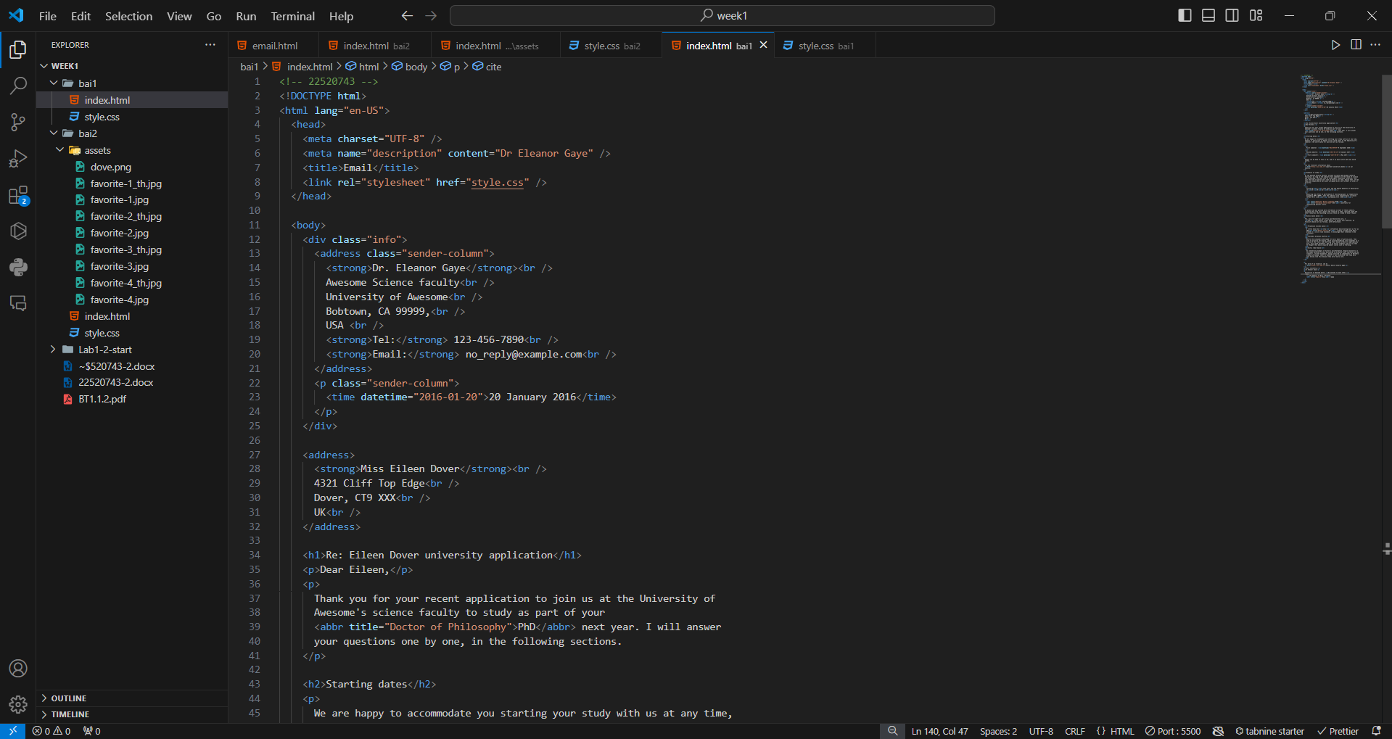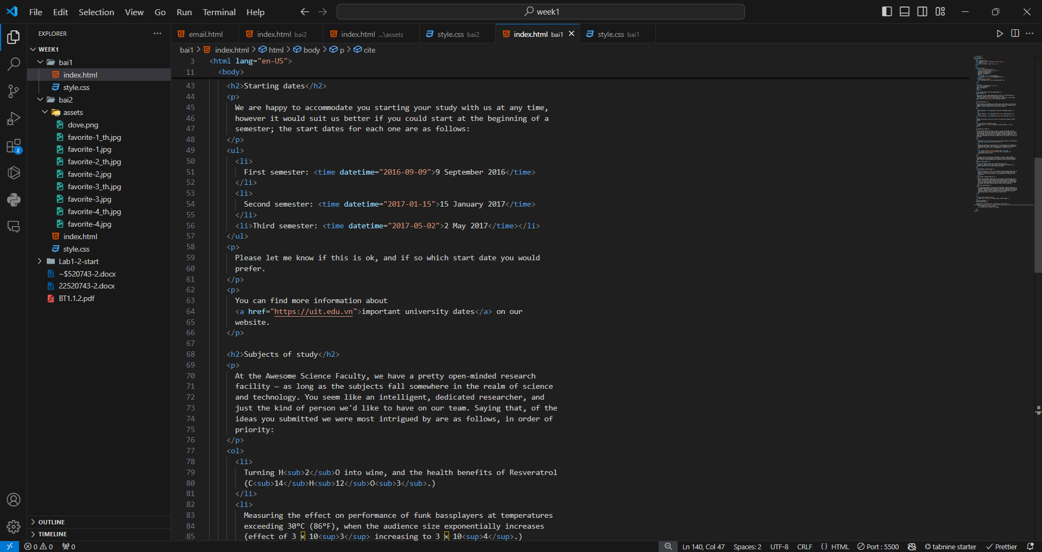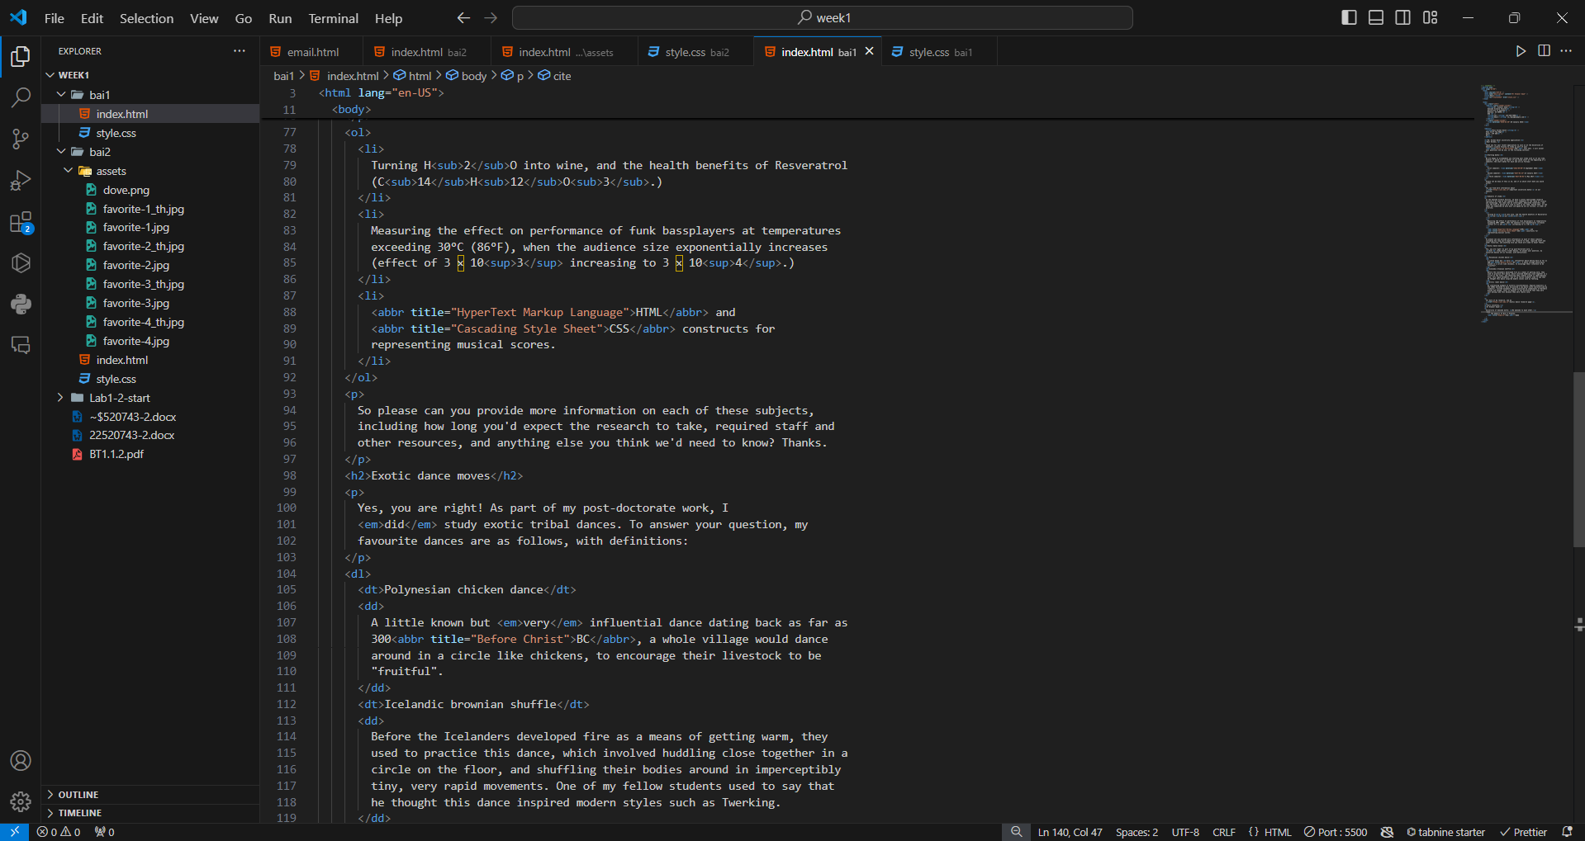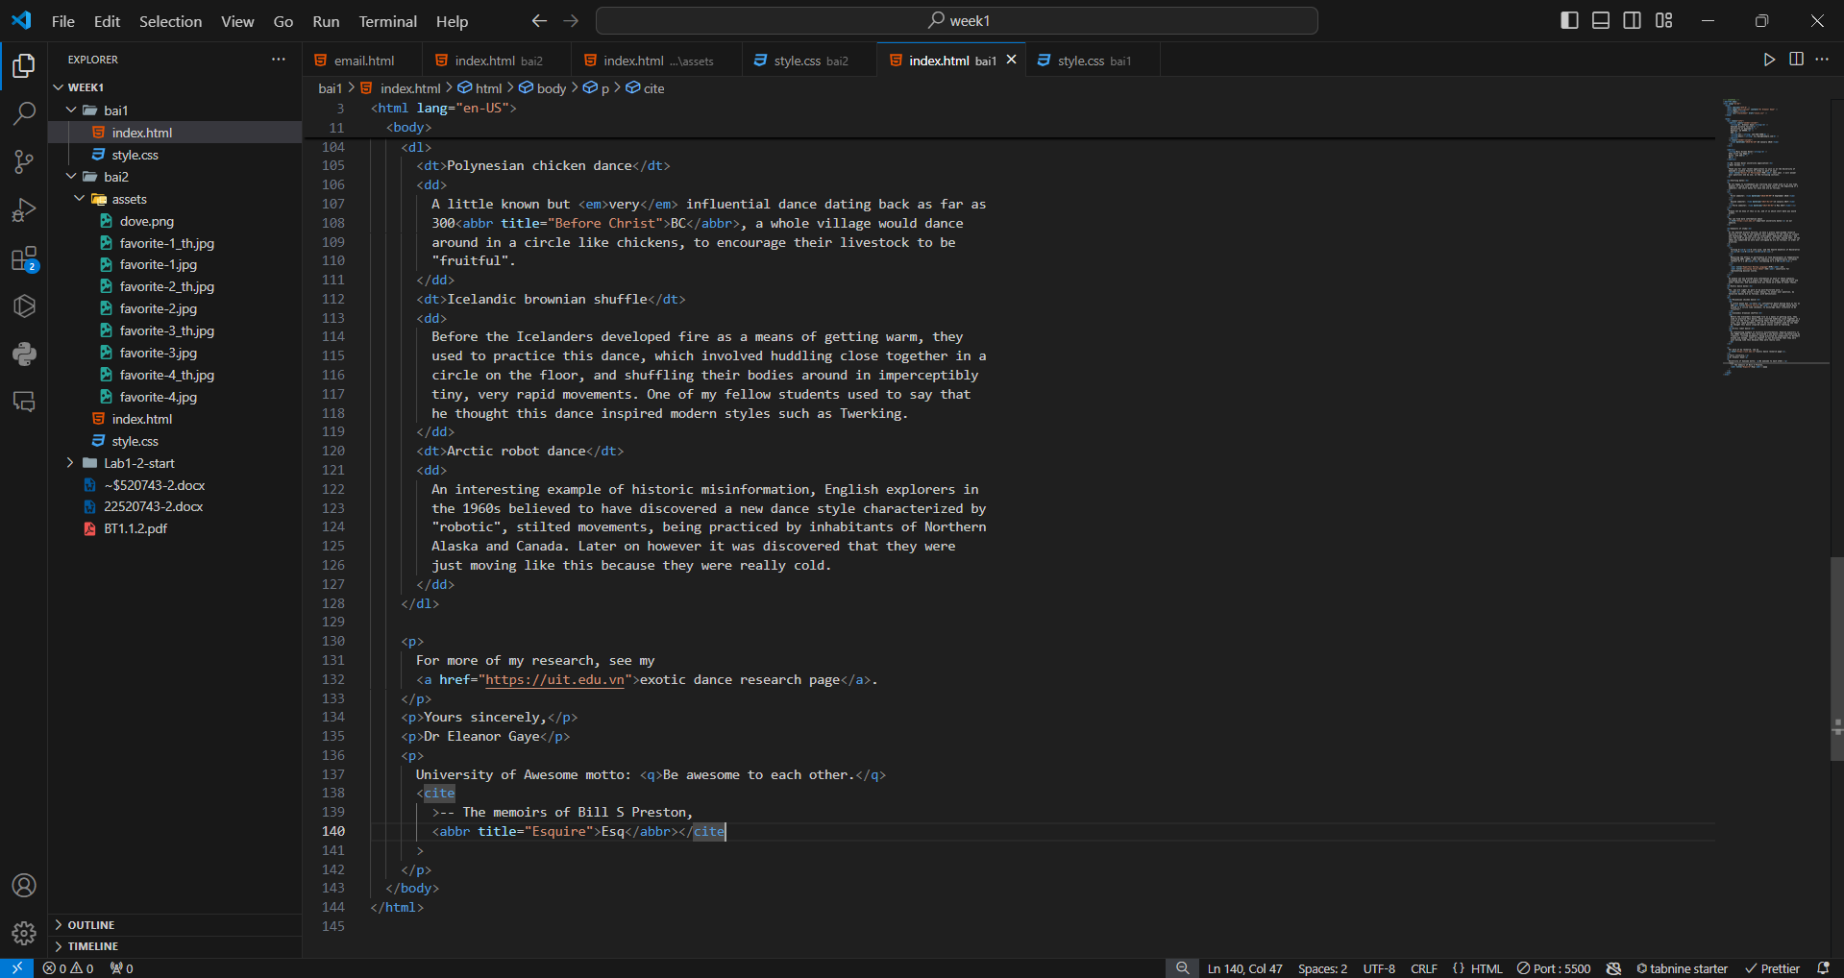

Kết quả:

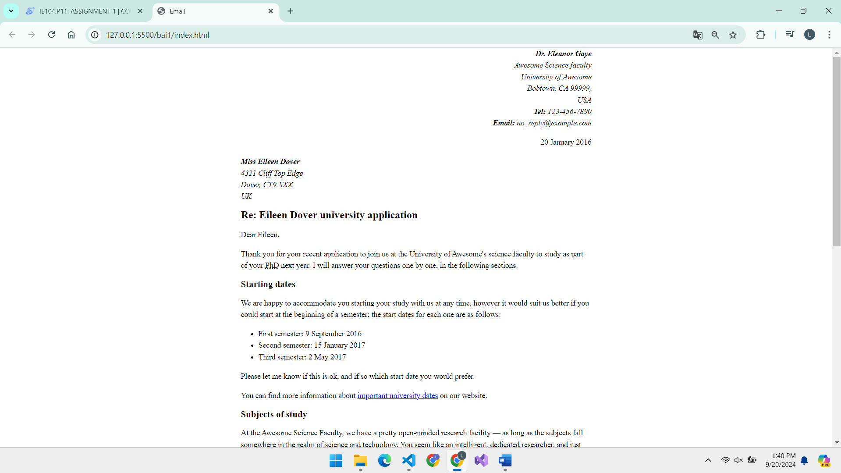

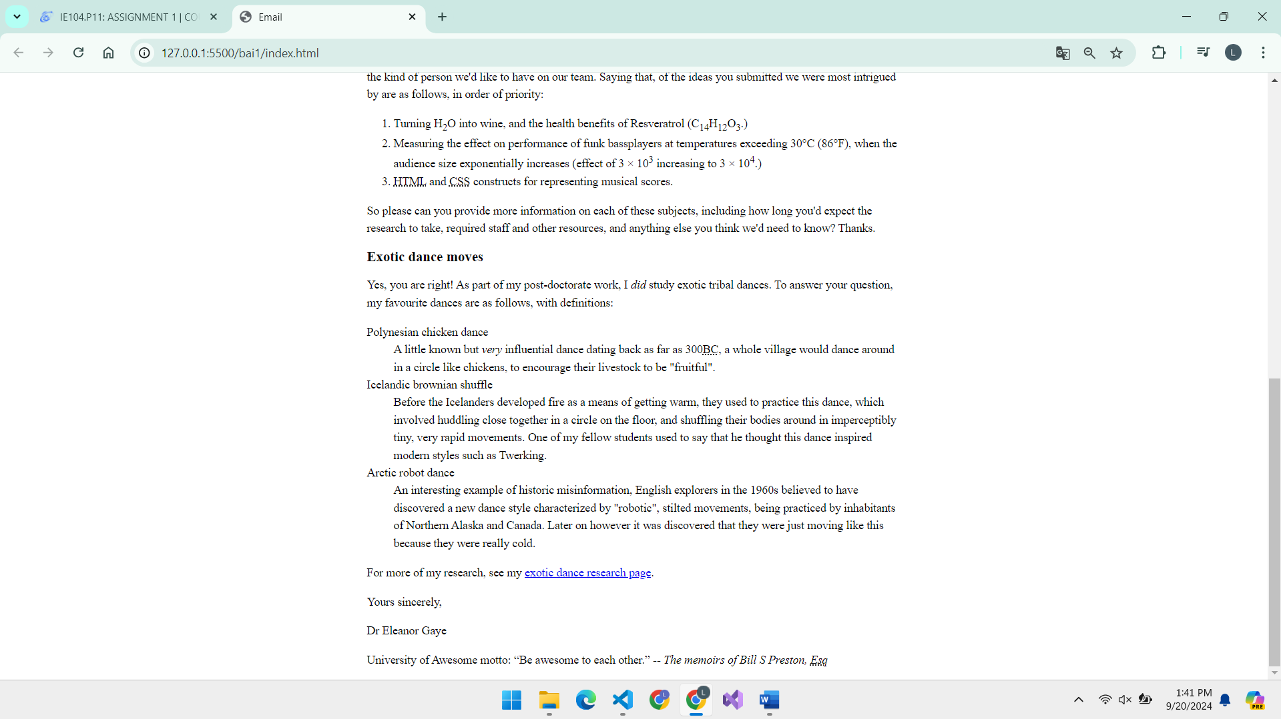

**Bài 2:**

Code:

|  |
| --- |
| <!—22520743 -->  <!DOCTYPE html>  <html lang="en">  <head>    <meta charset="utf-8">    <title>Birdwatching</title>    <link href="https://fonts.googleapis.com/css?family=Roboto+Condensed:300%7CCinzel+Decorative:700" rel="stylesheet">    <link rel="stylesheet" href="style.css">    <!--[if lt IE 9]>        <script src="https://cdnjs.cloudflare.com/ajax/libs/html5shiv/3.7.3/html5shiv.js"></script>      <endif]-->  </head>  <body>    <header>      <h1>Birdwatching</h1>      <img src="./assets/dove.png" alt="a simple dove logo">      <nav>        <ul>          <li><span>Home</span></li>          <li><a href="#">Get started</a></li>          <li><a href="#">Photos</a></li>          <li><a href="#">Gear</a></li>          <li><a href="#">Forum</a></li>        </ul>      </nav>    </header>    <main>      <section>        <h2>Welcome</h2>        <p>Welcome to our fake birdwatching site. If this were a real site, it would be the ideal place to come to learn          more          about birdwatching, whether you are a beginner looking to learn how to get into birding, or an expert wanting to          share ideas, tips, and photos with other like-minded people.</p>          <p>So don't waste time! Get what you need, then turn off that computer and get out into the great outdoors!</p>      </section>      <aside>        <h2>Favourite photos</h2>        <a href="./assets/favorite-1.jpg"><img src="./assets/favorite-1_th.jpg"            alt="Small black bird, black claws, long black slender beak, links to larger version of the image"></a>        <a href="./assets/favorite-2.jpg"><img src="./assets/favorite-2_th.jpg"            alt="Top half of a pretty bird with bright blue plumage on neck, light colored beak, blue headdress, links to larger version of the image"></a>        <a href="./assets/favorite-3.jpg"><img src="./assets/favorite-3_th.jpg"            alt="Top half of a large bird with white plumage, very long curved narrow light colored break, links to larger version of the image"></a>        <a href="./assets/favorite-4.jpg"><img src="./assets/favorite-4_th.jpg"            alt="Large bird, mostly white plumage with black plumage on back and rear, long straight white beak, links to larger version of the image"></a>      </aside>    </main>    <footer>      <p>This fake website example is CC0 — any part of this code may be reused in any way you wish. Original example        written by Chris Mills, 2016.</p>      <p><a href="http://game-icons.net/lorc/originals/dove.html">Dove icon</a> by Lorc.</p>    </footer>  </body>  </html> |

**Screenshort:**

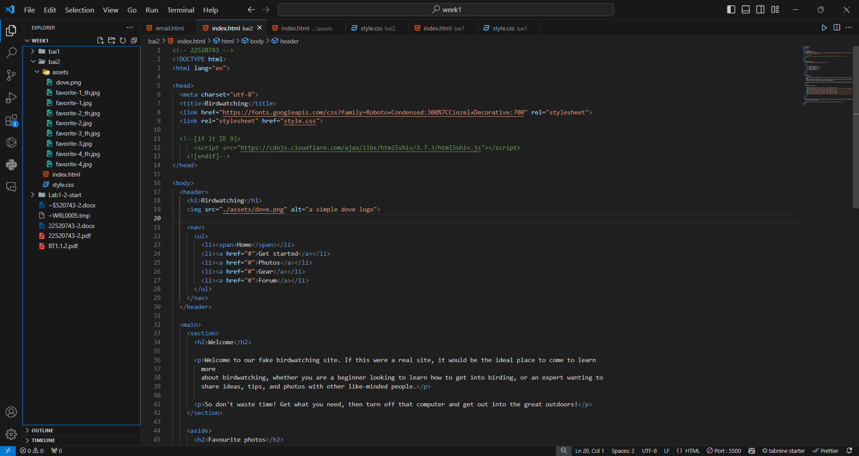

**Kết quả:**

