

CAPSTONE PROJECT REPORT
Report 3 – Software Requirement Specification

– Hanoi, Aug 2026 –
Table of Contents
Change Log 4
Definition and Acronyms 5
I. Overall Requirements 5
1. Context Diagram 5
2. Main Business Flow 5
2.1 Candidate Self-Service (BF-01) 5
2.2 End-to-End Recruitment (BF-02) 5
2.3 Business Flow Name (Code) 6
3. Conceptual Data Model 6
3.1 Entity Relationship Diagram 6
3.2 Entity Descriptions 6
3.3 Data Business Rules 7
4. User Requirements 8
4.1 Actors 8
4.2 Use Cases (UC) 8
4.3 Use Case Diagrams 9
4.4 Permission Matrix 9
5. System Functionalities 10
5.1 Screen Inventory 10
5.2 External API Inventory 10
5.3 Background Job Inventory 11
II. Use Case Specifications 11
1. <<Feature Name1>> 11
1.1 UC Name1 11
1.2 Login System 12
1.3 UC Name2 12
2. Xyz Feature 12
III. Functional Requirements 13
1. Feature Name1 13
1.1 SubFeature Name1.1 13
1.2 SubFeature Name1.2 13
2. User Authentication 13
2.1 User Register 13
2.2 User Login 13
3. System Administration 14
3.1 System Settings 14
3.2 User Management 15
4. Feature NameN 15
5. Background Job Inventory 15
5.1 Unlock Expired Locked Accounts (JOB-01) 15
5.2 Clean Up Old Audit Log Entries (JOB-02) 15
6. External API Inventory 16
6.1 HTTP Method: URL pattern (API-ID) 16
6.2 VnPay Webhook (API-02) 16
6.3 SePay Webhook (API-03) 16
IV. Non-Functional Requirements 16
1. External Interfaces 16
2. Quality Attributes 16
2.1 Usability 16
2.2 Performance 17
2.3 Security 17
V. Requirement Appendix 17
1. Business Rules 17
2. System Messages 18
3. Other Requirements 18

Change Log
Date | A*  M, D | In charge | Change Description
*A - Added M - Modified D - Deleted

Definition and Acronyms
[Fill all the definitions, acronyms,… used within the whole project in the table format as below]
Acronym | Definition
COS | Cafeteria Ordering System
…

I. Overall Requirements

1. Context Diagram
[Provides the overall description about the product with some introduction and the context diagram]
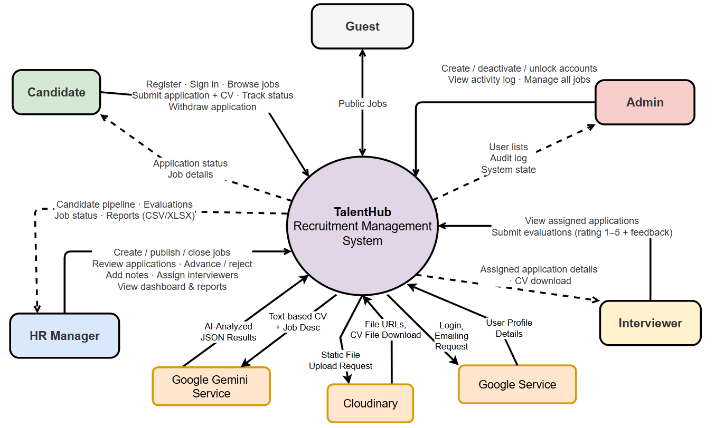

2. Main Business Flow
[List all flows with swimlane diagrams as samples below].

2.1 Candidate Self-Service (BF-01)
Trigger: Candidate creates an account.
End condition: Candidate has seen the final outcome of all applications.
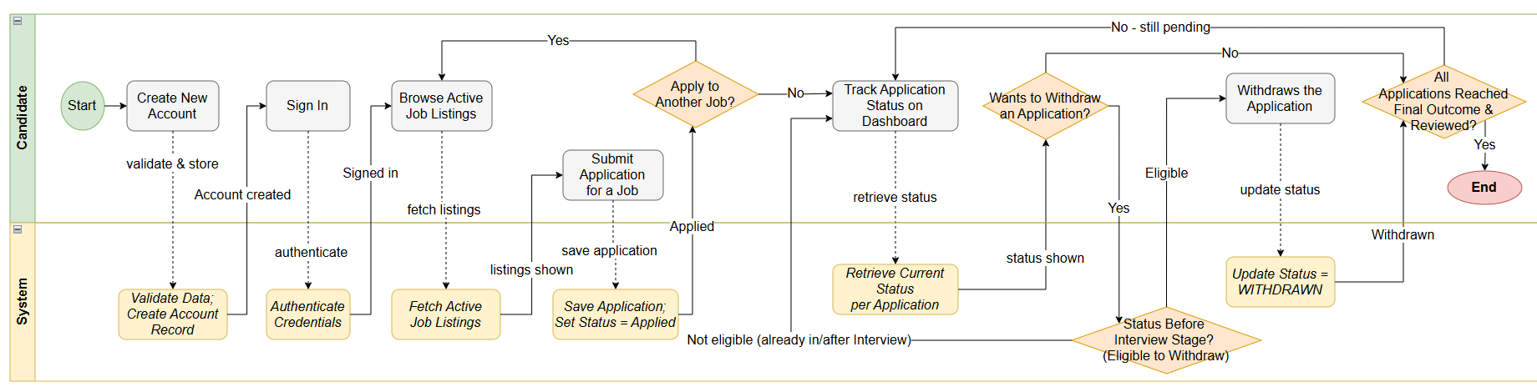

2.2 End-to-End Recruitment (BF-02)
Trigger: HR Manager decides to open a new position and creates a job posting.
End condition: Candidate status reaches HIRED or REJECTED (both terminal).

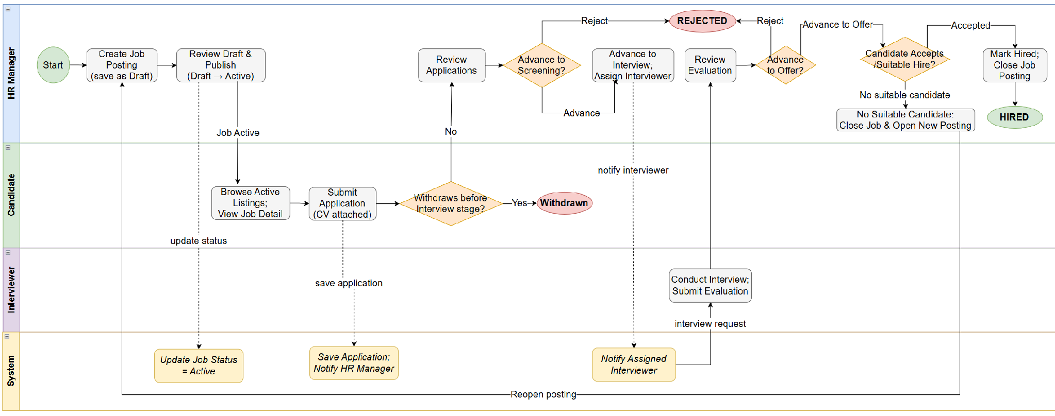

2.3 Business Flow Name (Code)
…

3. Conceptual Data Model

3.1 Entity Relationship Diagram
[Provide the ERD using the Crow-Foot notation and the entity descriptions as below. Relationship labels are business verb-ing]
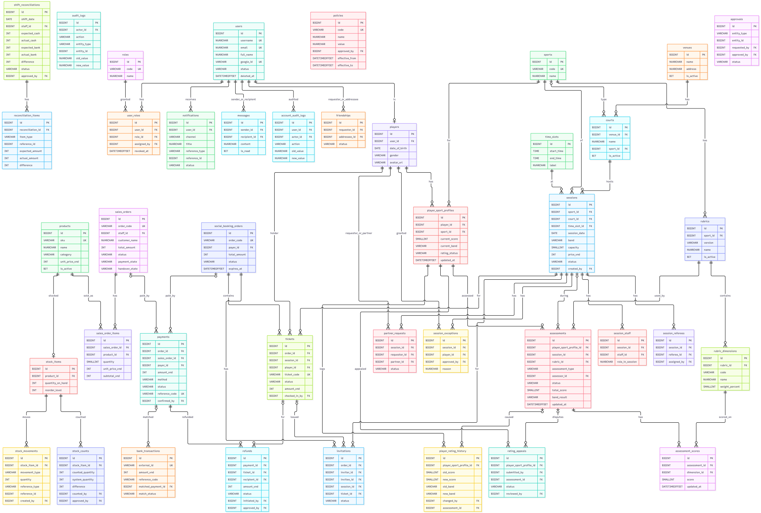

3.2 Entity Descriptions
[Provide one block per entity with descriptions and key business attributes only.]

Num | Entity | Description
1 | Role | Stores the six fixed system roles: Owner, Manager, System Admin, Staff, Referee, and Player.
2 | User | Stores all system accounts except Guest. Includes username, email, full name, Google ID, and account status.
3 | User Role | Links a user to one assigned role. Supports revocation while preserving assignment history.
4 | Account Audit Log | Records every change made to an account, including actor, action, old and new values, and reason.
5 | Sport | Stores the two supported sports: badminton and pickleball.
6 | Player | Stores additional information for users with the Player role, such as date of birth, gender, and avatar.
7 | Player Sport Profile | Stores a player's current score, band, and rating status for one sport. Separate profile per sport.
8 | Player Rating History | Records every change to a player's rating, including old and new values, reason, assessor, and linked assessment.
9 | Rubric | Stores a versioned skill assessment rubric for one sport. Only one active rubric per sport.
10 | Rubric Dimension | Stores each dimension within a rubric, including code, name, weight percentage, and description.
11 | Assessment | Stores one skill assessment event for a player, including type, assessor, rubric version, total score, and band result.
12 | Assessment Score | Stores the score and evidence for each rubric dimension within an assessment.
13 | Rating Appeal | Stores a player's disputed-rating request, including reason, evidence, reviewer, and resolution status.
14 | Venue | Stores the physical venue information. Currently only TK Sport is supported.
15 | Court | Stores each court within a venue, including supported sport and operating status.
16 | Time Slot | Stores the three fixed two-hour operating periods: 16:00–18:00, 18:00–20:00, and 20:00–22:00.
17 | Session | Stores one bookable social session with sport, court, date, time slot, band, capacity, price, and status.
18 | Session Referee | Links a referee to a session. One session may have multiple referees.
19 | Session Staff | Links a staff member to a session with a role such as check-in, sales, or support.
20 | Session Exception | Records a referee-approved exception allowing a player outside the session's band to join. Does not change the player's rating.
21 | Social Booking Order | Stores a participation-charge order for one or more players. Contains only social tickets, not goods.
22 | Ticket | Stores one player's place in a session. Becomes a valid ticket only after payment and entry checks pass.
23 | Invitation | Stores a friend invitation to a session, including inviter, invitee, payment choice, and response status.
24 | Partner Request | Stores a player's request to play with a specific partner in a shared session. Referee decides actual rotation.
25 | Payment | Stores one payment transaction for either a Social Booking Order or a Sales Order. Uses a unique reference code.
26 | Bank Transaction | Stores an authenticated incoming transaction event from the bank integration, including match status and raw payload.
27 | Refund | Stores a refund for an affected future ticket. Includes original payer, reason, approval, and completion status.
28 | Product | Stores goods sold at the counter, including SKU, name, category, and unit price.
29 | Sales Order | Stores a goods-only order created by Staff at the venue. Payment and handover states are independent.
30 | Sales Order Item | Stores one product line within a Sales Order, including quantity, unit price, and subtotal.
31 | Stock Item | Stores the current on-hand quantity and reorder level for one product.
32 | Stock Movement | Records every stock change: receipt, allocation, usage, return, adjustment, or count. Append-only.
33 | Stock Count | Records a physical stock count, including counted quantity, system quantity, difference, and approver.
34 | Shift Reconciliation | Records a staff shift reconciliation with expected and actual cash and bank amounts, and approval status.
35 | Reconciliation Item | Stores one discrepancy line within a shift reconciliation, including type, expected, actual, and difference.
36 | Policy | Stores an Owner-approved business policy such as cancellation, refund, or hold duration, with effective dates.
…

4. User Requirements

4.1 Actors
[An actor is someone/something that interacts with the system.
- The only external entities that interact with the system
- ﻿Actors are outside the system and not part of it
- ﻿A user is an individual, whereas an actor represents the role played by all users of the same type
- There are other types of actors in addition to or in place of human actors: external systems, I/O devices, or timers
Following are some questions you might ask to help user representatives identify actors
- Who (or what) is notified when something occurs within the system?
- Who (or what) provides information or services to the system?
- Who (or what) helps the system respond to and complete a task?
This part gives the description of system actors, you can follow the table form as below]
# | Actor | Description
1 | Guest | Unauthenticated visitor who registers for a Player account, signs in, or requests account recovery.
2 | Player | Registered participant who manages profiles, books sessions, pays, views tickets and refunds, and uses community features.
3 | Referee | Approved on-court organizer who records attendance, assessments, skill exceptions, and supply requests.
4 | Staff | Operational employee who handles counter sales, stock, payment exceptions, repayments, and shift reconciliation.
5 | Manager | Venue operator who manages sessions, personnel, disputed ratings, and business exceptions within Owner policy.
6 | Owner | Court owner who approves policies, prices, and Manager appointments, and reviews business summaries.
7 | System Admin | Technical operator who provisions accounts, maintains integrations, handles incidents, and performs access handover.
8 | External Services | Bank/Payment Service, Google OAuth, Cloudinary, Firebase, and Email Service exchange

4.2 Use Cases (UC)
[A use case (UC) describes a sequence of interactions between a system and an external actor that results in the actor being able to achieve some outcome of value. The names of use cases are always written in the form of a verb followed by an object. Select strong, descriptive names to make it evident from the name that the use case will deliver something valuable for some user.
Following are some questions you might ask to help user representatives identify use cases
- What will the actor use the system for?
- Will the actor create, store, change, remove, or read data in the system?
- Will the actor need to inform the system about external events or changes?
- Will the actor need to be informed about certain occurrences in the system?
This part describes the use cases following the form of the table as below]
ID | Use Case | Feature | Use Case Description
UC-01 | Register Player account | Common | The guest creates a Player account using local credentials or Google OAuth. The system assigns the Player role only.
UC-02 | Sign in | Common | The guest authenticates with a local account or verified Google identity and enters the workspace of the account's approved role. Includes sign out and password reset.
UC-03 | View own profile | Profile | The player views permitted personal information and the separate sport profile for each sport.
UC-04 | Update own profile | Profile | The player updates permitted personal fields and profile image without changing role or verified skill results.
UC-05 | Complete sport survey | Skill Assessment | The player answers a sport-specific questionnaire and receives a labelled provisional level.
UC-06 | Find suitable session | Session Discovery | The player searches available sessions by sport and date and receives eligibility-based suggestions.
UC-07 | Register for session | Session Registration | The player requests a timed place hold after eligibility and capacity checks. Includes Check registration eligibility (UC-32).
UC-08 | Invite eligible friends | Session Registration | The player selects accepted friends who meet the session conditions and sends separate invitations. An invitation alone does not reserve a place.
UC-09 | Pay for own registration | Social Payments | The player pays for their own accepted place using the social order reference and receives a confirmed ticket after bank verification.
UC-10 | Pay for accepted friends | Social Payments | The payer transfers money for accepted friend registrations. Each friend's ticket is confirmed separately.
UC-11 | View own tickets and payments | Social Payments | The player views issued tickets, their validity, and authorized payment records including payments made for friends.
UC-12 | Request rating review | Skill Assessment | The player submits a disputed-rating review request with a reason. Extends Resolve rating review (UC-28).
UC-13 | Manage friendships and messages | Community | The player searches member-visible profiles, manages friend requests, and exchanges direct messages with accepted friends.
UC-14 | View assigned session roster | Session Operations | The assigned referee views confirmed participants and admission information for sessions assigned to them.
UC-15 | Record player attendance | Session Operations | The referee verifies the named ticket holder and records attendance once. Manager may support the process.
UC-16 | Record on-court assessment | Skill Assessment | The referee records observed skills and internal evidence for an attending player using the active rubric version.
UC-17 | Review skill progress | Skill Assessment | The referee views assessment history and proposes a band change when supported by two separate observations.
UC-18 | Request session supplies | Session Supplies | The assigned referee requests items and quantities for a specific session from the venue's stock.
UC-19 | Create counter order | Counter Sales | The staff creates a goods-only order with fixed prices, stock reservation, and a payment reference separate from social bookings.
UC-20 | Confirm payment and handover | Counter Sales | The staff records verified payment and separately records physical goods handover. Payment and delivery states remain independent.
UC-21 | Manage stock and session supplies | Stock | The staff records receipts, issues supplies to a session, records use and unused returns, and performs physical counts.
UC-22 | Reconcile and handover shift | Reconciliation | The staff prepares a shift reconciliation showing separate social receipts, goods receipts, refunds, and unresolved differences.
UC-23 | Process eligible ticket repayment | Social Payments | The staff processes a refund for an affected future ticket and records verified repayment evidence.
UC-24 | Review payment exceptions | Social Payments | The staff investigates unmatched, partial, late, or surplus transfers and records a supported resolution proposal.
UC-25 | Create and publish session | Session Management | The manager creates and publishes a court session with sport, time, skill conditions, capacity, and an approved price.
UC-26 | Assign Referees and Staff | Session Management | The manager assigns approved Referees and Staff to sessions without overlapping assignments.
UC-27 | Decide skill exception | Skill Assessment | The manager or assigned referee approves or rejects a session-specific skill exception with a reason. Approval does not change the player's rating.
UC-28 | Resolve rating review | Skill Assessment | The manager reviews Referee evidence and decides to keep or correct a disputed rating. The decision is final.
UC-29 | Correct disputed rating | Skill Assessment | The manager records a corrected result with reason and evidence, preserving the previous published value.
UC-30 | Approve business adjustment | Business Reporting | The manager approves or rejects an evidenced money or stock adjustment within Owner-approved policy.
UC-31 | View operations and trial feedback | Business Reporting | The manager reviews session records, payment states, and trial feedback for the pilot report.
UC-32 | Approve business policy and price | Business Policy | The owner approves business policies, ticket prices, and product prices without rewriting paid-order prices.
UC-33 | Approve Manager appointment | Business Policy | The owner approves a named person's Manager appointment and its business scope.
UC-34 | View business summary | Business Reporting | The owner views recorded social receipts, goods receipts, refunds, and supplies as separate summaries.
UC-35 | Manage role accounts and access | Technical Administration | The system admin provisions approved role accounts and implements authorized access changes while preserving history.
UC-36 | Configure system and hand over access | Technical Administration | The system admin maintains settings, investigates incidents through masked logs, retries stored events, and hands over access to a separate account.
UC-37 | Integrate external services | Common | Bank/Payment Service sends authenticated transaction events; Google OAuth returns verified sign-in identities; Cloudinary, Firebase, and Email Service exchange authorized data.
…

4.3 Use Case Diagrams
In this section, you need to provide the UC diagram(s) to show the actor-UCs and UC-UC relationships like the sample below. You can have multiple UC diagrams for the system, each diagram is for one human actor or one workflow]

4.3.1 UCs for Guest
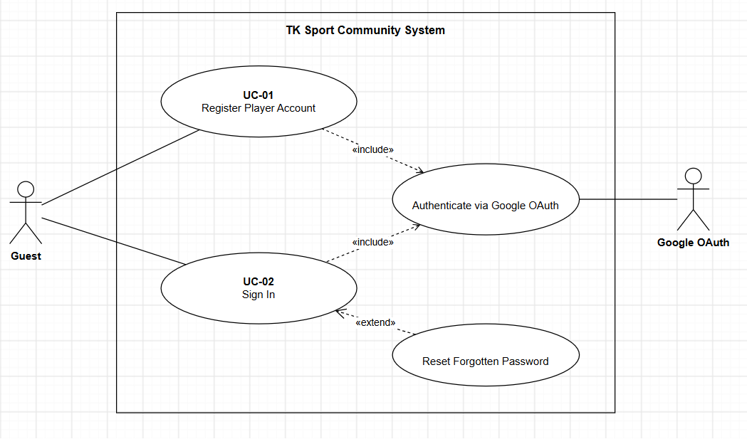

4.3.4 UCs for Staff
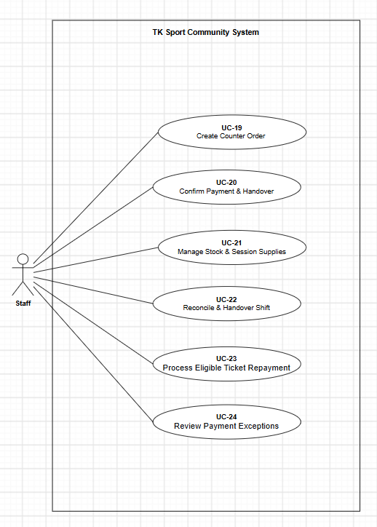

4.3.3 …

5. System Functionalities
[Provide functionality overview of software system]

5.1 Screen Inventory

a. Screen Flow
[This part shows the system screens and the relationship among screens – see sample below]
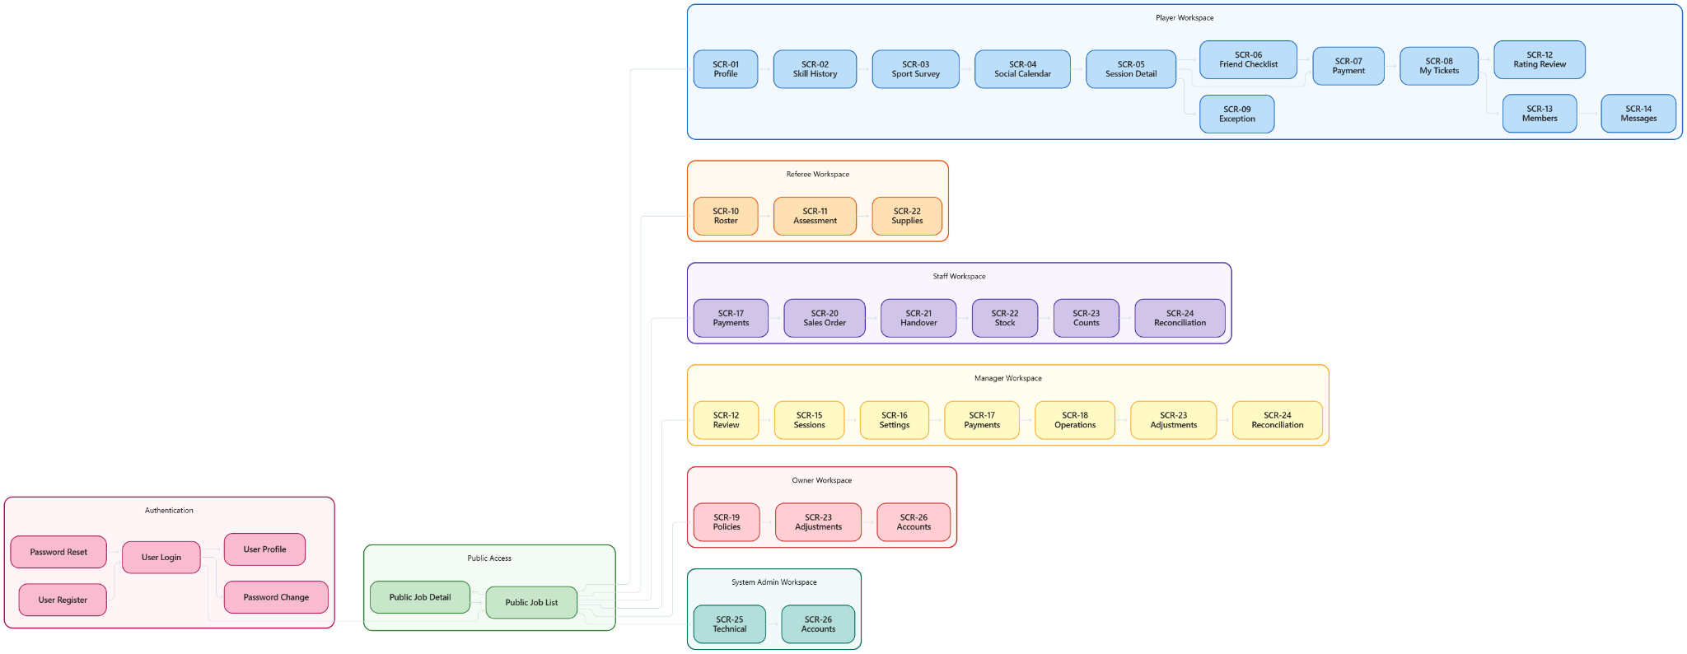

b. Screen List
[Fill details of each screen into the table with the columns and sample data as below]
# | Screen Name | Feature | Description
1 | Sign In | Authentication | Allows any registered user to authenticate and reach their role-specific workspace.
2 | User Register | Authentication | Allows a new Guest to create a Player account using local credentials or Google OAuth.
3 | Password Reset | Authentication | Allows a Guest or account holder to request and set a new password through a verified email link.
4 | My Profile | Profile | Allows a Player to view personal information and the separate sport profile for each sport.
5 | Update Profile | Profile | Allows a Player to update permitted personal fields and profile image without changing role or verified skill results.
6 | Sport Survey | Skill Assessment | Allows a Player to answer a sport-specific questionnaire and receive a provisional level.
7 | Social Calendar | Session Discovery | Allows a Player to search open sessions by sport and date and view eligibility-based suggestions.
8 | Session Details | Session Discovery | Allows a Player to view court, time, skill band, price, participants, and available places.
9 | Friend Checklist | Session Registration | Allows a Player to select eligible friends, choose a payment mode, and send separate invitations.
10 | Payment Instructions | Social Payments | Allows a Player to view the unique order reference, bank details, exact amount, and payment deadline.
11 | My Tickets | Social Payments | Allows a Player to view issued tickets, their validity, and the refund status of affected tickets.
12 | Skill Exception Request | Skill Assessment | Allows a Player to request permission to join a session outside their normal skill band.
13 | Rating Review | Skill Assessment | Allows a Player to submit a disputed-rating review request and view the outcome summary.
14 | Members | Community | Allows a Player to search member-visible profiles and send or respond to friend requests.
15 | Messages | Community | Allows a Player to exchange direct messages with accepted friends and manage partner preferences.
16 | Assigned Roster | Session Operations | Allows a Referee to view confirmed participants and admission information for assigned sessions.
17 | Assessment Form | Skill Assessment | Allows an assigned Referee to record observed skills and internal evidence using the active rubric.
18 | Publish Result | Skill Assessment | Allows an authorized Referee to publish a supported assessment and update the player's sport profile.
19 | Session Management | Session Management | Allows a Manager to create, update, publish, and close a court session with approved conditions.
20 | Sport Assessment Settings | Skill Assessment | Allows a Manager to maintain versioned sport criteria, bands, and scoring rules.
21 | Payments and Refunds | Social Payments | Allows Staff and Manager to review unmatched transfers, confirm payments, and process eligible refunds.
22 | Skill Exception Decision | Skill Assessment | Allows an assigned Referee or Manager to approve or reject a session-specific skill exception.
23 | Rating Review Decision | Skill Assessment | Allows a Manager to review Referee evidence and decide to keep or correct a disputed rating.
24 | Operations and Trial Feedback | Business Reporting | Allows a Manager to review session records, payment states, and record trial feedback.
25 | Business Policies | Business Policy | Allows an Owner to approve business policies, ticket prices, and product prices with effective dates.
26 | Appointments | Business Policy | Allows an Owner to approve Manager appointments and a Manager to approve Staff or Referee appointments.
27 | Business Summary | Business Reporting | Allows an Owner to view recorded social receipts, goods receipts, refunds, and supplies as separate summaries.
28 | Counter Sales Order | Counter Sales | Allows Staff to create a goods-only Sales Order with fixed prices, stock reservation, and a unique payment reference.
29 | Sales Payment and Handover | Counter Sales | Allows Staff to record verified payment and separately record physical goods handover.
30 | Stock and Session Supplies | Stock | Allows Staff to record stock receipts, issue supplies to a session, and record use and unused returns.
31 | Counts and Adjustments | Stock | Allows Staff to submit a stock count and a proposed adjustment for Manager or Owner review.
32 | Shift Reconciliation | Reconciliation | Allows Staff to prepare a shift reconciliation with separate social, goods, refund, and unresolved totals.

II. Use Case Specifications
[Provide specifications for the use cases (UCs) those are covered in the system. The UCs are grouped by the system features and even sub features. You just need to provide UC specifications for UCs involving in the main workflows (business processes) or the complex ones. Other UCs (i.e CRUD or data-viewing UCs) are simple, and you just need to refer the descriptions in the Functional Requirement (part III) below)]

1. <<Feature Name1>>

1.1 UC Name1
Primary Actors |  | Secondary Actors
Description
Preconditions
Normal Flow
Alternative Flows
Postconditions

Primary and Secondary Actors
An actor is a person or other entity external to the software system being specified who interacts with the system and performs use cases to accomplish tasks. Name the primary actor that will be initiating this UC and any other secondary actors who will participate in completing execution of the UC.
Description
Provide a brief description of the reason for and outcome of this use case, or a high-level description of the sequence of actions and the outcome of executing the use case. The description can be in the form of a user story (As a <type of user>, I want <some goal> so that <some reasons>)
Preconditions
List any activities that must take place, or any conditions that must be true, before the use case can be started.
Normal Flow
Provide a description of the user actions and corresponding system responses that will take place during execution of the use case under normal, expected conditions.
Alternative Flows
Describe below two information if any:
- Other successful usage scenarios that can take place within this use case. State the alternative flow, and describe any differences in the sequence of steps that take place.
- Any anticipated error conditions that could occur during execution of the use case and how the system is to respond to those conditions.
Postconditions
- Describe the state of the system at the successful conclusion of the use case execution.

1.2 Login System
Primary Actors | Customer | Secondary Actors | None
Description | As a user, I want to be able to log into the system so that I can use the system’s authenticated features and access my personalized account.
Preconditions | User account has been created & authorized
Normal Flow | Login System  - User clicks Login button from the page header or accesses an authenticated feature (from a link or type the page URL directly into the address bar)  - System show the User Login screen  - User types in the login details (email, password)  - User clicks the Login button  - System validates the login details (GBR-04, GBR-05)  - System allows user to access  - System tracks user’s success login to the Activity Log  - System directs user to the Home Page (or the previous calling page if any)
Alternative Flows | Step 2.1_Google Login  - User clicks Google Login button to login system using Google account  - System redirects the user to the Google’s Login screen  - User types in the Google account details and chooses to login  - Google validates user’s login information successfully and redirect him/her back to the system  - Return to step 5 of normal flow.  Step 4_System can’t authenticate the user  User can’t be authenticated & get relevant error message in one of below cases  - He/she leaves the Email and/or Password field blank (MSG10)  - Input Email or Password are incorrect (MSG09)  - Input Email/Password are correct but email has not been verified (MSG11)  - The user account is blocked / inactive (MSG12)  If user inputs wrong logging-in details 5 times continuously, system will lock his/her account in 30 minutes (with relevant warning message - MSG13)
Postconditions | - User logs in the system successfully  - The system tracked successful login into the Activity Log

1.3 UC Name2
…

2. Xyz Feature
…

III. Functional Requirements
[Provide descriptions about the system’s functions/screens. The screens are grouped by the system features, and even sub-features if needed, and you need to provide the screen layouts (mock-up screens) and relevant specifications if needed. Other functions (background jobs, external APIs) are provided in the last two sections (Background Job Inventory, External API Inventory)]

1. Feature Name1

1.1 SubFeature Name1.1

1.1.1 Screen Name1
[Content #1: UI layout (Wireframe or Mockup for the screen]
[Content #2: brief descriptions of the screen/function, mapped to the relevant use cases]
[Content #3: provide further descriptions for the screen’s components/fields using table format below]
Field Name | Description
Field Name1 | Field description: data type min/max length or value, initial data, etc.
Field Name2 | …
Field Group-Name1
Field Name3 | …
Field Name4 | …
Field Group-Name2
… | …

1.1.2 Screen Name2
…

1.2 SubFeature Name1.2
…

2. User Authentication

2.1 User Register
…

2.2 User Login
…

3. System Administration

3.1 System Settings

3.1.1 Setting List
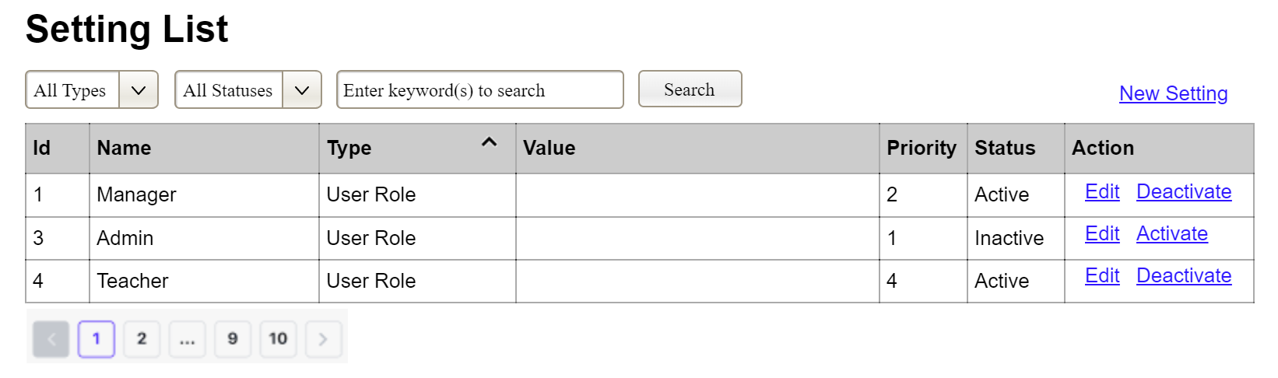
(1)
(2)
(3)
This screen allows the Administrator to:
- View Setting List: view list of current master data.
- Filter Setting List: filter master data by data types, statuses
- Search Settings: enter keyword(s) to search master data by their names or values
- Sort Setting List: sort mater data list (ascending, descending) by clicking column headers
On the screen, s/he can also
- Activate/Deactivate Setting: change status of a specific inactive/active master data
- Choose to go to the Setting Details screens for adding new or updating an existing master data by clicking the New Setting or Edit link.
Field Description
Field Name | Description
(1) | Initial values: all the active setting names with null or blank type  Hover the mouse to show the field name: “Setting Type”
(2) | Initial values: All Statuses, Active, Inactive (default value “All Status”)  Hover the mouse to show the field name: “Setting Status”
(3) | The change-status action is Activate or Deactivate depending on the current status of the relevant setting (Inactive or Active, respectively).

3.1.2 Setting Details
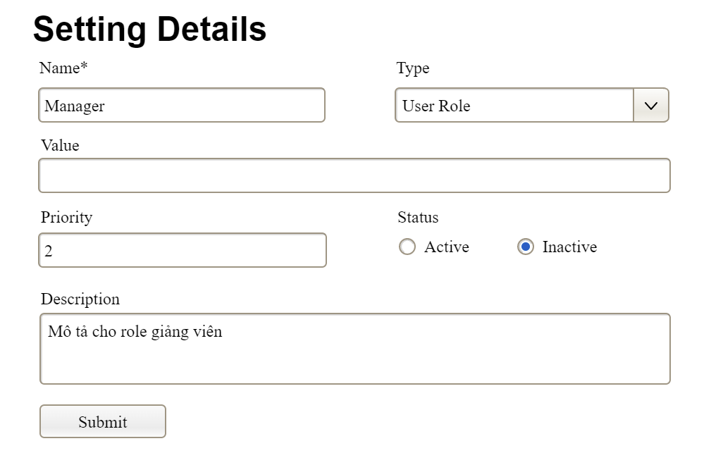
This screen allows the Administrator to:
- Add New Setting: add new master data.
- Update Setting Details: update details of a specific master data
Field Description
Field Name | Description
Name | Data type: non-digit string, max length of 20 characters
Type | Initial data values: all active setting names (with null or blank type)
Value | Data type: any string, max length of 100 characters
Priority | Data type: a positive integer
Description | Data type: any string, max length of 200 characters

3.2 User Management

3.2.1 User List
…

3.2.2 User Details
…

4. Feature NameN
…

5. Background Job Inventory

5.1 Unlock Expired Locked Accounts (JOB-01)
Trigger: Scheduled — every 15 minutes
Purpose: Automatically unlocks accounts that were locked after failed sign-in attempts, once the lockout duration has elapsed
Processing steps:
- Find all accounts with status = Locked where the lockout timestamp is more than 10 minutes ago.
- For each account found: reset the failed sign-in count to zero, set status back to Active.
- Log the number of accounts unlocked in this run.
Failure behavior:
Scenario | System behavior
Database unreachable | Job retries up to 3 times with 30-second intervals. If still failing, logs a critical error. Accounts remain locked until the next successful run.
No locked accounts found | Job completes immediately with no action — this is normal and expected.

5.2 Clean Up Old Audit Log Entries (JOB-02)
Trigger: Scheduled — daily at 2:00 AM
Purpose: Removes audit log entries older than the configured retention period to prevent unbounded database growth.
Processing steps:
- Determine the configured log retention period (default: 90 days).
- Find all audit log entries with a timestamp older than the retention threshold.
- Delete the old entries in batches of up to 5,000 records per run — to avoid locking the database for an extended period.
- If records remain after one batch, schedule the next batch to run 5 minutes later rather than deleting everything at once.
- Log the total number of entries deleted and the number of batches processed.
Failure behavior:
Scenario | System behavior
Database timeout during delete | Current batch rolled back. Job logs a warning. Tries again at the next scheduled time. No data corruption.
Retention period not configured | Job uses default of 90 days and logs a warning that the setting was not found.

6. External API Inventory

6.1 HTTP Method: URL pattern (API-ID)
URL | HTTP method: URL pattern
Purpose | Purpose in one plain-language sentence
Caller | Who the caller is (which external system)
Auth | Authentication requirement (yes/no + type)

6.2 VnPay Webhook (API-02)
URL | POST: /api/v1/commerce/payment/webhook/vnpay
Purpose | Receives payment confirmation (IPN) from VNPay; triggers access grant creation
Caller | VNPay payment gateway
Auth | HMAC-SHA512 signature validation

6.3 SePay Webhook (API-03)
URL | POST: /api/v1/commerce/payment/webhook/sepay
Purpose | Receives payment confirmation from SePay; triggers access grant creation
Caller | SePay payment gateway
Auth | HMAC signature validation

IV. Non-Functional Requirements

1. External Interfaces
[This section provides information to ensure that the system will communicate properly with users and with external hardware or software/system elements.]

2. Quality Attributes
[List all the required system characteristics (quality attributes) specification. Some of the possible attributes are provided with the guide/descriptions are mentioned here]

2.1 Usability
[This section includes all those requirements that affect usability. For example, specify the required training time for a normal user and a power user to become productive at particular operations specify measurable task times for typical tasks or base the new system’s usability requirements on other systems that the users know and like specify requirement to conform to common usability standards, such as IBM’s CUA standards Microsoft’s GUI standards]

2.2 Performance
[The system’s performance characteristics are outlined in this section. Some samples are as below]
Requirement | Target | Condition
Page load time | Any page loads within 2 seconds | Up to 100 users active simultaneously
Form submission response | System acknowledges within 2 seconds | Up to 100 users active simultaneously
Maximum simultaneous users | System remains fully functional for up to 100 users | Single server deployment

2.3 Security
[State the requirement of security, not the implementation mechanism. Some samples are as below]
Requirement | Description
Authentication required | Every page and action other than the sign-in page, registration page, and public job listings requires the user to be signed in.
Password protection | Passwords must never be stored in a form that a person or program can read.
Account lockout | After a defined number of consecutive failed sign-in attempts, the account is temporarily locked. Threshold and duration defined in TDS §4.
CV file access | CV files may only be accessed by users with permission to view the associated Application. The system verifies permission on every access.

V. Requirement Appendix
[Provide business rules, common requirements, or other extra requirements information here]

1. Business Rules
[Provide common business rules that you must follow. The information can be provided in the table format as the sample below]
GBR-ID | Rule Statement | Applies To | Rationale | Enforced By
GB-01 | Status changes are one-way and permanent. No status may be reverted to a previous value. | Job posting status, Application status, Interview status | Prevents data integrity loss; maintains clear audit trail. | The system automatically on every status change
GB-02 | Internal Notes are never visible to Candidates, regardless of how they access the system. | All views accessible to Candidates | Allows HR to write candid internal assessments. | The system automatically on every page and data request
GB-03 | CV files may only be accessed by staff with permission to view the associated Application. Access verified on every download. | All CV file access | Protects Candidates' personal data from unauthorised access. | The system automatically on every file access request
GB-04 | When a sign-in fails, the message must not reveal whether the username exists or the password was wrong. | Sign-in | Prevents attackers from discovering valid usernames. | The system automatically on every failed sign-in
GB-05 | A deactivated account cannot sign in, regardless of password correctness. | Sign-in | Ensures departed staff lose access immediately. | The system automatically on every sign-in attempt
GB-06 | An Interviewer may only access Applications they have been explicitly assigned to. | Application access | Maintains pipeline confidentiality; prevents evaluation bias. | The system automatically on every Application access request

2. System Messages
# | Message code | Message Type | Context | Content
1 | MSG01 | In line | There is not any search result | No search results.
2 | MSG02 | In red, under the text box | Input-required fields are empty | The * field is required.
3 | MSG03 | Toast message | Updating asset(s) information successfully | Update asset(s) successfully.
4 | MSG04 | Toast message | Adding new asset successfully | Add asset successfully.
5 | MSG05 | Toast message | Confirming email of asset hand-over is sent successfully | A confirmation email has been sent to {email_address}.
6 | MSG08 | In red, under the text box | Input value length > max length | Exceed max length of {max_length}.
7 | MSG09 | In line | Username or password is not correct when clicking sign-in | Incorrrect user name or password. Please check again.
8 | ..

3. Other Requirements
…

