Andrea Wood
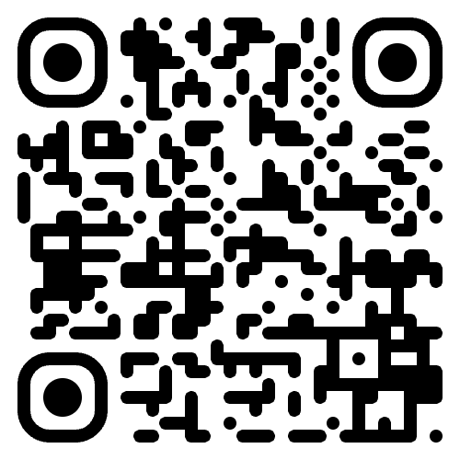
  - Carrboro, NC | (919) 245-7449 | andreawood@alumni.unc.edu

Professional Profile
Library and information professional with experience in instruction, instructional design, reference and circulation services, web technologies and community-based leadership. Skilled in creating learner-centered resources, improving access to information and collaborating.

Professional Experience
NC LIVE, Raleigh NC
Accessibility Instruction Intern, August-December 2025
Created instructional videos and guides. Collaborated in teaching webinars to train librarians on how to create accessible digital resources.
UNC Cares, Chapel Hill NC
Instructional Design Intern, January-April 2025
Revised video content for adult learners, emphasizing clarity, usability and engagement.
Smith Middle School, Chapel Hill NC
Media Center Intern, January-April 2023
Delivered media literacy instruction and created instructional resources. Assisted with services, circulation and student research support.
Delta Analytical Corporation, Silver Spring MD
Part-time Assistant Bookkeeper, 2012-2016
Maintained bookkeeping records and supported financial administration, documentation and office processes.

South Estes Farmers’ Market (now Chapel Hill Farmers’ Market)
Market Manager, October 2009-July 2010
Coordinated market operations, vendors, logistics and community outreach.

UNC Health Sciences Library, Chapel Hill NC
Support Services Process Analyst, November 2007-June 2009
Student and Web Technologies Manager, July 2009-December 2009
Analyzed workflows and managed student and web-technology operations, supporting process improvement and service delivery. Provided reference and database support at the user services desk.
Harvard Law School Library, Cambridge MA
Circulation Desk Assistant, June-October 2007
Provided circulation desk service, patron assistance and access support in a research library setting.

UNC Undergraduate Library, Chapel Hill NC
Circulation Supervisor/Library Technical Assistant, September 2003-May 2007
Fines and Billing Manager, September 2003-June 2004, August 2005-May 2007
Copyright Manager, June 2004-August 2005
Supervised circulation desk and student staff. Managed billing and copyright permissions.

Davis Library, UNC-Chapel Hill
Circulation Desk Student Assistant, Jan. 2000-July 2003
Assisted with circulation, shelving and patron questions in a large academic library.
Education and Certifications
University of North Carolina at Greensboro
Master of Library and Information Science & PBC in Instructional Design, 2025
North Carolina Botanical Gardens
Advanced Certificate in Native Plant Studies, 2025
Hill Learning Center
Understanding Learning Disabilities & ADHD, 2023
The Science of Reading Short Course, 2024
Central Carolina Community College
Certificate in Sustainable Vegetable Production, 2015
University of North Carolina at Chapel Hill
BA with distinguishment, May 2003
Political Science major, Religious Studies minor

DIKEMES, Athens, Greece, Spring 2002
Carolina Business Institute, Summer 2002

Projects, Leadership and Volunteering
Lands & Waters South, Secretary of the Board, 2020-2022
Supported board governance, records and communications for an environmental nonprofit.
Go Conscious Earth, Secretary of the Board, 2012-2014
Helped gain 501(c)3 status & preserve over 1 million acres of rainforest in the DRC.
Understory Farm, co-owner, 2013-2016
Co-owned a small mushroom farm enterprise.
Weaver Community Housing Association, 2010-2016
Contributed to cooperative housing governance, communication and community coordination.
Carrboro Greenspace Collective, organizer, 2006-2012
Organized, publicized and taught sustainability workshops. Worked with a team on events.
Crop Mob, organizer, 2008-2014
Organized volunteer workdays connecting community members with local farms.

Technical Skills
Microsoft Office Suite, Adobe Creative Suite, Google Workspace, Canva, Canvas LMS, iSpring, Quickbooks, Website authoring & design (HTML, CMS, PHP & CSS), C++ & Java, proficiency with social media platforms, library systems & Libguide, photography

References
Devon Waugh, NC LIVE Instruction Librarian, devon@nclive.org, (919) 513-0447
Gabriel Graña, NC State Digital Media Librarian, grgraa@ncsu.edu, (919) 513-7192
Julia Shaw-Kokot, retired, UNC Health Sciences Library, jsk@med.unc.edu
Kim Appel, Instructional Designer, UNC Cares, kpappel@unc.edu, (919) 843-9225

