 |  | 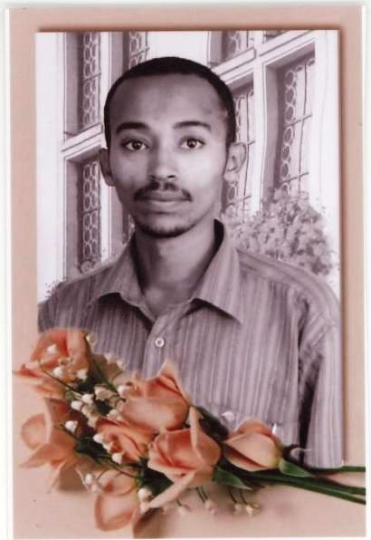
Europass
Curriculum Vitae
Personal information
First name(s) / Surname(s) |  | MOGES ASHAGRIE RETTA
Address |  | 364 BAHIR-DAR (Ethiopia)
Telephone(s) |  | +251-58-2-203657 |  |  |  |  | Mobile |  | +251-
E-mail(s) |  | xxx@yahoo.com
Nationality |  | Ethiopian
Date of birth |  | dd/mm/yyyy
Gender |  | Male
Desired employment / Occupational field |  | lecturer
Work experience
Dates |  | 13/07/2008 - 13/07/2009
Occupation or position held |  | Assistant Lecturer
Main activities and responsibilities |  | Lecturer on Fluid machinery and course assistant on Renewable energy Technology  Final year project adviser on " Analysis of process steam demand reduction option in sugar and ethanol production"  Laboratory supervisor on Reaction engineering Lab
Name and address of employer |  | Bahir-Dar University , Faculty of Engineering  26 Bahir-Dar (Ethiopia)
Dates |  | 03/05/2009 - 30/08/2009
Occupation or position held |  | Industrial energy projects consultant
Main activities and responsibilities |  | Principal investigator on energy utilization problems identification and feasibility studies on energy saving options and solutions to problems in boilers and its feed water treatment units in textile factory.  Team leader on implementation of potential solutions on boiler , steam distribution systems and water treatment units
Name and address of employer |  | Bahir-Dar Textile share company  15 Bahir-Dar (Ethiopia)
Dates  Occupation or position held  Main activities and  Responsibilities |  | 13/07/2007-13/07/2008  Assistant Lecturer  Lecturer on Computer applications in industrial chemistry  Lecturer on Fluid mechanics for chemical engineers
Name and address of  employer |  | Principal investigator on energy and eco sanitation projects  Principal investigator on “Human waste based biogas plant design for universities in Ethiopia; case study in Bahir-dar University”  Member of departmental academic commission  Bahir-Dar University, Faculty of Engineering  26 Bahir-Dar (Ethiopia)
Dates |  | 13/07/2006 - 13/07/2007
Occupation or position held |  | Graduate Assistant II
Main activities and responsibilities |  | Course Assistant on chemical process control and dynamics  Course Assistant on Fluid mechanics for chemical engineers  Final year project co-adviser on "Plant design for the production of high fructose corn syrup"  Laboratory Supervisor on mass transfer and process control lab  Laboratory supervisor on environmental and food processing lab
Name and address of employer |  | Bahir-Dar University, Faculty of Engineering  26 Bahir-Dar (Ethiopia)
Education and training
Dates |  | 28/08/2008 - 30/07/2010
Title of qualification awarded |  | MSc student in Mechanical Engineering
Principal subjects / occupational skills covered |  | Sustainable energy engineering (remote campus based)
Name and type of organisation providing education and training |  | KTH Royal institute of technology  SE-100 44 Stockholm (Sweden)
Level in national or international classification |  | ISCED 5
Dates  CGPA |  | 11/09/2000 - 06/06/2006
Title of qualification awarded |  | B.Sc in Chemical Engineering
Name and type of organisation providing education and training  CGPA |  | Bahir-Dar University  26 Bahir-Dar (Ethiopia)
Personal skills and competences
Mother tongue(s) |  | Amharic
Self-assessment |  |  | Understanding |  |  |  | Speaking |  |  |  | W r i t i n g
European level (*) |  |  | Listening |  | Reading |  | Spoken interaction |  | Spoken production
English |  |  | C2 | Proficient user | C2 | Proficient user | C2 | Proficient user | C2 | Proficient user | C2 | Proficient user
 |  | (*) Common European Framework of Reference (CEF) level
Social skills and competences |  | I have worked in various types of teams with people from a diverse range of cultural backgrounds.  Good communication skills developed during to my active participation in Anti AIDS club.  Good team spirit and leadership developed while working on implementation of research projects in Bahir-Dar textile share company.  Member of the Ethiopian society of chemical engineers.
Organisational skills and competences |  | Very good leadership skills acquired during my positions on student’s advisory, member of departmental academic commission and principal investigator on energy research projects.
Computer skills and competences |  | Working knowledge on Mat Lab & C++ programming, Ms Office,  HOMER-hybrid optimization model for electric renewable.
Artistic skills and competences |  | Memory Art
Additional information |  | Publication  “Process design on the production on protein from rapeseed meal”, Journal of Ethiopian society of chemical engineers, Vol. 11.No.1, August 2008.  Contacts: esche_addis@yahoo.com , P.O.Box 81264,Addis Ababa, Ethiopia  Language Test  GRE on October 2007, Quantitative xxx, Verbal xxx, Analytical writing xx  Award  Second prize of the Ethiopian society of chemical engineers scholastic award for best final year project of the year 2005/2006.  contacts: esche_addis@yahoo.com ,P.O.Box 81264,Addis Ababa, Ethiopia  References  DR.xxx  ASSISTANT PROFESSOR  BAHIR-DAR UNIVERSITY,FACULTY OF ENGINEERING  DEPARTMENT OF xxxxxxx  TEL +251xxxxx  E-MAIL- xxxxxxxxx@yahoo.com  Dr.xxxxxx  ASSISTANT PROFESSOR  BAHIR-DAR UNIVERSITY,FACULTY OF ENGINEERING  DEPARTMENT OF xxxxxxxx  Tel +251xxxxxx  E-mail xxxx@xxx

