1. Acknowledgement

We extend our heartfelt gratitude to our mentor, Gyani Ray, whose invaluable assistance has played a pivotal role in the development of our e-commerce website project. Gyani's unwavering guidance, unwavering support, and profound expertise have been instrumental in navigating the complexities of our endeavor.

Throughout our journey, Gyani's mentorship has proven indispensable. His insightful advice, constructive feedback, and innovative ideas have consistently propelled us forward, enabling us to overcome challenges and achieve our objectives. We are deeply appreciative of the time and effort Gyani has devoted to mentoring us, demonstrating remarkable patience and a genuine willingness to share his extensive knowledge.

Gyani's mentorship has not only enriched our project but has also significantly contributed to our personal and professional growth. His guidance has not only been instrumental in the success of this endeavor but has also equipped us with valuable skills and insights that will serve us well in our future endeavors.

In conclusion, we express our sincere gratitude to Gyani Ray for his exceptional mentorship, without which our e-commerce platform would not have reached its full potential. We are truly fortunate to have had the opportunity to learn from such a dedicated and knowledgeable mentor.

1. Abstract

The report elucidates the development and implementation of a cutting-edge online platform for the buying and selling of second-hand books, as well as fresh publications. The platform, Book Bounty is intended to foster sustainability and affordability within the book industry, while concurrently offering a machine learning (ML) book recommendation system to augment user experience. The ML system is meticulously engineered to analyze user preferences and suggest pertinent books, thereby elevating customer satisfaction and engagement. Book Bounty encompasses the creation of a user-friendly interface, secure payment gateways, and a sophisticated search engine to facilitate effortless transactions and book discovery. Furthermore, the report delves into the challenges encountered during the development process and the strategies implemented to surmount them. In essence, the project exemplifies the potential of digital platforms to revolutionize traditional industries and promote sustainable consumption practices.

1. Introduction
   1. Introduction

In the era of rapid technological advancement, the demand for convenient and accessible services has surged, fueled by the ubiquitous presence of the internet and the widespread adoption of smartphones. Against this backdrop, this report meticulously documents the inception and evolution of Book Bounty, an e-commerce platform meticulously crafted to cater to the discerning needs of book enthusiasts and avid readers, spanning a diverse demographic spectrum.

Our platform stands as a beacon of seamless functionality, offering users an intuitive and aesthetically pleasing interface that simplifies the entire process of browsing, buying, and selling books. Unlike its counterparts plagued by convoluted interfaces, Book Bounty prides itself on its user-centric design philosophy, ensuring an effortless and enjoyable experience for all patrons.

Powered by cutting-edge e-commerce technologies, our platform orchestrates a symphony of efficiency, facilitating swift navigation, seamless transactions, and prompt delivery. Moreover, distinguishing itself from the competition, Book Bounty integrates a state-of-the-art book recommendation system driven by machine learning algorithms. This innovative feature serves as a testament to our commitment to embracing technological advancements to enhance user experience and foster a deeper connection between readers and literature.

By capitalizing on the prevailing zeitgeist of personalized and streamlined digital experiences, Book Bounty endeavors to carve a niche for itself in the competitive landscape of online commerce. With a laser focus on user satisfaction and technological innovation, we aspire to emerge as the preeminent destination for book enthusiasts, establishing a lasting legacy of excellence across our targeted markets.

* 1. Problem Definition

In countries like Nepal, where a vibrant community of book lovers thrives, accessing beloved literature often entails a journey to physical bookshops, a task made challenging by their limited availability. While a handful of websites endeavor to bridge this gap, their offerings often fall short of meeting the personalized needs and expectations of discerning readers. Moreover, inefficiencies in their operations further exacerbate the plight of book enthusiasts, leaving them longing for a more seamless and tailored experience.

Despite the palpable appetite for literature in Nepal, the existing online platforms struggle to capture the essence of personalized service, leaving readers yearning for a digital oasis that resonates with their unique preferences. Coupled with logistical hurdles and subpar user experiences, the gap between the thriving book market and its online representation widens, presenting a compelling opportunity for innovation and disruption.

* 1. Problem Objectives

The objectives of this project are:

1. *Gap Identification:* A critical analysis to discern the existing gaps within the realm of online book platforms, particularly focusing on the deficiencies in user experience and the inadequate efficiency in serving customers. By identifying these gaps, we aim to pave the way for tailored solutions that address the unmet needs of readers.
2. *Performance Optimization:* A commitment to ongoing evaluation and refinement of the platform's performance and product offerings, ensuring alignment with market dynamics and the evolving expectations of customers. Through continuous tracking and assessment, we strive to uphold optimal efficiency and enhance customer satisfaction.
3. *Diverse Book Selection:* Curate a vast and diverse collection of books spanning various genres, languages, and categories to cater to the eclectic tastes of readers.
4. *Enhanced Search and Filtering:* Implement advanced search and filtering options, allowing users to easily find specific books based on criteria such as genre, author, publication date, and reader reviews.
5. *Community Engagement:* Foster a vibrant online community where readers can connect, share recommendations, and engage in discussions about their favorite books and authors.
6. *Personalized Recommendations:* Further enhance the machine learning-based recommendation system to deliver even more personalized book suggestions based on users' reading history, preferences, and behavior patterns.

By fulfilling these objectives, Book Bounty is positioned to satisfy the growing demand and enhance the reading experience for customers, providing them with personalized access to their preferred books.

* 1. Proposed System

In accordance with user types, our web platform is structured into two primary sections:

1. Selling User
2. Buying User
   * 1. *Selling User*

Within this portal, users intending to sell books, including both used and new, can easily list their items for sale. Upon registration, sellers can conveniently upload book details and pricing information via a quick form submission process, facilitating seamless integration of their offerings into our platform.

* + 1. *Buying User*

Similarly, registered customers gain access to a comprehensive selection of books, encompassing both pre-owned and new titles. With a user-friendly interface, buyers can explore our extensive catalogue, add desired items to their cart, and proceed with secure transactions. To streamline payment processes, we've seamlessly integrated the eSewa API, ensuring a hassle-free monetary exchange for our valued customers.

* 1. Scope and Limitations

The scope of Book Bounty is immense, promising to revolutionize the way people access and engage with literature. With its user-friendly interface and extensive book selection, the platform aims to transcend geographical boundaries, reaching readers worldwide and providing them with personalized recommendations tailored to their preferences. Book Bounty not only fosters a vibrant online community of book enthusiasts but also supports authors by offering a platform to showcase their work. Through continuous innovation and a commitment to sustainability, Book Bounty has the potential to enrich the lives of readers, promote literacy, and contribute to the cultural enrichment of society.

Limitations of the project include:

1. *Limited Physical Access*: Despite the convenience of an online platform, some users may still prefer the tactile experience of browsing physical bookstores. Book Bounty can address this limitation by offering virtual tours or partnering with local bookshops to provide a click-and-collect service, combining the benefits of online convenience with the charm of in-person browsing.
2. *Internet Connectivity Issues:* In regions with unreliable internet access, users may face difficulties accessing the platform. Book Bounty can mitigate this limitation by optimizing its website for low bandwidth connections, offering offline browsing options, and providing downloadable catalogs for offline reference.
3. *Limited Availability of Rare Books:* While Book Bounty strives to offer a diverse selection of books, rare or out-of-print titles may still be challenging to procure. To address this limitation, the platform can collaborate with rare book dealers, establish partnerships with publishers to reissue rare titles, or facilitate user-to-user transactions for rare book exchanges.
4. *Security Concerns*: Online transactions carry inherent security risks, including data breaches and fraudulent activities. Book Bounty can enhance security measures by implementing robust encryption protocols, two-factor authentication, and regular security audits to safeguard users' personal and financial information.
5. *Shipping Delays and Costs:* Delays in book delivery or unexpected shipping costs can impact user satisfaction. Book Bounty can tackle this limitation by partnering with reliable logistics providers, offering expedited shipping options, and transparently communicating shipping fees upfront to users, ensuring a seamless and cost-effective shopping experience.
6. Designs
   1. Use Case Diagram

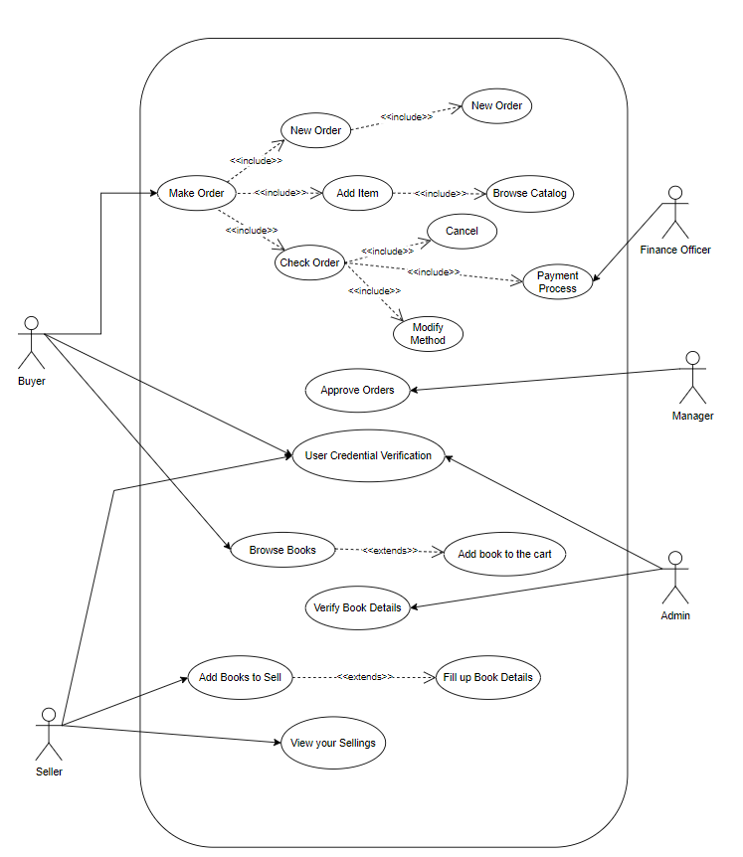

* 1. ER-Diagram

