This document explains briefly the new design of the anti-polling. Another document UML oriented will follow to describe in term of development (java classes, database tables, etc...) what we need to do on the existing architecture to be able to remove the actual polling.

- Anti-Polling

The polling appears only on the learner module. As soon as a user has selected a sequence to work with (start a new sequence, resume an existing sequence) the polling is starting in the Flash module. The new design is to remove completely this approach which will also reduce the number of unnecessary requests.

We will see the four major steps.

- Select the learner module
- Select a sequence (new sequence, started sequence)
- Do an activity
- Select a specific task

- Select the learner module

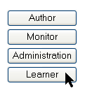
(Select the learner module)

This part of the process will not be affected by the anti-polling approach except the fact that we can now remove the ‘pollInterval’ parameter set on the learnerBottomFrame.jsp

This step allows the user to enter in the Learner module.

- Select the learner button on the index.jsp page

- Execute the following Struts action (home.do?method=learner)
(java class HomeAction.java)

- Validate and update some user information

(java class ClientSessionDataManager.java)
(java class ClientSessionData.java)

- Display the learner pages
(jsp pages : LearnerFrSet.jsp with two frames learnerTopFrame.jsp and learnerBottomFrame.jsp )

LearnerFrSet.jsp

→ learnerTopFrame.jsp

→ LearnerTopUI.swf
Flash component which will manage Top menu bar

→ learnerBottomFrame.jsp

→ LearnerLeftUI.swf (flash component)
Flash component which will manage Left side user interface. This component is called with the pollingInterval value. We have to remove it.

→ noSession.jsp

Welcome page to advise the user that he can now select a sequence.

- Request for the Learning Sequence Activity

As soon as the Flash component is displayed (LearnerLeftUI.swf) this component will request for the learning sequence activities (new, started and finished) by sending the following URL to the server side learner.do?method=getLearningSession.

The server answer to this request by sending back a WDDX packet which is contained the list of the sequence activities. This process is the same as before.

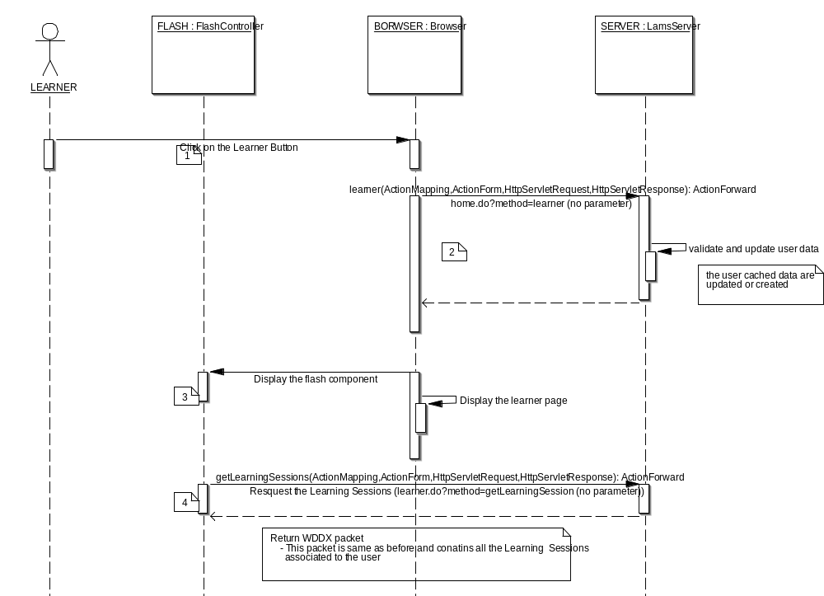

- Select a sequence (new sequence, started sequence)

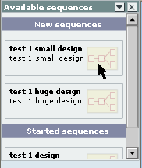
(Select a sequence)

This process is now different from the previous one. There is no need to start the polling. We have three steps to launch a sequence.

- Start a new sequence

- Restart a sequence

- Resume a sequence

Start a new sequence

For starting a new sequence the user click on a sequence listed in the ‘New Sequences’ window.

- Flash send a request to start the new sequence. Flash send the following action (url).
learner.do?method=startSequence&LearningSessionID=xxxx

- A acknowledged WDDX packet is sending back to Flash

- Flash request the progress data by sending an action (url) to the server

learner.do?method=geProgress&LearningSessionID=xxxx
- The WDDX packet containing the progress data is sending back to Flash

- Flash send a request to resume the sequence. Flash send the following action (url).
learner.do?method=resumeSequence&LearningSessionID=xxxx

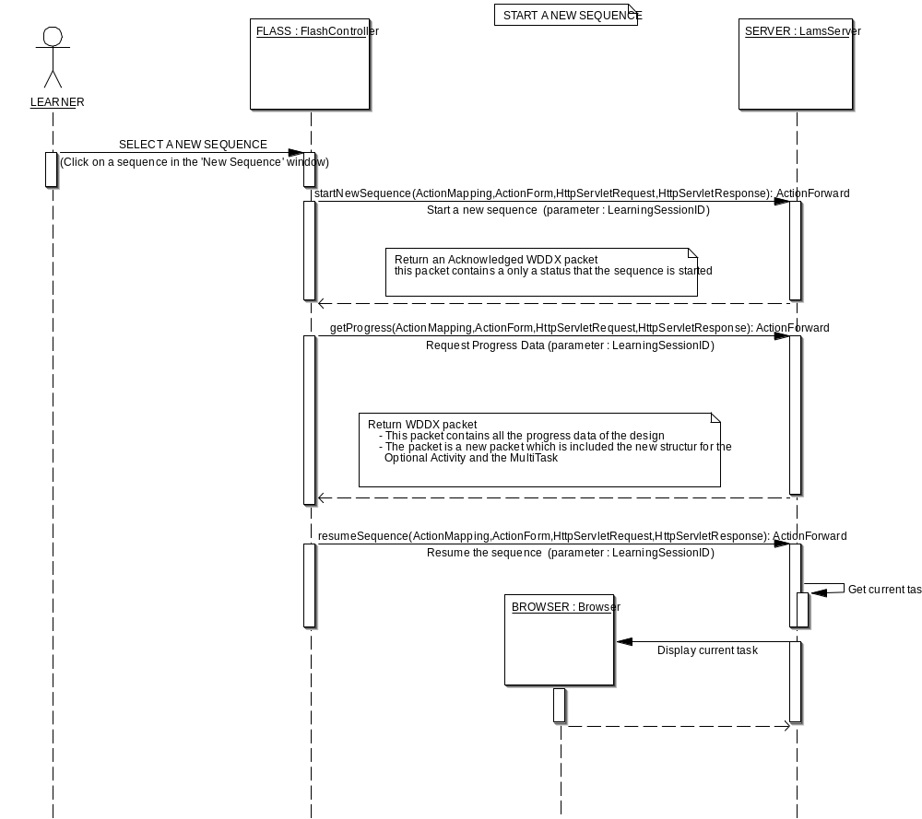

Restart a sequence

For restarting a sequence the user click on a sequence listed in the ‘Started Sequences’ window.
- Flash send a request to start the new sequence. Flash send the following action (url).
learner.do?method=restartSequence&LearningSessionID=xxxx
- A acknowledged WDDX packet is sending back to Flash
- Flash request the progress data by sending an action (url) to the server
learner.do?method=geProgress&LearningSessionID=xxxx
- The WDDX packet containing the progress data is sending back to Flash
- Flash send a request to resume the sequence. Flash send the following action (url).
learner.do?method=resumeSequence&LearningSessionID=xxxx

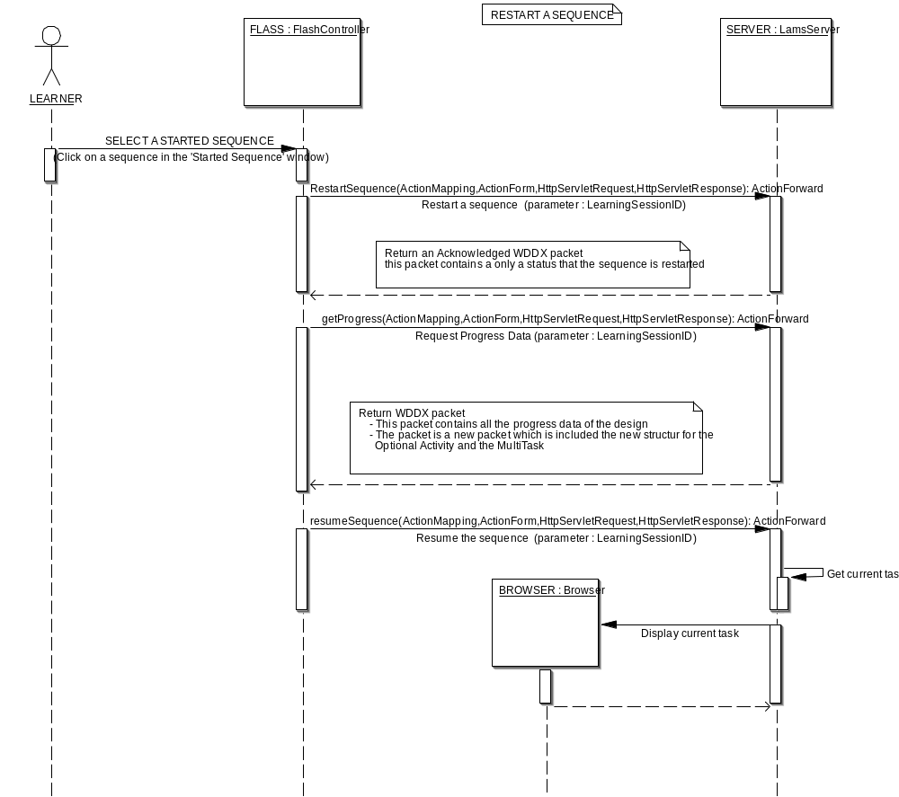

Resume sequence

For resuming a sequence the user click on the ‘Resume’ button on the top frame. The resume is effective only if a sequence is launched.

- Flash send a request to resume the sequence. Flash send the following action (url).
learner.do?method=resumeSequence&LearningSessionID=xxxx

- Do an activity

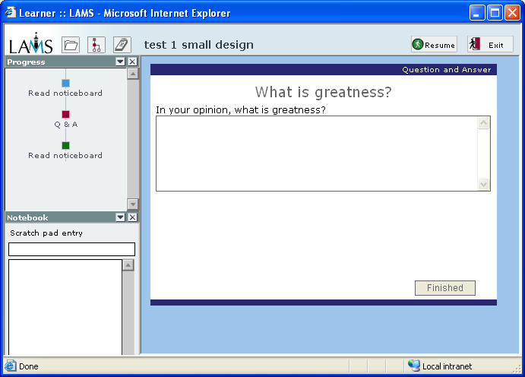
(Do an activity)

This process is now different from the previous one. The Flash module doesn’t send any request at the server.

- Search for the next task and display the task’s jsp page (server).

- Do the task and select the next action (next page or finish the task) (server + browser)

- The states Flash need to track are

Which task has started (which task is being displayed?)

When a task has finished or attempted

Tasks which have not been attempted

To reflect these states two parameters could be sending separately as needed.

taskID or status

For example, send taskID when the JSP page loads successfully, and send status when the "Finish" button is pressed (to finish a task). Imagine the same scenario above with this new mechanism:

  - A task (taskID = 1) loads successfully, taskID is sent to Flash
  - Flash receives this parameter and understands that taskID = 1 has loaded, and change the icon to reflect this
  - The user decides to jump to a previously attempted task (taskID = 10) by double-clicking on the progress. Request is sent to the server to load this task
  - When taskID = 10 loads successfully, taskID is sent to Flash
  - Flash receives this parameter, but since the current task is still taskID = 1 on the Flash side, it understands that the user must have jumped to the new task, it then change the taskID = 1 icon back to normal, and change taskID = 10 icon to the current task icon

Scenario 2: User finishes a task and the next one loads

  - taskID = 1 is loaded and parameter sent to Flash
  - Flash changes the icon for taskID = 1 to the current task icon
  - the user clicks "Finish" button to finish the current task, status=FINISH is sent to Flash and JSP page submitted to the server
  - Flash receives status=FINISH and change the current task's icon (taskID = 1) to indicate it has finished. Now it waits for the next taskID parameter. At this stage, no task is current (server loading)
  - Server loads the next task, say taskID = 2. This task loads successfully, taskID=2 is sent to Flash
  - Flash receives taskID = 2 and change the icon for the task with ID = 2 to the current task icon

Remark:

Another alternative is to set only one variable for example progressStatus=”TO UPDATE”. As soon as Flash read this variable Flash send the request to retrieve the progress data (learner.do?method=geProgress&LearningSessionID=xxxx).

With this solution Flash doesn’t need to do some work on the progress data because Flash always received the all the data to display. But it required some work on the server side (data base requests for example).
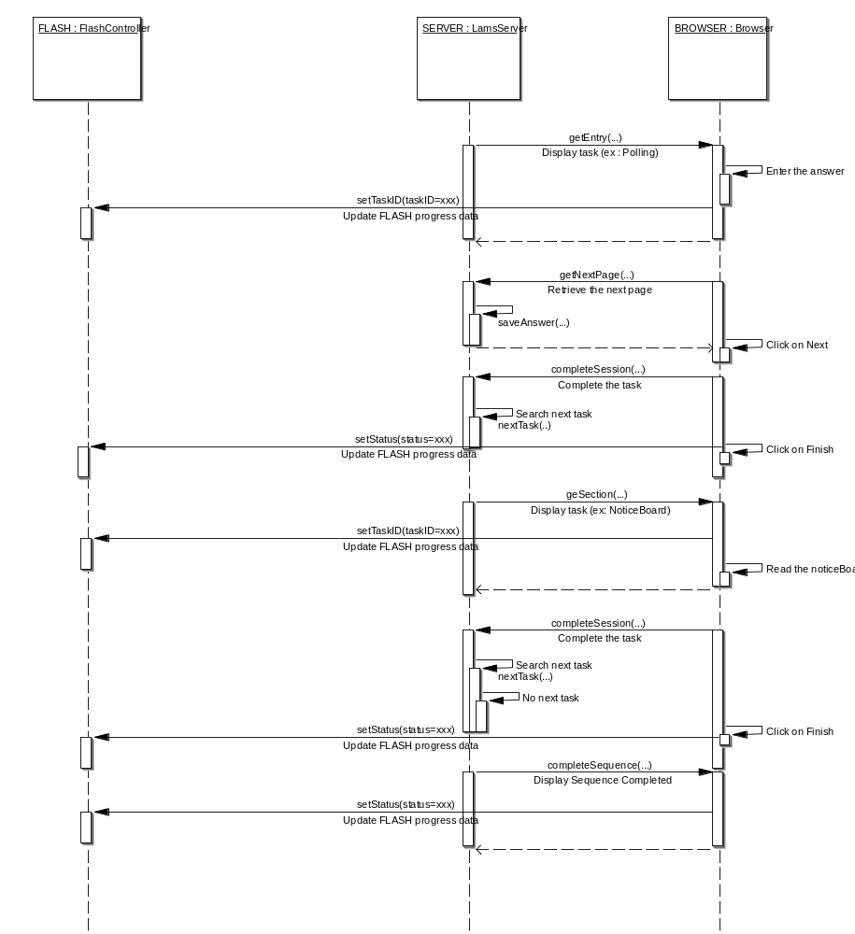

- Select a specific task

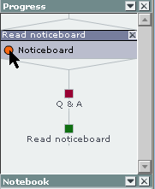
(Select a task)

This process is exactly the same as before. As soon as the user selects a task the following url is sent to the server

learner.do?method=getTask&TaskInstanceId=xxxx

- Summary

Components | Messages | Purposes
browser→server | home.do?method=learner | Select the learner module
flash→server | learner.do?method=getLearningSession. | Request the list of the sequence activities
flash→server | learner.do?method=geProgress&LearningSessionID=xxx | Request the progress data
flash→server | learner.do?method=startSequence&LearningSessionID=xxx | Start a new sequence
flash→server | learner.do?method=restartSequence&LearningSessionID=xxx | Restart a sequence
flash→server | learner.do?method=resumeSequence&LearningSessionID=xxxx | Start a sequence activity
browser—>flash | taskID=xxxx | Update the progress information by indicating which task is load
browser—>flash | status=xxxx | Update the progress information by indicating that the status of the current task
flash→server | learner.do?method=getTask&TaskInstanceId=xxxx | Select a task

- Removing the messages send between Flash and the server

Hibernate mapping

controller.hmb.xml

Remove the following mappings:
com.webmcq.ld.controller.learner.WorkSpace,
com.webmcq.ld.controller.SimpleMessage

Modify the following mappings:
com.webmcq.ld.controller.Learner remove the workspace association

Java classes to remove

Theses following classes have to be removed. These classes were in charge to define a workspace to the user and the associated messages. The workspace and the messages were used by the polling process only.

Workspace.java
WorkspaceDAO.java
SimpleMessage.java
SimpleMessageData.java

Java classes to modify

Tools

ChatGroupAction.java
- Change the extension of the class. The class now extends ToolAction.java
- Remove the ‘complete’ action forward which is now in ToolAction.java
- The ‘completeSession’ process now call the ‘displayTask(…)’ service of ToolAction.java for displaying the task
- The ‘completeSession’ service return now DisplayTaskData which contains some information of the task to display
- change the completeSession(...) for managing the multiple submission

ChatServiceBean.java
- The ‘completeSession’ service returns now DisplayTaskData which contains some information of the next task to display.

GroupReportAction.java
GroupReportServiceBean.java
- Same type of modification of the ‘Chat Tool’

ImgGalleryServiceBean.java
- Same type of modification of the ‘Chat Tool’

IngRankingServiceBean.java
- Same type of modification of the ‘Chat Tool’

JournalAction.java
JrnlServiceBean.java
- Same type of modification of the ‘Chat Tool’

MBForumAction.java
MBServiceBean.java
- Same type of modification of the ‘Chat Tool’

NoticeBoardAction.java
NBServiceBean.java
- Same type of modification of the ‘Chat Tool’

QNAAction.java
QNAServiceBean.java
- Same type of modification of the ‘Chat Tool’

ReportSubmissionAction.java
ReportSubmissionServiceBean.java
- Same type of modification of the ‘Chat Tool’

SimpleAssessmentAction.java
SimpleAssessmentServiceBean.java
- Same type of modification of the ‘Chat Tool’

URLContentAction.java
URLContentServiceBean.java
- Same type of modification of the ‘Chat Tool’

VoteRankAction.java
VoteRankServiceBean.java
- Same type of modification of the ‘Chat Tool’

GroupingAction.java
- Same type of modification of the ‘Chat Tool’

OptionAction.java
- Change the extension of the class. The class now extends ToolAction.java
- The ‘getOptions(…)’ process now call the ‘displayTask(…)’ service of ToolAction.java for displaying the task. The DisplayTaskData has been introduced it contains some information of the task to display.
- The ‘chooseActivity(…)’ process now call the ‘displayTask(…)’ service of ToolAction.java for displaying the task. The DisplayTaskData has been introduced it contains some information of the task to display.
- The ‘finish(…)’ process now call the ‘displayTask(…)’ service of ToolAction.java for displaying the task. The DisplayTaskData has been introduced it contains some information of the task to display.

SyncAction.java
- Change the extension of the class. The class now extends ToolAction.java
- The ‘waitForGroup(…)’ process now call the ‘displayTask(…)’ service of ToolAction.java for displaying the task. The DisplayTaskData has been introduced it contains some information of the task to display.
- Add a new action forward page which displayed the synchronization page

Utils

WebUtil.java
- Add two new tags ‘current_task’ and ‘previous_task’
- Add ‘saveTaskURL (…)’ method. This method allows setting two attributes in the HttpSession. Theses attributes are the current task and the previous task. The setting is done before to display the task’s page

Controller

Group.java
- Modify the toNextTask(…) method by removing the saving of the workspace. Remove the WorkSpaceDAO reference in this method.

LearnerGroup.java
- Change the signature of the ‘join(…)’ method for removing the workspace parameter.
SupportToolServiceBean.java
- The ‘joinWaitingTool(…) now return the DisplayTaskData The DisplayTaskData contains some information of the task to display.
- The ‘releaseLearners(…)’ required another parameter which the current userId.

LearnerAction.java
- Add ‘restartSequence’ action. This action will be call as soon as the user select a started sequence.
- Add ‘startSequence’ action. This action will be call as soon as the user select a new sequence

Learner.java
- Remove the Workspace reference which is not necessary (class variable).
- Modify the constructor by removing the workspace variable.
- Remove the getter and setter of the workspace.
- The getUser(…) now retrieve the user data directly from UserServiceDelegate instead of the work space.
- The following methods toNextTask, toTask, completeSession, runTaskInstance and resume now return the DisplayTaskData object. This object contains some data related to the task.

LearningSession.java
- Modify the join(…) method. The ‘WorkSpace’ parameter has to be removing. Also remove the saving of the workspace by removing the WorkSpaceDAO reference in this method.
- Add a new findLearner(…) method base on the userId. The method allows retrieving the Learner information without to have all the user data but only the userId.
- The following methods join(…)now return the DisplayTaskData object. This object contains some data related to the task.

MessageType.java
- Add a new tag
- Add some new message types

MultiTaskInstance.java
- The following methods run(…) and resume(…) now return the DisplayTaskData object. This object contains some data related to the task.
- Remove from the perform(…) method the SimpleMessage and WorkSpace references.

SingleTaskInstance.java
- The following methods run(…) and resume(…) now return the DisplayTaskData object. This object contains some data related to the task.

OptionalTaskInstance.java
- The following methods run(…) and resume(…) now return the DisplayTaskData object. This object contains some data related to the task.

TaskInstance.java
- The following methods run(…) and resume(…) now return the DisplayTaskData object. This object contains some data related to the task.

SyncTaskInstance.java
- The following releaseLearners(…) now return the DisplayTaskData object. This object contains some data related to the task.

LearnerServiceBean.java
- Modify the join(…) method. The ‘WorkSpace’ parameter has to be removing. Also remove the saving of the workspace by removing the WorkSpaceDAO reference in this method.
- Modify the gotoTask(…) method. The ‘WorkSpace’ parameter has to be removing. Also remove the saving of the workspace by removing the WorkSpaceDAO reference in this method.
- Modify the resume(…) method. Retrieve the Learner only with userID.
- Modify the nextTask(…) method. The ‘WorkSpace’ parameter has to be removing. Also remove the saving of the workspace by removing the WorkSpaceDAO reference in this method.
- The following methods join(…), moveToNextTask(…), gotoTask(…), resume(…), nextTask(…) and completeMultiTask(…) now return the DisplayTaskData object. This object contains some data related to the task.

LearnerServiceDelegate.java
- The following methods join(…) and moveToNextTask now return the DisplayTaskData object. This object contains some data related to the task.

GroupAction.java
- change the completeSession(...) for managing the multiple submission

Java classes to add

ToolAction.java
- New class. This class is the parent of each tool action class for example NoticeBoardAction, QNAAction, …

DisplayTaskData.java
- This object contains some data related to the task

JSP Pages to modify

learnerBottomFtrame.jsp
- Remove the interval polling parameter

definenoticeboard.jsp
entrynoticeboard.jsp
section.jsp
- These pages have been modified to change the button type form ‘submit’ to ‘button’. Without these modifications the request was sent twice.

definequestion.jsp
entryquestion.jsp
- These pages have been modified to change the button type form ‘submit’ to ‘button’. Without these modifications the request was sent twice.

allvotes.jsp
definepoll.jsp
entryvote.jsp
- These pages have been modified to change the button type form ‘submit’ to ‘button’. Without these modifications the request was sent twice.

JSP Pages to add

verify_sync.jsp
- This page is displayed as soon as the learner arrives at a synchronization point.

displaysingletask.jsp
- This page displays a single task

displaymultitask.jsp
- This page displays a multi task

taskcompleted.jsp (tool/common/)
- This page displays a message to the user. In case of a multi task if the user finish one of the task this message will be displayed.

error.jsp (tool/common/)
- Displays an error message to the user.

DataBase

Remove tables

The following tables will be removed from the database: c_message_to_send, c_message and c_workspace. These tables were in charge of saving the messages that had to be read during the polling process. By removing the polling these tables are not relevant.

Change tables

The ‘c_learner’ table has to be changed by removing the following field ‘workspace_id’ and also his related constraint.

