In host pc:

1. Open SQL Server Configuration Manager

If has in opening error: Open Cmd as admin: cd to C:\Program Files (x86)\Microsoft SQL Server\130\Shared. Then write command:

mofcomp sqlmgmproviderxpsp2up.mof

if sqlmgmproviderxpsp2up.mof not exists in directory search for it , then write command.

Then open SQL Server Configuration Manager.

|  |  |
| --- | --- |
|  | SQL Server 2016 C:\Windows\SysWOW64\SQLServerManager13.msc  SQL Server 2014 C:\Windows\SysWOW64\SQLServerManager12.msc  SQL Server 2012 C:\Windows\SysWOW64\SQLServerManager11.msc  SQL Server 2008 C:\Windows\SysWOW64\SQLServerManager10.msc |

1. select **SQL Server Services** . start on SQL Server Browser
2. On SQL Server Browser Properties, move to **Service** tab and change **Start Mode** to **Automatic .** right-click on **SQL Server Bowser** on the right window and select **Start** to start the service.
3. **SQL Server Network Configuration** -> **Protocols for MSBSQL**. You see that TCP/IP protocol status is disabled

Right-click on **TCP/IP** and select **Enable** to enable the protocol.

On the left window, select **SQL Server Services**. Select **SQL Server** on the right window -> click **Restart**. The SQL Server service will be restarted.

Open Microsoft SQL Server Management Studio and connect to the SQL Server

Right-click on the SQL Server Instance and select **Properties**

On Server Properties, select **Security** on the left window. Then, select **SQL Server and Windows Authentication** mode.

Right-click on the SQL Server Instance and select **Restart**.

Check and/or set, your firewall settings for the computer that is hosting the SQL Server. If you are using Windows 7 then go to Control Panel and search for "Firewall" click on "Allow a program through Windows Firewall".

* Create an inbound rule for port TCP 1433 - allow the connection
* Create an outbound rule for port TCP 1433 - allow the connection

When you are finished with the firewall settings you are going to want to check one more thing. Open up the "SQL Server Configuration Manager" locate: SQL Server Network Configuration - Protocols for SQL (or equivalent) - TCP/IP

* + Double click on TCP/IP
  + Click on the IP Addresses tab
  + Under IP1 set the TCP Port to 1433 if it hasn't been already
  + Under IP All set the TCP Port to 1433 if it hasn't been already

Restart SQL Server and SQL Browser (do both just to be on the safe side)

In client:

1. On a second computer that contains the SQL Server client tools, log in with an account authorized to connect to SQL Server, and open Management Studio.
2. In the **Connect to Server** dialog box, confirm **Database Engine** in the **Server type** box.
3. In the **Server name** box, type **tcp:** to specify the protocol, followed by the computer name, a comma, and the port number. To connect to the default instance, the port 1433 is implied and can be omitted; therefore, type **tcp:**. In our example for a named instance, type **tcp:,49172**.

Note

If you omit **tcp:** from the **Server name** box, then the client will attempt all protocols that are enabled, in the order specified in the client configuration.

1. In the **Authentication** box, confirm what is needed

For example:

If host computer name is : Sayar8-PC then

Client server name is : tcp:Sayar8-PC,1433

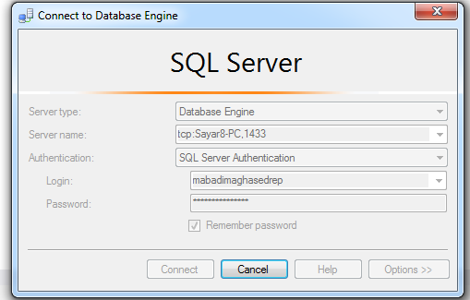

Get host computer name from: host pc/my computer/ right click/ properties/ computer name is shown