

AWS First Cloud AI Journey – Project Plan

Serverless Student Cloud Team – FPT University – Server-less Student Management System

[2025-12-07]
Table of Contents
1 BACKGROUND and motivation 3
1.1 executive summary 3
1.2 PROJECT SUCCESS CRITERIA 3
1.3 Assumptions 4
2 SOLUTION ARCHITECTURE / ARCHITECTURAL DIAGRAM 4
2.1 Technical Architecture Diagram 4
2.2 Technical Plan 5
2.3 Project Plan 5
2.4 Security Considerations 5
3 Activities AND Deliverables 6
3.1 Activities and deliverables 6
3.2 OUT OF SCOPE 7
3.3 PATH TO PRODUCTION 7
4 EXPECTED AWS COST BREAKDOWN BY SERVICES 8
5 TEAM 6

BACKGROUND and motivation

executive summary
The Serverless Student Management System is a student management platform built entirely on AWS Serverless technologies. The goal is to deliver a modern, cost-efficient, scalable solution for managing students, courses, assignments, and grades using AWS services such as API Gateway, Lambda, Dynamo Db, Cognito, and Amplify.
Customer background:
This project is designed as an internal application used within an educational environment. The system is intended for administrators, teachers, and students who require a centralized platform for managing academic information such as students, courses, grades, and assignments.

Business & technical objectives:
- Build a truly 90% serverless student management application
- Optimize operational cost (under $20/month)
- Fully implement CI/CD from GitLab → CodePipeline
- Build a complete full-stack system (React/Amplify + API Gateway + Lambda + DynamoDB)

Use cases:
- Student management (CRUD, search, import)
- Course, assignment, and grade management
- Admin/teacher dashboard
- Authentication & authorization with Cognito

Professional services delivered:
- Serverless architecture design following AWS Well-Architected Framework
- Backend, frontend, CI/CD implementation

PROJECT SUCCESS CRITERIA
- One API Gateway with resources `/` and `/{proxy+}` (proxy resource), using ANY and OPTIONS methods, proxy integration forwards all requests to 1 Lambda Function.
- 1 AWS Lambda functions with >80% unit test coverage
- 5 fully functional modules: Students, Courses, Grades, Assignments, Dashboard
- React/TypeScript frontend deployed via Amplify with 15+ pages
- API response time < 500ms
- Uptime ≥ 99%
- CI/CD automated from GitLab → CodeBuild → CodeDeploy/Amplify → Production
- Infrastructure cost maintained < $20/month

Assumptions
- AWS Free Tier is used throughout the project
- All environments use serverless services only (no EC2)
- Active users < 200 per month
- API calls < 500k/month
- DynamoDB data volume < 10GB
- Team has basic knowledge of React, Java, and AWS Cloud
- Services like Route53 domain and WAF may incur costs but are included in scope

SOLUTION ARCHITECTURE / ARCHITECTURAL DIAGRAM

Technical Architecture Diagram

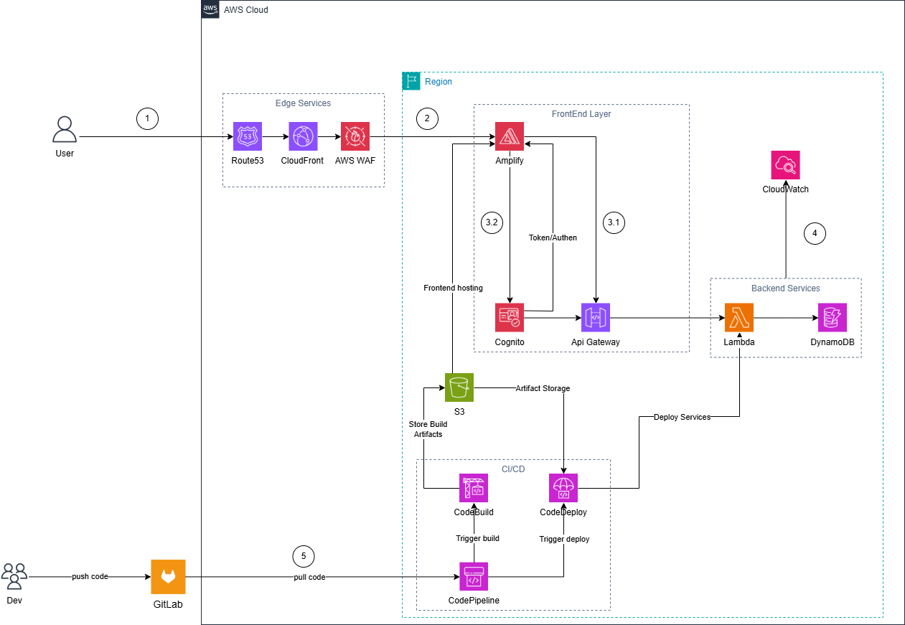

Technical Plan
The system is built using AWS Serverless Architecture, consisting of 5 major layers:
- Edge Layer:Route53, CloudFront, WAF
- Frontend Layer: Amplify, Cognito
- Backend Layer: API Gateway, Lambda, DynamoDB
- Monitoring: CloudWatch
- CI/CD: GitLab, CodePipeline, CodeBuild, CodeDeploy, S3
Main API groups:
- `/students/` (CRUD, search, import/export)
- `/courses/`
- `/grades/`
- `/assignments/`
- `/auth/`

Project Plan
The project will be implemented in 5 weeks:
- Week 1: AWS setup, IaC, DynamoDB, Cognito, Git repository
- Week 2: Backend & Frontend Phase 1 (Lambda + API Gateway + basic UI)
- Week 3: Backend & Frontend Phase 2 (15+ pages, integration test, CloudFront + WAF)
- Week 4: CI/CD (CodeBuild, CodeDeploy, CodePipeline)
- Week 5: Testing, optimization, documentation, demo

Security Considerations
- IAM least privilege
- Cognito User Pool + JWT authentication
- API Gateway throttling (rate limiting)
- WAF rules (SQLi/XSS, IP block, rate limiting)
- DynamoDB encryption
- CloudWatch alarms

Activities AND Deliverables

Activities and deliverables

Project Phase | Timeline | Activities | Deliverables/Milestones | Total man-day
Assessment | Week 1 | - Setup AWS account, IAM, billing alerts  - Create DynamoDB + GSI tables  - Configure Cognito user groups and groups  - Design detailed architecture, sequence diagrams  - Initialize IaC structure (CDK/CloudFormation), Git repo | - AWS foundation complete  - DynamoDB + Cognito operational  - Architecture documentation + workflow diagrams  - Repo & IaC ready | 28 man-day
Setup base infrastructure | Week 2 | - Backend: build Lambda (Students, Courses, Grades, Assignments, Auth)  - Setup API Gateway endpoints  - Unit tests 80%+  - Frontend: implement Amplify, routing, UI core layout  - Integrate state management, API client | - Lambda functions working  - API Gateway stable  - Frontend base UI complete  - Unit test passed1 | 35 man-day
Setup component 1 | Week 3 | - Backend: automatic workflow integration, integration testing  - Frontend: build 15+ pages (Students, Courses, Grades, Assignments)  - CloudFront connection – Route53 – WAF – SSL/TLS  - End-to-end integration FE ↔ BE | - Complete backend workflow  - Full operational management page  - Domain + CDN + WAF + HTTPS running smoothly  - E2E test passed | 35 man-day
Setup component 2 (CI/CD) | Week 4 | - Configure CodeBuild for FE & BE  - Set up CodePipeline (source → build → deploy)  - Configure CodeDeploy to deploy backend & frontend  - Test the entire pipeline | - Complete CI/CD pipeline  - Automatic build & deploy  - Test pipeline report | 25 man-day]
Testing & Golive | Week 5 | - E2E testing, edge cases, load testing 100+ users  - Performance optimization (Lambda, DynamoDB, CloudFront)  - Standardization of technical documentation, user manual  - Demo preparation and testing | - Load test report  - Optimized and stable system  - Full documentation (architecture, API, deployment guide)  - Complete demo | 35 man-day

OUT OF SCOPE
- Mobile Applications (iOS/Android)
- AI recommender system / ML scoring
- Multi-region failover
- Enterprise SSO (SAML, OIDC)

PATH TO PRODUCTION
- Commit code → GitLab
- CodePipeline (source stage)
- CodeBuild (frontend & backend build)
- CodeDeploy (Lambda deployment + Amplify)
- CloudWatch (logs & monitoring)
- DNS routing via Route53 + CloudFront

EXPECTED AWS COST BREAKDOWN BY SERVICES
AWS monthly pricing calculator
Service | Monthly Estimate | Notes
API Gateway | ~$3.8 | 100k–500k requests
Lambda | ~$0.5 | Free Tier includes 1M requests
DynamoDB | ~$1 | <10GB data
Cognito | $0 | <10k MAU
S3 | ~$0.13 | Artifacts & hosting
CloudWatch | ~$4 | Logs & metrics
Amplify | ~$1 | Frontend hosting
Route53 | ~$1 | DNS hosted zone
WAF | ~$7 | Web ACL
CodeBuild | ~$0.9 | ~100 build minutes
CodePipeline | ~$1 | 1 pipeline
CloudFront | ~$1 | CDN traffic

Total Estimated Cost: ~ $7 – $20 / month
For 3 months: ~$21 – $60 (can be reduced to $15–30 with Free Tier).

TEAM
Partner Project Team
Name | Title | Role | Email / Contact Info
Nguyễn Hoàng Nam | FCJ Cloud Intern | Project Lead/ Backe-End | namnhse182076@fpt.edu.vn
Phạm Bảo Phi | FCJ Cloud Intern | Full Stack | phipbse185046@fpt.edu.vn
Nguyễn Nhật Kim Ngân | FCJ Cloud Intern | Frontend /BA | ngannnkse182088@fpt.edu.vn
Đặng Huy Hoàng | FCJ Cloud Intern | Back-End/DevOps | hoangdhse184661@fpt.edu.vn
Lâm Thanh Phúc | FCJ Cloud Intern | Back-End/DevOps | phucltse184678@fpt.edu.vn

