
CAPSTONE PROJECT REPORT
Report 4 – Software Design Document
Ho Chi Minh City, 31 October 2026

Table of Contents
I. Record of Changes 3
II. Software Design Document 3
1. System Design 3
1.1 System Architecture 3
1.1.1 Authority and Data Boundaries 5
1.1.2 Main Interface Contracts 5
1.1.3 Deployment View (Logical) 5
1.1.4 Technology, DevOps and External Services 6
1.2 Package Diagram 6
2. Database Design 7
2.1 Data Storage Strategy 7
2.2 Relational Data Model (PostgreSQL) 7
2.2.1 Table Descriptions – Accounts and Economy 8
2.2.2 Table Descriptions – Match, Reward and AI 9
2.2.3 Persistence Integrity Rules 9
2.3 Telemetry Document Model (MongoDB) 9
3. Detailed Design 10
3.1 Account Authentication and Profile 10
3.2 Multiplayer Lobby and Session Lifecycle 11
3.3 Player Interaction, Life State and Revive 14
3.4 Expedition Mission and Objective Control 16
3.5 Stalker Monster AI 18
3.6 Adaptive Experience Director and Telemetry 20
3.7 Match Result and Reward Processing 21
3.8 Virtual Shop, Wallet and Inventory 22
3.9 UI, HUD and Gameplay Feedback 24
3.10 Main Business Workflows 26

I. Record of Changes
Date | A/M/D | In charge | Change Description
28/10/2026 | A | ECHO PROTOCOL team | Initial SDD using the school Report 4 outline, Report 1–3 and the inspected GitHub source. Player participation scope fixed at 1–4.
30/10/2026 | M | Lâm Thanh Phúc | Selected LTP source; added versioned Legal Agreements lifecycle and consent entity, corrected Adaptive AI/fixed fallback boundary; registry unchanged.
31/10/2026 | M | Nguyễn Nhật Lệ Thuyên | Corrected interaction class descriptions, aligned LTP technology and deployment references, and added the agreement acceptance ERD extension.
31/10/2026 | A | ECHO PROTOCOL team | Added four main business workflows (WF-01–WF-04); WF-03 documents Stalker gameplay and player survival.

A = Added; M = Modified; D = Deleted.

II. Software Design Document

1. System Design

1.1 System Architecture
ECHO PROTOCOL separates real-time session state from persistent backend state. Unity owns player presentation and local input; Photon Fusion Host Mode provides network session connectivity, while the session Host validates critical gameplay changes. ASP.NET Core handles authenticated APIs, game results, rewards, wallet operations, inventory, and AI records. PostgreSQL is the transactional store, and MongoDB stores gameplay telemetry.

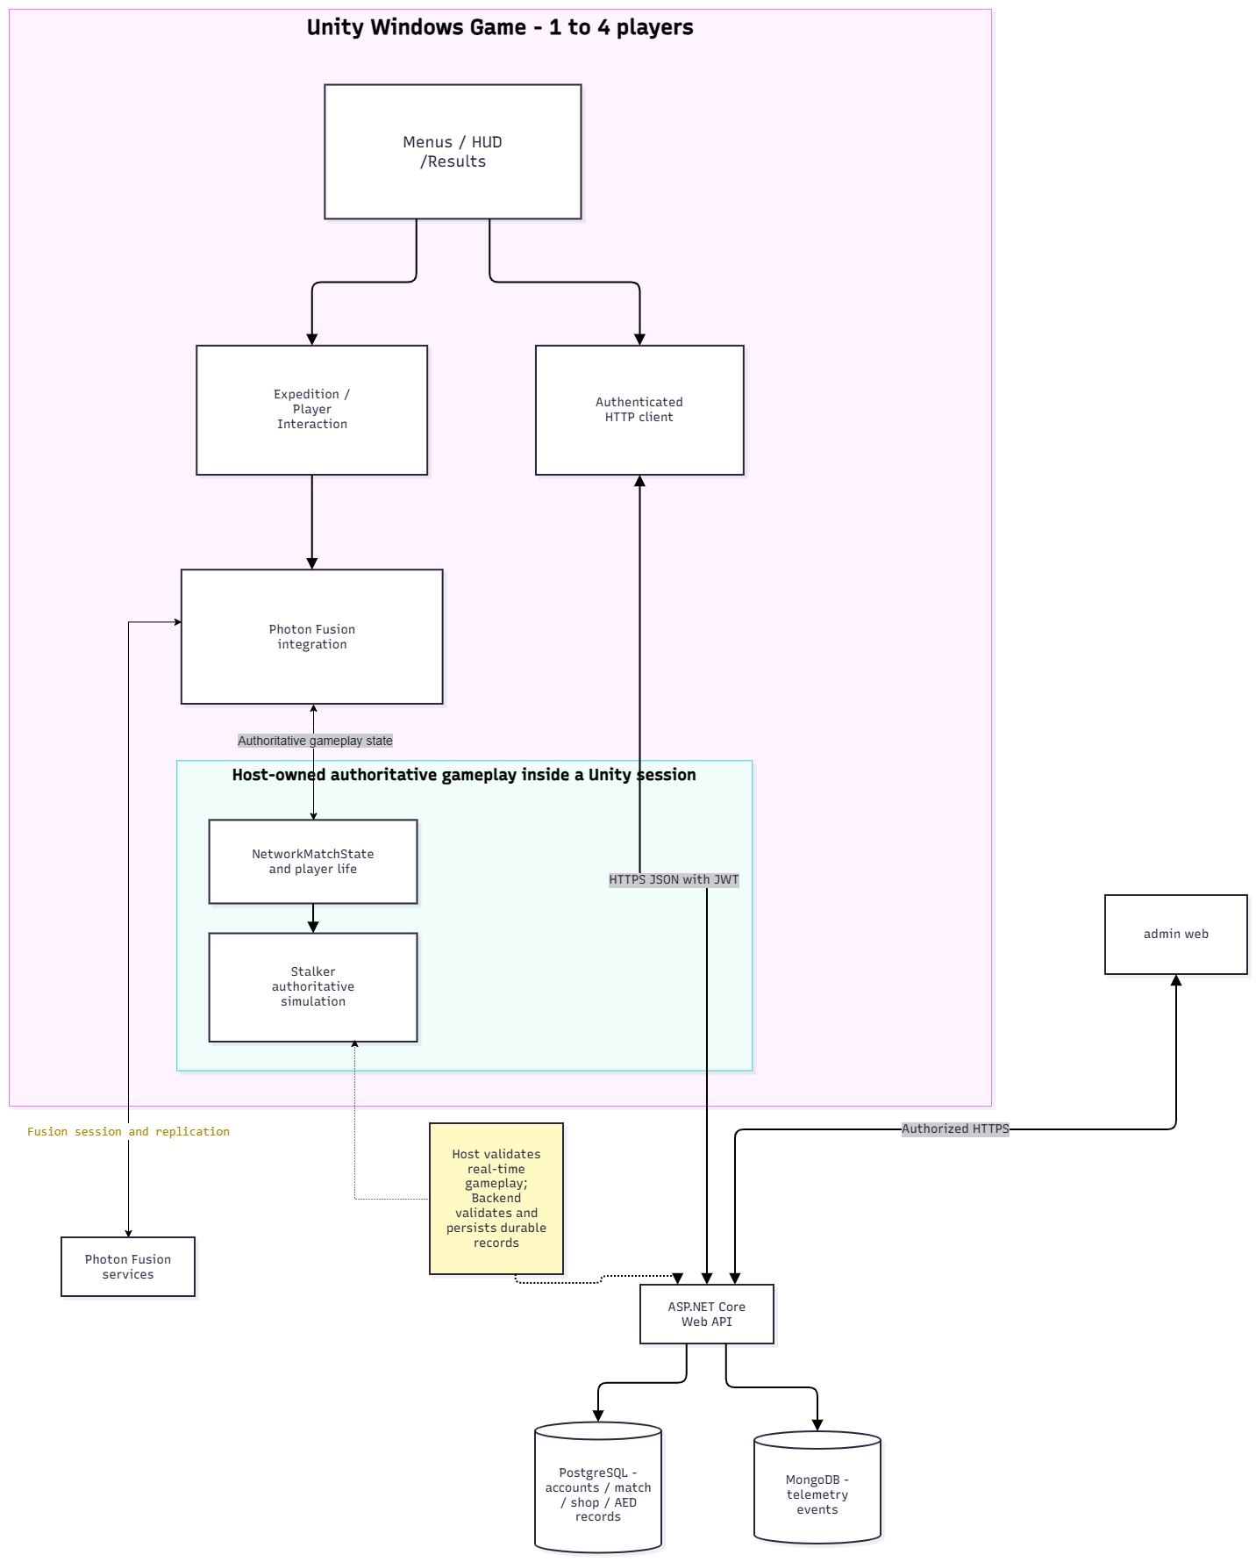
Figure 1. Overall logical architecture and external interfaces
Component | Key responsibility | Integration
Unity client | Input, player actions, expedition controllers, AI presentation, HUD, menu, result and shop | Photon networking; HTTPS API
Photon Fusion / Host | Session membership, network runner, replicated state; host-only authoritative gameplay mutation | Fusion protocol / callbacks / RPC
ASP.NET Core API | Authentication, authority binding, result validation, reward, shop, roles, scenario records | HTTPS JSON / JWT
PostgreSQL | Relational identity, progression, economy, match and scenario records | EF Core / Npgsql
MongoDB | Backend-ingested gameplay event telemetry. | MongoDB driver / repository
Admin web | View limited protected user/economy data and permitted auditable changes | Authenticated Backend API

1.1.1 Authority and Data Boundaries
Player requests do not directly own final mission state. Locally collected input or interaction commands are validated at State Authority before any corresponding replicated state is changed. Client HUD and effects read the accepted Networked state. The Backend must independently validate Host identity and registered match before committing results, rewards, and wallet transactions; a client display is not evidence of server acceptance.

1.1.2 Main Interface Contracts
Interface | Transport / Authority | Design constraints
Unity <-> Photon Fusion | NetworkRunner, NetworkBehaviour, RPC, Networked state | Host validation; no direct arbitrary client commit of objective/result
Unity / authorized Host <-> Backend | HTTPS REST + JWT | Validate identity/roster/permissions; return explicit rejection
Backend <-> PostgreSQL | EF Core transactions | Consistency, unique keys, idempotency for reward/purchase
Backend <-> MongoDB | Telemetry repository | Match identity, event sequence, timestamps and schema version
Admin Web <-> Backend | Authorized HTTPS API | RBAC enforced server-side, not only hidden UI controls
Unity/Web <-> Agreement API | HTTPS JSON/JWT; GET documents/status, POST accept | Current bundle/hash match; all required flags; 403 AGREEMENT_REQUIRED for protected operations; no cash/payment obligation added.

1.1.3 Deployment View (Logical)
ECHO PROTOCOL runs as a Windows Unity client connected to Photon Fusion Host Mode and an ASP.NET Core backend deployed on AWS EC2. GitHub Actions supports build and release workflows, while Docker Compose manages backend, web and database services. PostgreSQL and MongoDB connection settings are supplied by environment configuration. The design snapshot corresponds to LTP commit 3c853fec.

1.1.4 Technology, DevOps and External Services
Technology, integration services and workflows for the reviewed LTP baseline are listed below.
CATEGORY | VERSION / SERVICE | PURPOSE / DATA / VERIFICATION
Game engine | Unity 6000.5.8f1; C#; Photon Fusion Host Mode | Windows game, network session membership, replicated gameplay; Photon service receives session/connection data.
Backend / web | .NET 8 / ASP.NET Core; Next.js 16.4.3 | Authenticated REST APIs; limited Admin UI. JSON/JWT, authorization and explicit errors.
Databases | PostgreSQL (EF Core/Npgsql 8.0.11); MongoDB.Driver 3.11.0 | Relational user, match, reward and economy records; MongoDB event telemetry. Server versions depend on deployment.
Deployment / CI | GitHub Actions; Docker Compose; AWS EC2 | GitHub Actions pipelines build and check backend/Unity code; Docker Compose supports AWS EC2 deployment and operational scripts.
External services | Photon Fusion; AWS | Photon Fusion handles network sessions; AWS hosts backend/data services.
AI tools used | OpenAI ChatGPT (GPT-6) | Assisted with requirements, documentation, diagram/source review and test planning; project team verifies technical decisions.

1.2 Package Diagram

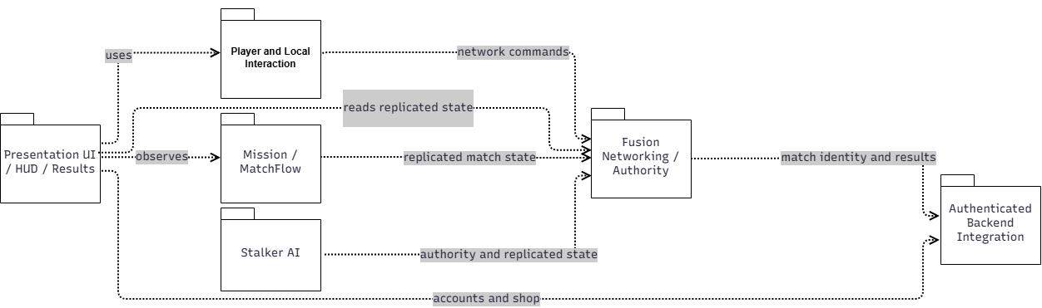
Figure 2. Unity gameplay and networking packages

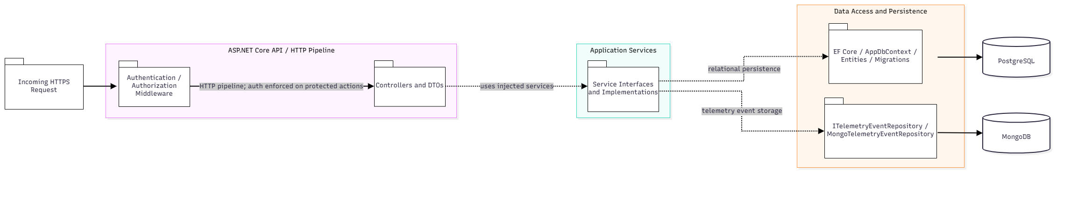

Figure 3. Backend and persistence packages
No. | Package | Description / source area
01 | Presentation | MainMenu, Lobby UI, HUD, Result and shop presentation components.
02 | Player & Interaction | Handles local player input, equipment and interaction prompts.
03 | Mission & Match Flow | MatchFlowController, energy cores, objectives, power/security, evacuation.
04 | Stalker AI | StalkerController, StalkerVisionSensor, StalkerFusionRuntime, scenario resolution.
05 | Networking & Authority | Manages Fusion sessions, RPCs, player life state, replicated match state and Host authority.
06 | Backend API / Services | Controllers, DTOs, authentication, match, reward, purchase, inventory and admin services.
07 | Persistence & Telemetry | AppDbContext entities/migrations; MongoTelemetryEventRepository.

2. Database Design

2.1 Data Storage Strategy
PostgreSQL is the authoritative source for persistent user and transactional records. Tables are mapped with Entity Framework Core via AppDbContext. MongoDB stores event-oriented telemetry records used by analysis and adaptive inputs. Photon replicated state (e.g., current mission phase, player life and enemy state) is transient session state and should not be modeled as a database table unless it is explicitly persisted by a backend contract.

2.2 Relational Data Model (PostgreSQL)
The PostgreSQL logical model separates account/economy entities (Figure 4) from match, reward and adaptive-decision entities (Figure 5). A versioned acceptance record, UserAgreementAcceptances, references Users by UserId and uses the composite key (UserId, BundleVersion),
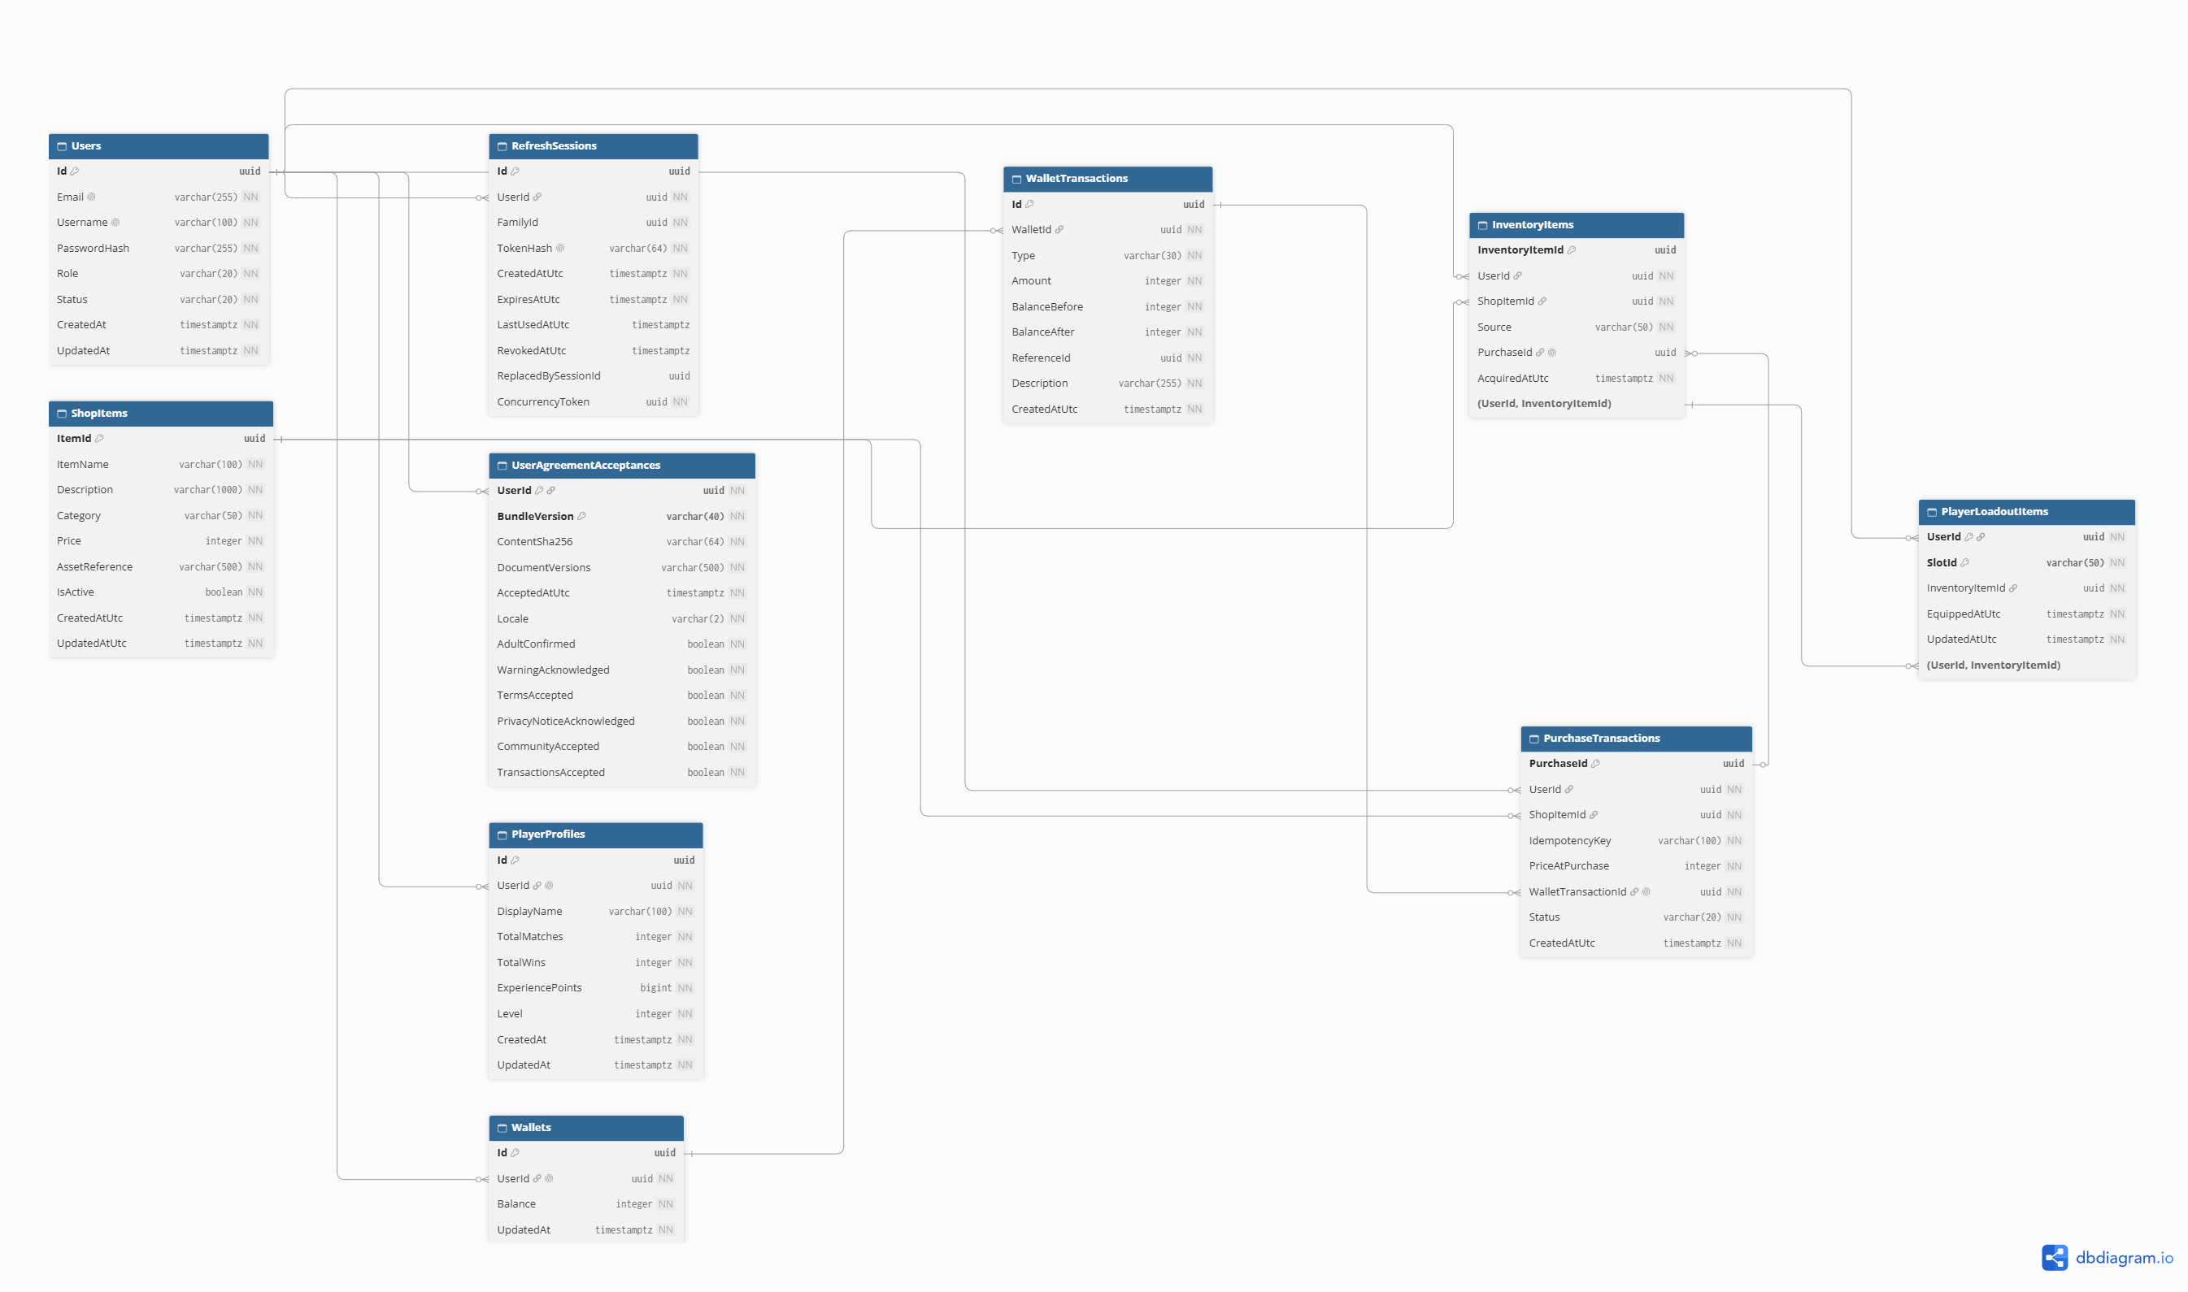
Figure 4. Core account and virtual economy ERD (logical cardinalities)

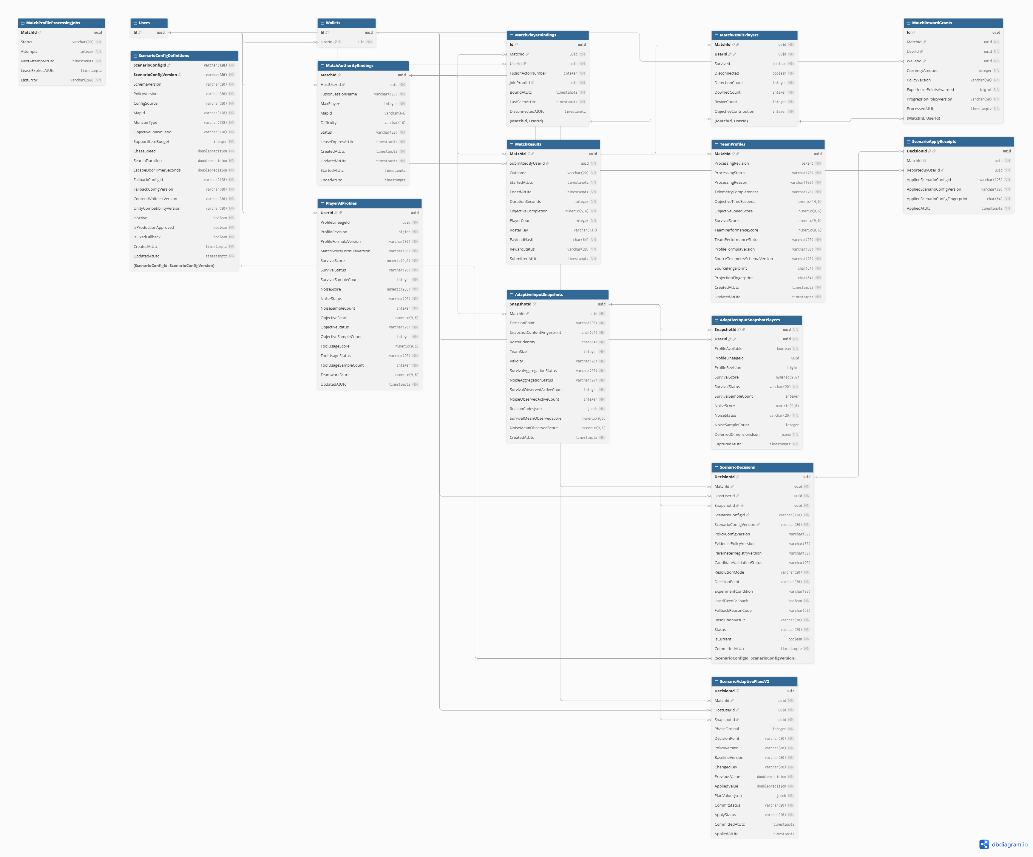
Figure 5. Core match, reward and adaptive-record relationships

2.2.1 Table Descriptions – Accounts and Economy
Table | Purpose / key fields
Users | PK Id; account identity, hashed password, role and status.
RefreshSessions | Authentication refresh sessions; user reference, token hash and expiry/concurrency constraints.
PlayerProfiles | Account progression and profile data; one-to-one user association.
Wallets | PK Id, FK UserId; persistent ECHO Credits balance.
WalletTransactions | PK Id, FK WalletId; type, amount, before/after balance, reference identity.
ShopItems | Eligible server-side catalogue, price, status and category.
PurchaseTransactions | PK PurchaseId, FK UserId, ShopItemId, WalletTransactionId; IdempotencyKey.
InventoryItems | PK InventoryItemId, FK UserId, ShopItemId, optional PurchaseId; ownership source.
PlayerLoadoutItems | Account equipment selections referencing owned compatible inventory.  PK (UserId, SlotId); composite FK to owned inventory.
UserAgreementAcceptances | UserId FK → Users; composite PK (UserId, BundleVersion). Version/hash, document versions, UTC acceptance, locale and six acknowledgement flags; added by LTP migration 20261030090842.

2.2.2 Table Descriptions – Match, Reward and AI
Table | Purpose / key fields
MatchAuthorityBindings | PK MatchId; Host UserId, room binding, status, lease and selected match configuration.
MatchPlayerBindings | Participant identity/roster binding associated with authoritative match.
MatchResults | PK MatchId; authoritative match outcome, duration, submitted-by user and roster identity.
MatchResultPlayers | PK (MatchId, UserId); per-player match result and objective/survival statistics.
MatchRewardGrants | PK Id; MatchId, UserId, WalletId, CurrencyAmount, XP and policy versions.
MatchScores | Validated match scoring records associated with players/results.
PlayerAIProfiles | PK/FK UserId; aggregated player behaviour/profile data for AED inputs.
TeamProfiles | PK/FK MatchId; aggregated team-level behaviour/result data.
ScenarioConfigs / ScenarioContentDefinitions | Versioned allowed scenario configurations and content.
AdaptiveInputSnapshots / AdaptiveInputSnapshotPlayers | Pre-match observed input snapshot and constituent players.  PK (SnapshotId, UserId); player snapshot data.
ScenarioDecisions / ScenarioApplyReceipts | Decision identity, version/fingerprint, fallback reason and application receipt.  PK/FK DecisionId; records scenario application.

2.2.3 Persistence Integrity Rules
- Wallet balances must not be trusted from Unity input. PurchaseService checks eligible item, ownership and available balance, and creates ledger + purchase + inventory grant within a database transaction.
- A repeated purchase IdempotencyKey must not charge Credits again or duplicate ownership. Conflicting replay requests must be rejected.
- MatchResultService checks Host authorization, active match state, roster and accepted result identity before committing. RewardService grants the corresponding reward once, with replay handling.
- Physical constraints and indexes are defined in EF Core model configuration and migrations.

2.3 Telemetry Document Model (MongoDB)
Field | Type / role
Id | Guid; event document identity
MatchId | Guid; match correlation
UserId | Nullable Guid; user correlation if applicable
EventType | String; event classification
Ts | UTC timestamp of source event
EventSequence | Long; authoritative event ordering
ValueJson | BSON document; event payload
ReasonCode | Optional string; explanation for outcomes
SchemaVersion | String; compatibility/version
SemanticFingerprint | String; replay/content identity
IngestedAt | UTC ingestion timestamp

3. Detailed Design

3.1 Account Authentication and Profile
After authentication, Unity/Web requests agreement status and current documents through GET /api/agreements/status and GET /api/agreements/documents. The player accepts the matching bundle version/hash and required declarations via POST /api/agreements/accept. UserAgreementAcceptances stores the accepted version, locale, time and flags. AgreementGateMiddleware blocks protected match, scenario, write-inventory and purchase operations with 403 AGREEMENT_REQUIRED until consent is valid.

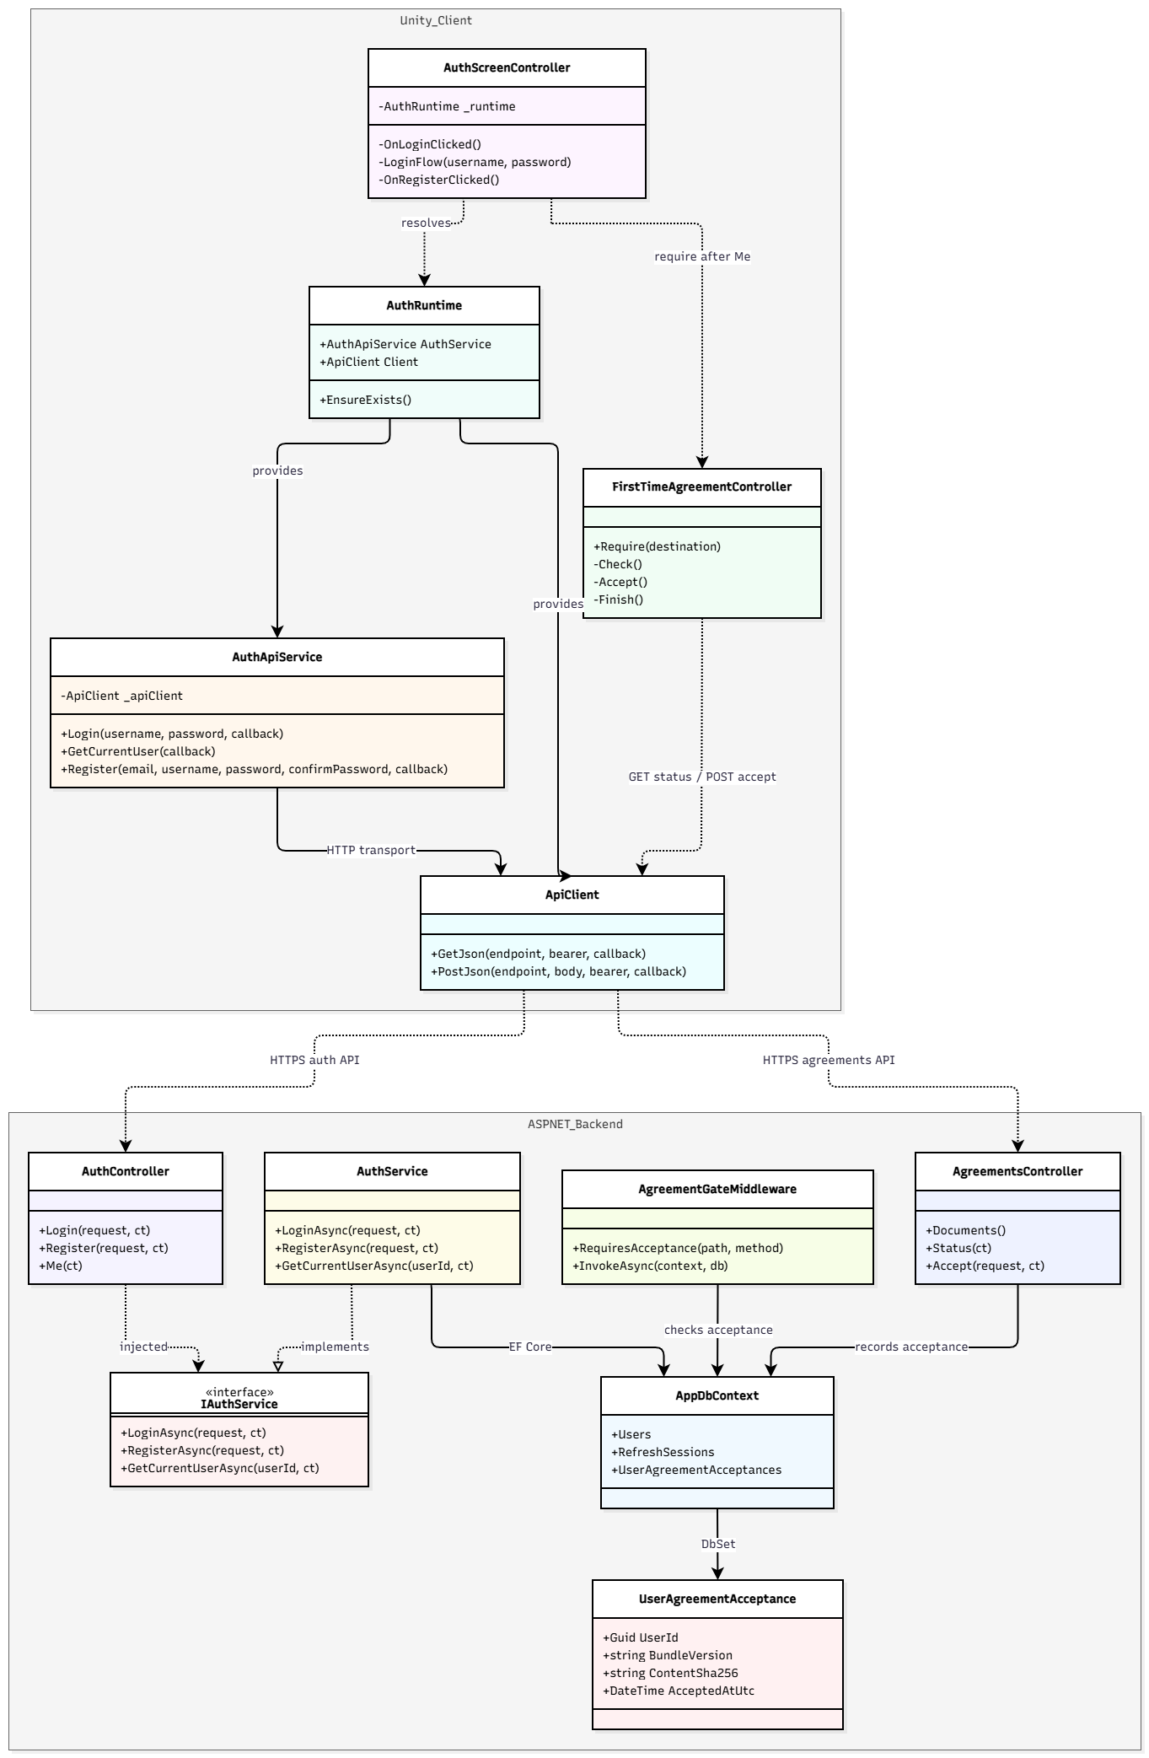
Figure 6. Selected authentication class/component diagram
Class / Component | Design responsibility / selected operations
AuthScreenController / AuthRuntime | Handles authentication UI and initializes Unity authentication services.
AuthApiService / ApiClient | Manages authentication requests, tokens and HTTP communication.
AuthController | Exposes protected authentication endpoints.
IAuthService / AuthService | Validates credentials and manages token issuance and refresh.
AppDbContext / User | Persists user identity, account status and authentication records.

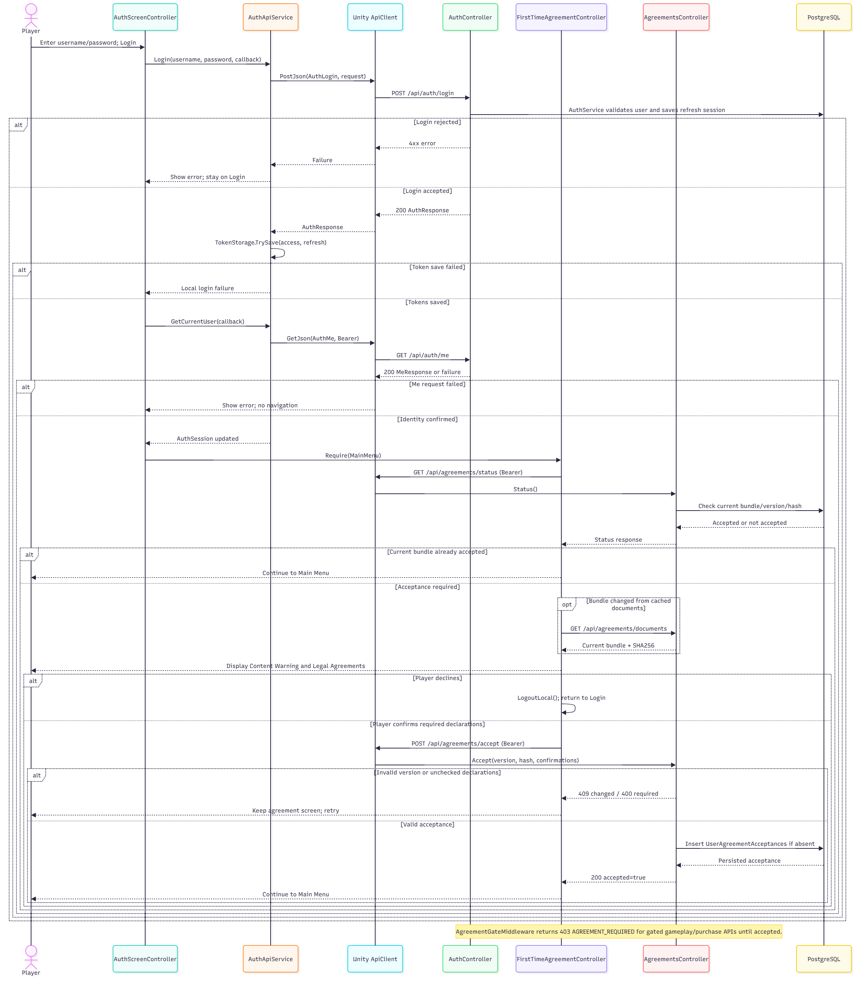
Figure 7. Login and authenticated session sequence

3.2 Multiplayer Lobby and Session Lifecycle
Field | Specification
Purpose | Create/join a private room, synchronize player readiness and start a host-authoritative Expedition.
Inputs / triggers | Room name, maximum room capacity, ready flags, selected difficulty/mode and Start input.
Authority / owner | NetworkBootstrap owns the runner; LobbyManager requests and validates Host-only start; MatchAuthorityRuntime binds backend authority.
Failure / negative path | Reject missing session, full/invalid room, non-host start, missing ready state or backend binding failure; never assume success on a failed transition.
SRS trace | FR-MUL-01–05; UC-03–05

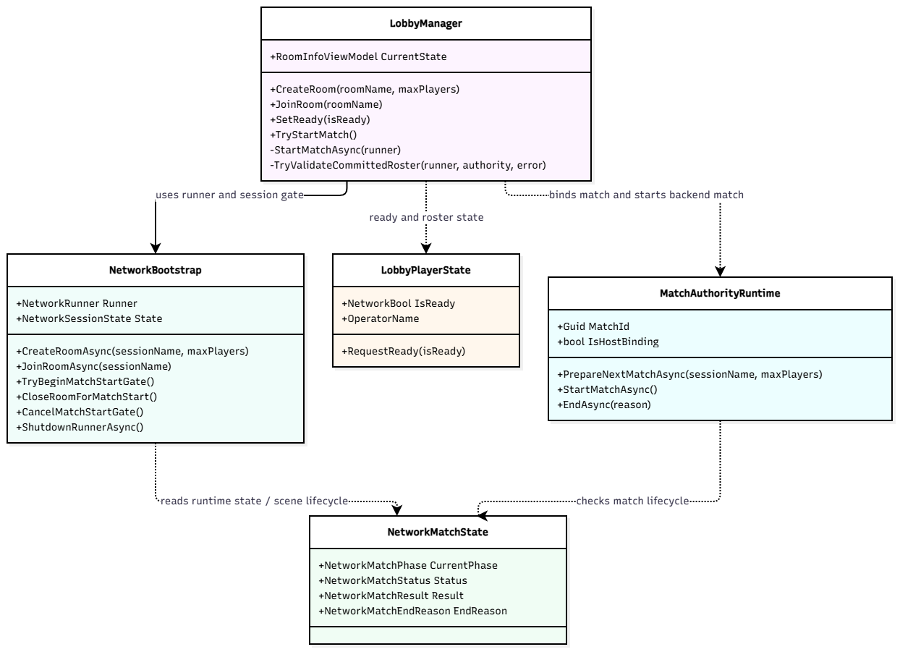
Figure 8. Lobby, runner and authoritative match state classes
Class / Component | Design responsibility / selected operations
NetworkBootstrap | NetworkRunner lifecycle; CreateRoomAsync, JoinRoomAsync, disconnect/reconnect and scene transitions.
LobbyManager / LobbyPlayerState | Lobby UI projection, ready and host-controlled match-start gate.
MatchAuthorityRuntime | Authoritative match binding and backend start flow.
NetworkMatchState | Replicated match state, phase and terminal outcome.

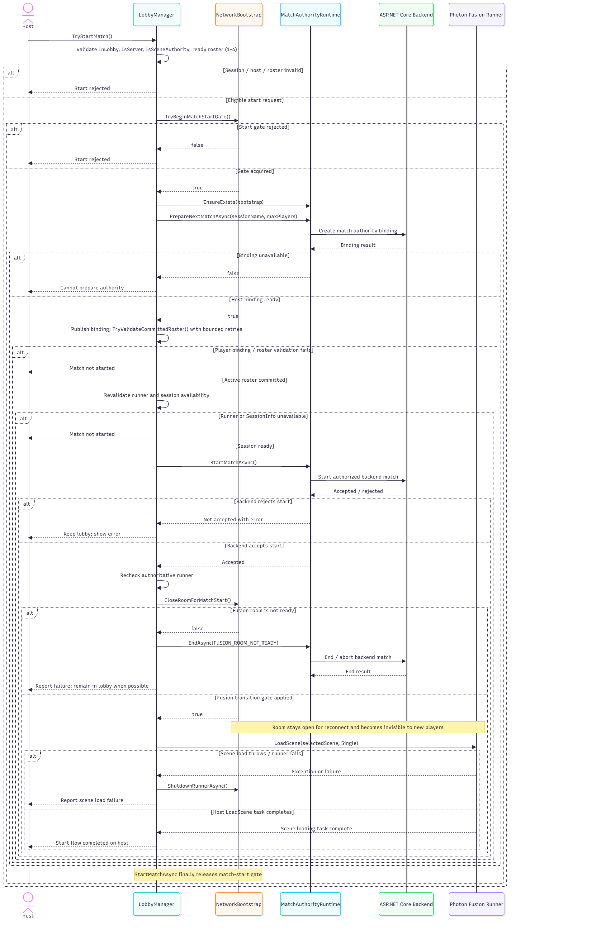
Figure 9. Host starts a private Expedition sequence (simplified)
Expedition supports 1–4 active players, including solo Host. The room capacity and number of active participants are separate; a Host-only start gate verifies membership/readiness and backend match authority before transitioning to gameplay.

3.3 Player Interaction, Life State and Revive
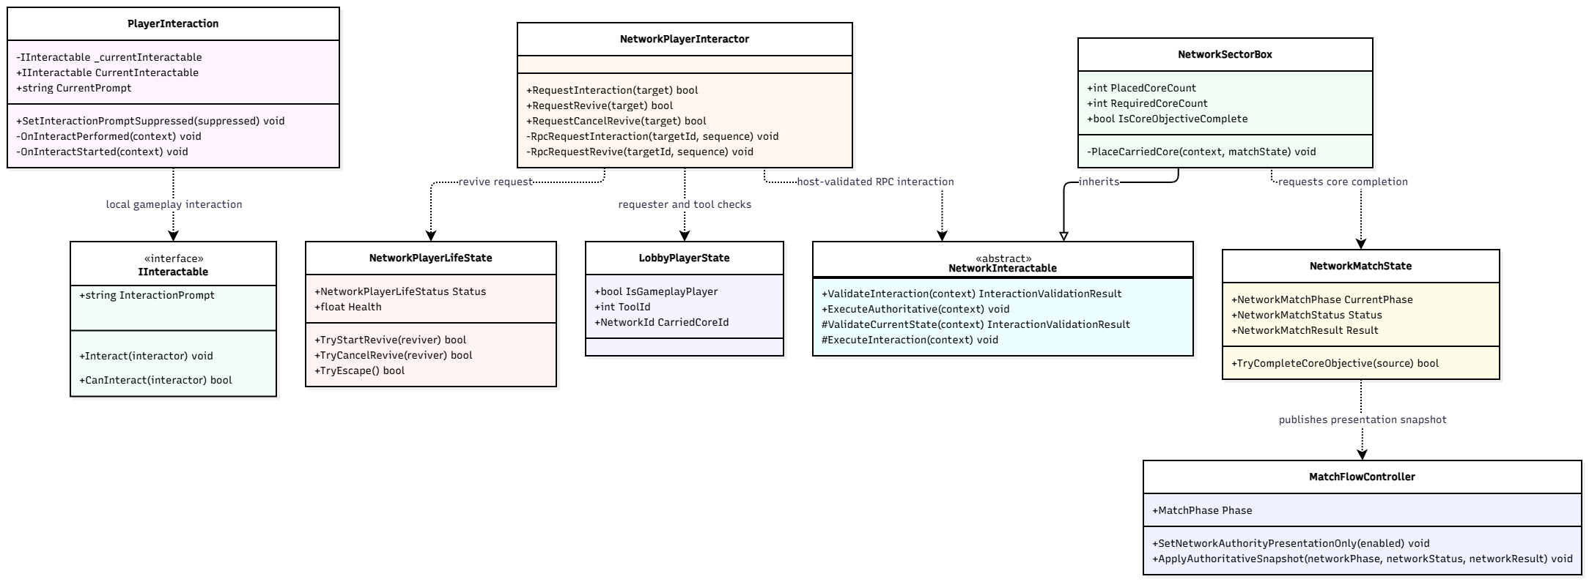
Figure 10. Selected player, objective and authoritative gameplay classes
Class / Component | Design responsibility / selected operations
PlayerInteraction / IInteractable | Detect eligible raycast target, issue interaction and publish prompt.
NetworkPlayerLifeState / Rules | Alive, Downed, Eliminated, Escaped and Caught; validate revive and damage.
NetworkMatchState | Game-wide authoritative state, ending and integration.
NetworkPlayerInteractor / NetworkInteractable | Sends and validates authoritative network interaction requests through Fusion RPCs.

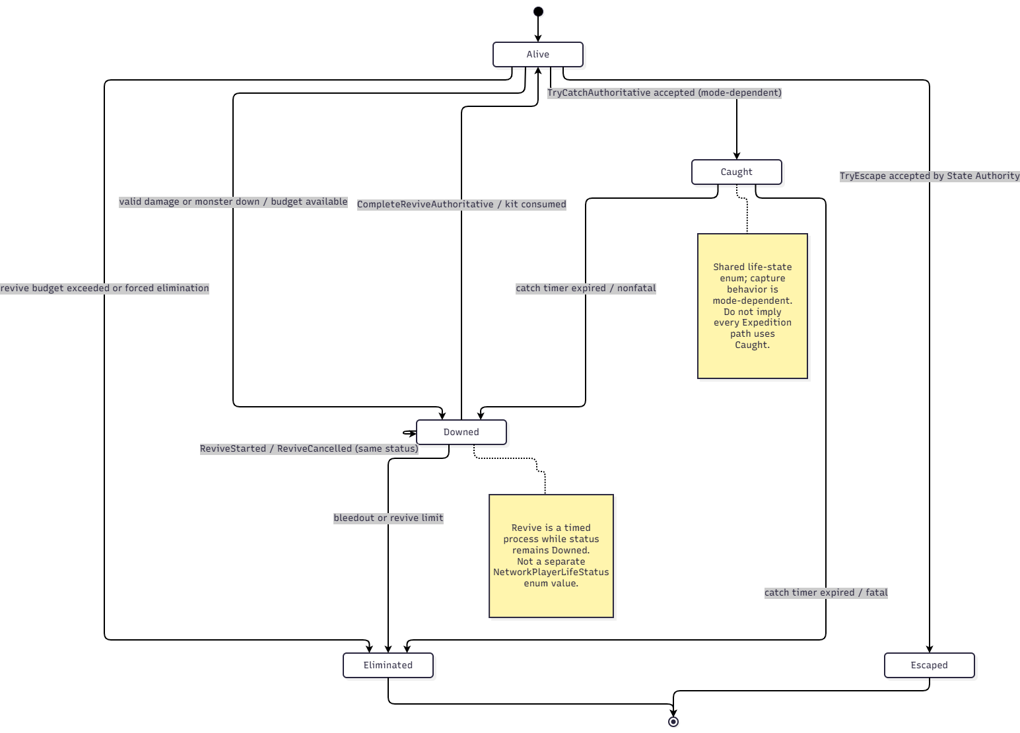
Figure 11. Player life-state transitions (abstracted from NetworkPlayerLifeStatus)

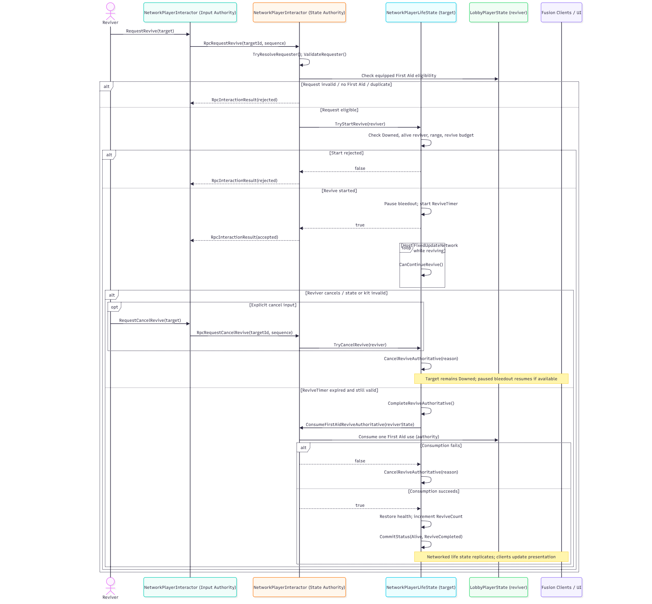
Figure 12. Eligible teammate revive sequence

3.4 Expedition Mission and Objective Control

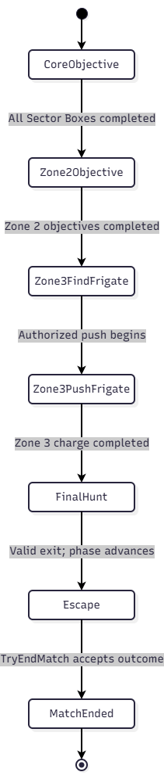
Figure 13. Primary Expedition phase progression (successful path)
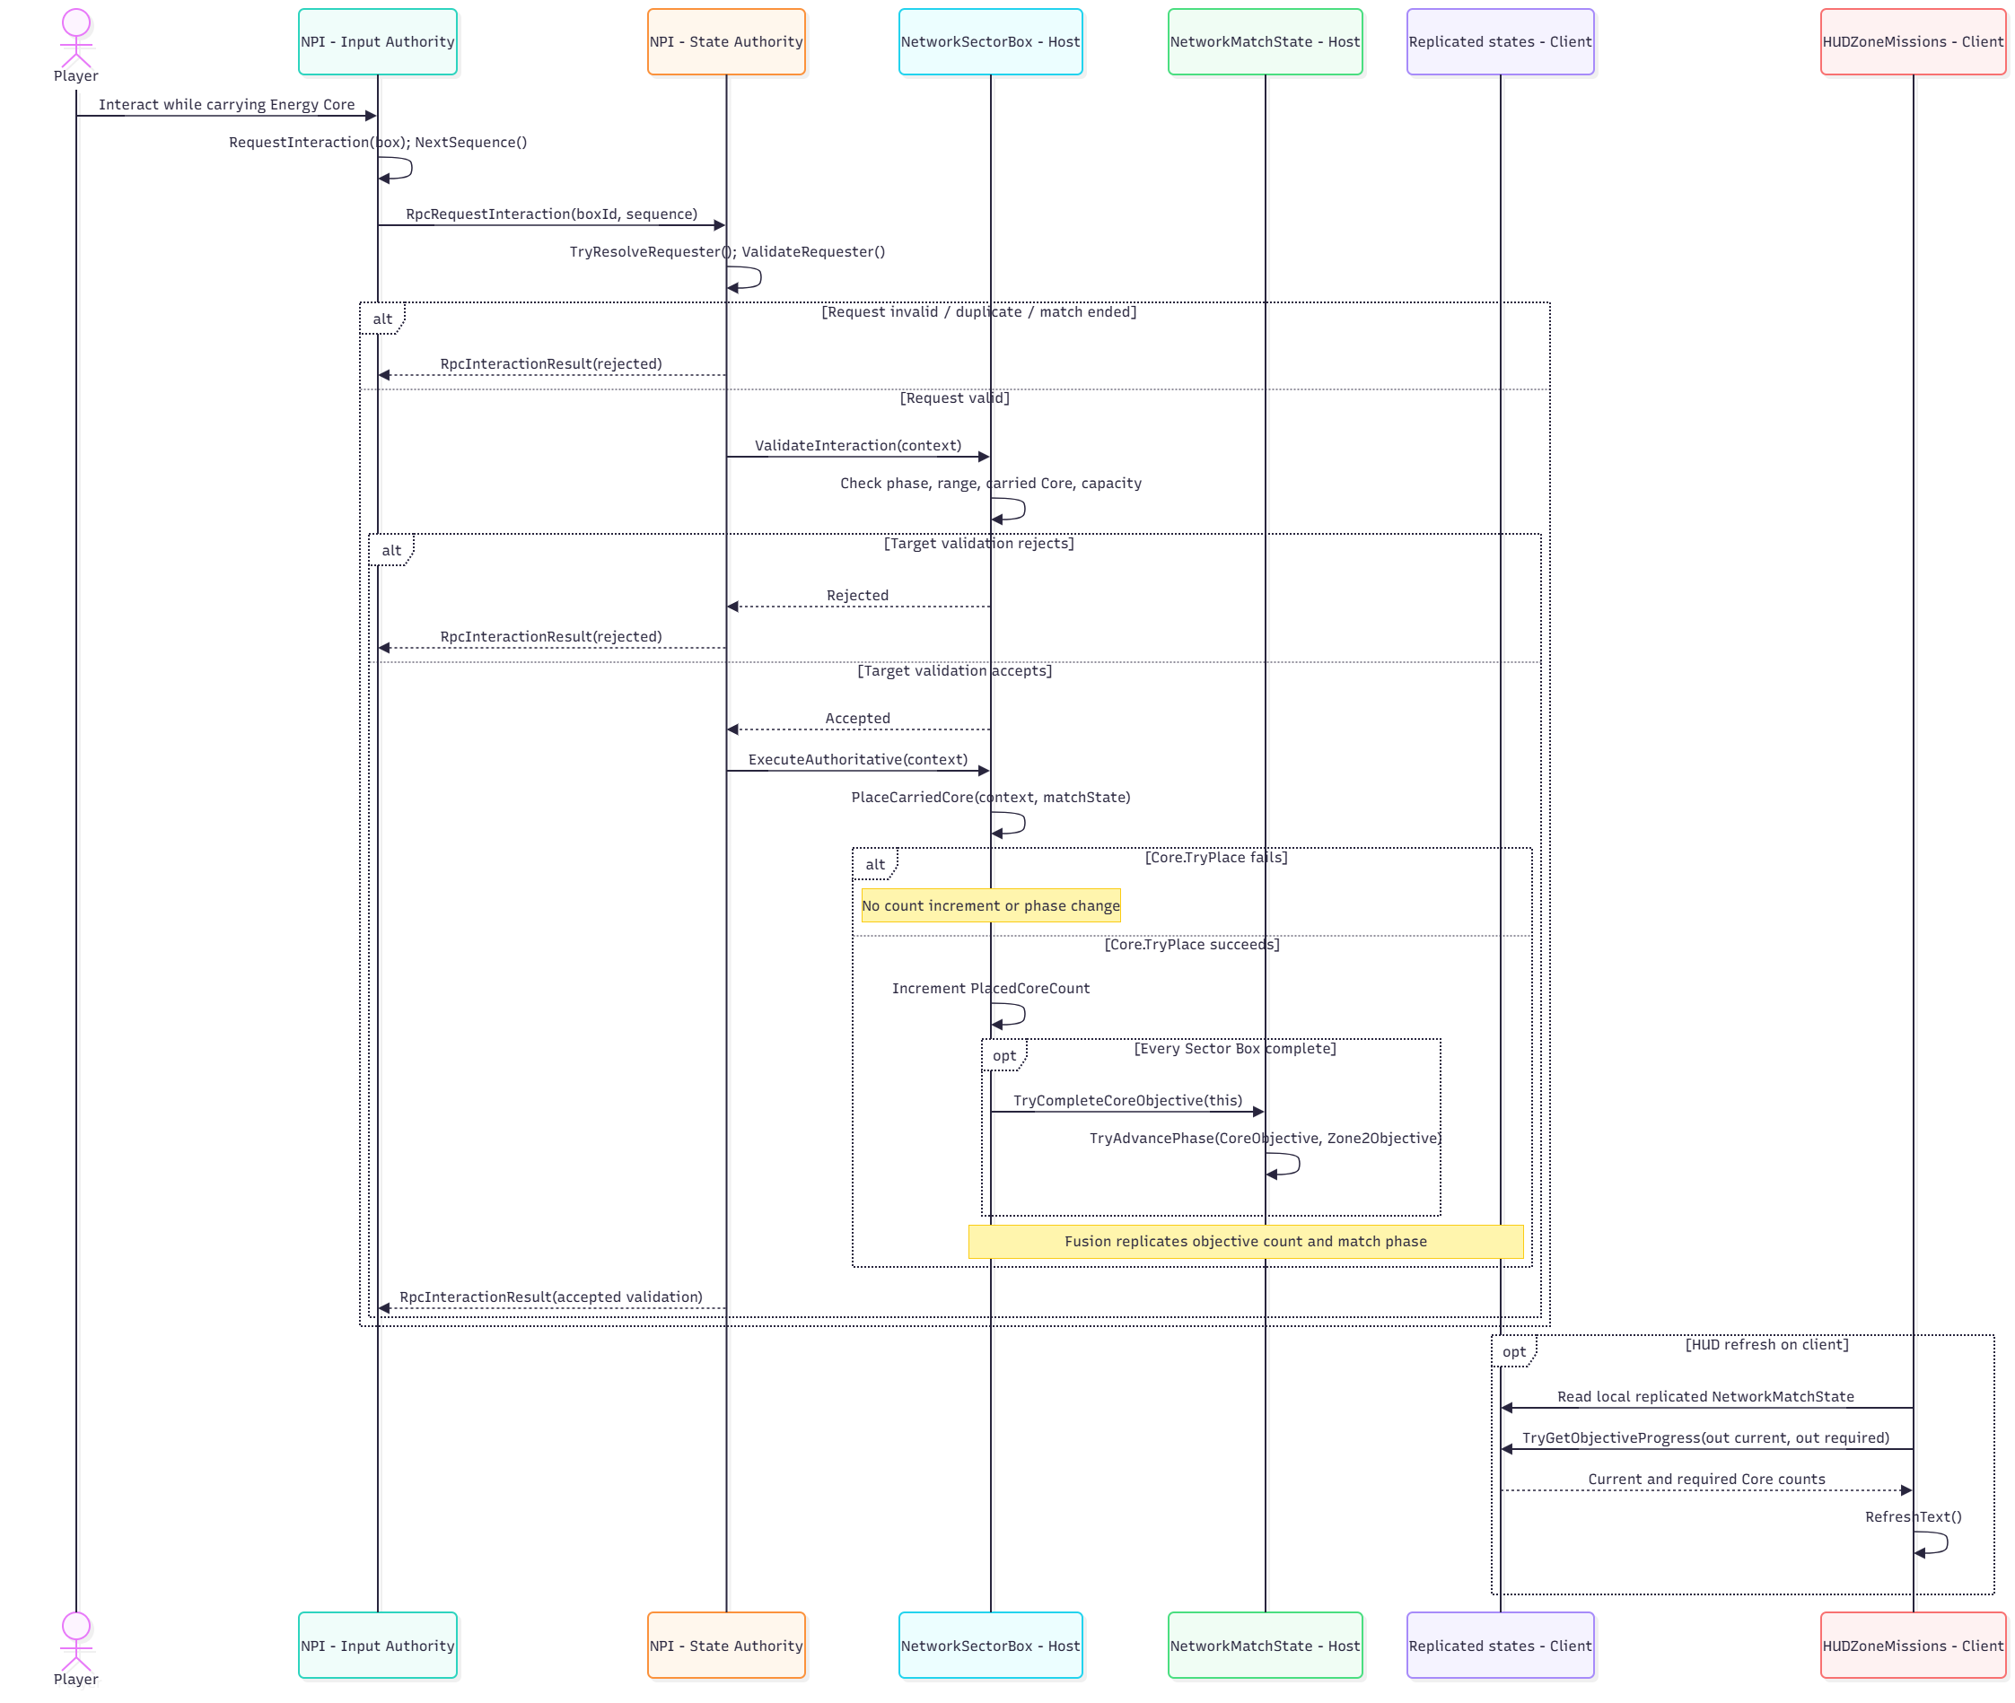
Figure 14. Authoritative objective interaction and HUD update sequence
Class / Component | Design responsibility / selected operations
NetworkPlayerInteractor | Routes interaction requests as RPCs to the owning State Authority, which validates them.
NetworkSectorBox | Validates Energy Core insertion against authoritative state and updates accepted objective progress.
NetworkMatchState | Owns replicated mission phase, objective flags and match result snapshots.
PlayerInteraction / IInteractable | Selects eligible local targets and displays interaction prompts; cannot directly commit shared state.
Zone2MissionDirector / Zone3MissionDirector | Manages mission prerequisites and scene presentation, using Host-accepted game state.

3.5 Stalker Monster AI
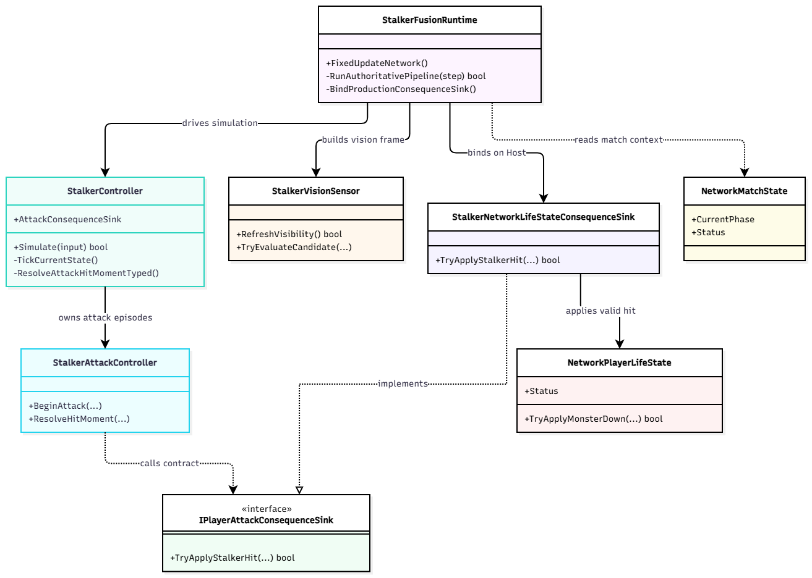
Figure 15. Stalker AI class/component diagram
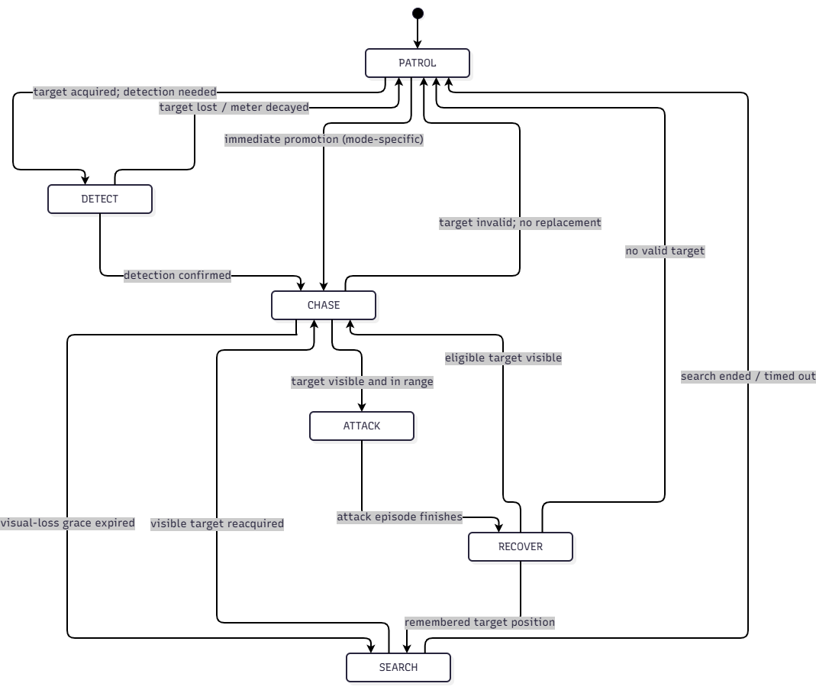
Figure 16. Primary Stalker finite-state machine (logical transitions)
StalkerState enum includes PATROL, DETECT, CHASE, ATTACK, RECOVER and SEARCH. The diagram expresses expected high-level transitions; it does not assert every runtime transition must traverse the same path. Exact vision angle, range, noise scoring, UV resource and cooldown are controlled by serialized/game settings and require scene tests.

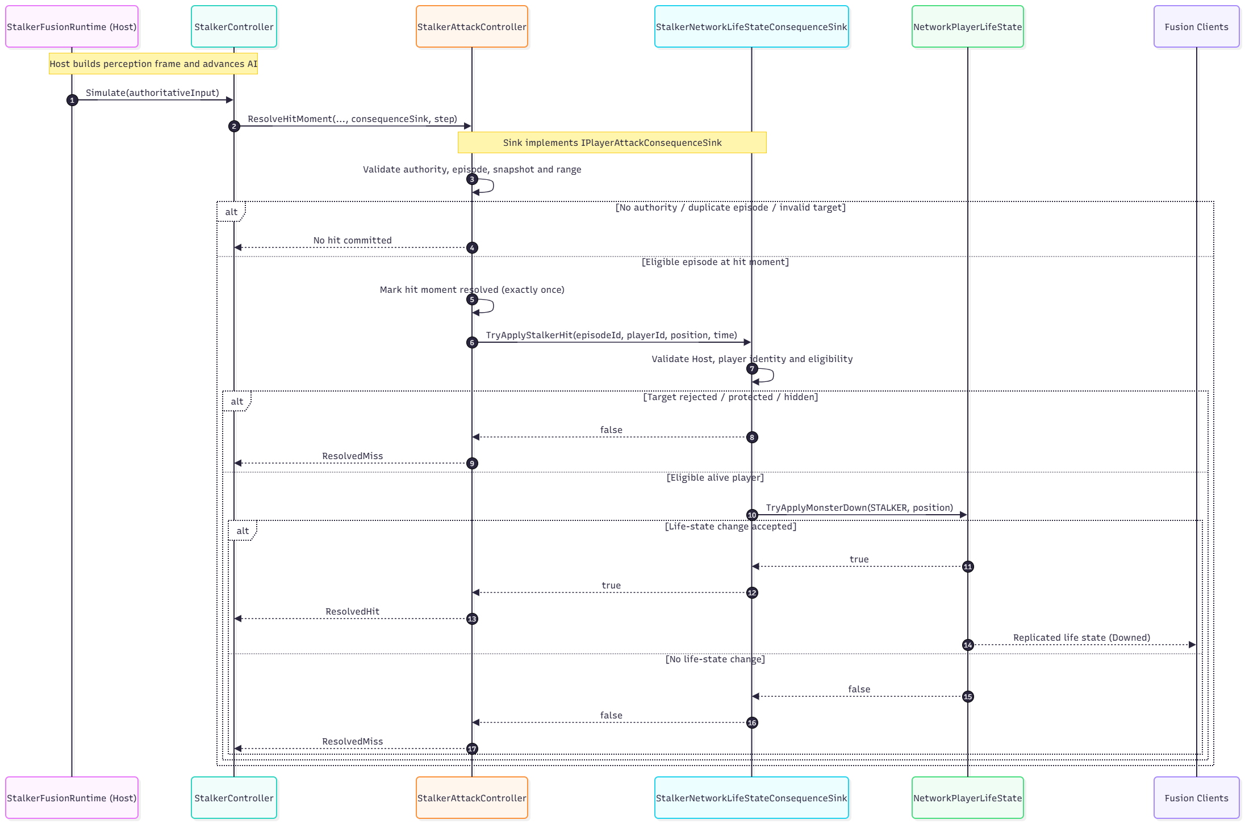
Figure 17. Host-authoritative Stalker attack and replicated outcome sequence

3.6 Adaptive Experience Director and Telemetry
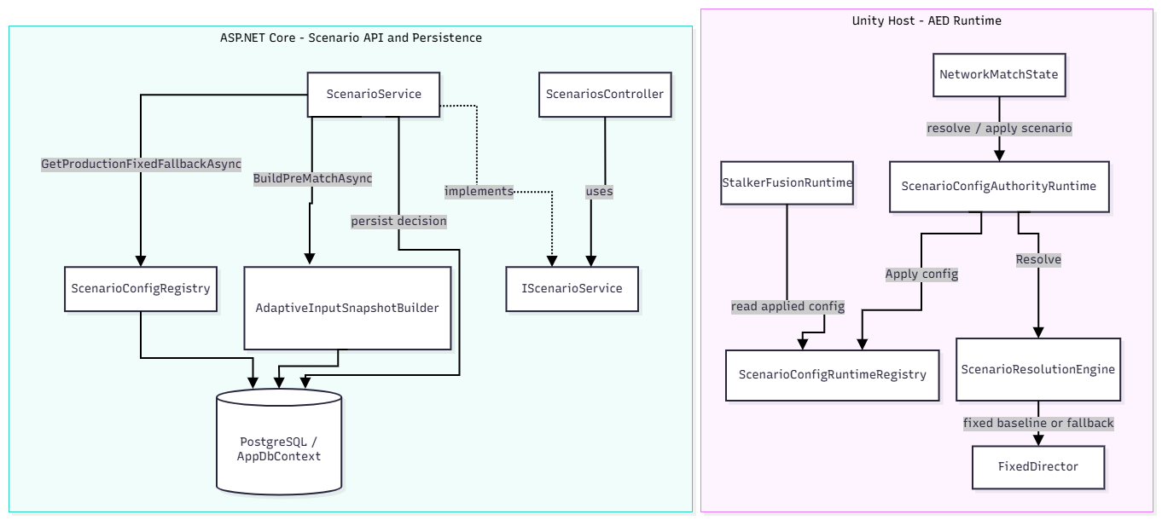
Figure 18. AED and pre-match scenario decision components
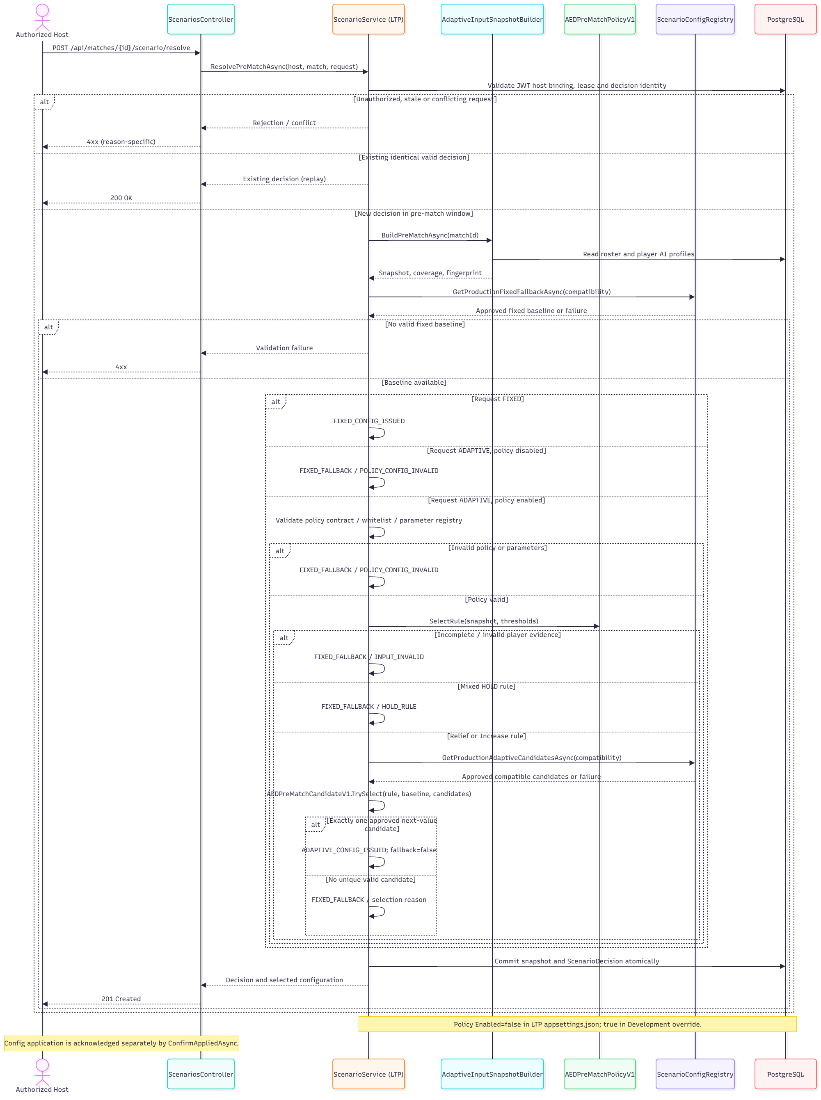
Figure 19. Pre-match scenario resolution with bounded Adaptive selection and Fixed Fallback

ScenarioService loads an approved fixed baseline for every resolution. When Adaptive mode is requested and AEDPreMatchPolicy is enabled, it validates the policy contract and observed Survival/Noise team evidence, then selects an allowed configuration within bounded support-item/chase-speed candidates. Missing evidence, invalid policy or unavailable candidates lead to a fixed fallback with a recorded reason. The decision, fingerprint and applied configuration are persisted for traceability; in-match pilot extensions remain separately gated.

3.7 Match Result and Reward Processing
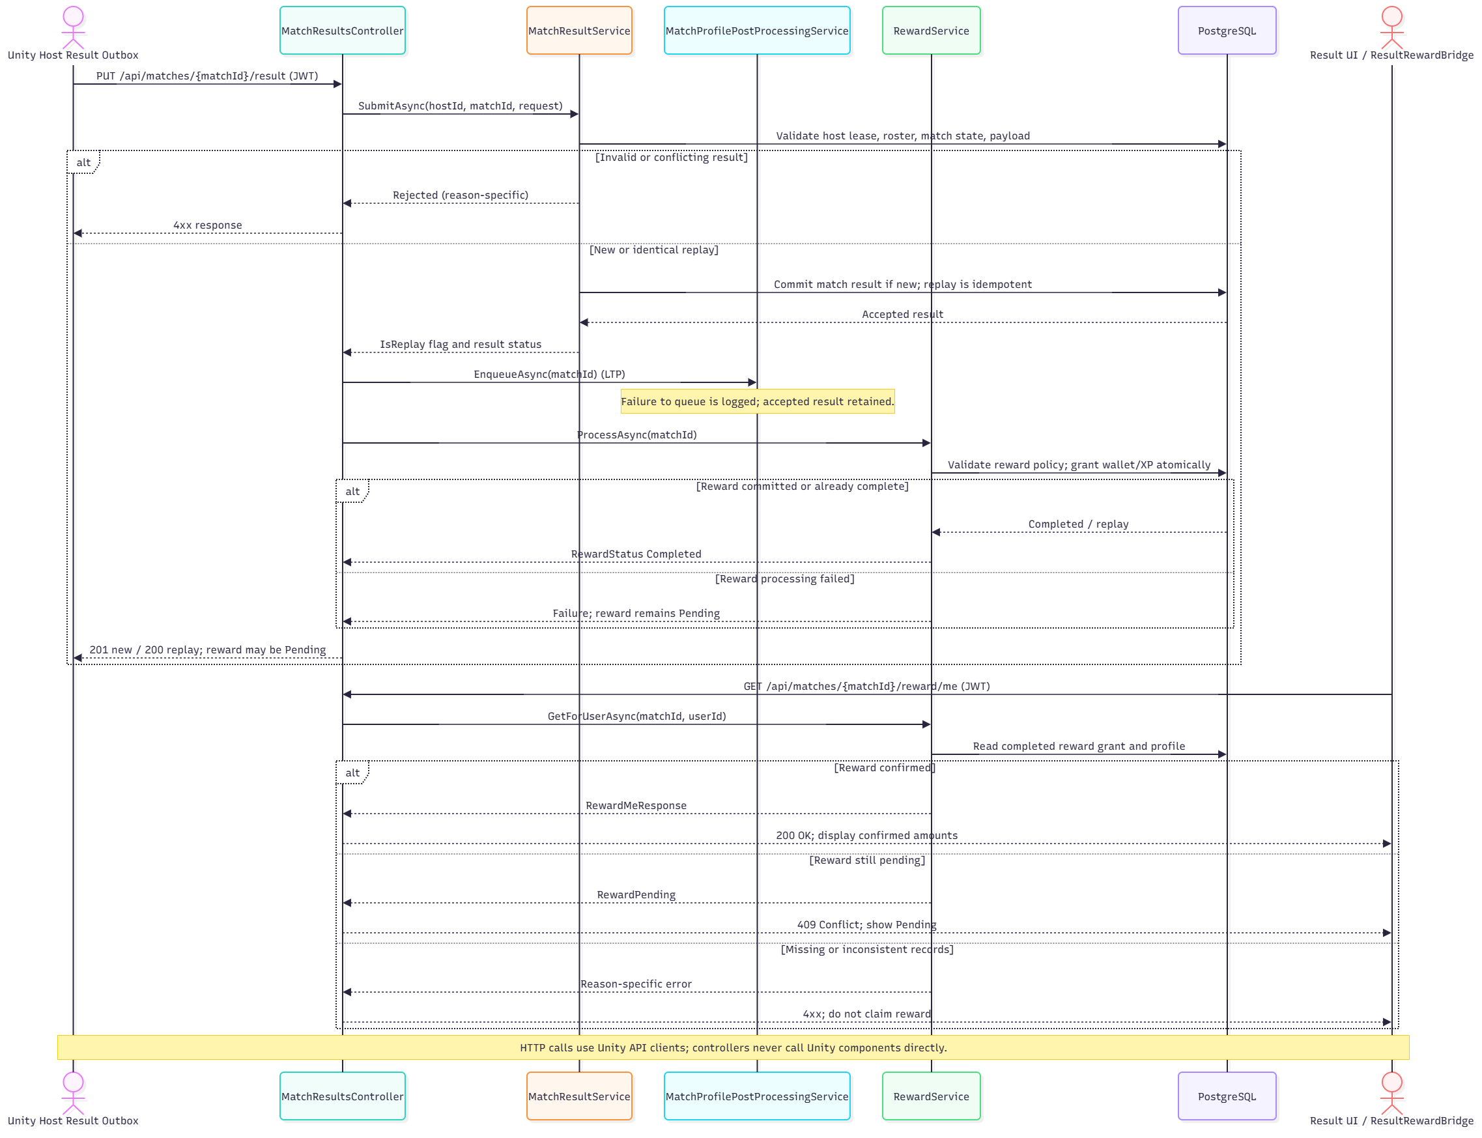
Figure 20. Match result validation, replay handling and reward-processing flow
Class / Component | Design responsibility / selected operations
MatchResultsController | Receives PUT /api/matches/{matchId}/result with authenticated user.
MatchResultService | Checks Host binding, match status, lease, roster, payload and idempotent replay.
RewardService | Applies configured reward/progression policies and stores one set of grants.
ResultRewardBridge | Loads confirmed player rewards through the backend API and distinguishes confirmed, pending and failed reward states.

3.8 Virtual Shop, Wallet and Inventory
Field | Specification
Purpose | Buy eligible items using persistent ECHO Credits, grant ownership and maintain an auditable ledger.
Inputs / triggers | Authenticated UserId, ShopItemId and IdempotencyKey.
Authority / owner | Backend PurchaseService and PostgreSQL transaction; Unity only requests and renders server-accepted state.
Failure / negative path | Inactive/unavailable item, already owned, insufficient balance, conflicting key, concurrency and unauthorized requests never charge twice.

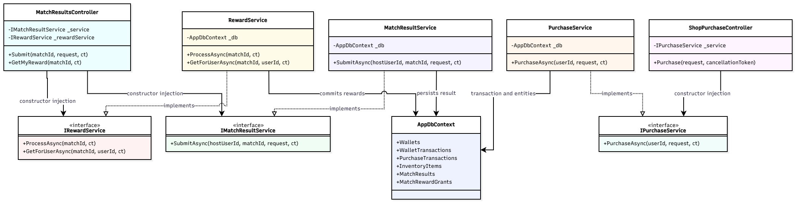
Figure 21. Backend economy and result service dependencies
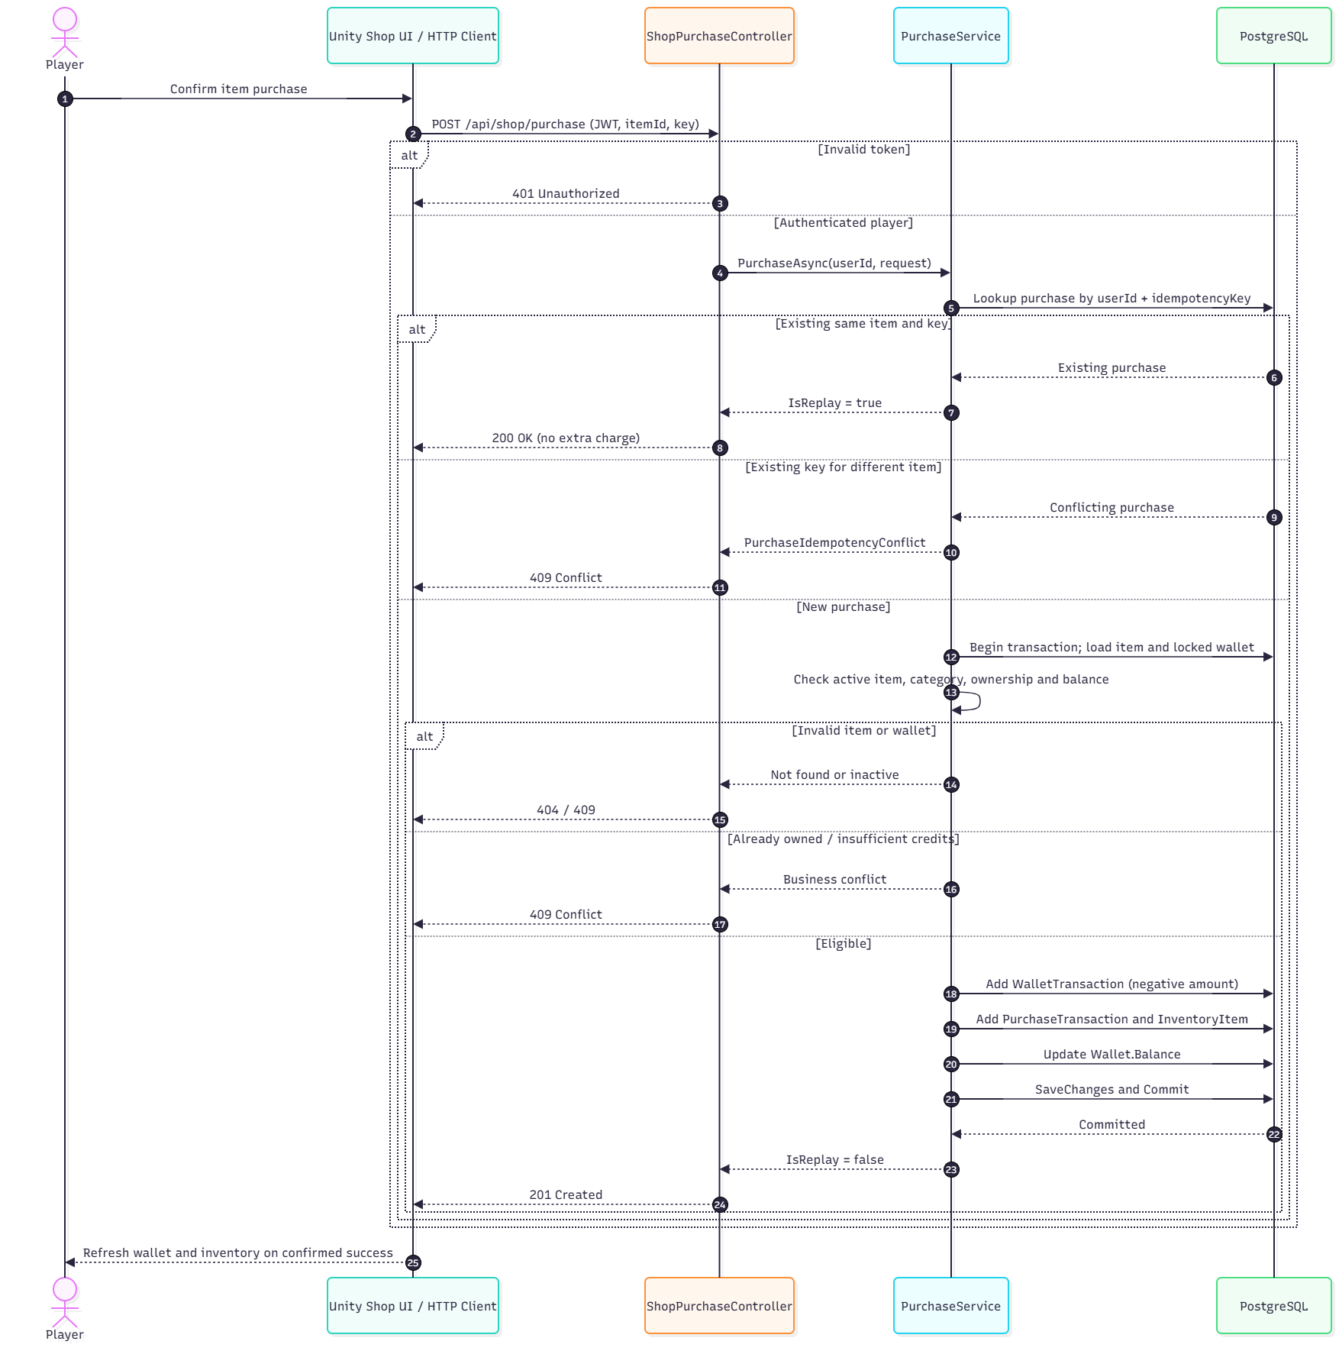
Figure 22. ECHO Credits purchase with atomic updates and replay safety
Class / Component | Design responsibility / selected operations
ShopPurchaseController | Protected POST /api/shop/purchase endpoint.
PurchaseService | Validates price/availability/ownership/balance and handles replay.
Wallet / WalletTransaction | Balance plus immutable debit/grant history.
PurchaseTransaction / InventoryItem | Persistent purchase identity and granted ownership.
InventoryService / LoadoutService | Reads and validates owned/compatible equipment selection.

The registered economy uses ECHO Credits only: validated match rewards or authorized administrative/test allocations. Real-money checkout and payOS are outside the acceptance scope; the limited Admin UI supports permitted, audited operations.

3.9 UI, HUD and Gameplay Feedback
Field | Specification
Purpose | Display mission status, equipment, interaction prompt, teammate life and authoritative result without inventing accepted state.
Inputs / triggers | NetworkMatchState, PlayerLifeState, scene interactions, backend reward/shop responses.
Authority / owner | Local UI renders replicated gameplay state or authenticated API response; server/Host owns accepted mutations.
Failure / negative path | Hide unsupported/inapplicable prompts; show rejected actions, disconnected status, pending reward and session failure correctly.
SRS trace | FR-UI-01–05

Class / Component | Design responsibility / selected operations
Main menu / Lobby UI | Show authorized navigation, selected room/mode/difficulty, ready state and failure feedback.
PlayerInteraction.PromptChanged | Contextual interaction message based on current eligible target.
Match/Player HUD presenters | Read networked objective, status and tool state; update only on actual transitions.
ResultSession / ResultRewardBridge | Distinguish local match outcome from accepted backend reward.
Admin UI | Shows records permitted by backend role; no direct database modification.

Design rule: HUD should be event/state-driven rather than showing all objectives or warnings continuously. Scene-specific art, animation and sound clip lists belong to the GDD/asset inventory; this SDD documents their triggering contracts rather than replicating the full content catalogue.

3.10 Main Business Workflows
Four end-to-end workflows cover authentication and lobby admission, Expedition progression, Stalker encounters and player survival, and result/reward with the virtual economy. All workflows use the selected 1–4-player Expedition scope and Host-authoritative state changes. The diagrams describe design paths; test execution is documented separately in Report 5.

3.10.1 WF-01 – Authentication, Legal Agreement and Lobby
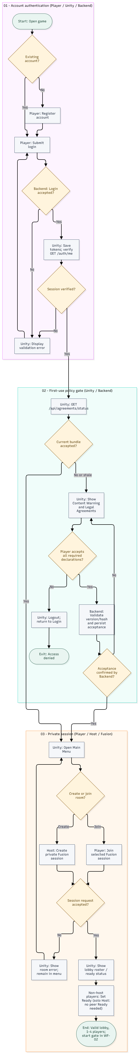
Figure 23. Authentication, Legal Agreement and Lobby Workflow
Field | Description
Owner | Hứa Thành Đạt
Actors / Components | Guest, Player, Host Player, Unity Client, Backend API, Photon Fusion
Trigger | A user registers or logs in and requests access to a private session.
Business Outcome | A user with a verified session and current legal acceptance enters a valid 1–4-player lobby; solo Host is supported.
State Changes | Unauthenticated → Authenticated; Agreement Missing/Outdated → Accepted; Not Joined → In Lobby / Ready.
Related FRs | FR-AUT-01–05; FR-MUL-01–03; FR-UI-01.
Related Test Cases | TC-WF01-01 Valid login/lobby; TC-WF01-02 first-use legal acceptance; TC-WF01-03 invalid credentials, declined agreement or room.

3.10.2 WF-02 – Expedition Gameplay and Match Outcome
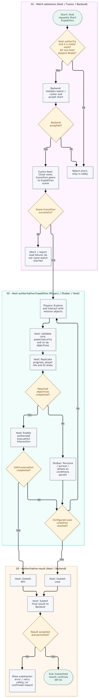
Figure 24. Expedition Gameplay and Match Outcome Workflow
Field | Description
Owner | Đặng Huy Hoàng
Actors / Components | Host Player, Players, Unity Client, Photon Fusion, Stalker AI, Backend API
Trigger | A Host requests to start Expedition from a valid lobby.
Business Outcome | Host validates match start and objectives, synchronizes Win/Lose, and submits an authorized result for Backend validation.
State Changes | Lobby → In Match → Match Ended; Objective Phases → Escape/Failure; Result Not Committed → Win/Lose Committed.
Related FRs | FR-MUL-03–05; FR-PLY-01–05; FR-EXP-01–05; FR-AI-01–05; FR-UI-02–03.
Related Test Cases | TC-WF02-01 successful Expedition; TC-WF02-02 configured Lose; TC-WF02-03 invalid start, premature evacuation or scene failure.

3.10.3 WF-03 – Stalker AI Gameplay and Player Survival

Figure 25. Stalker AI Gameplay and Player Survival Workflow
Field | Description
Owner | Lâm Thanh Phúc
Actors / Components | Player, Teammate, Host / State Authority, Stalker AI Runtime, Photon Fusion clients
Trigger | An active Expedition player becomes a valid visible target or produces an eligible noise cue.
Business Outcome | Host evaluates Stalker perception, pursuit/search and validated attacks. Player consequences and eligible revive outcomes are replicated to all clients.
State Changes | Stalker: PATROL, DETECT, CHASE, ATTACK, RECOVER, SEARCH; Player: Alive → Caught/Downed → Revived Alive or Eliminated under rules.
Related FRs | FR-AI-01–05; FR-PLY-01–04; FR-MUL-04; FR-UI-02.
Related Figures | Figures 11–12 and 15–17 (life state, revive, Stalker components/FSM/attack).
Related Test Cases | TC-WF03-01 sight/detection; TC-WF03-02 noise/search; TC-WF03-03 authoritative attack; TC-WF03-04 revive; TC-WF03-05 UV does not interrupt Stalker.
Scope note: UV does not stun, repel or interrupt the Expedition Stalker. Adaptive AI remains documented separately in Section 3.6 and Figures 18–19.

3.10.4 WF-04 – Match Result, Reward and Virtual Economy
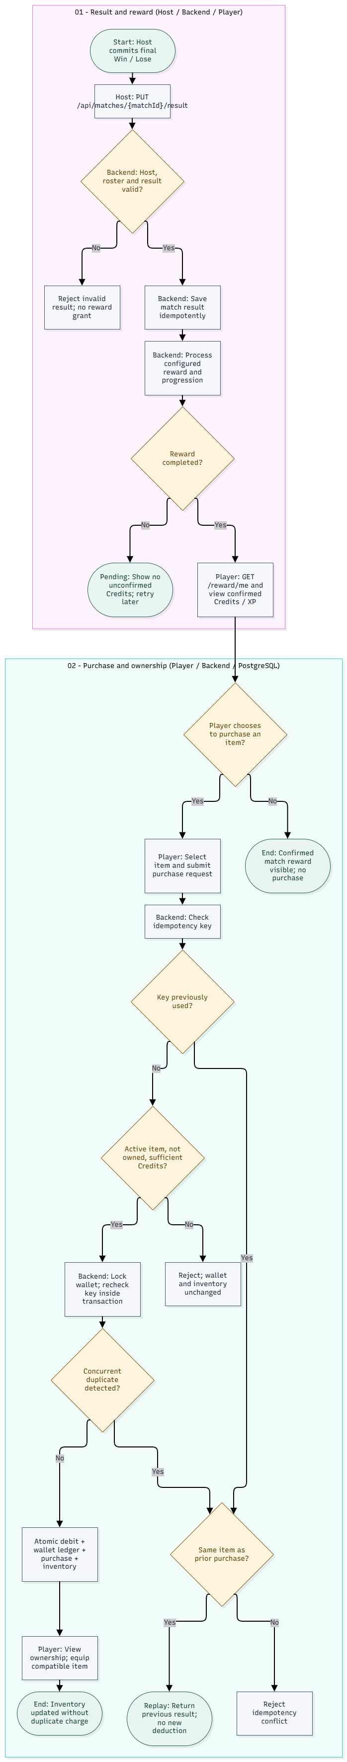
Figure 26. Match Result, Reward and Virtual Economy Workflow
Field | Description
Owner | Nguyễn Nhật Lệ Thuyên
Actors / Components | Host Player, Player, Unity Client, Backend API, PostgreSQL
Trigger | Host submits a finalized Win/Lose result; a player may subsequently choose to purchase an item.
Business Outcome | Backend validates and persists results/rewards without duplication. Optional valid purchases debit Credits and grant ownership atomically.
State Changes | Result Not Stored → Stored; Reward Pending → Completed on confirmation; Wallet balance updated; unowned item → owned after purchase.
Related FRs | FR-ECO-01–05; FR-UI-03–04.
Related Test Cases | TC-WF04-01 reward and purchase; TC-WF04-02 pending reward/replay; TC-WF04-03 insufficient Credits and duplicate/idempotency conflict.
Verification boundary: TC-WF01–TC-WF04 identifiers are proposed Report 5 references, not claims of executed or passed tests. Adaptive Candidate selection is not a prerequisite for the Stalker encounter workflow.

