

CAPSTONE PROJECT REPORT
Report 3 – Software Requirement Specification

Ho Chi Minh City, 31 October 2026

Table of Contents
I. Record of Changes 3
II. Software Requirement Specification 3
1. Product Overview 3
1.1 Product Purpose and Context 3
1.2 Product Boundaries and Registered Capabilities 3
1.3 Users, Assumptions and Dependencies 4
1.4 Definitions 4
2. User Requirements 4
2.1 Actors 4
2.2 Use Cases 5
2.2.1 Use Case Diagram(s) 5
2.2.2 Use Case Descriptions 5
2.2.3 Main and Alternate Use-Case Flows 6
3. Functional Requirements 6
3.1 System Functional Overview 6
3.1.1 Screens Flow 6
3.1.2 Screen Descriptions 6
3.1.3 Screen Authorization 7
3.1.4 Non-Screen Functions 7
3.1.5 Entity Relationship Diagram 7
3.2 Account and Authentication System 8
3.3 Multiplayer Session and Lobby System 9
3.4 Player and Cooperative Gameplay System 9
3.5 Expedition Mission and Level Content 10
3.6 Stalker Monster AI System 10
3.7 Adaptive AI and Evaluation 10
3.8 Virtual Economy, Shop and Limited Administration 11
3.9 UI, Results and Data Logging 11
4. Non-Functional Requirements 12
4.1 External Interfaces 12
4.2 Quality Attributes 12
4.2.1 Usability 12
4.2.2 Reliability 12
4.2.3 Performance 12
4.2.4 Security, Data Integrity, Compatibility and Testability 12
5. Requirement Appendix 13
5.1 Business / Game Rules 13
5.2 Common Requirements and Validation Patterns 13
5.3 Application Messages List 14
5.4 Configuration and Acceptance Parameters 14
5.5 Registration-to-Requirement Traceability 15
5.6 Verification Criteria 15

I. Record of Changes
Date | A / M / D | In charge | Change Description
24 Oct 2026 | A | Đặng Huy Hoàng | Initial Report 3 SRS prepared from the proposed Review 2 registration, reflecting the single-Expedition scope and verifiable requirements.
27 Oct 2026 | M | Đặng Huy Hoàng | Aligned documented difficulty profiles, entity terminology, out-of-scope boundaries and non-Adaptive verification criteria with main. Adaptive AI requirements unchanged; no executed-test claims.
30 Oct 2026 | M | Lâm Thanh Phúc | LTP baseline; versioned Legal Agreements FR/UC/tests and data traceability added; 1–4 player scope unchanged.
31 Oct 2026 | M | Nguyễn Nhật Lệ Thuyên | Aligned FR/UC traceability, Legal Agreements and the source baseline; refined diagrams and reader-facing requirement structure.

A = Added; M = Modified; D = Deleted.

II. Software Requirement Specification

1. Product Overview

1.1 Product Purpose and Context
ECHO PROTOCOL is a first-person cooperative survival-horror game for Windows 10/11 (64-bit). One to four players join a private host-controlled session, explore a single abandoned research facility, collect energy cores, restore designated power/security systems, complete cooperative tasks, evade one Stalker enemy, and attempt a valid evacuation. The gameplay experience must support both Win and Lose outcomes.
One player acts as session host and the remaining participants are clients. Photon Fusion synchronizes live player, item, enemy and mission state. An ASP.NET Core Web API hosted on AWS manages registered accounts, profiles, match results, rewards, ECHO Credits, shop purchases, item ownership and limited administration. Gameplay-authoritative decisions and backend-persistent records serve different responsibilities.
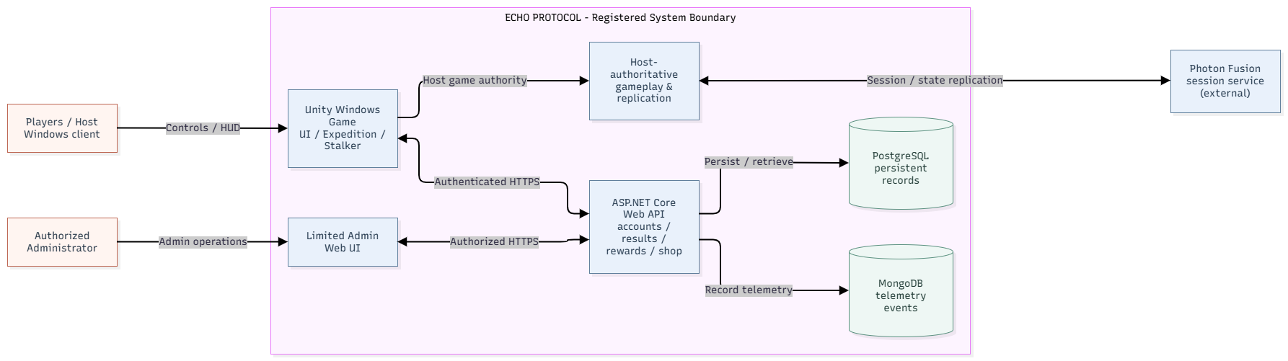
Figure 1. ECHO PROTOCOL system context and responsibility boundaries.

1.2 Product Boundaries and Registered Capabilities
AREA | REGISTERED EXPECTATION
Game client | One playable Research Facility Expedition with interaction, co-op and Win/Lose.
Cooperative gameplay | Movement, equipment/UV, noise, downed/revive, available assistance signals.
Enemy and adaptation | One Stalker with perception/state changes; at least one bounded adaptation; fixed fallback.
Economy and administration | Virtual-only ECHO Credits, validated match rewards, in-game shop/inventory and limited admin view/adjustments.
Evidence and quality | Fixed-versus-Adaptive comparison evidence, multiplayer and economy tests, reproducible FPS benchmark.
The registered Review 2 scope covers one Expedition in the Research Facility with one primary Stalker, multiplayer for 1–4 players, Adaptive AI with fixed fallback, account services, virtual ECHO Credits, shop and limited administration. Purge, additional maps/enemies, generative AI, advanced host migration, built-in voice chat, a separate player web portal, and real-money/payOS payments are outside the mandatory acceptance scope.

1.3 Users, Assumptions and Dependencies
Primary users are players who participate in private cooperative sessions; an eligible player also acts as host. Authorized administrators operate only the limited administration features. The design depends on supported Unity Windows builds, Photon Fusion sessions, an accessible AWS backend, approved game/AI configurations and network availability. The game must communicate session errors rather than silently treating invalid or disconnected states as successful.

1.4 Definitions
TERM | MEANING
Host authority | Session host validates authoritative gameplay state and outcomes.
Downed / Revive | A temporary incapacitated player state and valid teammate recovery action.
Fixed Baseline | A predefined non-adaptive configuration used when adaptive inputs are unavailable or for comparison.
Bounded Adaptive AI | Runtime decision constrained to explicitly configured safe parameter limits.
ECHO Credits | Virtual in-game currency; rewarded for validated matches or authorized test/admin allocations, not cash top-ups in scope.
Acceptance criteria | Objective observations/tests by which a specified requirement is passed or failed.

2. User Requirements

2.1 Actors
ACTOR | DESCRIPTION
Guest | User who has not authenticated; may reach registration/login but not private game/account operations.
Player | Authenticated person who views profile/shop/inventory, joins matches and plays Expedition.
Host Player | Authenticated player controlling private-room settings and authorized match start; also plays.
Administrator | Authorized operator of the limited admin interface for accounts, wallet/purchase records and permitted auditable adjustments.
Photon Fusion session service | External real-time networking service coordinating session connectivity; gameplay authority remains with host as defined in the registration.

2.2 Use Cases

2.2.1 Use Case Diagram(s)
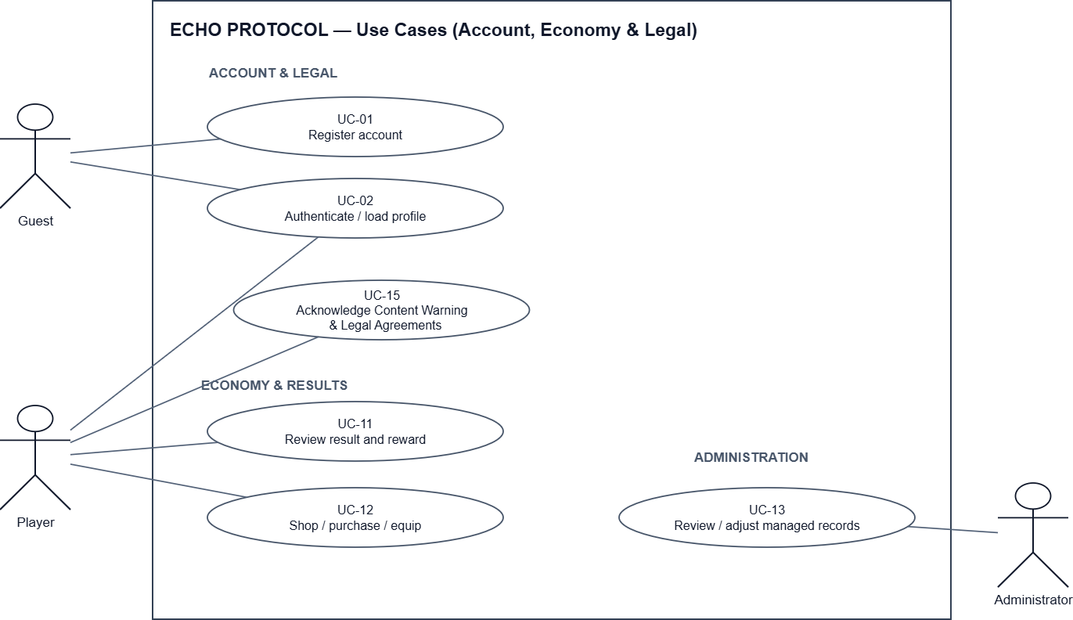

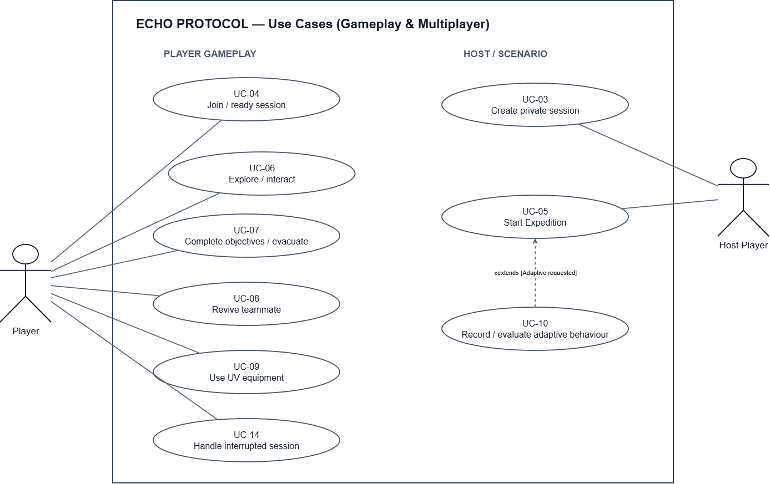
Figure 2. Use-case overview for player, host, administrator and system interactions.

2.2.2 Use Case Descriptions
ID | USE CASE | ACTORS | OUTCOME
UC-01 | Register account | Guest | Create an account and receive validation feedback.
UC-02 | Authenticate and load profile | Guest / Player | Log in, view own profile and progression; reject invalid access.
UC-03 | Create private session | Host Player | Select supported Expedition configuration and create a private room.
UC-04 | Join and ready session | Player | Join valid room, view participants, update ready state.
UC-05 | Start Expedition | Host Player | Start only as host with valid participants/configuration; load one mission.
UC-06 | Explore and interact | Player | Move, use equipment and interact with eligible objects.
UC-07 | Complete objectives and evacuate | Player / Host | Validate ordered mission goals and commit Win/Lose.
UC-08 | Revive teammate | Player | Consume required resource and restore only eligible Downed teammate.
UC-09 | Use UV equipment | Player | Use UV under eligible input and energy/cooldown rules; it does not stun or interrupt the Expedition Stalker.
UC-10 | Record and evaluate adaptive behaviour | Host system / Backend | Apply bounded change or fallback; retain decisions and metrics for evaluation.
UC-11 | Review match result and reward | Player / Backend | Display committed result and accepted reward exactly once.
UC-12 | Browse, purchase and equip item | Player / Backend | Validate cost/eligibility; grant ownership and apply equip rules.
UC-13 | View/adjust managed records | Administrator | Read permitted records and audit authorized wallet adjustments.
UC-14 | Handle interrupted session | Player / Host | Show reconnect/session-ended status without unauthorized completion.
UC-15 | Acknowledge Content Warning and Legal Agreements | Player | Display current terms; record all required declarations; refuse protected actions if unaccepted or stale.

2.2.3 Main and Alternate Use-Case Flows
UC-05 · Start Expedition
Main flow: Host selects an existing difficulty (Easy, Normal or Hard), verifies the registered 1–4-player lobby and issues Start. Session validates host authority and loads the same Research Facility mission on every accepted client.
Exception / alternate flow: Non-host Start is rejected; a participant with an invalid/failed join is not admitted; unrecoverable loading/session failure yields an error rather than a falsely active match.
UC-07 · Complete Objectives and Evacuate
Main flow: Team collects valid energy cores, performs configured power/security and cooperative prerequisites, then activates evacuation when all requirements are met. Host commits one Win result and sends the authoritative result to persistence.
Exception / alternate flow: Premature evacuation or duplicate objective execution cannot advance or commit result; failure state commits Lose under configured mission rules.
UC-08 · Revive Teammate
Main flow: Eligible teammate with required medical resource initiates revive on Downed player; host verifies range/state/resource/configured limits and applies successful revive once.
Exception / alternate flow: Invalid state, missing resource, interrupted revive or exhausted revive limit does not restore life or incorrectly consume resources.
UC-12 · Purchase Virtual Item
Main flow: Authenticated player browses server catalogue; submits item/price request; backend checks item validity, sufficient Credits and ownership rules, then atomically deducts credits and grants ownership; compatible items can be equipped.
Exception / alternate flow: Insufficient Credits, expired/invalid product, repeated request and unowned/incompatible equip are rejected without partial deduction or duplicate grant.

3. Functional Requirements

3.1 System Functional Overview
The system combines player-facing screens with host-authoritative gameplay functions and authenticated backend services. The following sections define the supported interfaces and functional responsibilities.

3.1.1 Screens Flow
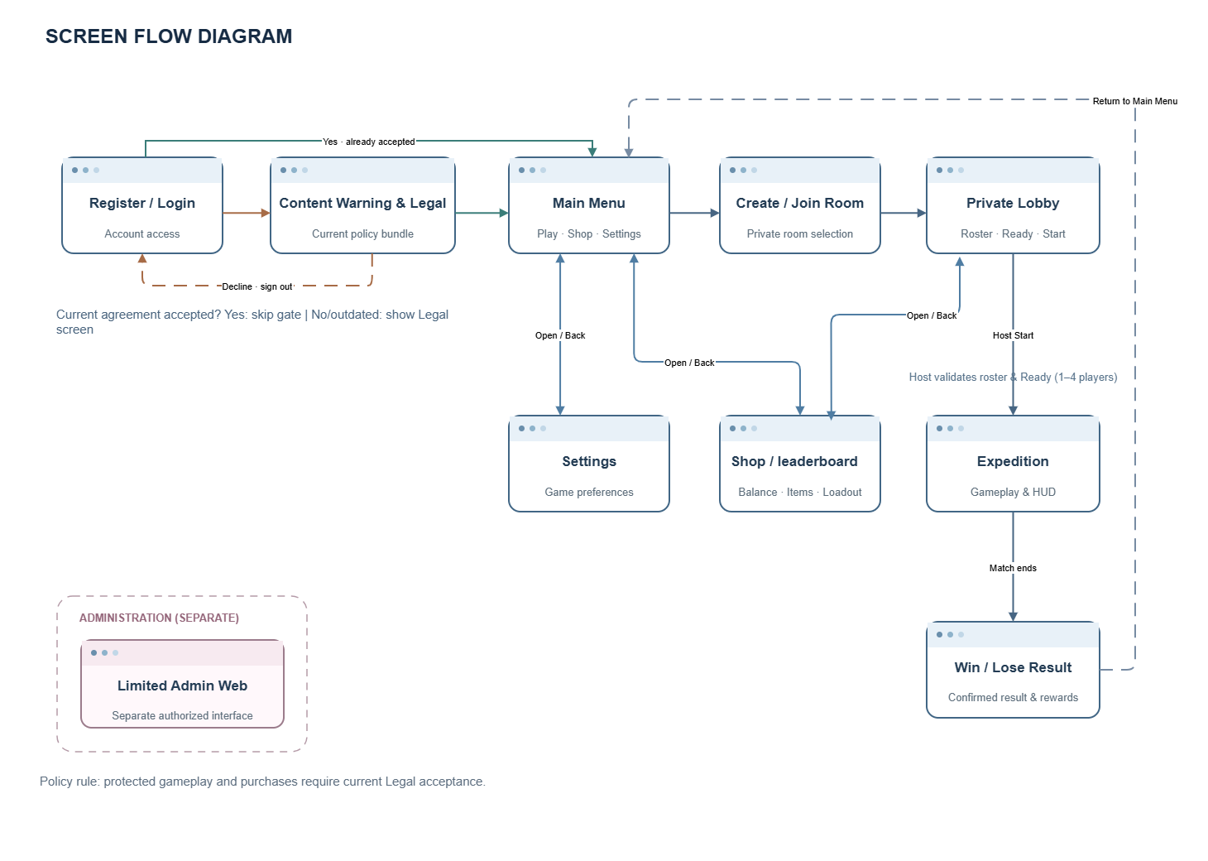
Figure 3. Game screen navigation and first-use agreement gate.

3.1.2 Screen Descriptions
SCREEN | FUNCTIONAL PURPOSE / DISPLAY
Register / Login | Account creation and authentication; validation errors and loading status.
Main Menu | Entry points to private room, shop, inventory and settings.
Create / Join Room | Host configures Expedition difficulty; client joins valid room information.
Private Lobby | Player identities, readiness, selected appearance, session and Host Start.
Expedition HUD | Context-relevant objective progress, interaction prompts, teammate status and UV/resource indicators.
Inventory / Shop | Owned items, compatible equips, catalogue, price, balance and purchase feedback.
Result | Win/Lose, progress, survival information, accepted Credits/XP and return navigation.
Settings | Supported game/display controls; actual configurable options follow the Windows build.
Limited Admin Web UI | Authorized user/wallet/purchase records and auditable permitted wallet changes.
Content Warning / Legal Agreements | Versioned first-use acknowledgement, adult declaration, privacy/community/transaction terms; blocking error if declined/outdated.

3.1.3 Screen Authorization
SCREEN / ACTION | GUEST | PLAYER | HOST | ADMIN
Register and log in | Yes | Yes | Yes | Yes
View own profile, inventory or shop | No | Yes | Yes | If authorized as player
Join private room / play Expedition | No | Yes | Yes | No admin privilege implied
Create a private room | No | Yes | Yes | No admin privilege implied
Choose difficulty / start hosted match | No | No | Yes | No admin privilege implied
View own results and rewards | No | Yes | Yes | No admin privilege implied
View permitted users, wallets, purchases | No | No | No | Yes
Perform auditable permitted wallet adjustment | No | No | No | Yes

A Host is a session role, not a global application administrator. Back-end permissions must be enforced server-side; hiding a control in the UI is not authorization.

3.1.4 Non-Screen Functions
FUNCTION | RESPONSIBILITY
Host-authoritative session replication | Validate player/objective/enemy/life/result actions and synchronize accepted state to peers.
Mission rules engine | Validate energy cores, power/security prerequisites, co-op interactions, evacuation gate, Win/Lose.
Stalker perception and behaviour | Consume allowed vision/noise/cue data, navigate, investigate, chase, attack and recover.
Adaptive AI engine | Read observed metrics; produce one or more bounded adjustments or fixed fallback with evidence.
Account and authorization API | Authenticate tokens, manage own profile and enforce privileges.
Match result and reward service | Validate committed outcomes, calculate configured rewards, deduplicate repeated results.
Virtual shop and wallet service | Validate product/price/balance/eligibility and apply atomic purchase/ownership changes.
Admin audit function | Permit authorized wallet adjustment with traceable records.
Persistence and telemetry | Save accounts, purchases, match outcomes, AI decisions and comparison metrics.

3.1.5 Entity Relationship Diagram
The diagram shows the principal account, economy, match and Adaptive AI data relationships. PostgreSQL stores persistent records, while Photon Fusion manages transient session states. Detailed keys and persistence constraints are specified in Report 4 (SDD).
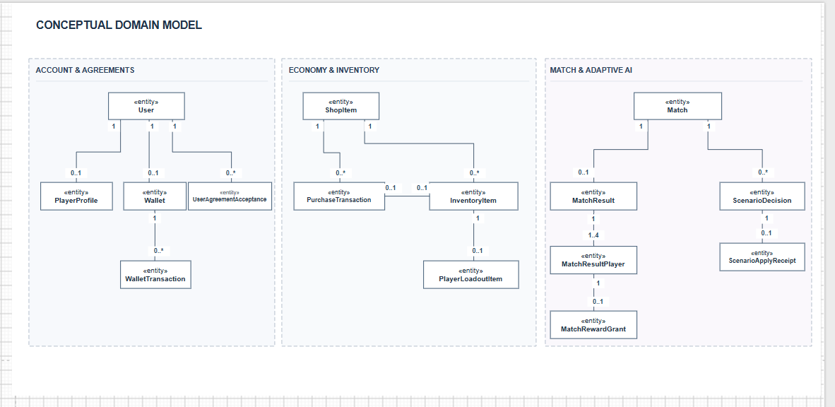
Figure 4. Conceptual relationships among persistent domain entities.
ENTITY | PURPOSE / INVARIANT
User / PlayerProfile | Registered identity, roles and profile/progression information (EF Core DbSets).
Wallet / WalletTransaction | Current virtual credit balance and auditable debit/credit history.
ShopItem / PurchaseTransaction | Server-approved catalogue and accepted purchase records, with replay safety.
InventoryItem / PlayerLoadoutItem | Owned items and equipped loadout mappings for an eligible player.
MatchResult / MatchResultPlayer / MatchRewardGrant | Host-validated match outcome, roster details and immutable reward records.
ScenarioDecision / ScenarioApplyReceipt | Persisted decision and apply evidence. Adaptive AI is not asserted complete in this revision.
UserAgreementAcceptance | Versioned per-player acknowledgements; user + bundle version, content hash and acceptance timestamp (PostgreSQL).

Player life state, active mission progress and Stalker state are host-authoritative runtime states rather than standalone persistent entities. Their transitions are described in the software design.

3.2 Account and Authentication System
After authentication, the player is presented with the current Content Warning and Legal Agreements when the required version has not been accepted. The system records the acceptance against the authenticated account. Match/scenario and protected purchase operations are rejected with AGREEMENT_REQUIRED until acceptance; invalid declarations or outdated document versions are rejected without creating an accepted record.
The following functional requirements specify observable success and rejection conditions. Unless otherwise stated, protected actions require authentication, an authorized session and current agreement acceptance.
FR ID | MANDATORY FUNCTION | ACCEPTANCE / NEGATIVE CASE | REG. AREA
FR-AUT-01 | Guest registers and authenticates; backend issues access only after valid credentials. | PASS: Valid credentials permit own session/profile; invalid credentials are rejected without protected data disclosure. | Account/Auth
FR-AUT-02 | Authenticated player can log out and retrieve only their own profile and progression. | PASS: Expired/invalid token or another user’s profile request is rejected. | Account/Auth
FR-AUT-03 | Player client loads server-accepted Credits balance, inventory ownership and selected customization. | PASS: Displayed data matches latest accepted server record after refresh; client-edited values cannot become authoritative. | Account/Auth
FR-AUT-04 | Backend hashes passwords, verifies access tokens and enforces role authorization on critical operations. | PASS: Unauthorized balance/ownership/reward/admin modifications are rejected server-side. | Account/Auth
FR-AUT-05 | Authenticated players must accept the current versioned Content Warning/Legal Agreements before protected gameplay/shop actions; acceptance is persisted per user and bundle version. | PASS: valid current acceptance enables protected actions; FAIL: missing/stale acceptance yields explicit rejection without side effect. | Account/Auth

3.3 Multiplayer Session and Lobby System
FR ID | MANDATORY FUNCTION | ACCEPTANCE / NEGATIVE CASE | REG. AREA
FR-MUL-01 | Host creates a private Expedition session supporting 1–4 active players (solo or cooperative) and selects an available difficulty. | PASS: a valid 1-, 2-, 3- or 4-player lobby can start through the authoritative Host; non-host participants must be Ready. Full/invalid room joins are rejected. | Lobby
FR-MUL-02 | Client joins using valid room information; invalid/full requests do not alter existing room state. | PASS: Invalid code/full room is refused with feedback; current connected participants remain unchanged. | Lobby
FR-MUL-03 | Lobby shows identity, ready state and host controls; only host may start. | PASS: Host-only start and required Ready states are checked for 1–4 participants; all accepted players enter the same Expedition. Solo Host start is a valid acceptance case. | Lobby
FR-MUL-04 | Host validates and synchronizes relevant player life, mission-objective, enemy and match states. | PASS: After accepted action, clients converge to same mission state; invalid client actions cannot commit state. | Lobby
FR-MUL-05 | Disconnect of client/host produces reconnect or session-ended feedback according to supported policy. | PASS: interrupted client/host obtains supported reconnect or session-ended status, no false result/reward commits. Exercise timeout and host-loss cases; no advanced host-migration success is mandatory. | Lobby

3.4 Player and Cooperative Gameplay System
FR ID | MANDATORY FUNCTION | ACCEPTANCE / NEGATIVE CASE | REG. AREA
FR-PLY-01 | Player can walk, sprint, crouch, interact, carry defined items, activate UV and use available assistance signals. | PASS: Eligible actions work in match; unavailable/invalid actions leave authoritative state unchanged. | Player
FR-PLY-02 | Noise from configured movements/interactions is available to Stalker perception. | PASS: Valid noise can trigger Stalker response; silent/ineligible actions do not fabricate noise events. | Player/AI
FR-PLY-03 | A player can transition into a Downed state under legitimate Stalker attacks and may be eliminated under match rules. | PASS: All peers observe authoritative life-state outcome; no duplicate damage changes committed state twice. | Player
FR-PLY-04 | Teammate with required medical resource can revive eligible Downed player within configured limitations. | PASS: Valid revive restores player once; missing item, wrong state or exceeded rule cannot revive. | Player
FR-PLY-05 | Equipment, inventory and item interactions respect ownership/eligibility and session authority. | PASS: Item cannot be reused, spawned or equipped by an unauthorized state or non-owner. | Player/Shop

3.5 Expedition Mission and Level Content
FR ID | MANDATORY FUNCTION | ACCEPTANCE / NEGATIVE CASE | REG. AREA
FR-EXP-01 | Registered build contains one reachable abandoned Research Facility level with Expedition objective/evacuation positions. | PASS: Level loads in Windows build; all mandatory interaction points reachable under gameplay conditions. | Expedition
FR-EXP-02 | Players collect required energy cores and restore designated power/security systems subject to prerequisites. | PASS: Accepted objectives advance in correct sequence; absent resources/prerequisites prevent advancement. | Expedition
FR-EXP-03 | Configured cooperative interactions must be completed as prerequisites before evacuation is unlocked. | PASS: Host rejects premature activation; accepted co-op progress appears consistently on connected clients. | Expedition
FR-EXP-04 | Mission interface communicates current objectives and eligible interactions. | PASS: HUD reflects host-accepted objective state and updates after prerequisite completion. | Expedition/UI
FR-EXP-05 | Expedition shall commit Win only after prerequisites and valid evacuation; otherwise defined Lose condition may terminate. | PASS: evacuation is accepted only after prerequisites, Host commits one Win/Lose outcome, and Backend accepts/replays one result identity without duplicate reward; test invalid early exit and repeated submission. | Expedition/Result

3.6 Stalker Monster AI System
FR ID | MANDATORY FUNCTION | ACCEPTANCE / NEGATIVE CASE | REG. AREA
FR-AI-01 | One primary Stalker uses the six source states PATROL, DETECT, CHASE, ATTACK, RECOVER and SEARCH; visual detection and noise cues cause only valid state transitions. | PASS: Behaviour transitions occur on valid stimuli; after losing target Stalker returns to search/patrol. | Stalker
FR-AI-02 | Stalker detection uses observable vision, noise and recent encounter cues; no unrestricted hidden-player location knowledge. | PASS: Occlusion/no-cue test avoids instant illicit detection; valid sight or noise can initiate detection. | Stalker
FR-AI-03 | Attack effects on players, including Downed state, must be host-authoritative. | PASS: Invalid/duplicate client reports do not create damage or life-state corruption. | Stalker/Host
FR-AI-04 | UV equipment use obeys configured energy, targeting and input rules. The Expedition Stalker is not stunned, repelled or interrupted by UV. | PASS: valid UV activation consumes/recharges energy as configured without changing Stalker pursuit; invalid/depleted activation is rejected. | Stalker/Player
FR-AI-05 | Stalker navigation and reaction must remain testable throughout mandatory mission path. | PASS: Navigation playtest detects no blocker that prevents completing the intended match. | Stalker/Expedition

3.7 Adaptive AI and Evaluation
FR ID | MANDATORY FUNCTION | ACCEPTANCE / NEGATIVE CASE | REG. AREA
FR-ADA-01 | System records supported observed player/team gameplay metrics as inputs to Adaptive AI. | PASS: Valid observed metrics have reproducible match linkage; missing inputs are flagged. | Adaptive
FR-ADA-02 | When inputs and configuration are valid, at least one gameplay parameter may be adjusted within configured min/max bounds. | PASS: Test produces an applied decision inside the configured range; out-of-bounds value is never used. | Adaptive
FR-ADA-03 | Missing, invalid or insufficient metrics must select a fixed-baseline fallback instead of an unvalidated adaptation. | PASS: Invalid-input test returns fixed settings and records fallback reason. | Adaptive
FR-ADA-04 | Each evaluated fixed/adaptive run records match identity, mode, selected adjustment or fallback and outcome metrics. | PASS: Logs permit matching and checking comparable runs without claiming untested effectiveness. | Adaptive/Eval
FR-ADA-05 | Team provides repeatable Fixed-versus-Adaptive test cases and comparison results after evaluation. | PASS: At least one documented controlled comparison includes configuration, observed metrics and outcome evidence; claims match actual results. | Adaptive/Eval

3.8 Virtual Economy, Shop and Limited Administration
FR ID | MANDATORY FUNCTION | ACCEPTANCE / NEGATIVE CASE | REG. AREA
FR-ECO-01 | Game shop displays backend catalogue, item price, description, owned status and server Credits balance. | PASS: Catalogue/balance match authorized API response; UI cannot override price. | Shop
FR-ECO-02 | Authenticated player purchases eligible item only with sufficient ECHO Credits after server-side product, balance and ownership checks. | PASS: Valid purchase succeeds; insufficient, invalid or ineligible request fails without partial effects. | Shop
FR-ECO-03 | Each successful purchase deducts Credits and grants ownership atomically. | PASS: Repeated requests never grant duplicate ownership or debit more than accepted purchase. | Shop
FR-ECO-04 | Player views inventory and equips only owned, compatible supported customization/equipment. | PASS: Unowned/incompatible item is rejected; accepted equip reflects server record. | Shop
FR-ECO-05 | Validated Expedition result produces a configured Credits/XP reward through server-verifiable outcome submission. | PASS: verified Expedition match outcome is accepted from authorized Host, resulting Credits/XP appear only after server confirmation; replay/duplicate submissions never grant an additional reward. | Reward
FR-ECO-06 | Authorized administrator may view user, wallet and purchase records, and make permitted auditable wallet adjustments. | PASS: Unauthorized access blocked; valid adjustment records actor, target and change. | Administration

3.9 UI, Results and Data Logging
FR ID | MANDATORY FUNCTION | ACCEPTANCE / NEGATIVE CASE | REG. AREA
FR-UI-01 | Windows client provides authentication, main menu, private lobby, Expedition HUD, settings, shop, inventory and result view. | PASS: All registered screens reachable by eligible role and valid navigation. | UI
FR-UI-02 | HUD shows context-relevant objectives, teammate life state, prompts, mission items, UV/resources and evacuation status. | PASS: Indicators update from authoritative state and do not display completed objectives as pending. | UI
FR-UI-03 | Result view displays Win/Lose, mission progress, survival information and accepted rewards after completion. | PASS: result view differentiates pending, accepted and rejected/temporarily unavailable Backend reward; no locally estimated Credits/XP are shown as confirmed. Compare to result and reward API records. | UI/Result
FR-UI-04 | Backend persists authorized accounts, progression, wallets, purchases, inventory, match results and AI evaluation records. | PASS: Records retrievable by authorized scope; sensitive data not exposed to unrelated user. | Data
FR-UI-05 | Game gives actionable errors for invalid input, denied actions, connection loss and failed purchases. | PASS: User sees clear non-success status; failure does not silently commit invalid action. | UI

4. Non-Functional Requirements

4.1 External Interfaces
INTERFACE | REQUIREMENT / BOUNDARY
Unity Windows Client ↔ Photon Fusion | Game sessions must provide host-authoritative real-time state; no advanced host migration commitment.
Unity Client ↔ ASP.NET Core Web API | Authenticated HTTPS/REST communication for profiles, results, Credits, shop and inventory.
ASP.NET Core Backend ↔ Persistent Storage | Persist validated game/economy data; backup and recovery to be verified in test environment.
Admin Web Interface ↔ Backend | Limited authorized records and wallet adjustments; no mandatory shop-product CRUD.
Player Input/Display | Windows 10/11 64-bit, 1920×1080 Low preset; keyboard/mouse and configured display UI.
Excluded external interfaces | payOS, commercial payment processor and separate player-facing web portal not needed for registered acceptance.

4.2 Quality Attributes
The quality requirements below specify measurable targets for the registered Windows game and its supporting services.

4.2.1 Usability
Interface messages and game HUD elements shall represent the latest accepted game or backend state. Failed joins, purchases, unauthorized operations and unavailable objectives must display feedback without implying successful completion.

4.2.2 Reliability
On interrupted networking, the game shall show either a supported reconnect state or a session-ended outcome. Repeated result, reward and purchase requests must not duplicate committed records. Advanced host migration is outside mandatory scope.

4.2.3 Performance
Target minimum PC configuration: Intel Core i5-8400 or AMD Ryzen 5 2600, 16 GB RAM, GTX 1060 6 GB or RX 580 8 GB, and 15 GB SSD storage. Recommended configuration: Intel Core i5-10400F or Ryzen 5 3600, 16 GB RAM, GTX 1660 SUPER 6 GB or RX 5600 XT 6 GB, and SSD storage. Windows 10/11 64-bit and broadband network connectivity are required. Performance acceptance is defined by NFR-01 and NFR-06.

4.2.4 Security, Data Integrity, Compatibility and Testability
ID | ATTRIBUTE | METRIC / TARGET | VERIFICATION METHOD
NFR-01 | Performance | Average rendered FPS · ≥30 FPS | Record FPS/frame time using a 15-minute representative Expedition session on the target Windows build at 1920×1080 Low. A separate 29 October four-player 50.02 FPS capture used preset PC, not Low; report results by their actual preset.
NFR-02 | Capacity & sync | Connected participants and authoritative match-state divergence · 1–4 participants; zero conflicting final objective/result states | Create/join/play with 1, 2, 3 and 4 participants; compare Host/client mission and result at synchronization checkpoints.
NFR-03 | Transaction integrity | Invalid/repeated economy requests causing duplicate credit/grant or negative balance · Zero duplicate reward/item grant or negative balance in rejection/replay test set | Backend/API tests: insufficient balance, duplicate purchase, replayed match result, invalid wallet operation.
NFR-04 | Security | Unauthorized successful access to protected resources · Zero unauthorized operations in defined negative authorization suite | Use unauthorized and role-mismatched tokens against own/other profiles, shop, wallets and admin endpoints; record HTTP/result evidence.
NFR-05 | Persistence & recovery | Recovery procedure validated under test conditions · Successful restoration of designated persistent records; specific RPO/RTO not specified | Document backup/restore rehearsal in AWS test environment and compare record samples and access policies.
NFR-06 | Windows compatibility | Supported OS/graphics configuration · Windows 10/11 64-bit; 1920×1080 Low preset | Launch packaged build, select target display preset, complete representative session; record hardware and OS.

5. Requirement Appendix

5.1 Business / Game Rules
ID | RULE DEFINITION
BR-01 | The only mandatory playable mode and location are Expedition and the abandoned Research Facility.
BR-02 | Committed Expedition participation is 1–4, including solo Host. Non-host members must be Ready; only the Host can start.
BR-03 | Host-authoritative state governs player life, objectives, Stalker effects and committed outcome.
BR-04 | Evacuation remains locked until all configured required objectives are complete.
BR-05 | A mission ends in one committed Win or Lose according to configured match rules.
BR-06 | Revive requires an eligible teammate, valid Downed target, medical resource and configured limits.
BR-07 | Stalker detection depends on observable cues. UV equipment consumes resources but does not interrupt the Expedition Stalker by design.
BR-08 | Adaptive AI modifies at least one selected parameter only inside declared minimum/maximum; invalid input uses Fixed Fallback.
BR-09 | Results/rewards are server-validated; repeated accepted match identifier cannot award twice.
BR-10 | ECHO Credits are virtual-only in scope; no real-money purchases or payOS top-ups are mandatory.
BR-11 | Shop purchases check availability, ownership and balance; deduction + ownership update is atomic.
BR-12 | Administrator access is restricted and wallet adjustments must be auditable; broad product CRUD is not required.
BR-13 | Unowned/incompatible items cannot be equipped.
BR-14 | No additional map, Purge, independent enemy, voice chat or separate Player Web Portal is required for acceptance.
BR-15 | Protected match/scenario/shop actions require recorded acceptance of the current policy bundle for the authenticated user; no acceptance means an explicit authorization-style rejection.

5.2 Common Requirements and Validation Patterns
PATTERN | REQUIRED BEHAVIOUR
Unauthorized or malformed request | Reject without modifying protected state; provide appropriate error feedback.
Idempotent result/reward requests | Repeated submission does not issue an additional result or grant.
Race conditions / replay of purchase | Deduction and ownership must remain atomic and consistent.
Network disconnect | Client sees accurate reconnect/ended state; do not fabricate match success.
Config-dependent limits | Use approved difficulty/revive/UV/AI bounds from tested configuration; no hard-coded values assumed in SRS.
Defect evidence | Each negative test must include preconditions, observed state/log, expected outcome and owner.

5.3 Application Messages List
CODE | TYPE | CONTEXT | PROPOSED MESSAGE / MEANING
MSG-01 | Error | Login | Invalid credentials or expired session. Please sign in again.
MSG-02 | Error | Private room | Room unavailable, invalid, or full.
MSG-03 | Information | Lobby | Only the host can start the match.
MSG-04 | Information | Connectivity | Connection interrupted. Reconnecting or ending session.
MSG-05 | Prompt | Objective | Complete the required objectives before evacuation.
MSG-06 | Feedback | Revive | Revive is unavailable under current conditions.
MSG-07 | Warning | UV equipment | UV cannot be used: check energy, range, or cooldown.
MSG-08 | Result | Match | Expedition complete. Result: Win / Lose.
MSG-09 | Error | Shop | Insufficient ECHO Credits.
MSG-10 | Error | Shop | Item unavailable or already owned.
MSG-11 | Feedback | Inventory | Only compatible owned items can be equipped.
MSG-12 | Result | Rewards | Reward granted / not yet verified.
MSG-13 | Error | Account | You are not authorized to perform this action.
MSG-14 | Result | Administration | Wallet adjustment recorded.

Messages describe required feedback; exact wording may vary by localization.

5.4 Configuration and Acceptance Parameters
TOPIC | CONFIGURATION / DESIGN BASIS | ACCEPTANCE CONDITION
Difficulty levels | Three difficulty profiles: Easy, Normal and Hard. | Each selectable difficulty must map to the supported Research Facility game configuration; verify differences in AI and revive settings.
Energy core / objective counts | Research Facility Expedition uses energy-core, power/security and evacuation prerequisites across its three zones. | The match follows the configured objective sequence. Evacuation is unavailable before required prerequisites are complete.
Revive limits | Revive uses an eligible Downed target, First Aid and defined range/time/budget rules. Source difficulty budgets: Easy 4, Normal 3, Hard 2 per zone. | Check eligibility, resource consumption, interruption, valid/invalid states and the selected difficulty budget in a Windows multiplayer build.
UV equipment boundaries | UV operates with energy, range and cooldown limits; it does not affect Expedition Stalker pursuit. | Verify resource feedback and unchanged Stalker pursuit during valid UV activation; reject invalid/depleted use.
Stalker tuning | Stalker uses six FSM states and scene-configured vision, noise and movement settings. | Check perception and valid state transitions throughout the mandatory route, including blocked sightlines.
Adaptive parameter bounds | Pre-match policy reads Survival and Noise metrics (threshold bands 30/70, minimum 1 sample per observed player, full roster). Candidate settings include SupportItemBudget {0,1,2}, ChaseSpeed {9,10,11}. Fixed fallback is available. | For the enabled Adaptive configuration, verify a bounded decision; for missing/invalid data verify Fixed Fallback with recorded reason. Evaluate comparable Fixed and Adaptive runs.
Rewards and items | Reward amounts, eligible shop items and costs are defined by the active backend policies and catalogue. | Validate balance, ownership, idempotent purchase and reward grants against server-accepted policy values.
Data model and recovery | Account, wallet, match, reward, agreement and Adaptive AI records are persisted by backend data models; telemetry is maintained separately. | Review data schema and migrations; verify recovery of designated persistent records through the defined test environment.

5.5 Registration-to-Requirement Traceability
REGISTRATION AREA | SRS IDS | COVERING UC / EVIDENCE
Multiplayer Session and Lobby System | FR-MUL-01 to FR-MUL-05 | UC-03, UC-04, UC-05, UC-14
Player and Cooperative Gameplay | FR-PLY-01 to FR-PLY-05 | UC-06, UC-08, UC-09
Expedition Mission and Level | FR-EXP-01 to FR-EXP-05 | UC-07
Monster AI | FR-AI-01 to FR-AI-05 | UC-06, UC-09
Adaptive AI and Evaluation | FR-ADA-01 to FR-ADA-05 | UC-10
Account and Authentication | FR-AUT-01 to FR-AUT-05 | UC-01, UC-02, UC-15
Virtual Shop, Wallet and Limited Administration | FR-ECO-01 to FR-ECO-06 | UC-11, UC-12, UC-13
UI, Results and Data Logging | FR-UI-01 to FR-UI-05 | UC-11
Registered NFR | NFR-01 to NFR-06 | NFR-01–06 measurement methods

5.6 Verification Criteria
Functional requirements are evaluated using their positive and rejection criteria; NFRs use the stated metrics and measurement methods. Executed test results and defects are maintained in the test report.

