

Requirement & Design Specification
HomeMart - Household Appliances Sales Management Website
Version: 1.0

– Can Tho, September 2026 –

Record of Changes
Version | Date | A*  M, D | In charge | Change Description
1.0 | 10/09/2026 | A | ChuanDH, AnNP | Initialized the HomeMart project proposal; defined system scope (1 store, 1 central warehouse); established the 35 Use Cases matrix and specifications (UC01 - UC35).
1.0 | 13/09/2026 | A | ThienTP | Designed the Entity-Relationship Diagram (ERD) featuring core hm_* entities and orthogonal diamond relationships according to conceptual data modeling standards.
1.0 | 16/09/2026 | A,M | ThienTP, NhaLP | Constructed the 24-table physical Database Schema; specified data types, standard system audit fields, and standalone id: bigint primary keys; optimized connector routing to eliminate line overlap.
1.0 | 19/09/2026 | A | AnNP, TranLTB | Documented comprehensive schema specifications for all 24 tables (functional descriptions, Primary keys, Foreign keys); constructed the Package Diagram with 9 business modules following the lecturer's guidelines.
1.0 | 22/09/2026 | A,M | All Members | Added detailed narrative descriptions for all 9 packages; conducted cross-artifact verification to ensure full consistency among 35 Use Cases, ERD, Database Schema, and Package Diagram.
*A - Added M - Modified D - Deleted

Contents
Record of Changes 2
I. Overview 5
1. User Requirements 5
1.1 Actors 5
1.2 Use Cases 7
a. Diagram(s) 7
b. Descriptions 11
2. Overall Functionalities 17
2.1 Screens Flow 17
2.2 Screen Descriptions 20
2.3 Screen Authorization 23
2.4 Non-UI Functions 25
3. System High Level Design 26
3.1 ERD 26
3.2. Database Design 27
a. Database Schema 27
b. Table Descriptions 27
3.3 Code Packages 37
II. Requirement Specifications 38
1. Register 38
a. Functionalities 38
b. Business Rules 39
2.Login 39
a. Functionalities 39
b. Business Rules 40
3.UC-03:Logout 41
a. Functionalities 41
b. Business Rules 42
6.UC-06:Reset Forgotten Password 42
a. Functionalities 42
b. Business Rules 43
7.UC-07:Manage Accounts 43
a. Functionalities 43
b. Business Rules 44
11.UC-11:Manage Product Classification Data 45
a. Functionalities 45
b. Business Rules 46
12.UC-12: Manage Brands 46
a. Functionalities 46
b. Business Rules 47
8. Browse and Search Products 47
a. Functionalities 48
b. Business Rules 49
9. View Product Detail 49
a. Functionalities 49
b. Business Rules 51
10. Manage Shopping Cart 51
a. Functionalities 51
b. Business Rules 53
14. Place Customer Order 53
a. Functionalities 53
b. Business Rules 55
16. View Own Orders and Tracking 55
a. Functionalities 55
b. Business Rules 57
17. Cancel Eligible Own Order 57
a. Functionalities 57
b. Business Rules 59
30. Request Return for Own Order 59
a. Functionalities 59
b. Business Rules 61
18.View Sales Order Details 62
a. Functional Description 62
b. Business Rules 63
19.Confirm Sales Order 63
a. Functional Description 63
b. Business Rules 65
20.Process Point-of-Sale Transaction 65
a. Functional Description 65
b. Business Rules 67
21.Pack and Ship Order 67
a. Functional Description 67
b. Business Rules 69
22.Record Delivery Outcome 69
a. Functional Description 69
b. Business Rules 70
23.Cancel Order by Store 71
a. Functional Description 71
b. Business Rules 72
31.Create In-Store Return Request 73
a. Functional Description 73
b. Business Rules 74
III. Design Specifications 75
1. Register 75
UI Design 76
Database Access 77
IV. Appendix 77
1. Assumptions & Dependencies 77
2. Limitations & Exclusions 78
3. Business Rule 78

I. Overview

1. User Requirements

1.1 Actors

# | Actor | Description
1 | Guest | Guest users who haven't logged in; can browse categories, search, filter, and view product/SKU (Stock Keeping Unit) details; register a new account.
2 | Customer | Customers have logged in; manage their personal shopping cart, profile, and address book; place home delivery orders, pay online, track order progress; cancel valid orders themselves (not yet shipped); request returns for the purchased SKU (Stock Keeping Unit). Customers can also change their password or request a password reset via email if they forget it.
3 | Staff | Store/warehouse staff; log into the system to look up orders, confirm orders, pack, ship, and update delivery results; check inventory; receive goods from suppliers according to PO (Purchase Order); retail at the counter; handle product returns.
4 | Admin | Administrator; has full staff privileges plus: managing user accounts, categories, brands, products, and SKUs (Stock Keeping Unit); managing suppliers and creating purchase orders; adjusting inventory and viewing transaction history; canceling store orders; approving returns and refunds; viewing reconciliation and cash flow reports.
5 | Payment Gateway | Online payment gateway; receives transactions, sends digitally signed results (signed callback) back to the system with an idempotent mechanism; supports online refunds.
6 | Email Service | Automated email service; sending account activation verification emails, setting up new employee accounts, and time-limited password reset links/tokens.

1.2 Use Cases

a. Diagram(s)
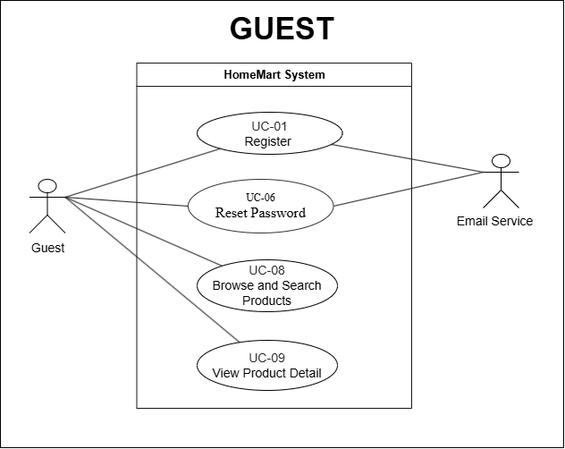
Figure 1. Use case diagram for guest actor

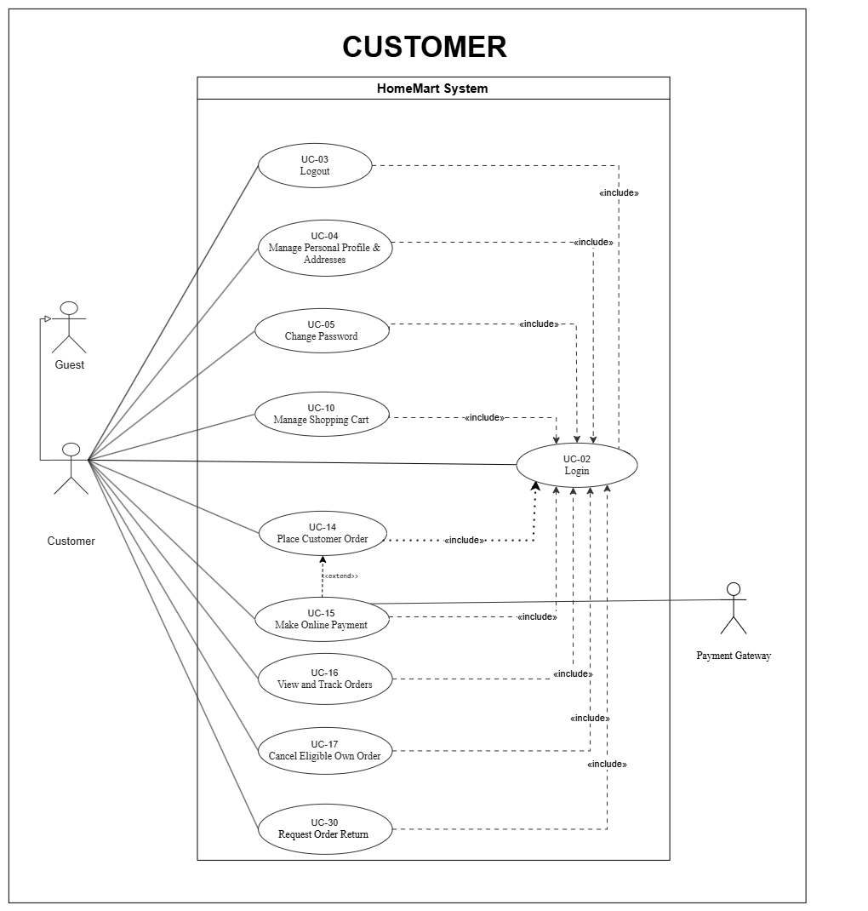
Figure 2. Use case diagram for customer actor

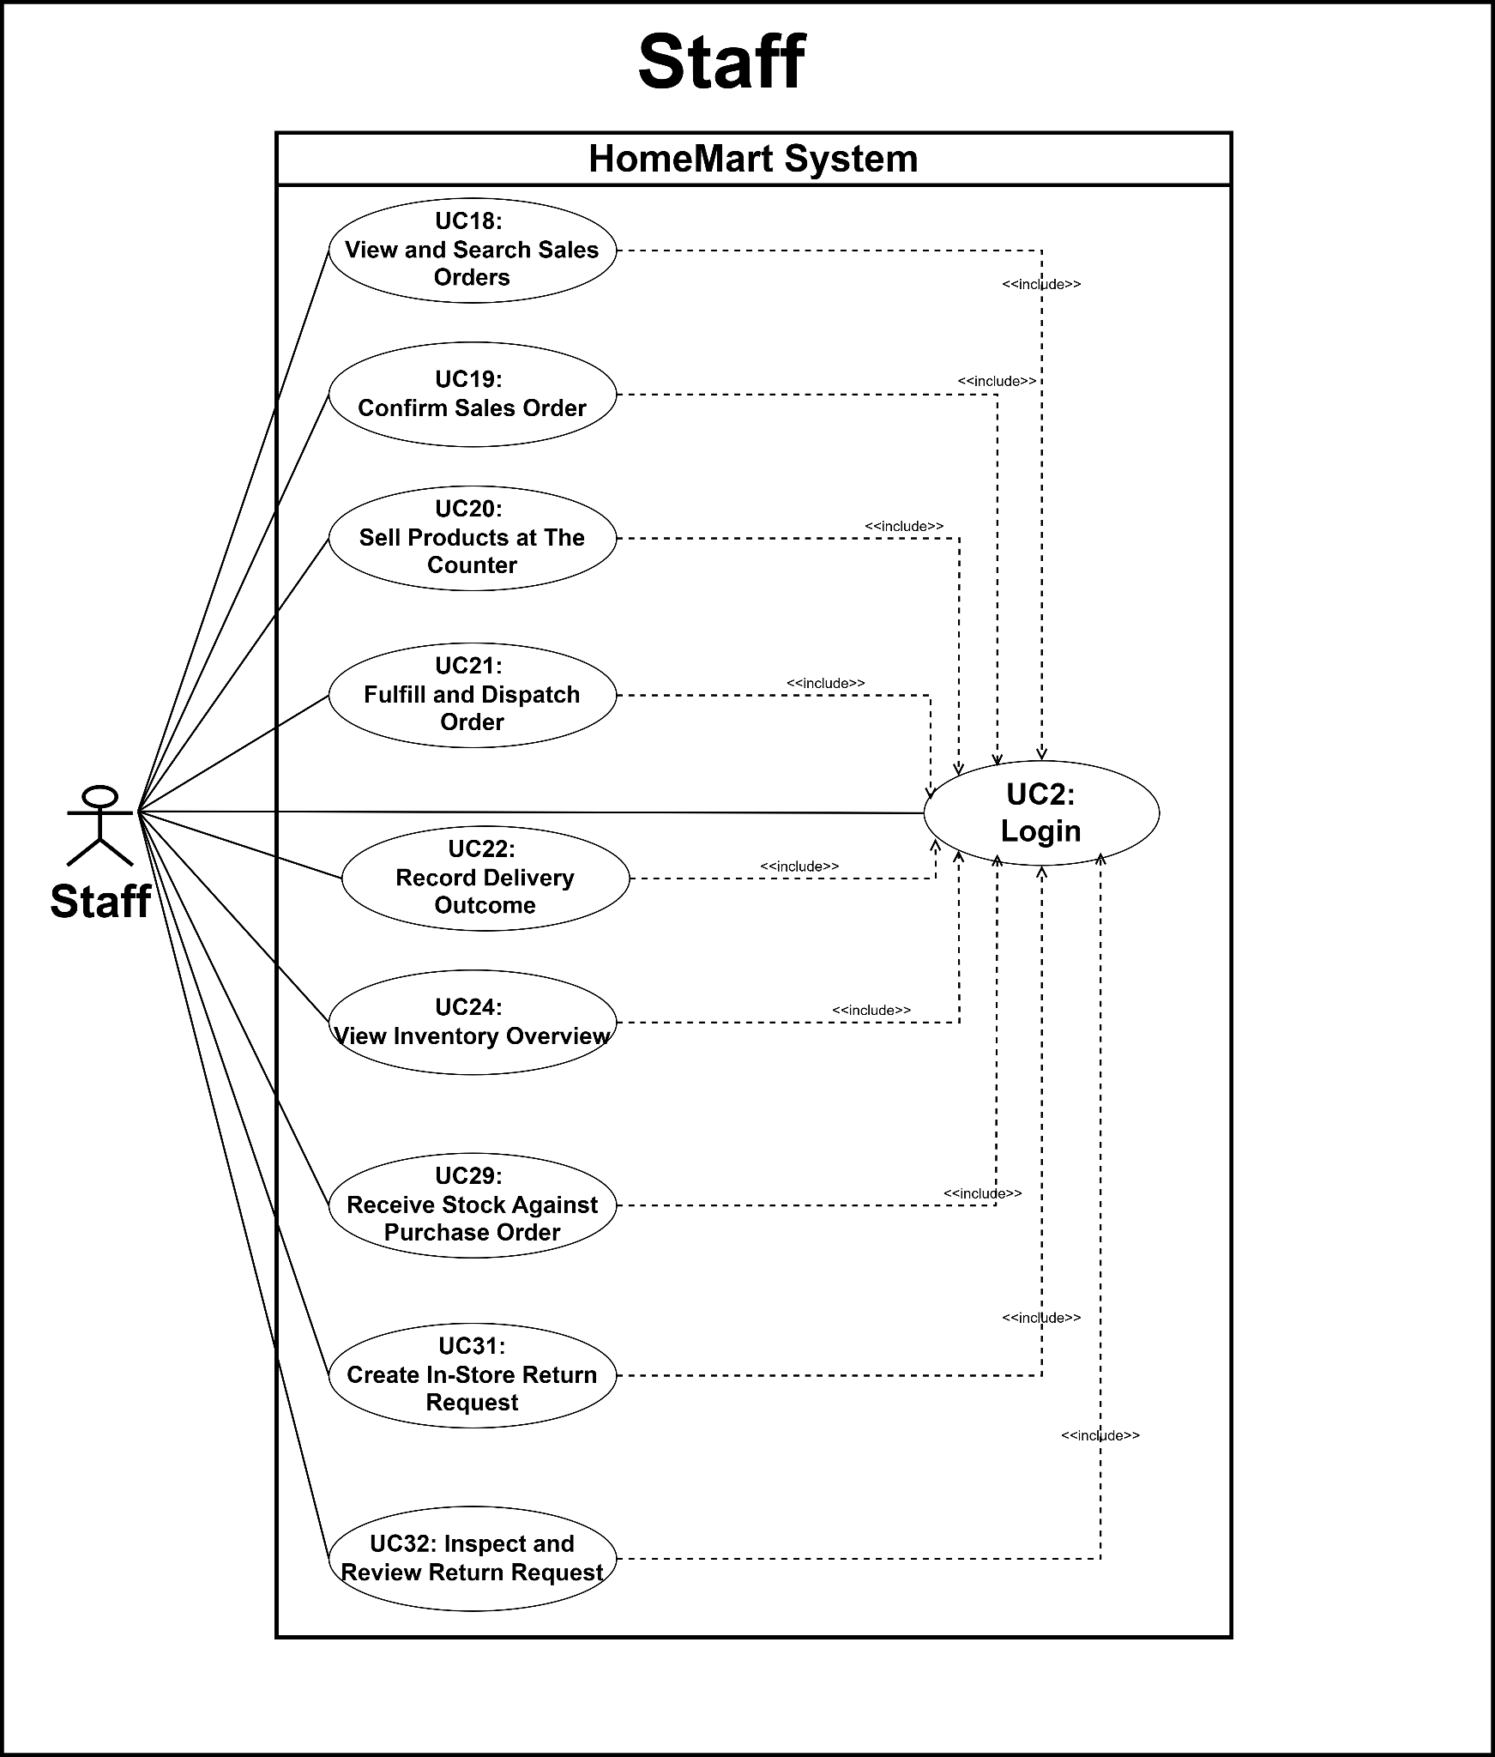
Figure 3. Use case diagram for staff actor
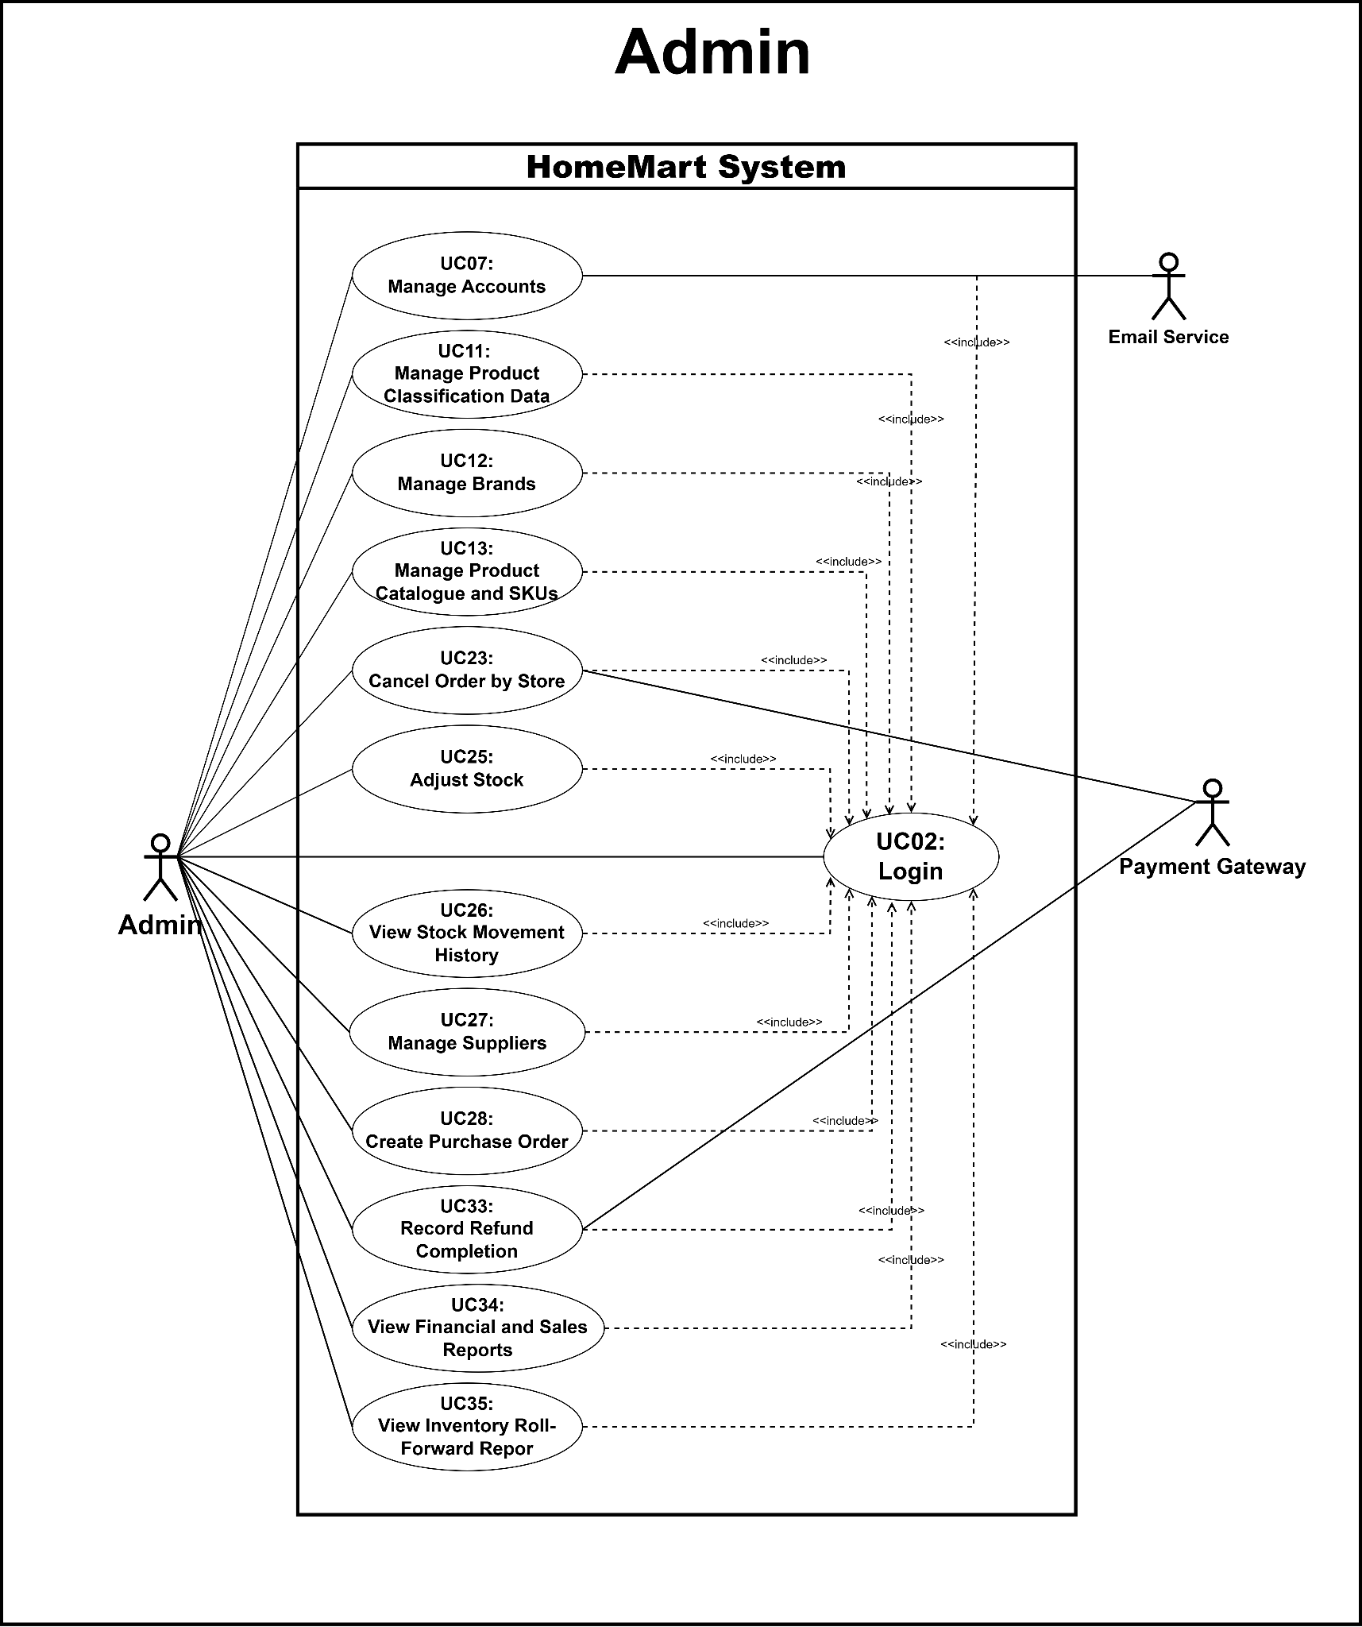
Figure 4. Use case diagram for admin actor

b. Descriptions

ID | Feature | Use Case | Use Case Description
UC-01 | Registration | Register | Guests can register a new customer account by providing the required registration information, with the Email Service involved in the registration process.
UC-02 | Authentication | Login | Customers, Staff, and Admin can log in to the HomeMart System to access functions available to their respective roles.
UC-03 | Authentication | Logout | Customers can log out of the HomeMart System and terminate their current session.
UC-04 | Customer Profile | Manage Personal Profile & Addresses | Customer manages their own profile and saved delivery addresses, including the single default address.
UC-05 | Account Security | Change Own Password | An authenticated user changes their own password after the current password is validated.
UC-06 | Account Recovery | Reset Password | Guests can reset their account password, with the Email Service involved in the password reset process.
UC-07 | Account Management | Manage Accounts | Admin can manage user accounts, with the Email Service involved in account-related interactions.
UC-08 | Product Discovery | Browse and Search Products | Guests can browse and search products available in the HomeMart System.
UC-09 | Product Discovery | View Product Detail | Guests can view detailed information about a selected product.
UC-10 | Shopping Cart | Manage Shopping Cart | Customers can manage products and quantities in their shopping cart.
UC-11 | Product Classification | Manage Product Classification Data | Admin can manage product classification data in the HomeMart System.
UC-12 | Brand Management | Manage Brands | Admin can manage product brands in the HomeMart System.
UC-13 | Product Catalogue | Manage Products and SKUs | Admin maintains products and manually entered SKUs with unique identifiers, prices, images, and stock thresholds.
UC-14 | Order Management | Place Customer Order | Customers can place an order for products in their shopping cart.
UC-15 | Payment | Process Online Payment | Customer pays for an eligible online order; the system verifies the signed gateway callback and records success or failure once.
UC-16 | Order Tracking | View and Track Orders | Customers can view their orders and track their current order status.
UC-17 | Order Cancellation | Cancel Eligible Own Order | Customers can cancel their own orders when the orders satisfy the applicable cancellation conditions.
UC-18 | Sales Order Management | View and Search Sales Orders | Staff can view and search sales orders in the HomeMart System.
UC-19 | Sales Order Processing | Confirm Sales Order | Staff can review and confirm sales orders for further processing.
UC-20 | Point-of-Sale | Sell Products at Counter | Staff can process product sales directly at the store counter.
UC-21 | Order Fulfillment | Fulfill and Dispatch Order | Staff can fulfill orders and dispatch them for delivery.
UC-22 | Delivery Management | Record Delivery Outcome | Staff can record the delivery outcome of an order.
UC-23 | Store Order Cancellation | Cancel Order by Store | Admin can cancel an order on behalf of the store, with the Payment Gateway involved when payment handling is applicable.
UC-24 | Inventory Monitoring | View Inventory Overview | Staff can view an overview of inventory information in the HomeMart System.
UC-25 | Inventory Adjustment | Adjust Stock | Admin can adjust stock quantities in the HomeMart System.
UC-26 | Inventory Audit | View Stock Movement History | Admin can view the history of stock movements in the HomeMart System.
UC-27 | Supplier Management | Manage Suppliers | Admin can manage supplier information in the HomeMart System.
UC-28 | Procurement | Create Purchase Order | Admin can create purchase orders for suppliers.
UC-29 | Stock Receiving | Receive Stock against Purchase Order | Staff can record stock received against an existing purchase order.
UC-30 | Customer Return | Request Order Return | Customers can submit a return request for an eligible order.
UC-31 | In-Store Return | Create In-Store Return Request | Staff can create an in-store return request on behalf of a customer.
UC-32 | Return Processing | Review Return Request | Staff inspects a return and Admin approves or rejects it; only approved resalable items return to stock.
UC-33 | Refund Management | Record Refund | Admin returns an approved amount through the original payment channel and records completion only after disbursement.
UC-34 | Reporting | View Financial Reports | Admin reviews sales by channel and settled payment and refund totals for a selected reporting period.
UC-35 | Inventory Reporting | View Inventory Roll-Forward Report | Admin can view inventory roll-forward reports for a selected reporting period.

2. Overall Functionalities

2.1 Screens Flow
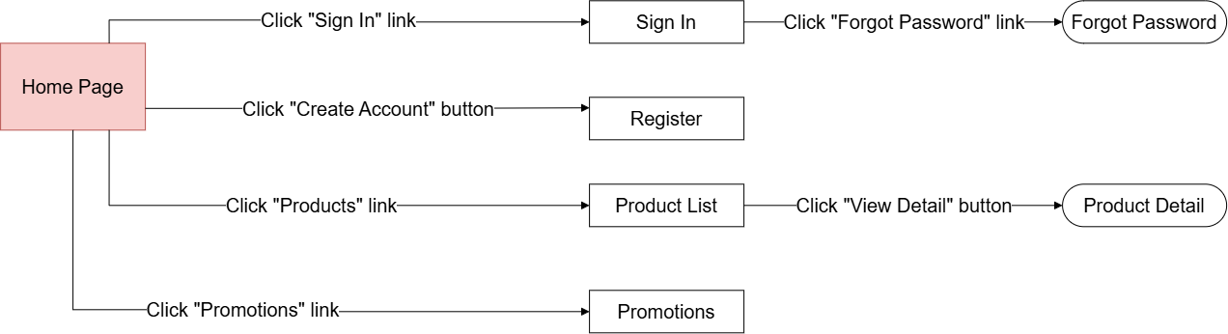
Figure 5. Screen flow for guest actor

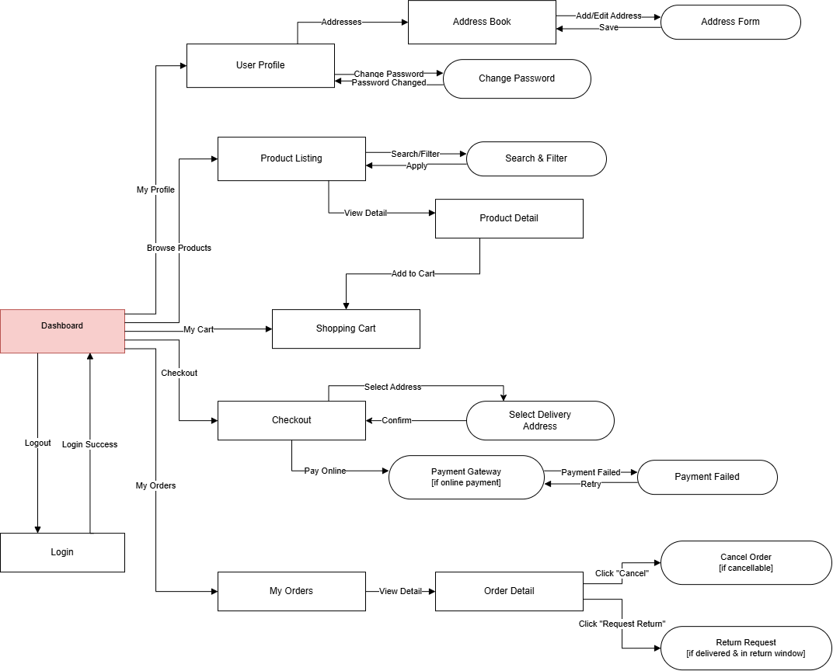
Figure 6. Screen flow for customer actor
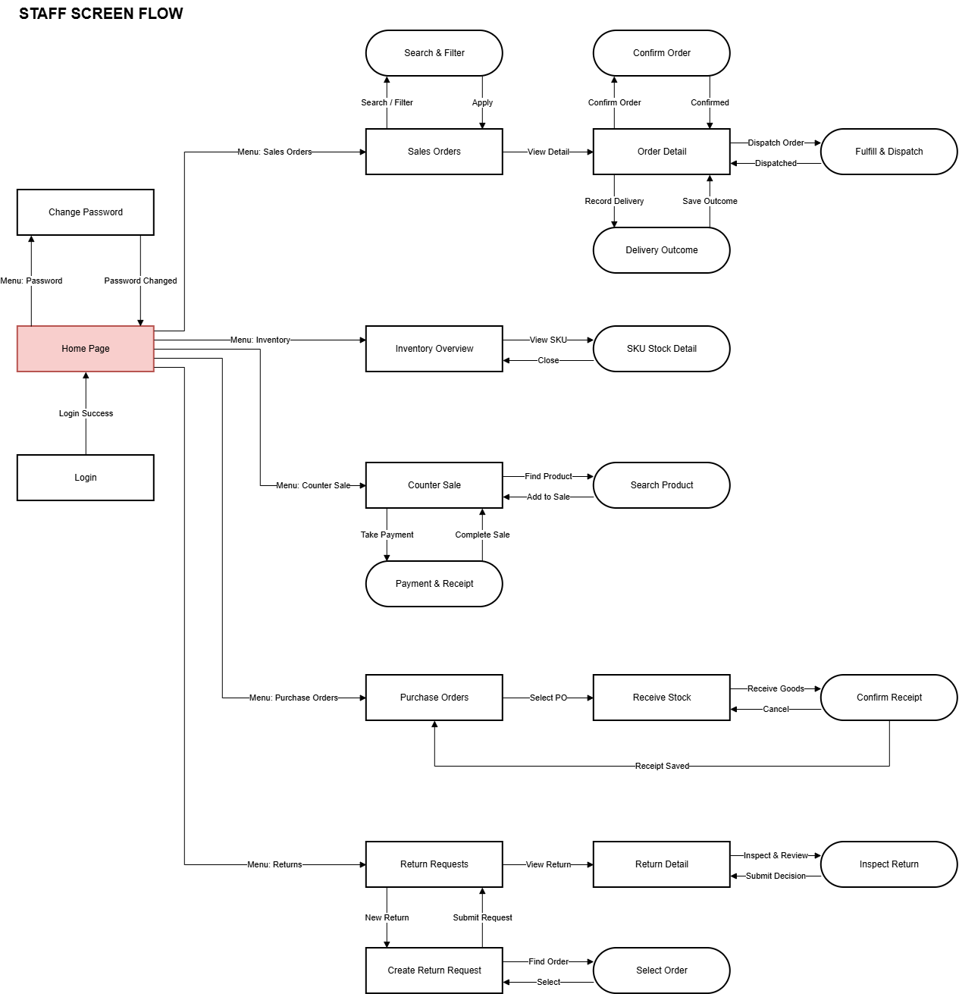
Figure 7. Screen flow for manager actor
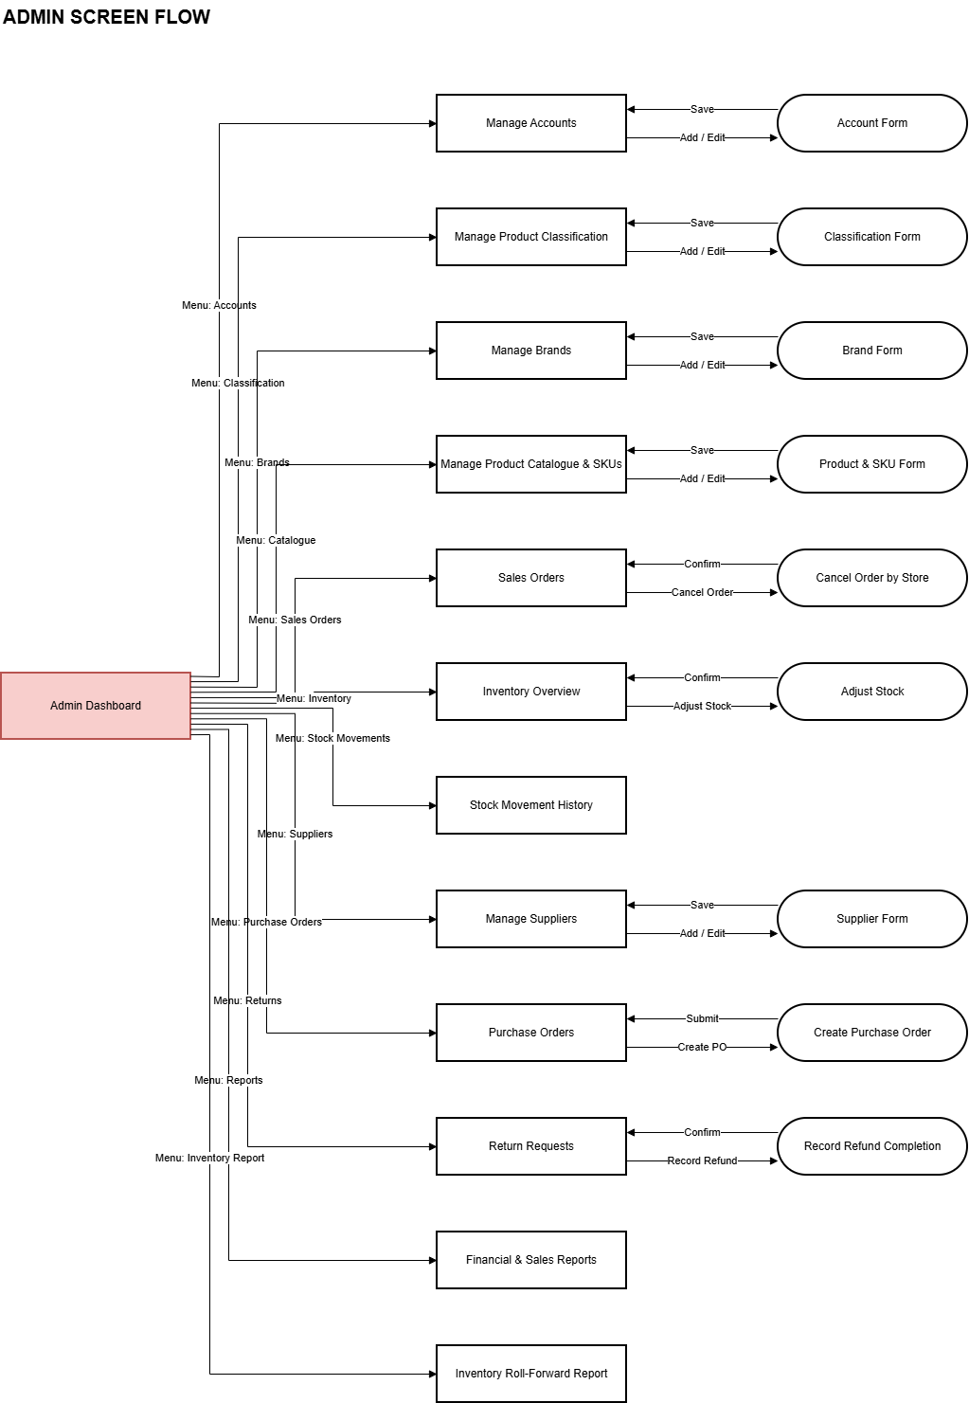
Figure 8. Screen flow for admin actor

2.2 Screen Descriptions
# | Feature | Screen | Description
1 | Register | Register | Users can create a new account using their email.
2 | Login | Login | Users can log into the system using their email and password.
3 | Logout | Confirm Logout | Users can log out of their account after confirming the action.
4 | Manage Personal Profile & Addresses | User Profile / Address Book / Address Form | Users can view and update their profile information and manage their saved delivery addresses.
5 | Change Own Password | Change Password | Users can change their current password from within their account settings.
6 | Reset Forgotten Password | Forgot Password / Reset Link Sent / Reset Password | Users can reset a forgotten password using a recovery link sent to their registered email.
7 | Manage Accounts | Manage Accounts / Account Form | Admin can create, edit, activate, or deactivate staff and admin accounts.
8 | Browse and Search Products | Product Listing / Search & Filter | Users can browse the product catalogue or search for products by name, category, or brand.
9 | View Product Detail | Product Detail | Users can view detailed information about a selected product, including price, description, and specifications.
10 | Manage Shopping Cart | Shopping Cart / Added to Cart | Customers can add products to their cart and update or remove items before checkout.
11 | Manage Product Classification Data | Manage Product Classification / Classification Form | Admin can create, edit, or delete product classification (category) data.
12 | Manage Brands | Manage Brands / Brand Form | Admin can create, edit, or delete product brands.
13 | Manage Product Catalogue and SKUs | Manage Product Catalogue & SKUs / Product & SKU Form | Admin can create, edit, or delete products and their SKUs in the product catalogue.
14 | Place Customer Order | Shopping Cart / Checkout / Select Address | Customers can select a delivery address and confirm checkout to place an order.
15 | Process Online Payment | Payment Gateway / Payment Failed | Customers can complete payment for their order online, with retry available if payment fails.
16 | View Own Orders and Tracking | My Orders / Order Detail / Order Tracking | Customers can view their order history and track the delivery status of each order.
17 | Cancel Eligible Own Order | Order Detail / Cancel Order | Customers can cancel an order that is still eligible for cancellation.
18 | View and Search Sales Orders | Sales Orders / Search & Filter | Staff can view and search sales orders by status, date, or customer.
19 | Confirm Sales Order | Order Detail / Confirm Order | Staff can review and confirm a sales order to move it into fulfillment.
20 | Sell Products at Counter | Counter Sale / Search Product / Payment & Receipt | Staff can create an in-store sale by finding products, taking payment, and issuing a receipt.
21 | Fulfill and Dispatch Order | Order Detail / Fulfill & Dispatch | Staff can prepare a confirmed order and dispatch it for delivery.
22 | Record Delivery Outcome | Delivery Outcome | Staff can record the outcome of a delivery attempt, such as delivered or failed.
23 | Cancel Order by Store | Sales Orders / Order Detail / Cancel Order by Store | Admin can cancel a customer order on behalf of the store.
24 | View Inventory Overview | Inventory Overview / SKU Stock Detail | Staff and Admin can view current stock levels across all SKUs.
25 | Adjust Stock | Inventory Overview / Adjust Stock | Admin can manually adjust the stock quantity of a SKU.
26 | View Stock Movement History | Stock Movement History | Admin can view the history of stock changes for a SKU.
27 | Manage Suppliers | Manage Suppliers / Supplier Form | Admin can create, edit, or delete supplier information.
28 | Create Purchase Order | Purchase Orders / Create Purchase Order | Admin can create a new purchase order to send to a supplier.
29 | Receive Stock against Purchase Order | Purchase Orders / Receive Stock / Confirm Receipt | Staff can receive goods and confirm stock quantities against an existing purchase order.
30 | Request Return for Own Order | Order Detail / Return Request | Customers can submit a return request for an eligible delivered order.
31 | Create In-Store Return Request | Return Requests / Create Return Request / Select Order | Staff can create a return request on behalf of a customer at the store counter.
32 | Inspect and Review Return Request | Return Detail / Inspect Return | Staff can inspect a submitted return request and approve or reject it.
33 | Record Refund Completion | Return Requests / Record Refund Completion | Admin can record the completion of a refund for an approved return.
34 | View Financial and Sales Reports | Financial & Sales Reports | Admin can view reports summarizing financial performance and sales activity.
35 | View Inventory Roll-Forward Report | Inventory Roll-Forward Report | Admin can view a report showing inventory changes (opening, additions, deductions, closing) over a selected period.

2.3 Screen Authorization

Screen/Function | Guest | User | Manager | Admin
Register | X
Login | X | X | X | X
Forgot Password | X | X
Reset Link Sent | X | X
Reset Password | X | X
Login Required (prompt) | X
Product Listing | X | X
Search & Filter (Products) | X | X
Product Detail | X | X
Added to Cart |  | X
Shopping Cart |  | X
Checkout |  | X
Select Address |  | X
Payment Gateway |  | X
Payment Failed |  | X
My Orders |  | X
Order Detail |  | X | X | X
Cancel Order |  | X
Return Request |  | X
Order Tracking |  | X
User Profile |  | X
Address Book |  | X
Address Form |  | X
Change Password |  | X | X
Confirm Logout |  | X
Sales Orders |  |  | X | X
Search & Filter (Orders) |  |  | X
Confirm Order |  |  | X
Fulfill & Dispatch |  |  | X
Delivery Outcome |  |  | X
Inventory Overview |  |  | X | X
SKU Stock Detail |  |  | X
Counter Sale |  |  | X
Search Product (Counter) |  |  | X
Payment & Receipt |  |  | X
Purchase Orders |  |  | X | X
Receive Stock |  |  | X
Confirm Receipt |  |  | X
Return Requests |  |  | X | X
Return Detail |  |  | X
Inspect Return |  |  | X
Create Return Request |  |  | X
Select Order (for Return) |  |  | X
Manage Accounts |  |  |  | X
Account Form |  |  |  | X
Manage Product Classification |  |  |  | X
Classification Form |  |  |  | X
Manage Brands |  |  |  | X
Brand Form |  |  |  | X
Manage Product Catalogue & SKUs |  |  |  | X
Product & SKU Form |  |  |  | X
Cancel Order by Store |  |  |  | X
Adjust Stock |  |  |  | X
Stock Movement History |  |  |  | X
Manage Suppliers |  |  |  | X
Supplier Form |  |  |  | X
Create Purchase Order |  |  |  | X
Record Refund Completion |  |  |  | X
Financial & Sales Reports |  |  |  | X
Inventory Roll-Forward Report |  |  |  | X

2.4 Non-UI Functions

# | Feature | System Function | Description
1 | Verify Email | Send Verification Email | The system sends a verification email to the user after they click the "verify email" button on the profile screen.
2 | Login | Authenticate User | The system authenticates users' credentials without any user interface beyond the login form.
3 | Forgot Password | Forgot Password API | Sends a password reset link to the user's email without requiring UI interaction beyond the initial request.
4 | Process Online Payment | Payment Gateway Charge API | The system sends a charge request to the payment gateway when a customer completes checkout (UC-15).
5 | Process Online Payment | Payment Gateway Webhook/Callback | Receives the payment result from the gateway and updates the order status to Paid or Failed.
6 | Record Refund Completion | Refund API to Payment Gateway | Sends a refund request to the payment gateway when Admin records a refund completion (UC-33).
7 | Cancel Order | Release Reserved Stock | Automatically returns reserved stock to inventory when an order is cancelled (UC-17, UC-23).
8 | Manage Stock | Inventory Sync on Order/Receipt | Deducts stock when an order is confirmed and increases stock when a purchase order is received (UC-19, UC-29), logging each change for the Stock Movement History report.
9 | Order Confirmation Email | Send Order Notification Email | Sends confirmation and status-update emails to the customer after checkout and at each order status change.

3. System High Level Design

3.1 ERD

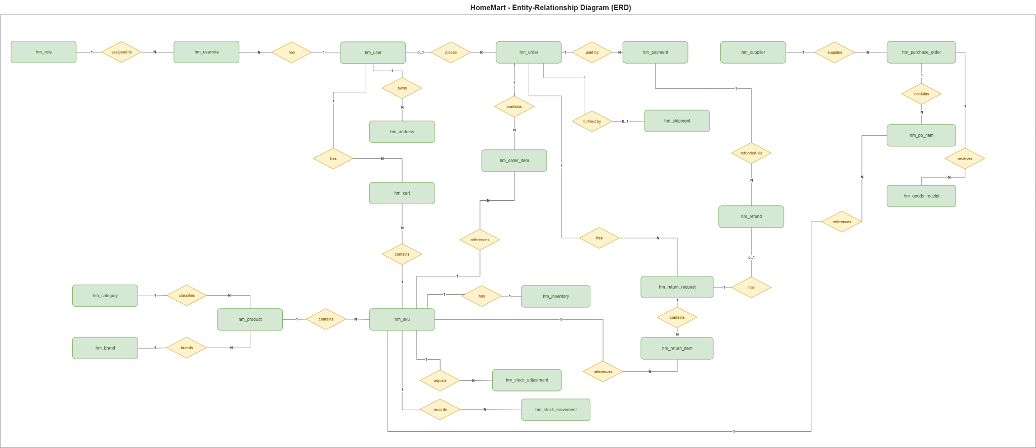
Figure 9. Entity Relationship Diagram

3.2. Database Design

a. Database Schema
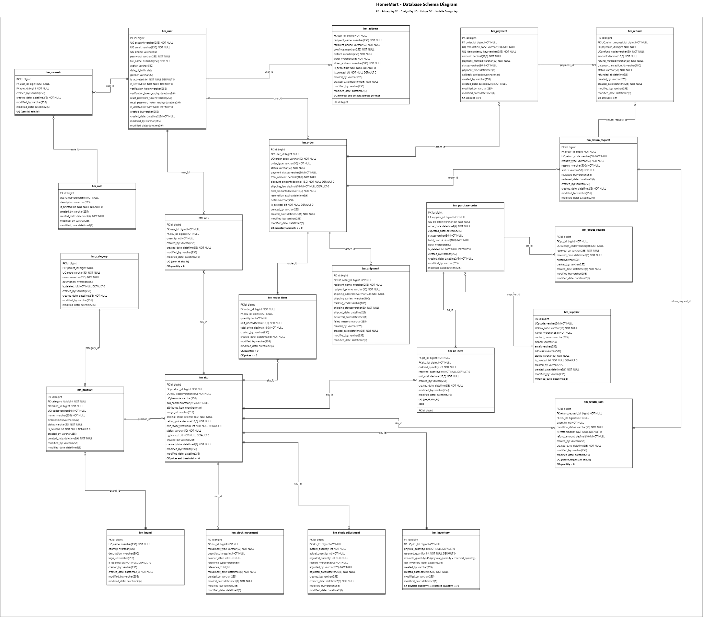
Figure 10. Database Schema

b. Table Descriptions

No | Table | Description
1 | hm_role | This table stores the security roles defined in the system (for example, Customer, Staff, and Admin) for authorization and feature access control.  Table fields:  id (bigint) - primary key  name (varchar(50)) - unique role name  description (nvarchar(255))  is_deleted (bit)  created_by (varchar(255))  created_date (datetime2(6))  modified_by (varchar(255))  modified_date (datetime2(6))
2 | hm_user | This table stores authentication credentials, account status, contact information, and personal profiles for customers, store staff, and administrators. It also stores one-time activation and password-reset tokens together with their expiration times.  Table fields:  id (bigint) - primary key  account (varchar(255)) - unique account name  email (varchar(255)) - unique email address  phone (varchar(50)) - unique phone number  password (varchar(255)) - salted one-way password hash  full_name (nvarchar(255))  avatar (varchar(512))  date_of_birth (date)  gender (varchar(20))  is_activated (bit)  is_verified (bit)  verification_token (varchar(255))  verification_token_expiry (datetime2(6))  reset_password_token (varchar(255))  reset_password_token_expiry (datetime2(6))  is_deleted (bit)  created_by (varchar(255))  created_date (datetime2(6))  modified_by (varchar(255))  modified_date (datetime2(6))
3 | hm_userrole | This junction table manages the many-to-many relationship between users and roles, specifying which security roles are assigned to each user. A user-role pair must be unique.  Table fields:  id (bigint) - primary key  user_id (bigint) - foreign key, references hm_user  role_id (bigint) - foreign key, references hm_role  created_by (varchar(255))  created_date (datetime2(6))  modified_by (varchar(255))  modified_date (datetime2(6))
4 | hm_address | This table stores customer delivery-address entries, including recipient information and Vietnamese administrative divisions. A filtered unique rule ensures that each user has at most one default address.  Table fields:  id (bigint) - primary key  user_id (bigint) - foreign key, references hm_user  recipient_name (nvarchar(255))  recipient_phone (varchar(50))  province (nvarchar(255))  district (nvarchar(255))  ward (nvarchar(255))  street_address (nvarchar(500))  is_default (bit)  is_deleted (bit)  created_by (varchar(255))  created_date (datetime2(6))  modified_by (varchar(255))  modified_date (datetime2(6))
5 | hm_supplier | This table stores the registered suppliers that provide household appliances to the store, including business identifiers, contact details, operating status, and tax information.  Table fields:  id (bigint) - primary key  code (varchar(50)) - unique supplier code  tax_code (varchar(50)) - unique tax code  name (nvarchar(255))  contact_name (nvarchar(255))  phone (varchar(50))  email (varchar(255))  address (nvarchar(500))  status (varchar(50))  is_deleted (bit)  created_by (varchar(255))  created_date (datetime2(6))  modified_by (varchar(255))  modified_date (datetime2(6))
6 | hm_category | This table stores the hierarchical product-category structure used to classify and navigate household appliances. A category may reference another category as its optional parent.  Table fields:  id (bigint) - primary key  parent_id (bigint) - nullable foreign key, references hm_category  code (varchar(50)) - unique category code  name (nvarchar(255))  description (nvarchar(500))  is_deleted (bit)  created_by (varchar(255))  created_date (datetime2(6))  modified_by (varchar(255))  modified_date (datetime2(6))
7 | hm_brand | This table stores household-appliance brand and manufacturer information, including the brand name, country of origin, description, and logo.  Table fields:  id (bigint) - primary key  name (nvarchar(255)) - unique brand name  country (nvarchar(100))  description (nvarchar(500))  logo_url (varchar(512))  is_deleted (bit)  created_by (varchar(255))  created_date (datetime2(6))  modified_by (varchar(255))  modified_date (datetime2(6))
8 | hm_product | This table stores master product information shared by all variants, including category, brand, general description, catalog code, and publication status.  Table fields:  id (bigint) - primary key  category_id (bigint) - foreign key, references hm_category  brand_id (bigint) - foreign key, references hm_brand  code (varchar(50)) - unique product code  name (nvarchar(255))  description (nvarchar(max))  status (varchar(50))  is_deleted (bit)  created_by (varchar(255))  created_date (datetime2(6))  modified_by (varchar(255))  modified_date (datetime2(6))
9 | hm_sku | This table stores concrete sellable Stock Keeping Units (SKUs) and manually created product variants, including variant attributes, unique identification codes, images, whole-VND prices, and the minimum-stock warning threshold.  Table fields:  id (bigint) - primary key  product_id (bigint) - foreign key, references hm_product  sku_code (varchar(100)) - unique SKU code  barcode (varchar(100)) - unique barcode  sku_name (nvarchar(255))  attributes_json (nvarchar(max))  image_url (varchar(512))  original_price (decimal(18,0))  selling_price (decimal(18,0))  min_stock_threshold (int)  status (varchar(50))  is_deleted (bit)  created_by (varchar(255))  created_date (datetime2(6))  modified_by (varchar(255))  modified_date (datetime2(6))
10 | hm_cart | This table stores the active shopping-cart selections of authenticated customers. Each row represents one SKU selected by one user and stores its quantity; the combination of user_id and sku_id must be unique.  Table fields:  id (bigint) - primary key  user_id (bigint) - foreign key, references hm_user  sku_id (bigint) - foreign key, references hm_sku  quantity (int) - must be greater than zero  created_by (varchar(255))  created_date (datetime2(6))  modified_by (varchar(255))  modified_date (datetime2(6))
11 | hm_order | This table stores order headers for online delivery orders and in-store Point-of-Sale (POS) sales, including fulfillment status, payment status, inventory-reservation expiry, and whole-VND financial totals. The user reference is optional for anonymous POS customers.  Table fields:  id (bigint) - primary key  user_id (bigint) - nullable foreign key, references hm_user  order_code (varchar(50)) - unique order code  order_type (varchar(50))  status (varchar(50))  payment_status (varchar(50))  total_amount (decimal(18,0))  discount_amount (decimal(18,0))  shipping_fee (decimal(18,0))  final_amount (decimal(18,0))  reservation_expiry (datetime2(6))  note (nvarchar(500))  is_deleted (bit)  created_by (varchar(255))  created_date (datetime2(6))  modified_by (varchar(255))  modified_date (datetime2(6))
12 | hm_order_item | This table stores the SKU line items included in each sales order, preserving the quantity, unit price at the time of purchase, and whole-VND line total for historical accuracy.  Table fields:  id (bigint) - primary key  order_id (bigint) - foreign key, references hm_order  sku_id (bigint) - foreign key, references hm_sku  quantity (int) - must be greater than zero  unit_price (decimal(18,0))  total_price (decimal(18,0))  created_by (varchar(255))  created_date (datetime2(6))  modified_by (varchar(255))  modified_date (datetime2(6))
13 | hm_payment | This table stores payment attempts and transaction logs for orders, including payment methods, gateway transaction references, idempotency keys, signed callback payloads, status, and whole-VND amounts.  Table fields:  id (bigint) - primary key  order_id (bigint) - foreign key, references hm_order  transaction_code (varchar(100)) - unique transaction code  idempotency_key (varchar(255)) - unique idempotency key  amount (decimal(18,0))  payment_method (varchar(50))  status (varchar(50))  payment_time (datetime2(6))  callback_payload (nvarchar(max))  created_by (varchar(255))  created_date (datetime2(6))  modified_by (varchar(255))  modified_date (datetime2(6))
14 | hm_shipment | This table stores delivery and fulfillment information for eligible orders, including the recipient snapshot, shipping carrier, tracking code, dispatch time, delivery outcome, and failure reason. The unique order reference allows at most one shipment record per order.  Table fields:  id (bigint) - primary key  order_id (bigint) - unique foreign key, references hm_order  recipient_name (nvarchar(255))  recipient_phone (varchar(50))  shipping_address (nvarchar(500))  shipping_carrier (nvarchar(100))  tracking_code (varchar(100))  shipping_status (varchar(50))  shipped_date (datetime2(6))  delivered_date (datetime2(6))  failed_reason (nvarchar(255))  created_by (varchar(255))  created_date (datetime2(6))  modified_by (varchar(255))  modified_date (datetime2(6))
15 | hm_purchase_order | This table stores purchase orders issued to registered suppliers for replenishing household-appliance stock, including expected receipt dates, status, notes, and whole-VND procurement totals.  Table fields:  id (bigint) - primary key  supplier_id (bigint) - foreign key, references hm_supplier  po_code (varchar(50)) - unique purchase-order code  order_date (datetime2(6))  expected_date (datetime2(6))  status (varchar(50))  total_cost (decimal(18,0))  note (nvarchar(500))  is_deleted (bit)  created_by (varchar(255))  created_date (datetime2(6))  modified_by (varchar(255))  modified_date (datetime2(6))
16 | hm_po_item | This table stores the SKU line items included in each purchase order, including the ordered quantity, cumulative received quantity, and agreed whole-VND unit cost. A SKU may appear only once in a purchase order.  Table fields:  id (bigint) - primary key  po_id (bigint) - foreign key, references hm_purchase_order  sku_id (bigint) - foreign key, references hm_sku  ordered_quantity (int) - must be greater than zero  received_quantity (int) - from zero to ordered_quantity  unit_cost (decimal(18,0))  created_by (varchar(255))  created_date (datetime2(6))  modified_by (varchar(255))  modified_date (datetime2(6))
17 | hm_goods_receipt | This table stores warehouse receiving slips created when staff inspect and accept supplier deliveries against a purchase order. Multiple receipts may be recorded for partial deliveries of the same purchase order.  Table fields:  id (bigint) - primary key  po_id (bigint) - foreign key, references hm_purchase_order  receipt_code (varchar(50)) - unique goods-receipt code  received_by (varchar(255))  received_date (datetime2(6))  note (nvarchar(500))  created_by (varchar(255))  created_date (datetime2(6))  modified_by (varchar(255))  modified_date (datetime2(6))
18 | hm_inventory | This table maintains the central warehouse stock balance for each SKU. Physical and reserved quantities are stored, while available_quantity is computed as physical_quantity minus reserved_quantity. Each SKU has exactly one inventory record.  Table fields:  id (bigint) - primary key  sku_id (bigint) - unique foreign key, references hm_sku  physical_quantity (int)  reserved_quantity (int)  available_quantity (computed int) - physical_quantity minus reserved_quantity  last_inventory_date (datetime2(6))  created_by (varchar(255))  created_date (datetime2(6))  modified_by (varchar(255))  modified_date (datetime2(6))
19 | hm_stock_adjustment | This table records manual stock corrections made after physical inventory checks, preserving the system quantity, counted quantity, adjustment amount, responsible auditor, date, and mandatory justification.  Table fields:  id (bigint) - primary key  sku_id (bigint) - foreign key, references hm_sku  system_quantity (int)  actual_quantity (int)  adjusted_quantity (int)  reason (nvarchar(500))  adjusted_by (varchar(255))  adjusted_date (datetime2(6))  created_by (varchar(255))  created_date (datetime2(6))  modified_by (varchar(255))  modified_date (datetime2(6))
20 | hm_stock_movement | This immutable inventory ledger records every stock change caused by supplier receipts, order shipments, approved return restocking, and manual adjustments. Reference fields identify the originating business transaction for inventory roll-forward reporting.  Table fields:  id (bigint) - primary key  sku_id (bigint) - foreign key, references hm_sku  movement_type (varchar(50))  quantity_change (int)  balance_after (int)  reference_type (varchar(50))  reference_id (bigint)  movement_date (datetime2(6))  created_by (varchar(255))  created_date (datetime2(6))  modified_by (varchar(255))  modified_date (datetime2(6))
21 | hm_return_request | This table stores return requests submitted by online customers or created by store staff, linking each request to its original order and tracking its reason, type, review information, and approval status.  Table fields:  id (bigint) - primary key  order_id (bigint) - foreign key, references hm_order  return_code (varchar(50)) - unique return-request code  request_type (varchar(50))  reason (nvarchar(500))  status (varchar(50))  reviewed_by (varchar(255))  reviewed_date (datetime2(6))  created_by (varchar(255))  created_date (datetime2(6))  modified_by (varchar(255))  modified_date (datetime2(6))
22 | hm_return_item | This table stores the SKU line items included in a return request, including the returned quantity, inspection condition, restock decision, and approved whole-VND refund amount. A SKU may appear only once in a return request.  Table fields:  id (bigint) - primary key  return_request_id (bigint) - foreign key, references hm_return_request  sku_id (bigint) - foreign key, references hm_sku  quantity (int) - must be greater than zero  condition_status (varchar(50))  is_restocked (bit)  refund_amount (decimal(18,0))  created_by (varchar(255))  created_date (datetime2(6))  modified_by (varchar(255))  modified_date (datetime2(6))
23 | hm_refund | This table records monetary refunds for approved return requests and links each refund to the original payment transaction so that the refund can be processed through the original payment channel.  Table fields:  id (bigint) - primary key  return_request_id (bigint) - unique foreign key, references hm_return_request  payment_id (bigint) - foreign key, references hm_payment  refund_code (varchar(50)) - unique refund code  amount (decimal(18,0))  refund_method (varchar(50))  gateway_transaction_id (varchar(100))  status (varchar(50))  refunded_at (datetime2(6))  created_by (varchar(255))  created_date (datetime2(6))  modified_by (varchar(255))  modified_date (datetime2(6))

3.3 Code Packages

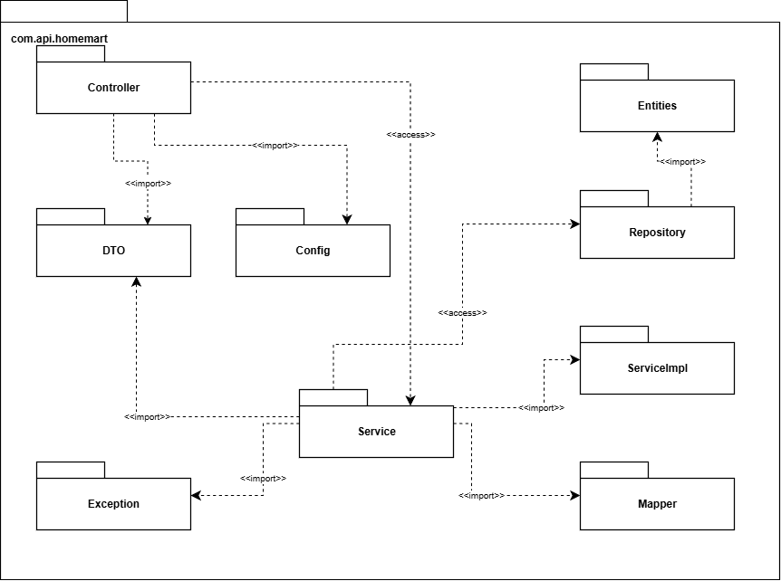
Figure 11. Package Diagram
Package descriptions
No | Package | Description
01 | Controller | Contains classes that handle HTTP requests, interact with services, and return responses.
02 | Config | Contains configuration classes for the application, such as Spring beans or settings.
03 | DTO | Contains data transfer object (DTO) classes, including request and response sub-packages, used for data exchange between layers.
04 | Service | Contains service interfaces and their implementations (e.g., serviceImpl) for business logic.
05 | Entities | Contains entity classes representing database tables or domain models.
06 | Mapper | Contains classes responsible for mapping between entities and DTOs.
07 | Repository | Contains repository interfaces for database operations, typically using JPA or similar ORM.
08 | Exception | Contains custom exception classes for error handling across the application.

II. Requirement Specifications

1. Register

a. Functionalities

UC ID and Name: | UC-01_Register
Created By: | ChuanDH | Date Created: | 20/09/2026
Primary Actor: | Guest | Secondary Actors: | Email Service
Trigger: | The Guest submits the registration form on the application interface.
Description: | A visitor registers with a unique email address, receives a verification token, and activates the customer account upon email confirmation.
Preconditions: | PRE-1. The user is currently unauthenticated (Guest state)
Postconditions: | POST-1. A new Customer profile is persisted in the database with an "Active" status.
Normal Flow | 1.0 User Registration  1. Guest navigates to the Registration interface.  2. Guest inputs required demographic and credential data (e.g., Email, Password) and clicks "Register".  3. System validates the payload and verifies the uniqueness of the email address. (See 1.0.E1)  4. System provisions a new user account with a "Pending Verification" status.  5. System generates a secure cryptographic token and dispatches an invocation to the Email Service to deliver the verification link.  6. Guest accesses their inbox and clicks the verification link containing the token.  7. System validates the token integrity and expiration.  8. System transitions the account status to "Active" and displays a success prompt.
Alternative Flows: | 1.0.A1 Google Registration  1. User chooses to register with their Google account.  2. System redirects the user to Google’s registration/authorization page.  3. User enters their Google credentials and chooses to register.  4. Google validates user’s information and redirects the user back to the system.  5. Return to step 6 of the normal flow.
Exceptions: | 1.0.E1 Email Conflict (Duplicate): System detects the email address already exists. The transaction is aborted and a validation error is returned to prevent duplicate primary keys.
Priority: | High, Must Have
Frequency of Use: | High
Business Rules: | BR01-01, BR01-02, BR01-03
Other Information: | The verification token TTL (Time-To-Live) is configured to 15 minutes.
Assumptions: | The external SMTP/Email Service is operational and highly available. .

b. Business Rules
Provide the business rules those are applied only to the use case
ID | Business Rule | Business Rule Description
BR01-01 | Password Encoding | User’s password must be encoded with BCrypt hashing
BR01-02 | Unique Email | User’s email must be unique across the system.
BR01-03 | Google integration | Google registration must be integrated and handle redirects properly.

2.Login

a. Functionalities

UC ID and Name: | UC-02_Login
Created By: | ChuanDH | Date Created: | 20/09/2026
Primary Actor: | Customer / Staff / Admin | Secondary Actors: | None
Trigger: | The user attempts to access a protected resource or explicitly submits the authentication form.
Description: | An active, verified user submits credentials to receive a secure, role-appropriate session and an access token.
Preconditions: | PRE-1: The user possesses an active, verified identity in the system.
Postconditions: | POST-1: The system generates a valid session and issues an authorization token (e.g., JW
Normal Flow: | 2.0 User Authentication  1. User accesses the Authentication interface.  2. User inputs their registered Email and Password, then submits the request.  3. System queries the database and verifies the credentials against the hashed payload. (See 2.0.E1)  4. System evaluates the authorization level (Role: Customer, Staff, or Admin).  5. System initiates a secure session, generates a role-based access token, and redirects the user to their respective personalized dashboard or intended URI..
Alternative Flows: | None
Exceptions: | 2.0.E1 Invalid Credentials  1. System determines the credentials do not match any active records.  2. System rejects the authentication request with a generic error (e.g., "Invalid email or password") to mitigate user enumeration attacks.
Priority: | High, Must Have
Frequency of Use: | Very High
Business Rules: | BR02-01,BR02-02,BR02-03,BR02-04
Other Information: | The login session should automatically time out after a specific period of inactivity for security purposes.
Assumptions: | Network connection is stable

b. Business Rules

ID | Business Rule | Business Rule Description
BR02-01 | The generated access token must encapsulate the user's role claims to enforce strict access control on backend API endpoints. | The generated access token must encapsulate the user's role claims to enforce strict access control on backend API endpoints.
BR02-02 | Role-Based Access Control | The generated access token (JWT) must encapsulate the user's role claims to enforce strict access control on backend API endpoints.
BR02-03 | Account Lockout Policy | The system must temporarily lock the account for 15 minutes after 5 consecutive failed login attempts to mitigate brute-force attacks.
BR02-04 | Session Timeout | Inactive user sessions must automatically expire and trigger a force-logout after 30 minutes of no interaction.

3.UC-03:Logout

a. Functionalities

UC ID and Name: | UC-03_Logout
Created By: | ChuanDH | Date Created: | 20/09/2026
Primary Actor: | Authenticated User | Secondary Actors: | None
Trigger: | The user invokes the logout function via the application header/menu.
Description: | Terminates the current user session securely and invalidates associated access tokens to prevent unauthorized replay attacks.
Preconditions: | PRE-1:The user has an active, valid session/token
Postconditions: | POST-1:The session is destroyed, and the token is revoked or discarded.
Normal Flow: | POST-1:The session is destroyed, and the token is revoked or discarded.
Alternative Flows: | None
Exceptions: | None
Priority: | Low, Could Have
Frequency of Use: | High
Business Rules: | BR03-01 Token Revocation
Other Information: | None
Assumptions: | The client application correctly processes the command to purge local storage and cookies upon receiving the termination response.

b. Business Rules

ID | Business Rule | Business Rule Description
BR03-01 | Token Revocation | Upon explicit logout, the system must immediately revoke the access token. If using stateful sessions, the session identifier must be added to a denylist to prevent subsequent reuse and unauthorized replay attacks.

4. Manage Personal Profile & Addresses

a. Functionalities
UC ID and Name: | UC-04_Manage Personal Profile & Addresses
Created By: | AnNP | Date Created: | 27/09/2026
Primary Actor: | Customer | Secondary Actors: | None
Trigger: | The Customer opens My Profile or My Addresses.
Description: | Allows an authenticated Customer to view and update their own profile and to add, edit, remove, or choose a default delivery address.
Preconditions: | PRE-1. The Customer is authenticated.  PRE-2. The requested profile or address belongs to the current Customer.
Postconditions: | POST-1. Successful profile or address changes are saved for the current Customer.  POST-2. When at least one address is saved, exactly one is the default delivery address.  POST-3. A failed change leaves the previous profile and address data unchanged.
Normal Flow | 4.0 View and update own profile  1. The Customer opens My Profile.  2. The system retrieves the current Customer's profile and saved delivery addresses.  3. The system displays editable profile fields and the address list.  4. The Customer changes their name or contact phone and selects Save.  5. The system validates the submitted fields and confirms ownership.  6. The system saves the changes and displays the updated profile.
Alternative Flows: | 4.0.A3.1 Add a delivery address  1. The Customer selects Add Address and enters recipient, phone, and delivery location.  2. The system validates the fields and saves the address under the current account.  3. If this is the first saved address, the system makes it the default.  4. Return to main flow step 3 with the refreshed address list.  4.0.A3.2 Edit an address  1. The Customer selects one of their addresses and edits its delivery details.  2. The system validates ownership and the new details, then saves the change.  3. Return to main flow step 3.  4.0.A3.3 Change the default address  1. The Customer selects another saved address as Default.  2. The system atomically removes the old default flag and marks the selected address as default.  3. Return to main flow step 3.  4.0.A3.4 Remove an address  1. The Customer selects Remove for one of their saved addresses.  2. The system confirms the selection and removes that address.  3. If other addresses remain and the removed address was default, the Customer selects a replacement default before removal completes.  4. Return to main flow step 3.
Exceptions: | 4.0.E1 Invalid profile input: At step 5, a required field or phone number is invalid. The system highlights the field and does not save.  4.0.E2 Unauthorized address: The selected address is missing or belongs to another Customer. The system denies the change without exposing that address.  4.0.E3 Default replacement required: The default address has no selected replacement while another address remains. The system requests a replacement and retains the previous data.  4.0.E4 Session or save failure: The session expires or saving fails. The system reports the failure and leaves stored data unchanged.
Priority: | Should Have
Frequency of Use: | Whenever a Customer updates contact or delivery information.
Business Rules: | BR-02, BR-04
Other Information: | Existing order delivery snapshots are not rewritten when a saved address changes. Checkout selects a current address in UC-14.
Assumptions: | A Customer may have no saved address before the first one is added. Changing the account email is outside this use case.

b. Business Rules
ID | Business Rule | Business Rule Description
BR-02 | Personal data access | Customer personal contact records and delivery addresses may be accessed by the owning authenticated Customer and authorized staff. Delivery information may be shared only with the designated carrier for order fulfillment.
BR-04 | Default delivery address | An authenticated customer can save multiple delivery destination entries in their address book, but exactly one address must be designated as the active default shipping address.

5. Change Own Password

a. Functionalities
UC ID and Name: | UC-05_Change Own Password
Created By: | AnNP | Date Created: | 27/09/2026
Primary Actor: | Authenticated User | Secondary Actors: | None
Trigger: | An authenticated user selects Change Password in account settings.
Description: | Allows the current user to replace their own password after the system verifies the current password and validates the new one.
Preconditions: | PRE-1. The user is authenticated.  PRE-2. The user knows their current password.
Postconditions: | POST-1. On success, the new password is stored only as a salted one-way hash and the previous password no longer authenticates.  POST-2. A rejected or failed request leaves the stored password unchanged.
Normal Flow | 5.0 Change own password  1. The user opens Change Password.  2. The system displays fields for current password, new password, and confirmation.  3. The user enters the three values and submits the form.  4. The system verifies the current password against the user's stored hash.  5. The system validates the new password, confirms the two new entries match, and checks that it differs from the current password.  6. The system stores a new salted one-way hash in one transaction.  7. The system confirms that the password has changed without displaying or logging either password.
Alternative Flows: | 5.0.A2 Cancel before submission  1. The user leaves the form without submitting it.  2. The system makes no credential change.
Exceptions: | 5.0.E1 Incorrect current password: At step 4, the current password is incorrect. The system rejects the request with a generic error and retains the old hash.  5.0.E2 Invalid new password: At step 5, the new password fails policy, matches the old password, or differs from confirmation. The system requests a correction and retains the old hash.  5.0.E3 Expired session: The session expires before submission. The system requests login and does not change the password.  5.0.E4 Storage failure: Storage fails at step 6. The system reports the failure and retains the previous credential.
Priority: | Should Have
Frequency of Use: | Occasionally, when a user rotates a known password.
Business Rules: | BR-01, BR-38
Other Information: | Forgotten-password recovery is UC-06. This use case changes only the signed-in user's credential.
Assumptions: | The configured password policy is shared with registration and forgotten-password reset.

b. Business Rules
ID | Business Rule | Business Rule Description
BR-01 | Password hashing | User passwords must be hashed using a standard salted one-way hashing algorithm (e.g., BCrypt) prior to persistent storage; storing or logging plain-text credentials is strictly prohibited.
BR-38 | Current password validation | Before changing an authenticated user's password, the system must verify the current password and reject a new password that does not meet the configured password policy or is identical to the current password. A rejected request leaves the stored credential unchanged.

6.UC-06:Reset Forgotten Password

a. Functionalities

UC ID and Name: | UC-06 Reset Forgotten Password
Created By: | ChuanDH | Date Created: | 20/09/2026
Primary Actor: | Unauthenticated User | Secondary Actors: | Email Service
Trigger: | The user clicks the "Forgot Password" hyperlink on the authentication interface.
Description: | The account owner utilizes an expiring, one-time email token to authenticate a password reset request and define a new credential.
Preconditions: | PRE-1. The user provides a syntactically valid email address.
Postconditions: | POST-1. The identity record is updated with a new hashed password.
Normal Flow: | 6.0 Password Recovery  1. User requests a password reset by providing their registered email.  2. System validates the email existence. (See 6.0.E1)  3. System generates a secure, time-bound One-Time Password (OTP) and invokes the Email Service to deliver it.  4. User retrieves the OTP and submits it along with a new password payload.  5. System verifies the OTP validity and expiration. (See 6.0.E2)  6. System overwrites the existing password hash with the new one and destroys the OTP.  7. System notifies the user of the successful update and redirects to the Login interface.
Alternative Flows: | None
Exceptions: | 6.0.E1 Unregistered Identity: System obfuscates the response (e.g., "If the email exists, a token has been sent") to prevent email enumeration attacks.  6.0.E2 Token Expiration / Invalidity: System rejects the transaction and mandates a new recovery request.
Priority: | Medium, Should Have
Frequency of Use: | Medium
Business Rules: | BR06-0:OTP Lifecycle Management  BR06-02:Password Complexity
Other Information: | None
Assumptions: | None

b. Business Rules

ID | Business Rule | Business Rule Description
BR06-01 | OTP Lifecycle Management | The recovery token must be strictly configured as a One-Time Password (OTP) with a maximum Time-To-Live (TTL) of 15 minutes to mitigate interception risks.
BR06-02 | Password Complexity | The new password payload must comply with system security standards (e.g., minimum 8 characters, containing uppercase, lowercase, and numeric characters).

7.UC-07:Manage Accounts

a. Functionalities

UC ID and Name: | UC-07 Manage Accounts
Created By: | ChuanDH | Date Created: | 20/09/2026
Primary Actor: | Admin | Secondary Actors: | Email Service
Trigger: | The Admin navigates to the Account Management module.
Description: | Enables the Admin to create new profiles (e.g., Staff accounts), modify account statuses (lock/unlock to restrict or grant access), and issue setup credentials.
Preconditions: | PRE-1. The Admin is authenticated and possesses identity management privileges.
Postconditions: | POST-1. The targeted account is provisioned, locked, or unlocked in the database.
Normal Flow: | 7.0 Provision New Account  1. Admin initiates the "Create Account" workflow.  2. Admin inputs user details (Name, Email) and assigns a specific Role (e.g., Staff).  3. System validates data uniqueness. (See 7.0.E1)  4. System persists the new account and triggers the Email Service to dispatch initial setup credentials to the user.  7.1 Lock/Unlock Account  1. Admin selects an existing account from the directory.  2. Admin toggles the account status (Lock or Unlock).  3. System applies the status mutation. If locked, the system instantly revokes any active sessions for that user
Alternative Flows: | None
Exceptions: | 7.0.E1 Duplicate Identity: System rejects account creation if the provided email already exists within the system repository.
Priority: | Medium, Should Have
Frequency of Use: | Low (Usually performed during onboarding/offboarding)
Business Rules: | BR07-01:Audit Logging  BR07-02:Session Revocation
Other Information: | Admins cannot view or retrieve plaintext passwords of any users.
Assumptions: | None

b. Business Rules

ID | Business Rule | Business Rule Description
BR07-01 | Audit Logging | Any administrative state mutation on user identities (e.g., account creation, role assignment, locking/unlocking) must be appended to an immutable audit trail for security compliance.
BR07-02 | Session Revocation | Upon transitioning an account status to "Locked", the system must immediately invalidate and terminate all currently active sessions and access tokens associated with that identity.

11.UC-11:Manage Product Classification Data

a. Functionalities

UC ID and Name: | UC-11 Manage Product Classification Data
Created By: | ChuanDH | Date Created: | 20/09/2026
Primary Actor: | Admin | Secondary Actors: | None
Trigger: | The Admin navigates to the Category Management dashboard.
Description: | Enables the Admin to perform CRUD operations (Create, Read, Update, and Deactivate) on product categories to organize the hierarchical catalog architecture
Preconditions: | PRE-1. The Admin is authenticated and possesses catalog management privileges
Postconditions: | POST-1. The category taxonomy is successfully updated and persisted in the database.
Normal Flow: | 11.0 Category Creation  1. Admin initiates a "Create New Category" action.  2. Admin inputs category metadata (Name, Description, Parent Category ID).  3. System validates the uniqueness of the category nomenclature. (See 11.0.E1)  4. System persists the entity with an "Active" state.  11.1 Category Update/Deactivation  1. Admin retrieves an existing category record.  2. Admin modifies the metadata attributes or flags the entity state as "Deactivated".  3. System commits the transaction and updates the cached catalog tree.
Alternative Flows: | None
Exceptions: | 11.0.E1 Nomenclature Conflict: System rejects the transaction if the proposed Category Name duplicates an existing node at the same hierarchical level.
Priority: | Medium, Should Have
Frequency of Use: | Low (Infrequent taxonomy updates)
Business Rules: | BR11-01:Soft Deletion Protocol  BR11-02:Unique Nomenclature
Other Information: | Changes to the category taxonomy require cache invalidation for the front-end catalog view to ensure real-time synchronization.
Assumptions: | None

b. Business Rules

ID | Business Rule | Business Rule Description
BR11-01 | Soft Deletion Protocol | Product categories must never be hard-deleted from the database if they possess historical associations (e.g., linked products). They must undergo a "Soft Delete" (Status = Deactivated) to maintain referential integrity.
BR11-02 | Unique Nomenclature | The proposed Category Name must be strictly unique within the same hierarchical level of the catalog tree to prevent data redundancy and user confusion.

12.UC-12: Manage Brands

a. Functionalities

UC ID and Name: | UC-12 Manage Brands
Created By: | ChuanDH | Date Created: | 20/09/2026
Primary Actor: | Admin | Secondary Actors: | None
Trigger: | The Admin navigates to the Brand Reference Management module
Description: | Facilitates the administration (Create, Update, Deactivate) of appliance brand reference entities, which act as standard metadata for product filtration and cataloging.
Preconditions: | PRE-1. The Admin is authenticated with corresponding authorization claims.
Postconditions: | POST-1. The brand reference data is successfully committed to the repository.
Normal Flow: | 12.0 Brand Entity Creation  1. Admin accesses the Brand Management interface and triggers the creation workflow.  2. Admin inputs standard brand metadata (Brand Name, Manufacturer details, Logo Media URI).  3. System validates payload integrity.  4. System persists the new brand entity to the reference data schema.  12.1 Brand Entity Modification  1. Admin selects a specific brand entity.  2. Admin alters the attributes or transitions the entity status to "Inactive/Deactivated".  3. System applies the mutation to the database.
Alternative Flows: | None
Exceptions: | None
Priority: | Medium, Should Have
Frequency of Use: | Low
Business Rules: | BR12-01:Cascading Visibility Constraints
Other Information: | Brand logos should be stored in a CDN or secure blob storage, saving only the URI in the relational database.
Assumptions: | None

b. Business Rules

ID | Business Rule | Business Rule Description
BR12-01 | Cascading Visibility Constraints | Deactivating a brand reference entity must not disrupt or delete existing product records in the database. However, front-end discovery filters and UI components must dynamically omit the deactivated brand from rendering.

13. Manage Products and SKUs

a. Functionalities
UC ID and Name: | UC-13_Manage Products and SKUs
Created By: | AnNP | Date Created: | 27/09/2026
Primary Actor: | Admin | Secondary Actors: | None
Trigger: | Admin opens product management to create or update a product or SKU.
Description: | Allows Admin to maintain master products and manually defined sale-unit SKUs, including identifiers, attributes, public prices, images, and minimum-stock thresholds.
Preconditions: | PRE-1. Admin is authenticated and authorized for catalogue management.  PRE-2. A category and brand are available when a product is published.
Postconditions: | POST-1. Valid product and SKU details are saved and can be reviewed by Admin.  POST-2. A product is public only when its required category, brand, and representative image are present.  POST-3. Catalogue changes do not directly change physical or reserved inventory.
Normal Flow | 13.0 Create a product and its sale-unit SKUs  1. Admin opens Product Management and selects Create Product.  2. The system displays product fields and available categories and brands.  3. Admin enters the product name, description, category, brand, and representative image.  4. Admin adds each intended SKU manually, entering its unique code and barcode, sale-unit attributes, VND selling price, and minimum-stock threshold.  5. The system validates required fields, references, unique identifiers, and nonnegative prices and thresholds.  6. Admin reviews the entered product and SKU list and selects Save.  7. The system saves the product and SKUs and displays their management details.
Alternative Flows: | 13.0.A1.1 Edit an existing product or SKU  1. Admin opens the record and changes permitted details or a SKU's selling price and threshold.  2. The system revalidates the changed fields and saves the update.  3. The system displays the updated record without rewriting historical order prices.  13.0.A1.2 Add another manual SKU  1. Admin enters a new sale-unit SKU and its identifiers, attributes, price, and threshold.  2. The system validates uniqueness and saves the new SKU under that product.  13.0.A1.3 Deactivate a product or SKU  1. Admin selects Deactivate and confirms the action.  2. The system removes the item from future public sale while preserving historical references.
Exceptions: | 13.0.E1 Duplicate SKU identifier: A SKU code or barcode already exists. The system identifies the conflicting field and does not save the duplicate.  13.0.E2 Missing publication data: A required category, brand, or image is missing when publication is requested. The system keeps the record unpublished and requests completion.  13.0.E3 Invalid price or threshold: A price or threshold is invalid. The system requests a valid whole-VND price or nonnegative threshold.  13.0.E4 Stale catalogue record: The record was changed or removed by another Admin. The system asks for a refresh before saving.  13.0.E5 Save failure: Saving fails. The system reports the failure and leaves the previous catalogue state intact.
Priority: | Must Have
Frequency of Use: | Whenever Admin creates or maintains a catalogue product or sale-unit SKU.
Business Rules: | BR-05, BR-06, BR-07, BR-08, BR-09, BR-14, BR-37
Other Information: | Stock receipts and adjustments are specified in UC-29 and UC-25. This use case does not generate SKU permutations automatically.
Assumptions: | A SKU represents a manually entered sellable model, capacity, or package unit; the store uses one stock location.

b. Business Rules
ID | Business Rule | Business Rule Description
BR-05 | Product and SKU relationship | A master product catalog record can contain multiple SKU variants, but each individual SKU must belong to exactly one parent product entity.
BR-06 | Manual SKU configuration | Administrators must define and configure SKU variants, attributes (e.g., color, wattage, capacity), and pricing manually; automatic permutation of SKU variants by the system is strictly prohibited.
BR-07 | Unique SKU identifiers | Each SKU must possess a unique SKU Code and Barcode across the entire catalog and inventory system to prevent cross-variant misidentification.
BR-08 | Public VND selling price | In accordance with e-commerce regulations, all public retail prices displayed for products and SKUs must represent the final selling price inclusive of Value Added Tax (VAT) and explicitly specify Vietnamese Dong (VND) as the legal currency unit.
BR-09 | Product publication requirements | A product or SKU cannot be activated for public sale without an assigned category, an assigned brand, and at least one representative product image.
BR-14 | Low-stock warning | The system must trigger an automatic warning notification to Administrators whenever the Available Quantity of an SKU falls below its pre-configured min_stock_threshold.
BR-37 | Whole VND values | All financial values, product pricing, tax calculations, shipping fees, discounts, and inventory asset valuations must be rounded and denominated in whole integer units of Vietnamese Dong (VND).

8. Browse and Search Products

a. Functionalities
UC ID and Name | UC-08_Browse and Search Products
Created By | NhaLP | Date Created | 22/Sep/2026
Primary Actor | Guest, Customer | Secondary Actors | None
Trigger | The user opens the storefront product list or submits a search.
Description | Allows users, including guests, to browse paginated product listings, search by product name, brand or SKU, and filter or sort results before purchasing. Covers UC-08.1 Browse Products, UC-08.2 Search Products, and UC-08.3 Filter and Sort Products.
Preconditions | PRE-1: The storefront is accessible. Authentication is not required.
Postconditions | POST-1: The system displays matching public products or an empty-results message.  POST-2: The selected search, filter, sort and page state is reflected in the results.  POST-3: Product and inventory data are unchanged.
Normal Flow | 8.0 Browse Products (UC-08.1)  1. The user opens the product list.  2. The system retrieves published products with active, visible sellable SKUs.  3. The system displays a paginated list with product names, images, brands and selling prices.  4. The user selects another page.  5. The system displays that page while retaining the current criteria.  6. The user selects a product.  7. The system opens View Product Detail (UC-09).
Alternative Flows | 8.1 Search Products (UC-08.2) - branches from main flow step 3.  1. The user enters a product-name, brand or SKU keyword and submits it.  2. The system validates and normalizes the keyword.  3. The system applies the keyword together with existing filters and resets pagination to the first page.  4. Return to main flow step 3 with the results.  8.2 Filter and Sort Products (UC-08.3) - branches from main flow step 3.  1. The user selects category, brand, price or attribute filters and a sort option.  2. The system validates the criteria and applies them with the current keyword.  3. The system sorts matching results and resets to the first page.  4. Return to main flow step 3.  8.3 Clear criteria - branches from main flow step 3.  1. The user clears the search and filters.  2. The system restores the default listing and sort order.  3. Return to main flow step 3.  8.4 No results - occurs while displaying results.  1. The system displays No products found.  2. The user changes or clears the criteria and repeats search or filtering.
Exceptions | 8.2.E1: At validation, a price is negative or nonnumeric, or the minimum exceeds the maximum. The system requests corrected criteria.  8.0.E1: Retrieval fails. The system reports the error and offers Retry; it does not report an empty catalogue as a successful result.  8.0.E2: A requested page no longer exists after catalogue changes. The system returns a valid page and updates the page count.
Priority | Must Have
Frequency of Use | Frequently during product discovery.
Business Rules | BR08-01, BR08-02, BR08-03, BR08-04, BR08-05, BR08-06
Other Information | Opening a result continues in UC-09. This use case does not add cart items or reserve stock.
Assumptions | Page size is a storefront configuration value. Newest refers to the product publication date. Supported attribute filters come from classification data maintained in UC-11.

b. Business Rules
ID | Business Rule | Business Rule Description
BR1 | Public scope | Only published products and active, visible SKUs are searchable on the storefront. Out-of-stock items may remain visible with their availability indicated.
BR2 | Search matching | Keywords match product name, brand name or SKU code using case-insensitive partial matching. Surrounding whitespace is ignored.
BR3 | Combined conditions | Different filter groups and the keyword are combined using AND. Multiple selected values within the same filter group are combined using OR. SKU-specific filters must be satisfied by the same eligible SKU.
BR4 | Price bounds | Price bounds are inclusive. Either bound may be omitted; an omitted minimum or maximum imposes no limit on that side.
BR5 | Sorting and pagination | Support price ascending, price descending and newest first. Newest first is the default. Price sorting uses the lowest eligible SKU price, with product ID as a stable tie-breaker. Preserve criteria across pages.
BR6 | Displayed price | Show one price when all eligible SKUs have the same price; otherwise show their minimum-to-maximum price range.

9. View Product Detail

a. Functionalities

UC ID and Name | UC-09_View Product Detail
Created By | NhaLP | Date Created | 22/Sep/2026
Primary Actor | Guest, Customer | Secondary Actors | None
Trigger | The user selects a product from a listing or opens its public URL.
Description | Allows users to view product descriptions, images, brand, available SKU variants, selling prices and stock availability.
Preconditions | PRE-1: The user can access the storefront. Authentication is not required.  PRE-2: A product identifier is supplied.
Postconditions | POST-1: A public product and its eligible variants are displayed, or an unavailable message is shown.  POST-2: Selecting a variant displays its corresponding price and availability.  POST-3: No stock is reserved or modified.
Normal Flow | 9.0 View a product  1. The user opens a product.  2. The system checks that the product is published and retrieves its details and visible, active SKUs.  3. The system displays the description, images, brand and variant options.  4. The user selects a SKU or a complete variant combination.  5. The system displays the selected SKU code, attributes, price and available stock.  6. The user reviews the information.
Alternative Flows | 9.1 Single eligible SKU - replaces main flow step 4.  1. The system automatically selects the only eligible SKU.  2. Continue at main flow step 5.  9.2 Change a variant - branches from main flow step 5.  1. The user selects another variant.  2. The system updates the selected SKU, price and stock information.  3. Return to main flow step 5.  9.3 Proceed to cart - branches from main flow step 5.  1. The user selects a quantity and Add to Cart.  2. The system invokes UC-10.1; a guest is redirected to Login (UC-02).  9.4 Out of stock - occurs at main flow step 5.  1. The system displays Out of Stock and disables adding that SKU to the cart.  2. The user may select another variant or return to browsing.
Exceptions | 9.0.E1: At step 2, the product is missing, hidden or has no publicly available SKU. The system displays Product unavailable and offers a return to browsing.  9.0.E2: At step 5, the selected variant combination is invalid or its SKU was hidden/deactivated. The system refreshes the valid options and requests a new selection.  9.0.E3: Details or inventory cannot be loaded. The system identifies the unavailable information and allows retry; unknown stock is not displayed as available stock.
Priority | Must Have
Frequency of Use | Whenever a user inspects a product or changes a variant.
Business Rules | BR09-01, BR09-02, BR09-03, BR09-04, BR09-05
Other Information | Product data is maintained in UC-13. Adding an item is specified separately in UC-10.
Assumptions | Product images use a default placeholder when no image is available. Inventory is tracked per SKU; no external inventory service is specified.

b. Business Rules
ID | Business Rule | Business Rule Description
BR1 | Public information | Hidden products/SKUs and internal cost prices are not exposed.
BR2 | SKU selection | A complete, valid SKU selection is required before adding to the cart.
BR3 | Correct variant data | Displayed price and stock must correspond to the selected SKU.
BR4 | Available stock | Available stock equals max(0, physical stock minus reserved stock). Viewing details does not reserve stock.
BR5 | Current information | Availability shown on the page is informational and must be checked again when adding to the cart and placing an order.

10. Manage Shopping Cart

a. Functionalities

UC ID and Name | UC-10_Manage Shopping Cart
Created By | NhaLP | Date Created | 22/Sep/2026
Primary Actor | Customer | Secondary Actors | None
Trigger | The Customer opens the cart or selects Add to Cart for a SKU. A guest attempting to add a SKU is directed to Login.
Description | Allows authenticated Customers to add selected SKUs, view cart contents and totals, update quantities, remove selected items or clear the cart. Covers UC-10.1 through UC-10.4.
Preconditions | PRE-1: The Customer is authenticated to access or modify a personal cart.  PRE-2: Adding an item requires a selected SKU and quantity.
Postconditions | POST-1: Successful changes are saved to the Customer's cart and totals are recalculated.  POST-2: A successful view displays current item details, quantities, prices and subtotal.  POST-3: Failed changes leave the stored cart unchanged.  POST-4: Cart operations do not reserve inventory or create orders.
Normal Flow | 10.0 View Cart (UC-10.2)  1. The Customer opens the cart.  2. The system identifies the Customer and retrieves their cart.  3. The system retrieves current SKU prices and availability.  4. The system displays each item, quantity, unit price, line total and cart subtotal, marking unavailable or insufficient-stock items.  5. The Customer reviews the cart.
Alternative Flows | 10.1 Add to Cart (UC-10.1) - starts from UC-09 or another product entry point with a selected SKU.  1. The Customer selects a SKU and quantity and chooses Add to Cart.  2. The system validates authentication, SKU eligibility and the resulting total cart quantity against available stock.  3. The system creates a cart line or increases the quantity of the existing line for that SKU.  4. The system saves the cart and displays the updated item count and subtotal.  10.2 Update Cart Item (UC-10.3) - branches from main flow step 4.  1. The Customer enters a new quantity.  2. The system validates the quantity and current stock.  3. The system saves the new quantity and recalculates totals.  4. Return to main flow step 4.  10.3 Remove from Cart (UC-10.4) - branches from main flow step 4.  1. The Customer selects one or more items and chooses Remove, or chooses Clear Cart.  2. For Clear Cart, the system requests confirmation and the Customer confirms.  3. The system removes the selected lines or all lines and saves the cart.  4. Return to main flow step 4.  10.4 Empty cart - occurs at main flow step 4.  1. The system displays Your cart is empty and a Continue Shopping action.  2. The Customer may return to UC-08.  10.5 Proceed to checkout - branches from main flow step 4.  1. The Customer chooses Checkout.  2. The system invokes UC-14 for the cart.  10.6 Guest access.  1. A guest attempts to add an item or open a personal cart.  2. The system redirects to UC-02 without modifying a cart.  3. After successful login, the Customer may repeat the operation.
Exceptions | 10.1.E1 / 10.2.E1: The quantity is not a positive integer or exceeds available stock. The system displays a validation message and retains the previous quantity.  10.1.E2 / 10.2.E2: The SKU has been hidden, deactivated or deleted. The system rejects the change and requests a refresh.  10.0.E1: Prices or availability have changed. The system shows current values and flags items requiring correction before checkout.  10.1.E3 / 10.2.E3 / 10.3.E1: Saving fails or the session expires. The system reports the error or requests login and does not confirm an unsaved change.
Priority | Must Have
Frequency of Use | During each authenticated shopping session.
Business Rules | BR10-01, BR10-02, BR10-03, BR10-04, BR10-05, BR10-06
Other Information | Order creation and final price/stock checks belong to UC-14. Removing a cart line does not release inventory because the cart holds none.
Assumptions | The cart is saved per Customer account. Clear Cart requires confirmation; removing individual selected lines takes effect immediately.

b. Business Rules
ID | Business Rule | Business Rule Description
BR1 | Personal cart | Customers can access only their own cart. Guests must log in before adding items.
BR2 | Unique SKU line | Each SKU occurs at most once per cart. Repeated additions increase that line's quantity.
BR3 | Quantity validation | Quantities must be positive integers. Adding or increasing a quantity must not exceed current available stock; validate the combined quantity of an existing line.
BR4 | Cart totals | Line total = current unit price multiplied by quantity. Cart subtotal is the sum of line totals; final shipping charges and payment total are determined at checkout.
BR5 | No reservation | Cart contents do not reserve stock, guarantee prices or guarantee availability.
BR6 | Unavailable lines | An unavailable line may remain visible for removal, but cannot be submitted as an eligible order line.

14. Place Customer Order

a. Functionalities

UC ID and Name | UC-14_Place Customer Order
Created By | NhaLP | Date Created | 22/Sep/2026
Primary Actor | Customer | Secondary Actors | None
Trigger | The Customer chooses Checkout from their shopping cart.
Description | Allows Customers to check out cart items for delivery, select delivery information, review charges, choose a payment method and confirm an online order. Covers UC-14.1 and UC-14.2.
Preconditions | PRE-1: The Customer is authenticated.  PRE-2: Their cart contains at least one item eligible for purchase.
Postconditions | POST-1: On success, one online order is recorded for the Customer with item, price, delivery and payment-method details.  POST-2: Ordered quantities are reserved and available stock is updated.  POST-3: The order awaits store confirmation; online payment is processed separately in UC-15.  POST-4: Failed creation leaves no partial order or reservation.
Normal Flow | 14.0 Select delivery information and confirm an order  1. The Customer selects Checkout.  2. The system loads cart items, current prices, availability, saved addresses and supported delivery methods.  3. The Customer selects or enters a delivery address, contact phone and delivery method (UC-14.1).  4. The system validates delivery information and calculates the shipping fee and order total.  5. The system displays the items, quantities, charges and total for review.  6. The Customer chooses a payment method and confirms the order (UC-14.2).  7. The system revalidates item eligibility, stock, prices and delivery information.  8. The system atomically creates the order and reserves the quantities for all its lines.  9. The system displays the order reference and status, and removes the ordered items from the cart.
Alternative Flows | 14.1 Edit delivery information - branches from main flow step 5.  1. The Customer changes the address, phone or delivery method.  2. The system validates the changes and recalculates shipping.  3. Return to main flow step 5.  14.2 Online payment - follows successful order creation at main flow step 8.  1. The system records the order as awaiting online payment.  2. The system starts UC-15 for that same order.  3. The system displays the order reference and the recorded payment status; selecting this method alone does not confirm payment.  14.3 Cancel checkout before submission.  1. Before creation, the Customer leaves checkout.  2. The cart remains available; no order or reservation is created.
Exceptions | 14.0.E1: At step 4 or 7, delivery information is missing, invalid or unsupported. The system requests a correction.  14.0.E2: At step 7, a SKU is unavailable or stock is insufficient. The system identifies affected lines and does not create an order.  14.0.E3: At step 7, prices or charges changed since review. The system displays a new total and requires confirmation.  14.0.E4: At step 8, creation fails. The system rolls back the order and reservations. If the response is lost after a successful commit, retrying the same submission returns the existing order.  14.2.E1: Payment initiation fails after order creation. The order remains recorded and unpaid; the Customer may use UC-15 to retry or UC-17 if cancellation is permitted.  14.0.E5: The session expires before submission. The system requests login and does not create the order.
Priority | Must Have
Frequency of Use | For each Customer checkout submission.
Business Rules | BR14-01, BR14-02, BR14-03, BR14-04, BR14-05, BR14-06, BR14-07
Other Information | Store confirmation is UC-19; dispatch is UC-21; viewing the created order is UC-16. No voucher operation is added because the supplied UC description does not specify one.
Assumptions | The ordering lifecycle reserves stock on creation and releases it on eligible cancellation, consistent with the reservation behavior referenced in UC-23. COD and online payment are assumed available; actual supported methods and shipping rates follow store configuration. Newly created orders use a Pending status.

b. Business Rules
ID | Business Rule | Business Rule Description
BR1 | Ownership | Orders are created for the authenticated Customer; another account's cart or saved addresses cannot be used.
BR2 | Final validation | The server validates positive integer quantities, current selling prices, product eligibility and available stock immediately before committing the order.
BR3 | Atomic reservation | Creating the order and reserving all lines must succeed or fail together. Concurrent requests must not reserve the same available units.
BR4 | Order total | The server calculates item subtotal and applicable shipping fee from the selected delivery method. The reviewed payable total is stored on the order.
BR5 | Stored snapshot | Store confirmed item identifiers, names, quantities, unit prices, delivery address, phone, method and charges. Later catalogue or profile edits do not rewrite the order.
BR6 | Payment separation | UC-15 owns online payment processing. This use case does not mark an order paid merely because online payment was selected.
BR7 | Duplicate submission | The same checkout submission identifier creates at most one order and one set of reservations.

15. Process Online Payment

a. Functionalities
UC ID and Name: | UC-15_Process Online Payment
Created By: | AnNP | Date Created: | 27/09/2026
Primary Actor: | Customer | Secondary Actors: | Payment Gateway
Trigger: | The Customer chooses online payment for an order created in UC-14 or retries an eligible unpaid order.
Description: | Allows a Customer to pay for an eligible online order through the Payment Gateway. The system decides the recorded payment result from a verified, idempotent server callback.
Preconditions: | PRE-1. The Customer is authenticated and owns an order awaiting online payment.  PRE-2. The order amount is final and its stock reservation remains active.
Postconditions: | POST-1. On a verified successful callback, the payment is recorded once as Paid with its gateway reference; the order awaits store confirmation.  POST-2. A failed attempt is not marked Paid. A timeout cancels the unpaid order and releases its reservation.  POST-3. Duplicate or invalid callbacks do not create duplicate transactions or reverse a final state.
Normal Flow | 15.0 Pay an online order  1. The Customer selects Pay Online for their eligible order.  2. The system verifies order ownership, payable total, pending payment status, and the active reservation.  3. The system creates a pending payment attempt with a unique reference and opens the configured Payment Gateway.  4. The Customer authorizes the payment on the gateway page.  5. The Payment Gateway sends a signed server callback containing the payment reference, order reference, amount, and result.  6. The system verifies the signature and matches the references and amount to the pending attempt.  7. The system applies the callback idempotently, records the successful transaction, and marks the payment Paid.  8. The system displays the recorded payment status for the order. Store confirmation remains UC-19.
Alternative Flows: | 15.0.A2 Retry while the reservation is active  1. The Customer selects Retry for a failed or abandoned attempt.  2. The system confirms the order is still unpaid and within the reservation window.  3. The system creates a new uniquely referenced attempt and continues at main flow step 3.  15.0.A4 Browser returns before callback  1. The system displays Payment Pending rather than treating the browser return as success.  2. The Customer refreshes the order; the system displays the latest recorded callback result.  15.0.A5 Gateway reports failure  1. After verification, the system records the attempt as Failed and leaves the order unpaid.  2. The Customer may retry under 15.0.A2 while the reservation remains active.  15.0.A7 Reservation expires without verified payment  1. The system cancels the unpaid order for payment timeout and releases its reserved quantities once.  2. The Customer sees the cancelled state and may start a new order from UC-14.
Exceptions: | 15.0.E1 Invalid gateway callback: At step 6, the signature, order reference, payment reference, or amount is invalid. The system rejects the callback, records the anomaly, and does not mark the order Paid.  15.0.E2 Duplicate callback: A duplicate callback arrives. The system acknowledges it without a second ledger entry or state transition.  15.0.E3 Late success callback: A success callback arrives after timeout or cancellation. The system does not reopen the order and flags the payment for reconciliation and possible refund.  15.0.E4 Gateway unavailable: The gateway is unavailable or initiation fails. The order remains unpaid; the Customer may retry while the reservation is active.
Priority: | Must Have
Frequency of Use: | For each Customer online-payment attempt.
Business Rules: | BR-11, BR-12, BR-21, BR-22, BR-23, BR-24, BR-37, BR-39
Other Information: | UC-14 creates the order and reservation. This use case records payment; UC-19 confirms the sales order and UC-33 records an approved return refund.
Assumptions: | The selected Payment Gateway supports a unique payment reference and a signed server callback. Provider-specific screens and credentials are configured separately.

b. Business Rules
ID | Business Rule | Business Rule Description
BR-11 | Temporary stock reservation | When an online order checkout is initiated, the system must immediately allocate and lock the required item quantities into Reserved Quantity for a maximum reservation window of 15 minutes pending payment confirmation.
BR-12 | Payment timeout release | If the payment gateway callback is not received within the 15-minute reservation window, the system must automatically release the locked stock back to Available Quantity and transition the order status to "Cancelled - Payment Timeout".
BR-21 | Signed payment callback | Inbound payment callbacks and webhook notifications from payment gateway partners must enforce cryptographic signature verification (HMAC-SHA512) before triggering order state changes.
BR-22 | Idempotent callback | Payment callback handling must implement an idempotent mechanism; duplicate callbacks sharing an identical transaction ID or idempotency key must be acknowledged without duplicate ledger postings or state re-transitions.
BR-23 | No sensitive card data | Under banking compliance and PCI-DSS standards, the system must never store sensitive payment card details (CVV, full card numbers, PINs, or banking passwords) in the HomeMart database.
BR-24 | Payment transaction evidence | Each payment transaction record must capture the payment provider, transaction timestamp, payment method (Cash, Credit/Debit Card, E-Wallet), and payment gateway reference code.
BR-37 | Whole VND values | All financial values, product pricing, tax calculations, shipping fees, discounts, and inventory asset valuations must be rounded and denominated in whole integer units of Vietnamese Dong (VND).
BR-39 | Authoritative payment result | An online payment may be marked Paid only after the system verifies a signed server-side gateway callback and matches its order reference, payment reference, and amount to the pending payment. A browser redirect alone cannot confirm payment.

16. View Own Orders and Tracking

a. Functionalities

UC ID and Name | UC-16_View Own Orders and Tracking
Created By | NhaLP | Date Created | 22/Sep/2026
Primary Actor | Customer | Secondary Actors | None
Trigger | The Customer opens My Orders or an order detail link.
Description | Allows Customers to view their own order history, filter by status or date, inspect order details and track fulfillment progress. Covers UC-16.1, UC-16.2 and UC-16.3.
Preconditions | PRE-1: The Customer is authenticated.
Postconditions | POST-1: Only orders owned by the Customer are displayed.  POST-2: Order details and recorded tracking stages are displayed when requested.  POST-3: No order, payment or inventory data is changed.
Normal Flow | 16.0 View order list and details  1. The Customer opens My Orders (UC-16.1).  2. The system retrieves orders owned by the current account.  3. The system displays order references, placement dates, totals and current statuses.  4. The Customer selects an order.  5. The system rechecks ownership and displays items, amounts, payment status and delivery address (UC-16.2).  6. The Customer opens tracking.  7. The system displays the recorded order stages and available timestamps (UC-16.3).
Alternative Flows | 16.1 Filter own orders - branches from main flow step 3.  1. The Customer selects an order status or date range.  2. The system validates the criteria and retrieves matching orders for that Customer only.  3. Return to main flow step 3.  16.2 Refresh tracking - branches from main flow step 7.  1. The Customer refreshes the order.  2. The system retrieves the latest recorded status and stages.  3. Return to main flow step 7.  16.3 No orders found - occurs at main flow step 3.  1. The system displays an empty-results message.  2. The Customer may clear filters or continue shopping.  16.4 Request cancellation - branches from main flow step 5.  1. The Customer chooses Cancel for an apparently eligible order.  2. The system starts UC-17, which rechecks eligibility.  16.5 Request a return - branches from main flow step 5.  1. The Customer chooses Request Return for a delivered order.  2. The system starts UC-30, which validates return eligibility.
Exceptions | 16.0.E1: At step 5 or 7, the order is missing or is not owned by the Customer. The system denies access without revealing another Customer's order information.  16.1.E1: The date range is invalid or the start date follows the end date. The system requests a correction.  16.0.E2: Retrieval fails. The system reports the error and allows retry.  16.0.E3: The session expires. The system requests login before displaying order data.
Priority | Must Have
Frequency of Use | Whenever a Customer reviews order history or checks progress.
Business Rules | BR16-01, BR16-02, BR16-03, BR16-04, BR16-05
Other Information | Order progress comes from store operations such as UC-19, UC-21 and UC-22. No live carrier-location tracking or carrier integration is specified.
Assumptions | The system records an order-status history. Typical stages are Pending, Confirmed, Shipping and Delivered, with Cancelled or delivery-failure outcomes when applicable.

b. Business Rules
ID | Business Rule | Business Rule Description
BR1 | Order privacy | Every list, detail and tracking request is scoped to the authenticated Customer, including direct URL requests.
BR2 | Separate statuses | Show payment status separately from fulfillment status. A Pending payment must not be presented as a completed payment.
BR3 | Recorded tracking | Display only stages and timestamps recorded by the system. Do not infer delivery completion or invent tracking events.
BR4 | Date filtering | Filter by order placement date using the application time zone, including the selected start and end dates.
BR5 | Read-only access | Viewing and refreshing do not change order state. Cancellation and return requests belong to UC-17 and UC-30.

17. Cancel Eligible Own Order

a. Functionalities

UC ID and Name | UC-17_Cancel Eligible Own Order
Created By | NhaLP | Date Created | 22/Sep/2026
Primary Actor | Customer | Secondary Actors | None
Trigger | The Customer selects Cancel on an order in UC-16.
Description | Allows Customers to cancel their own order while it is in a cancellable status, providing a cancellation reason.
Preconditions | PRE-1: The Customer is authenticated.  PRE-2: The selected order exists and belongs to the Customer.  PRE-3: Cancellation eligibility is checked at execution time.
Postconditions | POST-1: On success, the order is marked Cancelled and the reason, Customer and timestamp are recorded.  POST-2: Associated reserved stock is released exactly once.  POST-3: An already-paid order is flagged for refund handling; cancellation alone does not claim a refund was paid.  POST-4: Rejected or failed cancellation leaves the original order and reservation intact.
Normal Flow | 17.0 Cancel an eligible order  1. The Customer selects Cancel for an order.  2. The system checks ownership and the current cancellation eligibility.  3. The system displays order information and requests a cancellation reason.  4. The Customer enters the reason and confirms.  5. The system rechecks status and ownership to account for concurrent fulfillment changes.  6. The system atomically marks the order Cancelled, records the reason and releases its active stock reservation.  7. The system records any required payment follow-up without marking a refund complete.  8. The system displays the updated order and cancellation confirmation.
Alternative Flows | 17.1 Withdraw cancellation - branches from main flow step 3.  1. The Customer chooses Back or Keep Order.  2. The system closes the cancellation form without changes.  17.2 Already cancelled - occurs at main flow step 2 or 5.  1. The system detects the order was already cancelled.  2. It displays the existing cancellation status and does not release stock again.  17.3 Paid order - occurs at main flow step 7.  1. The system retains the successful payment record and flags refund handling as pending.  2. The system informs the Customer that cancellation succeeded and refund completion is a separate process.
Exceptions | 17.0.E1: The order is dispatched, delivered or otherwise ineligible. The system rejects cancellation and displays the current status.  17.0.E2: At step 4, the reason is blank. The system requests a reason before confirmation.  17.0.E3: The order is missing or belongs to another account. The system denies access.  17.0.E4: At step 5, the order has become ineligible since the form opened. The system rejects the request and refreshes the status.  17.0.E5: At step 6, saving or stock release fails. The operation is rolled back; a retry cannot release stock twice.  17.0.E6: The session expires. The system requests login without completing the cancellation.
Priority | Must Have
Frequency of Use | Occasionally, when a Customer needs to cancel an eligible order.
Business Rules | BR17-01, BR17-02, BR17-03, BR17-04, BR17-05, BR17-06
Other Information | Store-initiated cancellation is covered by UC-23. This use case does not perform direct payment-gateway refunds or inspect returned goods.
Assumptions | Pending and Confirmed orders are assumed cancellable until dispatch; the final status allowlist follows the team's lifecycle. The supplied list does not define a dedicated refund workflow for cancelled paid orders, so its owner and mechanism must be agreed separately. No refund-completion behavior is assigned to UC-33 here, which concerns approved returns.

b. Business Rules
ID | Business Rule | Business Rule Description
BR1 | Own orders only | A Customer may cancel only an order owned by their account.
BR2 | Cancellation window | Only statuses explicitly designated cancellable by the order lifecycle may be cancelled. Dispatched/Shipping and Delivered orders are not cancellable.
BR3 | Required reason | A nonblank cancellation reason is required and stored with the actor and timestamp.
BR4 | Atomic transition | Check eligibility, change status and release the active reservation in one atomic operation. A competing dispatch must not both succeed with cancellation.
BR5 | Stock release | Release only reserved quantities belonging to the order, once. Pre-dispatch cancellation does not add physical stock because that stock has not been issued.
BR6 | Payment truth | Keep payment history intact. An already-paid order requires separate refund handling; cancellation is not proof of refund completion.

30. Request Return for Own Order

a. Functionalities

UC ID and Name | UC-30_Request Return for Own Order
Created By | NhaLP | Date Created | 22/Sep/2026
Primary Actor | Customer | Secondary Actors | None
Trigger | The Customer selects Request Return for a delivered order in UC-16.
Description | Allows Customers to submit a return request for selected items and quantities from their own delivered order, with a return reason.
Preconditions | PRE-1: The Customer is authenticated.  PRE-2: The order belongs to the Customer and has been delivered.  PRE-3: At least one order line is eligible under the store's return policy.
Postconditions | POST-1: On success, a return request is saved with the order, selected lines, quantities, reason and submission time.  POST-2: The request is pending inspection/review under UC-32.  POST-3: Submitting the request does not increase stock, approve a return or complete a refund.  POST-4: Failed submission leaves no partial request.
Normal Flow | 30.0 Submit a return request  1. The Customer opens a delivered order and selects Request Return.  2. The system verifies ownership, delivery status and return eligibility.  3. The system displays eligible order lines and their remaining returnable quantities.  4. The Customer selects items, enters quantities and provides a reason.  5. The system displays a request summary for review.  6. The Customer confirms submission.  7. The system revalidates policy eligibility and remaining quantities against existing requests.  8. The system saves the request and its lines atomically with a Pending Review status.  9. The system displays the request reference and recorded status.
Alternative Flows | 30.1 Return part of the order - occurs at main flow step 4.  1. The Customer selects only some eligible lines or a smaller quantity than delivered.  2. The system recalculates the request summary for the selected quantities.  3. Continue at main flow step 5.  30.2 Revise before submission - branches from main flow step 5.  1. The Customer returns to item selection and changes items, quantities or the reason.  2. Continue at main flow step 5 after validation.  30.3 Abandon the draft - occurs before main flow step 8.  1. The Customer leaves without submitting.  2. No return request is saved.  30.4 Repeat the same submission - occurs at main flow step 8.  1. The system recognizes an already processed submission identifier.  2. It returns the existing request reference without creating duplicate lines.
Exceptions | 30.0.E1: At step 2 or 7, the order is not owned by the Customer, is not delivered, or is outside the applicable return policy. The system rejects the request and displays an appropriate message.  30.0.E2: No item is selected, a quantity is not a positive integer, or a quantity exceeds the remaining returnable amount. The system identifies the invalid lines and requests correction.  30.0.E3: The reason is blank. The system requires a reason.  30.0.E4: Another request has consumed the remaining returnable quantity before commit. The system refreshes eligibility and requires revised quantities.  30.0.E5: Saving fails. The system saves neither a partial header nor partial lines and allows safe retry.  30.0.E6: The session expires before submission. The system requests login and does not create the request.
Priority | Should Have
Frequency of Use | Occasionally, when a Customer requests a return after delivery.
Business Rules | BR30-01, BR30-02, BR30-03, BR30-04, BR30-05, BR30-06
Other Information | In-store requests are UC-31. This use case covers online request submission only; it does not inspect item condition, restock goods or pay a refund.
Assumptions | The store supplies the return window and other eligibility conditions; no unsupported number of days is assumed. One request-level reason applies to its selected lines. Pending Review is the initial request status; exact labels follow the shared return lifecycle.

b. Business Rules
ID | Business Rule | Business Rule Description
BR1 | Ownership and delivery | Only the owner of a delivered order may submit a Customer return request.
BR2 | Original order lines | Requested items must refer to lines actually delivered in the selected order, retaining their original SKU and order-line identifiers.
BR3 | Returnable quantity | Remaining returnable quantity equals delivered quantity minus quantities in active pending/approved requests and completed returns, without double-counting the same request. Rejected or cancelled requests do not consume eligibility.
BR4 | Reason and quantity | At least one line, a positive integer quantity per selected line, and a nonblank reason are required.
BR5 | Concurrent and duplicate requests | Validate remaining quantities atomically when saving. The same submission identifier creates at most one request.
BR6 | Separate approval and refund | A submitted request is not an approved return. Inspection/review is UC-32; refund completion for approved returns is UC-33. Submission does not change inventory.

18.View Sales Order Details

a. Functional Description

UC ID and Name: | UC-18_View Sales Order Details
Created By: | Lâm Thị Bảo Trân | Date Created: | 22-Sep-2026
Primary Actor: | Staff / Admin | Secondary Actors: | None
Trigger: | Staff selects a sales order from the Sales Order List, or opens a direct link/notification to an order.
Description: | Staff views complete details of a sales order, including customer information, ordered products, current status, payment information, delivery information, and order history/timeline.
Preconditions: | PRE-1. User is logged into the system with Online Ordering Staff or Admin role.  PRE-2. The sales order exists in the system.
Postconditions: | • POST-1. Order details are displayed to the user.  • POST-2. System may record the view action in the Activity Log.
Normal Flow: | 18.0 View Sales Order Details  1. Staff navigates to the Sales Order List screen or clicks a notification/link for a specific order.  2. System displays the list of sales orders.  3. Staff selects an order and clicks “View Details”.  4. System retrieves and displays full order information: customer details, product list (SKU, quantity, price, reserved/outbound stock), order status, payment status, delivery address, timeline/history, and related notes.  5. Staff can navigate to related actions (Confirm, Cancel, Pack & Ship…) depending on current status and authorization.
Alternative Flows: | 18.1 Filter / Search Orders  1. Staff applies filters (status, date range, customer name/phone, order code, channel).  2. System refreshes the list according to the filters.  3. Return to step 3 of normal flow.
Exceptions: | 18.0.E1 Order not found  1. System displays “Order not found or has been deleted” message.  2. Return to Sales Order List.  18.0.E2 Insufficient permission  1. System displays authorization error and redirects to authorized screen.
Priority: | Must Have
Frequency of Use: | High – multiple times per day by Online Ordering Staff and Admin.
Business Rules: | BR-SO-01, BR-SO-02
Other Information: | Staff must be able to see the complete audit trail (status changes, who confirmed, who packed, delivery outcome).
Assumptions: | Order data is consistent between online and offline channels.

b. Business Rules
ID | Business Rule | Business Rule Description
BR-SO-01 | Order Visibility | Online Ordering Staff can view only orders belonging to their assigned store/channel. Admin can view all orders.
BR-SO-02 | Sensitive Data | Payment card details (if any) are masked; only last 4 digits and transaction ID are shown.

19.Confirm Sales Order

a. Functional Description

UC ID and Name: | UC-19_Confirm Sales Order
Created By: | Lâm Thị Bảo Trân | Date Created: | 22-Sep-2026
Primary Actor: | Staff / Admin | Secondary Actors: | Inventory System, Notification Service
Trigger: | Staff clicks “Confirm Order” on a sales order that is in “Pending Confirmation” status.
Description: | Staff verifies customer and delivery information, confirms the order, changes status from “Pending Confirmation” to “Confirmed”, and reserves stock.
Preconditions: | PRE-1. User is logged in with Online Ordering Staff or Admin role.  PRE-2. Order status is “Pending Confirmation”.  PRE-3. Sufficient available stock exists for all ordered items.
Postconditions: | • POST-1. Order status is updated to “Confirmed”.  • POST-2. Stock is reserved (Reserved quantity increased by ordered quantities).  • POST-3. Customer receives confirmation notification (email/SMS/Zalo).  • POST-4. Activity Log records the confirmation (staff ID, timestamp).
Normal Flow: | 19.0 Confirm Sales Order  1. Staff opens order details (UC-18).  2. Staff reviews customer information, delivery address, products, and payment method.  3. Staff clicks “Confirm Order”.  4. System validates stock availability and customer data completeness (see 19.0.E1, 19.0.E2).  5. System updates order status to “Confirmed” and records confirmation timestamp + staff ID.  6. System reserves stock for the order items.  7. System sends confirmation notification to customer.  8. System returns to Order Details screen with updated status.
Alternative Flows: | 19.1 Request Customer Clarification  1. Staff finds incomplete or incorrect information.  2. Staff adds a note and changes status to “Waiting for Customer Response” (or contacts customer externally).  3. UC ends without confirmation.
Exceptions: | 19.0.E1 Insufficient stock  1. System displays the list of out-of-stock items and available quantities.  2. Staff can cancel the order (UC-23) or wait for restock.  19.0.E2 Order already confirmed or cancelled  1. System displays current status and prevents further confirmation.  19.0.E3 Prepaid order – stock insufficient after payment  1. System blocks confirmation and flags the order for refund or restock decision.
Priority: | Must Have
Frequency of Use: | High – every online order that requires manual confirmation.
Business Rules: | BR-SO-03, BR-SO-04, BR-INV-01
Other Information: | Confirmation is irreversible without using Cancel Order (UC-23).
Assumptions: | If the order is prepaid, payment has already been successfully captured or authorized before confirmation.

b. Business Rules
ID | Business Rule | Business Rule Description
BR-SO-03 | Confirmation Authority | Only Online Ordering Staff or Admin can confirm orders.
BR-SO-04 | Stock Reservation | On confirmation, system must reserve the exact ordered quantity. Partial confirmation is not allowed; if any item is short, confirmation is blocked and shortage list is shown.
BR-INV-01 | Reservation Integrity | Reserved quantity cannot exceed available quantity at the time of confirmation.

20.Process Point-of-Sale Transaction

a. Functional Description
UC ID and Name: | UC-20_Process Point-of-Sale Transaction
Created By: | Lâm Thị Bảo Trân | Date Created: | 22-Sep-2026
Primary Actor: | Staff / Admin | Secondary Actors: | Payment Gateway / Cash Drawer, Inventory System, Receipt Printer
Trigger: | Staff starts a new POS sale at the counter.
Description: | Staff creates an immediate retail sale, selects products, processes payment (cash/card/e-wallet), immediately deducts physical stock, and issues a receipt.
Preconditions: | PRE-1. User is logged in with Counter Sales Staff or Admin role.  PRE-2. POS terminal is online and connected to inventory and payment systems.
Postconditions: | • POST-1. Sales order is created with status “Completed”.  • POST-2. Physical stock is deducted immediately.  • POST-3. Payment is recorded and receipt is printed/issued.  • POST-4. Activity Log records the transaction.
Normal Flow: | 20.0 Process POS Transaction  1. Staff opens POS screen and starts “New Sale”.  2. Staff scans or searches products and adds them to the cart (quantity, price, discount if any).  3. System calculates subtotal, tax, and total.  4. Staff selects payment method (Cash, Card, E-wallet, or Mixed).  5. Staff processes payment.  6. System validates payment success (see 20.0.E1).  7. System creates Sales Order with status “Completed”, deducts physical stock, and generates receipt.  8. System prints receipt (or sends digital receipt) and returns to ready state for next transaction.
Alternative Flows: | 20.1 Apply Discount / Promotion  1. Staff applies promotion code or manual discount.  2. System recalculates total.  3. Continue from step 4 of normal flow.  20.2 Split Payment  1. Staff selects multiple payment methods and enters amounts for each.  2. System records each payment portion.  3. If any portion fails, system rolls back the entire transaction (no partial stock deduction) and returns to payment step (see 20.0.E1).  4. On full success, continue from step 7 of normal flow.
Exceptions: | 20.0.E1 Payment failed  1. System displays payment error.  2. No stock is deducted and no order is created.  3. Staff can retry payment or cancel the sale.  20.0.E2 Insufficient stock  1. System prevents adding the item beyond available quantity and notifies staff of the available quantity.
Priority: | Must Have
Frequency of Use: | Very High – continuous during store opening hours.
Business Rules: | BR-POS-01, BR-POS-02, BR-INV-02
Other Information: | POS transactions bypass “Pending Confirmation” and “Reserved” stages; stock is deducted immediately upon successful payment.
Assumptions: | Receipt printer and payment terminal are functioning.

b. Business Rules
ID | Business Rule | Business Rule Description
BR-POS-01 | Immediate Stock Deduction | POS sales deduct physical stock only after successful payment of the full amount. No partial stock deduction is allowed.
BR-POS-02 | Receipt Mandatory | Every completed POS transaction must generate a receipt (printed or digital).
BR-INV-02 | Real-time Stock Check | POS cart must reflect real-time available quantity; overselling is not allowed.

21.Pack and Ship Order

a. Functional Description
UC ID and Name: | UC-21_Pack and Ship Order
Created By: | Lâm Thị Bảo Trân | Date Created: | 22-Sep-2026
Primary Actor: | Staff / Admin | Secondary Actors: | Inventory System, Delivery Provider API
Trigger: | Staff selects a “Confirmed” order and clicks “Pack & Ship”.
Description: | Staff packs the confirmed items, updates status to “Packed”, then moves inventory from “Reserved” to “Outbound” and hands the order over to the delivery provider (status becomes “Out for Delivery”).
Preconditions: | PRE-1. User is logged in with Fulfillment & Delivery Staff or Admin role.  PRE-2. Order status is “Confirmed”.  PRE-3. All items are available in reserved stock.
Postconditions: | • POST-1. Order status is updated first to “Packed”, then to “Out for Delivery” after handover.  • POST-2. Reserved stock is moved to Outbound.  • POST-3. Shipping label / tracking number is generated and recorded.  • POST-4. Delivery provider is notified (if integrated).
Normal Flow: | 21.0 Pack and Ship Order  1. Staff opens order details of a Confirmed order.  2. Staff verifies items against the packing list.  3. Staff clicks “Start Packing”.  4. System displays packing checklist.  5. Staff confirms all items are packed and enters package dimensions/weight if required.  6. System updates status to “Packed” and records packing staff + timestamp.  7. Staff clicks “Ship” / “Hand over to Delivery”.  8. System generates tracking number, moves stock from Reserved to Outbound, updates status to “Out for Delivery”, and notifies delivery provider.  9. System prints shipping label (optional) and returns to Order Details.
Alternative Flows: | 21.1 Partial Packing (only if business rule allows)  1. Staff packs only available items and creates a partial shipment.  2. Remaining items stay in “Confirmed” or move to “Backorder” according to configuration.  3. Continue with steps 6–9 for the packed portion.  Note: If partial packing is disabled by business rule, this flow is not available.
Exceptions: | 21.0.E1 Missing items during packing  1. System allows staff to mark items as missing.  2. Staff can cancel the remaining items (UC-23) or wait for restock.  21.0.E2 Delivery provider API failure  1. System records the order as “Packed – Pending Handover” and allows manual tracking number entry later.
Priority: | Must Have
Frequency of Use: | High – every confirmed online order.
Business Rules: | BR-FF-01, BR-FF-02, BR-INV-03
Other Information: | Staff can attach photos of the packed order for audit. Partial packing is controlled by a configurable business rule.
Assumptions: | Delivery provider integration is available or manual tracking entry is allowed.

b. Business Rules
ID | Business Rule | Business Rule Description
BR-FF-01 | Packing Authority | Only Fulfillment Staff or Admin can change status from Confirmed → Packed → Out for Delivery.
BR-FF-02 | Stock Movement | Reserved quantity is moved to Outbound only after packing is confirmed and handover is completed.
BR-INV-03 | Outbound Tracking | Every unit moved to Outbound must be linked to a tracking number or delivery batch.

22.Record Delivery Outcome

a. Functional Description
UC ID and Name: | UC-22_Record Delivery Outcome
Created By: | Lâm Thị Bảo Trân | Date Created: | 22-Sep-2026
Primary Actor: | Staff / Admin | Secondary Actors: | Inventory System, Payment Gateway (for COD)
Trigger: | Staff receives delivery result from the delivery provider or updates the outcome manually.
Description: | Staff records the final delivery outcome: successful delivery (with COD collection if applicable) or failed delivery (with return-to-stock handling).
Preconditions: | PRE-1. User is logged in with Fulfillment & Delivery Staff or Admin role.  PRE-2. Order status is “Out for Delivery”.
Postconditions: | • POST-1. Order status is updated to “Delivered” or “Delivery Failed”.  • POST-2. If successful + COD: payment is recorded as collected.  • POST-3. If failed: stock is returned from Outbound to Available and reservation is released.  • POST-4. Customer is notified of the outcome.
Normal Flow: | 22.0 Record Successful Delivery  1. Staff opens order that is “Out for Delivery”.  2. Staff selects “Delivered Successfully”.  3. If COD, staff enters collected amount (see 22.0.E1).  4. System updates status to “Delivered”, records delivery timestamp, and marks payment as completed (for COD).  5. System sends delivery confirmation to customer.  22.1 Record Failed Delivery  1. Staff selects “Delivery Failed” and chooses reason from predefined list (customer not home, wrong address, refused, etc.).  2. System updates status to “Delivery Failed”.  3. System returns stock from Outbound to Available inventory.  4. Staff can initiate return process or schedule re-delivery.
Alternative Flows: | 22.2 Partial Delivery (only if business rule allows)  1. Only part of the order is delivered successfully.  2. System allows splitting the order outcome (delivered items vs failed items).  3. Stock of failed items is returned to Available.
Exceptions: | 22.0.E1 COD amount mismatch  1. System warns staff that collected amount differs from order total.  2. Staff must enter a mandatory note explaining the difference before confirming.  22.0.E2 Order not in Out for Delivery status  1. System blocks the action and displays current status.
Priority: | Must Have
Frequency of Use: | High – every shipped order.
Business Rules: | BR-FF-03, BR-FF-04, BR-PAY-01
Other Information: | Failed delivery reasons must be selected from a predefined list for reporting.
Assumptions: | Delivery provider may push status via webhook; manual update is always possible.

b. Business Rules
ID | Business Rule | Business Rule Description
BR-FF-03 | COD Collection | For COD orders, delivery is considered successful only when the collected amount is recorded.
BR-FF-04 | Stock Return on Failure | Failed delivery automatically returns outbound quantity to available stock.
BR-PAY-01 | COD Reconciliation | Collected COD amount should match order total. Any difference requires a mandatory note.

23.Cancel Order by Store

a. Functional Description
UC ID and Name: | UC-23_Cancel Order by Store
Created By: | Lâm Thị Bảo Trân | Date Created: | 22-Sep-2026
Primary Actor: | Admin / Payment Gateway | Secondary Actors: | Inventory System, Payment Gateway
Trigger: | Staff clicks “Cancel Order” on an order that has not yet been handed over to the delivery provider.
Description: | Admin or authorized staff cancels an order before it reaches “Out for Delivery” for an auditable reason, releases reserved/outbound stock, and initiates a refund if payment has been collected.
Preconditions: | PRE-1. User has Cancel permission (Admin, or Online Ordering Staff with limited rights).  PRE-2. Order status is one of: Pending Confirmation, Confirmed, or Packed (before handover).
Postconditions: | • POST-1. Order status is updated to “Cancelled by Store”.  • POST-2. Reserved stock (or Outbound stock if already Packed) is fully released back to Available.  • POST-3. If payment was collected, refund is initiated via Payment Gateway.  • POST-4. Customer is notified of cancellation and refund status.  • POST-5. Cancellation reason and staff ID are recorded in the audit log.
Normal Flow: | 23.0 Cancel Order by Store  1. Staff opens order details.  2. Staff clicks “Cancel Order”.  3. System displays cancellation form (mandatory reason from controlled list + optional note).  4. Staff selects reason and confirms.  5. System validates that order is still cancellable (see 23.0.E1, 23.0.E2).  6. System updates status to “Cancelled by Store”, releases stock (Reserved or Outbound → Available), and initiates refund if applicable.  7. System sends cancellation notification to customer.  8. System returns to Order Details with updated status.
Alternative Flows: | None
Exceptions: | 23.0.E1 Order already Out for Delivery or Delivered  1. System blocks cancellation and informs staff to use Return process (UC-31) instead.  23.0.E2 Refund failure  1. System marks order as “Cancelled – Refund Pending” and creates a task for the finance team.  23.0.E3 Insufficient permission  1. Online Ordering Staff without full cancel rights is blocked; only Admin can cancel after Packing.
Priority: | Must Have
Frequency of Use: | Medium – mainly when stock shortage, customer request, or data error occurs.
Business Rules: | BR-SO-05, BR-SO-06, BR-INV-04, BR-PAY-02
Other Information: | Cancellation reason is mandatory and must be selected from a controlled list. Online Ordering Staff may be restricted to cancel only before Packing.
Assumptions: | Payment Gateway supports refund API or a defined manual refund process exists.

b. Business Rules
ID | Business Rule | Business Rule Description
BR-SO-05 | Cancellation Window | Orders can be cancelled by store only while status is Pending Confirmation, Confirmed, or Packed (before Out for Delivery).
BR-SO-06 | Audit Trail | Every cancellation must record staff ID, timestamp, and reason from a controlled list.
BR-INV-04 | Stock Release on Cancel | All reserved or outbound quantities for the cancelled order must be released immediately back to Available.
BR-PAY-02 | Refund Initiation | If payment was captured, a refund request must be created automatically or flagged for finance.

24. Monitor Stock Levels

a. Functionalities
UC ID and Name: | UC-24_Monitor Stock Levels
Created By: | ThienTP | Date Created: | 20/Step/2026
Primary Actor: | Staff / Admin | Secondary Actors: | None
Trigger: | Staff or Admin navigates to the Inventory Management interface and requests to view current stock levels.
Description: | This use case allows Staff and Admin users to monitor the current inventory levels of all active SKUs. The system calculates available quantities from physical and reserved stock, displays stock information, and highlights SKUs that fall below their configured minimum stock thresholds.
Preconditions: | PRE-1: The actor is authenticated and has Staff or Admin authorization.  PRE-2: The inventory records and SKU catalog are accessible.  PRE-3: The requested inventory data exists in the system.
Postconditions: | POST-1: The system displays the inventory records matching the actor's search and filter criteria.  POST-2: The system calculates and displays the Available Quantity for each SKU.  POST-3: SKUs below their minimum stock threshold are identified and warning notifications are triggered when applicable.  POST-4: No inventory quantities are modified by this use case.
Normal Flow | 24.0 Monitor Inventory Levels  - Staff or Admin navigates to the Inventory Management interface.  - System retrieves inventory records, SKU information, and stock thresholds.  - System calculates Available Quantity using the formula: Physical Quantity - Reserved Quantity.  - System displays the inventory list, including SKU Code, SKU Name, Physical Quantity, Reserved Quantity, Available Quantity, and Minimum Stock Threshold.  - Actor searches for a specific SKU or applies filters such as stock status, category, or low-stock condition.  - System validates the search and filter criteria.  - System displays the filtered inventory results.  - Actor selects an SKU to view detailed inventory information.  - System displays the selected SKU's stock information and relevant inventory records.  - Actor finishes monitoring the inventory levels.
Alternative Flows: | 24.1 Filter Low-Stock SKUs  - Branches from Step 5 of the normal flow.  - Actor selects the Low Stock filter.  - System identifies SKUs whose Available Quantity is below the configured minimum stock threshold.  - System displays the matching SKUs.  - Flow returns to Step 10 of the normal flow.  24.2 View Inventory Without Reserved Stock  - Branches from Step 3 of the normal flow.  - If an SKU has no reserved quantity, the system treats Reserved Quantity as zero.  - System calculates Available Quantity based on the current physical stock.  - Flow continues to Step 4 of the normal flow.
Exceptions: | 24.0.E1 – Unauthorized Access  - If the actor does not have sufficient permissions, the system denies access.  - The system displays an authorization error message.  - The use case terminates without exposing inventory information.  24.0.E2 – Inventory Data Retrieval Failure  - If the system cannot retrieve inventory records, it displays an error message.  - No inventory information is presented as verified.  - The actor may retry the operation.  24.0.E3 – Invalid Inventory Data  - If physical or reserved quantities are missing or invalid, the system reports the affected records.  - The system does not display an incorrectly calculated stock balance as valid.  - The error is logged for investigation.
Priority: | Must Have
Frequency of Use: | High
Business Rules: | BR-10, BR-14
Other Information: | - The system should support pagination and search for large inventory datasets.  - Inventory monitoring must be read-only.  - Inventory quantities should be retrieved consistently to reduce inaccurate stock displays.  - If a warning notification fails, the system should log the failure without modifying inventory data.
Assumptions: | - Each SKU has an associated inventory record.  - The minimum stock threshold is configured by an authorized administrator.  - Physical Quantity and Reserved Quantity are maintained by inventory-related transactions.

b. Business Rules
Provide the business rules those are applied only to the use case
ID | Business Rule | Business Rule Description
BR10 | Available Stock Calculation | Available Quantity = Physical Quantity - Reserved Quantity.
BR14 | Low-Stock Notification | The system warns Administrators when Available Quantity falls below the configured minimum stock threshold.

25. Adjust Stock Count

a. Functionalities
UC ID and Name: | UC-25_Adjust Stock Count
Created By: | ThienTP | Date Created: | 20/Step/2026
Primary Actor: | Admin | Secondary Actors: | None
Trigger: | Admin identifies a discrepancy between the recorded physical stock and the verified warehouse stock count.
Description: | This use case allows an Admin to adjust an SKU's recorded physical inventory quantity after verifying a discrepancy during a warehouse audit. The system requires a discrepancy reason and auditor identity, records the adjustment, and updates the physical inventory balance while preserving the historical stock movement record.
Preconditions: | PRE-1: The actor is authenticated and authorized as Admin.  PRE-2: The target SKU and its inventory record exist.  PRE-3: The physical stock discrepancy has been verified through an inventory audit.  PRE-4: The actor has the verified discrepancy quantity and reason.
Postconditions: | POST-1: The SKU's Physical Quantity is updated according to the approved adjustment.  POST-2: A stock adjustment record is created with the discrepancy reason, auditor identity, quantity, and timestamp.  POST-3: The resulting inventory balance is reflected in the inventory records.  POST-4: The historical stock adjustment record cannot be modified or deleted as an ordinary transaction update.
Normal Flow | 25.0 Adjust Inventory Count  - Admin navigates to the Stock Adjustment interface.  - System displays available SKU inventory records.  - Admin selects the SKU requiring an inventory adjustment.  - System displays the current Physical Quantity, Reserved Quantity, and Available Quantity.  - Admin enters the verified adjusted quantity or adjustment difference.  - Admin provides the discrepancy reason and auditor identity.  - System validates the quantity, reason, and auditor information.  - System displays a confirmation screen containing the current quantity, adjustment amount, resulting quantity, and adjustment reason.  - Admin reviews and confirms the adjustment.  - System begins a transaction to record the adjustment and update the SKU's physical inventory.  - System creates a stock adjustment record and a corresponding stock movement record.  - System commits the transaction successfully.  - System displays the updated inventory balance and adjustment confirmation.
Alternative Flows: | 25.1 Increase Physical Stock  - Branches from Step 5 of the normal flow.  - Admin enters a positive adjustment quantity.  - System calculates the resulting Physical Quantity by adding the approved adjustment.  - Flow continues to Step 7 of the normal flow.  25.2 Decrease Physical Stock  - Branches from Step 5 of the normal flow.  - Admin enters a negative adjustment quantity.  - System validates that the resulting physical quantity is not invalid.  - Flow continues to Step 7 of the normal flow.  25.3 Cancel Adjustment Before Confirmation  - Branches from Step 9 of the normal flow.  - Admin cancels the adjustment.  - System discards the unsubmitted adjustment data.  - No stock quantity or adjustment record is changed.  - The use case terminates.
Exceptions: | 25.0.E1 – Invalid Adjustment Quantity  - If the adjustment quantity is missing, non-numeric, or invalid, the system displays a validation error.  - Admin must correct the quantity before continuing.  25.0.E2 – Missing Discrepancy Reason or Auditor Identity  - If the discrepancy reason or auditor identity is not provided, the system rejects the adjustment.  - System displays a message requiring the missing information.  - Admin returns to Step 6 of the normal flow.  25.0.E3 – Insufficient Stock for Decrease  - If the proposed adjustment results in an invalid physical stock balance, the system rejects the adjustment.  - System displays an error message.  - Admin may revise the adjustment.  25.0.E4 – Transaction Failure  - If the database transaction fails during the adjustment, the system rolls back the inventory update and newly created adjustment records.  - The original inventory balance remains unchanged.  - System displays a failure message and logs the error.
Priority: | Must Have
Frequency of Use: | Medium
Business Rules: | BR-15, BR-36
Other Information: | - The adjustment process must use a database transaction to ensure atomicity.  - Every adjustment should record the adjustment quantity, reason, auditor identity, and timestamp.  - Historical stock movements must remain immutable.  - The system should prevent duplicate submission of the same adjustment request.
Assumptions: | - Only Admin users can directly adjust physical inventory.  - Warehouse audits are completed before adjustments are submitted.  - The system has an inventory transaction mechanism that supports rollback.

b. Business Rules
Provide the business rules those are applied only to the use case
ID | Business Rule | Business Rule Description
BR15 | Verified Stock Adjustment | Manual stock adjustments require a verified discrepancy reason and auditor identity.
BR36 | Immutable Historical Records | Historical stock movement and transaction records cannot be modified or hard deleted.

26. View Stock Movement History

a. Functionalities
UC ID and Name: | UC-26_View Stock Movement History
Created By: | ThienTP | Date Created: | 20/Step/2026
Primary Actor: | Admin | Secondary Actors: | None
Trigger: | Admin requests to inspect the historical stock movements of an SKU or inventory record.
Description: | This use case allows Admin to review historical inventory movements, including stock increases, decreases, purchase receipts, shipments, returns, and manual adjustments. The system provides an immutable record of stock movement transactions for audit and inventory reconciliation purposes.
Preconditions: | PRE-1: The actor is authenticated and authorized as Admin.  PRE-2: The stock movement records are accessible.  PRE-3: The requested SKU or inventory reference is valid if a specific SKU is selected.
Postconditions: | POST-1: The system displays stock movement records according to the selected search and filter criteria.  POST-2: Each displayed record contains relevant movement information.  POST-3: No historical stock movement records are modified or deleted.
Normal Flow | 26.0 View Stock Movement History  - Admin navigates to the Stock Movement History interface.  - System retrieves historical stock movement records.  - System displays the movement history with fields such as SKU, movement type, quantity change, reference type, reference ID, timestamp, and related user information when available.  - Admin searches for a specific SKU or applies filters such as movement type, date range, or reference ID.  - System validates the search and filter criteria.  - System retrieves and displays matching stock movement records.  - Admin selects a stock movement record to view its details.  - System displays the complete available information for the selected movement.  - Admin finishes reviewing the historical records.
Alternative Flows: | 26.1 Filter by Movement Type  - Branches from Step 4 of the normal flow.  - Admin selects a movement type, such as Purchase Receipt, Shipment, Return, or Adjustment.  - System displays only matching movement records.  - Flow returns to Step 7 of the normal flow.  26.2 Filter by Date Range  - Branches from Step 4 of the normal flow.  - Admin specifies a valid start date and end date.  - System retrieves movements within the selected date range.  - Flow returns to Step 6 of the normal flow.  26.3 No Matching Records  - Branches from Step 6 of the normal flow.  - If no records match the search criteria, the system displays an empty result message.  - Admin may revise the filters or return to the inventory history interface.
Exceptions: | 26.0.E1 – Unauthorized Access  - If the actor does not have Admin authorization, the system denies access.  - System displays an authorization error.  - No stock movement history is disclosed.  26.0.E2 – Invalid Date Range  - If the date range is invalid, the system displays a validation message.  - Admin must correct the date range before continuing.  26.0.E3 – Data Retrieval Failure  - If the system cannot retrieve the historical records, it displays an error message.  - The actor may retry the operation.  - No data is modified.
Priority: | Must Have
Frequency of Use: | Medium
Business Rules: | BR-36
Other Information: | - Historical records should be read-only.  - Search and filtering should support audit investigation.  - The system should preserve the original transaction timestamps and references.  - The use case does not create, update, or delete stock movement records.
Assumptions: | - Stock movements are generated by relevant inventory, sales, purchasing, and return transactions.  - Each stock movement record is linked to an SKU.  - Historical records are stored in the hm_stock_movement table.

b. Business Rules
Provide the business rules those are applied only to the use case
ID | Business Rule | Business Rule Description
BR36 | Immutable Historical Records | Historical stock movements cannot be updated or hard deleted.

27. Manage Suppliers

a. Functionalities
UC ID and Name: | UC-27_Manage Suppliers
Created By: | ThienTP | Date Created: | 20/Step/2026
Primary Actor: | Admin | Secondary Actors: | None
Trigger: | Admin needs to register a new supplier or maintain existing supplier information for purchasing activities.
Description: | This use case allows Admin to create, view, update, and manage registered suppliers that provide products to HomeMart. The system validates supplier information, including business code and contract-related requirements, to ensure suppliers are eligible for purchase orders.
Preconditions: | PRE-1: The actor is authenticated and authorized as Admin.  PRE-2: The supplier management interface is available.  PRE-3: For new suppliers, the required supplier information is available.
Postconditions: | PPOST-1: A valid new supplier is stored in the supplier records.  POST-2: Valid updates to supplier information are persisted.  POST-3: Supplier records used by existing purchase orders remain traceable.  POST-4: Invalid or incomplete supplier records are not saved.
Normal Flow | 27.0 Manage Supplier Information  - Admin navigates to the Supplier Management interface.  - System retrieves and displays the registered supplier list.  - Admin chooses an action: Create, View, or Update supplier information.  - System displays the appropriate supplier form or details.  - Admin enters or modifies supplier information, including supplier name, business code, address, contact details, email, phone number, tax code, and contract-related information.  - System validates the required fields and supplier business code.  - System checks whether the business code conflicts with an existing supplier.  - Admin reviews the supplier information and confirms the operation.  - System persists the new supplier or approved changes.  - System displays a successful operation message and refreshes the supplier list.
Alternative Flows: | 27.1 Create New Supplier  - Branches from Step 3 of the normal flow.  - Admin selects Create Supplier.  - System displays an empty supplier registration form.  - Admin provides the required supplier information.  - System validates the input and checks business code uniqueness.  - System saves the supplier record.  - Flow returns to Step 10 of the normal flow.  27.2 Update Existing Supplier  - Branches from Step 3 of the normal flow.  - Admin selects an existing supplier.  - System displays the current supplier information.  - Admin modifies permitted fields.  - System validates and saves the changes.  - Flow returns to Step 10 of the normal flow.  27.3 View Supplier Details  - Branches from Step 3 of the normal flow.  - Admin selects View Supplier.  - System displays supplier information and associated purchasing references.  - No supplier information is modified.  - The use case terminates.
Exceptions: | 27.0.E1 – Duplicate Business Code  - If the entered business code already belongs to another supplier, the system rejects the operation.  - System displays a duplicate business code message.  - Admin must enter a valid business code.  27.0.E2 – Missing Required Information  - If required supplier information is missing, the system displays validation errors.  - Admin corrects the missing information.  - The operation continues after successful validation.  27.0.E3 – Supplier Has Existing Purchase Orders  - If an update or deactivation affects a supplier referenced by existing purchase orders, the system checks the permitted operation.  - The system must preserve existing purchase order references.  - If the operation is not permitted, the system rejects it and explains the reason.  27.0.E4 – Database Operation Failure  - If the supplier operation fails, the system displays an error message.  - The database transaction is rolled back when applicable.  - The previous supplier record remains unchanged.
Priority: | Must Have
Frequency of Use: | Medium
Business Rules: | BR-27
Other Information: | - Supplier information should be validated before saving.  - Existing purchase orders must retain their supplier references.  - The system should support searching and filtering suppliers.  - Supplier records should be protected against unauthorized modifications.
Assumptions: | - Each supplier has a unique business code.  - Supplier records include relevant contact and commercial information.  - Supplier management is restricted to Admin users.

b. Business Rules
Provide the business rules those are applied only to the use case
ID | Business Rule | Business Rule Description
BR27 | Valid Registered Supplier | Every Purchase Order must reference exactly one registered external supplier with a valid business code and commercial contract.

28. Create Purchase Order

a. Functionalities
UC ID and Name: | UC-28_Create Purchase Order
Created By: | ThienTP | Date Created: | 20/Step/2026
Primary Actor: | Admin | Secondary Actors: | None
Trigger: | Admin decides to procure products from a registered supplier to replenish or maintain inventory.
Description: | This use case allows Admin to create a Purchase Order (PO) for a registered supplier by selecting SKUs and specifying ordered quantities and unit costs. The system validates the supplier and order details before creating a purchase order that can be used for receiving purchased goods.
Preconditions: | PRE-1: The actor is authenticated and authorized as Admin.  PRE-2: At least one eligible registered supplier exists.  PRE-3: The selected SKUs exist in the catalog and are eligible for purchasing.  PRE-4: The supplier has a valid business code and commercial contract.  PRE-5: The requested purchase quantities and unit costs are available.
Postconditions: | POST-1: A new Purchase Order is created and linked to exactly one supplier.  POST-2: The Purchase Order contains one or more valid PO items.  POST-3: The PO stores the ordered quantities, unit costs, status, and creation information.  POST-4: The system makes the PO available for the receiving process.  POST-5: Physical inventory is not increased at the time of PO creation.
Normal Flow | 28.0 Create Purchase Order  - Admin navigates to the Purchase Order Management interface.  - System displays eligible suppliers and existing purchase orders.  - Admin selects Create Purchase Order.  - System displays the purchase order form.  - Admin selects one registered supplier.  - System retrieves and displays the supplier information.  - Admin adds one or more SKUs to the purchase order.  - Admin enters the ordered quantity and unit cost for each SKU.  - System validates the selected SKUs, quantities, and unit costs.  - System calculates the purchase order subtotal and relevant order information.  - Admin reviews the supplier, PO items, quantities, and costs.  - Admin confirms the purchase order.  - System creates the Purchase Order and its PO items.  - System assigns a unique PO identifier and sets the initial purchase order status.  - System displays a successful creation message.  - The PO becomes available for subsequent goods receiving.
Alternative Flows: | 28.1 Add Multiple SKUs  - Branches from Step 7 of the normal flow.  - Admin adds additional eligible SKUs.  - System validates each SKU and quantity.  - System updates the purchase order totals.  - Flow returns to Step 11 of the normal flow.  28.2 Save Purchase Order as Draft  - Branches from Step 12 of the normal flow, if draft functionality is supported.  - Admin chooses Save as Draft.  - System stores the PO with a Draft status.  - The PO can be reviewed and completed later.  - No stock is received or increased.  28.3 Cancel Before Confirmation  - Branches from Step 11 of the normal flow.  - Admin cancels the operation.  - System discards unsaved purchase order information.  - No new PO is created.
Exceptions: | 28.0.E1 – Invalid Supplier  - If the supplier is not registered, lacks a valid business code, or does not meet the contract requirement, the system rejects the PO.  - System displays an error message.  - Admin must select an eligible supplier.  28.0.E2 – Invalid PO Item  - If an SKU does not exist, is invalid, or has an invalid ordered quantity, the system rejects the affected item.  - System displays the validation error.  - Admin must correct or remove the invalid item.  28.0.E3 – Empty Purchase Order  - If Admin attempts to confirm a PO without any items, the system rejects the submission.  - System requests at least one valid PO item.  28.0.E4 – Database Transaction Failure  - If PO creation fails, the system rolls back the creation of the PO and its associated items.  - No incomplete purchase order is presented as successfully created.  - System displays an error message.
Priority: | Must Have
Frequency of Use: | Medium
Business Rules: | BR-27, BR-28, BR-37
Other Information: | - The PO and PO items should be created in a database transaction.  - Each PO must have exactly one supplier.  - Purchase order creation does not increase Physical Quantity.  - The system should support PO status management and traceability.  - Purchase order totals must use whole integer VND values.
Assumptions: | - Suppliers are registered before purchase order creation.  - The Admin is responsible for selecting suppliers and entering purchasing details.  - Goods receiving is performed separately through UC-29.  - The system supports PO status tracking.

b. Business Rule
Provide the business rules those are applied only to the use case
ID | Business Rule | Business Rule Description
BR27 | Valid Registered Supplier | Each Purchase Order is assigned to exactly one registered supplier with a valid business code and commercial contract.
BR28 | Purchase Order Receiving Limits | Cumulative received quantities must not exceed the originally ordered quantities without an Admin-approved PO amendment.
BR37 | VND Monetary Precision | Financial values and purchasing amounts are rounded and denominated in whole VND units.

29. Manage Suppliers

a. Functionalities
UC ID and Name: | UC-27_Manage Suppliers
Created By: | ThienTP | Date Created: | 20/Step/2026
Primary Actor: | Staff / Admin | Secondary Actors: | None
Trigger: | Staff or Admin receives purchased goods from a supplier against an approved Purchase Order.
Description: | This use case allows Staff or Admin to record the receipt of purchased goods against an approved Purchase Order. The system supports full or partial deliveries, validates received quantities, creates a Goods Receipt record, and increases physical inventory using the verified received quantity.
Preconditions: | PRE-1: The actor is authenticated and authorized as Staff or Admin.  PRE-2: An approved Purchase Order exists and is linked to a registered supplier.  PRE-3: The received SKU is included in the selected Purchase Order.  PRE-4: The actual delivered quantities have been physically verified.  PRE-5: The cumulative received quantity will not exceed the ordered quantity unless an Admin-approved amendment exists.
Postconditions: | POST-1: A Goods Receipt record is created for the accepted shipment.  POST-2: Received quantities are recorded in the corresponding PO items.  POST-3: Physical Quantity is increased by the verified received quantity upon receipt confirmation.  POST-4: Stock movement records are created for accepted inventory increases.  POST-5: The Purchase Order receiving status is updated according to cumulative received quantities.  POST-6: The receiving transaction and inventory update are committed consistently.
Normal Flow | 29.0 Receive Purchased Stock  - Staff or Admin navigates to the Goods Receiving interface.  - System displays eligible approved Purchase Orders.  - Actor selects a Purchase Order for the arriving shipment.  - System retrieves the PO details, supplier information, and ordered SKU quantities.  - Actor inspects the delivered goods and compares them with the Purchase Order.  - Actor enters the verified received quantity for each delivered SKU.  - System validates the received quantities against the remaining outstanding quantities.  - System identifies whether the delivery is complete or partial.  - Actor enters relevant goods receipt information, such as receipt date, notes, and delivery reference when available.  - System displays a confirmation summary of the accepted items and quantities.  - Actor confirms the Goods Receipt.  - System creates a Goods Receipt record and its associated received item records.  - System updates the cumulative received quantities of the PO items.  - System increases Physical Quantity for each accepted SKU using the verified received quantity.  - System creates the corresponding stock movement records.  - System updates the Purchase Order status according to the receiving result.  - System commits the transaction.  - System displays the successful receipt confirmation.
Alternative Flows: | 29.1 Partial Shipment  - Branches from Step 8 of the normal flow.  - System identifies that the received quantity is lower than the outstanding quantity.  - System records the received quantity as a partial shipment.  - The remaining outstanding quantity stays available for subsequent receipts.  - Flow continues to Step 9 of the normal flow.  29.2 Complete Shipment  - Branches from Step 8 of the normal flow.  - System identifies that all outstanding quantities have been received.  - System marks the relevant PO items as fully received.  - The PO receiving status is updated to the appropriate completed state.  - Flow continues to Step 17 of the normal flow.  29.3 Receive Multiple SKUs  - Branches from Step 6 of the normal flow.  - Actor enters the verified received quantity for multiple SKU items.  - System validates each item independently.  - System includes all accepted items in the Goods Receipt.  - Flow returns to Step 10 of the normal flow.
Exceptions: | 29.0.E1 – Received Quantity Exceeds Remaining Quantity  - If the received quantity exceeds the remaining ordered quantity, the system rejects the excess quantity.  - System displays the allowed remaining quantity.  - Actor must correct the received quantity or provide an eligible Admin-approved PO amendment.  29.0.E2 – Invalid Purchase Order Status  - If the selected PO is not eligible for receiving, the system prevents the operation.  - System displays an error explaining the PO status.  - Actor must select an eligible PO.  29.0.E3 – Unrecognized SKU  - If the delivered SKU is not included in the selected PO, the system rejects the item from that receipt.  - The actor may verify the delivery or request an authorized PO amendment.  29.0.E4 – Invalid or Missing Received Quantity  - If the received quantity is missing, negative, or otherwise invalid, the system displays a validation error.  - Actor must correct the quantity.  29.0.E5 – Transaction Failure  - If any database operation fails during receipt confirmation, the system rolls back the Goods Receipt creation, PO received quantity update, physical stock increase, and stock movement creation.  - The inventory and PO remain in their previous consistent state.  - System logs the error and displays a failure message.
Priority: | Must Have
Frequency of Use: | Medium
Business Rules: | BR-28, BR-29, BR-36, BR-37
Other Information: | - Goods Receipt and inventory updates must be processed atomically.  - The system must support single and partial shipments.  - The system must not increase physical inventory before receiving confirmation.  - The system should maintain traceability between PO, Goods Receipt, PO items, and stock movements.  - Duplicate receipt submission should be prevented.  - Historical inventory records must remain immutable.
Assumptions: | - A Purchase Order is created before purchased goods are received.  - Staff or Admin physically verifies the received goods.  - The system supports partial and complete goods receipt operations.  - The Goods Receipt record is stored in hm_goods_receipt and associated PO item records.

b. Business Rules
Provide the business rules those are applied only to the use case
ID | Business Rule | Business Rule Description
BR28 | Purchase Order Receiving Limits | Cumulative received quantity cannot exceed the ordered quantity without an Admin-approved PO amendment.
BR29 | Physical Inventory Update | Physical Quantity = Physical Quantity + Verified Received Quantity.
BR36 | Immutable Historical Records | Historical stock movement and transaction records cannot be modified or hard deleted.
BR37 | VND Monetary Precision | Financial values are rounded and denominated in whole VND units.

31.Create In-Store Return Request

a. Functional Description
UC ID and Name: | UC-31_Create In-Store Return Request
Created By: | Lâm Thị Bảo Trân | Date Created: | 22-Sep-2026
Primary Actor: | Staff / Admin | Secondary Actors: | Inventory System, Original Sales Order
Trigger: | Customer brings product and purchase receipt to the store for return.
Description: | Staff creates an in-store return request, inspects the product, links it to the original sales order, and initiates the return process (refund or exchange).
Preconditions: | PRE-1. User is logged in with Returns Processing Staff or Admin role.  PRE-2. Original sales order exists and is in “Delivered” or “Completed” status.  PRE-3. Return is within the allowed return window (configurable business rule).
Postconditions: | • POST-1. Return Request is created with status “Pending Inspection” or “Approved”.  • POST-2. Original order is linked to the return request.  • POST-3. If approved, eligible stock is returned to Available inventory and refund/exchange is processed.
Normal Flow: | 31.0 Create In-Store Return Request  1. Staff opens “Create Return” screen.  2. Staff searches original order by order code, phone, or scans receipt barcode.  3. System displays original order details and eligible items.  4. Staff selects items to return, enters quantity (must not exceed originally delivered quantity), and reason.  5. Staff performs physical inspection and records condition (Good / Damaged / Used…).  6. Staff submits the return request.  7. System creates Return Request, updates inventory for items in acceptable condition, and initiates refund or exchange workflow.  8. System prints return receipt for the customer.
Alternative Flows: | 31.1 Exchange instead of Refund  1. Staff selects “Exchange” and chooses replacement product(s).  2. System creates a linked exchange order and adjusts stock accordingly.
Exceptions: | 31.0.E1 Return window expired  1. System blocks the return and displays the policy message.  31.0.E2 Item not eligible for return  1. System highlights non-returnable items (e.g. hygiene products, final sale).  31.0.E3 Return quantity exceeds delivered quantity  1. System prevents submitting a quantity greater than the quantity originally delivered for that item.  31.0.E4 Item already returned or exchanged  1. System blocks return of items that have already been fully returned or exchanged.
Priority: | Should Have
Frequency of Use: | Medium
Business Rules: | BR-RT-01, BR-RT-02, BR-RT-03, BR-RT-04
Other Information: | Photos of returned items can be attached for audit.
Assumptions: | Return policy (time window, condition) is configurable per product category if needed.

b. Business Rules
ID | Business Rule | Business Rule Description
BR-RT-01 | Return Window | Returns are accepted only within X days from delivery/purchase date (X is configurable).
BR-RT-02 | Condition Check | Only items in acceptable condition can be returned to sellable stock.
BR-RT-03 | Original Order Link | Every return request must be linked to a valid original sales order.
BR-RT-04 | Quantity Limit | Return quantity of an item cannot exceed the quantity originally delivered for that order.

32. Review Return Request

a. Functionalities
UC ID and Name: | UC-32_Review Return Request
Created By: | AnNP | Date Created: | 27/09/2026
Primary Actor: | Staff / Admin | Secondary Actors: | None
Trigger: | A return request from UC-30 or UC-31 is ready for physical inspection and review.
Description: | Allows Staff to inspect returned goods and record their condition. Admin reviews the evidence, approves or rejects the request, and restores only approved resalable quantities to stock.
Preconditions: | PRE-1. Staff or Admin is authenticated for return processing.  PRE-2. The request is pending, refers to an authentic completed order and its purchased items, and is within the permitted return window.  PRE-3. The returned goods are available for physical inspection.
Postconditions: | POST-1. Inspection findings and the Admin decision are recorded with actor and time.  POST-2. Approved resalable quantities are restocked once; rejected or non-resalable quantities are not added to available stock.  POST-3. An approved refund remains a separate action in UC-33.
Normal Flow | 32.0 Inspect and approve a return request  1. Staff opens a pending return request and its original order.  2. The system shows the purchased order lines, delivered quantities, requested quantities, and earlier returns.  3. Staff checks the physical item, packaging, accessories, and reason for return.  4. Staff records the inspection condition and evidence and submits a recommendation.  5. Admin reviews the request, original order, quantities, and inspection findings.  6. Admin approves eligible quantities and records the decision.  7. The system updates the return status and restores each approved resalable quantity to inventory once.  8. The system displays the decision and makes any approved refund eligible for UC-33.
Alternative Flows: | 32.0.A5.1 Reject the request  1. Admin selects Reject and enters a reason.  2. The system records the rejected decision without changing inventory or creating a refund.  32.0.A6 Approve a non-resalable item  1. Admin records the approved customer remedy and marks the inspected item non-resalable.  2. The system records the decision but does not add that quantity to available stock.  32.0.A5.2 Request more inspection information  1. Admin returns the request to Staff with a note.  2. Staff adds the missing evidence and resubmits it for review.
Exceptions: | 32.0.E1 Unverifiable return: At step 2, the original order, SKU, or returnable quantity cannot be verified. The system blocks approval and requests correction.  32.0.E2 Expired return window: The return window has expired. The system blocks approval under the recorded policy.  32.0.E3 Unauthorized decision: Staff attempts to approve or reject. The system denies the decision while retaining inspection data.  32.0.E4 Concurrent decision or stock failure: Another reviewer has already decided the request or stock posting fails. The system prevents a duplicate decision or restock and shows the current state.
Priority: | Should Have
Frequency of Use: | For each returned item submitted for inspection.
Business Rules: | BR-30, BR-31, BR-32, BR-40
Other Information: | UC-30 and UC-31 create requests. Review and approval belong here; payment or cash refund completion belongs to UC-33.
Assumptions: | The team has a physical inspection step before final review for both online and in-store returns.

b. Business Rules
ID | Business Rule | Business Rule Description
BR-30 | Return eligibility window | In compliance with Consumer Protection Laws, customers are eligible to submit return requests within 7 calendar days from delivery completion for defective, damaged, or mismatched household appliances.
BR-31 | Original order and SKU | A return request must reference an authentic, completed sales order and identify the specific purchased SKU; requests submitted for unverified SKUs or third-party items must be rejected.
BR-32 | Physical inspection and restock | All returned items must undergo physical condition inspection by store staff; only items verified as undamaged, intact with original packaging/accessories, and resalable can be restocked into Physical Quantity and Available Quantity.
BR-40 | Return decision and restock | Staff may record a physical return inspection, but only Admin may approve or reject the return request. An approved, resalable returned quantity may be restored to available inventory once; a rejected or non-resalable quantity must not be restocked.

33. Record Refund

a. Functionalities
UC ID and Name: | UC-33_Record Refund
Created By: | AnNP | Date Created: | 27/09/2026
Primary Actor: | Admin | Secondary Actors: | Payment Gateway
Trigger: | Admin opens an approved return request that is eligible for a refund.
Description: | Allows Admin to calculate, execute, and record a refund for an approved return through the original payment channel, using the Payment Gateway for online payments.
Preconditions: | PRE-1. Admin is authenticated and the return request has an approved decision from UC-32.  PRE-2. The original completed payment and any earlier refunds are available for verification.
Postconditions: | POST-1. A completed refund has one immutable record of amount, original payment, channel, actor, time, and transaction or payout reference.  POST-2. Failed or pending disbursement is not reported as completed.  POST-3. A retry or duplicate gateway response cannot pay or record the same refund twice.
Normal Flow | 33.0 Refund an approved online return  1. Admin opens an approved return request and selects Record Refund.  2. The system retrieves the original payment, approved items and quantities, earlier refunds, and their references.  3. The system calculates the refundable amount from original item prices and prorated discounts and checks the remaining paid balance.  4. Admin reviews the amount and confirms refund through the original online payment channel.  5. The system submits a uniquely referenced refund request to the Payment Gateway.  6. The gateway returns a verified refund result.  7. On confirmed disbursement, the system writes one immutable refund record and marks that refund Completed.  8. The system displays the actual refund status and reference to Admin.
Alternative Flows: | 33.0.A4 Counter refund through the original cash or voucher channel  1. Admin verifies whether the counter purchase was paid in cash or voucher and disburses the approved amount through the corresponding store process.  2. Admin records the payout reference or receipt and the actual disbursement time.  3. The system checks the remaining refundable balance and continues at main flow step 7.  33.0.A6 Gateway refund is pending  1. The system records Pending and retains the unique refund reference.  2. Admin reviews status later; only a verified completed result continues at main flow step 7.
Exceptions: | 33.0.E1 Refund exceeds balance: The original payment is missing, was not completed, or the calculated refund exceeds its remaining balance. The system blocks disbursement.  33.0.E2 Refund failed or pending: The gateway rejects or fails the refund. The system records Failed or Pending, without marking money returned.  33.0.E3 Duplicate refund result: The same refund request or gateway result is received again. The system returns the existing status and creates no duplicate ledger entry.  33.0.E4 Unauthorized refund: The return is not approved or Admin permission is absent. The system denies the action.
Priority: | Should Have
Frequency of Use: | For each approved return that requires money to be returned.
Business Rules: | BR-23, BR-33, BR-34, BR-36, BR-37, BR-41
Other Information: | Approval in UC-32 establishes refund eligibility; it is not evidence that a refund has been disbursed.
Assumptions: | The selected Payment Gateway supports a refund reference and an authoritative outcome for online payments.

b. Business Rules
ID | Business Rule | Business Rule Description
BR-23 | No sensitive card data | Under banking compliance and PCI-DSS standards, the system must never store sensitive payment card details (CVV, full card numbers, PINs, or banking passwords) in the HomeMart database.
BR-33 | Approved refund amount | Refund Amount for approved returns is calculated as: Refund Amount = Sum(Returned SKU Unit Price at purchase × Approved Quantity) - Prorated Discounts Applied.
BR-34 | Original payment channel | Refund disbursements must be executed back through the original payment channel (online gateway payment reversal for online orders, or cash/voucher disbursement for POS counter purchases) upon final Admin approval.
BR-36 | Immutable transaction records | In accordance with financial accounting and auditing regulations, historical ledger entries in order history, payment transactions, and stock movements are immutable; updates or hard deletions of past transaction logs are strictly prohibited.
BR-37 | Whole VND values | All financial values, product pricing, tax calculations, shipping fees, discounts, and inventory asset valuations must be rounded and denominated in whole integer units of Vietnamese Dong (VND).
BR-41 | Refund limit and idempotency | A completed refund must correspond to an approved return, must not exceed the unrefunded amount of its original captured payment, and must create at most one refund ledger entry per refund reference even when a request or gateway response is retried.

34. View Financial Reports

a. Functionalities
UC ID and Name: | UC-34_View Financial Reports
Created By: | AnNP | Date Created: | 27/09/2026
Primary Actor: | Admin | Secondary Actors: | None
Trigger: | Admin opens Financial Reports and chooses a reporting period.
Description: | Allows Admin to review sales by online and counter channel, completed payment inflows, completed refund outflows, and net settled cash flow for a selected period.
Preconditions: | PRE-1. Admin is authenticated and authorized to view financial reports.  PRE-2. The requested reporting period is valid.
Postconditions: | POST-1. The report displays totals and supporting recorded transactions for the selected period and channel.  POST-2. Viewing or filtering does not change sales, payment, refund, or inventory records.
Normal Flow | 34.0 View a financial report  1. Admin opens Financial Reports.  2. The system displays period and sales-channel filters.  3. Admin selects a start date, end date, and online, counter, or all channels.  4. The system validates the criteria and retrieves recorded completed sales payments and refunds for the store-local period.  5. The system calculates whole-VND payment inflow, refund outflow, and net settled cash flow, with an online/counter breakdown.  6. The system displays the totals and the transactions that support them.  7. Admin selects a reported figure to inspect its underlying records.
Alternative Flows: | 34.0.A6 Change report criteria  1. Admin changes the date range or channel.  2. The system reruns the report and returns to main flow step 6.  34.0.A4 No completed transactions  1. The system displays zero totals and an empty-record message for the selected criteria.
Exceptions: | 34.0.E1 Invalid date range: The start date is after the end date or a date is invalid. The system requests corrected criteria.  34.0.E2 Report query failure: The report query fails. The system reports the error and allows retry without showing partial totals as complete.  34.0.E3 Unsettled transaction: A transaction status is Pending or Failed. The system excludes it from settled totals rather than counting it as revenue.  34.0.E4 Unauthorized access: A non-Admin requests the report. The system denies access.
Priority: | Should Have
Frequency of Use: | Daily or weekly when Admin reviews store sales and cash movement.
Business Rules: | BR-36, BR-37, BR-42
Other Information: | This report uses recorded payment and refund transactions. Inventory roll-forward is specified separately in UC-35.
Assumptions: | Online and counter sales can be distinguished in the recorded sales/payment data; report dates use the store's local time zone.

b. Business Rules
ID | Business Rule | Business Rule Description
BR-36 | Immutable transaction records | In accordance with financial accounting and auditing regulations, historical ledger entries in order history, payment transactions, and stock movements are immutable; updates or hard deletions of past transaction logs are strictly prohibited.
BR-37 | Whole VND values | All financial values, product pricing, tax calculations, shipping fees, discounts, and inventory asset valuations must be rounded and denominated in whole integer units of Vietnamese Dong (VND).
BR-42 | Settled financial totals | For the selected store-local reporting period and sales channel, settled cash inflow is the sum of completed customer payments and refund outflow is the sum of completed refunds; net settled cash flow is inflow minus outflow. Pending or failed payments are excluded from settled totals.

35. View Inventory Roll-Forward Report

a. Functionalities
UC ID and Name: | UC-35_View Inventory Roll-Forward Report
Created By: | ThienTP | Date Created: | 20/Step/2026
Primary Actor: | Staff / Admin | Secondary Actors: | None
Trigger: | Admin requests an inventory roll-forward report for a specified reporting period to reconcile inventory balances.
Description: | This use case allows Admin to generate and view an Inventory Roll-Forward Report for a specified reporting period. The system calculates beginning stock, purchased stock received, shipped orders, restocked returns, and stock adjustments to determine the ending stock balance. The report supports inventory reconciliation and auditing.
Preconditions: | PRE-1: The actor is authenticated and authorized as Admin.  PRE-2: The selected reporting period is valid.  PRE-3: Historical inventory transactions are available for the reporting period.  PRE-4: Inventory movement records are sufficiently complete for reconciliation.
Postconditions: | POST-1: The system generates an inventory roll-forward report for the selected period.  POST-2: The report displays the beginning stock, inventory increases, inventory decreases, adjustments, and ending stock.  POST-3: The report reflects the inventory roll-forward accounting equation.  POST-4: No inventory quantities or historical transaction records are modified.
Normal Flow | 35.0 View Inventory Roll-Forward Report  - Admin navigates to the Reporting & Reconciliation interface.  - System displays the available reporting options.  - Admin selects Inventory Roll-Forward Report.  - Admin specifies the reporting start date and end date.  - Admin optionally selects an SKU, category, or inventory scope.  - System validates the reporting period and selected filters.  - System retrieves the relevant historical inventory records, including purchases, shipments, returns, and adjustments.  - System calculates the beginning stock balance at the start of the reporting period.  - System calculates total purchased stock received during the reporting period.  - System calculates total stock deducted from shipped orders.  - System calculates total restocked returns and audited stock adjustments.  - System calculates the ending stock using the roll-forward equation.  - System validates the calculated inventory balance against the recorded ending stock.  - System displays the Inventory Roll-Forward Report.  - Admin reviews the report and its reconciliation details.  - Admin finishes the reporting operation.
Alternative Flows: | 35.1 Generate Report for a Specific SKU  - Branches from Step 5 of the normal flow.  - Admin selects a specific SKU.  - System calculates inventory movements only for the selected SKU.  - Flow continues to Step 7 of the normal flow.  35.2 Generate Report for All SKUs  - Branches from Step 5 of the normal flow.  - Admin selects the entire inventory scope.  - System calculates the roll-forward balance for all applicable SKUs.  - System presents the report grouped by SKU or an appropriate inventory category.  - Flow continues to Step 14 of the normal flow.  35.3 Reconciliation Difference Detected  - Branches from Step 13 of the normal flow.  - System detects that the calculated ending stock does not match the recorded ending stock.  - System flags the report with a reconciliation discrepancy.  - System displays relevant stock movement records for investigation.  - Admin may review the discrepancy and initiate a separate inventory audit or adjustment process.
Exceptions: | 35.0.E1 – Invalid Reporting Period  - If the start date is later than the end date or the date range is invalid, the system rejects the report request.  - System displays a validation error.  - Admin must enter a valid reporting period.  35.0.E2 – Incomplete Inventory Records  - If relevant inventory transaction records are missing or incomplete, the system identifies the affected data.  - System displays a warning that the report may not be fully reconciled.  - The system must not silently treat missing transactions as verified zero values.  35.0.E3 – Report Generation Failure  - If the report cannot be generated due to a database or processing failure, the system displays an error message.  - No inventory records are modified.  - Admin may retry the report generation.  35.0.E4 – Reconciliation Mismatch  - If the calculated ending stock differs from the recorded ending stock, the system marks the report as requiring investigation.  - System displays the calculated values and relevant movement references.  - No automatic historical record modification is performed.
Priority: | Must Have
Frequency of Use: | Medium
Business Rules: | BR-29, BR-35, BR-36, BR-37
Other Information: | - The report should support date-range filtering and SKU-based filtering.  - The system should provide detailed movement references for reconciliation.  - The roll-forward calculation must be consistent with inventory movement data.  - The report should be read-only.  - Report generation should not create or modify stock movement records.  - For large datasets, report generation should use optimized queries and appropriate pagination or aggregation.
Assumptions: | - The system records inventory increases and decreases through relevant transaction processes.  - Beginning stock can be derived from the inventory records and historical movements.  - The reporting period uses the system's configured business timezone.  - Stock adjustment records and restocked returns are available for reconciliation.

b. Business Rules
Provide the business rules those are applied only to the use case
ID | Business Rule | Business Rule Description
BR29 | Physical Inventory Update | Physical Quantity = Physical Quantity + Verified Received Quantity when purchased stock is accepted.
BR35 | Inventory Roll-Forward Equation | Ending Stock = Beginning Stock + Total Purchased Received - Total Shipped Orders + Total Restocked Returns ± Audited Stock Adjustments.
BR36 | Immutable Historical Records | Historical inventory and transaction records cannot be modified or hard deleted.
BR37 | VND Monetary Precision | Financial and inventory valuation values are denominated in whole VND units.

III. Design Specifications

1. Register
Allows users to create a new account to use the web services.

UI Design
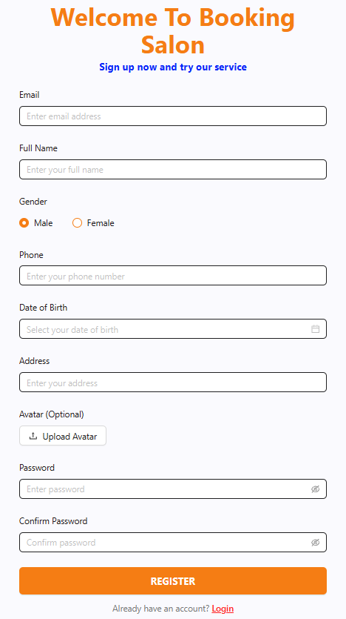

Field Name | Field Type | Description
Email | Text Box | This is for the user to input their email address.
Full Name | Text Box | This is for the user to input their full name.
Gender | Radio Box | This is for the user to choose their gender.
Phone | Text Box | This is for the user to input their phone number.
Date of Birth | Date Picker | This is for the user to select their date of birth.
Address | Text Box | This is for the user to input their address.
Avatar (Optional) | File Upload | This allows the user to upload a profile picture.
Password | Password Box | This is for the user to input a password for their account.
Confirm Password | Password Box | This is for the user to re-enter the password to confirm.
REGISTER | Button | The user clicks this button to submit their registration details.
Login | Hyperlink | The user clicks this link to be redirected to the login page.

Database Access
Table | CRUD | Description
User | C | Creates a new user record in the database.

IV. Appendix

1. Assumptions & Dependencies

AS-1: Customers have access to a stable internet connection and devices (computers, smartphones) to register accounts, log in, and make purchases on the website.
AS-2: Store staff and managers are available to process orders, pack items, deliver shipments, and handle returns according to the system's operational procedures.
AS-3: The store has sufficient resources (warehouse inventory, staff, packaging equipment) to fulfill orders and maintain stock levels for the declared product catalog.
AS-4: Products are managed by SKU variants manually declared by the administrator; the system does not automatically generate product variant combinations.
AS-5: Incoming inventory is always linked to a specific supplier through a Purchase Order.

DE-1: Account activation email verification, staff account setup, and password reset functionalities depend on a reliable Email Service to send verification and recovery links.
DE-2: The system integrates with an online Payment Gateway that supports digitally signed callbacks with idempotent mechanisms and online refunds.
DE-3: Inventory data depends on staff accurately updating records when receiving incoming stock and shipping outgoing orders.

2. Limitations & Exclusions

LI-1: The system is limited to a single store and warehouse scope; multi-branch management is not supported in the current version.
LI-2: Product SKU variants are managed manually by the administrator; the system does not automatically generate variant combinations from product attributes.
LI-3: The current version does not include a mobile application; users must access the system via a web browser.
LI-4: There is no online chat or chatbot feature for customer support.

EX-1: The system does not process offline transactions or orders created outside the platform.
EX-2: Multi-language support is not included; all content and interface use a single language (Vietnamese).
EX-3: Promotion, discount codes, or loyalty programs are not included in the initial version.
EX-4: Integration with third-party e-commerce platforms (marketplace, social commerce) is not supported.

3. Business Rule
ID | Category | Rule Definition
BR-01 | Constraints | User passwords must be hashed using a standard salted one-way hashing algorithm (e.g., BCrypt) prior to persistent storage; storing or logging plain-text credentials is strictly prohibited.
BR-02 | Constraints | Customer personal contact records and delivery addresses may be accessed by the owning authenticated Customer and authorized staff. Delivery information may be shared only with the designated carrier for order fulfillment.
BR-03 | Constraints | Account activation tokens and password-reset links generated by the Email Service must expire exactly 15 minutes after issuance and become permanently invalid immediately upon first use.
BR-04 | Facts | An authenticated customer can save multiple delivery destination entries in their address book, but exactly one address must be designated as the active default shipping address.
BR-05 | Facts | A master product catalog record can contain multiple SKU variants, but each individual SKU must belong to exactly one parent product entity.
BR-06 | Constraints | Administrators must define and configure SKU variants, attributes (e.g., color, wattage, capacity), and pricing manually; automatic permutation of SKU variants by the system is strictly prohibited.
BR-07 | Constraints | Each SKU must possess a unique SKU Code and Barcode across the entire catalog and inventory system to prevent cross-variant misidentification.
BR-08 | Constraints | In accordance with e-commerce regulations, all public retail prices displayed for products and SKUs must represent the final selling price inclusive of Value Added Tax (VAT) and explicitly specify Vietnamese Dong (VND) as the legal currency unit.
BR-09 | Constraints | A product or SKU cannot be activated for public sale without an assigned category, an assigned brand, and at least one representative product image.
BR-10 | Computations | Available stock quantity for any SKU is calculated dynamically as: Available Quantity = Physical Quantity - Reserved Quantity.
BR-11 | Constraints | When an online order checkout is initiated, the system must immediately allocate and lock the required item quantities into Reserved Quantity for a maximum reservation window of 15 minutes pending payment confirmation.
BR-12 | Constraints | If the payment gateway callback is not received within the 15-minute reservation window, the system must automatically release the locked stock back to Available Quantity and transition the order status to "Cancelled - Payment Timeout".
BR-13 | Constraints | Physical inventory is officially decremented only when warehouse staff transitions an online order to "Packed/Shipped", or instantly upon completing an in-store Point-of-Sale (POS) counter transaction.
BR-14 | Constraints | The system must trigger an automatic warning notification to Administrators whenever the Available Quantity of an SKU falls below its pre-configured min_stock_threshold.
BR-15 | Constraints | Any manual physical inventory adjustment following warehouse audits strictly requires the Administrator to input a verified discrepancy reason and log the auditor's identity.
BR-16 | Constraints | In accordance with consumer protection provisions for e-commerce, customers must be provided with an order review screen to verify SKU selections, quantities, shipping address, and total fee breakdown prior to final payment submission.
BR-17 | Computations | Total Order Amount is calculated as: Total Order Amount = Sum(SKU Unit Price at purchase × Purchased Quantity) - Discount Amount + Shipping Fee.
BR-18 | Constraints | Point-of-Sale (POS) counter transactions require atomic and simultaneous execution of sales order creation, immediate payment settlement, receipt generation, and real-time physical inventory deduction.
BR-19 | Constraints | A customer is permitted to self-cancel an online order if and only if the order fulfillment status remains in "Pending" or "Confirmed" state and has not yet advanced to "Packed/Shipped".
BR-20 | Constraints | If a stock shortage or item damage is detected during packing, the system must switch the order to "Undeliverable - Out of Stock", release remaining reserved stock, and prompt Admin authorization for order cancellation and full refund.
BR-21 | Constraints | Inbound payment callbacks and webhook notifications from payment gateway partners must enforce cryptographic signature verification (HMAC-SHA512) before triggering order state changes.
BR-22 | Constraints | Payment callback handling must implement an idempotent mechanism; duplicate callbacks sharing an identical transaction ID or idempotency key must be acknowledged without duplicate ledger postings or state re-transitions.
BR-23 | Constraints | Under banking compliance and PCI-DSS standards, the system must never store sensitive payment card details (CVV, full card numbers, PINs, or banking passwords) in the HomeMart database.
BR-24 | Facts | Each payment transaction record must capture the payment provider, transaction timestamp, payment method (Cash, Credit/Debit Card, E-Wallet), and payment gateway reference code.
BR-25 | Constraints | An online order cannot be dispatched for delivery without an assigned shipping carrier, recipient name, validated contact phone number, destination street address, and tracking number.
BR-26 | Constraints | When an order delivery fails due to customer refusal or unreachable contact, delivery staff must document the specific return reason, and returned goods must be placed in warehouse quarantine prior to restock review.
BR-27 | Facts | Each Purchase Order (PO) must be assigned to exactly one registered external supplier possessing a valid business code and commercial contract.
BR-28 | Constraints | Warehouse staff may accept goods against an approved PO in single or partial shipments; however, cumulative received quantities for an SKU cannot exceed the originally ordered quantity without an Admin-approved PO amendment.
BR-29 | Computations | Upon warehouse confirmation of an accepted Goods Receipt slip, the SKU physical balance is updated as: Physical Quantity = Physical Quantity + Verified Received Quantity.
BR-30 | Constraints | In compliance with Consumer Protection Laws, customers are eligible to submit return requests within 7 calendar days from delivery completion for defective, damaged, or mismatched household appliances.
BR-31 | Constraints | A return request must reference an authentic, completed sales order and identify the specific purchased SKU; requests submitted for unverified SKUs or third-party items must be rejected.
BR-32 | Constraints | All returned items must undergo physical condition inspection by store staff; only items verified as undamaged, intact with original packaging/accessories, and resalable can be restocked into Physical Quantity and Available Quantity.
BR-33 | Computations | Refund Amount for approved returns is calculated as: Refund Amount = Sum(Returned SKU Unit Price at purchase × Approved Quantity) - Prorated Discounts Applied.
BR-34 | Constraints | Refund disbursements must be executed back through the original payment channel (online gateway payment reversal for online orders, or cash/voucher disbursement for POS counter purchases) upon final Admin approval.
BR-35 | Computations | The inventory balance across any reporting period must strictly satisfy the Roll-Forward accounting equation: Ending Stock = Beginning Stock + Total Purchased Received - Total Shipped Orders + Total Restocked Returns ± Audited Stock Adjustments.
BR-36 | Constraints | In accordance with financial accounting and auditing regulations, historical ledger entries in order history, payment transactions, and stock movements are immutable; updates or hard deletions of past transaction logs are strictly prohibited.
BR-37 | Facts | All financial values, product pricing, tax calculations, shipping fees, discounts, and inventory asset valuations must be rounded and denominated in whole integer units of Vietnamese Dong (VND).
BR-38 | Constraints | Before changing an authenticated user's password, the system must verify the current password and reject a new password that does not meet the configured password policy or is identical to the current password. A rejected request leaves the stored credential unchanged.
BR-39 | Constraints | An online payment may be marked Paid only after the system verifies a signed server-side gateway callback and matches its order reference, payment reference, and amount to the pending payment. A browser redirect alone cannot confirm payment.
BR-40 | Constraints | Staff may record a physical return inspection, but only Admin may approve or reject the return request. An approved, resalable returned quantity may be restored to available inventory once; a rejected or non-resalable quantity must not be restocked.
BR-41 | Constraints | A completed refund must correspond to an approved return, must not exceed the unrefunded amount of its original captured payment, and must create at most one refund ledger entry per refund reference even when a request or gateway response is retried.
BR-42 | Computations | For the selected store-local reporting period and sales channel, settled cash inflow is the sum of completed customer payments and refund outflow is the sum of completed refunds; net settled cash flow is inflow minus outflow. Pending or failed payments are excluded from settled totals.

