**Manuscript Title**

Firstname Middlename Lastname1, Firstname Middlename Lastname2

*1Department, Faculty, Universitas, City, Country*

*2Department, Faculty, Universitas, City, Country*

*All author’s email*

|  |  |
| --- | --- |
| Keywords: | Times New Rowman, fontsize 9 [Please add 3-5 keywords from the MeSH database] |
| Abstract: | Times New Rowman, fontsize 9, you may or not, put out the title such as background, method, result or recommendation. Word count in the abstract is 150-250 words. |

1. **BACKGROUND**

Fontsize 10 with Times New Rowman style. Single spacing and make this manuscript into two columns. The citation in your manuscript should be in Harvard style. **Word count is created to be less than 3000 words.** (include references, article title, author’s name and affiliation).

For the second, third, etc, use “tab” in the first sentence of the paragraph.

* 1. **Aim**

1. **METHOD**

Fontsize 10 with Times New Rowman style. Single spacing and make this manuscript into two columns.

* 1. **Eligibility Criteria (Heading 2)**

Fontsize 10 with Times New Rowman style. Single spacing and make this manuscript into two columns.

1. ***Heading 3***

Fontsize 10 with Times New Rowman style. Single spacing and make this manuscript into two columns.

* 1. **Review Team**
  2. **Search methods**
  3. **Definition of Variables**
  4. **……**

1. **RESULTS**

Fontsize 10 with Times New Rowman style. Single spacing and make this manuscript into two columns.

Present your table or figure with caption and the legend.

Table 1: *Table’s title*

|  |  |
| --- | --- |
| Study Data | Description |
| Study Identifier | Unique id for the study |
| Type of article | Book chapter, Conference, Journal, Workshop |
| Application context | Industrial, academic |

*table caption

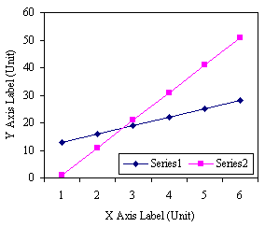

Figure 1: *Figure’s title*

1. **CONCLUDING REMARKS**

Fontsize 10 with Times New Rowman style. Single spacing and make this manuscript into two columns.

**ACKNOWLEDGEMENT**

Fontsize 10 with Times New Rowman style. Single spacing and make this manuscript into two columns.

**REFERENCES**

Please make your references into Hardvard style. Kindly check this link for the guidelines. [<http://www.citethisforme.com/citation-generator/harvard>]