#1

n=7;

A=randn(n)

[Q,R]=qr(A)

Q'\*Q

norm(eye(n)-Q'\*Q)

norm(A-Q\*R)

A =

0.5377 0.3426 0.7147 -1.2075 0.2939 1.4384 0.3192

1.8339 3.5784 -0.2050 0.7172 -0.7873 0.3252 0.3129

-2.2588 2.7694 -0.1241 1.6302 0.8884 -0.7549 -0.8649

0.8622 -1.3499 1.4897 0.4889 -1.1471 1.3703 -0.0301

0.3188 3.0349 1.4090 1.0347 -1.0689 -1.7115 -0.1649

-1.3077 0.7254 1.4172 0.7269 -0.8095 -0.1022 0.6277

-0.4336 -0.0631 0.6715 -0.3034 -2.9443 -0.2414 1.0933

Q =

-0.1586 -0.0656 -0.2608 0.7699 0.3940 -0.3353 0.2051

-0.5408 -0.6490 0.1739 -0.1128 -0.1944 -0.3857 -0.2382

0.6662 -0.4669 0.1306 -0.1756 0.1207 -0.3440 0.3967

-0.2543 0.2299 -0.6014 -0.5235 0.0758 -0.3791 0.3119

-0.0940 -0.5386 -0.4456 -0.0231 0.0797 0.6697 0.2170

0.3857 -0.1154 -0.5100 0.0120 0.0428 -0.1412 -0.7456

0.1279 0.0153 -0.2536 0.2982 -0.8823 -0.0908 0.2086

R =

-3.3908 0.1849 0.0360 0.9095 0.6745 -1.1647 -0.3910

0 -5.6675 -0.4256 -1.6808 0.4372 1.2919 0.2060

0 0 -2.6551 -0.3962 2.2282 -0.3652 -0.6477

0 0 0 -1.6585 -0.1033 0.4523 0.7154

0 0 0 0 2.7670 0.5885 -0.9926

0 0 0 0 0 -1.9775 -0.2170

0 0 0 0 0 0 -0.6373

ans =

1.0000 -0.0000 -0.0000 0.0000 0.0000 -0.0000 0.0000

-0.0000 1.0000 -0.0000 0.0000 0.0000 -0.0000 0.0000

-0.0000 -0.0000 1.0000 -0.0000 -0.0000 0.0000 -0.0000

0.0000 0.0000 -0.0000 1.0000 0 0.0000 -0.0000

0.0000 0.0000 -0.0000 0 1.0000 -0.0000 0.0000

-0.0000 -0.0000 0.0000 0.0000 -0.0000 1.0000 -0.0000

0.0000 0.0000 -0.0000 -0.0000 0.0000 -0.0000 1.0000

ans =

1.0352e-15

ans =

2.5532e-15

#2

A=[0 0 1;1 0 0;0 1 0];

B=A;

m=size(A,1);

a=zeros(m);

for k=1:m-1

x=A(:,k);

beta=max(x);

n=size(x,1);

I=eye(n);

xsum=0;

if beta == 0

gamma = 0;

else

x(1:n)=x(1:n)/beta;

for i = 1:n

% x(i)=x(i)/beta;

xsum=xsum+(x(i))^2;

end

tau=sqrt(xsum);

if x(1) < 0

tau=-tau;

end

x(1)=tau+x(1);

gamma=x(1)/tau;

x(2:n)=x(2:n)/x(1);

x(1)=1;

tau=tau\*beta;

A(k:n,k)=x;

end

Q(:,:,k)=I-gamma\*x\*(x.')

A(k:m,k+1:m)=Q(k)\*A(k:m,k+1:m);

A(k,k)=-tau;

A

end

Subscripted assignment dimension mismatch.

Error in Q2 (line 30)

Q(:,:,k)=I-gamma\*x\*(x.')

#3A

n=6;

m=3;

A=randn(n,m)

[Q,R]=qr(A)

Q'\*Q

norm(eye(n)-Q'\*Q)

norm(A-Q\*R)

>> Q3A

A =

1.4090 0.4889 0.8884

1.4172 1.0347 -1.1471

0.6715 0.7269 -1.0689

-1.2075 -0.3034 -0.8095

0.7172 0.2939 -2.9443

1.6302 -0.7873 1.4384

Q =

-0.4677 -0.1262 0.3688 0.4829 0.2116 -0.5927

-0.4704 -0.4911 -0.0245 0.1880 0.1909 0.6820

-0.2229 -0.3914 -0.0672 -0.0934 -0.8691 -0.1690

0.4008 0.0307 -0.2764 0.8399 -0.2079 0.1153

-0.2381 -0.0944 -0.8803 -0.0704 0.2398 -0.3116

-0.5412 0.7615 -0.0872 0.1107 -0.2504 0.2115

R =

-3.0124 -0.6430 -0.0395

0 -1.4909 2.2181

0 0 3.1176

0 0 0

0 0 0

0 0 0

ans =

1.0000 0.0000 -0.0000 -0.0000 0 0.0000

0.0000 1.0000 0.0000 -0.0000 -0.0000 -0.0000

-0.0000 0.0000 1.0000 -0.0000 -0.0000 -0.0000

-0.0000 -0.0000 -0.0000 1.0000 -0.0000 -0.0000

0 -0.0000 -0.0000 -0.0000 1.0000 -0.0000

0.0000 -0.0000 -0.0000 -0.0000 -0.0000 1.0000

ans =

9.6387e-16

ans =

1.9038e-15

#3B

A=[0 0;-1 0;0 1];

b=[1; -1; 1];

m=size(A,2);

[Q,R]=qr(A);

Rhat=R(1:m,1:m);

b=Q.'\*b;

b=b(1:m,1);

ls0=inv(Rhat)\*b

%Ex 3.3.9 part a

t=[-1;-0.75;-0.5;0;0.25;0.5;0.75];

A=[1 -1 1;1 -0.75 0.5625; 1 -0.5 0.25;1 0 0; 1 0.25 0.0625; 1 0.5 0.25; 1 0.75 0.5625];

b=[1;0.8125;0.75;1;1.3125;1.75;2.3125];

m=size(A,2);

[Q,R]=qr(A);

Rhat=R(1:m,1:m);

b=Q.'\*b;

b=b(1:m,1);

ls1=inv(Rhat)\*b

% Part b alpha

t=[1000;1050;1060;1080;1110;1130];

A=[50 -65;50 -15;50 -5;50 15;50 45;50 65];

b=[6010;6153;6421;6399;6726;6701];

x=linspace(1000,1130);

x1=6360+5.9\*x-6283.5;

plot(t,b,x,x1)

m=size(A,2);

[Q,R]=qr(A);

Rhat=R(1:m,1:m);

b=Q.'\*b;

b=b(1:m,1);

ls2=inv(Rhat)\*b

b=[9422;9300;9220;9150;9042;8800];

x2=9185.6-4.5039\*x+4797

plot(t,b,x,x2)

b=Q.'\*b;

b=b(1:m,1);

ls3=inv(Rhat)\*b

>> Q3B

ls0 =

1

1

ls1 =

1.0000

1.0000

1.0000

ls2 =

127.2458

5.9067

ls3 =

183.7139

-4.5039

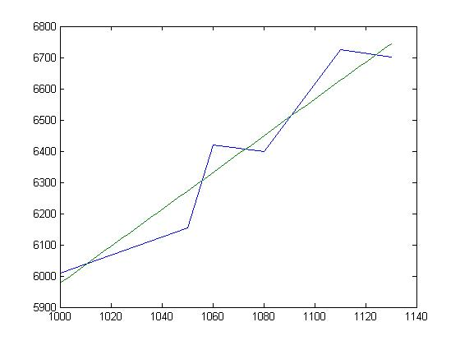

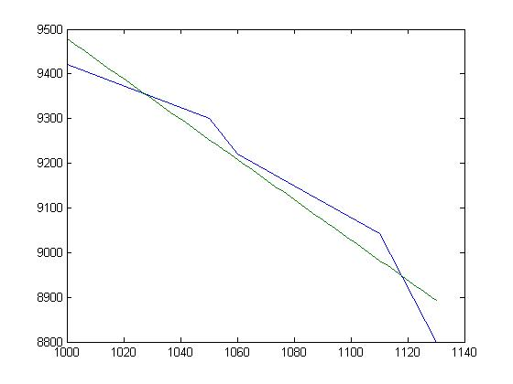

#4

m=4;

n=3;

v=randn(m,n)

a=v;

for k=1:n

r(1:k-1,k)=v(:,1:k-1).'\*v(:,k);

v(:,k)=v(:,k)-v(:,1:k-1)\*r(1:k-1,k);

r(k,k)=norm(v(:,k));

if r(k,k)~=0

v(:,k)=1/r(k,k)\*v(:,k);

end

end

v

R=v.'\*a

v =

-0.4762 -0.8487 -1.1176

0.8620 -0.3349 1.2607

-1.3617 0.5528 0.6601

0.4550 1.0391 -0.0679

v =

-0.2735 -0.5884 -0.4010

0.4951 -0.1939 0.7046

-0.7821 0.3222 0.4693

0.2614 0.7158 -0.3501

R =

1.7410 -0.0945 0.3958

0.0000 1.4862 0.5774

-0.0000 0.0000 1.6699