Milestone 2
Feasibility
Friday November 21, 2025
Liron Black (blackl10), Noah Jaye (jayen), Ezzeldin Afifi (mohame23),
Damian Starosolski (starosod), Liam Ye (yel20)

A - Environmental Analysis
SWOT Analysis
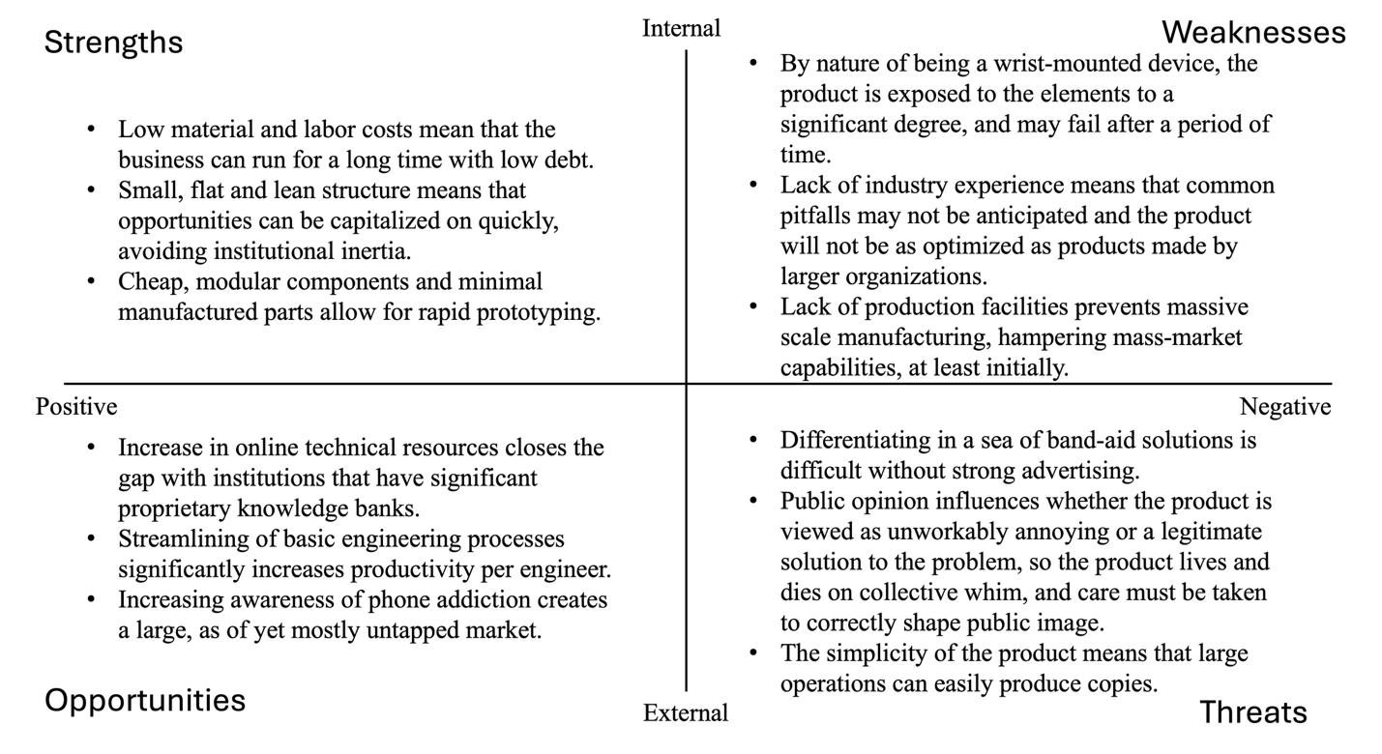
Key Takeaways
In summary, our product is small, simple, and agile. As a small company, decisions can propagate very quickly, and the goals and methods of our organization will be easily mutable. This also means that new ideas will spread quickly, and so innovation can be pursued at a relentless pace. The simplicity of our product contributes to this ease of change, with only a few major components that can easily be repositioned when a better idea comes up.
This simplicity and ease of transition has downsides, though. Because there is reduced inertia and the product isn’t well-defined, there is a less well-understood shared vision of the product, and so two people making changes or discussing the product may have different mental models. Additionally, a product this simple is easily copied by large firms with expertise, cash reserves and economy of scale dwarfing any startup’s. This means that considerable effort should be put towards making the product distinctive and unique, so that copies seem like cheap imitations instead of legitimate competitors.
PESTLE
Factor | Points - Opportunities and Threats
Political | - School and workplace policies increasingly restrict phone use (Ontario.ca, 2025)  - This provides a wearable product to encourage compliance to the trend  - Governments encourage digital wellbeing through digital-wellbeing initiatives  - This creates a favourable climate for technologies supporting these initiatives  - There could be policy concerns about privacy and biometric data  - This would lead to strict regulations and oversight
Economic | - Low-cost components make manufacturing affordable  - This will keep price low for price sensitive buyers such as students  - Market growth for wearable products  - Increasing demand for lightweight, single function, wearable products (Singh & Arnott, 2024)  - Economic pressure on post-secondary students increased demand for productivity tools  - Tuition and living costs continue to increase meaning students continue to look for products to help maximize efficiency and time
Social | - Phones being distracting is a widely recognized problem  - Increase in digital self-discipline (American Psychological Association, 2023)  - More awareness around screen addiction and mental health supports non-invasive support tools  - Widely accepted use of wearables  - Students and professionals use smartwatches and fitness trackers on a daily base  - Habit formation and gamification is socially valued  - Apps like Duolingo and Apple Fitness provide streaks, rewards, and progress tracking features
Technological | - Bluetooth connectivity enables seamless phone communication  - Simple integration with calendar apps and safe monitoring  - Low-tech design increases reliability  - Fewer components mean fewer technical failures and longer battery life  - Potential to integrate with third-party apps  - Technological advancements in haptic feedback  - Possible expansion into biometrics  - Heart rate, stress detection, etc.
Environmental | - Concerns with electronic waste  - Must have end of life recycling solutions  - Environmentally favourable low energy consumption  - Low power haptics and microcontrollers allow for smaller battery requirements  - Possibility of economically friendly wrist bands  - Use recycled silicone or biodegradable materials  - Minimalist packing  - Since the device is small, it can be accompanied by minimal and eco-conscious packaging
Legal | - Data privacy laws will apply  - The companion app will collect user data meaning that clear consent and data storage policies are required  - Safety certifications  - The product must comply with electronic device regulations  - Liability concerns with product failure  - Reliance on the product during failure can raise accountability questions  - App Store and Google Play Compliance  - Companion app must meet policies given by digital stores it is sold on
Key Takeaways
The focus wristband will operate in a favourable environment with strong opportunity and clear risks to manage. Politically, increasing phone restrictions and digital-wellbeing initiatives support the product, but privacy regulations can create challenges. Economically, low manufacturing costs and rising student demand for productivity tools make the wristband affordable and attractive. Socially, phone distraction is a widely recognized problem. Wearables are normalized and gamified tools align well with current user preferences. Technologically, simple Bluetooth based design ensures reliability along with other features like haptics, app integration, and biometrics. Environmentally, e-waste concerns must be addressed. On the other hand, the small size of the product, low energy use, and potential eco-friendly materials support sustainability. Legally, the product must comply with privacy laws, safety certifications, and app store policies. It also bears the risk of liability issues in cases of device failure. In conclusion, the focus wristband is in an excellent spot to succeed in a supportive market, but must manage privacy, sustainability, and compliance risks to fully capitalize on its opportunities in its social, economic, and technological environment.
Porter’s Five Forces
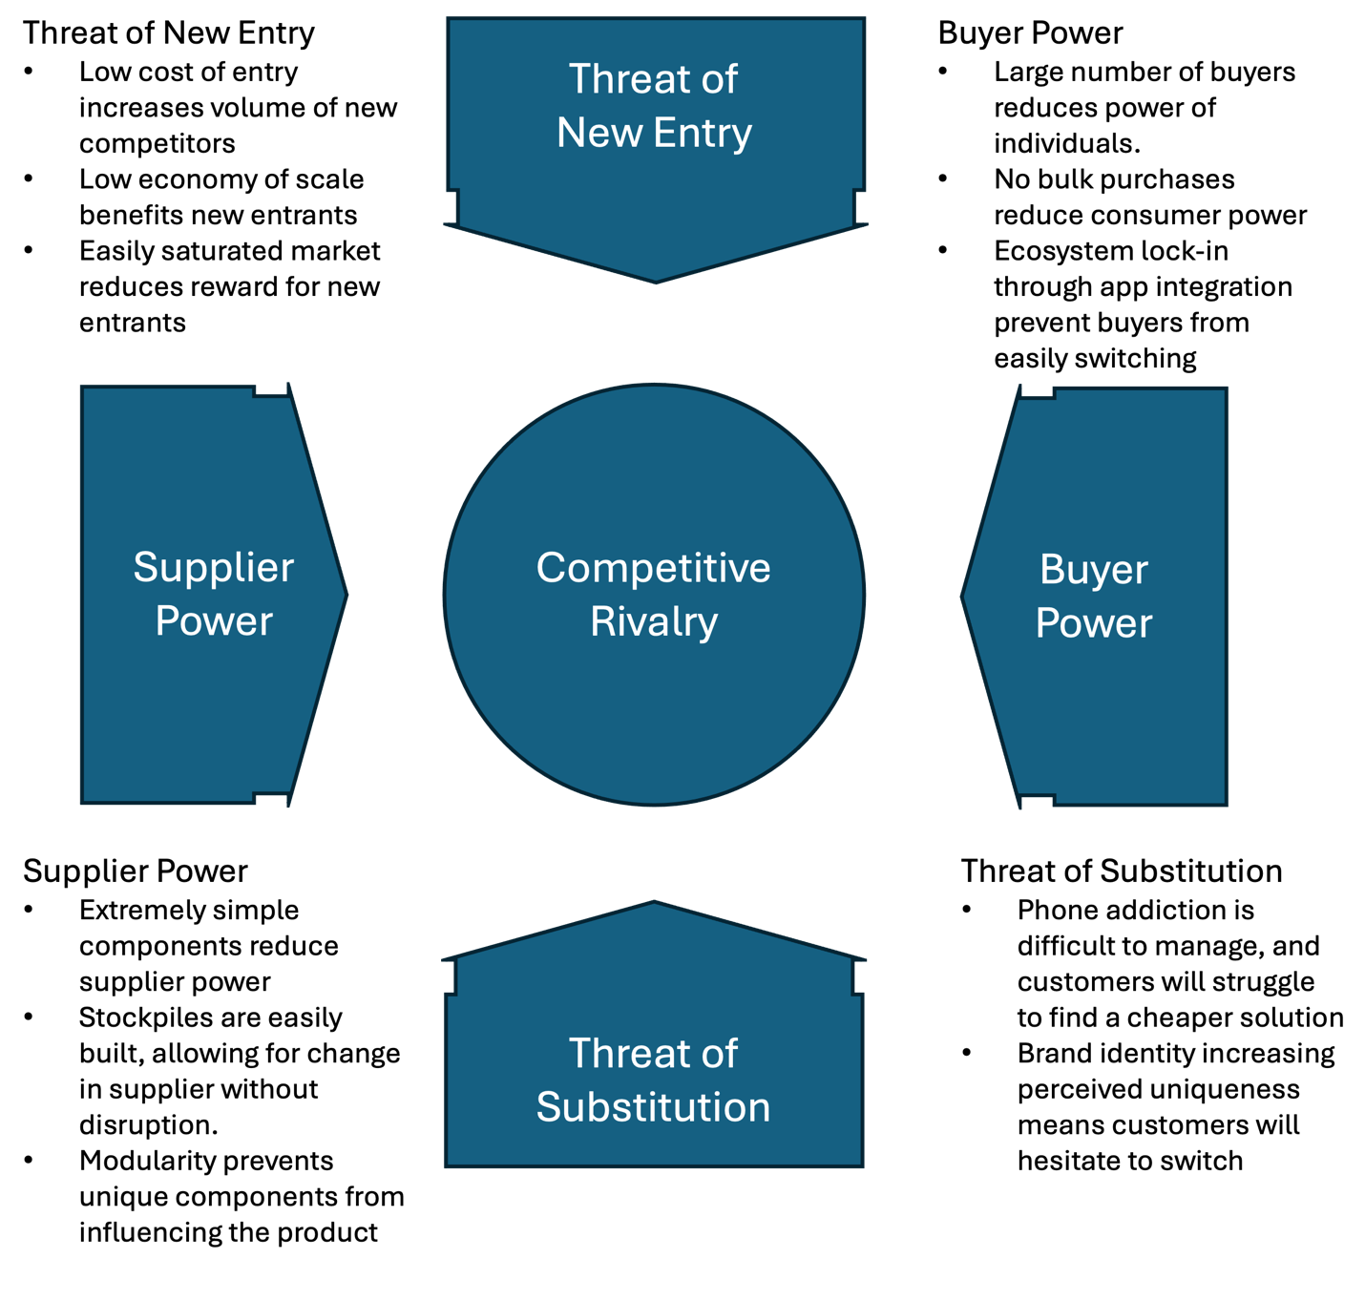
Key Takeaways
In short, our product occupies a tumultuous but very high leverage space in the market. While other businesses can get started relatively easily in this space, consumers will very likely stick with the first product of this type that they buy, as they integrate with its various services and the product becomes part of everyday life. A consequence of this is that the wristband will have a core of dedicated customers at a baseline, who will recommend the product and provide stable income. The strength of our product operating in a market like this is that neither suppliers nor consumers have undue power over the business, as both are in ample supply and do not have to be relied on.
To summarize, the market favors a business that aggressively gains customers, potentially at an initial loss, to lock in a dedicated customer base. The business can negotiate cheap bulk purchases with suppliers, and consumers cannot do the same, which heavily favors the business, and further improves the potential for this short-term explosive growth in deficit followed by consolidation and focus on profit
Identify key stakeholders
The key stakeholders in this business can be split into two major groups, internal and external stakeholders. Key internal stakeholders are investors, employees, and owners, who exist to some degree as a part of the organization. Key external stakeholders are customers, suppliers, competitors, and downstream beneficiaries of phone addiction. Notably, not all external stakeholders want the business to succeed, and even then they aren’t unified, with predatory phone companies working against both the business and its competitors.
Investors want the business to make as much money as it can, in as short a period of time as possible, for as long as possible. Investors provide capital to the company, allowing it to function, and if the business fails, they cannot recoup their loss and lose money. Employees want the business to succeed because it provides stable employment, and if the business goes under, they have to seek alternate methods of employment. Owners want the business to succeed because they have their livelihood staked in its success.
On the outside, customers grow to rely on the business to provide continuous support for their wristbands, so they are stakeholders. Suppliers will sign bulk deals with the business as it scales, and so will become accustomed to the business’s continued operation. On the negative side, competitors want the business to fail, and their success is inversely related to that of the business. Predatory mobile app developers are similar, and want the business to fail.
B – Business model
Lean Canvas
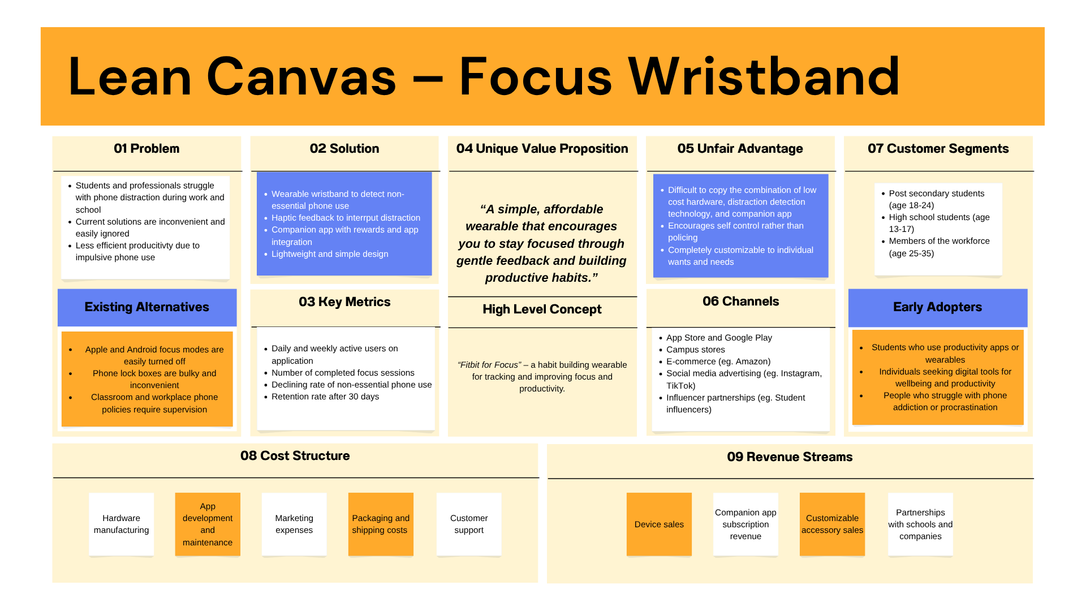KPIs
Discussion of Key Elements
The unique value proposition “A simple, affordable wearable that encourages you to stay focused through gentle feedback and building productive habits” is strong because it clearly communicates the selling points of the product: its simplicity, affordability, and habit formation. Having a strong unique value proposition is important as it will catch the attention of people suffering from the problem that the product intends to solve. Being able to attract the attention of the intended audience is essential to the success of the product. Having clearly defined customer segments and outlined early adopters is essential to the early success of the product. These groups are already aware of the problem and are motivated to find tools to solve it. Interacting with these customers is important to achieving initial reviews, product testing, and referral momentum. Outlining key metrics such as active users, completed focus sessions, declining rate of non-essential phone use, and retention rate are critical to being able to measure the success of the product in solving the problem.
Key Performance Indicators
- Daily and Weekly Active Users – This KPI measures the engagement with the wristband and companion app. Understanding engagement is essential to having users form positive habits and solve their distraction problems. This KPI can be monitored through app analytics, engagement drop-off points after certain periods of time, and personalized reminders.
- Number of Completed Focus Sessions per User – This measures if users act on their planned focus sessions. If customers continue to complete focus sessions, their positive habits will strengthen and their retention with the product will increase. This KPI can be monitored through session counts and duration, reward structures, and pattern monitoring to adjust individual customization for sessions.
- Rate of Non-Essential Phone Use – This KPI measure the rate of impulsive phone checking during a session. If, over a period of time this rate declines, it shows that customers are receiving value from the product. This KPI can be monitored through tracking distractions per session and progress dashboards for users showing percent distraction reduction per week and month.
C – Break Even
The break even point is after 13 months of continued operation, assuming a growth rate of 0.2. At this point, the business will have a revenue of $7615 a month and will sell 381 units per month, which allows the business to begin making money. 13 months is a healthy break-even point, as it means that investors will not grow impatient, but the business grows as quickly as it can initially, taking on some debt to do so.

References
American Psychological Association. (2023, April). What is digital health?. American Psychological Association. https://www.apa.org/practice/digital-therapeutics-mobile-health
Cellphones and other mobile devices in schools. ontario.ca. (2025, June 23). https://www.ontario.ca/page/cellphones-and-other-mobile-devices-schools
Singh, N., & Arnott, M. (2024, August 23). Personal Portable Electronics: Rising demand for multi-function and hybrid wearable devices leading to 3.2 billion devices in 2033. Reports & Insights. https://transformainsights.com/research/reports/personal-portable-electronics

