 

**本科生实验报告**

**课程名称： 电路分析基础（全英文）**

**实验名称： 课内实验**

|  |  |  |  |  |  |  |
| --- | --- | --- | --- | --- | --- | --- |
| 任课教师： |  | | | 实验教师： | | 张峰、方芸 |
| 实验日期： | 7周-12周 | | | 实验地点： | | 工训楼502、503 |
| 实验类型： | √基础内容 □综合设计 □自主创新 | | | | | |
| 学生姓名： |  | 班级： |  | | 学号： |  |
| 学 院： | 计算机学院 | | | 专 业： | | 数据科学与大数据技术（全英文） |
| 组 号： |  | 同组同学： | |  | | |
| 成 绩： |  | | | | | |



**EXPERIMENT ONE**

Measurement of the volt-ampere characteristics

of fundamental components

* 1. **Tasks of the experiment**

1. Measure the volt-ampere characteristics of linear resistors.
2. Measure the volt-ampere characteristics of non-linear resistors.
3. Measure the volt-ampere characteristics of ideal voltage sources.
4. Measure the volt-ampere characteristics of practical voltage sources.
   1. **Aims of the experiment**
5. Understand the concept of linear resistors, non-linear resistors, ideal voltage sources and practical voltage sources.
6. Master the fundamental methods to measure voltages and currents.
   1. **Equipments required**
7. Experiment box.
8. DC stabilivolt source.
9. Multimeter.
10. Resistance decade box.
    1. **Steps of the experiment**
       1. **Measure the volt-ampere characteristics of linear resistors**
11. Connect up the circuit shown in Figure 1.1, measure the volt-ampere characteristic of linear resistor *R*.

Where: *mA* ─ the amperemeter on the experiment box.

*V* ─ the voltmeter by using of DC voltage gear of the multimeter.

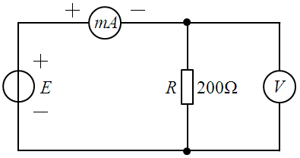

Figure 1.1

1. Before the power is applied, set voltmeter *V* to the maximum full-scale deflection to avoid destroying it if you can’t estimate the actual measured value.
2. Adjust the output voltage of DC stabilivolt source *E*, when voltmeter *V* shows the readings as the values of voltage *V* in Table 1.1, record the readings of amperemeter *mA* as current *I* in Table 1.1.

Table 1.1

|  |  |  |  |  |  |  |
| --- | --- | --- | --- | --- | --- | --- |
| ***V* (*V*)** | **0.0** | **2.0** | **4.0** | **6.0** | **8.0** | **10.0** |
| ***I* (*mA*)** | **0.0** | **10.2** | **20.3** | **30.6** | **40.9** | **51.4** |

1. Draw up the curve of *V* against *I* in Figure 1.2.

10.

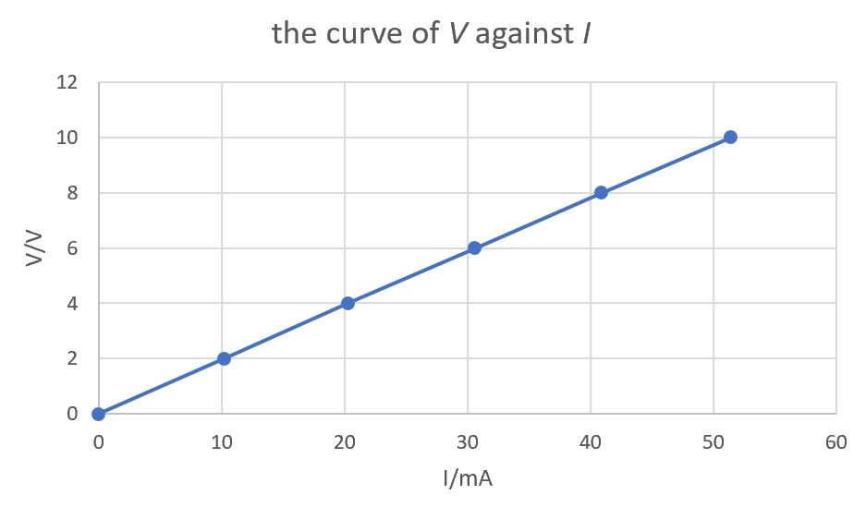

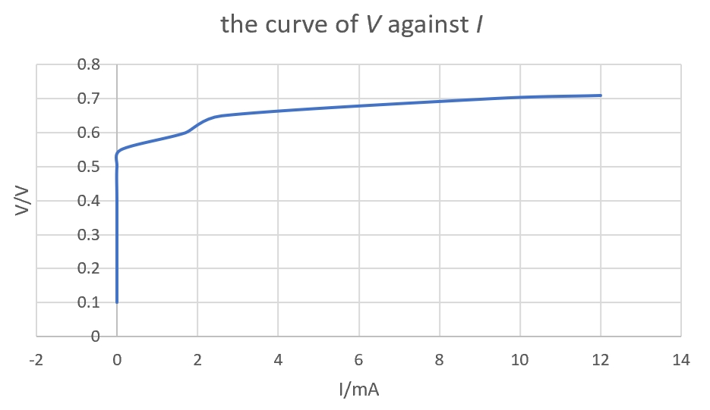

Figure 1.2 Figure 1.3

* + 1. **Measure the volt-ampere characteristics of non-linear resistors**

1. Connect up the circuit shown in Figure 1.4, measure the forward volt-ampere characteristic of semi-conductor diode *D*.

Where: *D* ─ the semi-conductor diode 1N4004 on the experiment box.

*RW* ─ the potentiometer on the experiment box.

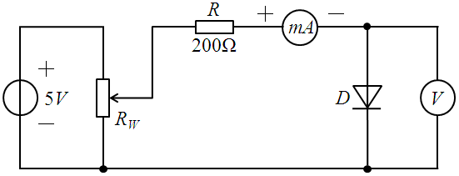

Figure 1.4

1. Before the power is applied, set voltmeter *V* to the maximum full-scale deflection to avoid destroying it if you can’t estimate the actual measured value.
2. Adjust the output voltage of DC stabilivolt source as 5*V*.
3. Adjust the output resistance of potentiometer *RW*, when voltmeter *V* shows the readings as the values of voltage *V* in Table 1.2, record the readings of amperemeter *mA* as current *I* in Table 1.2.

Table 1.2

|  |  |  |  |  |  |  |  |  |  |  |
| --- | --- | --- | --- | --- | --- | --- | --- | --- | --- | --- |
| ***V* (*V*)** | **0.1** | **0.2** | **0.3** | **0.4** | **0.5** | **0.55** | **0.6** | **0.65** | **0.7** | **0.71** |
| ***I* (*mA*)** | **0** | **0** | **0** | **0** | **0** | **0.1** | **1.7** | **2.6** | **9.2** | **12.0** |

1. Draw up the curve of *V* against *I* in Figure 1.3.
   * 1. **Measure the volt-ampere characteristics of ideal voltage sources**
2. Set voltmeter *V* to the maximum full-scale deflection to avoid destroying it if you can’t estimate the actual measured value.
3. At first, connect up the circuit shown in Figure 1.5, use voltmeter *V* to calibrate the output voltage of ideal voltage source (DC stabilivolt source) to 10*V* shown as Row 2/Column 2 in Table 1.3.
4. Then, connect up amperemeter *mA*, resistor *R*, resistance decade box *RL* shown in Figure 1.6.

Where: *R* ─ the resistor to confine the current through the circuit so as to protect the DC

stabilivolt source.

*RL* ─ the resistance decade box.

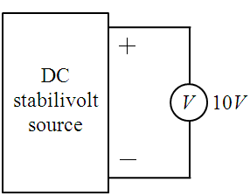 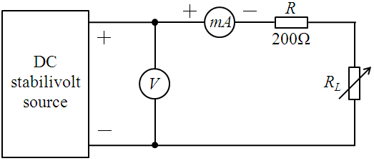

Figure 1.5 Figure 1.6

1. Adjust the output resistance of resistance decade box *RL*, when amperemeter *mA* shows the readings as the values of current *I* in Table 1.3, record the readings of voltmeter *V* as voltage *V* in Table 1.3.

Table 1.3

|  |  |  |  |  |  |
| --- | --- | --- | --- | --- | --- |
| ***I* (*mA*)** | **0.0** | **10.0** | **20.0** | **30.0** | **40.0** |
| ***V* (*V*)** | **10.0** | **10.0** | **10.0** | **10.0** | **10.0** |

1. Draw up the curve of *V* against *I* in Figure 1.7.

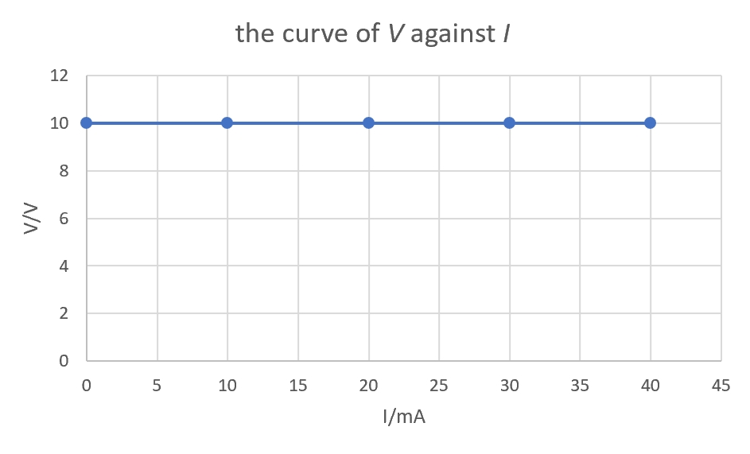

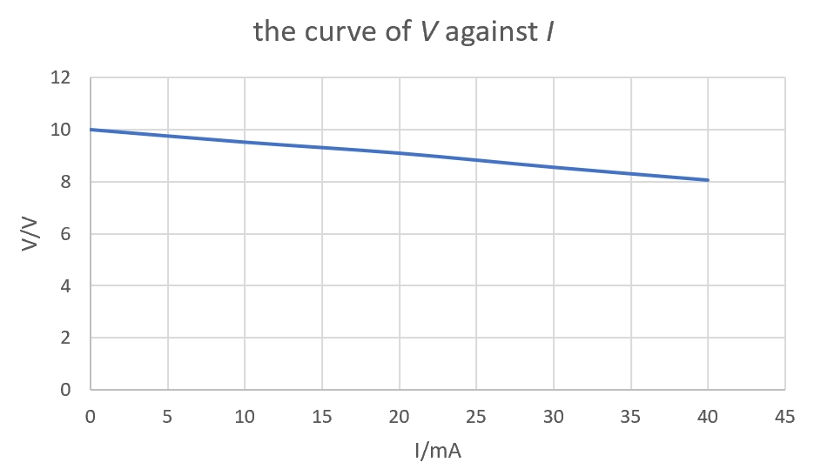

Figure 1.7 Figure 1.8

* + 1. **Measure the volt-ampere characteristics of practical voltage sources**

1. Set voltmeter *V* to the maximum full-scale deflection to avoid destroying it if you can’t estimate the actual measured value.
2. At first, connect up the circuit shown in Figure 1.9, use voltmeter *V* to calibrate the output voltage of practical voltage source (DC stabilivolt source in series connection with resistor *RS*) to 10*V* shown as Row 2/Column 2 in Table 1.4.

Where: *RS* ─ the internal resistance of practical voltage source.

1. Then, connect up amperemeter *mA*, resistance decade box *RL* shown in Figure 1.10.

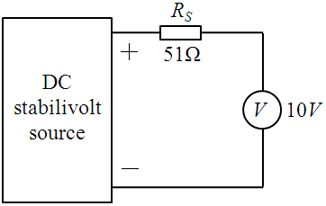 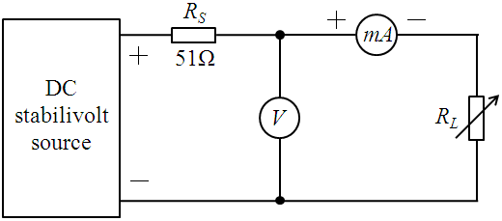

Figure 1.9 Figure 1.10

1. Adjust the output resistance of resistance decade box *RL*, when amperemeter *mA* shows the readings as the values of current *I* in Table 1.4, record the readings of voltmeter *V* as voltage *V* in Table 1.4.

Table 1.4

|  |  |  |  |  |  |
| --- | --- | --- | --- | --- | --- |
| ***I* (*mA*)** | **0.0** | **10.0** | **20.0** | **30.0** | **40.0** |
| ***V* (*V*)** | **10.0** | **9.52** | **9.10** | **8.56** | **8.07** |

1. Draw up the curve of *V* against *I* in Figure 1.8.
   1. **What conclusions or gains can you get from EXPERIMENT ONE?**

1. About the experiment 1 and 2 :

I understand the concept of linear and non-linear resistor. The linear resistors are the one whose voltage is proportional to the current. In the graph, the curve of V against I is a straight and inclined line.

2. About the experiment 3 and 4 :

I actually feel the difference between the ideal and practical source. The voltage in the ideal voltage source remain the same value even the currents floating are changed .However, the voltage in practical one is changed with the change of current. Probably ,that is because the practical one has the inner resistor.

3. This is the first time I do experiments about circuit. I learned how to use the basic experimental equipment. The circuit experiment is very strict and rigorous. We should do it with patience and care so we can avoid the mistakes and dangers.

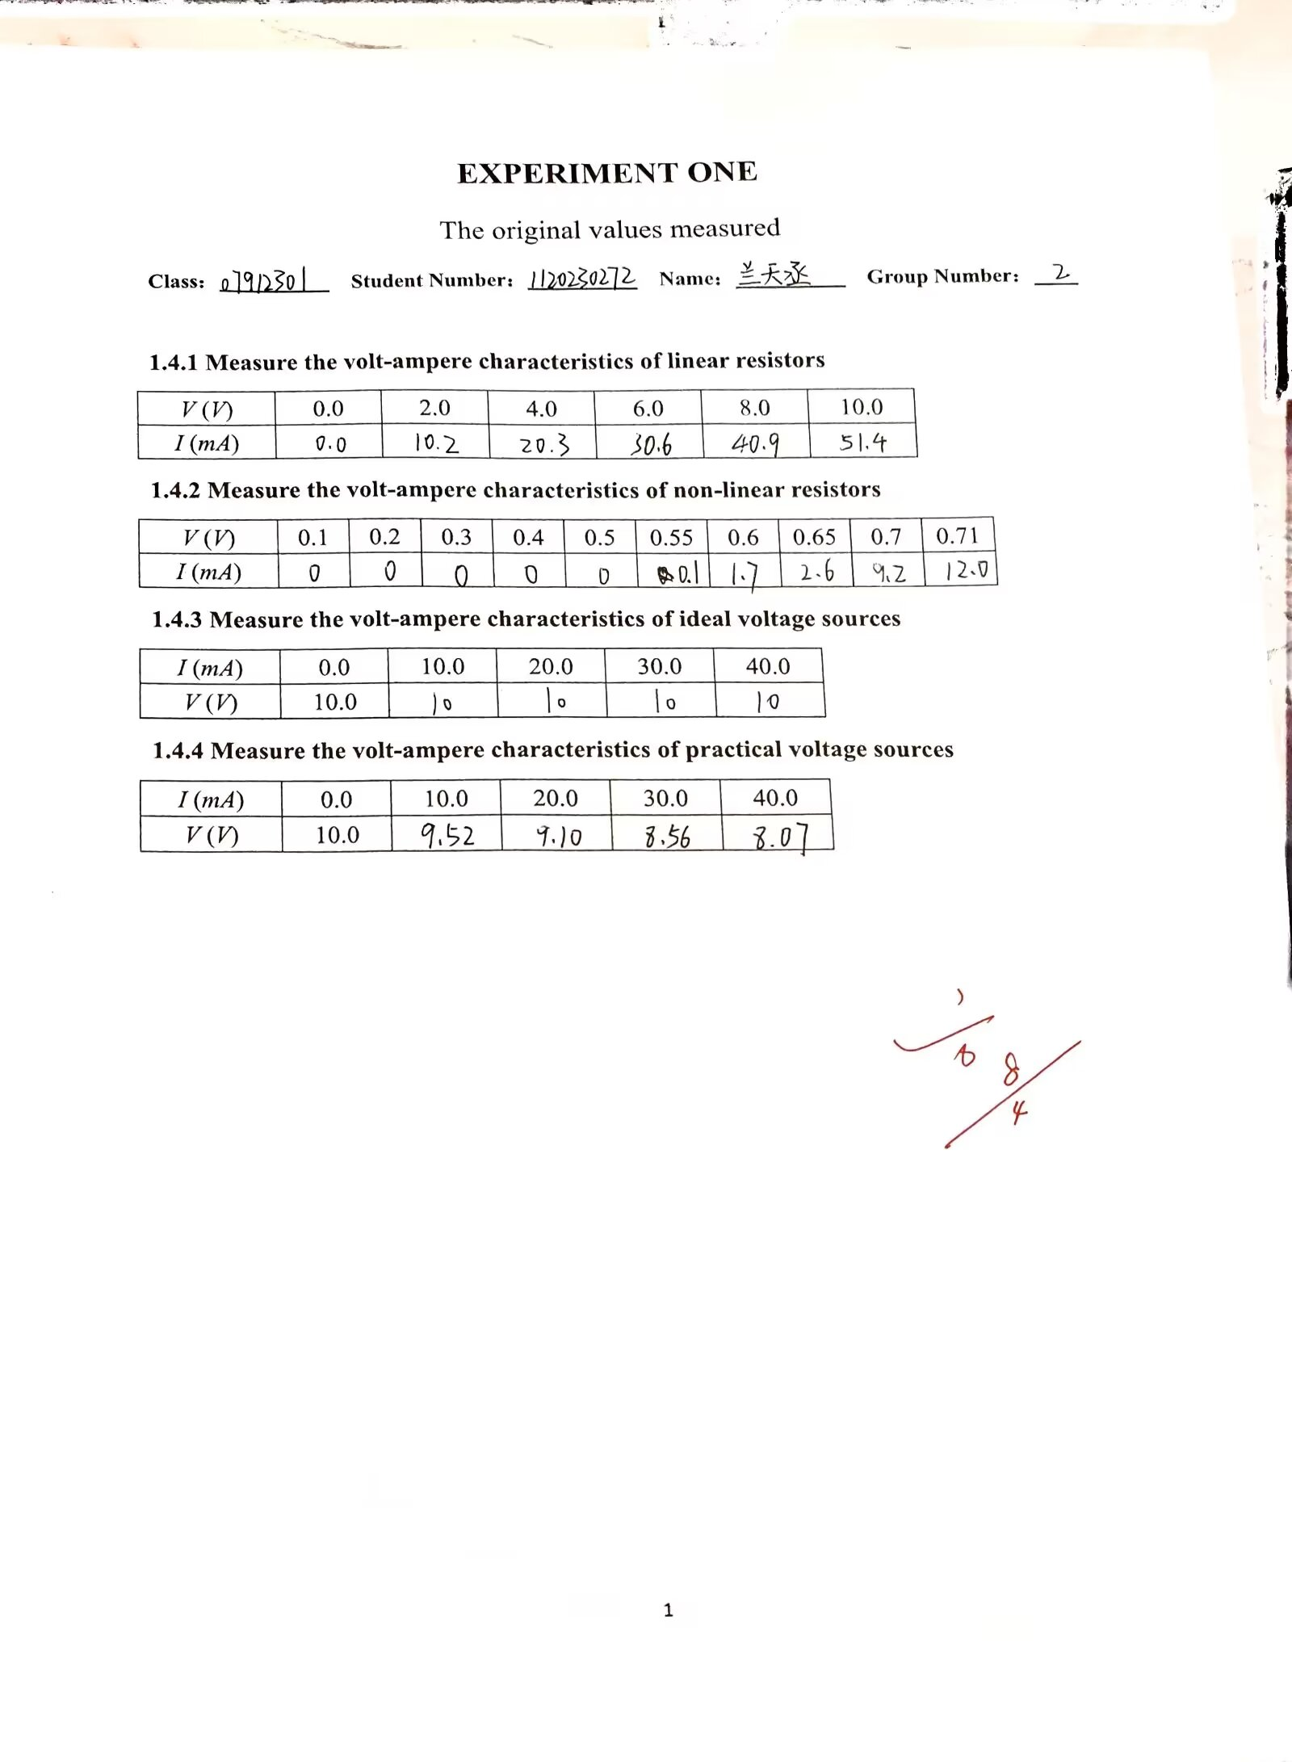

**EXPERIMENT TWO**

The equivalent circuit of an active single-terminal pair

and the measurement of the parameters of the equivalent circuit

* 1. **Tasks of the experiment**

1. Measure the volt-ampere characteristic at the output terminals of a given active single-terminal pair.
2. Measure the parameters of the Thevenin equivalent circuit for a given active single-terminal pair, and the volt-ampere characteristic at the output terminals of the equivalent circuit.
3. Measure the parameters of the Norton equivalent circuit for a given active single-terminal pair, and the volt-ampere characteristic at the output terminals of the equivalent circuit.
   1. **Aims of the experiment**
4. Get a deeper understanding of the concept of equivalent circuit by measuring and comparing the external characteristic of an active single-terminal pair with its two equivalent circuits.
5. Learn some basic methods to measure equivalent circuit.
   1. **Equipments required**
6. Experiment box.
7. DC stabilivolt source.
8. Multimeter.
9. Resistance decade box.
   1. **Steps of the experiment**
      1. **Measure the volt-ampere characteristic at the output terminals of an active single-terminal pair**
10. Connect up the circuit shown in Figure 2.1, measure the volt-ampere characteristic at the output terminals of the given active single-terminal pair.

**The given active single-terminal pair**

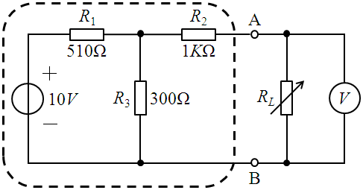

Figure 2.1

1. Before the power is applied, set voltmeter *V* to the maximum full-scale deflection to avoid destroying it if you can’t estimate the actual measured value.
2. Adjust the output voltage of DC stabilivolt source as 10*V*.
3. Adjust the output resistance of resistance decade box *RL*, when it shows the readings as the values of resistance *RL* in Table 2.1, record the readings of voltmeter *V* as voltage *V*AB in Table 2.1.
4. Calculate current *I*AB, and fill the values in Table 2.1.



Table 2.1

|  |  |  |  |  |  |
| --- | --- | --- | --- | --- | --- |
| ***RL* (*K*Ω)** | **1.0** | **2.0** | **3.0** | **4.0** | **5.0** |
| ***V*AB (*V*)** | **1.68** | **2.31** | **2.64** | **2.84** | **2.97** |
| ***I*AB (*mA*)** | **1.68** | **1.16** | **0.88** | **0.71** | **0.59** |

1. Draw up the curve of *V*AB against *I*AB in Figure 2.2.

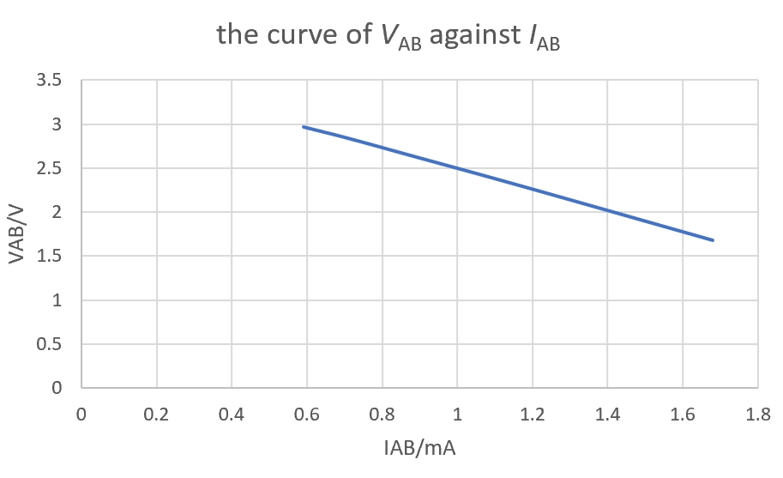

Figure 2.2

* + 1. **Measure the parameters of the equivalent circuit**

1. **Measure the open-circuit voltage *U*OC**
2. Connect up the circuit shown in Figure 2.3.

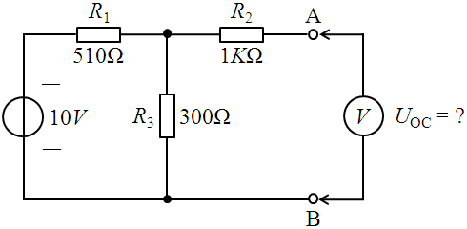

Figure 2.3

1. Before the power is applied, set voltmeter *V* to the maximum full-scale deflection to avoid destroying it if you can’t estimate the actual measured value.
2. Adjust the output voltage of DC stabilivolt source as 10*V*.
3. Record the reading of voltmeter *V* as the open-circuit voltage *U*OC.

***U*OC = 3.68V**

1. **Measure the short-circuit current *I*SC**
2. Connect up the circuit shown in Figure 2.4.

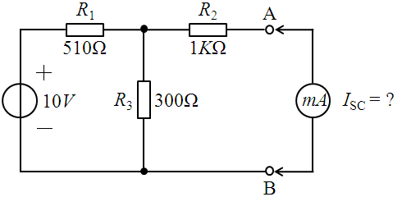

Figure 2.4

1. Adjust the output voltage of DC stabilivolt source as 10*V*.
2. Record the reading of amperemeter *mA* as the short-circuit current *I*SC.

***I*SC = 3.0mA**

1. **Measure the equivalent internal resistance *R*0**
2. Connect up the circuit shown in Figure 2.5.

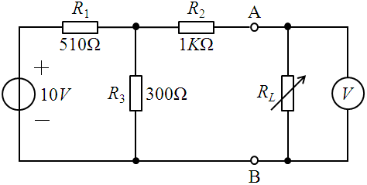

Figure 2.5

1. Before the power is applied, set voltmeter *V* to the maximum full-scale deflection to avoid destroying it if you can’t estimate the actual measured value.
2. Adjust the output voltage of DC stabilivolt source as 10*V*.
3. Adjust the output resistance of resistance decade box *RL*, when voltmeter *V* shows the reading as the value of half open-circuit voltage *U*OC measured before, record the reading of resistance decade box *RL* as the equivalent internal resistance *R*0.

***R*0 = 1227Ω**

* + 1. **The Thevenin equivalent circuit**

1. Connect up the circuit shown in Figure 2.6, measure the volt-ampere characteristic at the output terminals of the Thevenin equivalent circuit.

Where: *R*0 ─ the resistance decade box.

**The Thevenin equivalent circuit**

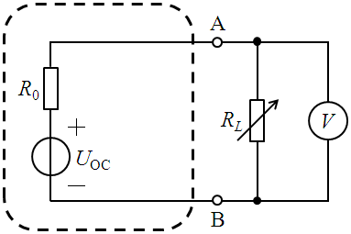

Figure 2.6

1. Before the power is applied, set voltmeter *V* to the maximum full-scale deflection to avoid destroying it if you can’t estimate the actual measured value.
2. Adjust the output voltage of DC stabilivolt source *U*OC as the value of the open-circuit voltage *U*OC measured before.
3. Adjust the output resistance of resistance decade box *R*0 as the value of the equivalent internal resistance *R*0 measured before.
4. Adjust the output resistance of resistance decade box *RL*, when it shows the readings as the values of resistance *RL* in Table 2.2, record the readings of voltmeter *V* as voltage *V*AB in Table 2.2.
5. Calculate current *I*AB, and fill the values in Table 2.2.



Table 2.2

|  |  |  |  |  |  |
| --- | --- | --- | --- | --- | --- |
| ***RL* (*K*Ω)** | **1.0** | **2.0** | **3.0** | **4.0** | **5.0** |
| ***V*AB (*V*)** | **1.70** | **2.53** | **2.66** | **2.87** | **3.01** |
| ***I*AB (*mA*)** | **1.70** | **1.17** | **0.89** | **0.72** | **0.60** |

1. Draw up the curve of *V*AB against *I*AB in the same coordinate in Figure 2.2 so as to verify the equivalence.
   * 1. **The Norton equivalent circuit**
2. Connect up the circuit shown in Figure 2.7, measure the volt-ampere characteristic at the output terminals of the Norton equivalent circuit.

Where: *I*SC ─ the constant current source on the experiment box.

**The Norton equivalent circuit**

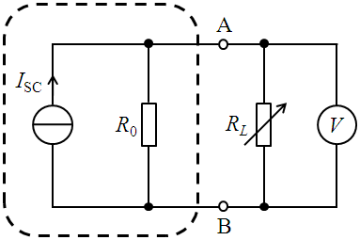

Figure 2.7

1. Before the power is applied, set voltmeter *V* to the maximum full-scale deflection to avoid destroying it if you can’t estimate the actual measured value.
2. Adjust the output current of constant current source *I*SC as the value of the short-circuit current *I*SC measured before.
3. Adjust the output resistance of resistance decade box *R*0 as the value of the equivalent internal resistance *R*0 measured before.
4. Adjust the output resistance of resistance decade box *RL*, when it shows the readings as the values of resistance *RL* in Table 2.3, record the readings of voltmeter *V* as voltage *V*AB in Table 2.3.
5. Calculate current *I*AB, and fill the values in Table 2.3.



Table 2.3

|  |  |  |  |  |  |
| --- | --- | --- | --- | --- | --- |
| ***RL* (*K*Ω)** | **1.0** | **2.0** | **3.0** | **4.0** | **5.0** |
| ***V*AB (*V*)** | **1.66** | **2.28** | **2.60** | **2.80** | **2.94** |
| ***I*AB (*mA*)** | **1.66** | **1.14** | **0.87** | **0.70** | **0.59** |

1. Draw up the curve of *V*AB against *I*AB in the same coordinate in Figure 2.2 so as to verify the equivalence.
   1. **What conclusions or gains can you get from EXPERIMENT TWO?**
2. Any linear, two-terminal circuit can be replaced by a single voltage source in series with a resistor.

The voltage of the source is equal to the open-circuit voltage *U*OC.

The value of the resistor is equal to the R that the input or equivalent resistance at the terminals when all independent sources are turned off

2. Any linear, two-terminal circuit can be replaced by a single current source in parallel with a resistor.

The current of the source is the short-circuit current at the terminals

The value of the resistor is R that the input or equivalent resistance at the terminals when all independent sources are turned off

3.The opinion of equivalent is very important. It can use a simple circuit to replace the complex one. With it , we can solve the circuit problems easier and more efficient.

4.We should learn various ways to calculate and measure equivalent circuit.

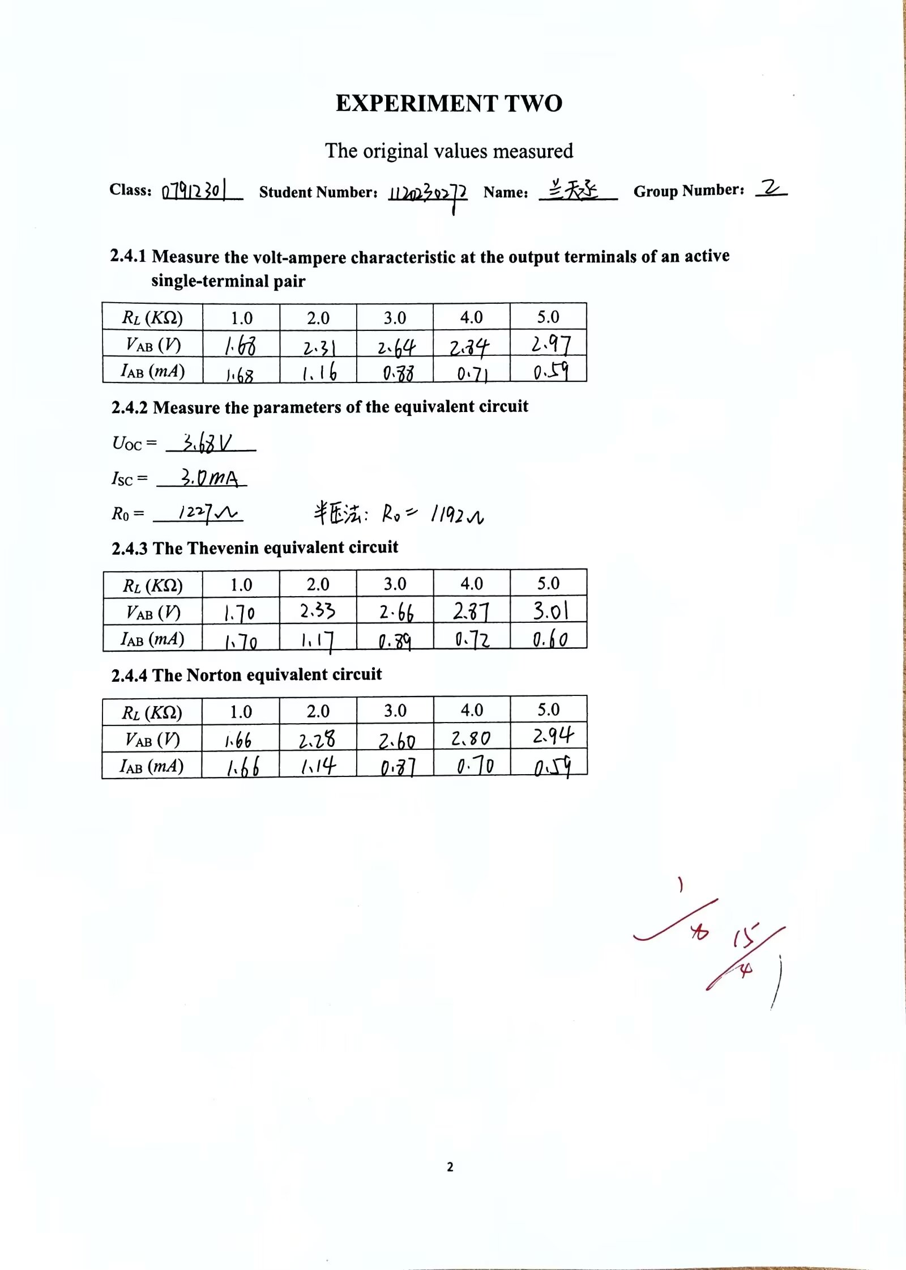

**EXPERIMENT THREE**

Study on the response of first order dynamic RC circuit

* 1. **Tasks of the experiment**

1. Study the zero state response of first order dynamic RC circuit.
2. Study the zero input response of first order dynamic RC circuit.
   1. **Aims of the experiment**
3. Understand the concept of zero state response and zero input response of first order dynamic RC circuit.
4. Master some basic methods to measure the response of first order dynamic RC circuit.
5. Learn how to use digital oscilloscope.
   1. **Equipments required**
6. Experiment box.
7. Digital oscilloscope.
   1. **Steps of the experiment**
      1. **Measure the zero state response of first order dynamic RC circuit**
8. Connect up the circuit shown in Figure 3.1, where the values of resistor *R* and capacitor *C* are 2*K*Ω and 0.01*μ*F individually.

Where: *CH*1 ─ the channel 1 of the digital oscilloscope.

*CH*2 ─ the channel 2 of the digital oscilloscope.

*ui* ─ the periodic step signal supplied by signal-generator on the experiment box.

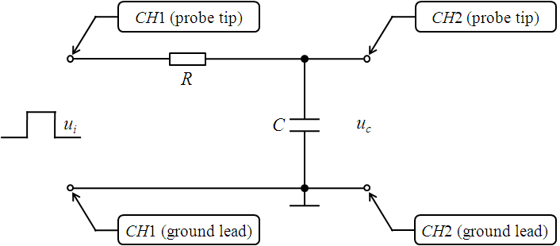

Figure 3.1

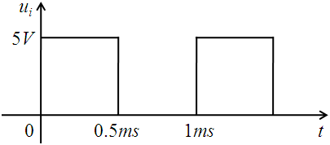

Figure 3.2

1. Use the automatic set-up function “AUTO” of digital oscilloscope to display the signals of *CH*1 and *CH*2 on the screen of digital oscilloscope.
2. Adjust the controls manually to get the best results if necessary.
3. Use the automatic measurement function “Measure” of digital oscilloscope to measure the input signal *ui* (*CH*1), record its relevant parameters: amplitude, periodic time, and impulse width.

**amplitude = 5.16V**

**periodic time = 1.00ms**

**impulse width = 500.0μs**

1. Use the cursor measurement function “Cursor” (“Track” mode) of digital oscilloscope to measure the zero state response signal *uc* (*CH*2), record its relevant parameters: steady voltage *uc*(∞) and time constant *τ*.

***uc*(∞) = 5.16V**

***τ* = 20.80μs**

1. The input and output oscillogram is shown below.

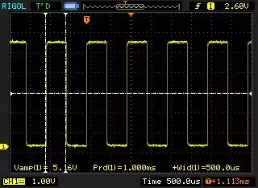 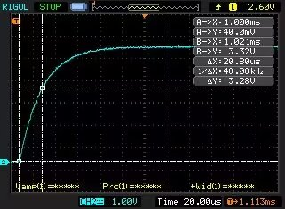

* + 1. **Measure the zero input response of first order dynamic RC circuit**

1. Connect up the circuit shown in Figure 3.3, where the values of resistor *R* and capacitor *C* are 2*K*Ω and 0.01*μ*F individually.

Where: *ui* ─ the periodic narrow impulse signal supplied by signal-generator on the

experiment box.

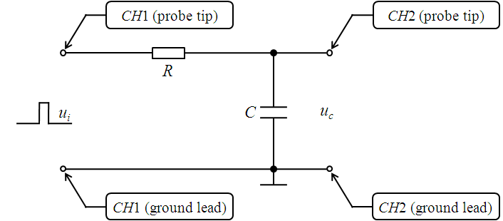

Figure 3.3

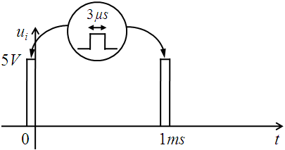

Figure 3.5

1. Use the automatic set-up function “AUTO” of digital oscilloscope to display the signals of *CH*1 and *CH*2 on the screen of digital oscilloscope.
2. Adjust the controls manually to get the best results if necessary.
3. Use the automatic measurement function “Measure” of digital oscilloscope to measure the input signal *ui* (*CH*1), record its relevant parameters: amplitude, periodic time, and impulse width.

**amplitude = 5.19V**

**periodic time = 1.020ms**

**impulse width = 4.000μs**

1. Use the cursor measurement function “Cursor” (“Track” mode) of digital oscilloscope to measure the zero input response signal *uc* (*CH*2), record its relevant parameters: initial voltage *uc*(0) and time constant *τ*.

***uc*(0) = 720mV**

***τ* = 20.80μs**

(6) The input and output oscillogram is shown below.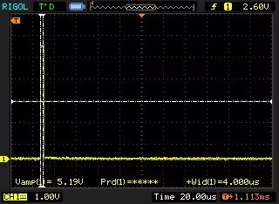 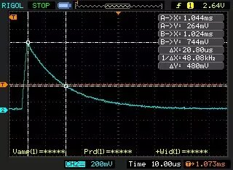

* 1. **What conclusions or gains can you get from EXPERIMENT THREE?**

1. In this experiment , I learned how to use the oscilloscope . I know how to display the diagram on the screen and sort the pictures in my own sorts. Also , I master some basic methods to measure the response of first order dynamic RC circuit.
2. From this experiment , I understood the concept of zero response and zero input response of the first order dynamic RC circuit. The first order dynamic circuit is formed by an independent dynamic component, which is capacitor or inductor, and some resistors. The zero input response, also known as the natural response is caused by the initial energy storage of the circuit, with no input applied.

3. The ideal source containing linear single port network is a theoretical model that can describe the behavior of actual circuits using equivalent circuits and parameters. In the experiment, we can understand the behavior and characteristics of the circuit by measuring the input and output signals of the circuit and using an equivalent circuit model to calculate the parameters of the circuit.

4.In the experiment, we measured the input and output voltages of an ideal source containing linear single port network, and calculated the equivalent resistance, equivalent inductance, and equivalent capacitance of the circuit. The experimental results show that in an ideal source containing linear single port network, the voltage and current of the signal source are independent of each other, that is, the voltage and current changes of the signal source do not affect the current and voltage of other components in the circuit. This allows us to independently measure and calculate the parameters of each component in the circuit, and to use equivalent circuit models to analyze and design the circuit.

In addition, we also found that in an ideal source containing linear single port network, the equivalent circuit model can well describe the behavior of the circuit, and the experimentally measured equivalent circuit parameters are very close to the theoretical values. This indicates that we can better understand the behavior and characteristics of circuits through equivalent circuit models, providing more accurate references for circuit design and optimization.

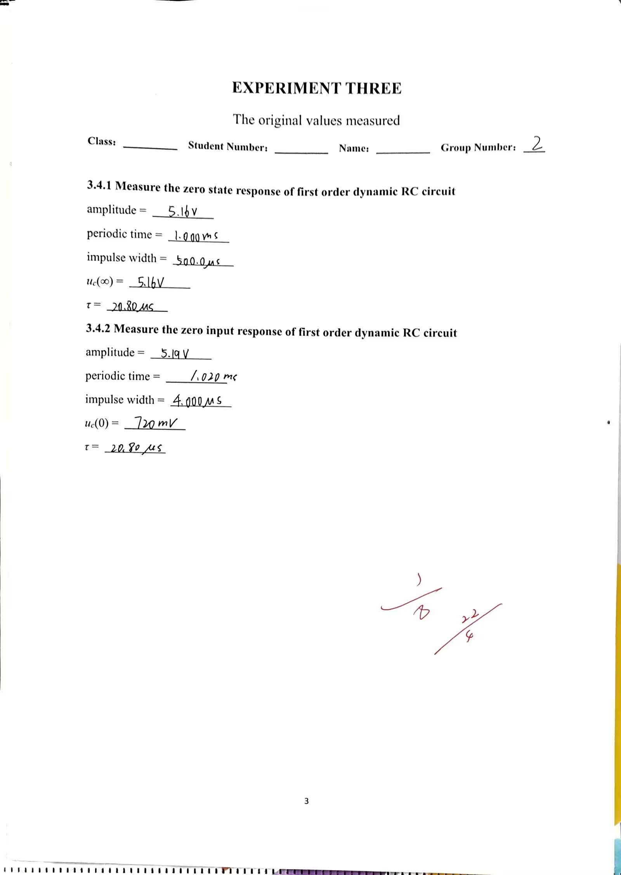

**EXPERIMENT FOUR**

Study on the response of second order dynamic series RLC circuit

* 1. **Tasks of the experiment**

1. Study the zero state response of second order dynamic series RLC circuit.
2. Study the zero input response of second order dynamic series RLC circuit.
   1. **Aims of the experiment**
3. Understand the concept of zero state response and zero input response of second order dynamic series RLC circuit.
4. Master some basic methods to measure the response of second order dynamic series RLC circuit.
5. Learn how to use digital oscilloscope further.
   1. **Equipments required**
6. Experiment box.
7. Digital oscilloscope.
8. Resistance decade box.
   1. **Steps of the experiment**
      1. **Measure the zero state response of second order dynamic RLC circuit**
9. Connect up the circuit shown in Figure 4.1, where the values of inductor *L* and capacitor *C* are 2.7*m*H and 0.01*μ*F individually.

Where: *R* ─ the resistance decade box.

*ui* ─ the periodic step signal supplied by signal-generator on the experiment box.

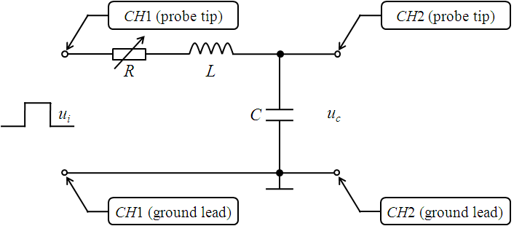

Figure 4.1



Figure 4.2

1. Use the automatic set-up function “AUTO” of digital oscilloscope to display the signals of *CH*1 and *CH*2 on the screen of digital oscilloscope.
2. Adjust the controls manually to get the best results if necessary.
3. Use the automatic measurement function “Measure” of digital oscilloscope to measure the input signal *ui* (*CH*1), record its relevant parameters: amplitude, periodic time, and impulse width.

**amplitude = 5.16V**

**periodic time = 1.000ms**

**impulse width = 500.0μs**

1. Adjust the output resistance of resistance decade box *R*, observe the three cases of the zero state response signal *uc* (*CH*2): under-damping, critical-damping, and over-damping. Then, draw up them in the same coordinate in Figure 4.3.

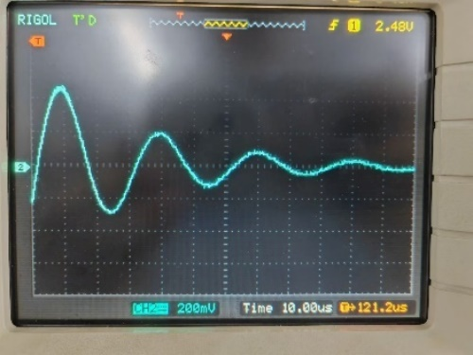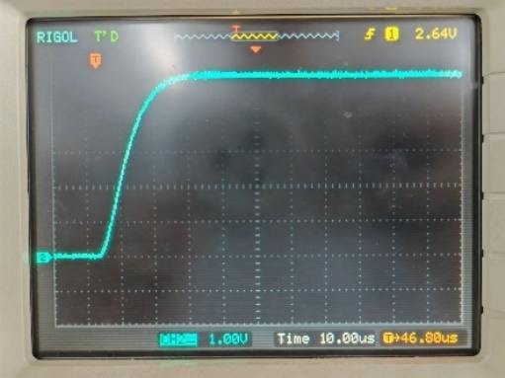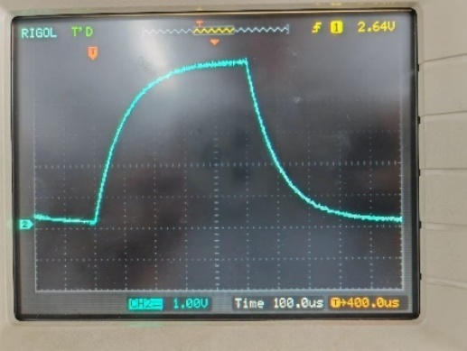

Under-damping critical-damping over-damping

Figure 4.3

* + 1. **Measure the zero input response of second order dynamic RLC circuit**

1. Connect up the circuit shown in Figure 4.4, where the values of inductor *L* and capacitor *C* are 2.7*m*H and 0.01*μ*F individually.

Where: *ui* ─ the periodic narrow impulse signal supplied by signal-generator on the

experiment box.

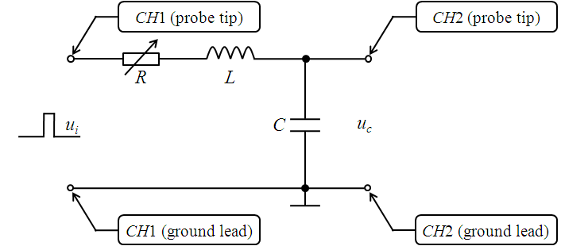

Figure 4.4



Figure 4.5

1. Use the automatic set-up function “AUTO” of digital oscilloscope to display the signals of *CH*1 and *CH*2 on the screen of digital oscilloscope.
2. Adjust the controls manually to get the best results if necessary.
3. Use the automatic measurement function “Measure” of digital oscilloscope to measure the input signal *ui* (*CH*1), record its relevant parameters: amplitude, periodic time, and impulse width.

**amplitude = 5.19V**

**periodic time = 1.020ms**

**impulse width = 4.000μs**

1. Adjust the output resistance of resistance decade box *R*, observe the three cases of the zero input response signal *uc* (*CH*2): under-damping, critical-damping, and over-damping. Then, draw up them in the same coordinate in Figure 4.6.

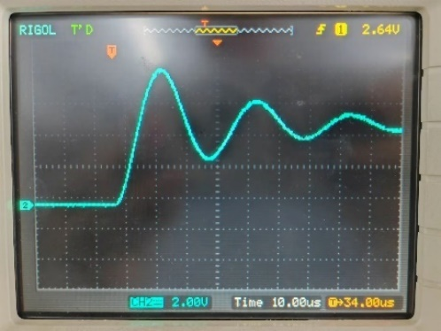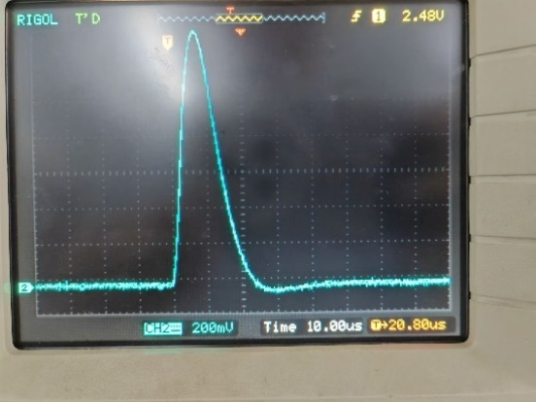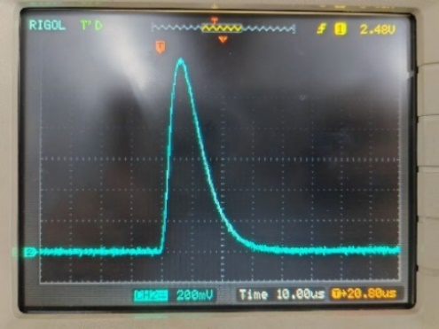

Under-damping critical-damping over-damping

Figure 4.6

1. Adjust the output resistance of resistance decade box *R* as 100Ω. Use the cursor measurement function “Cursor” (“Track” mode) of digital oscilloscope to measure and calculate natural frequency *ωd* and attenuation coefficient *α*.

 **0.191 rad/us**

 **0.0497**

* 1. **What conclusions or gains can you get from EXPERIMENT FOUR?**

1.Second order circuits are a common type of circuit with complex frequency response characteristics. In the experiment, we studied the response of second-order circuits and measured their amplitude frequency and phase frequency characteristics.

The experimental results indicate that the amplitude frequency characteristics and phase frequency characteristics of second-order circuits are related to the parameters of the circuit. When the circuit parameters change, the amplitude frequency characteristics and phase frequency characteristics of the circuit will also change. In addition, we also found that the amplitude frequency characteristics and phase frequency characteristics of second-order circuits can be predicted and described by calculating the transfer function of the circuit.

In the experiment, we use an oscilloscope and signal generator to measure the input and output signals of the circuit, and calculate the transfer function of the circuit. By analyzing and processing experimental data, we can obtain the amplitude frequency characteristics and phase frequency characteristics of the circuit, and analyze and study the response of the circuit.

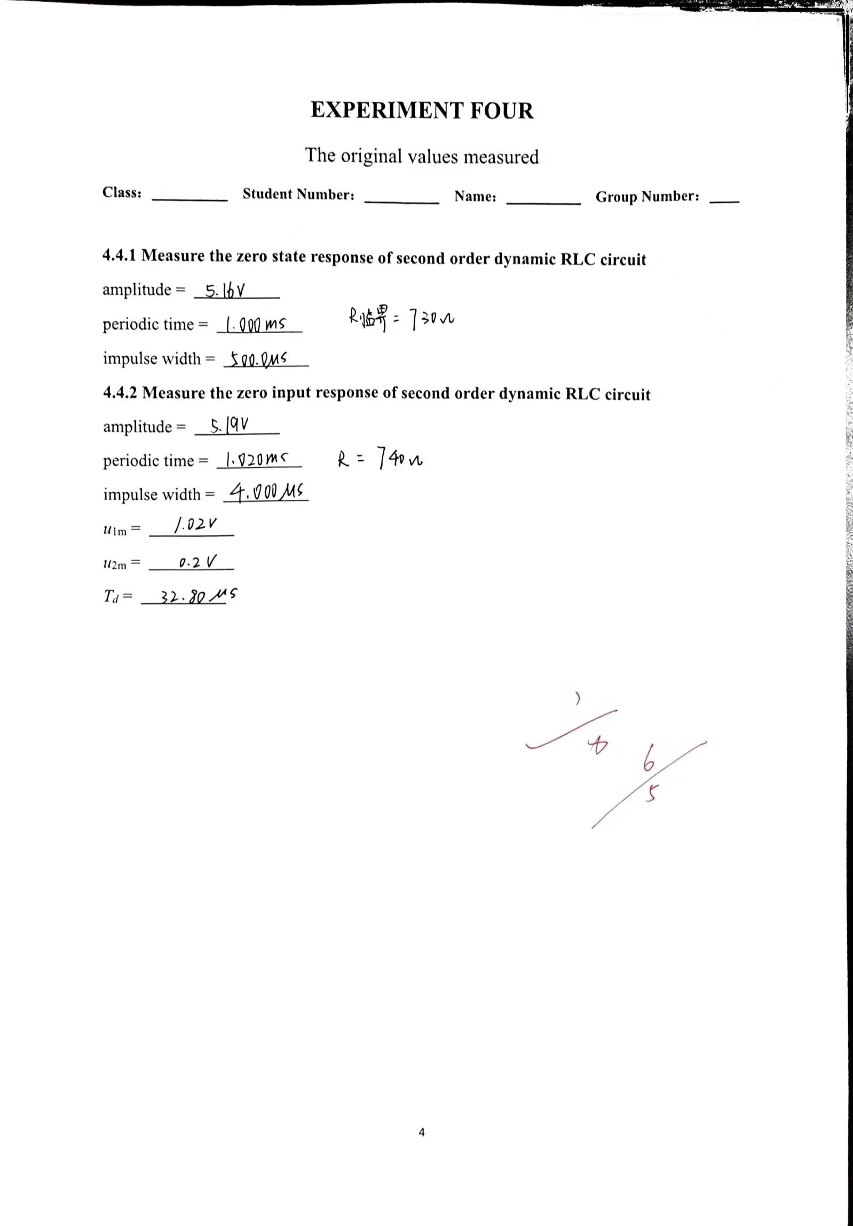

**EXPERIMENT FIVE**

The impedance-frequency characteristic of the single component

* 1. **Tasks of the experiment**

1. Measure the amplitude-frequency characteristic of impedance for the three components *R*, *L*, *C* individually.
2. Measure the impedance angle of the three components *R*, *L*, *C* individually.
3. Observe the volt-ampere track of the three components *R*, *L*, *C* individually.
   1. **Aims of the experiment**
4. Build up the concept of frequency characteristic for a component or a circuit preliminarily.
5. Learn the method for measuring frequency characteristic.
6. Strengthen to study the using of digital oscilloscope.
   1. **Equipments required**
7. Experiment box.
8. DDS function generator.
9. Digital oscilloscope.
   1. **Steps of the experiment**

We choose the circuit shown in figure 5.1 as the measured circuit, where the values of resistor *R*, inductor *L* and capacitor *C* are 2*K*Ω, 2.7*m*H and 0.1*μ*F individually.

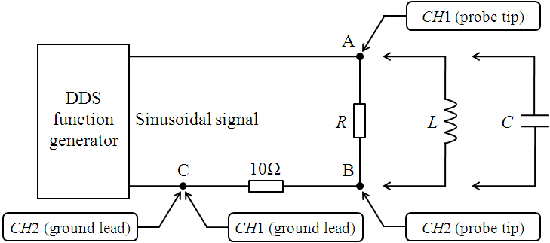

Figure 5.1

* + 1. **Measure the amplitude-frequency characteristic of impedance for the three components *R*, *L*, *C* individually**

1. Adjust the frequency of sinusoidal signal supplied by DDS function generator as 10*K*Hz shown as Row 1/Column 2 in Table 5.1.
2. Use the automatic set-up function “AUTO” of digital oscilloscope to display the signals of *CH*1 and *CH*2 on the screen of digital oscilloscope.
3. Use the automatic measurement function “Measure” of digital oscilloscope to measure the amplitude of sinusoidal signal supplied by DDS function generator (*CH*1). If it isn’t 2*V* rms shown as Row2 in Figure 5.1, adjust DDS function generator.
4. Use the automatic measurement function “Measure” of digital oscilloscope to measure the voltage across resistor 10Ω (*CH*2), record it as voltage *U*BC in Table 5.1.
5. Repeat the process of (1)～(4) to get the other voltages *U*BC, and record them in Table 5.1.
6. Calculate current *I*AB and amplitude , and fill the values in Table 5.1.

 

Table 5.1

|  |  |  |  |  |  |  |
| --- | --- | --- | --- | --- | --- | --- |
| ***f* (*K*Hz)** | | **10** | **20** | **30** | **40** | **50** |
| ***U*S (*V*)** | | **2** | | | | |
| ***U*BC (*mV*)** | ***R*** | **9.99** | **9.97** | **10.0** | **9.98** | **10.0** |
| ***L*** | **119** | **60.6** | **41.4** | **31.6** | **26.4** |
| ***C*** | **120** | **230** | **342** | **450** | **570** |
| ***I*AB (*mA*)** | ***R*** | **0.999** | **0.997** | **1.00** | **0.998** | **1.00** |
| ***L*** | **11.9** | **6.06** | **4.14** | **3.16** | **2.64** |
| ***C*** | **12.0** | **23.0** | **34.2** | **45.0** | **57.0** |
| **(*K*Ω)** | ***R*** | **2.00** | **2.01** | **2.00** | **2.00** | **2.00** |
| ***L*** | **0.168** | **0.330** | **0.483** | **0.633** | **0.758** |
| ***C*** | **0.167** | **0.087** | **0.058** | **0.044** | **0.035** |

1. Draw up the curves of  against *f* for the three components *R*, *L*, *C* in the same coordinate in Figure 5.2.

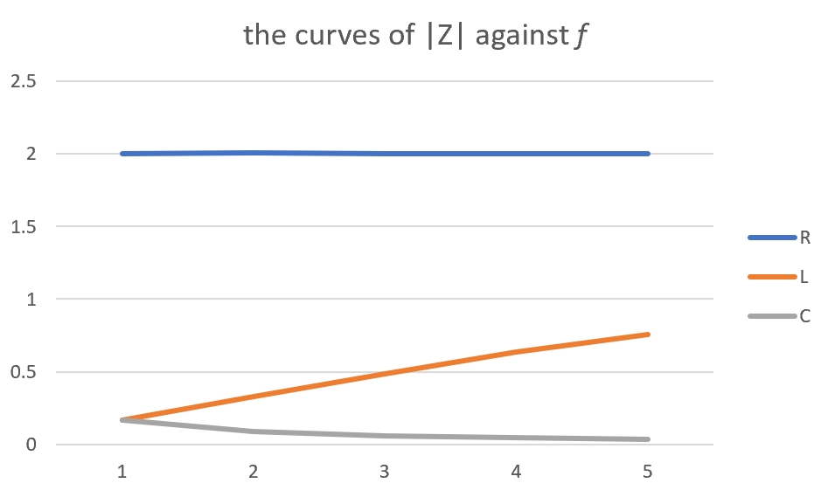

Figure 5.2

* + 1. **Measure the impedance angle of the three components *R*, *L*, *C* individually**

1. Adjust the frequency of sinusoidal signal supplied by DDS function generator as 10*K*Hz.
2. Use the automatic set-up function “AUTO” of digital oscilloscope to display the signals of *CH*1 and *CH*2 on the screen of digital oscilloscope.
3. Use the automatic measurement function “Measure” of digital oscilloscope to measure the amplitude of sinusoidal signal supplied by DDS function generator (*CH*1). If it isn’t 2*V* rms, adjust DDS function generator.
4. Adjust the controls manually to get the best results if necessary.
5. Measure the impedance angle of the three components *R*, *L*, *C* individually. On the one hand, observe and record whether the voltage leads or lags the current. On the other hand, use the cursor measurement function “Cursor” (“Manual” mode) of digital oscilloscope to measure and calculate phase difference  between the voltage and the current.

**For *R*:**  **0**

**Conclusion: The voltage is almost same as the current**

**For *L*:**  **77.64**

**Conclusion: The voltage leads the current.**

**For *C*:**  **79.20**

**Conclusion: The voltage lags the current.**

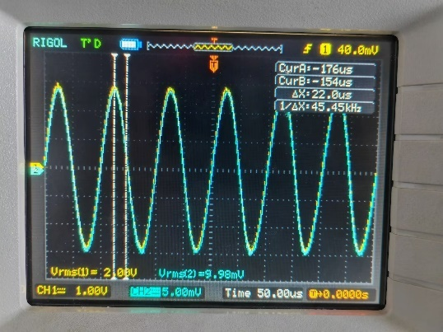 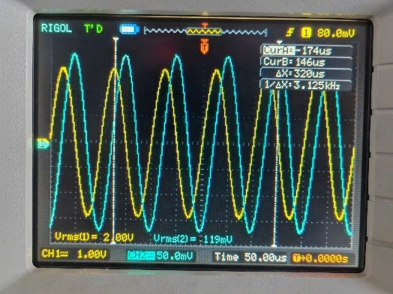 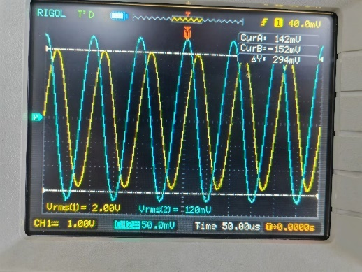

R L C

* + 1. **Observe the volt-ampere track of the three components *R*, *L*, *C* individually**

1. Adjust the frequency of sinusoidal signal supplied by DDS function generator as 10*K*Hz.
2. Use the automatic set-up function “AUTO” of digital oscilloscope to display the signals of *CH*1 and *CH*2 on the screen of digital oscilloscope.
3. Use the automatic measurement function “Measure” of digital oscilloscope to measure the amplitude of sinusoidal signal supplied by DDS function generator (*CH*1). If it isn’t 2*V* rms, adjust DDS function generator.
4. Adjust the controls manually to get the best results if necessary.
5. First, press the “MENU” button in the horizontal control area to display the menu. Second, press the “Time Base” soft button to select “X-Y” mode. Then, we can observe the volt-ampere track of the three components *R*, *L*, *C* individually
6. Use the cursor measurement function “Cursor” (“Manual” mode) of digital oscilloscope to measure and record the length *a* of the semi-major axis and the length *b* of the semi-minor axis.

**For *R*: *a* = 3.04V**

***b* = 14.7mV**

**For *L*: *a* = 2.96V**

***b* = 174mV**

**For *C*: *a* = 2.90V**

***b* = 176mV**

1. Draw up the volt-ampere track of the three components *R*, *L*, *C* in Figure 5.3.

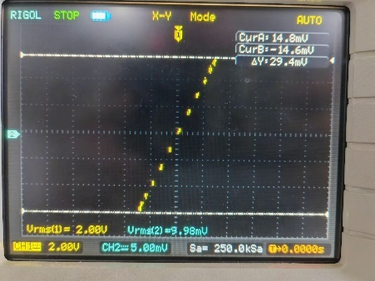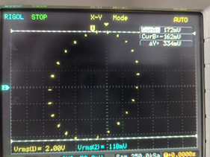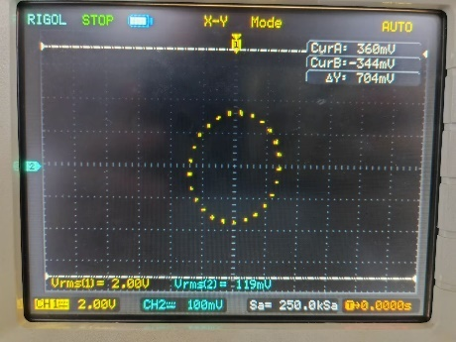

R L C

Figure 5.3

* 1. **What conclusions or gains can you get from EXPERIMENT FIVE?**

The experimental results show that for a single resistor, its impedance remains constant with frequency variation, that is, the impedance of the resistor remains constant throughout the entire frequency range.

For a single inductor, its impedance increases linearly with frequency, meaning that the higher the frequency, the greater the impedance of the inductor.

For a single capacitor, its impedance decreases linearly with frequency, meaning that the higher the frequency, the smaller the impedance of the capacitor.

In addition, we also found that the impedance changes of resistance, inductance, and capacitance with frequency are consistent with theoretical expectations.

In the experiment, we use a signal generator and oscilloscope to measure the input and output signals of the circuit, and calculate the impedance of the circuit. By analyzing and processing experimental data, we can obtain the characteristics of impedance changes of resistance, inductance, and capacitance with frequency, and analyze and study the impedance of electronic components.

