## 建表语句

CREATE TABLE EMP

(EMPNO FLOAT(4) PRIMARY KEY, -- 员工编号

ENAME VARCHAR(10), -- 员工姓名

JOB VARCHAR(9), -- 员工职位

MGR FLOAT(4), -- 员工上级工号

HIREDATE DATE, -- 生日

SAL FLOAT(7,2), -- 薪水

COMM FLOAT(7,2), -- 年终奖

DEPTNO FLOAT(2) -- 部门号

INSERT INTO EMP (EMPNO, ENAME, JOB, MGR, HIREDATE, SAL, COMM, DEPTNO) VALUES (7369, 'SMITH', 'CLERK', 7902, '1980-12-17', 800, NULL, 20);

INSERT INTO EMP (EMPNO, ENAME, JOB, MGR, HIREDATE, SAL, COMM, DEPTNO) VALUES (7499, 'ALLEN', 'SALESMAN', 7698, '1981-02-20', 1600, 300, 30);

INSERT INTO EMP (EMPNO, ENAME, JOB, MGR, HIREDATE, SAL, COMM, DEPTNO) VALUES (7521, 'WARD', 'SALESMAN', 7698, '1981-02-22', 1250, 500, 30);

INSERT INTO EMP (EMPNO, ENAME, JOB, MGR, HIREDATE, SAL, COMM, DEPTNO) VALUES (7566, 'JONES', 'MANAGER', 7839, '1981-04-02', 2975, NULL, 20);

INSERT INTO EMP (EMPNO, ENAME, JOB, MGR, HIREDATE, SAL, COMM, DEPTNO) VALUES (7654, 'MARTIN', 'SALESMAN', 7698, '1981-09-28', 1250, 1400, 30);

INSERT INTO EMP (EMPNO, ENAME, JOB, MGR, HIREDATE, SAL, COMM, DEPTNO) VALUES (7698, 'BLAKE', 'MANAGER', 7839, '1981-05-01', 2850, NULL, 30);

INSERT INTO EMP (EMPNO, ENAME, JOB, MGR, HIREDATE, SAL, COMM, DEPTNO) VALUES (7782, 'CLARK', 'MANAGER', 7839, '1981-06-09', 2450, NULL, 10);

INSERT INTO EMP (EMPNO, ENAME, JOB, MGR, HIREDATE, SAL, COMM, DEPTNO) VALUES (7788, 'SCOTT', 'ANALYST', 7566, '1987-04-19', 3000, NULL, 20);

INSERT INTO EMP (EMPNO, ENAME, JOB, MGR, HIREDATE, SAL, COMM, DEPTNO) VALUES (7839, 'KING', 'PRESIDENT', NULL, '1981-11-17', 5000, NULL, 10);

INSERT INTO EMP (EMPNO, ENAME, JOB, MGR, HIREDATE, SAL, COMM, DEPTNO) VALUES (7844, 'TURNER', 'SALESMAN', 7698, '1981-09-08', 1500, 0, 30);

INSERT INTO EMP (EMPNO, ENAME, JOB, MGR, HIREDATE, SAL, COMM, DEPTNO) VALUES (7876, 'ADAMS', 'CLERK', 7788, '1987-05-23', 1100, NULL, 20);

INSERT INTO EMP (EMPNO, ENAME, JOB, MGR, HIREDATE, SAL, COMM, DEPTNO) VALUES (7900, 'JAMES', 'CLERK', 7698, '1981-12-03', 950, NULL, 30);

INSERT INTO EMP (EMPNO, ENAME, JOB, MGR, HIREDATE, SAL, COMM, DEPTNO) VALUES (7902, 'FORD', 'ANALYST', 7566,'1981-12-02', 3000, NULL, 20);

INSERT INTO EMP (EMPNO, ENAME, JOB, MGR, HIREDATE, SAL, COMM, DEPTNO) VALUES (7934, 'MILLER', 'CLERK', 7782, '1982-01-23', 1300, NULL, 10);

1)查询没有上级的员工全部信息（也就是说 员工上级编号为 NULL 的）

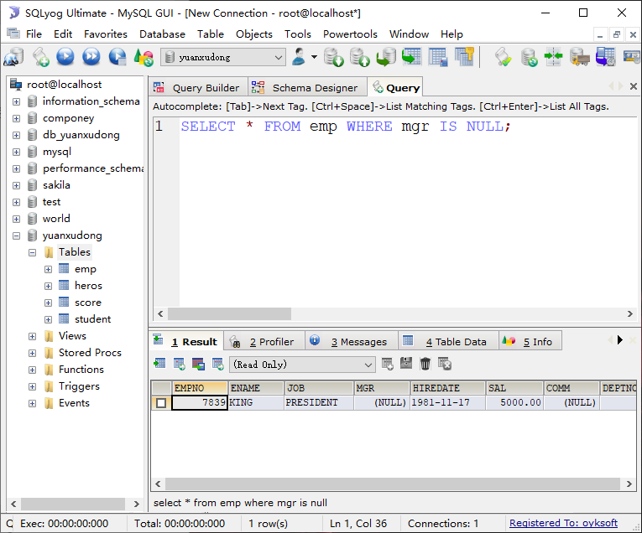

2)列出30号部门所有员工的姓名、薪资

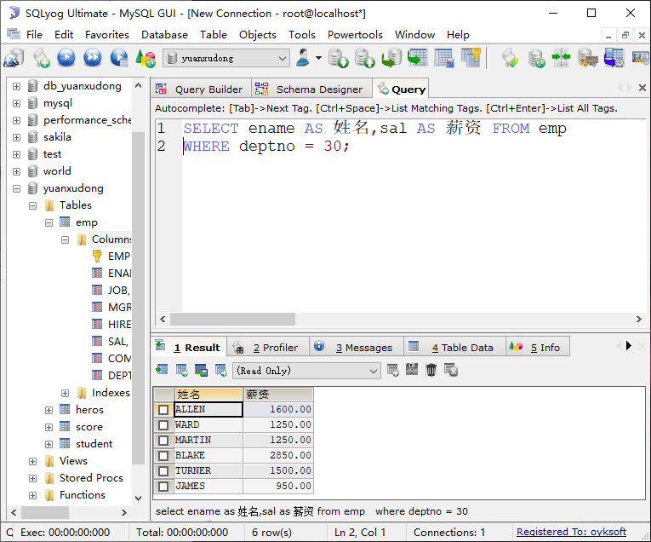

3)查询员工“TURNER”的员工编号和薪资

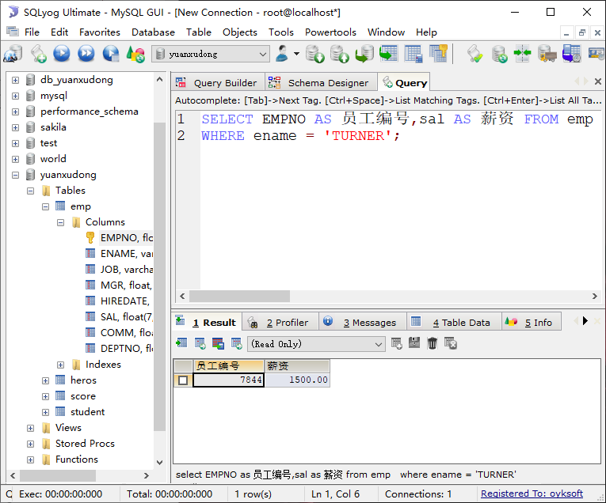

4) 查询10号部门的平均薪资、最高薪资、最低薪资

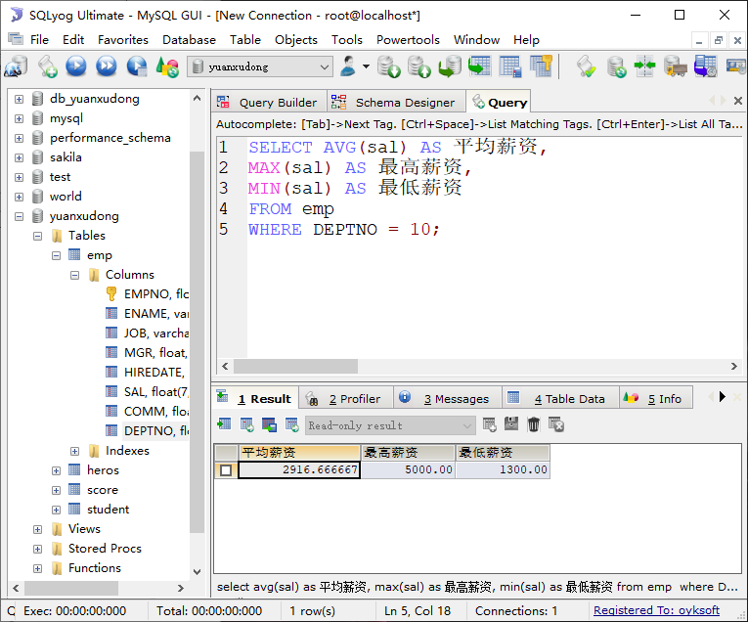

5)查询薪资最高的员工的信息 ----子查询

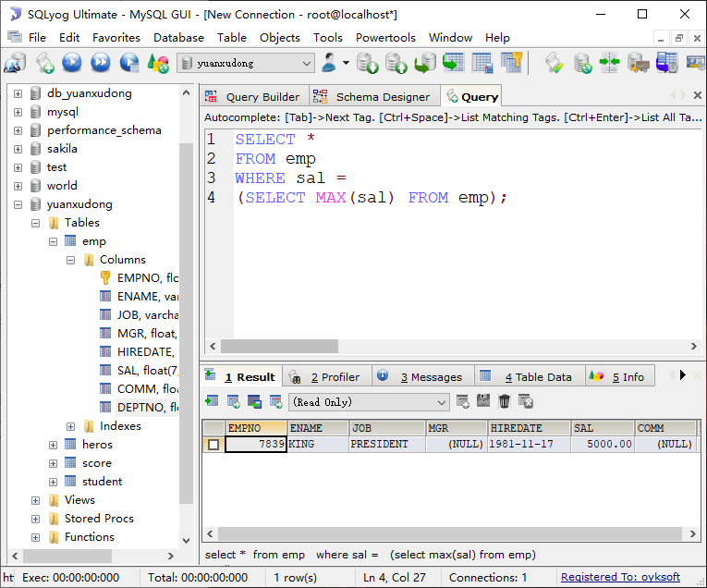

6)列出薪金比员工“ TURNER ”多的所有员工姓名（ENAME）、员工薪资（SAL） , 再按照薪资降序排列 ----子查询

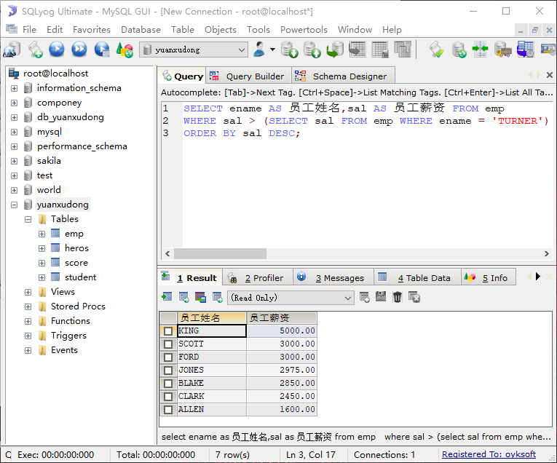

7)列出薪金高于公司平均薪金的所有员工姓名、薪金。----子查询

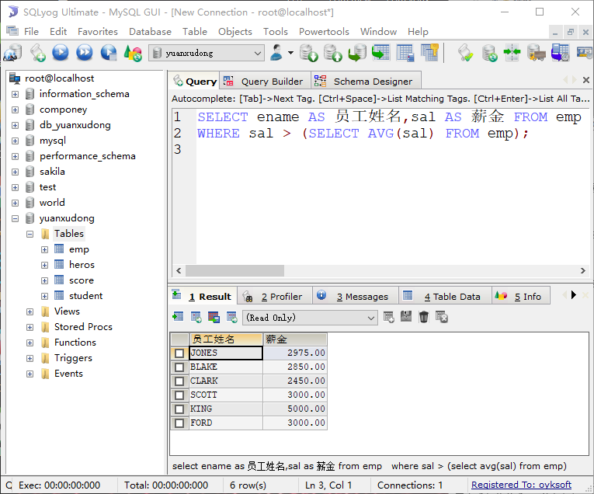

8)列出与“SCOTT”从事相同工作的所有员工姓名、工作名称----子查询

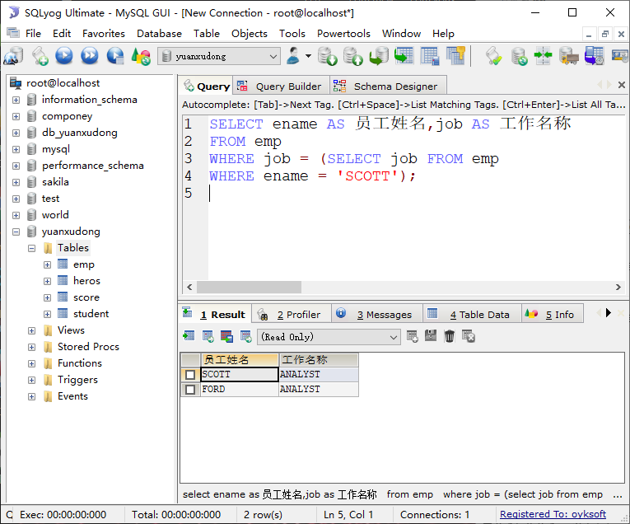

9)列出与“SCOTT”从事相同工作的所有员工姓名、工作名称(且不展示Scott的姓名、工作) ----子查询

