**周考试题**

给定建表语句，以及预支数据sql,完成以下功能

**建表语句：**

|  |
| --- |
| #建学生信息表student  create table student  (  sno varchar(20) not null primary key,  sname varchar(20) not null,  ssex varchar(20) not null,  sbirthday datetime,  class varchar(20)  );  #建立教师表  create table teacher  (  tno varchar(20) not null primary key,  tname varchar(20) not null,  tsex varchar(20) not null,  tbirthday datetime,  prof varchar(20),  depart varchar(20) not null  );  #建立课程表course  create table course  (  cno varchar(20) not null primary key,  cname varchar(20) not null,  tno varchar(20) not null,  foreign key(tno) references teacher(tno)  );  #建立成绩表  CREATE TABLE score (  sno VARCHAR (20) NOT NULL ,  FOREIGN KEY (sno) REFERENCES student (sno),  cno VARCHAR (20) NOT NULL,  FOREIGN KEY (cno) REFERENCES course (cno),  degree DECIMAL  ); |

**预支数据sql**

|  |
| --- |
| #添加学生信息  insert into student values('108','曾华','男','1977-09-01','95033');  insert into student values('105','匡明','男','1975-10-02','95031');  insert into student values('107','王丽','女','1976-01-23','95033');  insert into student values('101','李军','男','1976-02-20','95033');  insert into student values('109','王芳','女','1975-02-10','95031');  insert into student values('103','陆君','男','1974-06-03','95031');  #添加教师表  insert into teacher values('804','李诚','男','1958-12-02','副教授','计算机系');  insert into teacher values('856','张旭','男','1969-03-12','讲师','电子工程系');  insert into teacher values('825','王萍','女','1972-05-05','助教','计算机系');  insert into teacher values('831','刘冰','女','1977-08-14','助教','电子工程系');  #添加课程表  insert into course values('3-105','计算机导论','825');  insert into course values('3-245','操作系统','804');  insert into course values('6-166','数字电路','856');  insert into course values('9-888','高等数学','831');  #添加成绩表  insert into score values('103','3-245','86');  insert into score values('105','3-245','75');  insert into score values('109','3-245','68');  insert into score values('103','3-105','92');  insert into score values('105','3-105','88');  insert into score values('109','3-105','76');  insert into score values('103','3-105','64');  insert into score values('105','3-105','91');  insert into score values('109','3-105','78');  insert into score values('103','6-166','85');  insert into score values('105','6-166','79');  insert into score values('109','6-166','81'); |

**完成题目如下：**

1.查询Student表中Sname、Ssex和Class列的所有信息。（4分）

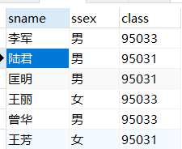

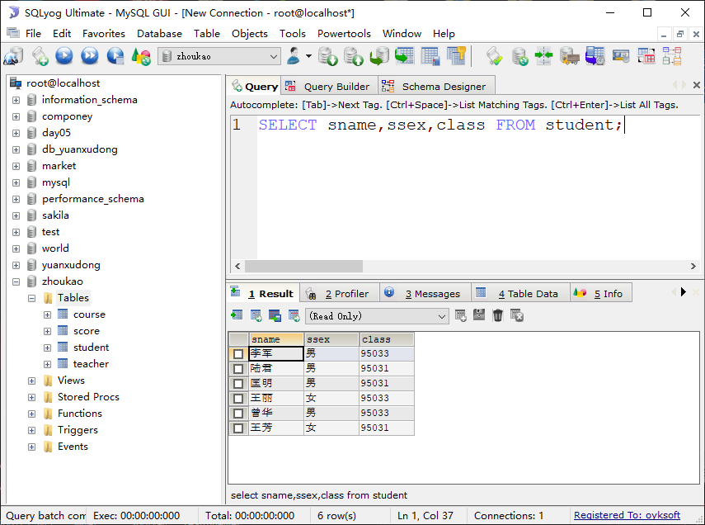

select sname, ssex,class from student;

2、 查询教师表中Depart列的所有信息并去除重复值。（4分）

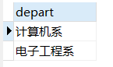

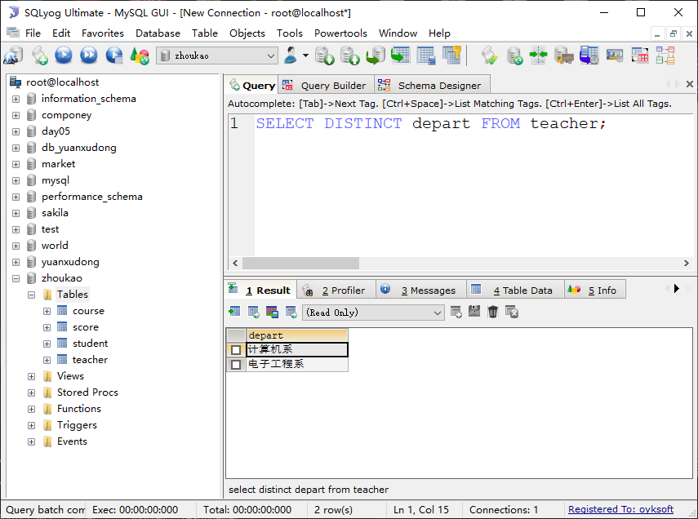

SELECT DISTINCT depart FROM teacher;

3、 查询Score表中成绩在60到80之间的所有信息。（4分）

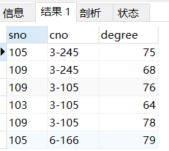

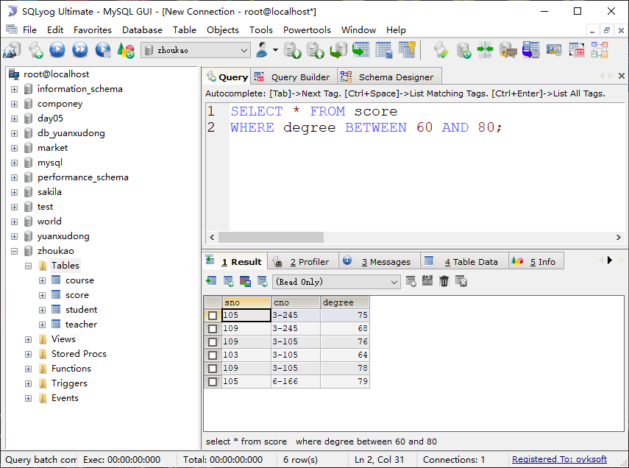

SELECT * FROM score

WHERE degree BETWEEN 60 AND 80;

4、 查询Score表中成绩为85，86或88的所有信息。（4分）

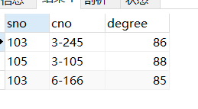

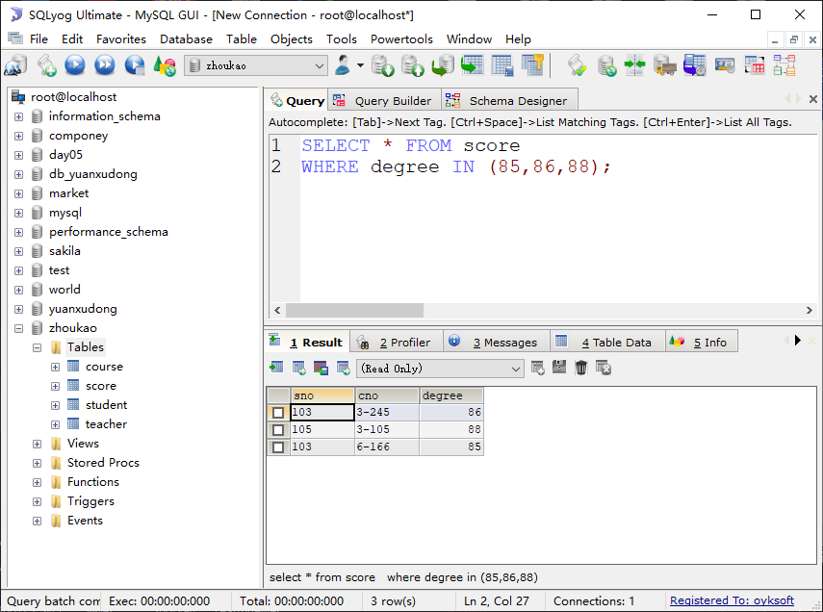

select * from score

where degree in (85,86,88);

5、 查询成绩存在有85分以上的课程的Cno列信息，并对课程Cno去重. （4分）

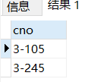

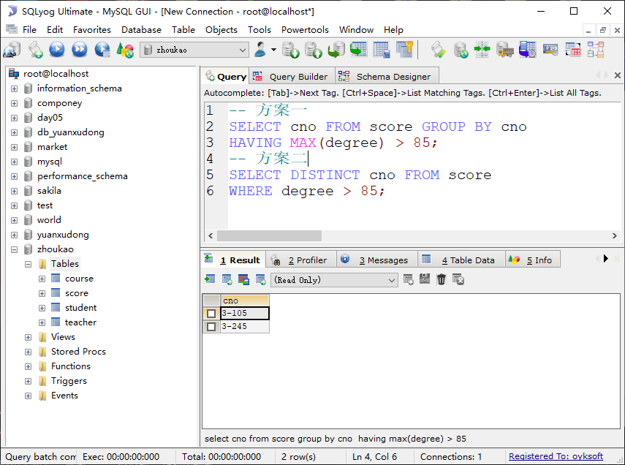

-- 方案一

SELECT cno FROM score GROUP BY cno

HAVING MAX(degree) > 85;

-- 方案二

SELECT DISTINCT cno FROM score

WHERE degree > 85;

6、查询“计算机系”与“电子工程系“所有教师的Tname和Prof列信息。（4分）

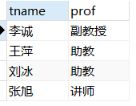

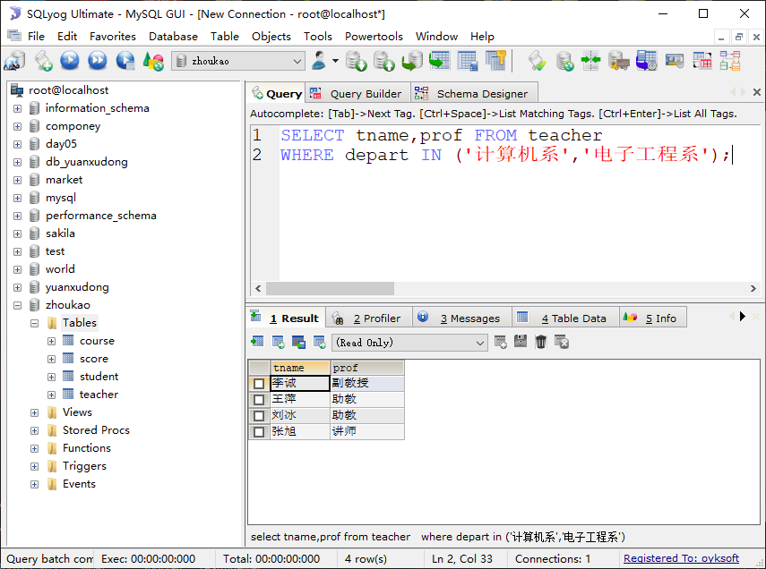

select tname, prof from teacher

where depart in ('计算机系','电子工程系');

7、 查询Student表中班级为“95031”班或性别为“女”的所有学生的信息。（4分）

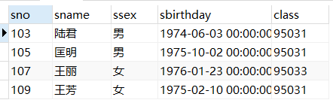

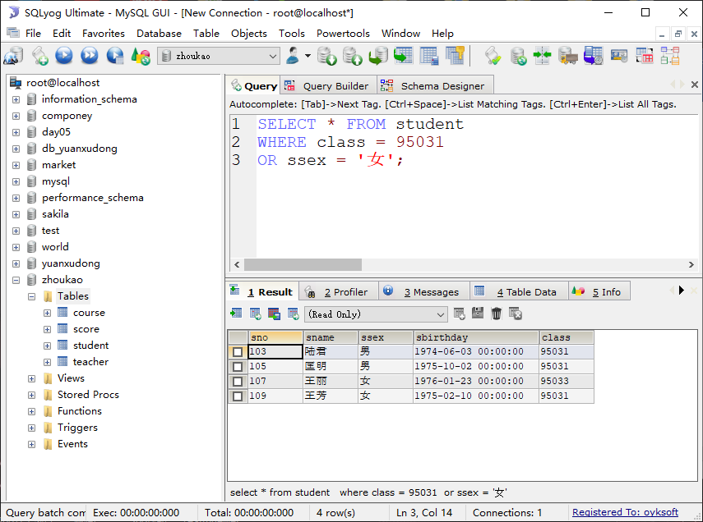

SELECT * FROM student

WHERE class = 95031

OR ssex = '女';

8、 查询Score表的所有信息吗，查询结果按照Cno升序、Degree降序排列。（4分）

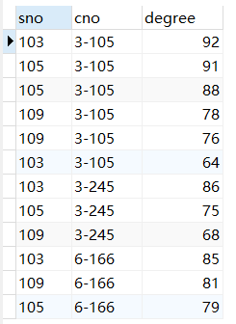

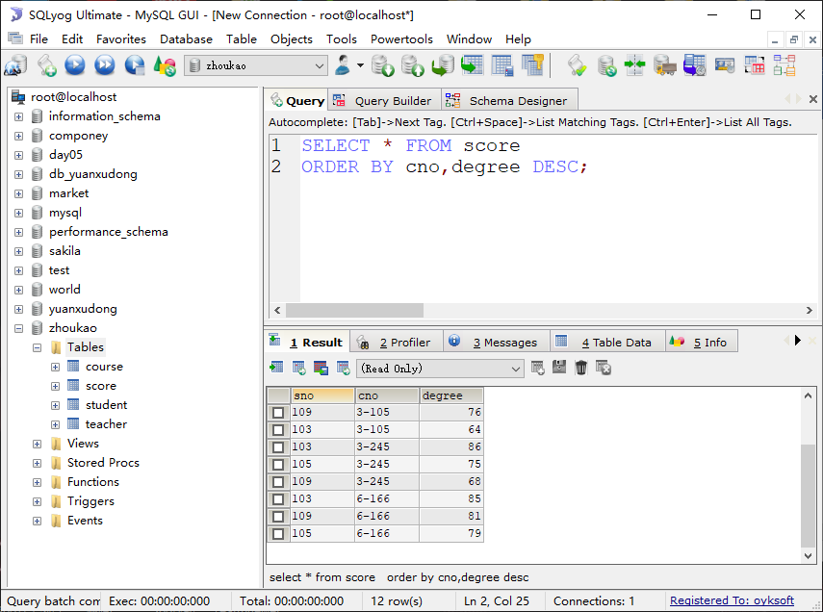

select * from score order by cno,degree desc;

9、 查询“95031”班的学生人数。（4分）



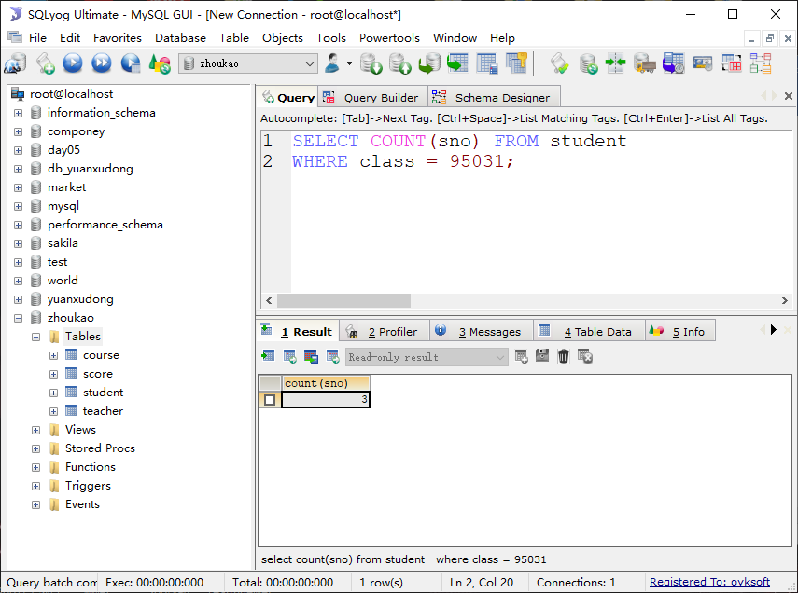

select count(sno) from student where class = 95031;

10、查询Score表中的最高分的学生学号和课程号。（用子查询）（4分）



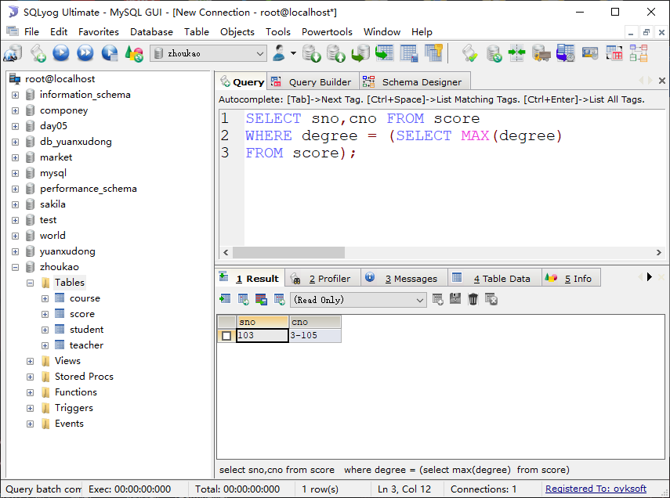

select sno,cno from score where degree = (select max(degree) from score);

11、查询每门课程的平均成绩。（4分）

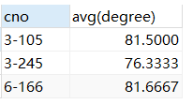

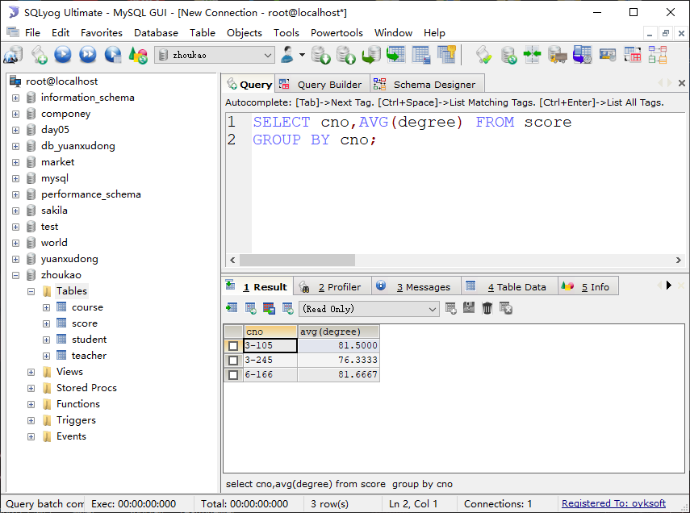

select cno,avg(degree) from score group by cno;

12、查询Student表中不姓“王”的同学记录。（4分）

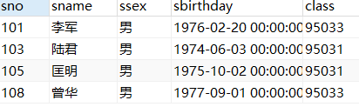

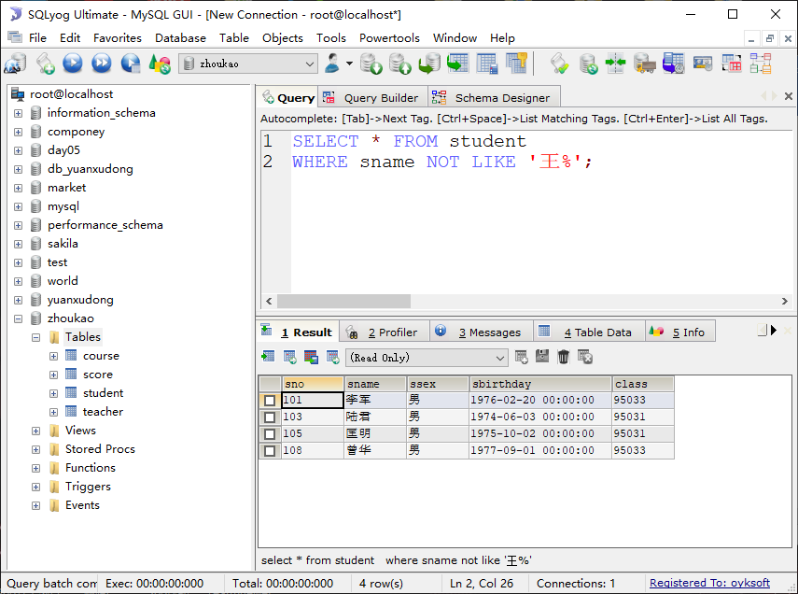

select * from student where sname not like ‘王%’;

13、查询Student表中最大和最小的Sbirthday日期值。（4分）

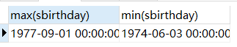

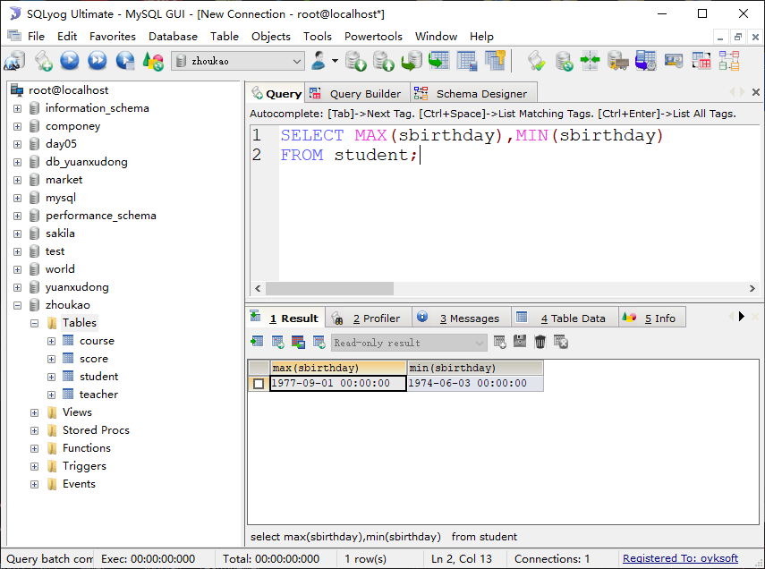

select max(sbirthday),min(sbirthday) from student;

14、查询Student表中的所有学生的年龄（4分）

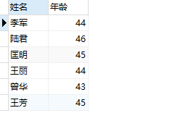

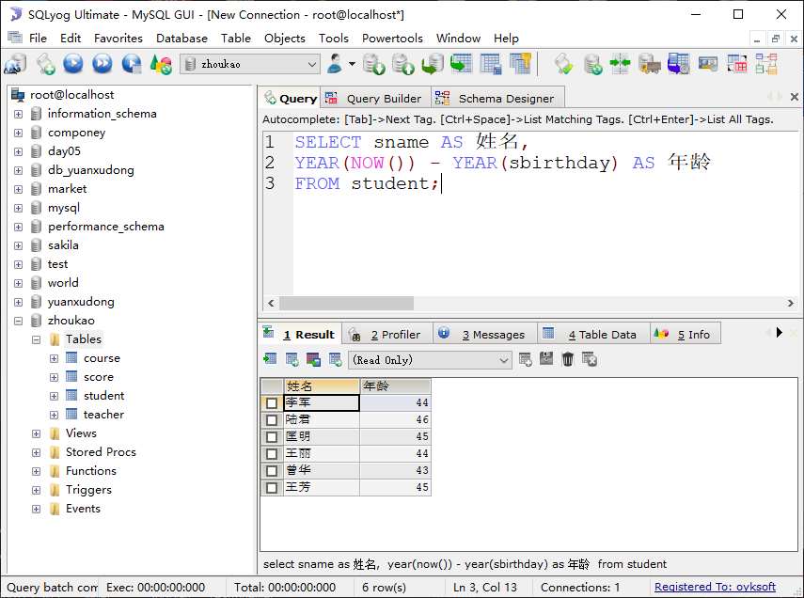

select sname as 姓名,

year(NOw()) - year(sbirthday) as 年龄

from student;

15、 查询Student表中男、女各有多少人（4分）

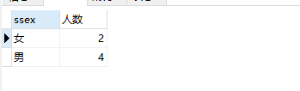

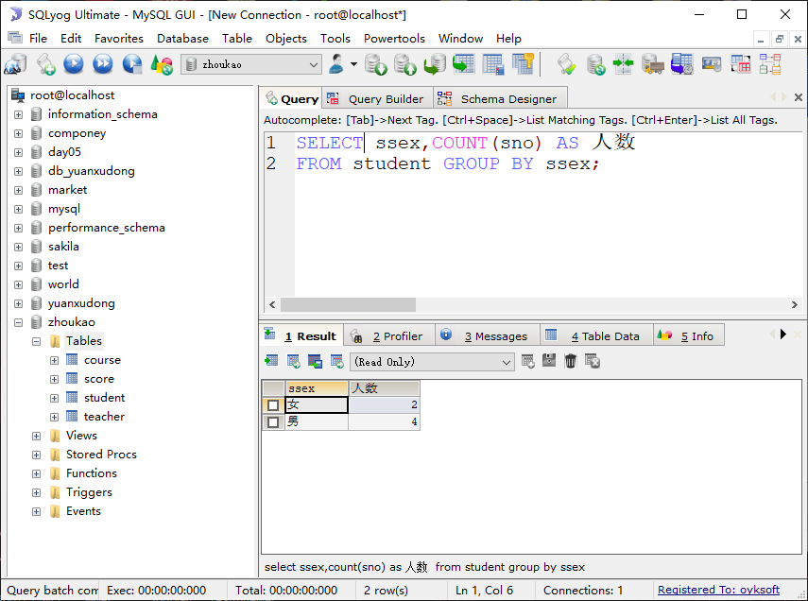

SELECT ssex,COUNT(sno) AS 人数

FROM student GROUP BY ssex;

16、在Teacher表中查询年龄最大的老师的信息（4分）



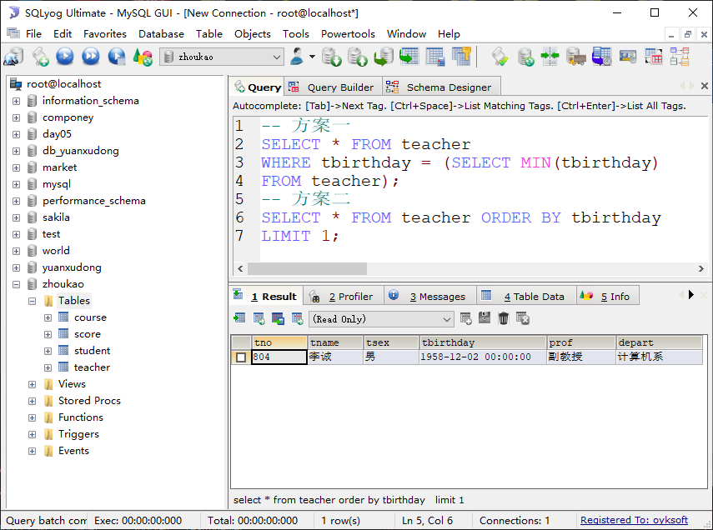

select * from teacher

where tbirthday = (select min(tbirthday)

from teacher);

select * from teacher order by tbirthday

limit 1;

17、查询学生”王芳”没有选修的课程有哪些(子查询) （4分）

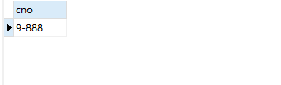

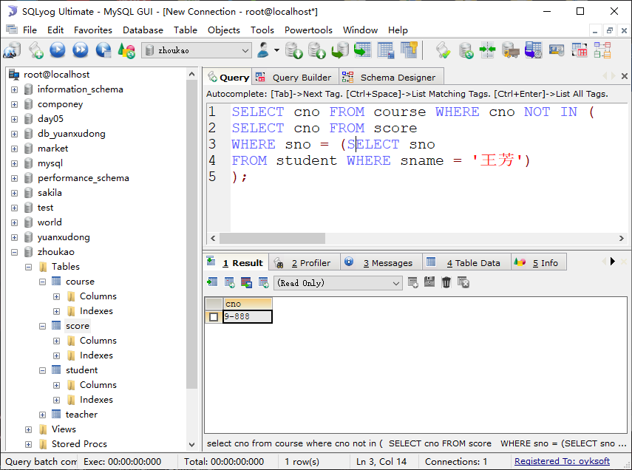

select cno from course where cno not in (

select cno from score

where sno = (select sno

from student where sname = '王芳')

)

18、查询Teacher表中所在系别是”电子工程系”并且职位是“讲师”的老师的信息（4分）



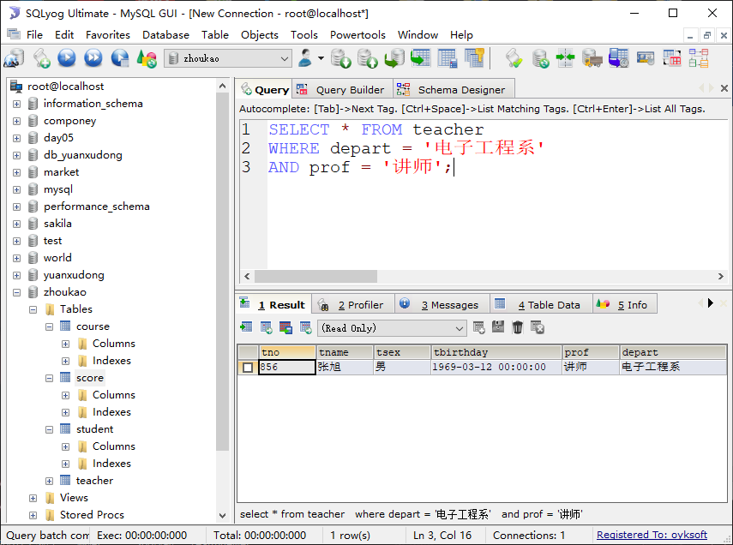

select * from teacher where depart = ‘电子工程系’ and prof = ‘讲师’;

19、查询Score表中学号是103所选的课程，并按照降序的方式排序（4分）

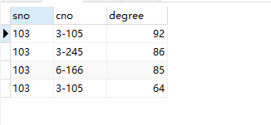

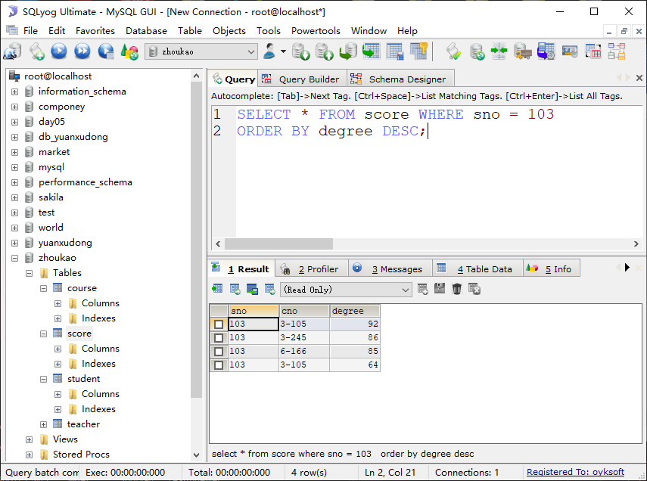

select * from score where sno = 103 order by degree desc;

20、查询和“李军”同性别的所有同学的Sname列信息（4分）

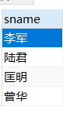.

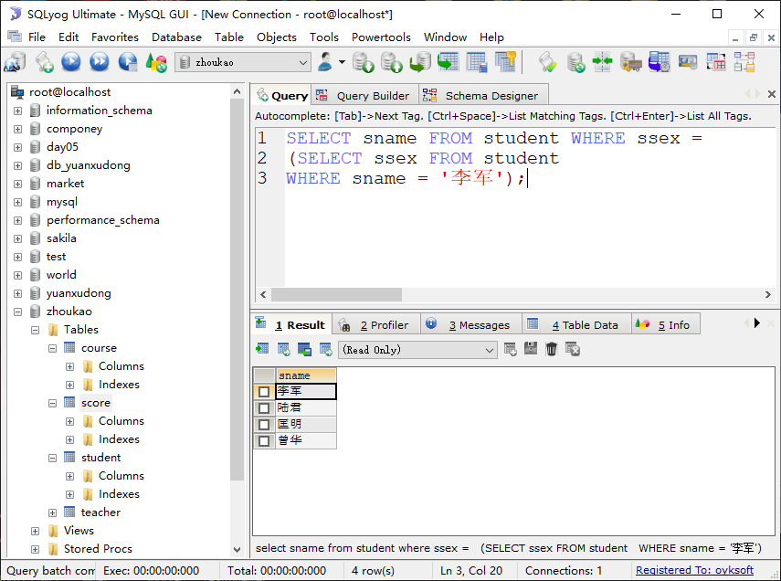

select sname from student where ssex = (select ssex from student where sname = ‘李军’);

21、查询”王萍”老师所教授的课程有哪些（两表连接实现）（4分）

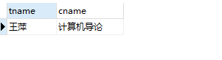

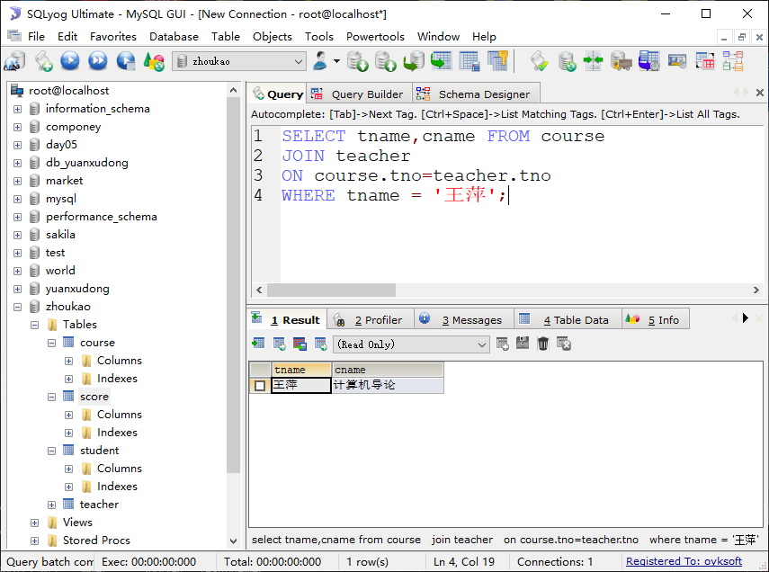

select tname,cname from course join teacher on course.tno = teacher.tno where tname = ‘王萍’;

22、查询Score表中每门课程的平均分数（要求查询的课程至少要有五个成绩）。（4分）

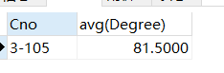

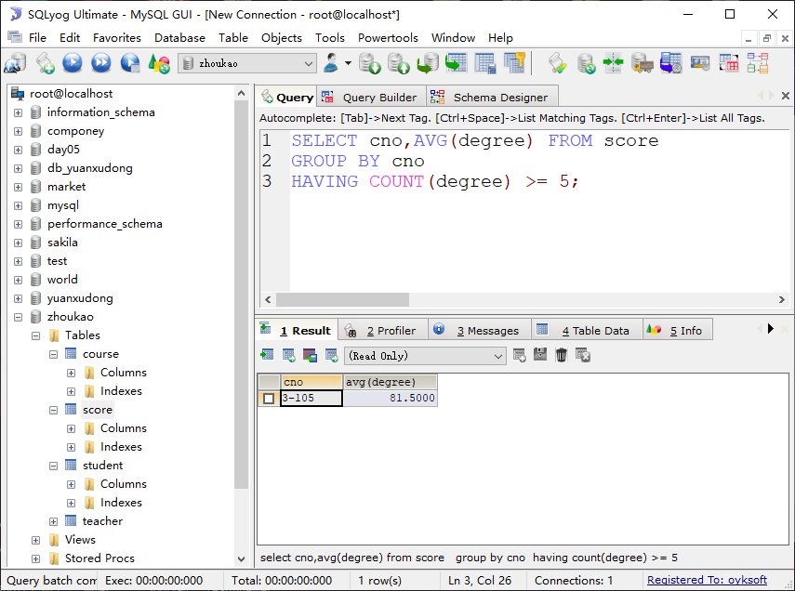

select cno,avg(degree) from score group by cno having count(degree) >= 5;

23、查询所有学生的Sname、Cno和Degree列(两表内连接)。（4分）

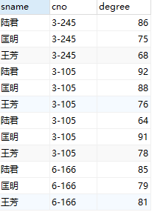

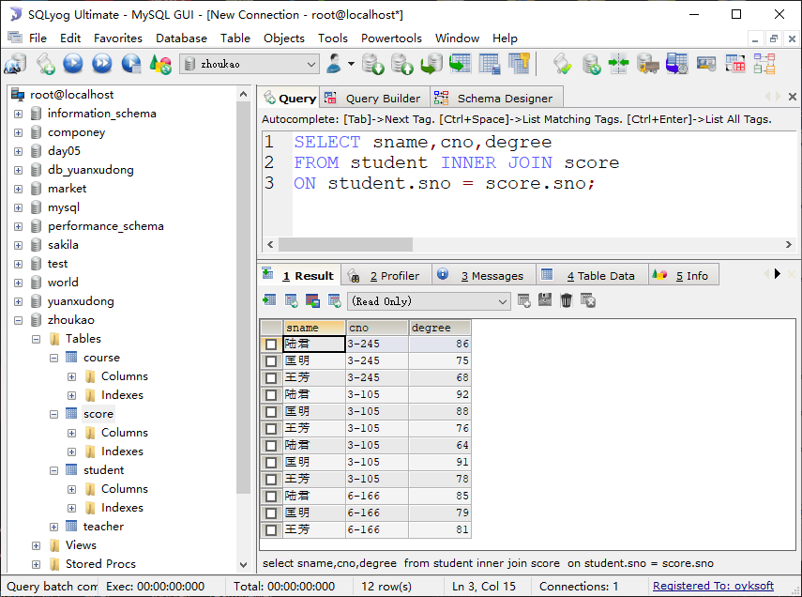

select sname,cno,degree

from student inner join score

on student.sno = score.sno;

24、查询“男”教师的名称及其所上的课程的名称（两表内连接）。（4分）

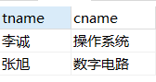

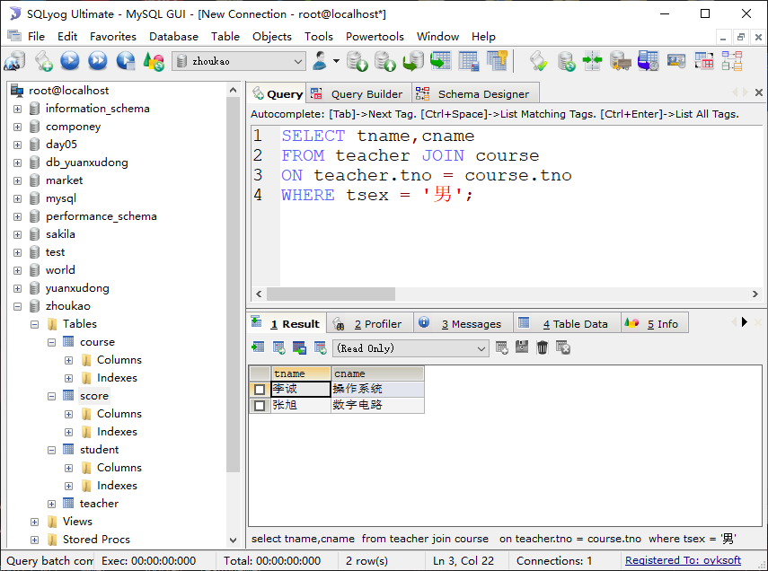

select tname,cname from teacher join course on teacher.tno = course.tno where tsex = ‘男’;

25、查询学生”陆君”所选每门课的平均分（两表内连接）。（4分）

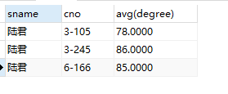

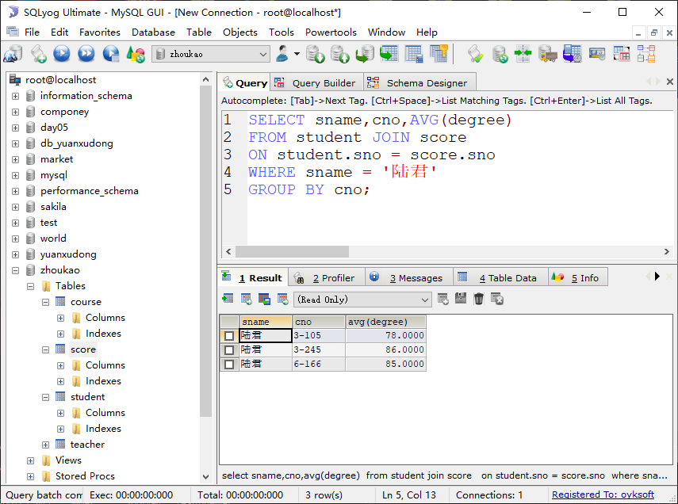

SELECT sname,cno,AVG(degree)

FROM student JOIN score

ON student.sno = score.sno

WHERE sname = '陆君'

GROUP BY cno;