ECEN 3314 — Lab 3
Diode and Rectifier Circuits — Simulation Results
OrCAD Capture / PSpice + MATLAB
Generated 2026-07-19 16:17
Project: orcadcpmtest

1. Summary
This document compiles Section 6 simulation deliverables [S-1]–[S-8] from ECEN3314 Lab 3 (Diode and Rectifier Circuits). Circuits were entered in OrCAD Capture; analyses were run with PSpice (psp_cmd); waveforms and I–V curves were plotted in MATLAB. PSpice Probe UI screenshots were not available through automation, so MATLAB plots are used for simulation results.

2. Schematics (Capture)
All four Lab 3 circuits were placed on SCHEMATIC1 / PAGE1. Overview screenshot from OrCAD Capture:
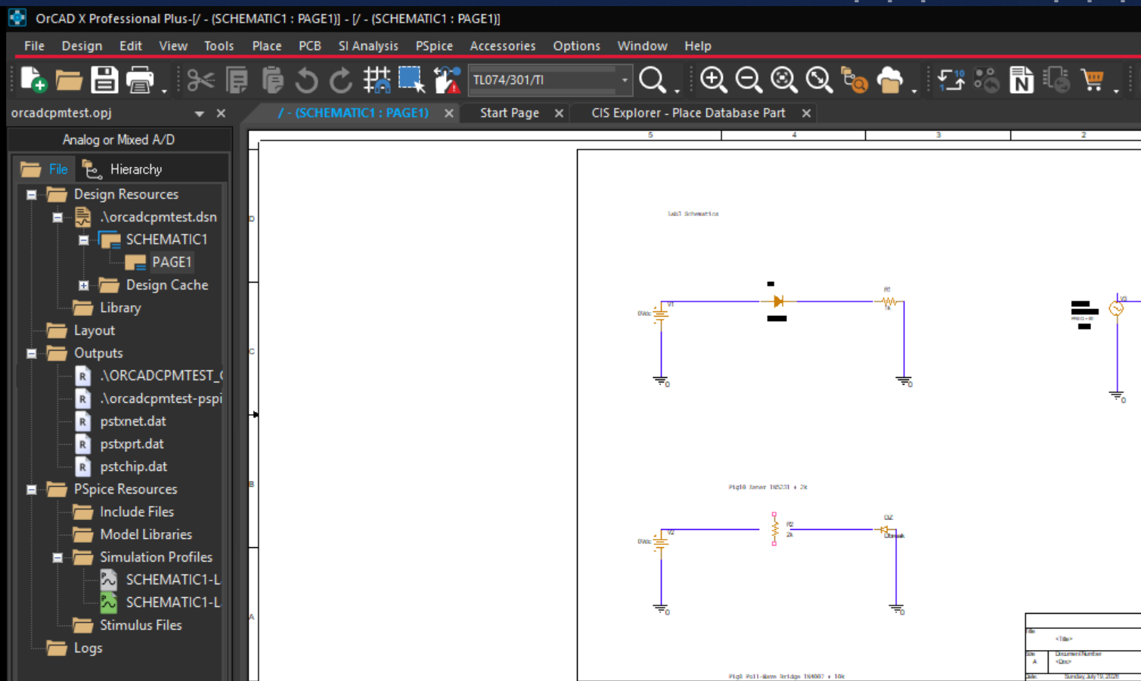
Figure A. Capture PAGE1 overview — Fig 9 (diode I–V), Fig 10 (Zener), and Fig 11 (peak rectifier, partial).
Schematic notes:
• [S-1] Fig 9: V1 (VDC) → D1 (1N4148) → R1 = 1 kΩ → GND
• [S-3] Fig 10: V2 (VDC) → R2 = 2 kΩ → DZ (Dbreak / MODEL D1N5231, reverse) → GND
• [S-5] Fig 11: V3 (VSIN, 3 V, 50 Hz) → D2 (1N4007) → R3 = 150 Ω || C1 = 47 µF → GND
• [S-7] Fig 8: Full-wave bridge (4×1N4007) + RL = 10 kΩ, VSIN 3 V / 50 Hz (on page below/right of overview crop)

3. [S-2] Diode I–V Characteristics (Fig 9)
DC sweep of VIN from 0 V to 5 V (0.01 V step). Diode 1N4148 with series 1 kΩ. Plotted: diode current ID vs diode voltage VD = V(anode) − V(cathode).
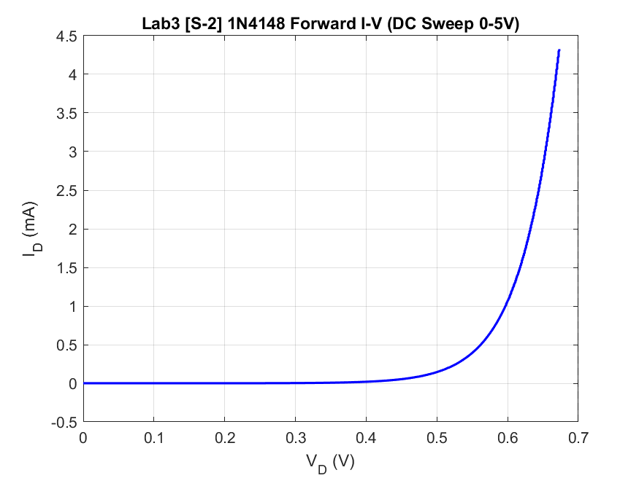
Figure B. [S-2] 1N4148 forward I–V from PSpice DC sweep (MATLAB).
Observed: knee near ~0.5–0.6 V; at VIN = 5 V, VD ≈ 0.67 V and ID ≈ 4.3 mA (consistent with ~0.7 V silicon forward drop and IR drop on 1 kΩ).

4. [S-4] Zener Diode Reverse I–V (Fig 10)
DC sweep of VIN from 0 V to 15 V (0.05 V step). 1N5231 (Vz ≈ 5.1 V) reverse-biased with series 2 kΩ (VIN+ → R → cathode; anode → GND).
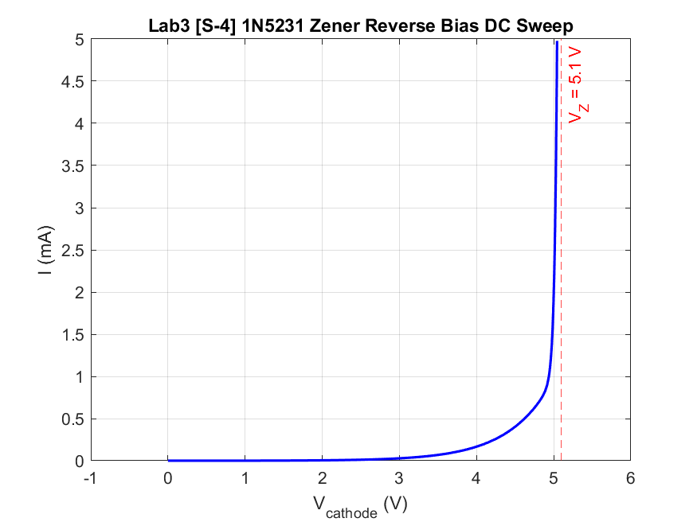
Figure C. [S-4] 1N5231 reverse characteristic — Vcathode vs current (MATLAB).
Observed: current rises sharply near Vz = 5.1 V. At VIN = 15 V, Vcathode ≈ 5.04 V and I ≈ 5.0 mA (regulation around the Zener voltage).

5. [S-6] Peak Rectifier (Fig 11)
Transient analysis, VSIN amplitude 3 V, 0 V offset. Diode 1N4007, R = 150 Ω, C = 47 µF. Each plot shows two full input cycles with VIN and VOUT.

5.1 Frequency = 50 Hz
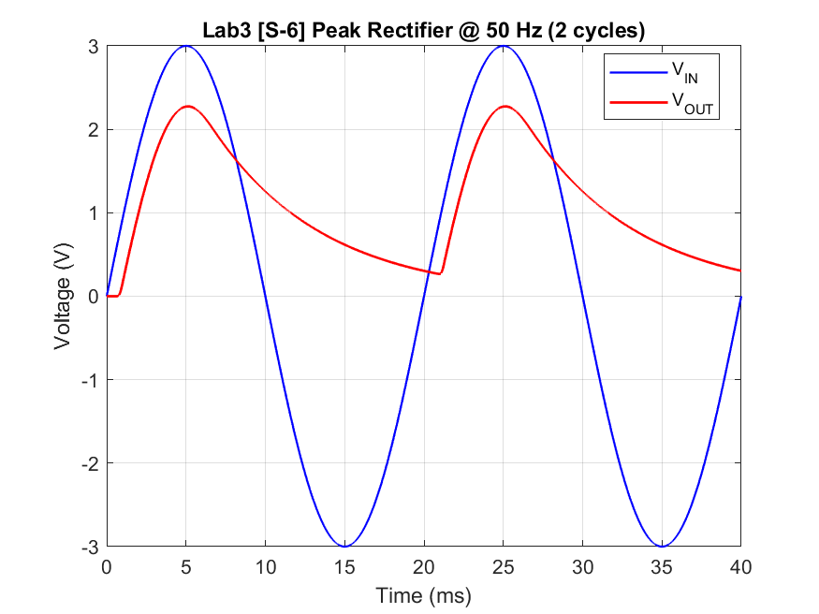
Figure D-50. [S-6] Peak rectifier @ 50 Hz — VIN (blue), VOUT (red).
VIN(peak) = 3.0 V, VO(peak) ≈ 2.274 V, VRipple(p-p) ≈ 2.007 V. Diode drop ≈ VIN(peak) − VO(peak) ≈ 0.73 V.

5.2 Frequency = 150 Hz
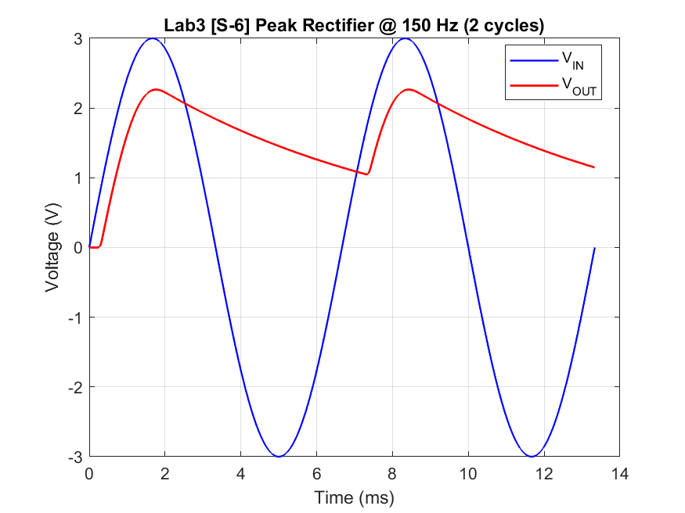
Figure D-150. [S-6] Peak rectifier @ 150 Hz — VIN (blue), VOUT (red).
VIN(peak) = 3.0 V, VO(peak) ≈ 2.265 V, VRipple(p-p) ≈ 1.216 V. Diode drop ≈ VIN(peak) − VO(peak) ≈ 0.73 V.

5.3 Frequency = 500 Hz
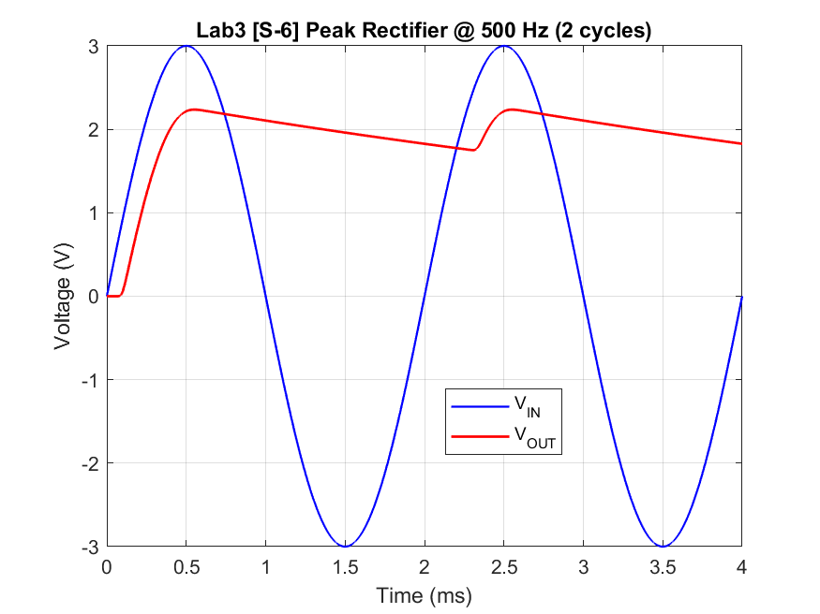
Figure D-500. [S-6] Peak rectifier @ 500 Hz — VIN (blue), VOUT (red).
VIN(peak) = 3.0 V, VO(peak) ≈ 2.236 V, VRipple(p-p) ≈ 0.485 V. Diode drop ≈ VIN(peak) − VO(peak) ≈ 0.76 V.
Trend: ripple decreases as frequency increases (less discharge time per cycle for fixed RC). Large ripple at 50 Hz is expected with R = 150 Ω and C = 47 µF (τ = RC ≈ 7 ms vs T = 20 ms).

6. [S-8] Full-Wave Bridge Rectifier (Fig 8)
Transient analysis, VSIN 3 V peak, 50 Hz, two cycles. Bridge of four 1N4007 diodes with RL = 10 kΩ. VOUT measured across the load (VA − VB).
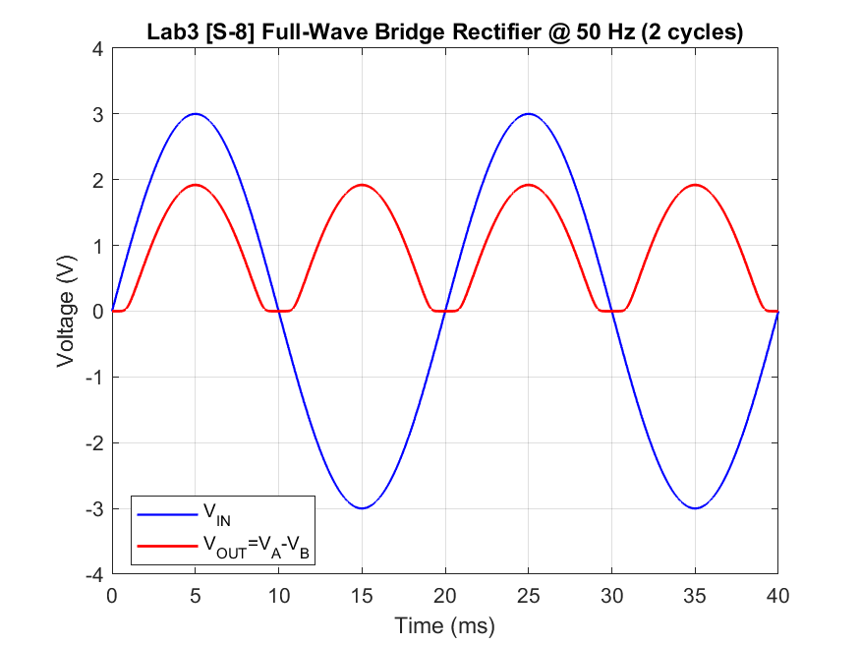
Figure E. [S-8] Full-wave bridge @ 50 Hz — VIN and rectified VOUT (MATLAB).
Observed: output is full-wave rectified with peak ≈ 1.9–2.0 V (≈ two diode forward drops below the 3 V input peak). Dead zones near zero-crossings where |VIN| is below 2×Von.

7. Simulation Setup Notes
• Diode models: labs/lab3_results/models (1N4148, 1N4007, D1N5231).
• Headless runs via psp_cmd.exe; .PRINT used V([node]) syntax.
• CSV data: labs/lab3_results/data/
• Waveform plots: MATLAB Engine MCP (R2024b).

8. File Index
Report root: labs/lab3_results/
figures/ — Capture overview + MATLAB plots
data/ — CSV traces
netlists/ — .cir used for psp_cmd
models/ — diode .lib files

