Domain Controller
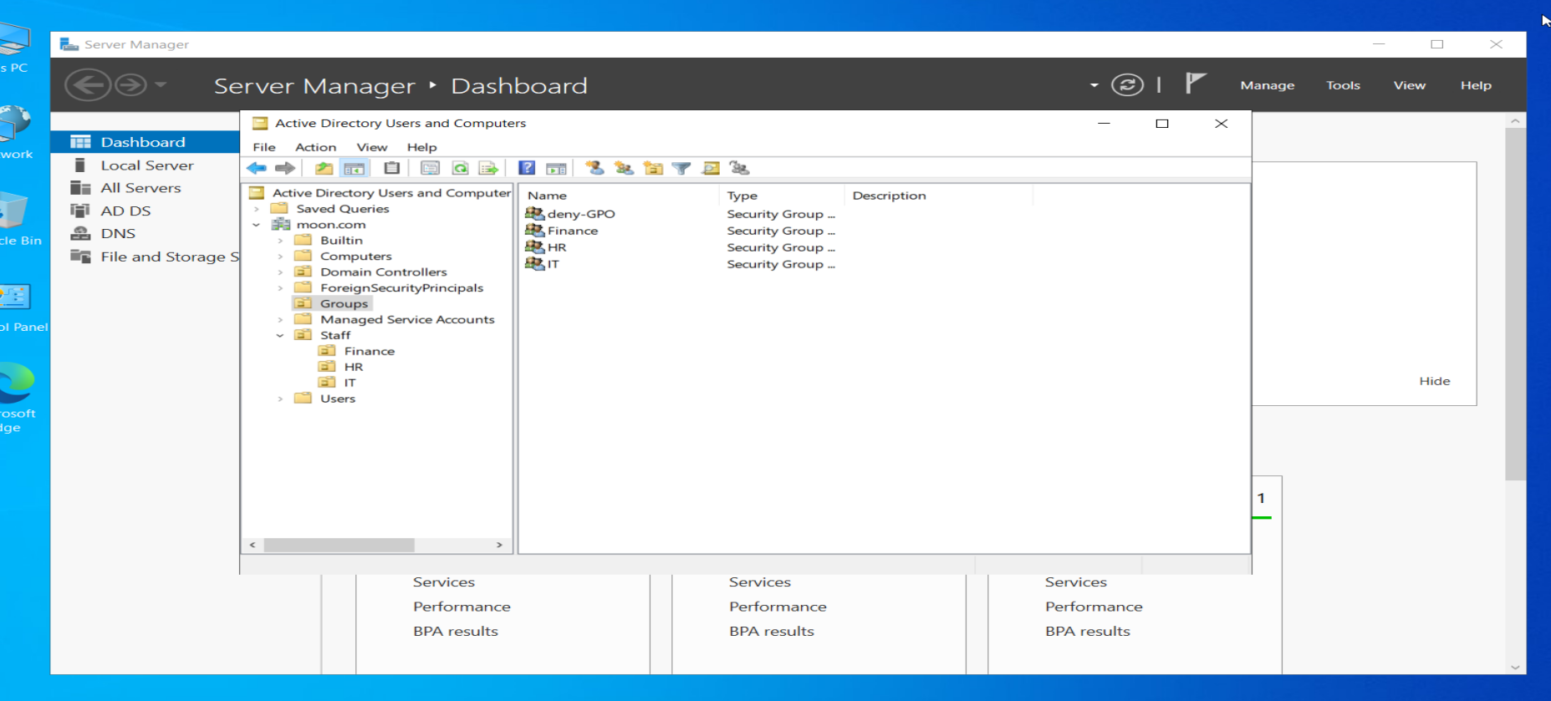
Domain Name: moon.com
Staff are divided as required:
HR – IT – Finance
HR member: Yazeed Ahmad
Finance member: Sara Ahmad
IT members: Mohammad Ahmad – Haya Ahmad – Yousef Ahmad

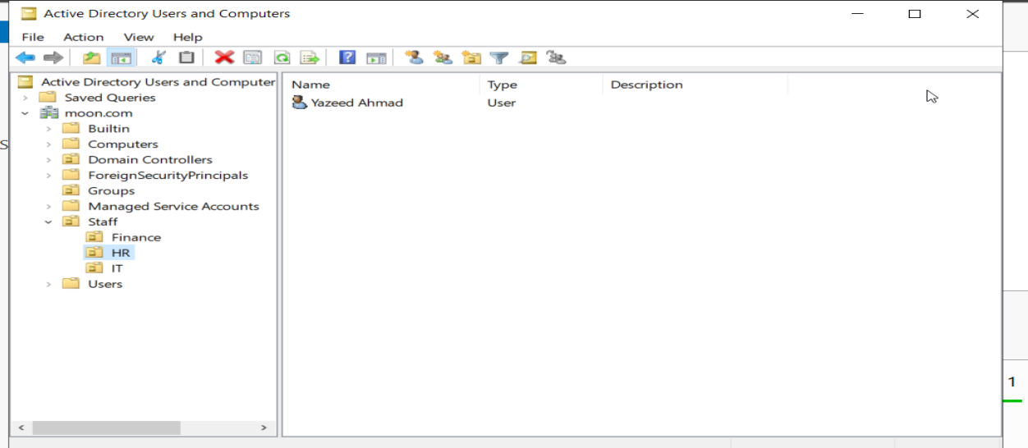

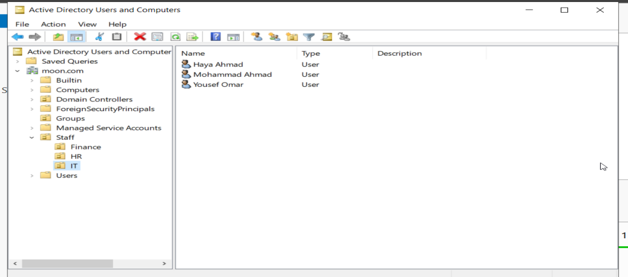
OU Name: Staff
Groups including all Staff members and a new group Called Deny GPO for denying IT members from GPOs effects
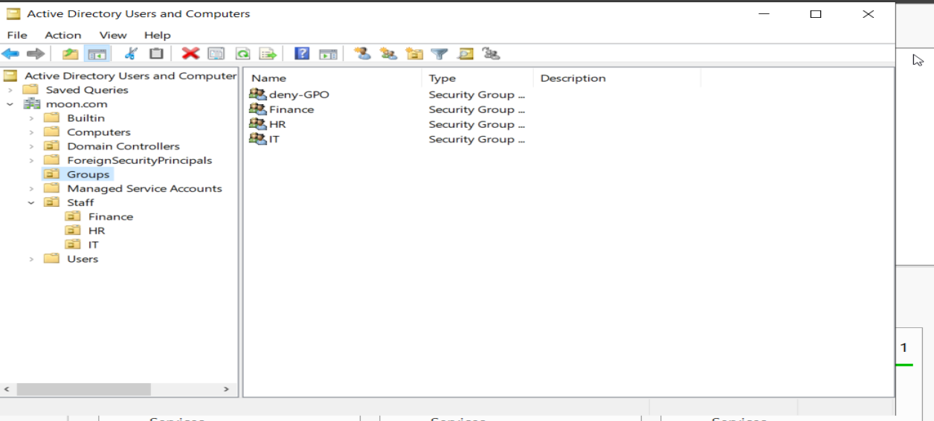
Client computer (Sara Ahmad from Finance team):
Domain status = Joined
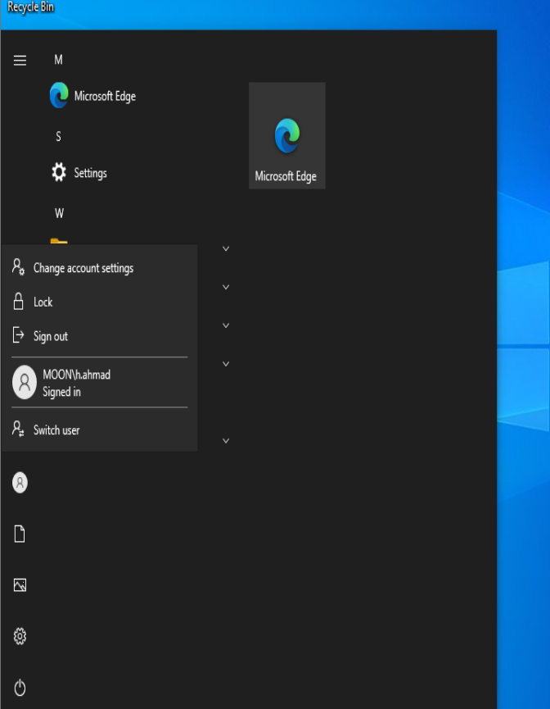

Policies are applied to prevent the user from accessing Task manager
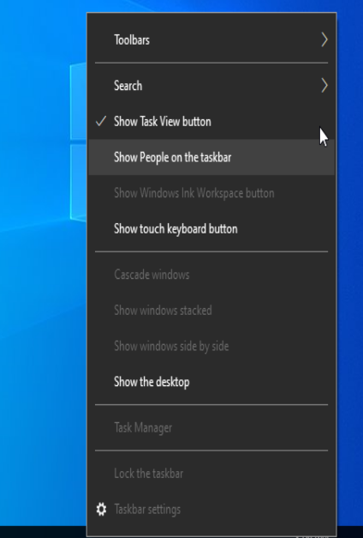
Shared folder:
Name: Calc
The folder containing a file that can open the calculator to all users, but can’t be edited, only IT members can.
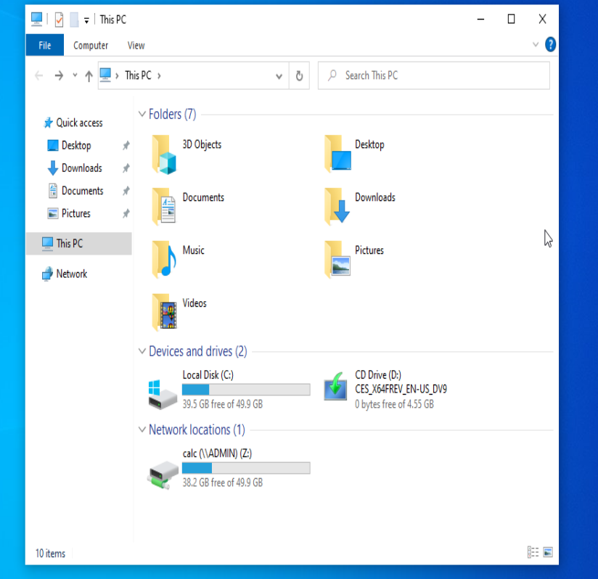

HR team can read and execute:
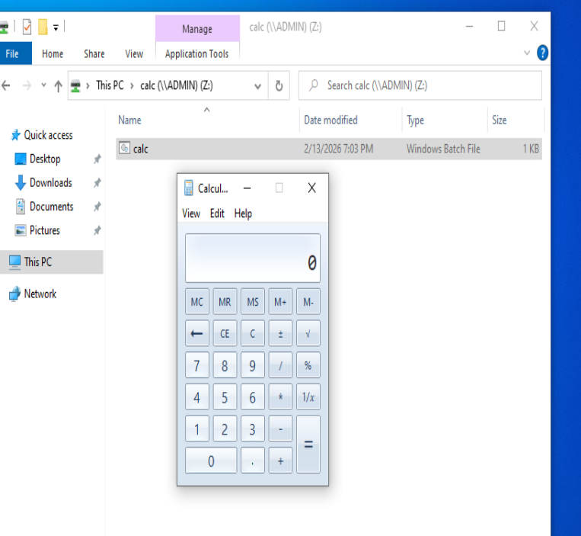
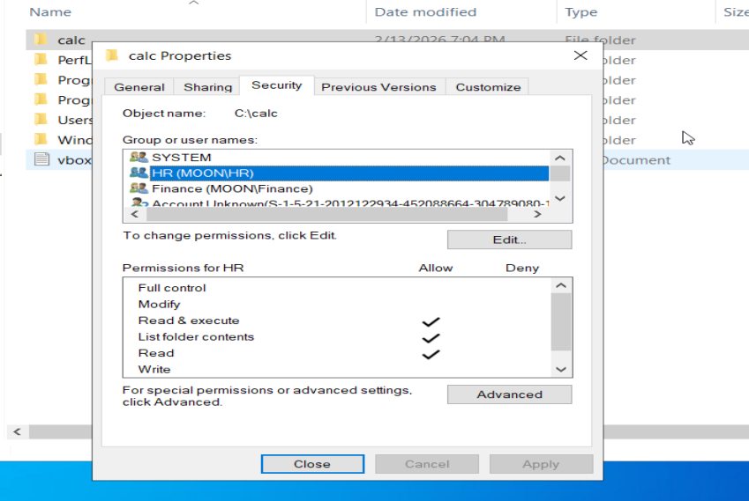
Finance team can only read
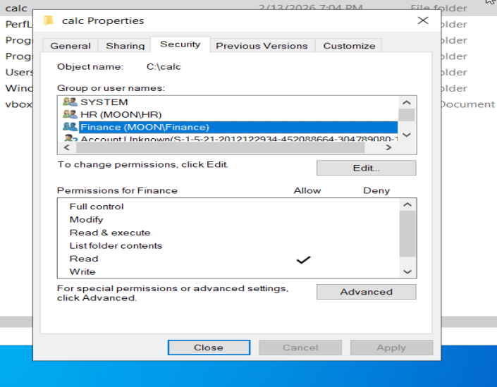
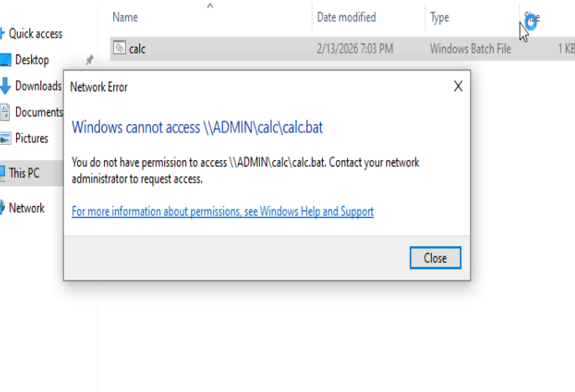

IT team full access
