Final Report: Appendix B.2.

NHL Goalies Exploratory Data Analysis
Lana Robison
2026-02-27

Research Question: How does NHL team defensive systems relate to goalie performance?
library(tidyverse)
library(janitor)
library(readr)
library(stringr)
library(ggplot2)
library(ggcorrplot)
master_clean <- read_csv("C:/Users/lanac/OneDrive - Baylor University/STA 43C8 Capstone/data_clean/master_goalie_dataset.csv")

Basic Structure of Dataset
dim(master_clean)
## [1] 1230 151
colnames(master_clean)
## [1] "player_id"
## [2] "season"
## [3] "team"
## [4] "gp_mp"
## [5] "icetime"
## [6] "x_goals"
## [7] "goals"
## [8] "unblocked_shot_attempts"
## [9] "x_rebounds"
## [10] "rebounds"
## [11] "x_freeze"
## [12] "freeze"
## [13] "x_on_goal"
## [14] "ongoal"
## [15] "x_play_stopped"
## [16] "play_stopped"
## [17] "x_play_continued_in_zone"
## [18] "play_continued_in_zone"
## [19] "x_play_continued_outside_zone"
## [20] "play_continued_outside_zone"
## [21] "flurry_adjustedx_goals"
## [22] "low_danger_shots"
## [23] "medium_danger_shots"
## [24] "high_danger_shots"
## [25] "low_dangerx_goals"
## [26] "medium_dangerx_goals"
## [27] "high_dangerx_goals"
## [28] "low_danger_goals"
## [29] "medium_danger_goals"
## [30] "high_danger_goals"
## [31] "blocked_shot_attempts"
## [32] "penality_minutes"
## [33] "penalties"
## [34] "player"
## [35] "team_games_played"
## [36] "team_x_goals_percentage"
## [37] "team_corsi_percentage"
## [38] "team_fenwick_percentage"
## [39] "team_ice_time"
## [40] "team_x_on_goal_for"
## [41] "team_x_goals_for"
## [42] "team_x_rebounds_for"
## [43] "team_x_freeze_for"
## [44] "team_x_play_stopped_for"
## [45] "team_x_play_continued_in_zone_for"
## [46] "team_x_play_continued_outside_zone_for"
## [47] "team_flurry_adjustedx_goals_for"
## [48] "team_score_venue_adjustedx_goals_for"
## [49] "team_flurry_score_venue_adjustedx_goals_for"
## [50] "team_shots_on_goal_for"
## [51] "team_missed_shots_for"
## [52] "team_blocked_shot_attempts_for"
## [53] "team_shot_attempts_for"
## [54] "team_goals_for"
## [55] "team_rebounds_for"
## [56] "team_rebound_goals_for"
## [57] "team_freeze_for"
## [58] "team_play_stopped_for"
## [59] "team_play_continued_in_zone_for"
## [60] "team_play_continued_outside_zone_for"
## [61] "team_saved_shots_on_goal_for"
## [62] "team_saved_unblocked_shot_attempts_for"
## [63] "team_penalties_for"
## [64] "team_penality_minutes_for"
## [65] "team_face_offs_won_for"
## [66] "team_hits_for"
## [67] "team_takeaways_for"
## [68] "team_giveaways_for"
## [69] "team_low_danger_shots_for"
## [70] "team_medium_danger_shots_for"
## [71] "team_high_danger_shots_for"
## [72] "team_low_dangerx_goals_for"
## [73] "team_medium_dangerx_goals_for"
## [74] "team_high_dangerx_goals_for"
## [75] "team_low_danger_goals_for"
## [76] "team_medium_danger_goals_for"
## [77] "team_high_danger_goals_for"
## [78] "team_score_adjusted_shots_attempts_for"
## [79] "team_unblocked_shot_attempts_for"
## [80] "team_score_adjusted_unblocked_shot_attempts_for"
## [81] "team_d_zone_giveaways_for"
## [82] "team_x_goals_fromx_rebounds_of_shots_for"
## [83] "team_x_goals_from_actual_rebounds_of_shots_for"
## [84] "team_reboundx_goals_for"
## [85] "team_total_shot_credit_for"
## [86] "team_score_adjusted_total_shot_credit_for"
## [87] "team_score_flurry_adjusted_total_shot_credit_for"
## [88] "team_x_on_goal_against"
## [89] "team_x_goals_against"
## [90] "team_x_rebounds_against"
## [91] "team_x_freeze_against"
## [92] "team_x_play_stopped_against"
## [93] "team_x_play_continued_in_zone_against"
## [94] "team_x_play_continued_outside_zone_against"
## [95] "team_flurry_adjustedx_goals_against"
## [96] "team_score_venue_adjustedx_goals_against"
## [97] "team_flurry_score_venue_adjustedx_goals_against"
## [98] "team_shots_on_goal_against"
## [99] "team_missed_shots_against"
## [100] "team_blocked_shot_attempts_against"
## [101] "team_shot_attempts_against"
## [102] "team_goals_against"
## [103] "team_rebounds_against"
## [104] "team_rebound_goals_against"
## [105] "team_freeze_against"
## [106] "team_play_stopped_against"
## [107] "team_play_continued_in_zone_against"
## [108] "team_play_continued_outside_zone_against"
## [109] "team_saved_shots_on_goal_against"
## [110] "team_saved_unblocked_shot_attempts_against"
## [111] "team_penalties_against"
## [112] "team_penality_minutes_against"
## [113] "team_face_offs_won_against"
## [114] "team_hits_against"
## [115] "team_takeaways_against"
## [116] "team_giveaways_against"
## [117] "team_low_danger_shots_against"
## [118] "team_medium_danger_shots_against"
## [119] "team_high_danger_shots_against"
## [120] "team_low_dangerx_goals_against"
## [121] "team_medium_dangerx_goals_against"
## [122] "team_high_dangerx_goals_against"
## [123] "team_low_danger_goals_against"
## [124] "team_medium_danger_goals_against"
## [125] "team_high_danger_goals_against"
## [126] "team_score_adjusted_shots_attempts_against"
## [127] "team_unblocked_shot_attempts_against"
## [128] "team_score_adjusted_unblocked_shot_attempts_against"
## [129] "team_d_zone_giveaways_against"
## [130] "team_x_goals_fromx_rebounds_of_shots_against"
## [131] "team_x_goals_from_actual_rebounds_of_shots_against"
## [132] "team_reboundx_goals_against"
## [133] "team_total_shot_credit_against"
## [134] "team_score_adjusted_total_shot_credit_against"
## [135] "team_score_flurry_adjusted_total_shot_credit_against"
## [136] "gp_nhl"
## [137] "gs"
## [138] "cg"
## [139] "ig"
## [140] "cg_percent"
## [141] "gs_900"
## [142] "gs_900_percent"
## [143] "gf"
## [144] "ga"
## [145] "gfa"
## [146] "gaa"
## [147] "row"
## [148] "rol"
## [149] "sa_60"
## [150] "sv_percent"
## [151] "toi_min"
summary(master_clean$sv_percent)
## Min. 1st Qu. Median Mean 3rd Qu. Max.
## 0.8360 0.8990 0.9090 0.9073 0.9170 0.9540
summary(master_clean$gaa)
## Min. 1st Qu. Median Mean 3rd Qu. Max.
## 1.220 2.450 2.730 2.787 3.070 4.710
- dataset contains 1,230 goalie-season observations and 151 variables

Distributions of Key Outcomes
ggplot(master_clean, aes(x = sv_percent)) +
geom_histogram(bins = 30) +
labs(title = "Distribution of Save Percentage (2008–2024)",
x = "Save Percentage",
y = "Count")
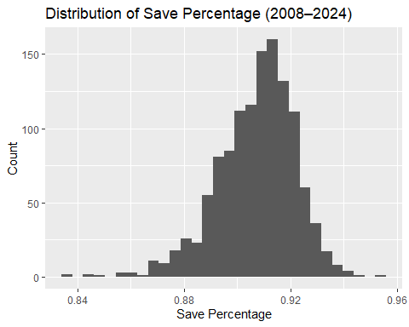
summary(master_clean$sv_percent)
## Min. 1st Qu. Median Mean 3rd Qu. Max.
## 0.8360 0.8990 0.9090 0.9073 0.9170 0.9540
- Save percentage is tightly clustered in this dataset, with a mean of 0.9073 and median of 0.9090
- suggests most NHL goalies perform within a narrow range, so even small differences may matter
ggplot(master_clean, aes(x = gaa)) +
geom_histogram(bins = 30) +
labs(title = "Distribution of Goals Against Average",
x = "GAA",
y = "Count")
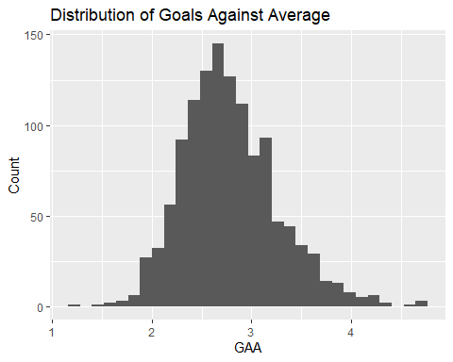
summary(master_clean$gaa)
## Min. 1st Qu. Median Mean 3rd Qu. Max.
## 1.220 2.450 2.730 2.787 3.070 4.710
- Goals against average is more spread out than save percentage

Era Trends
league_sv <- master_clean %>%
group_by(season) %>%
summarise(mean_sv = mean(sv_percent))
ggplot(league_sv, aes(x = season, y = mean_sv)) +
geom_line() +
geom_point() +
labs(title = "League Average Save Percentage by Season",
y = "Mean SV%",
x = "Season")
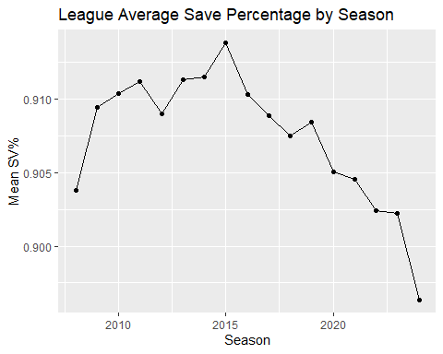
- League-average save percentage changes over time, so goalie results should be interpreted within the season they occurred
league_gaa <- master_clean %>%
group_by(season) %>%
summarise(mean_gaa = mean(gaa))
ggplot(league_gaa, aes(x = season, y = mean_gaa)) +
geom_line() +
geom_point() +
labs(title = "League Average GAA by Season",
y = "Mean GAA",
x = "Season")
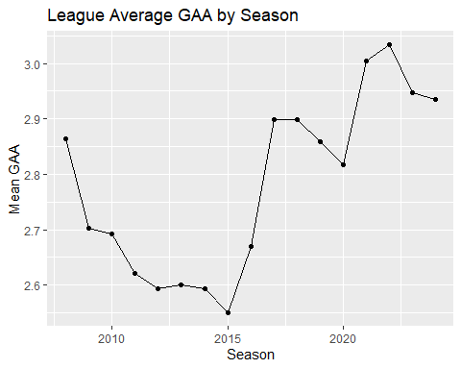
- League-average GAA also changes across seasons, which suggests league environment may affect traditional goalie stats

Team Defense Distributions
ggplot(master_clean, aes(x = team_x_goals_against)) +
geom_histogram(bins = 30) +
labs(title = "Distribution of Team Expected Goals Against")
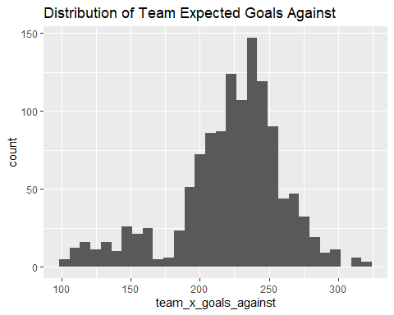
- Team expected goals against varies across observations, so goalies face different defensive environments
ggplot(master_clean, aes(x = team_high_danger_shots_against)) +
geom_histogram(bins = 30) +
labs(title = "Distribution of Team High Danger Shots Against")
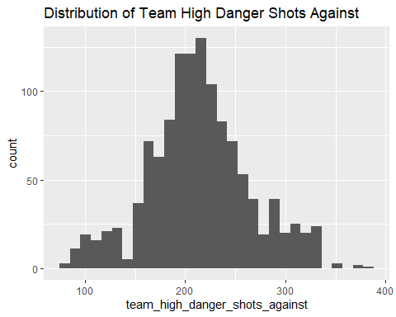
- High-danger shots against also varies across teams, suggesting some goalies face more dangerous chances than others
ggplot(master_clean, aes(x = team_corsi_percentage)) +
geom_histogram(bins = 30) +
labs(title = "Distribution of Team Corsi Percentage")
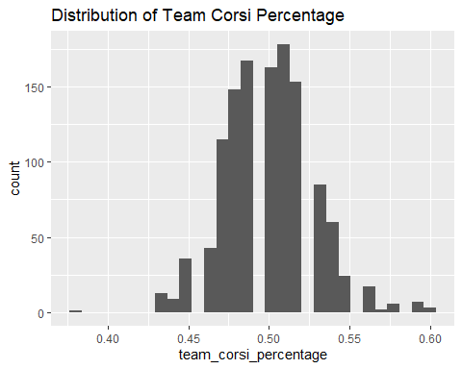
- team corsi %: measures a team’s share of total shot attempts while at even strength, it is meant to determine a teams puck possession as teams who control the puck tend to generate more shot attempts
- Team Corsi percentage varies across teams, which suggests teams differ in territorial control and puck possession

Goalie vs. Team Defense
ggplot(master_clean,
aes(x = team_x_goals_against, y = sv_percent)) +
geom_point(alpha = 0.4) +
geom_smooth(method = "lm") +
labs(title = "Save Percentage vs Team xGoals Against",
x = "Team xGA",
y = "SV%")
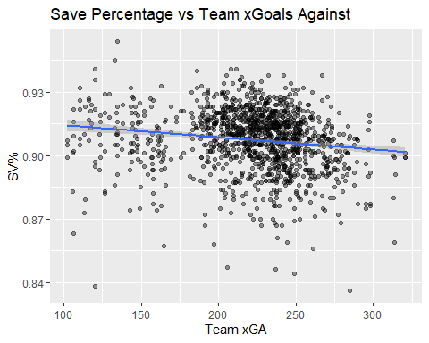
- plot suggests team defensive environment is related to goalie save percentage
- Goalies on teams allowing tougher defensive conditions may be more likely to post lower save percentages
ggplot(master_clean,
aes(x = team_high_danger_shots_against, y = sv_percent)) +
geom_point(alpha = 0.4) +
geom_smooth(method = "lm")
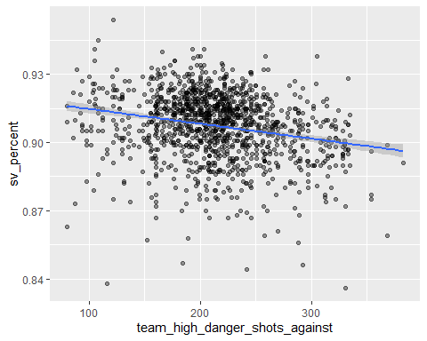
- This plot suggests that allowing more dangerous chances may be associated with worse goalie outcomes

Workload Effects
ggplot(master_clean,
aes(x = gp_nhl, y = sv_percent)) +
geom_point(alpha = 0.4) +
geom_smooth(method = "lm") +
labs(title = "Workload vs Save Percentage")
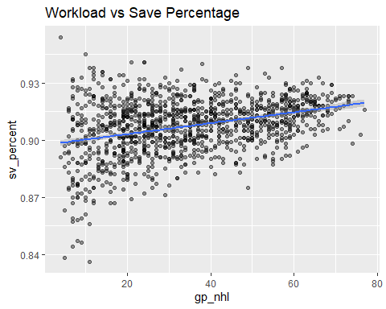
- Games played appears to have only a modest relationship with save percentage
- This suggests workload alone does not fully explain goalie performance

Correlation Matrix
numeric_vars <- master_clean %>%
select(
sv_percent,
gaa,
gp_nhl,
sa_60,
team_x_goals_against,
team_high_danger_shots_against,
team_corsi_percentage,
team_fenwick_percentage
)
corr_matrix <- cor(numeric_vars, use = "complete.obs")
ggcorrplot(
corr_matrix,
type = "lower",
lab = TRUE,
hc.order = TRUE,
title = "Correlation Matrix: Goalie Performance & Team Defense"
)
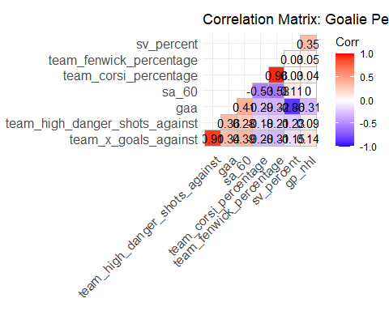
- Several team defensive variables appear to be related to one another
- This suggests multicollinearity may be an issue in later regression models

Fun Facts
best_season_sv <- master_clean %>%
filter(gp_nhl >= 50) %>%
arrange(desc(sv_percent)) %>%
select(player, season, team, sv_percent, gp_nhl) %>%
slice(1:20)
best_season_sv
## # A tibble: 20 × 5
## player season team sv_percent gp_nhl
## <chr> <dbl> <chr> <dbl> <dbl>
## 1 Tim Thomas 2010 BOS 0.938 57
## 2 Igor Shesterkin 2021 NYR 0.935 53
## 3 Tim Thomas 2008 BOS 0.933 54
## 4 Carey Price 2014 MTL 0.933 66
## 5 Sergei Bobrovsky 2016 CBJ 0.931 63
## 6 Pekka Rinne 2010 NSH 0.93 64
## 7 Henrik Lundqvist 2011 NYR 0.93 62
## 8 Mike Smith 2011 ARI 0.93 67
## 9 Tuukka Rask 2013 BOS 0.93 58
## 10 Ryan Miller 2009 BUF 0.929 69
## 11 Jonathan Quick 2011 LAK 0.929 69
## 12 Devan Dubnyk 2014 MIN 0.929 58
## 13 Roberto Luongo 2010 VAN 0.928 60
## 14 Steve Mason 2014 PHI 0.928 51
## 15 Semyon Varlamov 2013 COL 0.927 63
## 16 Carey Price 2013 MTL 0.927 59
## 17 Pekka Rinne 2017 NSH 0.927 59
## 18 Tomas Vokoun 2008 FLA 0.926 59
## 19 Ben Bishop 2015 TBL 0.926 61
## 20 John Gibson 2017 ANA 0.926 60
- Several elite goalie-seasons stand out in the sample, including Tim Thomas in 2010 and Igor Shesterkin in 2021

Goalie Instability: Count Unique Goalies per Team-Season
goalie_counts <- master_clean %>%
group_by(season, team) %>%
summarise(
n_goalies = n_distinct(player),
.groups = "drop"
) %>%
arrange(desc(n_goalies))
goalie_counts %>% slice(1:15)
## # A tibble: 15 × 3
## season team n_goalies
## <dbl> <chr> <int>
## 1 2018 PHI 5
## 2 2020 OTT 5
## 3 2021 NJD 5
## 4 2023 NJD 5
## 5 2008 TBL 4
## 6 2008 TOR 4
## 7 2008 VAN 4
## 8 2010 NYI 4
## 9 2010 OTT 4
## 10 2013 BUF 4
## 11 2013 MIN 4
## 12 2013 NSH 4
## 13 2017 CHI 4
## 14 2017 PHI 4
## 15 2018 ARI 4
- Some teams used many different goalies in a single season, suggesting instability in net

Goalie Instability: Teams with Most Goalie Turnover Overall (2008 - 2024)
team_turnover <- master_clean %>%
group_by(team) %>%
summarise(
total_goalies = n_distinct(player),
seasons = n_distinct(season),
avg_goalies_per_season = n() / seasons,
.groups = "drop"
) %>%
arrange(desc(avg_goalies_per_season))
team_turnover
## # A tibble: 34 × 4
## team total_goalies seasons avg_goalies_per_season
## <chr> <int> <int> <dbl>
## 1 BUF 21 17 2.71
## 2 PHI 22 17 2.71
## 3 NJD 20 17 2.65
## 4 TOR 22 17 2.65
## 5 CAR 17 17 2.59
## 6 OTT 19 17 2.59
## 7 DET 16 17 2.53
## 8 NYI 20 17 2.53
## 9 VGK 9 8 2.5
## 10 COL 22 17 2.47
## # ℹ 24 more rows

