Final Report: Appendix B.3.

Statistical Analysis Output
Lana Robison
2026-04-01

Research Question: How do NHL team defensive systems influence traditional goalie statistics?

Load Packages and Data
library(tidyverse)
library(tidymodels)
library(broom)
library(GGally)
library(car)
library(ggcorrplot)
nhl_dat <- read_csv("C:/Users/lanac/OneDrive - Baylor University/STA 43C8 Capstone/data_clean/master_goalie_dataset.csv")

Define Response Variable and Build Broad Predictor Variable Pool
- Save percentage was chosen as the response variable because it is a direct measure of goalie performance
- builds a broad predictor pool from dataset
- Team totals were converted to per-game rates to make defensive context more comparable across teams and seasons
- Variables closely tied to goals allowed or save outcomes were excluded to reduce leakage into the response
response_var = "sv_percent"
# Create rate-based defensive/context predictors
goalie_model_df = nhl_dat |>
mutate(
games_scale = if_else(team_games_played > 0, team_games_played, NA_real_),
# Team strength / territorial control
team_goals_for_pg = team_goals_for / games_scale,
# Defensive environment - volume / shot quality / play outcomes
team_x_goals_against_pg = team_x_goals_against / games_scale,
team_shots_on_goal_against_pg = team_shots_on_goal_against / games_scale,
team_shot_attempts_against_pg = team_shot_attempts_against / games_scale,
team_unblocked_shot_attempts_against_pg = team_unblocked_shot_attempts_against / games_scale,
team_blocked_shot_attempts_against_pg = team_blocked_shot_attempts_against / games_scale,
team_rebounds_against_pg = team_rebounds_against / games_scale,
team_freeze_against_pg = team_freeze_against / games_scale,
team_play_stopped_against_pg = team_play_stopped_against / games_scale,
team_play_continued_in_zone_against_pg = team_play_continued_in_zone_against / games_scale,
team_play_continued_outside_zone_against_pg = team_play_continued_outside_zone_against / games_scale,
# Turnover / discipline / support context
team_takeaways_against_pg = team_takeaways_against / games_scale,
team_giveaways_against_pg = team_giveaways_against / games_scale,
team_d_zone_giveaways_against_pg = team_d_zone_giveaways_against / games_scale,
team_penalties_against_pg = team_penalties_against / games_scale,
team_penality_minutes_against_pg = team_penality_minutes_against / games_scale,
# Danger-based team defense
team_low_danger_shots_against_pg = team_low_danger_shots_against / games_scale,
team_medium_danger_shots_against_pg = team_medium_danger_shots_against / games_scale,
team_high_danger_shots_against_pg = team_high_danger_shots_against / games_scale,
team_low_dangerx_goals_against_pg = team_low_dangerx_goals_against / games_scale,
team_medium_dangerx_goals_against_pg = team_medium_dangerx_goals_against / games_scale,
team_high_dangerx_goals_against_pg = team_high_dangerx_goals_against / games_scale,
# Shot credit / adjusted pressure
team_total_shot_credit_against_pg = team_total_shot_credit_against / games_scale,
team_score_adjusted_total_shot_credit_against_pg = team_score_adjusted_total_shot_credit_against / games_scale,
team_score_flurry_adjusted_total_shot_credit_against_pg = team_score_flurry_adjusted_total_shot_credit_against / games_scale
)
candidate_vars = c(
# team strength / support
"team_x_goals_percentage",
"team_corsi_percentage",
"team_fenwick_percentage",
"team_goals_for_pg",
# defensive environment
"team_x_goals_against_pg",
"team_shots_on_goal_against_pg",
"team_shot_attempts_against_pg",
"team_unblocked_shot_attempts_against_pg",
"team_blocked_shot_attempts_against_pg",
"team_rebounds_against_pg",
"team_freeze_against_pg",
"team_play_stopped_against_pg",
"team_play_continued_in_zone_against_pg",
"team_play_continued_outside_zone_against_pg",
# turnover / discipline
"team_takeaways_against_pg",
"team_giveaways_against_pg",
"team_d_zone_giveaways_against_pg",
"team_penalties_against_pg",
"team_penality_minutes_against_pg",
# danger profile
"team_low_danger_shots_against_pg",
"team_medium_danger_shots_against_pg",
"team_high_danger_shots_against_pg",
"team_low_dangerx_goals_against_pg",
"team_medium_dangerx_goals_against_pg",
"team_high_dangerx_goals_against_pg",
# adjusted pressure metrics
"team_total_shot_credit_against_pg",
"team_score_adjusted_total_shot_credit_against_pg",
"team_score_flurry_adjusted_total_shot_credit_against_pg",
# goalie context
"gp_nhl",
"gs",
"toi_min"
)
model_data = goalie_model_df |>
select(player, season, team, all_of(response_var), all_of(candidate_vars)) |>
drop_na()

Create train/ test split
set.seed(123)
data_split = initial_split(model_data, prop = 0.8)
train_data = training(data_split)
test_data = testing(data_split)

Create Cross-Validation Folds
cv_folds = vfold_cv(train_data, v = 5)

Create Common Preprocessing recipe
- standardizes predictors and marks player, season, and team as IDS, not predictors
base_recipe = recipe(
as.formula(paste(response_var, "~ .")),
data = train_data
) |>
update_role(player, season, team, new_role = "id variable") |>
step_zv(all_predictors()) |>
step_normalize(all_numeric_predictors())

Run Lasso for Variable Selection
- Lasso was used to reduce the broad predictor pool in a data-driven way
- The lasso model selected a penalty of 0.0000187
- Lasso retained 21 predictors, suggesting goalie save percentage may be associated with several aspects of team defensive environment.
lasso_model = linear_reg(mixture = 1, penalty = tune()) |>
set_engine("glmnet")
lasso_wf = workflow() |>
add_recipe(base_recipe) |>
add_model(lasso_model)
penalty_grid = grid_regular(
penalty(range = c(-6, 1)),
levels = 100
)
lasso_tune = tune_grid(
lasso_wf,
resamples = cv_folds,
grid = penalty_grid,
metrics = metric_set(rmse, rsq, mae)
)
collect_metrics(lasso_tune)
## # A tibble: 300 × 7
## penalty .metric .estimator mean n std_err .config
## <dbl> <chr> <chr> <dbl> <int> <dbl> <chr>
## 1 0.000001 mae standard 0.00804 5 0.000162 pre0_mod001_post0
## 2 0.000001 rmse standard 0.0110 5 0.000186 pre0_mod001_post0
## 3 0.000001 rsq standard 0.439 5 0.0241 pre0_mod001_post0
## 4 0.00000118 mae standard 0.00803 5 0.000163 pre0_mod002_post0
## 5 0.00000118 rmse standard 0.0110 5 0.000187 pre0_mod002_post0
## 6 0.00000118 rsq standard 0.439 5 0.0241 pre0_mod002_post0
## 7 0.00000138 mae standard 0.00803 5 0.000163 pre0_mod003_post0
## 8 0.00000138 rmse standard 0.0110 5 0.000187 pre0_mod003_post0
## 9 0.00000138 rsq standard 0.439 5 0.0241 pre0_mod003_post0
## 10 0.00000163 mae standard 0.00803 5 0.000164 pre0_mod004_post0
## # ℹ 290 more rows
autoplot(lasso_tune)
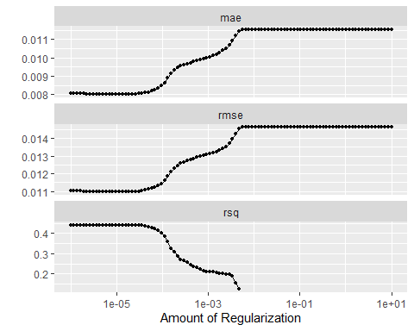
best_lasso = lasso_tune |>
select_best(metric = "rmse")
best_lasso
## # A tibble: 1 × 2
## penalty .config
## <dbl> <chr>
## 1 0.0000187 pre0_mod019_post0
final_lasso_wf = finalize_workflow(lasso_wf, best_lasso)
final_lasso_fit = final_lasso_wf |>
fit(data = train_data)
lasso_coefs = final_lasso_fit |>
extract_fit_parsnip() |>
tidy()
lasso_coefs
## # A tibble: 32 × 3
## term estimate penalty
## <chr> <dbl> <dbl>
## 1 (Intercept) 0.907 0.0000187
## 2 team_x_goals_percentage 0 0.0000187
## 3 team_corsi_percentage -0.000460 0.0000187
## 4 team_fenwick_percentage 0 0.0000187
## 5 team_goals_for_pg -0.0000917 0.0000187
## 6 team_x_goals_against_pg 0 0.0000187
## 7 team_shots_on_goal_against_pg 0.00610 0.0000187
## 8 team_shot_attempts_against_pg 0 0.0000187
## 9 team_unblocked_shot_attempts_against_pg -0.0711 0.0000187
## 10 team_blocked_shot_attempts_against_pg 0.0000561 0.0000187
## # ℹ 22 more rows
selected_vars = lasso_coefs |>
filter(term != "(Intercept)", estimate != 0) |>
pull(term)
selected_vars
## [1] "team_corsi_percentage"
## [2] "team_goals_for_pg"
## [3] "team_shots_on_goal_against_pg"
## [4] "team_unblocked_shot_attempts_against_pg"
## [5] "team_blocked_shot_attempts_against_pg"
## [6] "team_rebounds_against_pg"
## [7] "team_freeze_against_pg"
## [8] "team_play_stopped_against_pg"
## [9] "team_play_continued_in_zone_against_pg"
## [10] "team_play_continued_outside_zone_against_pg"
## [11] "team_takeaways_against_pg"
## [12] "team_giveaways_against_pg"
## [13] "team_d_zone_giveaways_against_pg"
## [14] "team_penality_minutes_against_pg"
## [15] "team_low_danger_shots_against_pg"
## [16] "team_high_danger_shots_against_pg"
## [17] "team_low_dangerx_goals_against_pg"
## [18] "team_high_dangerx_goals_against_pg"
## [19] "gp_nhl"
## [20] "gs"
## [21] "toi_min"
- retained variables were treated as the strongest candidates for the regression model in the original variable space

Run PCA for multicollinearity
- uses PCA to study the correlation structure and prepare for PCR
- helps determine whether multicollinearity is severe enough to justify a component-based model
- PCA suggests that many defensive variables measure overlapping parts of team environment
- This supports using a component-based model to address multicollinearity
# Correlation matrix first
train_predictors_only = train_data |>
select(all_of(candidate_vars))
cor_mat = cor(train_predictors_only, use = "pairwise.complete.obs")
ggcorrplot(
cor_mat,
hc.order = TRUE,
type = "lower",
lab = FALSE
)
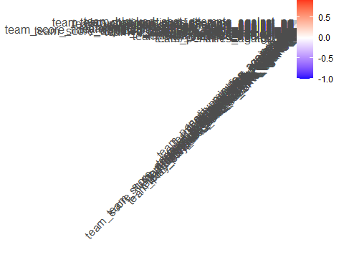
# PCA recipe for exploratory variance summary
pca_recipe = recipe(
as.formula(paste(response_var, "~ .")),
data = train_data
) |>
update_role(player, season, team, new_role = "id variable") |>
step_zv(all_predictors()) |>
step_normalize(all_numeric_predictors()) |>
step_pca(all_predictors(), threshold = 0.95)
pca_prep = pca_recipe |>
prep()
pca_variance = tidy(pca_prep, number = 3, type = "variance")
pca_loadings = tidy(pca_prep, number = 3)
pca_variance
## # A tibble: 124 × 4
## terms value component id
## <chr> <dbl> <int> <chr>
## 1 variance 13.0 1 pca_lfIon
## 2 variance 4.27 2 pca_lfIon
## 3 variance 3.06 3 pca_lfIon
## 4 variance 2.33 4 pca_lfIon
## 5 variance 1.77 5 pca_lfIon
## 6 variance 1.52 6 pca_lfIon
## 7 variance 1.14 7 pca_lfIon
## 8 variance 0.797 8 pca_lfIon
## 9 variance 0.652 9 pca_lfIon
## 10 variance 0.564 10 pca_lfIon
## # ℹ 114 more rows
pca_loadings
## # A tibble: 961 × 4
## terms value component id
## <chr> <dbl> <chr> <chr>
## 1 team_x_goals_percentage -0.210 PC1 pca_lfIon
## 2 team_corsi_percentage -0.197 PC1 pca_lfIon
## 3 team_fenwick_percentage -0.211 PC1 pca_lfIon
## 4 team_goals_for_pg -0.0210 PC1 pca_lfIon
## 5 team_x_goals_against_pg 0.253 PC1 pca_lfIon
## 6 team_shots_on_goal_against_pg 0.229 PC1 pca_lfIon
## 7 team_shot_attempts_against_pg 0.250 PC1 pca_lfIon
## 8 team_unblocked_shot_attempts_against_pg 0.264 PC1 pca_lfIon
## 9 team_blocked_shot_attempts_against_pg 0.137 PC1 pca_lfIon
## 10 team_rebounds_against_pg 0.173 PC1 pca_lfIon
## # ℹ 951 more rows
pca_scores = bake(pca_prep, new_data = NULL)
pc_names = names(pca_scores) |>
keep(~ str_detect(.x, "^PC")) |>
head(4)
ggpairs(
pca_scores |>
select(all_of(pc_names))
)
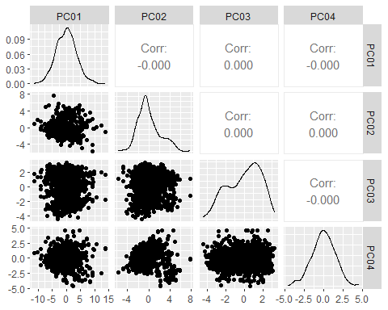

Fit lasso model
- fits an interpretable regression model using the lasso-selected variables
lasso_formula = as.formula(
paste(response_var, "~", paste(selected_vars, collapse = " + "))
)
lasso_recipe = recipe(lasso_formula, data = train_data)
model = linear_reg() |>
set_engine("lm")
lasso_wf = workflow() |>
add_recipe(lasso_recipe) |>
add_model(model)
lasso_fit = lasso_wf |>
fit(data = train_data)
lasso_fit |>
extract_fit_engine() |>
tidy(conf.int = TRUE)
## # A tibble: 22 × 7
## term estimate std.error statistic p.value conf.low conf.high
## <chr> <dbl> <dbl> <dbl> <dbl> <dbl> <dbl>
## 1 (Intercept) 9.16e-1 0.0198 46.3 1.85e-240 8.78e-1 0.955
## 2 team_corsi_percent… -2.42e-2 0.0247 -0.981 3.27e- 1 -7.26e-2 0.0242
## 3 team_goals_for_pg -6.34e-4 0.00120 -0.528 5.98e- 1 -2.99e-3 0.00172
## 4 team_shots_on_goal… 3.08e-3 0.000576 5.35 1.14e- 7 1.95e-3 0.00421
## 5 team_unblocked_sho… -2.69e-2 0.00180 -15.0 1.74e- 45 -3.04e-2 -0.0234
## 6 team_blocked_shot_… 3.30e-5 0.000295 0.112 9.11e- 1 -5.45e-4 0.000611
## 7 team_rebounds_agai… 2.98e-2 0.00219 13.6 2.21e- 38 2.55e-2 0.0341
## 8 team_freeze_agains… 2.81e-2 0.00165 17.0 2.19e- 56 2.48e-2 0.0313
## 9 team_play_stopped_… 2.60e-2 0.00213 12.2 9.12e- 32 2.18e-2 0.0302
## 10 team_play_continue… 2.73e-2 0.00171 16.0 7.08e- 51 2.39e-2 0.0306
## # ℹ 12 more rows
lasso_fit |>
extract_fit_engine() |>
glance()
## # A tibble: 1 × 12
## r.squared adj.r.squared sigma statistic p.value df logLik AIC BIC
## <dbl> <dbl> <dbl> <dbl> <dbl> <dbl> <dbl> <dbl> <dbl>
## 1 0.472 0.460 0.0107 38.4 8.99e-110 21 2893. -5740. -5628.
## # ℹ 3 more variables: deviance <dbl>, df.residual <int>, nobs <int>
lasso_fit |>
extract_fit_engine() |>
vif()
## team_corsi_percentage
## 3.693081
## team_goals_for_pg
## 1.516391
## team_shots_on_goal_against_pg
## 12.418021
## team_unblocked_shot_attempts_against_pg
## 211.842697
## team_blocked_shot_attempts_against_pg
## 2.431964
## team_rebounds_against_pg
## 11.749329
## team_freeze_against_pg
## 15.693319
## team_play_stopped_against_pg
## 5.247948
## team_play_continued_in_zone_against_pg
## 43.029316
## team_play_continued_outside_zone_against_pg
## 24.039778
## team_takeaways_against_pg
## 1.353797
## team_giveaways_against_pg
## 6.293690
## team_d_zone_giveaways_against_pg
## 4.867638
## team_penality_minutes_against_pg
## 1.459910
## team_low_danger_shots_against_pg
## 16.234586
## team_high_danger_shots_against_pg
## 45.832241
## team_low_dangerx_goals_against_pg
## 8.192503
## team_high_dangerx_goals_against_pg
## 32.402546
## gp_nhl
## 199.680307
## gs
## 208.577514
## toi_min
## 410.475751
- Several team defensive variables are statistically associated with save percentage in this model
- The lasso-selected regression has $R^{2}=0.472$ and adjusted $R^{2}=0.460$, so it explains a moderate amount of variation in save percentage
- VIF values are very large for several predictors, indicating substantial multicollinearity, because of this, coefficient-level interpretation should be made cautiously

Fit principal component regression model
- fits PCR as the multicollinearity-focused alternative
# Tune the number of PCs
pcr_recipe = recipe(
as.formula(paste(response_var, "~ .")),
data = train_data
) |>
update_role(player, season, team, new_role = "id variable") |>
step_zv(all_predictors()) |>
step_normalize(all_numeric_predictors()) |>
step_pca(all_predictors(), num_comp = tune())
pcr_wf = workflow() |>
add_recipe(pcr_recipe) |>
add_model(model)
pcr_grid = tibble(num_comp = 1:length(candidate_vars))
set.seed(123)
pcr_tune = tune_grid(
pcr_wf,
resamples = cv_folds,
grid = pcr_grid,
metrics = metric_set(rmse, rsq, mae)
)
collect_metrics(pcr_tune)
## # A tibble: 93 × 7
## num_comp .metric .estimator mean n std_err .config
## <int> <chr> <chr> <dbl> <int> <dbl> <chr>
## 1 1 mae standard 0.0114 5 0.000125 pre01_mod0_post0
## 2 1 rmse standard 0.0144 5 0.000225 pre01_mod0_post0
## 3 1 rsq standard 0.0283 5 0.00859 pre01_mod0_post0
## 4 2 mae standard 0.0110 5 0.000174 pre02_mod0_post0
## 5 2 rmse standard 0.0142 5 0.000188 pre02_mod0_post0
## 6 2 rsq standard 0.0644 5 0.0131 pre02_mod0_post0
## 7 3 mae standard 0.0102 5 0.000130 pre03_mod0_post0
## 8 3 rmse standard 0.0134 5 0.000177 pre03_mod0_post0
## 9 3 rsq standard 0.172 5 0.0260 pre03_mod0_post0
## 10 4 mae standard 0.0102 5 0.000135 pre04_mod0_post0
## # ℹ 83 more rows
autoplot(pcr_tune)
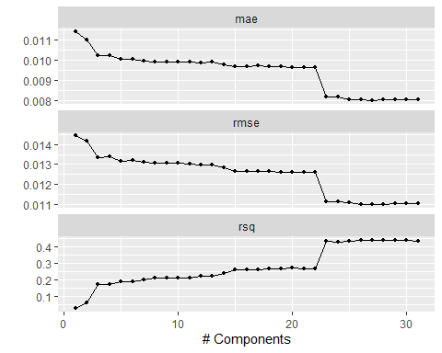
best_pcr = pcr_tune |>
select_best(metric = "rmse")
best_pcr
## # A tibble: 1 × 2
## num_comp .config
## <int> <chr>
## 1 27 pre27_mod0_post0
final_pcr_wf = finalize_workflow(pcr_wf, best_pcr)
pcr_fit = final_pcr_wf |>
fit(data = train_data)
pcr_fit |>
extract_fit_engine() |>
tidy(conf.int = TRUE)
## # A tibble: 28 × 7
## term estimate std.error statistic p.value conf.low conf.high
## <chr> <dbl> <dbl> <dbl> <dbl> <dbl> <dbl>
## 1 (Intercept) 0.907 0.000354 2566. 0 0.907 0.908
## 2 PC01 -0.000664 0.0000980 -6.77 2.26e-11 -0.000857 -0.000472
## 3 PC02 -0.00136 0.000171 -7.94 6.03e-15 -0.00170 -0.00102
## 4 PC03 -0.00272 0.000202 -13.4 1.27e-37 -0.00311 -0.00232
## 5 PC04 -0.0000138 0.000232 -0.0593 9.53e- 1 -0.000469 0.000441
## 6 PC05 -0.00171 0.000266 -6.41 2.28e-10 -0.00223 -0.00118
## 7 PC06 -0.000193 0.000287 -0.674 5.00e- 1 -0.000756 0.000370
## 8 PC07 -0.00161 0.000331 -4.85 1.47e- 6 -0.00226 -0.000956
## 9 PC08 0.00165 0.000397 4.16 3.54e- 5 0.000870 0.00243
## 10 PC09 -0.000594 0.000438 -1.35 1.76e- 1 -0.00145 0.000266
## # ℹ 18 more rows
pcr_fit |>
extract_fit_engine() |>
glance()
## # A tibble: 1 × 12
## r.squared adj.r.squared sigma statistic p.value df logLik AIC BIC
## <dbl> <dbl> <dbl> <dbl> <dbl> <dbl> <dbl> <dbl> <dbl>
## 1 0.473 0.457 0.0108 29.8 1.22e-105 27 2894. -5730. -5590.
## # ℹ 3 more variables: deviance <dbl>, df.residual <int>, nobs <int>
pcr_fit |>
extract_fit_engine() |>
vif()
## PC01 PC02 PC03 PC04 PC05 PC06 PC07 PC08 PC09 PC10 PC11 PC12 PC13 PC14 PC15 PC16
## 1 1 1 1 1 1 1 1 1 1 1 1 1 1 1 1
## PC17 PC18 PC19 PC20 PC21 PC22 PC23 PC24 PC25 PC26 PC27
## 1 1 1 1 1 1 1 1 1 1 1
- PCR selected 27 principal components
- The PCR model has $R^{2}=0.473$ and adjusted $R^{2}=0.457$, which is very similar to the lasso-selected regression
- All PCR VIF values equal 1, so multicollinearity was removed in this specification
- PCR is more stable statistically, but less directly interpretable in hockey terms

Diagnostics for lasso-informed regression model
- check regression assumptions
- plots were used to check linearity, constant variance, normality, and potential influence issues
- helps determine whether the regression results are appropriate for interpretation
lasso_diag = lasso_fit |>
extract_fit_engine() |>
augment()
ggplot(lasso_diag, aes(x = .fitted, y = .resid)) +
geom_point() +
geom_hline(yintercept = 0, linetype = "dashed", color = "red") +
labs(
title = "Lasso: Residuals vs Fitted",
x = "Fitted values",
y = "Residuals"
)
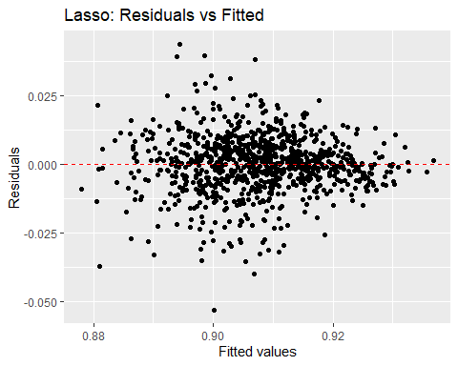
ggplot(lasso_diag, aes(sample = .std.resid)) +
stat_qq() +
stat_qq_line(color = "red") +
labs(title = "Lasso: Normal Q-Q Plot")
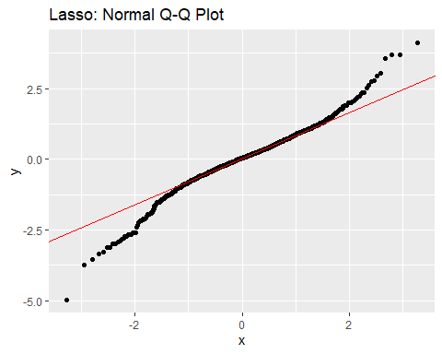
ggplot(lasso_diag, aes(x = .fitted, y = sqrt(abs(.std.resid)))) +
geom_point() +
geom_smooth(se = FALSE, method = "loess", color = "blue") +
labs(
title = "Lasso: Scale-Location Plot",
x = "Fitted values",
y = "Sqrt(|Standardized Residuals|)"
)
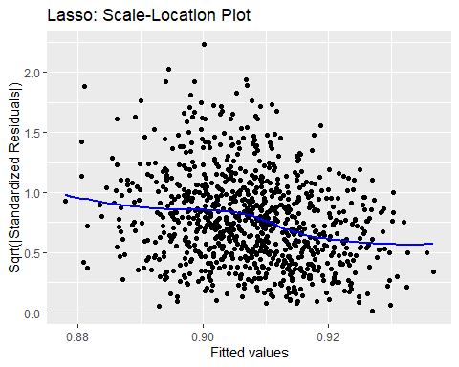
ggplot(lasso_diag, aes(x = .hat, y = .std.resid)) +
geom_point() +
labs(
title = "Lasso: Leverage vs Standardized Residuals",
x = "Leverage",
y = "Standardized residuals"
)
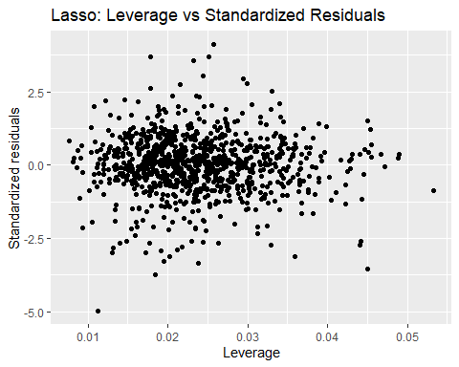
- checks were included so model quality could be assessed beyond predictive performance alone

Diagnostics for PCR and fit ridge
- PCR diagnostics were also reviewed to assess whether the model fit was reasonable
- Ridge regression was included as an additional benchmark model
pcr_diag = pcr_fit |>
extract_fit_engine() |>
augment()
ggplot(pcr_diag, aes(x = .fitted, y = .resid)) +
geom_point() +
geom_hline(yintercept = 0, linetype = "dashed", color = "red") +
labs(
title = "PCR: Residuals vs Fitted",
x = "Fitted values",
y = "Residuals"
)
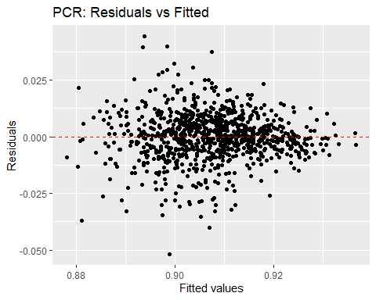
ggplot(pcr_diag, aes(sample = .std.resid)) +
stat_qq() +
stat_qq_line(color = "red") +
labs(title = "PCR: Normal Q-Q Plot")
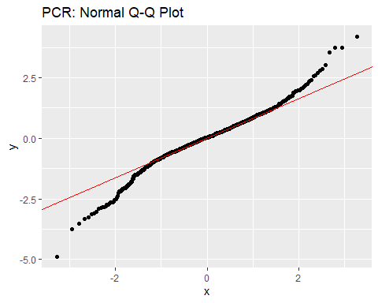
ridge_model = linear_reg(mixture = 0, penalty = tune()) |>
set_engine("glmnet")
ridge_wf = workflow() |>
add_recipe(base_recipe) |>
add_model(ridge_model)
set.seed(123)
ridge_tune = tune_grid(
ridge_wf,
resamples = cv_folds,
grid = penalty_grid,
metrics = metric_set(rmse, rsq, mae)
)
collect_metrics(ridge_tune)
## # A tibble: 300 × 7
## penalty .metric .estimator mean n std_err .config
## <dbl> <chr> <chr> <dbl> <int> <dbl> <chr>
## 1 0.000001 mae standard 0.00920 5 0.000186 pre0_mod001_post0
## 2 0.000001 rmse standard 0.0122 5 0.000242 pre0_mod001_post0
## 3 0.000001 rsq standard 0.320 5 0.0365 pre0_mod001_post0
## 4 0.00000118 mae standard 0.00920 5 0.000186 pre0_mod002_post0
## 5 0.00000118 rmse standard 0.0122 5 0.000242 pre0_mod002_post0
## 6 0.00000118 rsq standard 0.320 5 0.0365 pre0_mod002_post0
## 7 0.00000138 mae standard 0.00920 5 0.000186 pre0_mod003_post0
## 8 0.00000138 rmse standard 0.0122 5 0.000242 pre0_mod003_post0
## 9 0.00000138 rsq standard 0.320 5 0.0365 pre0_mod003_post0
## 10 0.00000163 mae standard 0.00920 5 0.000186 pre0_mod004_post0
## # ℹ 290 more rows
autoplot(ridge_tune)
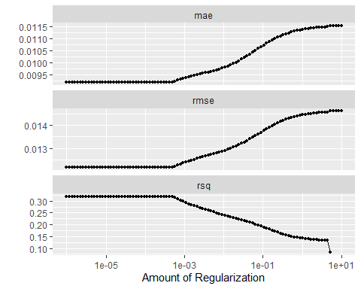
best_ridge = ridge_tune |>
select_best(metric = "rmse")
best_ridge
## # A tibble: 1 × 2
## penalty .config
## <dbl> <chr>
## 1 0.000001 pre0_mod001_post0
final_ridge_wf = finalize_workflow(ridge_wf, best_ridge)
final_ridge_fit = final_ridge_wf |>
fit(data = train_data)
final_ridge_fit |>
extract_fit_parsnip() |>
tidy()
## # A tibble: 32 × 3
## term estimate penalty
## <chr> <dbl> <dbl>
## 1 (Intercept) 0.907 0.000001
## 2 team_x_goals_percentage 0.00178 0.000001
## 3 team_corsi_percentage -0.000579 0.000001
## 4 team_fenwick_percentage 0.000271 0.000001
## 5 team_goals_for_pg 0.0000166 0.000001
## 6 team_x_goals_against_pg -0.00146 0.000001
## 7 team_shots_on_goal_against_pg 0.00235 0.000001
## 8 team_shot_attempts_against_pg -0.00190 0.000001
## 9 team_unblocked_shot_attempts_against_pg -0.00301 0.000001
## 10 team_blocked_shot_attempts_against_pg 0.000718 0.000001
## # ℹ 22 more rows

Compare models on the test set
- compares everything on the same test set
lasso_penalized_pred = predict(final_lasso_fit, new_data = test_data) |>
bind_cols(test_data |>
select(player, season, team, all_of(response_var))) |>
rename(actual = all_of(response_var), predicted = .pred) |>
mutate(model = "lasso_penalized")
lasso_regression_pred = predict(lasso_fit, new_data = test_data) |>
bind_cols(test_data |>
select(player, season, team, all_of(response_var))) |>
rename(actual = all_of(response_var), predicted = .pred) |>
mutate(model = "lasso_selected_regression")
pcr_pred = predict(pcr_fit, new_data = test_data) |>
bind_cols(test_data |>
select(player, season, team, all_of(response_var))) |>
rename(actual = all_of(response_var), predicted = .pred) |>
mutate(model = "pcr")
ridge_pred = predict(final_ridge_fit, new_data = test_data) |>
bind_cols(test_data |>
select(player, season, team, all_of(response_var))) |>
rename(actual = all_of(response_var), predicted = .pred) |>
mutate(model = "ridge")
all_preds = bind_rows(
lasso_penalized_pred,
lasso_regression_pred,
pcr_pred,
ridge_pred
)
model_summary = all_preds |>
group_by(model) |>
summarise(
rmse = rmse_vec(actual, predicted),
rsq = rsq_vec(actual, predicted),
mae = mae_vec(actual, predicted)
) |>
arrange(rmse)
model_summary
## # A tibble: 4 × 4
## model rmse rsq mae
## <chr> <dbl> <dbl> <dbl>
## 1 pcr 0.0121 0.411 0.00797
## 2 lasso_selected_regression 0.0121 0.408 0.00795
## 3 lasso_penalized 0.0121 0.409 0.00786
## 4 ridge 0.0128 0.361 0.00842
- PCR, lasso-selected regression, and penalized lasso performed very similarly on the test set
- Ridge performed somewhat worse than the other models
- Overall, team defensive context helps explain save percentage, but no single model overwhelmingly outperformed the others

Example: Real Goalie
- translates the model into a practical hockey application
- goal is to show how predicted save percentage changes under different defensive environments
- helps connect the statistical model back to player evaluation
example_goalie = model_data |>
filter(player == "Jonathan Quick", season == 2020) |>
slice(1)
example_observed = example_goalie |>
mutate(scenario = "Observed environment")
example_better_defense = example_goalie |>
mutate(
team_high_danger_shots_against_pg = team_high_danger_shots_against_pg * 0.90,
team_x_goals_against_pg = team_x_goals_against_pg * 0.95,
team_rebounds_against_pg = team_rebounds_against_pg * 0.90,
scenario = "Improved team defense"
)
example_compare = bind_rows(
example_observed,
example_better_defense
)
example_compare |>
mutate(
predicted_sv_lasso = predict(lasso_fit, new_data = example_compare)$.pred,
predicted_sv_pcr = predict(pcr_fit, new_data = example_compare)$.pred
) |>
select(player, season, team, scenario, sv_percent, predicted_sv_lasso, predicted_sv_pcr)
## # A tibble: 2 × 7
## player season team scenario sv_percent predicted_sv_lasso predicted_sv_pcr
## <chr> <dbl> <chr> <chr> <dbl> <dbl> <dbl>
## 1 Jonathan… 2020 LAK Observe… 0.898 0.904 0.904
## 2 Jonathan… 2020 LAK Improve… 0.898 0.896 0.901

