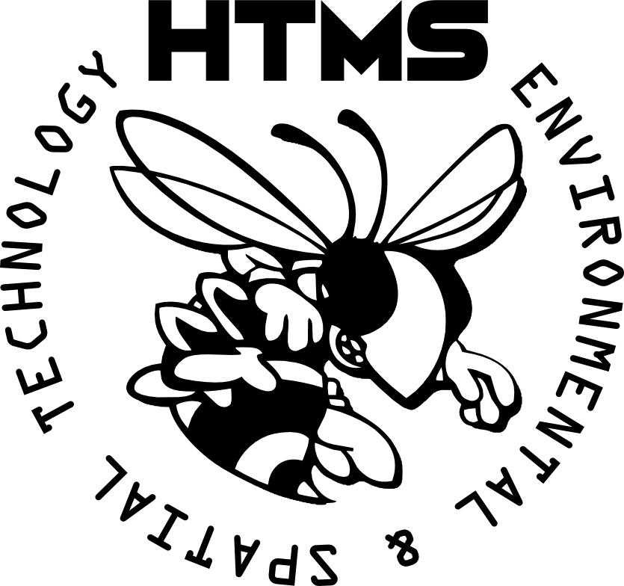

*My College Quest: A Plan for Learning*  ***University of EAST****@ Helen Tyson Middle School*

**Step 1: Identify Area of Study**

1. **I want to learn more about Audio Production.**

**By learning this, I will be able to produce and edit audio files.**

1. **Explore the pieces of software that would help you learn more. Describe what they do below.**
   1. **Software 1: Ableton Live**

**This software has splicing, editing, and a good MIDI sequencing software.**

* 1. **Software 2: FL Studio**

**A good software for beginners, and it has everything in an easy-access interface.**

**Step 2: Identify Resources to Learn**

1. **Describe two pieces of hardware that you might use in the college you have selected. What does it do, how is it useful, etc.** 
   1. **Hardware 1: Akai AR900**
   2. **Hardware 2: ______________________**

**_____________________________________________________________________________**

**_____________________________________________________________________________**

**Step 3: Identify What You Can Create**

1. **Describe two products/ projects you could produce using the software and hardware**
   1. **Idea 1: ______________________**

**_____________________________________________________________________________**

**_____________________________________________________________________________**

* 1. **Idea 2: ______________________**

**_____________________________________________________________________________**