class4.R

lanadoan

2024-01-23

# My first R script  
  
x <- 1:50  
plot(x, sin(x))

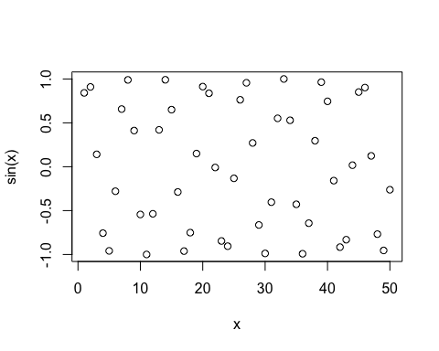

plot(x, sin(x), typ = "l", col="pink")

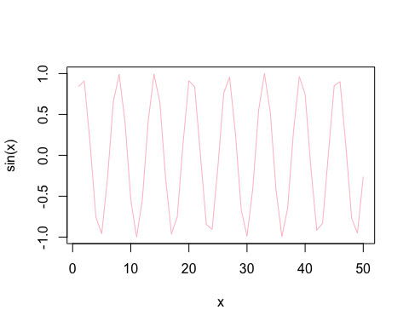

plot(x, sin(x), typ = "l", col="pink", lwd=2)

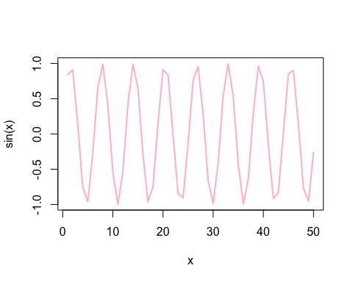

plot(x, sin(x), typ = "l", col="pink", lwd=2, xlab="hello")

