Serialization topics
http://www.beingjavaguys.com/2013/12/serialization-and-deserialization-in.html

Serialization is the process of converting an object's state (including its references) to a sequence of bytes(a.k.a write an object's state into a stream) , so that it can be transported through a network, as well as the process of rebuilding those bytes into a live object at some future time.

The idea is simple: "flatten" an object into stream of bytes in memory.
This Byte stream can be used for different purpose.
- Write to Disk
- Store in Memory
- Sent byte stream to other platform over network
- Save byte stream in DB(As BLOB)
Simple......Coverting an object to stream of bytes and bytes back to object.

So when is serialization used?

Serialization is used when you want to persist the object. It is also used by RMI to pass objects between JVMs, either as arguments in a method invocation from a client to a server or as return values from a method invocation.

In general, serialization is used when we want the object to exist beyond the lifetime of the JVM.

Object Serialization in Java is a process used to convert Object into a binary format which can be persisted into disk or sent over network to any other running Java virtual machine; the reverse process of creating object from binary stream is called deserialization in Java.

Need of Serialization
Serialization comes into picture when we need to send an object(not text) over network or store in a file so that the object can be rebuild again when needed. But the network infrastructure and hard disks does not understand java, what they understand are bytes only, and this is what serialization does. It converts java object to bytes and bytes to java object again.

How do you serialize?
When you want to serialize an object, that respective class should implement the marker interface Serializable. It just informs the compiler that this java class can be serialized.
Serializable Interface is a Marker Interface. Hence there is no method in Serializable interface.

If you want any class to be serialized then that class needs to implement Serializable interface.

package com.jbt;

import java.io.Serializable;

public class Employee implements Serializable
{
public String firstName;
public String lastName;
private static final long serialVersionUID = 5462223600l;
}

Serializable interface doesn't have any method and also called Marker Interface in Java. When your class implements java.io.Serializable interface it becomes Serializable in Java and gives compiler an indication that, use Java Serialization mechanism to serialize this object.

Understand the serialVersionUID
If you have ever implemented Serializable interface, you must encounter this warning message
The serializable class xxx does not declare a static final serialVersionUID field of type long
So, what is serialVersionUID??
The serialVersionUID is used as a version control in a Serializable class.
serialVersionUID is a version number associated to each serializable class by serialization runtime. This version number is used during deserialization process to verify that the sender and receiver of a serialized object have loaded class for that object which is compatible with respect to serialization.
If you do not explicitly declare a serialVersionUID, JVM will do it for you automatically, based on various aspects of your Serializable class.
If a serializable class have explicit serialVersionUID then this field should be of type long and must be static and final. It is advised to use private access modifier for serialVersionUID.

Example: private static final long serialVersionUID = 5462223600l;

What’s wrong with the default serialVersionUID?
If no serialVersionUID is specified explicitly, JVM will use its own algorithm to generate a default SerialVersionUID.
The default serialVersionUID computation is highly sensitive to class details and may vary from different JVM implementation, and result in an unexpected InvalidClassExceptions during the deserialization process.
The default serialVersionUID can vary based on compiler implementation. Hence it is advisable to define explicitly serialVersionUID.

How to generate serialVersionUID value??

'serialver' command

JDK has a build in command called “serialver” to generate the serialVersionUID
automatically.

In this example, you use “serialver” to generate a serialVersionUID for Address class. E:\workspace\target\classes>serialver Address
Address: static final long serialVersionUID = -687991492884005033L;
Use Eclipse IDE

If you are using Eclipse, move your mouse over the serialization class. Or Click on the serialization class and press “CTRL + 1“.

Anything you want
Just specify your own serialVersionUID , give a number and append an “L” behind.
private static final long serialVersionUID = 1L;

How do you Serialize and De-serialize??
You open a stream and write the object into it.
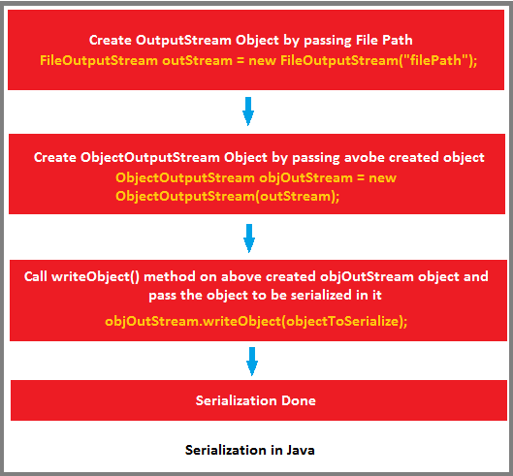
For Example, You want to write a Java object into a file for future access, this is called serialization.
In order to do this, you have to implement the Serializable interface, and use ObjectOutputStream to write the object into a file.
FileOutputStream fout = new FileOutputStream("c:\\address.ser");
ObjectOutputStream oos = new ObjectOutputStream(fout);
oos.writeObject(address);

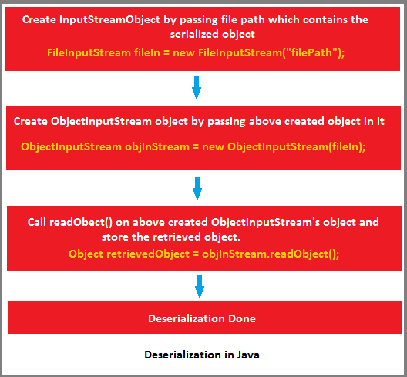

The deserialize process is quite similar with the serialization, you need to use ObjectInputStream to read the content of the file and convert it back to Java object.
FileInputStream fin = new FileInputStream("c:\\address.ser"); ObjectInputStream ois = new ObjectInputStream(fin);
address = (Address) ois.readObject();

What if the serialized object has a reference to another object??
In case the object we are going to serialize has some reference to other object, then what would happen ?In this case three possible conditions can arise.

Case 1 : If the referenced class implements Serializable
In case we have a reference to another object and the referenced class also implements Serializable, then the referenced class will be automatically serialized.

Case 2 : If the referenced class does not implent Serializable
In case we have a reference to another object and the referenced class does not implement Serializable interface, then there will be runtime error in serializing the class.

Case 3 : If the referenced class does not implement Serializable but it's reference variable is transient
In case we have a reference to another object and the referenced class does not implement Serializable interface, then there will be runtime error in serializing the class. To avoid this error, just make the reference variable as transient.
In this case, when we deserialize, there will a null value for reference variable.

Case 4 : If the referenced class does not implement Serializable and we still want to persist the state
If a reference variable is present, either the referenced class must be serializable or the reference variable must be declared transient.
Now the question arises, is it possible to persist states of a referenced class even if the class is not serializable and its reference variable is declared transient?? Yes, This is possible !
In that case, Java serialization provides a mechnism such that if you override writeObject and readObject methods with particular signature, then they will get called during serialization and deserialization.
private void writeObject(ObjectOutputStream ous)
private void readObject(ObjectInputStream ois)

Inheritance in Java Serialization
Incase of inheritance, when we want to serialize an object there may be three possible scenarios.
Case 1 : If super class is serializable
In case super class is Serializable than all its subclasses will be serializable by default. No need to implement serializable interface in subclass explicitly.

Case 2 : If super class is not serializable, but subclass is.
In case super class is not Serializable, then to serialize the subclass’s object we must implement serializable interface in subclass explicitly. In this case the superclass must have a no-argument constructor in it. Otherwise, we will get a run-time error: java.io.InvalidClassException: com.rdayala.serialization.XXXXX; no valid constructor
If superclass is not Serializable, then all values of the instance variables inherited from super class will be initialized by calling constructor of Non-Serializable Super class during deserialization process.

Case 3 : If super class is serializable, but we don't want the subclass to be serialized
To prevent subclass from being serialized we must implement writeObject() and readObject() methods and need to throw NotSerializableException from these methods.

Points:
- Java serialization process relies on correct serialVersionUID for recovering state of serialized object and throws java.io.InvalidClassException in case of serialVersionUID mismatch.
- If you don't want any field to be part of object's state then declare it either static or transient based on your need and it will not be included during Java serialization proces.
- If you try to serialize an object of a class which implements Serializable, but the object includes a reference to an non- Serializable class then a ‘NotSerializableException’ will be thrown at runtime.
- If a class is Serializable, but it's super-class is not. What will happen to the state of instance variables inherited from super class after de-serialization? Java serialization process only continues in object hierarchy till the class is Serializable i.e. implements Serializable interface in Java and values of the instance variables inherited from super class will be initialized by calling constructor of Non-Serializable Super class during deserialization process.

Can you Customize Serialization process or can you override default Serialization process in Java?
The answer is yes you can.
We all know that for serializing an object ObjectOutputStream.writeObject (saveThisobject) is invoked and for reading object ObjectInputStream.readObject() is invoked but there is one more thing which Java Virtual Machine provides you is to define these two method in your class.
If you define these two methods in your class then, JVM will invoke these two methods instead of applying default serialization mechanism.
You can customize behavior of object serialization and deserialization here.
Important point to note is making these methods private to avoid being inherited, overridden or overloaded. Since only Java Virtual Machine can call private method integrity of your class will remain and Java Serialization will work as normal.

If super class is serializable, but we don't want the subclass to be serialized
To prevent subclass from being serialized we must implement writeObject() and readObject() methods and need to throw NotSerializableException from these methods.
To avoid Java serialization you need to implement writeObject() and readObject() method in your Class and need to throw NotSerializableException from those method. This is another benefit of customizing java serialization process as described in above Serialization interview question and normally it asked as follow-up question as interview progresses.

Suppose you have a class which you serialized it and stored in persistence and later modified that class to add a new field. What will happen if you deserialize the object already serialized?

It depends on whether class has its own serialVersionUID or not. If we don't provide serialVersionUID in our code java compiler will generate it and normally it’s equal to hashCode of object. By adding any new field, there is chance that new serialVersionUID generated for that class version is not the same of already serialized object and in this case Java Serialization API will throw java.io.InvalidClassException and this is the reason its recommended to have your own serialVersionUID in code and make sure to keep it same always for a single class.

Which kind of variables is not serialized during Java Serialization?
Since static variables belong to the class and not to an object, they are not the part of the state of object so they are not saved during Java Serialization process. As Java Serialization only persist state of object and not object itself.

Transient variables are also not included in java serialization process and are not the part of the object’s serialized state.

References:
http://www.beingjavaguys.com/2013/12/serialization-and-deserialization-in.html
http://inheritingjava.blogspot.in/2011/04/core-java-interview-questions.html
http://www.jusfortechies.com/java/core-java/serialVersionUID.php – lot info
http://javapapers.com/core-java/serialize-de-serialize-java-object-from-database/
http://way2java.com/serialization/what-is-serialization/ - nageshwar rao tutorial

